Modify the given formula to the best of your ability to look like follows:

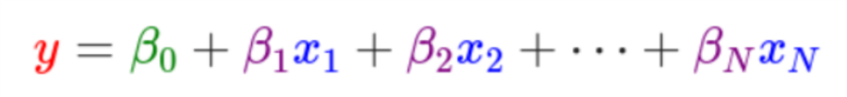

$$y = β_{0}+β_{1}x_{1}+β_{2}x_{2}+⋯+β_{N}x_{N}$$

Notify your facilitator and return to the previous tab when you are done.