**Borg & Puccini Interactive**

# **Starve Wars**

**Project Pitch for:**

Welcome to Starve Wars: Outlast, outmaneuver, and out-eat your enemies in the ultimate food fight!

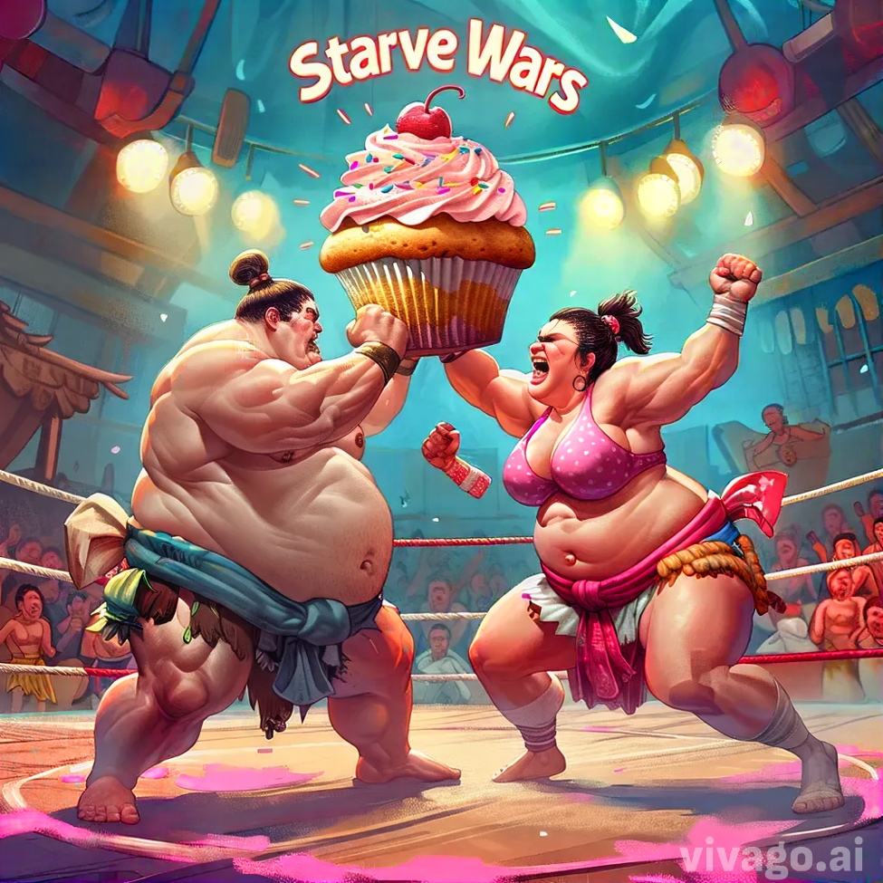

All work Copyright ©2024 by Borg Puccini Interactive

Written by Alissa Borg and Michael Puccini

Group 17

Version # 1.00 Sunday, August 18, 2024

**Game Overview**

**Aims:**

* To create an engaging and competitive multiplayer survival experience.
* To offer a dynamic and challenging environment that promotes strategic gameplay.

**Genre:** Fast paced multiplayer survival

**What is the game?**

*Starve Wars* is a dynamic multiplayer survival game where players vie to be the last one standing in a rapidly deteriorating environment. Each player begins with full health that depletes over time, requiring them to navigate the level to collect food for health restoration and power-ups for strategic advantages. Players must avoid enemies and make quick decisions to outlast their opponents. The goal is to avoid starvation and emerge as the ultimate survivor, combining strategy and reflexes for an engaging experience.

**What is the target audience?**

*Starve Wars* targets a broad range of mobile and pc gamers aged 12+, including both casual and competitive players. This demographic enjoys fast-paced gameplay that demands quick thinking and strategic movement. Our audience includes both genders who are drawn to multiplayer action games and survival challenges. We aim to offer an entertaining and engaging experience for a diverse group of mobile gamers.

**Design Concepts:**

* Fast-paced survival mechanics
* Resource collection and health management
* Dynamic enemy interactions and power-ups

**Features**

* **Unique Abilities and Power-ups:** Can purchase upgrades between levels
* **Varied Environments:** different level environments with different requirements

### **Gameplay Mechanics**

* **Time and Health Depletion:**
  + As the level progresses, both time and player health gradually deplete, creating a sense of urgency.
  + Players must actively seek out and collect consumables scattered throughout the environment to boost their health and extend their survival.
* **Consumables:**
  + **Health Boosts:** Restore a portion of the player's health, allowing them to survive longer.
  + **Speed Boosts:** Temporarily increase the player's movement speed, giving them an edge in escaping enemies or reaching valuable resources first.
  + **Radius Boosts:** Increase the player's detection radius, allowing them to spot enemies, traps, and consumables from a greater distance.
* **Traps and Bombs:**
  + **Enemy-Laid Traps:** Enemies place traps around the level, which players must avoid or deactivate. Triggering a trap can result in health loss or other negative effects.
  + **Bombs:** Certain enemies or the environment may have bombs that detonate after a short delay, causing damage to players within the blast radius

**Flow Chart**

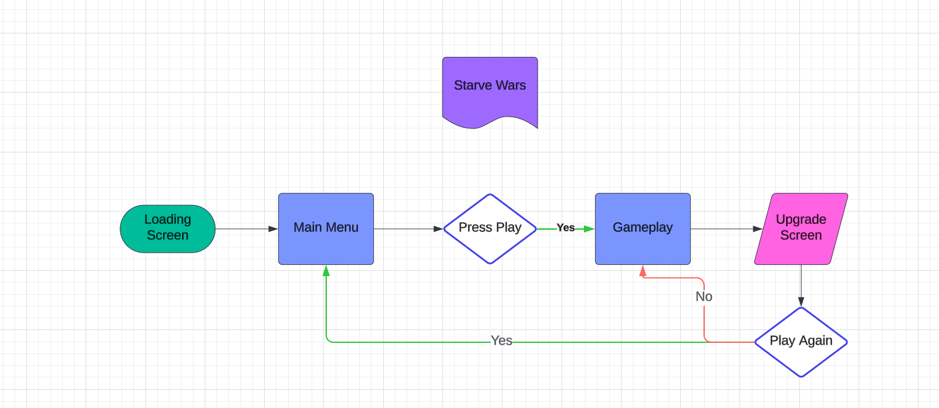

**Story Board**

