Table of Contents

Tree Phenology Logbook

- Author: Alissa Sophie Simon
- Due date: 08-03-2026
- Course: Tree Phenology analysis in R (Logbook)

1 Chapter 3 — Tree Dormancy
This chapter focuses on understanding dormancy in temperate fruit trees.

1.1 Estimating chilling and forcing requirements
Put yourself in the place of a breeder who wants to calculate the temperature requirements of a newly released cultivar. Which method will you use to calculate the chilling and forcing periods? Please justify your answer
I would use a statistical approach
- experimental method is time consuming and labor intensive, as you need to repeatedly collect buds in the field, place them in the growing chambers and observe the bud growth
- the statistical method analyzes field data together with temperature records
- by applying correlation or regression approaches, you can identify
  - periods with positive significant coefficients → chilling phases
  - periods with negative coefficients → forcing phase
- the statistical method provides an objective, data-driven estimation of temperature requirements, can be updated with new years of data and allows to model cultivar response under climate-change scenarios

1.2 Advantages of the BBCH scale
Which are the advantages of the BBCH scale compared with earlier scales?
- The BBCH scale provides a unified coding system applicable to most crops
- Earlier systems (e.g. Fleckinger 1948; Baglioni 1953) were species-specific
- Growth stages are described using easily recognizable field traits and a two-digit numeric code
- BBCH distinguishes:
  - principal growth stages (0–9)
  - secondary growth stages
- This allows a much more precise description of development
- Earlier scales often used only broad stages and missed intermediate steps

1.3 Classification of sweet cherry phenological stages
Classify the following phenological stages of sweet cherry according to the BBCH scale
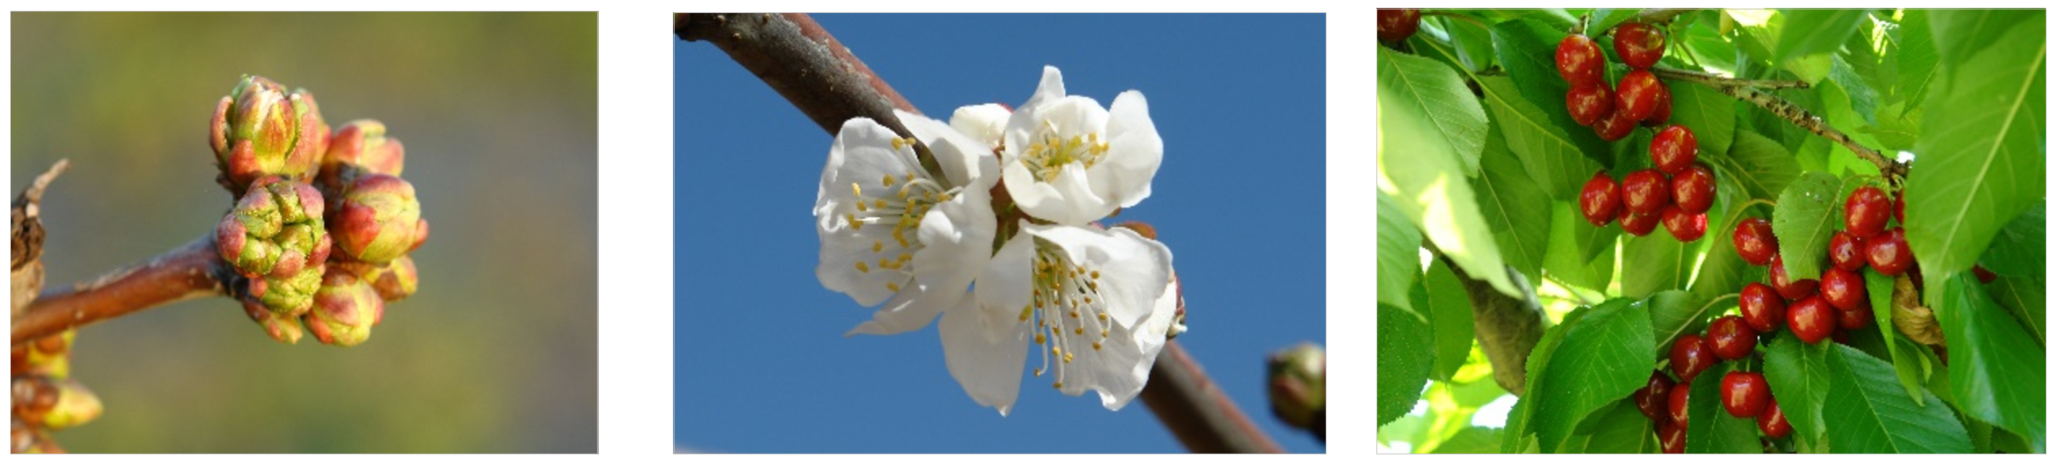
- Principal growth stage 5 → reproductive development or inflorescence emergence with single buds visible
- Principal growth stage 6 → flowering
- Principal growth stage 8 → ripening or maturity

2 Chapter 4 — Climate Change and Impact Projection
This chapter discusses how global warming affects chill accumulation and flowering timing.

2.1 Drivers of climate change
List the main drivers of climate change at the decade to century scale, and briefly explain the mechanism through which the currently most important driver affects our climate.
Main drivers at decadal to centennial scales:
- Greenhouse gases (GHGs) (CO₂, CH₄, N₂O)
- Aerosols
- Surface albedo changes
- Clouds
- Ozone
- Solar variability (minor role in recent decades)
- Volcanic activity (short-term effects)
Currently most important driver: Greenhouse gases
Greenhouse gases trap heat in the Earth’s atmosphere by absorbing long-wave radiation emitted from the Earth’s surface while also allowing short-wave solar radiation to pass through. This enhances the natural greenhouse effect, increasing Earth’s mean temperature. Human activities, especially fossil fuel combustion, cement production, and land-use change, have caused atmospheric CO₂ concentrations to rise faster and to higher levels than ever before in human history, making GHGs the dominant driver of recent climate change.

2.2 Recent temperature dynamics and causes for concern
Explain briefly what is special about temperature dynamics of recent decades, and why we have good reasons to be concerned.
Characteristics of recent warming:
- Rapid and global warming since about 1901, visible almost everywhere on earth
- The temperature is rising faster than ever before in human history
- The known “hockey stick” pattern is showing a sharp rise in recent temperatures
- Temperatures are rising much faster than during past natural climate changes
Why this is concerning:
- rapid change leave little time for natural and human systems to adapt
- It increases the risk of positive feedbacks, such as:
  - Melting ice and snow → reduced albedo means more warming
  - Permafrost thaw → methane release → further warming
- Even “moderate” warming targets (1.5–2°C) represent extreme changes compared to historical variability

2.3 Representative Concentration Pathways (RCPs)
What does the abbreviation ‘RCP’ stand for, how are RCPs defined, and what is their role in projecting future climates?
Definition:
RCP stands for Representative Concentration Pathway.
- RCPs are greenhouse gas concentration scenarios used by the IPCC
- They are defined by the additional radiative forcing (in W m⁻²) expected by the year 2100
  - Example: RCP2.6, RCP4.5, RCP6.0, RCP8.5
- The higher the RCP number, the greater the expected warming
Role in climate projections:
- RCPs provide standardized future forcing pathways
- They serve as inputs to Global Climate Models (GCMs)
- They allow scientists to explore different plausible futures rather than predict a single outcome
- RCPs are the starting point for climate and impact projections

2.4 Climate impact projection methods
Briefly describe the 4 climate impact projection methods described in the fourth video.
The four main climate impact projection methods are:
1. Statistical impact models
- Use statistical relationships between climate variables (e.g. temperature, rainfall) and observed impacts (e.g. crop yield, species presence)
- Useful for explaining past trends and projecting future impacts
- Key limitation → assume relationships remain valid in the future (stationarity)
2. Species Distribution Models (SDMs)
- Relate species occurrence to climatic variables
- Used to project current and future habitat suitability
- Results depend strongly on the chosen algorithm
- Often combined in ensemble modeling to address uncertainty
- Limited by equilibrium assumptions and missing non-climatic drivers
3. Process-based (mechanistic) models
- Explicitly simulate system processes using equations
- Common in agriculture, hydrology, and ecology
- Can test management and adaptation options
- Major limitations include:
  - Poor understanding of some processes
  - High parameter uncertainty
  - Risk of imbalance (some processes over-modeled, others ignored)
4. Climate analogue models
- Identify locations today with climates similar to a site’s projected future climate
- Use real-world systems to infer future impacts
- Particularly useful for participatory learning and adaptation planning
- Limitations include differences in soils, management,and socio-economic conditions

3 Chapter 5 — Winter Chill Projections
In this section, we simulate chill accumulation using temperature data and explore potential future reductions due to climate change.

3.1 Data access and processing challenges
Sketch out three data access and processing challenges that had to be overcome in order to produce chill projections with state-of-the-art methodology
Data availability and data volume
- Early climate model outputs were difficult to access and distributed as large global datasets (hundreds of MB per variable)
- Such datasets were hard to process on standard computers
- Researchers required location-specific, manageable datasets
- This challenge was later addressed by platforms such as ClimateWizard and AFRICLIM
Lack of hourly temperature data
- Most climate projections provide only daily minimum and maximum temperatures
- Many chill models (especially the Dynamic Model) require hourly temperature inputs
- This mismatch required the development of
  - interpolation methods
  - weather generators to derive hourly temperature series from daily data
Automation and reproducibility
- Chill projection studies typically involve
  - many locations
  - multiple climate models
  - several emission scenarios
- Manual processing is infeasible at this scale
- Automated workflows were required for
  - data cleaning
  - chill calculation
  - result visualization
- Programming environments such as R became essential for reproducible analyses

3.2 Basic workflow for chill projections
Outline, in your understanding, the basic steps that are necessary to make such projections
Step 1: Collect climate data
- Obtain temperature data from:
  - weather stations (historical)
  - climate model projections (future)
- Data are usually available as daily minimum and maximum temperatures
Step 2: Convert daily to hourly temperatures
- Hourly temperatures are estimated from daily Tmin and Tmax
- This can be done using:
  - interpolation formulas
  - weather generators
Step 3: Calculate chill accumulation
- Apply a chill model (e.g. the Dynamic Model)
- Calculate chill accumulation for each site and year
Step 4: Compare historical and future scenarios
- Repeat chill calculations for future climate scenarios
- Compare results to historical reference periods
- Quantify potential chill losses or gains
Step 5: Summarize and visualize results
- Present results using:
  - tables
  - maps (e.g. Safe Winter Chill maps)
  - time series or boxplots
Step 6: Interpret implications
- Translate results into practical consequences
- For example:
  - cultivar suitability
  - need for cultivar replacement
  - potential relocation of production areas

4 Chapter 6 — Manual chill analysis
In this chapter, we calculate warm hours above 25°C using the chillR package.

4.1 Calculating warm hours (>25 °C)
Write a basic function that calculates warm hours (>25°C) & Apply this function to the Winters_hours_gaps dataset.
library(chillR)
data(Winters_hours_gaps)
hours_over_25 <- sum(Winters_hours_gaps$Temp > 25, na.rm = TRUE)
print(paste("Total hours over 25°C:", hours_over_25))
## [1] "Total hours over 25°C: 1275"

4.2 Calculating warm hours for a defined time period
Extend this function, so that it can take start and end dates as inputs and sums up warm hours between these dates
calculate_warm_hours <- function(data, start_date, end_date) {
data$Date <- as.Date(paste(data$Year, data$Month, data$Day, sep = "-"))
data_filtered <- data[data$Date >= as.Date(start_date) & data$Date <= as.Date(end_date), ]
warm_hours <- sum(data_filtered$Temp > 25, na.rm = TRUE)
return(warm_hours)
}
start <- "2008-06-01"
end <- "2008-09-28"
result <- calculate_warm_hours(Winters_hours_gaps, start, end)
print(paste("Warm hours between", start, "and", end, ":", result))
## [1] "Warm hours between 2008-06-01 and 2008-09-28 : 1003"

5 Chapter 7 — Chill models
In this chapter, we explore how chill models quantify winter cold accumulation and learn to run, customize, and apply these models to temperature data.

5.1 Applying a built-in chill model
Run the chilling function on the Winters_hours_gap dataset
library(chillR)
data("Winters_hours_gaps")
output_chilling <- chilling(make_JDay(Winters_hours_gaps),
Start_JDay = 90,
End_JDay = 100)
print(output_chilling)
## Season End_year Season_days Data_days Perc_complete Chilling_Hours Utah_Model Chill_portions
## 1 2007/2008 2008 11 11 100 40 15.5 2.009147
## GDH
## 1 2406.52

5.2 Defining a custom chill model
Create your own temperature-weighting chill model using the step_model function
my_chill_model <- data.frame(
lower = c(-1000, 0, 3, 6, 9, 12, 15),
upper = c(0, 3, 6, 9, 12, 15, 1000),
weight = c(0, 0.5, 1, 0.5, 0, -0.5, -1)
)
print(my_chill_model)
## lower upper weight
## 1 -1000 0 0.0
## 2 0 3 0.5
## 3 3 6 1.0
## 4 6 9 0.5
## 5 9 12 0.0
## 6 12 15 -0.5
## 7 15 1000 -1.0
my_custom_chill <- function(x) step_model(x, my_chill_model)
my_custom_chill(Winters_hours_gaps$Temp)[1:20]
## [1] -1.0 -2.0 -3.0 -4.0 -5.0 -6.0 -7.0 -8.0 -9.0 -9.5 -9.5 -9.5 -9.5 -9.0 -8.5 -8.0 -7.5 -7.5
## [19] -7.0 -6.0

5.3 Applying the custom chill model
Run this model on the Winters_hours_gaps dataset using the tempResponse function.
output_custom <- tempResponse(make_JDay(Winters_hours_gaps),
Start_JDay = 90,
End_JDay = 100,
models = list(MyChill = my_custom_chill))
print(output_custom)
## Season End_year Season_days Data_days Perc_complete MyChill
## 1 2007/2008 2008 11 11 100 -77

6 Chapter 8 — Making hourly temperatures
In this chapter, we will explore how to create hourly temperature data from daily records using the chillR package. We will use both idealized and empirical temperature curves.

6.1 Daylength and solar geometry
Choose a location of interest, find out its latitude and produce plots of daily sunrise, sunset and daylength
Here, I use Edinburgh, Scotland (latitude = 55.95) as the example location.
library(chillR)
library(ggplot2)
library(tidyr)
latitude <- 55.95
Days <- chillR::daylength(latitude = 55.95, JDay = 1:365)
Days_df <-
data.frame(
JDay = 1:365,
Sunrise = Days$Sunrise,
Sunset = Days$Sunset,
Daylength = Days$Daylength
)
Days_df <- pivot_longer(Days_df,cols=c(Sunrise:Daylength))
ggplot(Days_df, aes(JDay, value)) +
geom_line(lwd = 1.5, col = "darkgreen") +
facet_grid(cols = vars(name)) +
ylab("Time of Day / Daylength (Hours)") +
xlab("Julian Day") +
ggtitle("Sunrise, Sunset and Daylength Over the Year") +
theme_bw(base_size = 16)
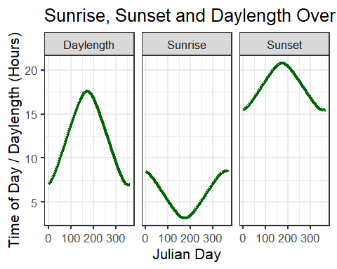

6.2 Idealized diurnal temperature curves
Produce an hourly dataset, based on idealized daily curves, for the KA_weather dataset
latitude <- 55.95
KA_hourly <- stack_hourly_temps(KA_weather, latitude = latitude)$hourtemps
head(KA_hourly, 24)
## Year Month Day Tmax Tmin JDay Hour Temp
## 1 1998 1 1 8.2 5.1 1 0 5.100000
## 4535 1998 1 1 8.2 5.1 1 1 5.100000
## 9069 1998 1 1 8.2 5.1 1 2 5.100000
## 13603 1998 1 1 8.2 5.1 1 3 5.100000
## 18137 1998 1 1 8.2 5.1 1 4 5.100000
## 22671 1998 1 1 8.2 5.1 1 5 5.100000
## 27205 1998 1 1 8.2 5.1 1 6 5.100000
## 31739 1998 1 1 8.2 5.1 1 7 5.100000
## 36273 1998 1 1 8.2 5.1 1 8 5.100000
## 40807 1998 1 1 8.2 5.1 1 9 5.568044
## 45341 1998 1 1 8.2 5.1 1 10 6.407520
## 49875 1998 1 1 8.2 5.1 1 11 7.142357
## 54409 1998 1 1 8.2 5.1 1 12 7.713744
## 58943 1998 1 1 8.2 5.1 1 13 8.075954
## 63477 1998 1 1 8.2 5.1 1 14 8.200000
## 68011 1998 1 1 8.2 5.1 1 15 8.075954
## 72545 1998 1 1 8.2 5.1 1 16 7.524906
## 77079 1998 1 1 8.2 5.1 1 17 7.000388
## 81613 1998 1 1 8.2 5.1 1 18 6.657063
## 86147 1998 1 1 8.2 5.1 1 19 6.401394
## 90681 1998 1 1 8.2 5.1 1 20 6.197605
## 95215 1998 1 1 8.2 5.1 1 21 6.028151
## 99749 1998 1 1 8.2 5.1 1 22 5.883114
## 104283 1998 1 1 8.2 5.1 1 23 5.756336

6.3 Empirical reconstruction of hourly temperatures
Produce empirical temperature curve parameters for the Winters_hours_gaps dataset, and use them to predict hourly values from daily temperatures.
Sometimes the idealized curve may not reflect real conditions (e.g., topographic or local effects). In such cases, empirical curves are better. They are based on real hourly observations.
empi_curve <- Empirical_daily_temperature_curve(Winters_hours_gaps)
ggplot(data = empi_curve[1:96, ], aes(Hour, Prediction_coefficient)) +
geom_line(lwd = 1.3, col = "red") +
facet_grid(rows = vars(Month)) +
xlab("Hour of the Day") +
ylab("Prediction Coefficient") +
theme_bw(base_size = 10)
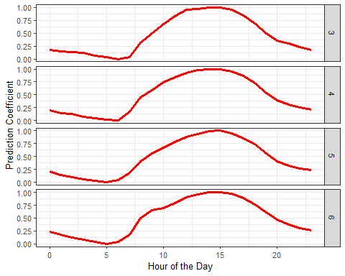
Winters_daily <- make_all_day_table(Winters_hours_gaps, input_timestep = "hour")
Winters_emp_hourly <- Empirical_hourly_temperatures(Winters_daily, empi_curve)
head(Winters_emp_hourly, 24)
## DATE Year Month Day Temp_gaps Tmin Tmean Tmax JDay Hour Temp
## 1 2008-03-03 12:00:00 2008 3 3 15.01593 7.92 15.01593 19.508 63 0 9.976706
## 41 2008-03-03 12:00:00 2008 3 3 15.01593 7.92 15.01593 19.508 63 1 9.716943
## 69 2008-03-03 12:00:00 2008 3 3 15.01593 7.92 15.01593 19.508 63 2 9.409812
## 91 2008-03-03 12:00:00 2008 3 3 15.01593 7.92 15.01593 19.508 63 3 9.247518
## 133 2008-03-03 12:00:00 2008 3 3 15.01593 7.92 15.01593 19.508 63 4 8.726599
## 151 2008-03-03 12:00:00 2008 3 3 15.01593 7.92 15.01593 19.508 63 5 8.313509
## 183 2008-03-03 12:00:00 2008 3 3 15.01593 7.92 15.01593 19.508 63 6 7.920000
## 207 2008-03-03 12:00:00 2008 3 3 15.01593 7.92 15.01593 19.508 63 7 8.282838
## 235 2008-03-03 12:00:00 2008 3 3 15.01593 7.92 15.01593 19.508 63 8 11.537726
## 273 2008-03-03 12:00:00 2008 3 3 15.01593 7.92 15.01593 19.508 63 9 13.659805
## 301 2008-03-03 12:00:00 2008 3 3 15.01593 7.92 15.01593 19.508 63 10 15.822638
## 320 2008-03-03 12:00:00 2008 3 3 15.01593 7.92 15.01593 19.508 63 11 17.453938
## 351 2008-03-03 12:00:00 2008 3 3 15.01593 7.92 15.01593 19.508 63 12 18.936122
## 378 2008-03-03 12:00:00 2008 3 3 15.01593 7.92 15.01593 19.508 63 13 19.117026
## 413 2008-03-03 12:00:00 2008 3 3 15.01593 7.92 15.01593 19.508 63 14 19.410656
## 444 2008-03-03 12:00:00 2008 3 3 15.01593 7.92 15.01593 19.508 63 15 19.508000
## 481 2008-03-03 12:00:00 2008 3 3 15.01593 7.92 15.01593 19.508 63 16 18.917381
## 499 2008-03-03 12:00:00 2008 3 3 15.01593 7.92 15.01593 19.508 63 17 17.750214
## 538 2008-03-03 12:00:00 2008 3 3 15.01593 7.92 15.01593 19.508 63 18 15.874616
## 568 2008-03-03 12:00:00 2008 3 3 15.01593 7.92 15.01593 19.508 63 19 13.650746
## 598 2008-03-03 12:00:00 2008 3 3 15.01593 7.92 15.01593 19.508 63 20 12.134141
## 612 2008-03-03 12:00:00 2008 3 3 15.01593 7.92 15.01593 19.508 63 21 11.364391
## 654 2008-03-03 12:00:00 2008 3 3 15.01593 7.92 15.01593 19.508 63 22 10.655172
## 683 2008-03-03 12:00:00 2008 3 3 15.01593 7.92 15.01593 19.508 63 23 9.999817

7 Chapter 9 — Some useful tools in R
This section introduces practical R tools for handling and visualizing data, using tidyverse workflows and basic iteration to clean, transform, and plot temperature data clearly and reproducibly.

7.1 Data wrangling and visualization with tidyverse
Based on the Winters_hours_gaps dataset, use magrittr pipes and functions of the tidyverse to accomplish the following:
Converting data to a tibble
library(tidyverse)
Winters_tib <- as_tibble(Winters_hours_gaps)
Subsetting rows
Winters_tib10 <- Winters_tib %>% slice(1:10)
Reshaping data: wide to long format
Winters_long <- Winters_tib10 %>%
pivot_longer(cols = c(Temp_gaps, Temp),
names_to = "measurement",
values_to = "value")
Faceted visualization with ggplot2
ggplot(Winters_long, aes(x = Hour, y = value)) +
geom_point(color = "steelblue") +
facet_wrap(~measurement, ncol = 1) +
theme_bw(base_size = 11) +
labs(title = "Temperature values (Temp vs Temp_gaps)",
x = "Hour of Day", y = "Temperature (°C)")
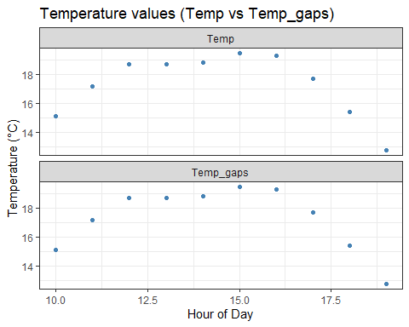
Reshaping data: long to wide format
Winters_wide <- Winters_long %>% pivot_wider(names_from = measurement, values_from = value)
Column selection
Winters_select <- Winters_wide %>% select(Year, Month, Day, Temp)
Sorting data
Winters_sorted <- Winters_select %>%
arrange(desc(Temp))
head(Winters_sorted)
## # A tibble: 6 × 4
## Year Month Day Temp
## <int> <int> <int> <dbl>
## 1 2008 3 3 19.5
## 2 2008 3 3 19.3
## 3 2008 3 3 18.8
## 4 2008 3 3 18.7
## 5 2008 3 3 18.7
## 6 2008 3 3 17.7

7.2 Using a for loop for data transformation
For the Winter_hours_gaps dataset, write a for loop to convert all temperatures (Temp column) to degrees Fahrenheit
Winters_for <- Winters_hours_gaps
for (i in 1:nrow(Winters_for)) {
Winters_for$Temp[i] <- (Winters_for$Temp[i] * 9/5) + 32
}
Winters_for <- as_tibble(Winters_for)
Winters_for
## # A tibble: 6,074 × 6
## Year Month Day Hour Temp_gaps Temp
## <int> <int> <int> <int> <dbl> <dbl>
## 1 2008 3 3 10 15.1 59.2
## 2 2008 3 3 11 17.2 62.9
## 3 2008 3 3 12 18.7 65.7
## 4 2008 3 3 13 18.7 65.7
## 5 2008 3 3 14 18.8 65.9
## 6 2008 3 3 15 19.5 67.1
## 7 2008 3 3 16 19.3 66.8
## 8 2008 3 3 17 17.7 63.9
## 9 2008 3 3 18 15.4 59.7
## 10 2008 3 3 19 12.7 54.9
## # ℹ 6,064 more rows

7.3 Using apply-family functions
Execute the same operation with a function from the apply family
Winters_apply <- Winters_hours_gaps
Winters_apply$Temp <- sapply(Winters_apply$Temp, function(x) (x * 9/5) + 32)
Winters_apply <- as_tibble(Winters_apply)
Winters_apply
## # A tibble: 6,074 × 6
## Year Month Day Hour Temp_gaps Temp
## <int> <int> <int> <int> <dbl> <dbl>
## 1 2008 3 3 10 15.1 59.2
## 2 2008 3 3 11 17.2 62.9
## 3 2008 3 3 12 18.7 65.7
## 4 2008 3 3 13 18.7 65.7
## 5 2008 3 3 14 18.8 65.9
## 6 2008 3 3 15 19.5 67.1
## 7 2008 3 3 16 19.3 66.8
## 8 2008 3 3 17 17.7 63.9
## 9 2008 3 3 18 15.4 59.7
## 10 2008 3 3 19 12.7 54.9
## # ℹ 6,064 more rows

7.4 Vectorized operations with tidyverse
Now use the tidyverse function mutate to achieve the same outcome
Winters_mutate <- Winters_hours_gaps %>%
mutate(Temp = (Temp * 9/5) + 32)
Winters_mutate <- as_tibble(Winters_mutate)
Winters_mutate
## # A tibble: 6,074 × 6
## Year Month Day Hour Temp_gaps Temp
## <int> <int> <int> <int> <dbl> <dbl>
## 1 2008 3 3 10 15.1 59.2
## 2 2008 3 3 11 17.2 62.9
## 3 2008 3 3 12 18.7 65.7
## 4 2008 3 3 13 18.7 65.7
## 5 2008 3 3 14 18.8 65.9
## 6 2008 3 3 15 19.5 67.1
## 7 2008 3 3 16 19.3 66.8
## 8 2008 3 3 17 17.7 63.9
## 9 2008 3 3 18 15.4 59.7
## 10 2008 3 3 19 12.7 54.9
## # ℹ 6,064 more rows

8 Chapter 10 — Getting temperature data
In this chapter, we learn how to obtain and prepare historical temperature data for a chosen location, using the Lake Constance region as an example.

8.1 Selecting a study location and nearby weather stations
Choose a location of interest and find the 25 closest weather stations using the handle_gsod function
Choice of study region:
- In general, I wanted to use the Lake Constance region because it is a major fruit production area in Germany
- Initially, I planned to use the same location, Gottmadingen (Baden-Württemberg), as in my bachelor’s thesis
- I quickly realized that there is no nearby weather station for Gottmadingen
- I then considered Consatnce, but the available weather data only extend until 2003
- Another option was the weather station in Schaffhausen, which has good data coverage
- However, I found the milder Lake Constance climate more interesting for the analysis
- The next weather station with nearly complete data is Güttingen (Thurgau), Switzerland, which is also located directly on Lake Constance
Climatic and agricultural relevance of the region:
- The Lake Constance region typically has mild, warm autumns, which are very favorable for fruit production and especially viticulture
- Large day–night temperature differences are a key factor that support optimal fruit ripening
- Güttingen hosts an agricultural experimental farm, the Schul- und Versuchsbetrieb in Güttingen, which is actively used for research in fruit and berry cultivation
- At this site, more than 10 fruit and berry species and over 100 different varieties are cultivated
- The Swiss canton of Thurgau is the largest fruit-growing region in Switzerland, with a gross income of approximately 80 million Swiss francs from fruit production
- Like most regions, Thurgau is affected by climate change, with meteorological records dating back to 1864 showing clear signals of climatic change
- Extreme weather events have become more frequent, including heatwaves (e.g. 2018) and heavy rainfall events (e.g. 2021)
- Since 1864, mean temperatures in Thurgau have increased by about 1.9 °C.
- Due to its importance for fruit production and its strong exposure to climate change, Güttingen is well suited for further studies in this module
Identifying nearby weather stations
library(chillR)
station_list<-handle_gsod(action="list_stations",
location=c( 8.77, 47.73),
time_interval=c(1990,2024))
head(station_list)
## # A tibble: 6 × 10
## chillR_code STATION.NAME CTRY Lat Long BEGIN END Distance Overlap_years
## <chr> <chr> <chr> <dbl> <dbl> <int> <int> <dbl> <dbl>
## 1 06620099999 SCHAFFHAUSEN CH 47.7 8.62 19550101 20250824 12.6 35
## 2 06671099999 STECKBORN CH 47.7 8.98 20120209 20250824 17.4 12.9
## 3 06623099999 SALEN-REUTENEN CH 47.6 9.02 20110124 20250824 20.5 13.9
## 4 06624099999 HALLAU CH 47.7 8.47 20120124 20250824 23.3 12.9
## 5 06679099999 AADORF-TAENIKON CH 47.5 8.9 19901101 20250824 29.2 34.2
## 6 10921099999 NEUHAUSEN OB ECK GM 48.0 8.9 19730102 19950228 29.8 5.16
## # ℹ 1 more variable: Perc_interval_covered <dbl>

8.2 Downloading historical weather data
Download weather data for the most promising station on the list
weather<-handle_gsod(action="download_weather",
location=station_list$chillR_code[14],
time_interval=c(1990,2024))
## Loading data for 35 years from station 'GUETTINGEN'
## ==================================================================================================
head(weather[[1]])
## STATION DATE LATITUDE LONGITUDE ELEVATION NAME TEMP TEMP_ATTRIBUTES DEWP
## 1 6621099999 1990-11-01 47.6 9.283333 440 GUETTINGEN, SZ 45.9 15 39.6
## 2 6621099999 1990-11-02 47.6 9.283333 440 GUETTINGEN, SZ 41.6 15 37.5
## 3 6621099999 1990-11-03 47.6 9.283333 440 GUETTINGEN, SZ 40.5 16 37.5
## 4 6621099999 1990-11-04 47.6 9.283333 440 GUETTINGEN, SZ 38.9 15 34.4
## 5 6621099999 1990-11-05 47.6 9.283333 440 GUETTINGEN, SZ 37.0 16 34.7
## 6 6621099999 1990-11-06 47.6 9.283333 440 GUETTINGEN, SZ 37.0 16 32.7
## DEWP_ATTRIBUTES SLP SLP_ATTRIBUTES STP STP_ATTRIBUTES VISIB VISIB_ATTRIBUTES WDSP
## 1 15 1009.0 15 956.8 15 999.9 0 999.9
## 2 15 1007.5 15 955.0 15 999.9 0 999.9
## 3 16 1007.9 16 955.2 16 999.9 0 999.9
## 4 15 1013.3 15 960.2 15 999.9 0 999.9
## 5 16 1020.9 16 967.2 16 999.9 0 999.9
## 6 16 1029.2 16 975.0 16 999.9 0 999.9
## WDSP_ATTRIBUTES MXSPD GUST MAX MAX_ATTRIBUTES MIN MIN_ATTRIBUTES PRCP PRCP_ATTRIBUTES SNDP
## 1 0 999.9 999.9 50.4 * 38.7 * 99.99 999.9
## 2 0 999.9 999.9 47.5 * 36.5 * 99.99 999.9
## 3 0 999.9 999.9 43.9 * 38.1 * 0.00 I 999.9
## 4 0 999.9 999.9 42.8 * 35.4 * 0.00 I 999.9
## 5 0 999.9 999.9 38.7 * 34.5 * 99.99 999.9
## 6 0 999.9 999.9 41.4 * 34.2 * 0.00 I 999.9
## FRSHTT
## 1 10000
## 2 10000
## 3 0
## 4 0
## 5 11000
## 6 0

8.3 Preparing weather data for chillR
Convert the weather data into chillR format
cleaned_weather<-handle_gsod(weather)
güttingen_weather <- cleaned_weather[[1]]
dir.create('data_güttingen')
## Warning in dir.create("data_güttingen"): 'data_güttingen' existiert bereits
write.csv(station_list,"data_güttingen/station_list.csv",row.names=FALSE)
write.csv(weather[[1]],"data_güttingen/Güttingen_raw_weather.csv",row.names=FALSE)
write.csv(cleaned_weather[[1]],"data_güttingen/Güttingen_chillR_weather.csv",row.names=FALSE)

8.4 Sources
Genusserbe Bayern – Lake Constance climate and viticulture https://www.genusserbe.bayern.de/355028/index.php
Arenenberg Thurgau – Experimental fruit production in Güttingen https://arenenberg.tg.ch/beratung/versuche/obstbau-guettingen.html/654
Arenenberg Thurgau – Fruit production in Thurgau https://arenenberg.tg.ch/beratung/obst.html/342
Canton of Thurgau – Climate change in Thurgau https://klima.tg.ch/klima-im-thurgau.html/16119

9 Chapter 11 — Filling gaps in temperature records
In this chapter, we identify gaps in temperature records and fill them using nearby high-quality weather stations.

9.1 Identifying gaps in the temperature record
Use chillR functions to find out how many gaps you have in this dataset (even if you have none, please still follow all further steps)
library(chillR)
library(tidyverse)
gut_raw <- read.csv("data_güttingen/Güttingen_raw_weather.csv")
gut <- read.csv("data_güttingen/Güttingen_chillR_weather.csv")
gut_qc <- fix_weather(gut)$QC
gut_qc
## Season End_year Season_days Data_days Missing_Tmin Missing_Tmax Incomplete_days
## 1 1989/1990 1990 365 365 304 304 304
## 2 1990/1991 1991 365 365 0 0 0
## 3 1991/1992 1992 366 366 0 0 0
## 4 1992/1993 1993 365 365 340 340 340
## 5 1993/1994 1994 365 365 365 365 365
## 6 1994/1995 1995 365 365 365 365 365
## 7 1995/1996 1996 366 366 366 366 366
## 8 1996/1997 1997 365 365 365 365 365
## 9 1997/1998 1998 365 365 365 365 365
## 10 1998/1999 1999 365 365 365 365 365
## 11 1999/2000 2000 366 366 366 366 366
## 12 2000/2001 2001 365 365 154 154 154
## 13 2001/2002 2002 365 365 0 0 0
## 14 2002/2003 2003 365 365 1 1 1
## 15 2003/2004 2004 366 366 0 0 0
## 16 2004/2005 2005 365 365 0 0 0
## 17 2005/2006 2006 365 365 0 0 0
## 18 2006/2007 2007 365 365 0 0 0
## 19 2007/2008 2008 366 366 0 0 0
## 20 2008/2009 2009 365 365 0 0 0
## 21 2009/2010 2010 365 365 5 5 5
## 22 2010/2011 2011 365 365 0 0 0
## 23 2011/2012 2012 366 366 0 0 0
## 24 2012/2013 2013 365 365 0 0 0
## 25 2013/2014 2014 365 365 2 2 2
## 26 2014/2015 2015 365 365 3 3 3
## 27 2015/2016 2016 366 366 0 0 0
## 28 2016/2017 2017 365 365 0 0 0
## 29 2017/2018 2018 365 365 1 1 1
## 30 2018/2019 2019 365 365 8 8 8
## 31 2019/2020 2020 366 366 0 0 0
## 32 2020/2021 2021 365 365 3 3 3
## 33 2021/2022 2022 365 365 4 4 4
## 34 2022/2023 2023 365 365 12 12 12
## 35 2023/2024 2024 366 366 21 21 21
## Perc_complete
## 1 16.7
## 2 100.0
## 3 100.0
## 4 6.8
## 5 0.0
## 6 0.0
## 7 0.0
## 8 0.0
## 9 0.0
## 10 0.0
## 11 0.0
## 12 57.8
## 13 100.0
## 14 99.7
## 15 100.0
## 16 100.0
## 17 100.0
## 18 100.0
## 19 100.0
## 20 100.0
## 21 98.6
## 22 100.0
## 23 100.0
## 24 100.0
## 25 99.5
## 26 99.2
## 27 100.0
## 28 100.0
## 29 99.7
## 30 97.8
## 31 100.0
## 32 99.2
## 33 98.9
## 34 96.7
## 35 94.3

9.2 Identifying nearby weather stations
Create a list of the 25 closest weather stations using the handle_gsod function
station_list <- handle_gsod(
action = "list_stations",
location = c(9.283, 47.600),
time_interval = c(1990, 2024)
)
station_list[1:25,]
## # A tibble: 25 × 10
## chillR_code STATION.NAME CTRY Lat Long BEGIN END Distance Overlap_years
## <chr> <chr> <chr> <dbl> <dbl> <int> <int> <dbl> <dbl>
## 1 06621099999 GUETTINGEN CH 47.6 9.28 19901101 20250824 0 34.2
## 2 06842099999 SITTERDORF CH 47.5 9.27 20080122 20190118 9.32 11.0
## 3 06678099999 BISCHOFSZELL CH 47.5 9.23 20150818 20250824 11.8 9.37
## 4 10929099999 KONSTANZ GM 47.7 9.18 19360102 20250611 11.9 35
## 5 10934099999 FRIEDRICHSHAFEN GM 47.6 9.48 19590801 19780126 16.0 0
## 6 10935099999 FRIEDRICHSHAFEN GM 47.7 9.51 19290801 20250824 18.8 35
## 7 10935399999 FRIEDRICHSHAFEN GM 47.7 9.52 19880105 19881011 19.1 0
## 8 06681099999 ST. GALLEN CH 47.4 9.4 19811101 20250824 20.6 35
## 9 06623099999 SALEN-REUTENEN CH 47.6 9.02 20110124 20250824 20.7 13.9
## 10 06671099999 STECKBORN CH 47.7 8.98 20120209 20250824 23.7 12.9
## # ℹ 15 more rows
## # ℹ 1 more variable: Perc_interval_covered <dbl>

9.3 Selecting suitable stations for gap filling
Identify suitable weather stations for patching gaps
Selected patching stations

  - Konstanz
  - Distance 11.90, overlap years 35.00, interval covered 100%

  - Friedrichshafen
  - Distance 18.84, overlap years 35.00, interval covered 100%

  - St. Gallen
  - Distance 20.57, overlap years 35.00, interval covered 100%

  - Aadorf-Taenikon
  - Distance 31.59, overlap years 34.17, interval covered 98%

  - Hoernli
  - Distance 36.06, overlap years 30.84, interval covered 88%

  - Bregenz
  - Distance 36.81, overlap years 35.00, interval covered 100%

9.4 Downloading patching station data AND Patching gaps in the temperature record
Download weather data for promising stations, convert them to chillR format and compile them in a list & Use the patch_daily_temperatures function to fill gaps
patch_weather<-
handle_gsod(action = "download_weather",
location = as.character(station_list$chillR_code[c(4, 6, 8, 13, 14, 15)]),
time_interval = c(1990,2024)) %>%
handle_gsod()
## Loading data for 35 years from station 'AADORF-TAENIKON'
## ==================================================================================================
##
## Loading data for 35 years from station 'ST. GALLEN'
## ==================================================================================================
##
## Loading data for 35 years from station 'HOERNLI'
## ==================================================================================================
##
## Loading data for 35 years from station 'KONSTANZ'
## ==================================================================================================
##
## Loading data for 35 years from station 'FRIEDRICHSHAFEN'
## ==================================================================================================
##
## Loading data for 35 years from station 'BREGENZ'
## ==================================================================================================
patched <- patch_daily_temperatures(weather = gut,
patch_weather = patch_weather)
patched$statistics[[1]]
## mean_bias stdev_bias filled gaps_remain
## Tmin 1.412 1.487 23 3392
## Tmax 0.240 1.330 23 3392
patched$statistics[[2]]
## mean_bias stdev_bias filled gaps_remain
## Tmin 0.534 2.060 3349 43
## Tmax 1.853 2.058 3349 43
patched$statistics[[3]]
## mean_bias stdev_bias filled gaps_remain
## Tmin 1.707 2.807 0 43
## Tmax 3.988 2.901 0 43

9.5 Evaluating patching success and final gap filling and data preparation
Investigate the results - have all gaps been filled? & If necessary, repeat until you have a dataset you can work with in further analyses
post_patch_stats <- fix_weather(patched)$QC
post_patch_stats
## Season End_year Season_days Data_days Missing_Tmin Missing_Tmax Incomplete_days
## 1 1989/1990 1990 365 365 0 0 0
## 2 1990/1991 1991 365 365 0 0 0
## 3 1991/1992 1992 366 366 0 0 0
## 4 1992/1993 1993 365 365 0 0 0
## 5 1993/1994 1994 365 365 0 0 0
## 6 1994/1995 1995 365 365 0 0 0
## 7 1995/1996 1996 366 366 0 0 0
## 8 1996/1997 1997 365 365 0 0 0
## 9 1997/1998 1998 365 365 1 1 1
## 10 1998/1999 1999 365 365 1 1 1
## 11 1999/2000 2000 366 366 0 0 0
## 12 2000/2001 2001 365 365 0 0 0
## 13 2001/2002 2002 365 365 0 0 0
## 14 2002/2003 2003 365 365 0 0 0
## 15 2003/2004 2004 366 366 0 0 0
## 16 2004/2005 2005 365 365 0 0 0
## 17 2005/2006 2006 365 365 0 0 0
## 18 2006/2007 2007 365 365 0 0 0
## 19 2007/2008 2008 366 366 0 0 0
## 20 2008/2009 2009 365 365 0 0 0
## 21 2009/2010 2010 365 365 0 0 0
## 22 2010/2011 2011 365 365 0 0 0
## 23 2011/2012 2012 366 366 0 0 0
## 24 2012/2013 2013 365 365 0 0 0
## 25 2013/2014 2014 365 365 0 0 0
## 26 2014/2015 2015 365 365 0 0 0
## 27 2015/2016 2016 366 366 0 0 0
## 28 2016/2017 2017 365 365 0 0 0
## 29 2017/2018 2018 365 365 0 0 0
## 30 2018/2019 2019 365 365 0 0 0
## 31 2019/2020 2020 366 366 0 0 0
## 32 2020/2021 2021 365 365 2 2 2
## 33 2021/2022 2022 365 365 0 0 0
## 34 2022/2023 2023 365 365 0 0 0
## 35 2023/2024 2024 366 366 11 11 11
## Perc_complete
## 1 100.0
## 2 100.0
## 3 100.0
## 4 100.0
## 5 100.0
## 6 100.0
## 7 100.0
## 8 100.0
## 9 99.7
## 10 99.7
## 11 100.0
## 12 100.0
## 13 100.0
## 14 100.0
## 15 100.0
## 16 100.0
## 17 100.0
## 18 100.0
## 19 100.0
## 20 100.0
## 21 100.0
## 22 100.0
## 23 100.0
## 24 100.0
## 25 100.0
## 26 100.0
## 27 100.0
## 28 100.0
## 29 100.0
## 30 100.0
## 31 100.0
## 32 99.5
## 33 100.0
## 34 100.0
## 35 97.0
# most of the gaps have been filled
Güttingen_weather<-fix_weather(patched)
patched_weather <- patched$weather
weather_full <- patched_weather %>% make_all_day_table()
Tmin_int <- interpolate_gaps(weather_full$Tmin)
weather_full <- weather_full %>%
mutate(
Tmin = Tmin_int$interp,
Tmin_interpolated = Tmin_int$missing
)
Tmax_int <- interpolate_gaps(weather_full$Tmax)
Tmin_int <- interpolate_gaps(weather_full$Tmin)
weather_full <- weather_full %>%
mutate(
Tmax = Tmax_int$interp,
Tmax_interpolated = Tmax_int$missing
)
any(is.na(weather_full$Tmin))
## [1] FALSE
any(is.na(weather_full$Tmax))
## [1] FALSE
final_qc <- fix_weather(weather_full)$QC
final_qc
## Season End_year Season_days Data_days Missing_Tmin Missing_Tmax Incomplete_days
## 1 1989/1990 1990 365 365 0 0 0
## 2 1990/1991 1991 365 365 0 0 0
## 3 1991/1992 1992 366 366 0 0 0
## 4 1992/1993 1993 365 365 0 0 0
## 5 1993/1994 1994 365 365 0 0 0
## 6 1994/1995 1995 365 365 0 0 0
## 7 1995/1996 1996 366 366 0 0 0
## 8 1996/1997 1997 365 365 0 0 0
## 9 1997/1998 1998 365 365 0 0 0
## 10 1998/1999 1999 365 365 0 0 0
## 11 1999/2000 2000 366 366 0 0 0
## 12 2000/2001 2001 365 365 0 0 0
## 13 2001/2002 2002 365 365 0 0 0
## 14 2002/2003 2003 365 365 0 0 0
## 15 2003/2004 2004 366 366 0 0 0
## 16 2004/2005 2005 365 365 0 0 0
## 17 2005/2006 2006 365 365 0 0 0
## 18 2006/2007 2007 365 365 0 0 0
## 19 2007/2008 2008 366 366 0 0 0
## 20 2008/2009 2009 365 365 0 0 0
## 21 2009/2010 2010 365 365 0 0 0
## 22 2010/2011 2011 365 365 0 0 0
## 23 2011/2012 2012 366 366 0 0 0
## 24 2012/2013 2013 365 365 0 0 0
## 25 2013/2014 2014 365 365 0 0 0
## 26 2014/2015 2015 365 365 0 0 0
## 27 2015/2016 2016 366 366 0 0 0
## 28 2016/2017 2017 365 365 0 0 0
## 29 2017/2018 2018 365 365 0 0 0
## 30 2018/2019 2019 365 365 0 0 0
## 31 2019/2020 2020 366 366 0 0 0
## 32 2020/2021 2021 365 365 0 0 0
## 33 2021/2022 2022 365 365 0 0 0
## 34 2022/2023 2023 365 365 0 0 0
## 35 2023/2024 2024 366 366 0 0 0
## Perc_complete
## 1 100
## 2 100
## 3 100
## 4 100
## 5 100
## 6 100
## 7 100
## 8 100
## 9 100
## 10 100
## 11 100
## 12 100
## 13 100
## 14 100
## 15 100
## 16 100
## 17 100
## 18 100
## 19 100
## 20 100
## 21 100
## 22 100
## 23 100
## 24 100
## 25 100
## 26 100
## 27 100
## 28 100
## 29 100
## 30 100
## 31 100
## 32 100
## 33 100
## 34 100
## 35 100
weather_final <- weather_full %>%
select(Year, Month, Day, Tmax, Tmin) %>%
mutate(
Year = as.integer(Year),
Month = as.integer(Month),
Day = as.integer(Day),
Tmax = as.numeric(Tmax),
Tmin = as.numeric(Tmin)
)
write.csv(weather_final,
"data_güttingen/Güttingen_clean_weather.csv",
row.names = FALSE)

10 Chapter 12 — Generating temperature scenarios
In this chapter, synthetic temperature scenarios are generated and compared with observed data to analyze winter chill and freezing patterns.

10.1 Generating synthetic temperature data
For the location you chose for your earlier analyses, use chillR’s weather generator to produce 100 years of synthetic temperature data.
library(chillR)
library(tidyverse)
library(lubridate)
library(dplyr)
Temp <- weather_final %>%
temperature_generation(years=c(1990,2023),
sim_years = c(2001,2100))
## Warning: scenario doesn't contain named elements - consider using the following element names:
## 'data', 'reference_year','scenario_type','labels'
## Warning: setting scenario_type to 'relative'
## Warning: Reference year missing - can't check if relative temperature scenario is valid
Temp <- Temp[[1]]
Temp$Data_source <- "simulated"
Temperatures <- weather_final %>%
filter(Year %in% 1990:2023) %>%
mutate(Data_source="observed") %>%
rbind(Temp[,c('Year','Month','Day','Tmin','Tmax', 'Data_source')] ) %>%
mutate(Date=as.Date(ISOdate(2000,Month,Day)))

10.2 Winter chill analysis of synthetic data
Calculate winter chill (in Chill Portions) for your synthetic weather, and illustrate your results as histograms and cumulative distributions.
ggplot(data=Temperatures,
aes(x = Date,y = Tmin)) +
geom_smooth(aes(colour = factor(Year)), show.legend = FALSE) +
facet_wrap(vars(Data_source)) +
theme_bw(base_size = 20) +
scale_x_date(date_labels = "%b")
## `geom_smooth()` using method = 'loess' and formula = 'y ~ x'
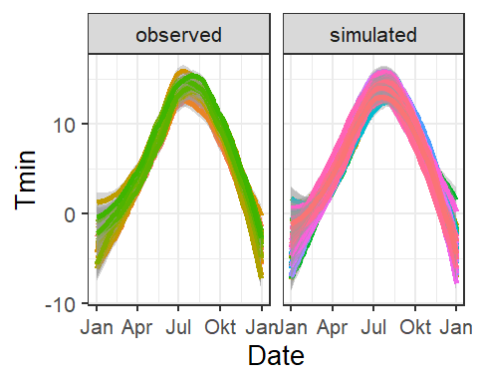
ggplot(data=Temperatures,
aes(x = Date,y = Tmax)) +
geom_smooth(aes(colour = factor(Year)), show.legend = FALSE) +
#geom_line(aes(colour = factor(Year)), show.legend = FALSE) +
facet_wrap(vars(Data_source)) +
theme_bw(base_size = 20) +
scale_x_date(date_labels = "%b")
## `geom_smooth()` using method = 'loess' and formula = 'y ~ x'
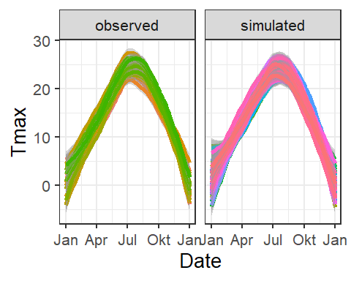

10.3 Freezing hour analysis in spring or autumn
Produce similar plots for the number of freezing hours (<0°C) in April (or October, if your site is in the Southern Hemisphere) for your location of interest.
chill_observed <- Temperatures %>%
filter(Data_source == "observed") %>%
stack_hourly_temps(latitude = 47.600) %>%
chilling(Start_JDay = 91,
End_JDay = 120)
chill_simulated <- Temperatures %>%
filter(Data_source == "simulated") %>%
stack_hourly_temps(latitude = 47.600) %>%
chilling(Start_JDay = 91,
End_JDay = 120)
chill_comparison <-
cbind(chill_observed,
Data_source = "observed") %>%
rbind(cbind(chill_simulated,
Data_source = "simulated"))
chill_comparison_full_seasons <-
chill_comparison %>%
filter(Perc_complete == 100)
ggplot(chill_comparison_full_seasons,
aes(x=Chill_portions)) +
geom_histogram(binwidth = 1,
aes(fill = Data_source)) +
theme_bw(base_size = 20) +
labs(fill = "Data source") +
xlab("Chill accumulation (Chill Portions)") +
ylab("Frequency")
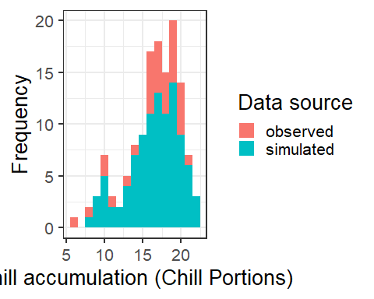
chill_simulations <-
chill_comparison_full_seasons %>%
filter(Data_source == "simulated")
ggplot(chill_simulations,
aes(x = Chill_portions)) +
stat_ecdf(geom = "step",
lwd = 1.5,
col = "blue") +
ylab("Cumulative probability") +
xlab("Chill accumulation (in Chill Portions)") +
scale_y_continuous(breaks = seq(0,1, by = 0.1)) +
theme_bw(base_size = 20)
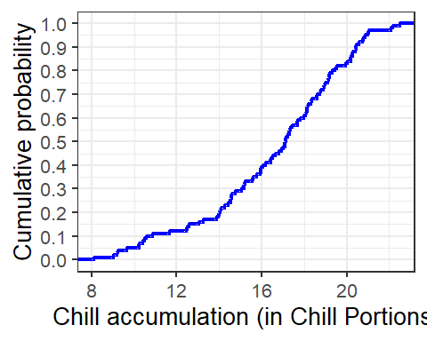

11 Chapter 14 — Historic temperature scenarios
In this chapter, observed temperature records are extended with simulated scenarios to analyze past temperature patterns and their effects on chill accumulation.
library(chillR)
library(tidyverse)
Goe_weather <- weather_final

11.1 Creating historic temperature scenarios
For the location you chose for previous exercises, produce historic temperature scenarios representing several years of the historic record (your choice).
Temp <- temperature_generation(
Goe_weather,
years = c(1990, 2005),
sim_years = c(2001, 2100)
)
## Warning: scenario doesn't contain named elements - consider using the following element names:
## 'data', 'reference_year','scenario_type','labels'
## Warning: setting scenario_type to 'relative'
## Warning: Reference year missing - can't check if relative temperature scenario is valid
Temp <- Temp[[1]]
Temp$Data_source <- "simulated"
Temperature_scenarios <- Goe_weather %>%
filter(Year %in% 1990:2005) %>%
mutate(Data_source = "observed") %>%
rbind(
Temp[, c('Year','Month','Day','Tmin','Tmax','Data_source')]
) %>%
mutate(Date = as.Date(ISOdate(2000, Month, Day)))

11.2 Chill accumulation under historic scenarios
Produce chill distributions for these scenarios and plot them and calculating winter chill for observed and simulated data
library(ggplot2)
library(dplyr)
library(chillR)
chill_observed <- Temperature_scenarios %>%
filter(Data_source == "observed") %>%
stack_hourly_temps(latitude = 47.6) %>%
chilling(Start_JDay = 91, End_JDay = 120)
chill_simulated <- Temperature_scenarios %>%
filter(Data_source == "simulated") %>%
stack_hourly_temps(latitude = 47.6) %>%
chilling(Start_JDay = 91, End_JDay = 120)
chill_comparison_full <- cbind(chill_observed, Data_source = "observed") %>%
rbind(cbind(chill_simulated, Data_source = "simulated")) %>%
filter(Perc_complete == 100)
Comparison of temperature patterns
# Tmin plot
ggplot(data = Temperature_scenarios, aes(x = Date, y = Tmin)) +
geom_smooth(aes(colour = factor(Year)), show.legend = FALSE) +
facet_wrap(vars(Data_source)) +
theme_bw(base_size = 20) +
scale_x_date(date_labels = "%b")
## `geom_smooth()` using method = 'loess' and formula = 'y ~ x'
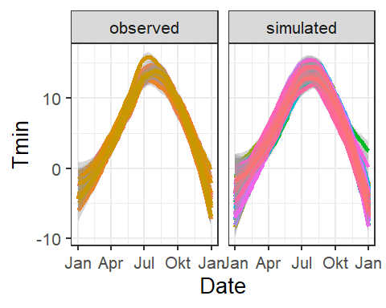
# Tmax plot
ggplot(data = Temperature_scenarios, aes(x = Date, y = Tmax)) +
geom_smooth(aes(colour = factor(Year)), show.legend = FALSE) +
facet_wrap(vars(Data_source)) +
theme_bw(base_size = 20) +
scale_x_date(date_labels = "%b")
## `geom_smooth()` using method = 'loess' and formula = 'y ~ x'
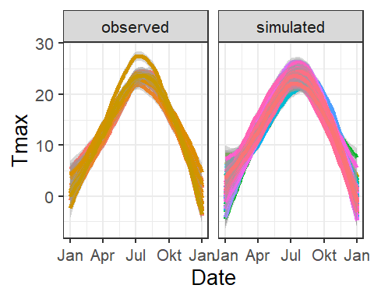
Chill distribution analysis
ggplot(chill_comparison_full, aes(x = Chill_portions)) +
geom_histogram(binwidth = 1, aes(fill = Data_source)) +
theme_bw(base_size = 20) +
labs(fill = "Data source") +
xlab("Chill accumulation (Chill Portions)") +
ylab("Frequency")
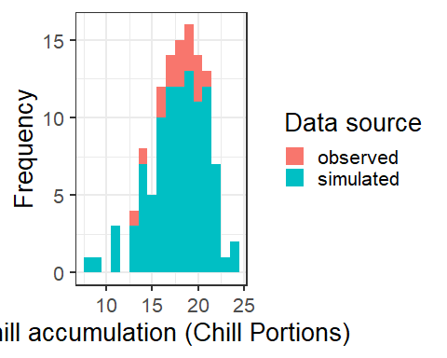
Cumulative distribution of chill accumulation
chill_sim <- chill_comparison_full %>%
filter(Data_source == "simulated")
ggplot(chill_sim, aes(x = Chill_portions)) +
stat_ecdf(geom = "step", lwd = 1.5, col = "blue") +
ylab("Cumulative probability") +
xlab("Chill accumulation (Chill Portions)") +
scale_y_continuous(breaks = seq(0,1,0.1)) +
theme_bw(base_size = 20)
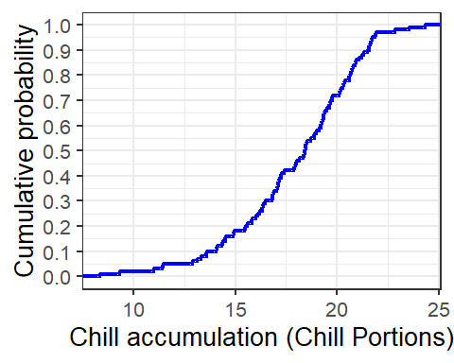
Saving scenario and chill data
write.csv(Temperature_scenarios,
file = "data_Güttingen/Temperatures_ch14.csv",
row.names = FALSE)
write.csv(chill_comparison_full,
file = "data_Güttingen/Chill_distributions_ch14.csv",
row.names = FALSE)

12 Chapter 15 — Future temperature scenarios
In this chapter, future climate scenarios are explored using RCPs and SSPs to assess potential temperature changes and their impacts.

12.1 RCPs and SSPs: concepts and differences
Briefly describe the differences between the RCPs and the SSPs (you may have to follow some of the links provided above)
Representative Concentration Pathways (RCPs):
- Introduced in IPCC AR5 (2014)
- Focus on radiative forcing, so the amount of the sun’s energy trapped by the Earth (measured in W/m²)
- Four original pathways: 2.6, 4.5, 6.0, 8.5 W/m², designed to explore a range of future greenhouse gas concentrations and climate change outcomes
- Their purpose is to serve as inputs for climate models to simulate the corresponding warming and climate impacts by the end of the century
- A Socioeconomic context is not explicitly included as RCPs focus on the physical aspect rather than human development pathways
Shared Socioeconomic Pathways (SSPs):
- Introduced in IPCC AR6 (2021)
- Include socioeconomic narratives describing potential futures in terms of population growth, economic development, urbanization, technology, and policy
Five primary SSPs:
SSP1 – Sustainability: Focused on sustainable growth and equality; low challenges to mitigation and adaptation.
SSP2 – Middle of the Road: Continuation of historical trends; moderate challenges to mitigation and adaptation.
SSP3 – Regional Rivalry: Fragmented world, nationalism, high challenges to mitigation and adaptation.
SSP4 – Inequality: Increasing inequality, high adaptation challenges but low mitigation challenges.
SSP5 – Fossil-fueled Development: Rapid growth, high emissions, low adaptation challenges but high mitigation challenges.
- Their purpose is to define the “societal stage” on which emissions reductions or increases occur. They are used in Integrated Assessment Models (IAMs) to simulate possible emissions trajectories.
- Each SSP can correspond to multiple RCP-like pathways, depending on mitigation actions.
Key differences and summary:
RCPs are simpler and physics focused pathways, where as SCCPs are more narrative-driven pathways, shwoing how society might develop and how that would influence emissions. SSPs allow for linking societal decisions, adaptation strategies, and climate mitigation, providing a more comprehensive framework for planning in climate change studies.

13 Chapter 16 — Making CMIP6 scenarios
In this chapter, CMIP6 climate projections are used to generate future temperature scenarios and assess their impacts on agroclimatic metrics.

13.1 Generating CMIP6-based temperature scenarios
Analyze the historic and future impact of climate change on two agroclimatic metrics of your choice, for the location you’ve chosen for your earlier analyses.
Study area and data sources
library(chillR)
library(tidyverse)
location <- c(8.9, 47.7)
area_buff <- 4
area <- c(
ceiling(location[2]) + area_buff, # north
floor(location[1]) - area_buff, # west
floor(location[2]) - area_buff, # south
ceiling(location[1]) + area_buff # east
)
Scenario generation and processing
download_cmip6_ecmwfr(
scenarios = c("ssp126", "ssp245", "ssp370", "ssp585"),
area = area,
model = 'default',
frequency = 'monthly',
variable = c('Tmin', 'Tmax'),
year_start = 2015,
year_end = 2100
)
download_baseline_cmip6_ecmwfr(
area = area,
model = 'match_downloaded',
frequency = 'monthly',
variable = c('Tmin', 'Tmax'),
year_start = 1986,
year_end = 2014,
month = 1:12
)
station <- data.frame(
station_name = c("Güttingen"),
longitude = c(8.9),
latitude = c(47.7)
)
summary(cars$dist)
summary(cars$speed)
Baseline adjustment and generation of future temperature scenarios
source('extract_cmip6_data_mod.R')
extracted <- extract_cmip6_data_mod(stations = station)
head(extracted$`ssp126_AWI-CM-1-1-MR`)
change_scenarios <- gen_rel_change_scenario(extracted,
scenarios = c(2050, 2085),
reference_period = c(1990:2024),
future_window_width = 30)
head(change_scenarios)
write.csv(change_scenarios, "data_Güttingen/all_change_scenarios.csv", row.names = FALSE)
scen_list <- convert_scen_information(change_scenarios)
scen_list$Güttingen$ssp126$`ACCESS-CM2`$'2050'
Güttingen_temps <- read_tab("data_Güttingen/Güttingen_clean_weather.csv")
temps_1996 <- temperature_scenario_from_records(Güttingen_temps, 1996)
temps_2000 <- temperature_scenario_from_records(Güttingen_temps, 2000)
base <- temperature_scenario_baseline_adjustment(
temps_1996, temps_2000
)
scen_list <- convert_scen_information(
change_scenarios,
give_structure = FALSE
)
ref_year <- unique(change_scenarios$reference_year)
temps_ref1 <- temperature_scenario_from_records(Güttingen_temps, ref_year)
temps_ref2 <- temperature_scenario_from_records(Güttingen_temps, ref_year)
base <- temperature_scenario_baseline_adjustment(
temps_ref1,
temps_ref2
)
adjusted_list <- temperature_scenario_baseline_adjustment(
base,
scen_list,
temperature_check_args =
list(scenario_check_thresholds = c(-5, 15))
)
temps <- temperature_generation(
Güttingen_temps,
years = c(1990, 2024),
sim_years = c(2001, 2100),
adjusted_list,
temperature_check_args = list(
scenario_check_thresholds = c(-5, 15)
)
)
save_temperature_scenarios(temps,
"data_Güttingen/future_climate",
"Güttingen_futuretemps")
for(scen in 1:length(adjusted_list))
{
if(!file.exists(paste0("data_Güttingen/future_climate2/Güttingen_futuretemps",
scen,"_",
names(adjusted_list)[scen],".csv")) )
{temp_temp <- temperature_generation(Bonn_temps,
years = c(1990, 2024),
sim_years = c(2001, 2100),
adjusted_list[scen],
temperature_check_args =
list( scenario_check_thresholds = c(-5, 15)))
write.csv(temp_temp[[1]],paste0("data_Güttingen/future_climate2/Güttingen_futuretemps",scen,"_",names(adjusted_list)[scen],".csv"),
row.names=FALSE)
print(paste("Processed object",scen,"of", length(adjusted_list)))
}
}

14 Chapter 18 — Plotting future scenarios
This chapter shows how to visualize historical and future chill scenarios using climate model projections.

14.1 Visualizing historical and future chill scenarios
Produce similar plots for the weather station you selected for earlier exercises.
library(chillR)
library(tidyverse)
library(ggpmisc)
library(patchwork)
library(kableExtra)
Loading historical and future chill scenarios
chill_hist_scenario_list <- load_temperature_scenarios(
path = "data_Güttingen",
prefix = "Guettingen_hist_chill_305_59"
)
actual_chill <- read_tab(
"data_Güttingen/Guettingen_observed_chill_305_59.csv"
)
chill_future_scenario_list <- load_temperature_scenarios(
path = "data_Güttingen/future_climate",
prefix = "Guettingen_futurechill_305_59"
)
Creating and organizing climate scenario objects
chills <- make_climate_scenario(
chill_hist_scenario_list,
caption = "Historic",
historic_data = actual_chill,
time_series = TRUE
)
Identify SSPs, GCMs, and time slices
SSPs <- c("ssp126", "ssp245", "ssp370", "ssp585")
Times <- c("2050", "2085")
list_ssp <- strsplit(names(chill_future_scenario_list), "\\.") %>%
map(2) %>% unlist()
list_gcm <- strsplit(names(chill_future_scenario_list), "\\.") %>%
map(3) %>% unlist()
list_time <- strsplit(names(chill_future_scenario_list), "\\.") %>%
map(4) %>% unlist()
Add FUTURE scenarios to climate object
for(SSP in SSPs)
for(Time in Times)
{
chill <- chill_future_scenario_list[
list_ssp == SSP & list_time == Time
]
names(chill) <- list_gcm[
list_ssp == SSP & list_time == Time
]
if(SSP == "ssp126") SSPcaption <- "SSP1"
if(SSP == "ssp245") SSPcaption <- "SSP2"
if(SSP == "ssp370") SSPcaption <- "SSP3"
if(SSP == "ssp585") SSPcaption <- "SSP5"
chills <- chill %>%
make_climate_scenario(
caption = c(SSPcaption, Time),
add_to = chills
)
}
Prepare HISTORIC simulated data
for(nam in names(chills[[1]]$data))
{
ch <- chills[[1]]$data[[nam]]
ch$GCM <- "none"
ch$SSP <- "none"
ch$Year <- as.numeric(nam)
if(nam == names(chills[[1]]$data)[1])
past_simulated <- ch
else
past_simulated <- rbind(past_simulated, ch)
}
past_simulated$Scenario <- "Historical"
kable(head(past_simulated)) %>%
kable_styling("striped", font_size = 8)
Season
End_year
Season_days
Data_days
Perc_complete
Chill_Portions
GDH
Frost_H
GCM
SSP
Year
Scenario
2001/2002
2002
120
120
100
71.45516
1757.5216
1209
none
none
1995
Historical
2002/2003
2003
120
120
100
75.51487
968.7052
1138
none
none
1995
Historical
2003/2004
2004
120
120
100
82.22191
2816.6989
529
none
none
1995
Historical
2004/2005
2005
121
121
100
81.74565
2353.6662
616
none
none
1995
Historical
2005/2006
2006
120
120
100
73.01427
1448.5466
931
none
none
1995
Historical
2006/2007
2007
120
120
100
82.65847
3053.9903
488
none
none
1995
Historical
Prepare FUTURE data
for(i in 2:length(chills))
for(nam in names(chills[[i]]$data))
{
ch <- chills[[i]]$data[[nam]]
ch$GCM <- nam
ch$SSP <- chills[[i]]$caption[1]
ch$Year <- as.numeric(chills[[i]]$caption[2])
if(i == 2 & nam == names(chills[[i]]$data)[1])
future_data <- ch
else
future_data <- rbind(future_data, ch)
}
Plot settings
metric <- "Chill_Portions"
axis_label <- "Chill accumulation (Chill Portions)"
rng <- range(
actual_chill[[metric]],
past_simulated[[metric]],
future_data[[metric]]
)
Historic plot
past_plot <- ggplot() +
geom_boxplot(
data = past_simulated,
aes(x = as.numeric(Year), y = .data[[metric]], group = Year),
fill = "skyblue"
) +
geom_point(
data = actual_chill,
aes(x = End_year, y = .data[[metric]]),
col = "blue"
) +
scale_y_continuous(limits = c(0, round(1.1 * rng[2]))) +
labs(x = "Year", y = axis_label) +
facet_grid(~ Scenario) +
theme_bw(base_size = 15) +
theme(
strip.background = element_blank(),
strip.text = element_text(face = "bold"),
axis.text.x = element_text(angle = 45, hjust = 1)
)
Future plots (2050 & 2085)
future_plot_list <- list()
time_points <- c(2050, 2085)
for(y in time_points)
{
future_plot_list[[as.character(y)]] <-
ggplot(future_data %>% filter(Year == y)) +
geom_boxplot(
aes(x = GCM, y = .data[[metric]], fill = GCM)
) +
facet_wrap(vars(SSP), nrow = 1) +
scale_x_discrete(labels = NULL, expand = expansion(add = 1)) +
scale_y_continuous(limits = c(0, round(1.1 * rng[2]))) +
geom_text_npc(
aes(npcx = "center", npcy = "top", label = Year),
size = 5
) +
theme_bw(base_size = 15) +
theme(
axis.text = element_blank(),
axis.title = element_blank(),
axis.ticks.y = element_blank(),
legend.position = "bottom",
strip.background = element_blank(),
strip.text = element_text(face = "bold")
)
}
Combine plots
final_plot <- (past_plot + future_plot_list) +
plot_layout(
guides = "collect",
widths = c(1, rep(2, length(future_plot_list)))
) &
theme(
legend.position = "bottom",
legend.text = element_text(size = 8),
legend.title = element_text(size = 10)
)
final_plot
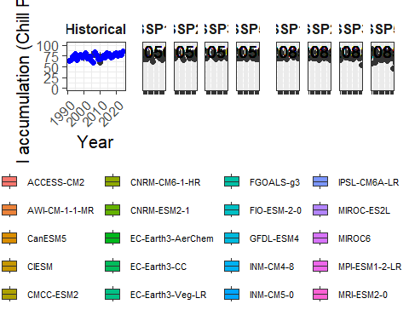

15 Chapter 19 — Chill model comparison
This chapter compares different chill models to show how their responses and estimates of Safe Winter Chill differ under the same historical and future climate scenarios.

15.1 Chill model comparison for a selected location
Perform a similar analysis for the location you’ve chosen for your exercises
Setup and model definition
library(chillR)
library(dormancyR)
library(tidyverse)
library(colorRamps)
library(patchwork)
library(gganimate)
library(gifski)
library(transformr)
Define chill models
hourly_models <- list(
Chilling_units = chilling_units,
Low_chill = low_chill_model,
Modified_Utah = modified_utah_model,
North_Carolina = north_carolina_model,
Positive_Utah = positive_utah_model,
Chilling_Hours = Chilling_Hours,
Utah_Chill_Units = Utah_Model,
Chill_Portions = Dynamic_Model
)
daily_models <- list(
Rate_of_Chill = rate_of_chill,
Chill_Days = chill_days,
Exponential_Chill = exponential_chill,
Triangular_Chill = triangular_chill_2
)
metrics <- c(names(daily_models), names(hourly_models))
model_labels <- c(
"Rate of Chill",
"Chill Days",
"Exponential Chill",
"Triangular Chill (Legave)",
"Chilling Units",
"Low-Chill Units",
"Modified Utah Units",
"North Carolina Units",
"Positive Utah Units",
"Chilling Hours",
"Utah Chill Units",
"Chill Portions"
)
Load observed weather
G_temps <- read_tab("data_Güttingen/Güttingen_clean_weather.csv")
Start_JDay <- 305
End_JDay <- 59
latitude <- 47.7
Load historical and future temperature scenarios
Temps_hist <- load_temperature_scenarios(
"data_Güttingen",
"Guettingen_hist_scenarios"
)
Chill for HISTORICAL scenarios
daily_hist <- tempResponse_list_daily(
Temps_hist, Start_JDay, End_JDay, daily_models
)
hourly_hist <- tempResponse_daily_list(
Temps_hist, latitude, Start_JDay, End_JDay,
hourly_models, misstolerance = 10
)
past_scenarios <- lapply(
names(daily_hist),
function(x)
cbind(daily_hist[[x]],
hourly_hist[[x]][, names(hourly_models)])
)
names(past_scenarios) <- names(daily_hist)
save_temperature_scenarios(
past_scenarios,
"data_Güttingen/future_climate",
"Güttingen_multichill_305_59_historic"
)
Chill for OBSERVED weather
daily_obs <- tempResponse_daily(
G_temps, Start_JDay, End_JDay, daily_models
)
hourly_obs <- tempResponse_daily_list(
G_temps, latitude, Start_JDay, End_JDay,
hourly_models, misstolerance = 10
)
past_observed <- cbind(
daily_obs,
hourly_obs[[1]][, names(hourly_models)]
)
write.csv(
past_observed,
"data_Güttingen/future_climate/Güttingen_multichill_305_59_observed.csv",
row.names = FALSE
)
FUTURE temperature scenarios
future_temps <- load_temperature_scenarios(
"data_Güttingen/future_climate2",
"Güttingen_futuretemps"
)
SSPs <- c("ssp126","ssp245","ssp370","ssp585")
Times <- c(2050, 2085)
list_ssp <- strsplit(names(future_temps), "\\.") %>% map(2) %>% unlist()
list_gcm <- strsplit(names(future_temps), "\\.") %>% map(3) %>% unlist()
list_time <- strsplit(names(future_temps), "\\.") %>% map(4) %>% unlist()
Chill for FUTURE scenarios
for (SSP in SSPs) {
for (Time in Times) {
fname <- paste0("Güttingen_multichill_305_59_", Time, "_", SSP)
if (length(list.files("data_Güttingen/future_climate", pattern = fname)) > 0)
next
Temps <- future_temps[list_ssp == SSP & list_time == Time]
names(Temps) <- list_gcm[list_ssp == SSP & list_time == Time]
daily_fut <- tempResponse_list_daily(
Temps, Start_JDay, End_JDay, daily_models
)
hourly_fut <- tempResponse_daily_list(
Temps, latitude, Start_JDay, End_JDay,
hourly_models, misstolerance = 10
)
future_chill <- lapply(
names(daily_fut),
function(x)
cbind(daily_fut[[x]],
hourly_fut[[x]][, names(hourly_models)])
)
names(future_chill) <- names(daily_fut)
save_temperature_scenarios(
future_chill,
"data_Güttingen/future_climate",
fname
)
}
}

15.2 Heat map of past and future Safe Winter Chill changes
Make a heat map illustrating past and future changes in Safe Winter Chill, relative to a past scenario, for the 13 chill models used here
Assemble RESULTS table
chill_hist <- load_temperature_scenarios(
"data_Güttingen/future_climate",
"Güttingen_multichill_305_59_historic"
)
chill_obs <- read_tab(
"data_Güttingen/future_climate/Güttingen_multichill_305_59_observed.csv"
)
results <- NULL
for (nam in names(chill_hist)) {
for (met in metrics) {
res <- data.frame(
Metric = met,
GCM = "none",
SSP = "none",
Year = as.numeric(nam),
Result = quantile(chill_hist[[nam]][, met], 0.1),
Scenario = "Historical"
)
results <- rbind(results, res)
}
}
for (SSP in SSPs) {
for (Time in Times) {
chill <- load_temperature_scenarios(
"data_Güttingen/future_climate",
paste0("Güttingen_multichill_305_59_", Time, "_", SSP)
)
for (gcm in names(chill)) {
for (met in metrics) {
res <- data.frame(
Metric = met,
GCM = gcm,
SSP = SSP,
Year = Time,
Result = quantile(chill[[gcm]][, met], 0.1),
Scenario = "Future"
)
results <- rbind(results, res)
}
}
}
}
NORMALIZE (baseline = first historical year, 1995)
ref_year <- min(results$Year[results$Scenario == "Historical"])
results$SWC <- NA
for (met in metrics) {
ref_val <- results$Result[
results$Metric == met &
results$Year == ref_year &
results$Scenario == "Historical"
][1]
results$SWC[results$Metric == met] <-
results$Result[results$Metric == met] / ref_val - 1
}
rng <- range(results$SWC, na.rm = TRUE)
HEAT MAPS
p_future <- ggplot(
results[results$Scenario == "Future",],
aes(GCM, factor(Metric, levels = metrics), fill = SWC)
) +
geom_tile() +
facet_grid(SSP ~ Year) +
scale_fill_gradientn(colours = matlab.like(15),
labels = scales::percent,
limits = rng) +
scale_y_discrete(labels = model_labels) +
theme_bw(14) +
theme(axis.text.x = element_text(angle = 75, hjust = 1))
p_past <- ggplot(
results[results$Scenario == "Historical",],
aes(Year, factor(Metric, levels = metrics), fill = SWC)
) +
geom_tile() +
scale_fill_gradientn(colours = matlab.like(15),
labels = scales::percent,
limits = rng) +
scale_y_discrete(labels = model_labels) +
scale_x_continuous(position = "top") +
theme_bw(14)
(p_past + p_future + plot_layout(nrow = 2, heights = c(1,3)))
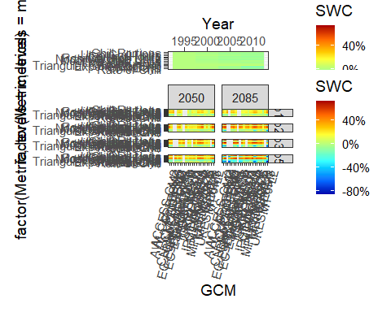

15.3 Animated time series of Safe Winter Chill
Produce an animated line plot of your results (summarizing Safe Winter Chill across all the GCMs)
hist <- results[results$Scenario == "Historical",]
hist <- do.call(rbind, lapply(
c("SSP1","SSP2","SSP3","SSP5"),
function(x) transform(hist, SSP = x)
))
future <- results[results$Scenario == "Future",]
GCM_mean <- aggregate(
SWC ~ Metric + SSP + Year,
data = future,
FUN = mean
)
typeof(hist$SSP)
## [1] "character"
GCM_mean$SSP <- factor(GCM_mean$SSP, levels = c('ssp126', 'ssp245', 'ssp370', 'ssp585'),
labels = c('SSP1', 'SSP2', 'SSP3', 'SSP5'))
TS <- rbind(
hist[, c("Metric","SSP","Year","SWC")],
GCM_mean
)
p_static <- ggplot(
TS,
aes(
x = Year,
y = SWC,
col = factor(Metric, levels = metrics),
group = interaction(SSP, Metric) # <- wichtig für Linien!
)
) +
geom_line(linewidth = 1.2) +
facet_wrap(~SSP, nrow = 4) +
scale_color_discrete(labels = model_labels) +
scale_y_continuous(labels = scales::percent) +
theme_bw(11)
p_static
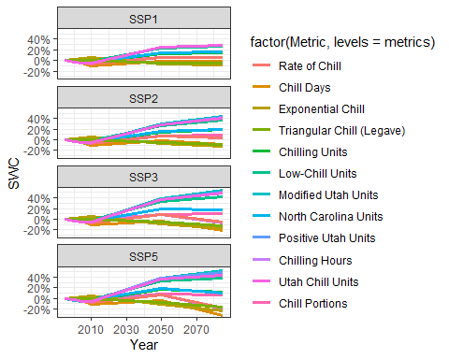

16 Chapter 20 — Simple phenology analysis
In this chapter, basic concepts of statistical inference and phenological modeling are discussed, with a focus on causal reasoning and process-based understanding.

16.1 P-hacking and its implications
Provide a brief narrative describing what p-hacking is, and why this is a problematic approach to data analysis.
What is p-hacking?
P-hacking is the practice of repeatedly testing different statistical models, variables, time windows, or data transformations until a statistically significant result (e.g. p < 0.05) is obtained.
Why is p-hacking problematic?
- It inflates false positives, meaning that with enough tests, random noise can appear statistically significant
- It leads to misleading conclusions, where statistical significance is mistaken for meaningful causation
- It encourages overfitting, resulting in models that fit observed data well but fail to generalize
- It undermines reproducibility, as results often cannot be replicated
- It ignores biological processes, focusing on correlations without reference to underlying system dynamics

16.2 Causal relationship between temperature and bloom dates
Provide a sketch of your causal understanding of the relationship between temperature and bloom dates.
Conceptual understanding
Calendar time (year) does not directly cause trees to bloom earlier. Instead, bloom timing is driven by temperature-dependent physiological processes.
Observed correlations between year and bloom date arise because temperatures have increased over time due to climate change. Thus, temperature is the true causal driver, while time is only indirectly related.
This relationship can be summarized as:
- Time → Climate warming → Temperature → Phenology
or
- Temperature (chilling + forcing) → Bloom date

16.3 Requirements for a process-based phenology model
What do we need to know to build a process-based model from this?
Chilling phase (endodormancy):
- When chilling is effective (start and end dates)
- How temperature contributes to chilling (temperature response function)
- The chilling requirement needed to release dormancy
Forcing phase (ecodormancy):
- When forcing begins, after the chilling requirement is met
- How temperature contributes to heat accumulation
- The forcing (heat) requirement needed to trigger bloom
Model structure:
- Clear definition of chilling and forcing periods
- Mathematical descriptions of chill and heat accumulation
- Thresholds for dormancy release and bloom
- Rules governing the transition from chilling to forcing
Calibration and validation:
- Model parameters must be fitted using observed bloom data
- Model structure should be guided by ecological theory, not trial-and-error
- Validation should be conducted using independent datasets to avoid overfitting

17 Chapter 21 — Delineating temperature response phases with PLS regression
In this chapter, Partial Least Squares (PLS) regression is used to explore how temperature signals relate to phenological timing and why such results must be interpreted with caution and biological context.

17.1 Interpreting PLS results with caution
Briefly explain why you shouldn’t take the results of a PLS regression analysis between temperature and phenology at face value. What do you need in addition in order to make sense of such outputs?
- PLS can detect patterns even when data contain a lot of noise
- Phenology datasets are small (≈ 40–60 years) compared to the number of temperature variables
- Results can be unstable and sensitive to random variation
- VIP scores and coefficients are not proof of causation
- Biological theory (chilling → forcing → bloom) is required to interpret results meaningfully
- Only broad, consistent patterns should be interpreted, not small fluctuations

17.2 Replicating the PLS analysis for ‘Roter Boskoop’
Replicate the PLS analysis for the Roter Boskoop dataset that you used in a previous lesson.
Load packages
library(chillR)
library(tidyverse)
library(ggplot2)
library(patchwork)
Prepare phenology data
Roter_first <- read_tab("data/Roter_Boskoop_bloom_1958_2019.csv") %>%
select(Pheno_year, First_bloom) %>%
mutate(
Year = as.numeric(substr(First_bloom, 1, 4)),
Month = as.numeric(substr(First_bloom, 5, 6)),
Day = as.numeric(substr(First_bloom, 7, 8))
) %>%
make_JDay() %>%
select(Pheno_year, JDay) %>%
rename(
Year = Pheno_year,
pheno = JDay
)
Prepare temperature data
KA_temps <- read_tab("data/TMaxTMin1958-2019_patched.csv") %>%
make_JDay()
Run PLS analysis
PLS_results <- PLS_pheno(KA_temps, Roter_first)
PLS_results$PLS_summary %>% head()
## Date JDay Coef VIP Tmean Tstdev
## 1 801 -152 -0.0550839319 0.4813947 18.32970 1.914004
## 2 802 -151 -0.0280285625 0.4583224 18.30846 1.884389
## 3 803 -150 0.0034427515 0.4856287 18.27148 1.844368
## 4 804 -149 0.0267715221 0.4904789 18.23742 1.886276
## 5 805 -148 0.0250187439 0.4832248 18.19609 1.884567
## 6 806 -147 -0.0003849407 0.5708911 18.17148 1.855337
Reshape PLS output for plotting
PLS_gg <- PLS_results$PLS_summary %>%
mutate(
Month = trunc(Date / 100),
Day = Date - Month * 100,
Date = NULL
)
# Convert Month/Day to a dummy Date for plotting (spans two calendar years)
PLS_gg$Date <- ISOdate(2002, PLS_gg$Month, PLS_gg$Day)
PLS_gg$Date[PLS_gg$JDay <= 0] <-
ISOdate(2001,
PLS_gg$Month[PLS_gg$JDay <= 0],
PLS_gg$Day[PLS_gg$JDay <= 0])
# Mark important VIP periods and combine with coefficient sign
PLS_gg <- PLS_gg %>%
mutate(
VIP_importance = VIP >= 0.8,
VIP_Coeff = factor(sign(Coef) * VIP_importance)
)
Plot 1 — VIP importance over the season
VIP_plot <- ggplot(PLS_gg, aes(x = Date, y = VIP)) +
geom_bar(stat = "identity", aes(fill = VIP > 0.8)) +
scale_fill_manual(
name = "VIP",
labels = c("<0.8", ">0.8"),
values = c("FALSE" = "grey", "TRUE" = "blue")
) +
theme_bw(base_size = 15) +
theme(
axis.text.x = element_blank(),
axis.ticks.x = element_blank(),
axis.title.x = element_blank()
)
VIP_plot
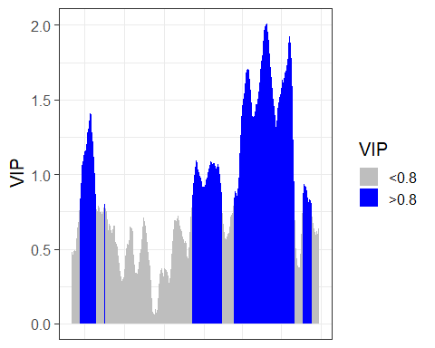
Plot 2 — Direction of effect (PLS coefficients)
coeff_plot <- ggplot(PLS_gg, aes(x = Date, y = Coef)) +
geom_bar(stat = "identity", aes(fill = VIP_Coeff)) +
scale_fill_manual(
name = "Effect direction",
labels = c("Advancing", "Unimportant", "Delaying"),
values = c("-1" = "red", "0" = "grey", "1" = "dark green")
) +
theme_bw(base_size = 15) +
ylab("PLS coefficient") +
theme(
axis.text.x = element_blank(),
axis.ticks.x = element_blank(),
axis.title.x = element_blank()
)
coeff_plot
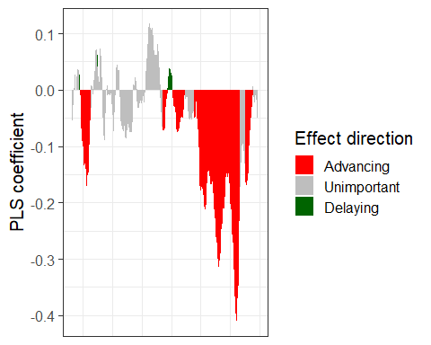
Plot 3 — Mean temperature with highlighted phases
temp_plot <- ggplot(PLS_gg) +
geom_ribbon(
aes(x = Date, ymin = Tmean - Tstdev, ymax = Tmean + Tstdev),
fill = "grey"
) +
geom_ribbon(
aes(x = Date,
ymin = Tmean - Tstdev * (VIP_Coeff == -1),
ymax = Tmean + Tstdev * (VIP_Coeff == -1)),
fill = "red"
) +
geom_ribbon(
aes(x = Date,
ymin = Tmean - Tstdev * (VIP_Coeff == 1),
ymax = Tmean + Tstdev * (VIP_Coeff == 1)),
fill = "dark green"
) +
geom_line(aes(x = Date, y = Tmean)) +
theme_bw(base_size = 15) +
ylab(expression(paste(T[mean], " (°C)")))
temp_plot
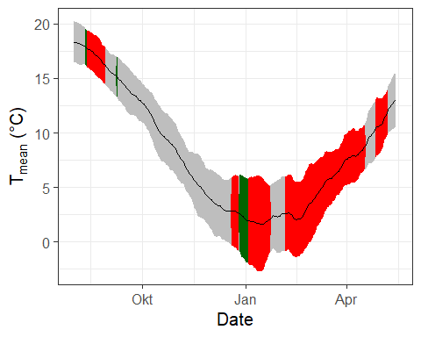
Combine all plots into one figure
plot <- (VIP_plot + coeff_plot + temp_plot +
plot_layout(ncol = 1, guides = "collect")) &
theme(
legend.position = "right",
legend.text = element_text(size = 8),
legend.title = element_text(size = 10),
axis.title.x = element_blank()
)
plot
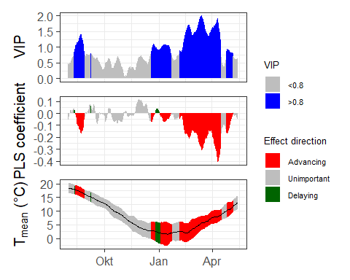
Wrap plotting into a function
ggplot_PLS <- function(PLS_results) {
PLS_gg <- PLS_results$PLS_summary %>%
mutate(
Month = trunc(Date / 100),
Day = Date - Month * 100,
Date = NULL
)
PLS_gg$Date <- ISOdate(2002, PLS_gg$Month, PLS_gg$Day)
PLS_gg$Date[PLS_gg$JDay <= 0] <-
ISOdate(2001,
PLS_gg$Month[PLS_gg$JDay <= 0],
PLS_gg$Day[PLS_gg$JDay <= 0])
PLS_gg <- PLS_gg %>%
mutate(
VIP_importance = VIP >= 0.8,
VIP_Coeff = factor(sign(Coef) * VIP_importance)
)
VIP_plot <- ggplot(PLS_gg, aes(x = Date, y = VIP)) +
geom_bar(stat = "identity", aes(fill = VIP > 0.8)) +
scale_fill_manual(
name = "VIP",
labels = c("<0.8", ">0.8"),
values = c("FALSE" = "grey", "TRUE" = "blue")
) +
theme_bw(base_size = 15) +
theme(
axis.text.x = element_blank(),
axis.ticks.x = element_blank(),
axis.title.x = element_blank()
)
coeff_plot <- ggplot(PLS_gg, aes(x = Date, y = Coef)) +
geom_bar(stat = "identity", aes(fill = VIP_Coeff)) +
scale_fill_manual(
name = "Effect direction",
labels = c("Advancing", "Unimportant", "Delaying"),
values = c("-1" = "red", "0" = "grey", "1" = "dark green")
) +
theme_bw(base_size = 15) +
ylab("PLS coefficient") +
theme(
axis.text.x = element_blank(),
axis.ticks.x = element_blank(),
axis.title.x = element_blank()
)
temp_plot <- ggplot(PLS_gg) +
geom_ribbon(
aes(x = Date, ymin = Tmean - Tstdev, ymax = Tmean + Tstdev),
fill = "grey"
) +
geom_ribbon(
aes(x = Date,
ymin = Tmean - Tstdev * (VIP_Coeff == -1),
ymax = Tmean + Tstdev * (VIP_Coeff == -1)),
fill = "red"
) +
geom_ribbon(
aes(x = Date,
ymin = Tmean - Tstdev * (VIP_Coeff == 1),
ymax = Tmean + Tstdev * (VIP_Coeff == 1)),
fill = "dark green"
) +
geom_line(aes(x = Date, y = Tmean)) +
theme_bw(base_size = 15) +
ylab(expression(paste(T[mean], " (°C)")))
(VIP_plot + coeff_plot + temp_plot +
plot_layout(ncol = 1, guides = "collect")) &
theme(
legend.position = "right",
legend.text = element_text(size = 8),
legend.title = element_text(size = 10),
axis.title.x = element_blank()
)
}
ggplot_PLS(PLS_results)


17.3 Why is the chilling response not detected?
Write down your thoughts on why we’re not seeing the temperature response pattern we may have expected. What happened to the chill response?
- The PLS results show string VIP values and negative coefficients in late winter to spring, indicating a heat response (forcing)
- in contrast, autumn and early winter temperatures show weak VIP scores and mostly unimportant coefficients, meaning chilling is not detected as influential at this point
Main reasons:
- Chilling is likely not limiting at this site
  - Winter temperatures are consistently cold enough for trees to meet their chilling requirement every year
  - Because chilling is always fulfilled, it does not explain year-to-year variation in bloom dates
- PLS only detects sources of variation
  - If chilling does not vary in its effectiveness between the years, PLS cannot identify a chill signal
  - Spring forcing temperatures vary much more and therefore dominate the statistical signal
- Chilling may occur outside the influential window
  - Effective chilling may accumulate earlier in winter, when temperature variability is low or VIP values are below the threshold
Chilling is consistently fulfilled under local climate conditions and therefore does not limit bloom timing. Because it shows little year-to-year variation, PLS detects almost no chilling signal, while highly variable spring forcing temperatures dominate the results.

18 Chapter 22 — Successes and limitations of PLS regression analysis
In this chapter, the conditions under which PLS regression can successfully identify chilling responses are discussed, along with key limitations and ways to overcome them.

18.1 When does PLS detect the chilling phase?
Briefly explain in what climatic settings we can expect PLS regression to detect the chilling phase - and in what settings this probably won’t work.
Climatic settings where PLS is likely to work:
PLS regression can detect a chilling phase when
- winter temperatures lie near the upper effective range for chill accumulation
- warmer winters consistently reduce chill accumulation
- there is a monotonic relationship between temperature and chill comparison
- typical for mild winters in e.g. California
Climatic settings where PLS is likely to fail:
PLS regression will likely fail to detect a chilling phase when
- winters are frequently cold
- temperatures often fall below the effective chill range
- warming sometimes increases chill (by moving temperatures into the optimal range
- the relationship between temperature and chill is non-monotonic
- typical for cool to cold climates like Germany and Beijing

18.2 How can these limitations be addressed?
How could we overcome this problem?
- use process-based chill models (e.g. dynamic model) instead of relying on temperature correlations
- explicitly calculate chill accumulation and and forcing accumulation before modeling phenology
- Separate the dormancy process into:
  - Chill accumulation (non-linear response to temperature)
  - Forcing accumulation (monotonic response to temperature)
- Apply mechanistic phenology models that represent biological processes rather than the statistical patterns
- Combine PLS with biological constraints or use it only as an exploratory tool

19 Chapter 23 — PLS regression with agroclimatic metrics
This chapter applies PLS regression with agroclimatic metrics to separate chilling and forcing processes and assess whether their effects on phenology can be clearly distinguished.

19.1 PLS regression using chill and heat metrics
Repeat the PLS_chill_force procedure for the ‘Roter Boskoop’ dataset. Include plots of daily chill and heat accumulation
Load packages and prepare hourly temperature data
library(chillR)
library(tidyverse)
temps_hourly <- read_tab("data/TMaxTMin1958-2019_patched.csv") %>%
stack_hourly_temps(latitude = 50.6)
head(temps_hourly$hourtemps)
## DATE YEARMODA Year Month Day Tmin Tmax Tmin_source Tmax_source no_Tmin no_Tmax JDay
## 1 01-01-58 19580101 1958 1 1 5 7.5 <NA> <NA> FALSE FALSE 1
## 22452 01-01-58 19580101 1958 1 1 5 7.5 <NA> <NA> FALSE FALSE 1
## 44903 01-01-58 19580101 1958 1 1 5 7.5 <NA> <NA> FALSE FALSE 1
## 67354 01-01-58 19580101 1958 1 1 5 7.5 <NA> <NA> FALSE FALSE 1
## 89805 01-01-58 19580101 1958 1 1 5 7.5 <NA> <NA> FALSE FALSE 1
## 112256 01-01-58 19580101 1958 1 1 5 7.5 <NA> <NA> FALSE FALSE 1
## Hour Temp
## 1 0 5
## 22452 1 5
## 44903 2 5
## 67354 3 5
## 89805 4 5
## 112256 5 5
Calculate daily chill and heat metrics
daychill <- daily_chill(hourtemps = temps_hourly,
running_mean = 1,
models = list(
Chilling_Hours = Chilling_Hours,
Utah_Chill_Units = Utah_Model,
Chill_Portions = Dynamic_Model,
GDH = GDH)
)
head(daychill$daily_chill)
## YYMMDD Year Month Day Chilling_Hours Utah_Chill_Units Chill_Portions GDH Tmean
## 1 19580101 1958 1 1 21 24.0 0.00000000 9.7845597 5.391120
## 2 19580102 1958 1 2 16 16.0 0.44448963 12.7332663 3.399713
## 3 19580103 1958 1 3 5 0.0 0.03830263 0.0000000 -2.601803
## 4 19580104 1958 1 4 10 3.0 0.32927146 0.0000000 -1.676056
## 5 19580105 1958 1 5 24 24.0 1.39200313 0.0000000 3.020140
## 6 19580106 1958 1 6 24 21.5 1.11615873 0.4716365 3.284117
## no_Tmin no_Tmax
## 1 FALSE FALSE
## 2 FALSE FALSE
## 3 FALSE FALSE
## 4 FALSE FALSE
## 5 FALSE TRUE
## 6 FALSE FALSE
Visualize daily chill accumulation
dc <- make_daily_chill_plot2(daychill,
metrics = c("Chill_Portions"),
cumulative = FALSE,
startdate = 300,
enddate = 30,
focusyears = c(2008),
metriclabels = "Chill Portions")
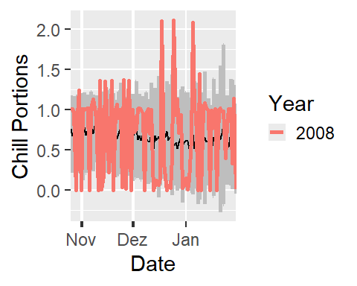
dc <- make_daily_chill_plot2(daychill,
metrics = c("Chill_Portions"),
cumulative = TRUE,
startdate = 300,
enddate = 30,
focusyears = c(2008),
metriclabels = "Chill Portions")
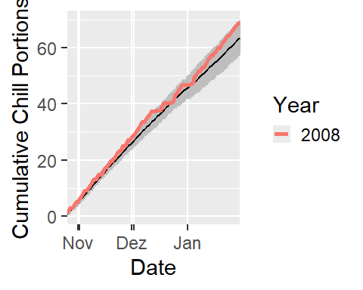
Prepare phenological bloom data (Roter Boskoop)
Roter_first <- read_tab("data/Roter_Boskoop_bloom_1958_2019.csv") %>%
select(Pheno_year, First_bloom) %>%
mutate(Year = as.numeric(substr(First_bloom, 1, 4)),
Month = as.numeric(substr(First_bloom, 5, 6)),
Day = as.numeric(substr(First_bloom, 7, 8))) %>%
make_JDay() %>%
select(Pheno_year,
JDay) %>%
rename(Year = Pheno_year,
pheno = JDay)
Run PLS regression with chill and heat metrics
plscf <- PLS_chill_force(daily_chill_obj = daychill,
bio_data_frame = Roter_first,
split_month = 6,
chill_models = "Chill_Portions",
heat_models = "GDH")
head(plscf$Chill_Portions$GDH$PLS_summary)
## Date Type JDay Coef VIP MetricMean MetricStdev
## 1 701 Chill -183 0.136520602 0.8277375 0.05017200 0.2205416
## 2 702 Chill -182 -0.008427281 0.3037853 0.04992673 0.2194706
## 3 703 Chill -181 0.056906091 0.6709700 0.05016162 0.2204947
## 4 704 Chill -180 -0.182946604 0.8110355 0.06711669 0.2532628
## 5 705 Chill -179 0.211426946 1.7753630 0.08346337 0.2792043
## 6 706 Chill -178 0.000000000 0.0000000 0.00000000 0.0000000
Define plotting function for PLS chill–forcing results
plot_PLS_chill_force <- function(plscf,
chill_metric = "Chill_Portions",
heat_metric = "GDH",
chill_label = "CP",
heat_label = "GDH",
chill_phase = c(-48, 62),
heat_phase = c(3, 105.5))
{
PLS_gg <- plscf[[chill_metric]][[heat_metric]]$PLS_summary %>%
mutate(Month = trunc(Date/100),
Day = Date - Month * 100,
Date = ISOdate(2002,
Month,
Day))
PLS_gg[PLS_gg$JDay <= 0,"Date"]<-
ISOdate(2001,
PLS_gg$Month[PLS_gg$JDay <= 0],
PLS_gg$Day[PLS_gg$JDay <= 0])
PLS_gg <- PLS_gg %>%
mutate(VIP_importance = VIP >= 0.8,
VIP_Coeff = factor(sign(Coef) * VIP_importance))
chill_start_date <- ISOdate(2001,
12,
31) + chill_phase[1] * 24 * 3600
chill_end_date <- ISOdate(2001,
12,
31) + chill_phase[2] * 24 * 3600
heat_start_date <- ISOdate(2001,
12,
31) + heat_phase[1] * 24 * 3600
heat_end_date <- ISOdate(2001,
12,
31) + heat_phase[2] * 24 * 3600
temp_plot <- ggplot(PLS_gg) +
annotate("rect",
xmin = chill_start_date,
xmax = chill_end_date,
ymin = -Inf,
ymax = Inf,
alpha = .1,
fill = "blue") +
annotate("rect",
xmin = heat_start_date,
xmax = heat_end_date,
ymin = -Inf,
ymax = Inf,
alpha = .1,
fill = "red") +
annotate("rect",
xmin = ISOdate(2001,
12,
31) +
min(plscf$pheno$pheno,
na.rm = TRUE) * 24 * 3600,
xmax = ISOdate(2001,
12,
31) +
max(plscf$pheno$pheno,
na.rm = TRUE) * 24 * 3600,
ymin = -Inf,
ymax = Inf,
alpha = .1,
fill = "black") +
geom_vline(xintercept = ISOdate(2001,
12,
31) +
median(plscf$pheno$pheno,
na.rm=TRUE) * 24 * 3600,
linetype = "dashed") +
geom_ribbon(aes(x = Date,
ymin = MetricMean - MetricStdev ,
ymax = MetricMean + MetricStdev ),
fill = "grey") +
geom_ribbon(aes(x = Date,
ymin = MetricMean - MetricStdev * (VIP_Coeff == -1),
ymax = MetricMean + MetricStdev * (VIP_Coeff == -1)),
fill = "red") +
geom_ribbon(aes(x = Date,
ymin = MetricMean - MetricStdev * (VIP_Coeff == 1),
ymax = MetricMean + MetricStdev * (VIP_Coeff == 1)),
fill = "dark green") +
geom_line(aes(x = Date,
y = MetricMean)) +
facet_wrap(vars(Type),
scales = "free_y",
strip.position = "left",
labeller =
labeller(
Type =
as_labeller(c(Chill = paste0("Chill (",
chill_label,
")"),
Heat = paste0("Heat (",
heat_label,
")"))))) +
ggtitle("Daily chill and heat accumulation rates") +
theme_bw(base_size = 15) +
theme(strip.background = element_blank(),
strip.placement = "outside",
strip.text.y = element_text(size = 12),
plot.title = element_text(hjust = 0.5),
axis.title.y = element_blank()
)
VIP_plot <- ggplot(PLS_gg,
aes(x = Date,
y = VIP)) +
annotate("rect",
xmin = chill_start_date,
xmax = chill_end_date,
ymin = -Inf,
ymax = Inf,
alpha = .1,
fill = "blue") +
annotate("rect",
xmin = heat_start_date,
xmax = heat_end_date,
ymin = -Inf,
ymax = Inf,
alpha = .1,
fill = "red") +
annotate("rect",
xmin = ISOdate(2001,
12,
31) + min(plscf$pheno$pheno,
na.rm = TRUE) * 24 * 3600,
xmax = ISOdate(2001,
12,
31) + max(plscf$pheno$pheno,
na.rm = TRUE) * 24 * 3600,
ymin = -Inf,
ymax = Inf,
alpha = .1,
fill = "black") +
geom_vline(xintercept = ISOdate(2001,
12,
31) + median(plscf$pheno$pheno,
na.rm = TRUE) * 24 * 3600,
linetype = "dashed") +
geom_bar(stat = 'identity',
aes(fill = VIP>0.8)) +
facet_wrap(vars(Type),
scales = "free",
strip.position = "left",
labeller =
labeller(
Type = as_labeller(c(Chill="VIP for chill",
Heat="VIP for heat")))) +
scale_y_continuous(
limits = c(0,
max(plscf[[chill_metric]][[heat_metric]]$PLS_summary$VIP))) +
ggtitle("Variable Importance in the Projection (VIP) scores") +
theme_bw(base_size = 15) +
theme(strip.background = element_blank(),
strip.placement = "outside",
strip.text.y = element_text(size = 12),
plot.title = element_text(hjust = 0.5),
axis.title.y = element_blank()
) +
scale_fill_manual(name = "VIP",
labels = c("<0.8", ">0.8"),
values = c("FALSE" = "grey",
"TRUE" = "blue")) +
theme(axis.text.x = element_blank(),
axis.ticks.x = element_blank(),
axis.title.x = element_blank(),
axis.title.y = element_blank())
coeff_plot <- ggplot(PLS_gg,
aes(x = Date,
y = Coef)) +
annotate("rect",
xmin = chill_start_date,
xmax = chill_end_date,
ymin = -Inf,
ymax = Inf,
alpha = .1,
fill = "blue") +
annotate("rect",
xmin = heat_start_date,
xmax = heat_end_date,
ymin = -Inf,
ymax = Inf,
alpha = .1,
fill = "red") +
annotate("rect",
xmin = ISOdate(2001,
12,
31) + min(plscf$pheno$pheno,
na.rm = TRUE) * 24 * 3600,
xmax = ISOdate(2001,
12,
31) + max(plscf$pheno$pheno,
na.rm = TRUE) * 24 * 3600,
ymin = -Inf,
ymax = Inf,
alpha = .1,
fill = "black") +
geom_vline(xintercept = ISOdate(2001,
12,
31) + median(plscf$pheno$pheno,
na.rm = TRUE) * 24 * 3600,
linetype = "dashed") +
geom_bar(stat = 'identity',
aes(fill = VIP_Coeff)) +
facet_wrap(vars(Type),
scales = "free",
strip.position = "left",
labeller =
labeller(
Type = as_labeller(c(Chill = "MC for chill",
Heat = "MC for heat")))) +
scale_y_continuous(
limits = c(min(plscf[[chill_metric]][[heat_metric]]$PLS_summary$Coef),
max(plscf[[chill_metric]][[heat_metric]]$PLS_summary$Coef))) +
ggtitle("Model coefficients (MC)") +
theme_bw(base_size = 15) +
theme(strip.background = element_blank(),
strip.placement = "outside",
strip.text.y = element_text(size = 12),
plot.title = element_text(hjust = 0.5),
axis.title.y = element_blank()
) +
scale_fill_manual(name = "Effect direction",
labels = c("Advancing",
"Unimportant",
"Delaying"),
values = c("-1" = "red",
"0" = "grey",
"1" = "dark green")) +
ylab("PLS coefficient") +
theme(axis.text.x = element_blank(),
axis.ticks.x = element_blank(),
axis.title.x = element_blank(),
axis.title.y = element_blank())
library(patchwork)
plot <- (VIP_plot +
coeff_plot +
temp_plot +
plot_layout(ncol = 1,
guides = "collect")
) & theme(legend.position = "right",
legend.text = element_text(size = 8),
legend.title = element_text(size = 10),
axis.title.x = element_blank())
plot
}
Re-run analysis with smoothed daily metrics
daychill <- daily_chill(hourtemps = temps_hourly,
running_mean = 11,
models = list(Chilling_Hours = Chilling_Hours,
Utah_Chill_Units = Utah_Model,
Chill_Portions = Dynamic_Model,
GDH = GDH)
)
plscf <- PLS_chill_force(daily_chill_obj = daychill,
bio_data_frame = Roter_first,
split_month = 6,
chill_models = c("Chilling_Hours",
"Utah_Chill_Units",
"Chill_Portions"),
heat_models = c("GDH"))
Plot results for individual chill models
plot_PLS_chill_force(plscf,
chill_metric = "Chilling_Hours",
heat_metric = "GDH",
chill_label = "CH",
heat_label = "GDH",
chill_phase = c(0,0),
heat_phase = c(0,0))
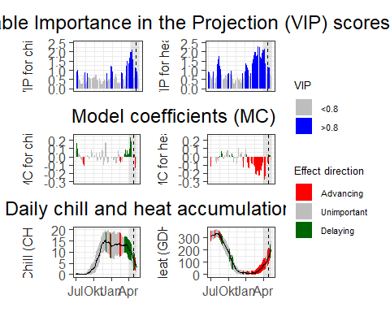
plot_PLS_chill_force(plscf,
chill_metric = "Utah_Chill_Units",
heat_metric = "GDH",
chill_label = "CU",
heat_label = "GDH",
chill_phase = c(0,0),
heat_phase = c(0,0))
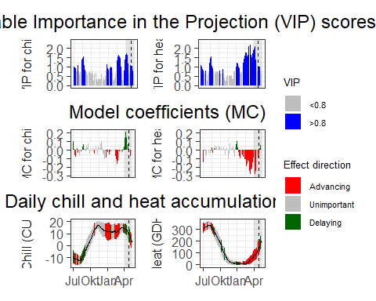
plot_PLS_chill_force(plscf)
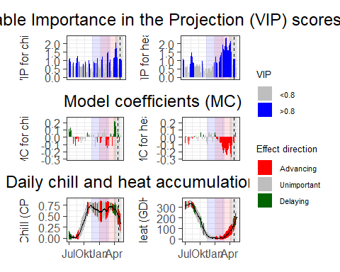

19.2 Delineating chilling and forcing phases across chill models
Run PLS_chill_force analyses for all three major chill models. Delineate your best estimates of chilling and forcing phases for all of them.
Chilling phase:
- Winter VIP values were intermittent and rarely exceeded the importance threshold for extended period
- Model coefficients during winter alternated between positive and negative values
- This indicates that winter temperature effects on bloom timing were inconsistent
- No clear or continuous chilling phase could be delineated for any chill model
- Chilling requirements are likely fulfilled every year and therefore do not drive interannual variation in bloom dates
Forcing phase:
- VIP values were consistently high (> 0.8) from late winter to spring
- Model coefficients during this period were predominantly negative
- Warmer temperatures during this phase consistently advanced bloom -> A clear forcing phase was identified
Best estimates Chilling phase: no clearly delineable period
Forcing phase: approximately January to April

19.3 Visualization and interpretation of chilling and forcing phases
Plot results for all three analyses, including shaded plot areas for the chilling and forcing periods you estimated.
- Forcing periods were shaded in red (January–April)
- No chilling period was shaded, as no consistent chilling phase could be identified
- The plots visually confirm that bloom timing is controlled primarily by spring forcing temperatures

20 Chapter 24 — Examples of PLS regression with agroclimatic metrics
This chapter shows how PLS regression with agroclimatic metrics works in different climates and where it can fail, especially when chilling and forcing periods overlap.

20.1 Patterns across climates
Look across all the PLS results presented above. Can you detect a pattern in where chilling and forcing periods could be delineated clearly, and where this attempt failed?
Across the examples, a clearer separation of chilling and forcing periods can be best observed in:
cold to moderately cold winter climates
- Beijing
- Klein-Altendorf
- Croatia
- California
Patterns which can be observed:
- winters are consistently cold enough for chill accumulation
- chill metrics show a small rise in autumn to winter
- PLS coefficients show positive chill effects in autumn to winter
Results:
PLS clearly identifies - a chilling window (often October - January) - followed by a forcing window (January - March)

20.2 Reasons for success and failure
Think about possible reasons for the success or failure of PLS analysis based on agroclimatic metrics. Write down your thoughts.
PLS struggled in warm winter climates: - Southern UK - Tunisia
Patterns which can be observed:
- chill accumulation is weak, fragmented, or overlapping with heat
- chill metrics increase slowly and irregularly
- forcing and chilling signals overlap strongly in time
Results:
No clear boundary between chilling and forcing phases
Reasons for success of PLS:
- Chilling and forcing are temporally separated -> cold winters → chill first, heat later
- Strong seasonal signal → clear temperature seasonality
- appropriate chill metric → dynamic model performs best across the different climates
- Penology is strongly temperature controlled
Reasons for failure of PLS:
PLS performs poorly when - Winters are too warm - chilling and forcing overlap - metric climate mismatch → simpler chill models fail under fluctuating temperatures - biological complexity → photoperiod, water stress, or genetic effects are not captured by temperature alone

21 Chapter 25 — Why PLS doesn’t always work
This chapter examines why PLS regression can fail, showing how overlapping temperature signals and model sensitivities can blur chill and heat responses.

21.1 Sensitivity analysis of chill and heat models
Produce chill and heat model sensitivity plots for the location you focused on in previous exercises.
Site definition and temperature ranges
library(chillR)
library(tidyverse)
library(ggplot2)
library(colorRamps)
latitude <- 47.7
month_range <- c(10, 11, 12, 1, 2, 3)
Tmins <- -20:20
Tmaxs <- -15:30
temp_model <- Dynamic_Model
Chill model sensitivity calculations
mins <- NA
maxs <- NA
CP <- NA
month <- NA
for (mon in month_range) {
days_month <- as.numeric(
difftime(
ISOdate(2002, mon + 1, 1),
ISOdate(2002, mon, 1)
)
)
if (mon == 12) days_month <- 31
weather <- make_all_day_table(
data.frame(
Year = c(2001, 2001),
Month = c(mon, mon),
Day = c(1, days_month),
Tmin = 0,
Tmax = 0
)
)
for (tmin in Tmins)
for (tmax in Tmaxs)
if (tmax >= tmin) {
hourtemps <- weather %>%
mutate(Tmin = tmin,
Tmax = tmax) %>%
stack_hourly_temps(latitude = latitude) %>%
pluck("hourtemps", "Temp")
CP <- c(
CP,
tail(Dynamic_Model(hourtemps), 1) / days_month
)
mins <- c(mins, tmin)
maxs <- c(maxs, tmax)
month <- c(month, mon)
}
}
results <- data.frame(
Month = month,
Tmin = mins,
Tmax = maxs,
CP = CP
)
results <- results[!is.na(results$Month), ]
write.csv(
results,
"data_Güttingen/Model_sensitivity_Guettingen_CP.csv",
row.names = FALSE
)
Sensitivity heat maps across winter months
results$Month_names <- factor(
results$Month,
levels = month_range,
labels = month.name[month_range]
)
DM_sensitivity <- ggplot(
results,
aes(Tmin, Tmax, fill = CP)
) +
geom_tile() +
scale_fill_gradientn(
colours = alpha(matlab.like(15), 0.6),
name = "Chill per day\n(Chill Portions)"
) +
facet_wrap(vars(Month_names)) +
xlab("Tmin (°C)") +
ylab("Tmax (°C)") +
theme_bw(base_size = 15)
DM_sensitivity
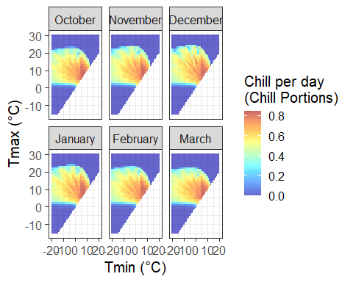
Comparison with observed temperature conditions
G_temps <- read_tab("data_Güttingen/Güttingen_clean_weather.csv") %>%
filter(Month %in% month_range) %>%
mutate(
Month_names = factor(
Month,
levels = month_range,
labels = month.name[month_range]
)
)
G_temps[G_temps$Tmax < G_temps$Tmin, c("Tmax","Tmin")] <- NA
DM_sensitivity +
geom_point(
data = G_temps,
aes(Tmin, Tmax),
inherit.aes = FALSE,
size = 0.25,
color = "black"
) +
ggtitle("Chill model sensitivity – Güttingen") +
theme(
strip.background = element_blank(),
strip.text = element_text(face = "bold")
)
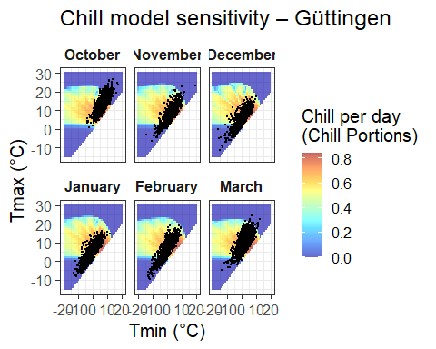
Compare Chill vs Heat
Model_sensitivities_Guettingen <- read.csv(
"data_Güttingen/Model_sensitivity_Guettingen_CP.csv"
)
Chill_sensitivity_temps <- function(
chill_model_sensitivity_table,
temperatures,
temp_model,
month_range = c(10, 11, 12, 1, 2, 3),
legend_label = "Chill/day"
) {
library(ggplot2)
library(colorRamps)
cmst <- chill_model_sensitivity_table
cmst <- cmst[cmst$Month %in% month_range, ]
cmst$Month_names <- factor(
cmst$Month,
levels = month_range,
labels = month.name[month_range]
)
p <- ggplot(
cmst,
aes(x = Tmin, y = Tmax, fill = .data[[temp_model]])
) +
geom_tile() +
facet_wrap(~Month_names) +
scale_fill_gradientn(
colours = alpha(matlab.like(15), 0.6),
name = legend_label
) +
theme_bw(base_size = 14) +
labs(x = "Tmin (°C)", y = "Tmax (°C)")
temperatures <- temperatures[temperatures$Month %in% month_range, ]
p +
geom_point(
data = temperatures,
aes(x = Tmin, y = Tmax),
inherit.aes = FALSE,
size = 0.3,
colour = "black"
)
}
G_temps <- read_tab("data_Güttingen/Güttingen_clean_weather.csv")
Chill_sensitivity_temps(
Model_sensitivities_Guettingen,
G_temps,
temp_model = "CP",
month_range = c(10, 11, 12, 1, 2, 3),
legend_label = "Chill per day\n(Chill Portions)"
) +
ggtitle("Chill model sensitivity at Güttingen")
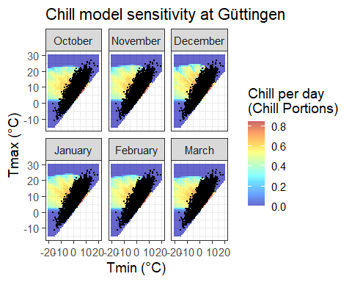

22 Chapter 26 — Evaluating PLS outputs
This chapter uses the Roter Boskoop dataset to assess PLS results, translating chilling and forcing phases into chill and heat requirements and showing when PLS is informative.

22.1 Reproducing analysis
Reproduce the analysis for the ‘Roter Boskoop’ dataset.
Load packages and phenology data
library(chillR)
library(tidyverse)
library(ggplot2)
library(colorRamps)
Roter_first <- read_tab("data/Roter_Boskoop_bloom_1958_2019.csv") %>%
select(Pheno_year, First_bloom) %>%
mutate(Year = as.numeric(substr(First_bloom, 1, 4)),
Month = as.numeric(substr(First_bloom, 5, 6)),
Day = as.numeric(substr(First_bloom, 7, 8))) %>%
make_JDay() %>%
select(Pheno_year, JDay) %>%
rename(Year = Pheno_year,
pheno = JDay)
Load temperature data and generate hourly temperatures
temps <- read_tab("data/TMaxTMin1958-2019_patched.csv")
temps_hourly <- temps %>%
stack_hourly_temps(latitude = 50.6)
Compute daily chill and heat metrics
daychill <- daily_chill(
hourtemps = temps_hourly,
running_mean = 1,
models = list(
Chilling_Hours = Chilling_Hours,
Utah_Chill_Units = Utah_Model,
Chill_Portions = Dynamic_Model,
GDH = GDH
)
)
Run PLS regression using agroclimatic metrics
plscf <- PLS_chill_force(
daily_chill_obj = daychill,
bio_data_frame = Roter_first,
split_month = 6,
chill_models = "Chill_Portions",
heat_models = "GDH",
runn_means = 11
)
Visualize PLS results and delineate response phases
source("data/plot_pls_ggplot.R")
plot_PLS_chill_force(
plscf,
chill_metric = "Chill_Portions",
heat_metric = "GDH",
chill_label = "CP",
heat_label = "GDH",
chill_phase = c(-40, 50),
heat_phase = c(10, 110)
)
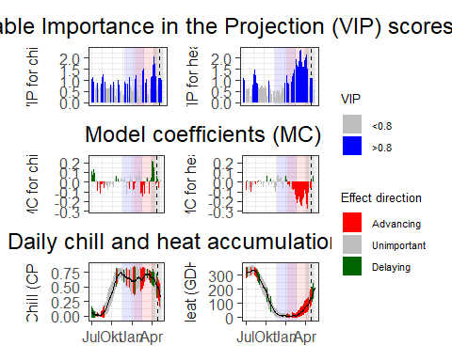
Estimate chilling and forcing requirements
chill_phase <- c(320, 50)
heat_phase <- c(10, 110)
chill <- tempResponse(
hourtemps = temps_hourly,
Start_JDay = chill_phase[1],
End_JDay = chill_phase[2],
models = list(Chill_Portions = Dynamic_Model),
misstolerance = 10
)
heat <- tempResponse(
hourtemps = temps_hourly,
Start_JDay = heat_phase[1],
End_JDay = heat_phase[2],
models = list(GDH = GDH)
)
Inspect chill and heat distributions
ggplot(chill, aes(x = Chill_Portions)) +
geom_histogram() +
theme_bw()
## `stat_bin()` using `bins = 30`. Pick better value `binwidth`.
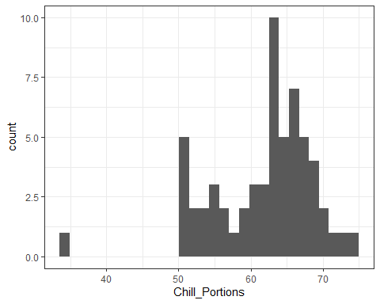
ggplot(heat, aes(x = GDH)) +
geom_histogram() +
theme_bw()
## `stat_bin()` using `bins = 30`. Pick better value `binwidth`.
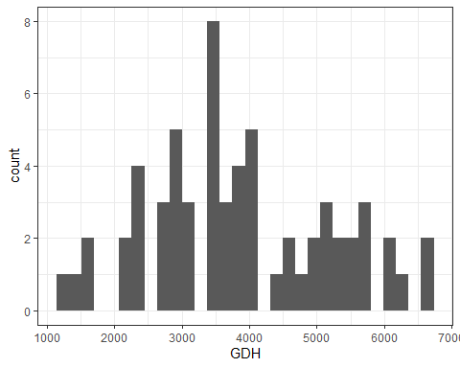
Quantify chill and heat requirements
chill_requirement <- mean(chill$Chill_Portions)
chill_req_error <- sd(chill$Chill_Portions)
heat_requirement <- mean(heat$GDH)
heat_req_error <- sd(heat$GDH)
Combine chill, heat, and phenology data
metrics_by_season <- merge(
chill[, c("Season", "End_year", "Chill_Portions")],
heat[, c("Season", "End_year", "GDH")],
by = c("Season", "End_year")
) %>%
merge(Roter_first, by.x = "End_year", by.y = "Year")
Plot chill vs heat colored by bloom date
ggplot(metrics_by_season, aes(Chill_Portions, GDH)) +
geom_point(aes(col = pheno), size = 2) +
scale_color_gradientn(colours = alpha(matlab.like(15)),
name = "Bloom date\n(DOY)") +
theme_bw()
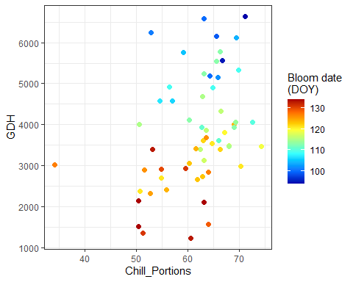
Compute mean temperatures during chilling and forcing phases
mean_temp_period <- function(
temps,
start_JDay,
end_JDay,
end_season = end_JDay
) {
temps_JDay <- make_JDay(temps) %>%
mutate(Season = Year)
if (start_JDay > end_season)
temps_JDay$Season[which(temps_JDay$JDay >= start_JDay)] <-
temps_JDay$Year[which(temps_JDay$JDay >= start_JDay)] + 1
if (start_JDay > end_season)
sub_temps <- subset(temps_JDay, JDay <= end_JDay | JDay >= start_JDay)
if (start_JDay <= end_JDay)
sub_temps <- subset(temps_JDay, JDay <= end_JDay & JDay >= start_JDay)
mean_temps <- aggregate(sub_temps[, c("Tmin", "Tmax")],
by = list(sub_temps$Season),
FUN = function(x) mean(x, na.rm = TRUE))
mean_temps[, "n_days"] <- aggregate(sub_temps[, "Tmin"],
by = list(sub_temps$Season),
FUN = length)[, 2]
mean_temps[, "Tmean"] <- (mean_temps$Tmin + mean_temps$Tmax) / 2
mean_temps <- mean_temps[, c(1, 4, 2, 3, 5)]
colnames(mean_temps)[1] <- "End_year"
mean_temps
}
mean_temp_chill <- mean_temp_period(
temps,
start_JDay = chill_phase[1],
end_JDay = chill_phase[2],
end_season = 60
)
mean_temp_heat <- mean_temp_period(
temps,
start_JDay = heat_phase[1],
end_JDay = heat_phase[2],
end_season = 60
)
mean_chill <- mean_temp_chill[, c("End_year", "Tmean")]
colnames(mean_chill)[2] <- "Tmean_chill"
mean_heat <- mean_temp_heat[, c("End_year", "Tmean")]
colnames(mean_heat)[2] <- "Tmean_heat"
phase_Tmeans <- merge(mean_chill, mean_heat, by = "End_year")
Tmeans_pheno <- merge(phase_Tmeans,
Roter_first,
by.x = "End_year",
by.y = "Year")
Interpolate bloom dates using kriging
library(fields)
k <- Krig(
x = as.matrix(Tmeans_pheno[, c("Tmean_chill", "Tmean_heat")]),
Y = Tmeans_pheno$pheno
)
pred <- predictSurface(k)
library(reshape2)
library(metR)
melted <- melt(pred$z)
colnames(melted) <- c("Tmean_chill", "Tmean_heat", "value")
Plot bloom date response surface
ggplot(melted,
aes(x = Tmean_chill,
y = Tmean_heat,
z = value)) +
geom_contour_fill(bins = 80) +
scale_fill_gradientn(
colours = alpha(matlab.like(15)),
name = "Bloom date\n(DOY)"
) +
geom_contour(col = "black") +
geom_point(
data = Tmeans_pheno,
aes(x = Tmean_chill,
y = Tmean_heat),
inherit.aes = FALSE,
size = 0.7
) +
geom_text_contour(stroke = 0.2) +
theme_bw(base_size = 15)
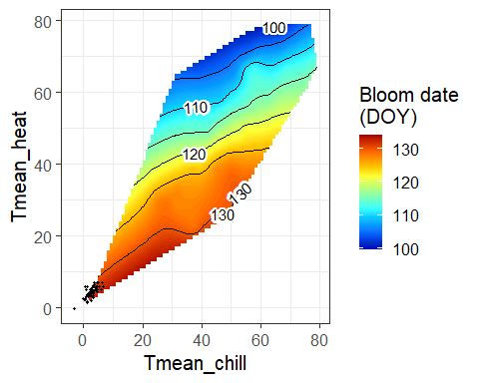

22.2 Interpreting surface plots across climates
We’ve looked at data from a number of locations so far. How would you expect this surface plot to look like in Beijing? And how should it look in Tunisia?
How would this surface look in Beijing?
- Much wider temperature space
- Clear separation between:
  - Cold chilling temperatures
  - Warm forcing temperatures
- Strong diagonal gradient
- Both chilling and forcing effects clearly visible → PLS and surface plots would work good there
How would this surface look in Tunisia?
- Narrow and fragmented temperature space
- Chilling and forcing overlap strongly
- Large white (unobserved) regions → Chilling signal could be weak or absent → PLS struggles

23 Chapter 27 - The relative importance of chill and heat
In this chapter, we explored how the effects of chilling and forcing temperatures on tree phenology vary across different climates, and why warming does not always lead to earlier spring events.

23.1 Temperature response hypothesis
Describe the temperature response hypothesis outlined in this chapter.
General idea:
- The chapter suggests that the importance of chilling and forcing temperatures changes depending on the climate
- Phenology does not always respond to temperature in the same way everywhere
Cold-winter climates:
- In cold climates, trees usually get enough chill
- Because chilling is not limiting, differences in winter temperature do not matter much
- Bloom or leaf-out mainly depends on spring (forcing) temperatures
- Warmer springs usually lead to earlier phenology
Intermediate climates:
- In moderately warm climates, chilling may start to matter
- Warmer winters can reduce chill accumulation
- This can delay phenology, even if spring temperatures are warm
- Both chilling and forcing seem to influence bloom timing
Warm-winter climates:
- In warm climates, chilling requirements may not be fulfilled
- Temperature during the chilling phase becomes very important
- Further warming does not necessarily advance phenology
- In some cases, warming can even delay bloom
Overall interpretation:
- The hypothesis suggests a gradual shift from forcing control to chilling control as winters get warmer
- This could explain why phenology does not always advance with climate warming
- The chapter presents this as a general idea that still needs more evidence

24 Chapter 29 - Making valid tree phenology models
In this chapter, we focus on why good model performance alone is not sufficient and why it is important to consider how phenology models work and under which conditions they can be used reliably.

24.1 Output vs. process validation
Explain the difference between output validation and process validation
- Output validation checks whether a model predicts observed bloom dates well
- This is usually done using statistical measures
- Process validation checks whether the model represents biological processes realistically
- A model can perform well in output validation but still be biologically unrealistic

24.2 Validity domain
Explain what a validity domain is and why it is important to consider this whenever we want to use our model to forecast something.
- The validity domain is the range of conditions under which a model is reliable
- It depends on the data used to build the model
- Predictions outside this range are uncertain
- This is important for climate change studies because future conditions may be outside past observations

24.3 Validation for purpose
What is validation for purpose?
- Validation for purpose means checking whether a model is suitable for what it is meant to be used for
- A model may work for current conditions but not for future projections
- The model should be tested under conditions similar to those it will be applied to

24.4 Ensuring model suitability
How can we ensure that our model is suitable for the predictions we want to make?
- Check that the model represents known biological processes
- Do not rely only on good statistical fit
- Identify the conditions under which the model was developed
- Compare these conditions with the ones the model will be used for
- Clearly state uncertainties and limitations

25 Chapter 30 - The PhenoFlex model
In this chapter, the PhenoFlex model is fitted to bloom data of Roter Boskoop apples and its performance is evaluated using predicted and observed bloom dates.
library(chillR)
library(tidyverse)
weather → hourly temps
CKA_weather <- read_tab("data/TMaxTMin1958-2019_patched.csv")
hourtemps <- stack_hourly_temps(CKA_weather, latitude = 50.6)
Phenology (First bloom)
Roter_first <- read_tab("data/Roter_Boskoop_bloom_1958_2019.csv") %>%
select(Pheno_year, First_bloom) %>%
mutate(
Year = as.numeric(substr(First_bloom, 1, 4)),
Month = as.numeric(substr(First_bloom, 5, 6)),
Day = as.numeric(substr(First_bloom, 7, 8))
) %>%
make_JDay() %>%
select(Pheno_year, JDay) %>%
rename(Year = Pheno_year, pheno = JDay) %>%
filter(!is.na(pheno)) %>%
arrange(Year)
Roter_first <- Roter_first %>% filter(Year >= 1959)
years_roter <- sort(unique(Roter_first$Year))
Build SeasonList
SeasonList <- genSeasonList(hourtemps$hourtemps,
mrange = c(8, 6),
years = years_roter)
stopifnot(length(SeasonList) == nrow(Roter_first))
Parameters + bounds
par <- c(40, 190, 0.5, 25, 3372.8, 9900.3, 6319.5,
5.939917e13, 4, 36, 4, 1.60)
upper <- c(41, 200, 1.0, 30, 4000.0, 10000.0, 7000.0,
6.e13, 10, 40, 10, 50.00)
lower <- c(38, 180, 0.1, 0 , 3000.0, 9000.0, 6000.0,
5.e13, 0, 0, 0, 0.05)

25.1 Parameterize PhenoFlex for Roter Boskoop
Parameterize the PhenoFlex model for `Roter Boskoop’ apples.
Fit_res <- phenologyFitter(
par.guess = par,
modelfn = PhenoFlex_GDHwrapper,
bloomJDays = Roter_first$pheno,
SeasonList = SeasonList,
lower = lower,
upper = upper,
control = list(
smooth = FALSE,
verbose = FALSE,
maxit = 1000,
nb.stop.improvement = 5
)
)
Roter_par <- Fit_res$par
stopifnot(length(Roter_par) == 12)
write.csv(Roter_par,
"data/PhenoFlex_parameters_Roter_Boskoop.csv",
row.names = FALSE)

25.2 Predicted vs. observed bloom dates
Produce plots of predicted vs. observed bloom dates and distribution of prediction errors
Roter_PhenoFlex_predictions <- Roter_first
Roter_PhenoFlex_predictions$predicted <- NA_real_
for (y in 1:nrow(Roter_PhenoFlex_predictions)) {
Roter_PhenoFlex_predictions$predicted[y] <-
PhenoFlex_GDHwrapper(SeasonList[[y]], Roter_par)
}
Roter_PhenoFlex_predictions$Error <-
Roter_PhenoFlex_predictions$predicted -
Roter_PhenoFlex_predictions$pheno
Predicted vs observed
ggplot(Roter_PhenoFlex_predictions,
aes(x = pheno, y = predicted)) +
geom_point() +
geom_abline(intercept = 0, slope = 1) +
theme_bw(base_size = 15) +
xlab("Observed bloom date (Day of the year)") +
ylab("Predicted bloom date (Day of the year)") +
ggtitle("Roter Boskoop – Predicted vs. observed bloom dates")
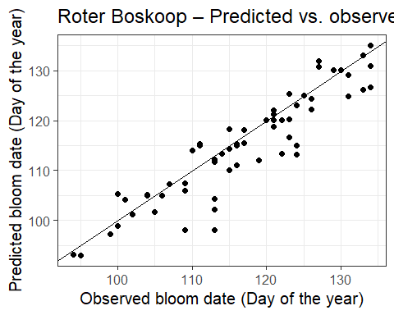
Error distribution
ggplot(Roter_PhenoFlex_predictions,
aes(Error)) +
geom_histogram(bins = 20) +
theme_bw(base_size = 15) +
xlab("Prediction error (days)") +
ggtitle("Roter Boskoop – Distribution of prediction errors")
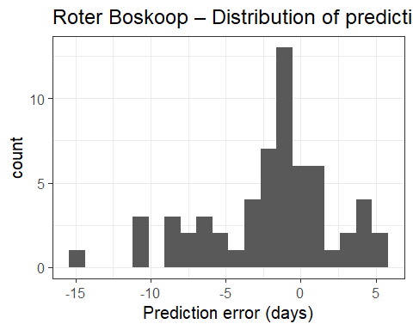

25.3 Model performance metrics
Compute the model performance metrics RMSEP, mean error and mean absolute error.
RMSEP(Roter_PhenoFlex_predictions$predicted,
Roter_PhenoFlex_predictions$pheno)
## [1] 4.690369
mean(Roter_PhenoFlex_predictions$Error)
## [1] -1.915972
mean(abs(Roter_PhenoFlex_predictions$Error))
## [1] 3.340972

26 Chapter 31 - The PhenoFlex model - a second look
This chapter takes a second look at the PhenoFlex model by showing how chill and heat responses change with temperature for Roter Boskoop at the Güttingen site.

26.1 Chill and heat response plots
Make chill and heat response plots for the ‘Roter Boskoop’ PhenoFlex model for the location you did the earlier analyses for.
library(tidyverse)
library(chillR)
Roter_par_raw <- read.csv(
"data/PhenoFlex_parameters_Roter_Boskoop.csv",
header = TRUE
)
Roter_par <- as.numeric(Roter_par_raw[[1]])
names(Roter_par) <- NULL
Roter_par <- Roter_par[!is.na(Roter_par)]
length(Roter_par)
## [1] 12
Roter_par
## [1] 39.4579019 195.5517993 0.3217589 25.0000000
## [5] 3372.8000000 9900.3000000 6187.3988009 59399307532103.6015625
## [9] 4.9785834 30.0691690 4.0000000 2.4947811
Helper functions - Chill response
apply_const_temp <- function(temp, par, portions = 1200) {
temp_vec <- rep(temp, portions)
res <- DynModel_driver(
temp = temp_vec,
A0 = par[7],
A1 = par[8],
E0 = par[5],
E1 = par[6],
Tf = par[9],
slope = par[12],
deg_celsius = TRUE
)
res$y[length(res$y)]
}
gen_chill_response <- function(par,
temp_values = seq(-5, 20, 0.1)) {
sapply(temp_values, apply_const_temp, par = par)
}
Helper functions - Heat response (GDH)
GDH_response <- function(T, par) {
Tb <- par[11]
Tu <- par[4]
Tc <- par[10]
w <- rep(0, length(T))
w[T >= Tb & T <= Tu] <-
0.5 * (1 + cos(pi + pi * (T[T >= Tb & T <= Tu] - Tb)/(Tu - Tb)))
w[T > Tu & T <= Tc] <-
(1 + cos(pi/2 + pi/2 * (T[T > Tu & T <= Tc] - Tu)/(Tc - Tu)))
w
}
Generate chill & heat response curve
temp_values <- seq(-5, 36, 0.1)
response_df <- data.frame(
Temperature = temp_values,
Chill_response = gen_chill_response(Roter_par, temp_values),
Heat_response = GDH_response(temp_values, Roter_par)
)
response_long <- pivot_longer(
response_df,
cols = c(Chill_response, Heat_response),
names_to = "Process",
values_to = "Response"
)
Plot
ggplot(response_long,
aes(x = Temperature, y = Response)) +
geom_line(linewidth = 1.5,
aes(color = Process)) +
facet_wrap(~Process,
scales = "free_y",
labeller = labeller(
Process = c(
Chill_response = "Chill response",
Heat_response = "Heat response"
)
)) +
scale_color_manual(values = c(
Chill_response = "blue",
Heat_response = "red"
)) +
theme_bw(base_size = 15) +
theme(legend.position = "none") +
xlab("Temperature (°C)") +
ylab("Response (arbitrary units)") +
ggtitle("PhenoFlex temperature responses – Roter Boskoop (Göttingen)")
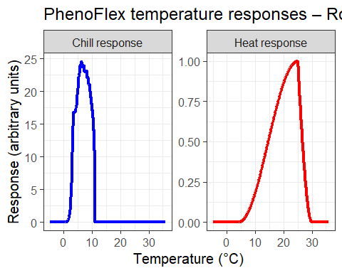

27 Chapter 32 - Can we improve the performance of PhenoFlex?
In this chapter, we explore whether the PhenoFlex model can be improved by changing the way it is calibrated, and what role extreme seasons play in model performance.

27.1 Objective of the analysis
What was the objective of this work?
- To check whether the performance of the PhenoFlex model can be improved
- To see how the choice of calibration data influences model results
- To test the effect of including very warm (“marginal”) seasons in the calibration

27.2 Main conclusion
What was the main conclusion?
- The model performed worse when very warm, marginal seasons were included
- Removing these seasons led to better predictions
- The temperature response of the model looked more realistic without the marginal seasons

27.3 Future experimental tests
What experiments could we conduct to test the hypothesis that emerged at the end of the conclusion?
- Experiments where trees are exposed to different winter temperature conditions
- Especially experiments focusing on unusually warm winters
- Studies that look more closely at how dormancy is affected under extreme conditions

28 Chapter 33 - Frost risk analysis
This chapter examines how flowering timing and frost events interact for the apple cultivar Roter Boskoop. Using long-term phenology and weather records, it explores changes in bloom timing, the occurrence of frost events, and whether the risk of spring frost during bloom has changed over time.

28.1 Developement of bloom period
Illustrate the development of the bloom period over the duration of the weather record. Use multiple ways to show this - feel free to be creative.
library(tidyverse)
library(chillR)
Roter_raw <- read_tab("data/Roter_Boskoop_bloom_1958_2019.csv")
Roter <- Roter_raw %>%
pivot_longer(First_bloom:Last_bloom,
names_to = "Stage",
values_to = "YEARMODA") %>%
mutate(Year = as.numeric(substr(YEARMODA, 1, 4)),
Month = as.numeric(substr(YEARMODA, 5, 6)),
Day = as.numeric(substr(YEARMODA, 7, 8))) %>%
make_JDay()
Illustration 1 – Bloom dates over time (lines + trend)
ggplot(Roter, aes(Year, JDay, col = Stage)) +
geom_line(alpha = 0.6) +
geom_smooth(method = "lm", se = FALSE) +
theme_bw() +
ylab("Julian day") +
xlab("Year") +
ggtitle("Development of bloom dates – Roter Boskoop")
## `geom_smooth()` using formula = 'y ~ x'
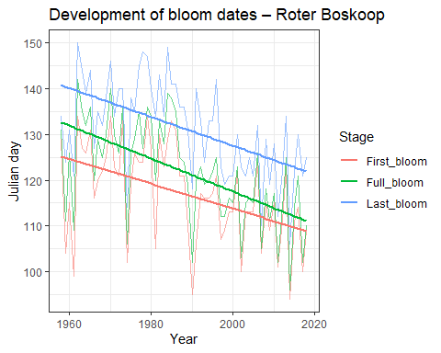
Illustration 2 – Bloom duration ribbon
Ribbon_Roter <- Roter %>%
select(Year, Stage, JDay) %>%
pivot_wider(names_from = Stage, values_from = JDay)
ggplot(Ribbon_Roter, aes(Year)) +
geom_ribbon(aes(ymin = First_bloom,
ymax = Last_bloom),
fill = "grey80") +
geom_line(aes(y = Full_bloom), linewidth = 1) +
theme_bw() +
ylab("Julian day") +
xlab("Year") +
ggtitle("Bloom period duration – Roter Boskoop")
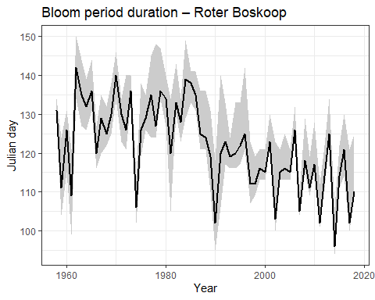
Illustration 3 – Bloom timing distribution (boxplots by decade)
Roter$Decade <- floor(Roter$Year / 10) * 10
ggplot(Roter %>% filter(Stage == "Full_bloom"),
aes(factor(Decade), JDay)) +
geom_boxplot(fill = "lightblue") +
theme_bw() +
ylab("Julian day of full bloom") +
xlab("Decade") +
ggtitle("Distribution of full bloom dates by decade")
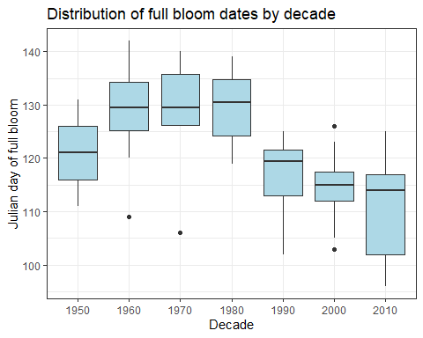

28.2 Occurence of frost events
Evaluate the occurrence of frost events at Klein-Altendorf since 1958. Illustrate this in a plot.
CKA_weather <- read_tab("data/TMaxTMin1958-2019_patched.csv")
frost_df <- data.frame(
lower = c(-1000, 0),
upper = c(0, 1000),
weight = c(1, 0)
)
frost_model <- function(x)
step_model(x, frost_df)
hourly <- stack_hourly_temps(CKA_weather, latitude = 50.6)
frost <- tempResponse(hourly,
models = c(frost = frost_model))
ggplot(frost, aes(End_year, frost)) +
geom_point() +
geom_smooth() +
theme_bw() +
ylab("Frost hours per year") +
xlab("Year")
## `geom_smooth()` using method = 'loess' and formula = 'y ~ x'
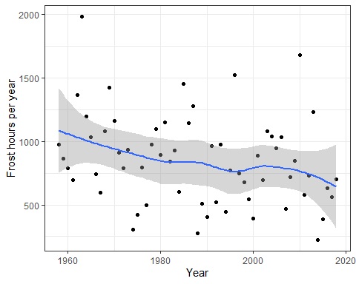
- The plot shows how many frost hours occurred each year at Klein-Altendorf since 1958
- There is a lot of variation between years, with some years having many frost hours and others having fewer
- The smoothed line suggests that frost hours have generally decreased over time
- Earlier years seem to have more frequent frost events than more recent years
- In the last decades, frost hours appear to be lower on average
- However, frost events still occur in some years, so frost risk has not completely disappeared
- Overall, the plot suggests a declining trend in frost occurrence, but with strong year-to-year variability

28.3 Spring frost and frost events
Produce an illustration of the relationship between spring frost events and the bloom period of ‘Roter Boskoop’.
frost_model_no_summ <- function(x)
step_model(x, frost_df, summ = FALSE)
hourly$hourtemps$frost <- frost_model_no_summ(hourly$hourtemps$Temp)
Daily_frost_hours <- aggregate(hourly$hourtemps$frost,
by = list(hourly$hourtemps$YEARMODA),
FUN = sum)
Daily_frost <- make_JDay(CKA_weather)
Daily_frost$Frost_hours <- Daily_frost_hours$x
Daily_frost$Frost_hours[Daily_frost$Frost_hours == 0] <- NA
Ribbon_Roter <- Roter %>%
select(Year, Stage, JDay) %>%
pivot_wider(names_from = Stage, values_from = JDay)
ggplot(Ribbon_Roter, aes(Year)) +
geom_ribbon(aes(ymin = First_bloom,
ymax = Last_bloom),
fill = "grey80") +
geom_line(aes(y = Full_bloom)) +
geom_point(data = Daily_frost,
aes(Year, JDay, size = Frost_hours),
col = "blue", alpha = 0.6) +
theme_bw() +
ylim(75, 140)
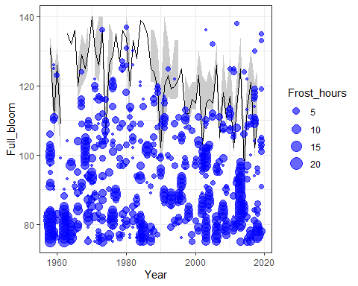

28.4 Trend of risk
Evaluate how the risk of spring frost for this cultivar has changed over time. Has there been a significant trend
Daily_frost$Bloom_phase <- "Before bloom"
Daily_frost$Bloom_phase[
Daily_frost$JDay >= Ribbon_Roter$First_bloom[
match(Daily_frost$Year, Ribbon_Roter$Year)
]] <- "During bloom"
Daily_frost$Bloom_phase[
Daily_frost$JDay >
Ribbon_Roter$Last_bloom[
match(Daily_frost$Year, Ribbon_Roter$Year)
]] <- "After bloom"
Bloom_frost <- aggregate(Daily_frost$Frost_hours,
by = list(Daily_frost$Year,
Daily_frost$Bloom_phase),
FUN = function(x) sum(x, na.rm = TRUE))
DuringBloom <- Bloom_frost[
Bloom_frost$Group.2 == "During bloom",]
library(Kendall)
Kendall(DuringBloom$Group.1, DuringBloom$x)
## tau = 0.0333, 2-sided pvalue =0.74038
lm(DuringBloom$x ~ DuringBloom$Group.1)
##
## Call:
## lm(formula = DuringBloom$x ~ DuringBloom$Group.1)
##
## Coefficients:
## (Intercept) DuringBloom$Group.1
## -91.48652 0.04786
- The Kendall test shows no significant trend in frost hours during bloom (p ≈ 0.74)
- The linear regression slope is very small and close to zero
- This suggests that frost risk during bloom has not changed clearly over time
- Even though overall frost has decreased, frost events can still happen during flowering

