CREATE DATABASE IndexDemo;
GO
USE IndexDemo;
GO
CREATE TABLE dbo.Customers (
CustomerID INT IDENTITY(1,1) NOT NULL,
Email NVARCHAR(100) NOT NULL,
LastName NVARCHAR(50) NOT NULL,
FirstName NVARCHAR(50) NOT NULL,
City NVARCHAR(50) NOT NULL,
RegistrationDate DATE NOT NULL,
Notes NVARCHAR(500) NULL
);
GO
-- Заполняем 50 000 строк тестовыми данными
INSERT INTO dbo.Customers (Email, LastName, FirstName, City, RegistrationDate, Notes)
SELECT TOP (50000)
'user' + CAST(ROW_NUMBER() OVER (ORDER BY (SELECT NULL)) AS NVARCHAR(10)) + '@example.com',
'LastName' + CAST(ABS(CHECKSUM(NEWID())) % 1000 AS NVARCHAR(10)),
'FirstName' + CAST(ABS(CHECKSUM(NEWID())) % 500 AS NVARCHAR(10)),
CASE ABS(CHECKSUM(NEWID())) % 5
WHEN 0 THEN N'Москва'
WHEN 1 THEN N'Санкт-Петербург'
WHEN 2 THEN N'Новосибирск'
WHEN 3 THEN N'Екатеринбург'
ELSE N'Казань'
END,
DATEADD(DAY, ABS(CHECKSUM(NEWID())) % 3650, '2015-01-01'),
REPLICATE(N'A', 500)
FROM sys.all_objects a
CROSS JOIN sys.all_objects b;
GO
-- Проверяем количество строк
SELECT COUNT(*) AS TotalRows FROM dbo.Customers;
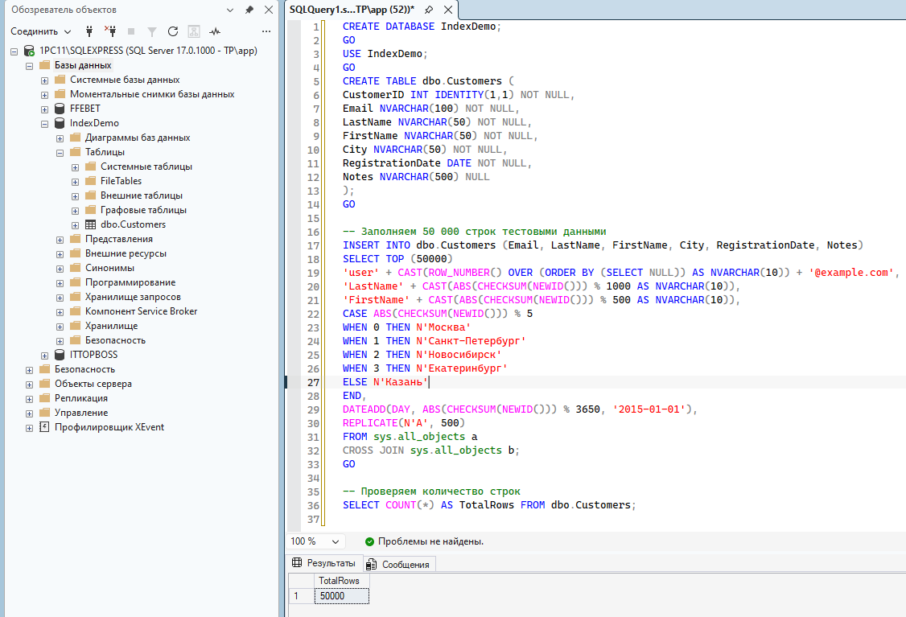

Практика
SET STATISTICS IO ON;
SET STATISTICS TIME ON;
SELECT CustomerID, Email, LastName
FROM dbo.Customers
WHERE Email = 'user12345@example.com';
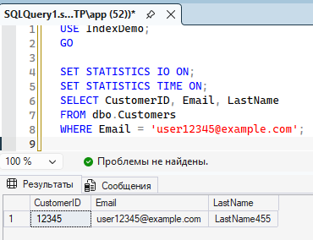
Ищем имейл со статистикой
Кластер
CREATE CLUSTERED INDEX CIX_Customers_CustomerID
ON dbo.Customers (CustomerID);
GO
EXEC sp_helpindex 'dbo.Customers';
SELECT CustomerID, Email, LastName
FROM dbo.Customers
WHERE CustomerID = 12345;
SELECT CustomerID, Email
FROM dbo.Customers
WHERE CustomerID BETWEEN 10000 AND 10100;

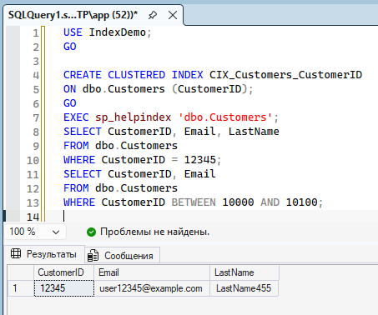
Не кластер

CREATE NONCLUSTERED INDEX NCIX_Customers_Email
ON dbo.Customers (Email);
GO
DROP INDEX NCIX_Customers_Email ON dbo.Customers;
CREATE NONCLUSTERED INDEX NCIX_Customers_Email
ON dbo.Customers (Email)
INCLUDE (LastName);
GO
SELECT CustomerID, Email, LastName
FROM dbo.Customers
WHERE Email = 'user12345@example.com';
CREATE NONCLUSTERED INDEX NCIX_Customers_City
ON dbo.Customers (City);
GO
-- Запрос, возвращающий ~20% строк (Москва)
SELECT * FROM dbo.Customers WHERE City = N'Москва';

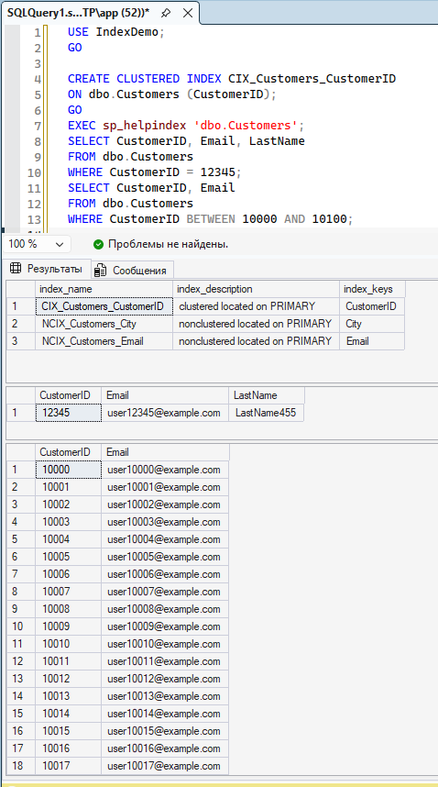
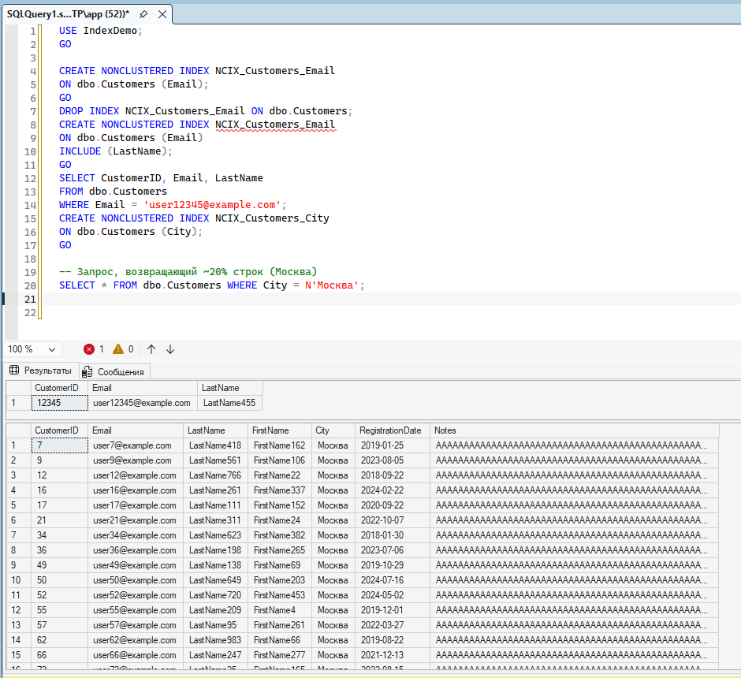

Работа с запросами
SET STATISTICS TIME ON;
INSERT INTO dbo.Customers (Email, LastName, FirstName, City, RegistrationDate, Notes)
SELECT TOP (1000)
'newuser' + CAST(ROW_NUMBER() OVER (ORDER BY (SELECT NULL)) AS NVARCHAR(10)) + '@test.com',
'NewLast' + CAST(ABS(CHECKSUM(NEWID())) % 100 AS NVARCHAR(10)),
'NewFirst' + CAST(ABS(CHECKSUM(NEWID())) % 100 AS NVARCHAR(10)),
N'Москва',
GETDATE(),
REPLICATE(N'B', 500)
FROM sys.all_objects;
GO
DROP INDEX NCIX_Customers_Email ON dbo.Customers;
DROP INDEX NCIX_Customers_City ON dbo.Customers;
-- Кластеризованный индекс оставляем для сравнения
-- Вставьте ещё 1000 строк с теми же данными
INSERT INTO dbo.Customers (Email, LastName, FirstName, City, RegistrationDate, Notes)
SELECT TOP (1000)
'newuser2_' + CAST(ROW_NUMBER() OVER (ORDER BY (SELECT NULL)) AS NVARCHAR(10)) + '@test.com',
'NewLast' + CAST(ABS(CHECKSUM(NEWID())) % 100 AS NVARCHAR(10)),
'NewFirst' + CAST(ABS(CHECKSUM(NEWID())) % 100 AS NVARCHAR(10)),
N'Москва',
GETDATE(),
REPLICATE(N'B', 500)
FROM sys.all_objects;
GO

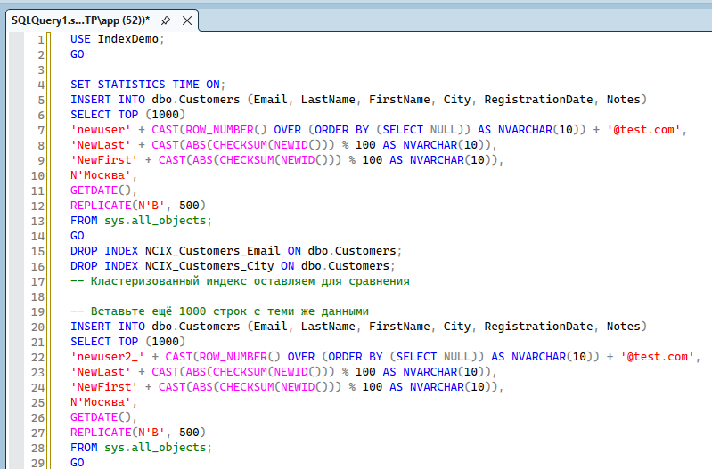
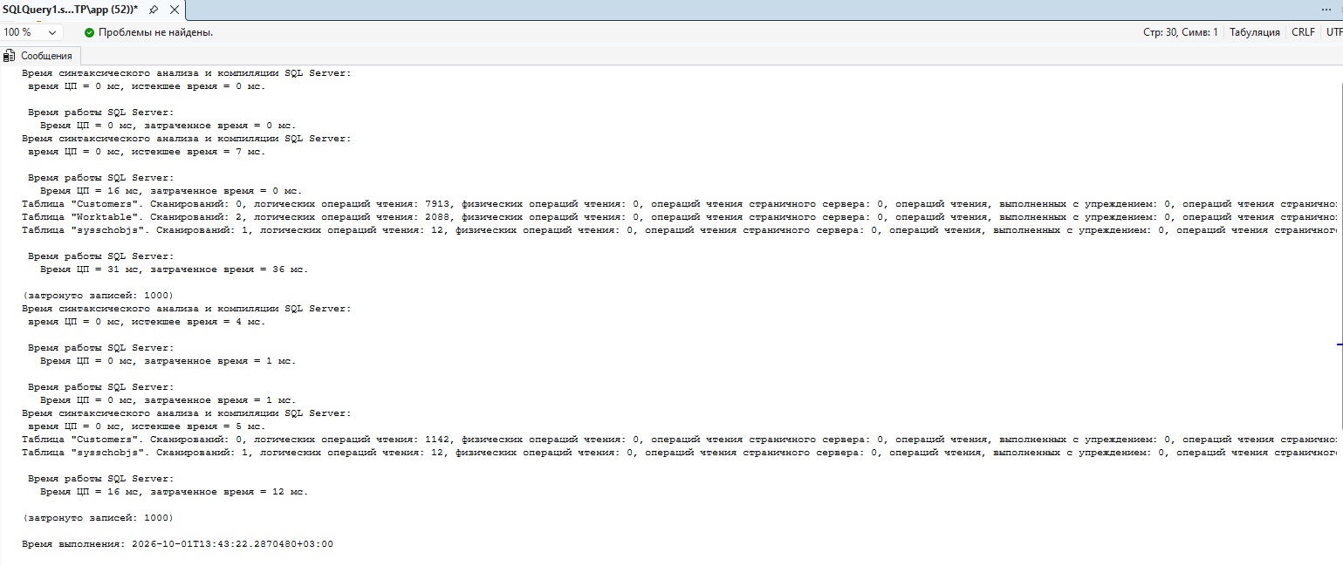
Explorer
EXEC sp_helpindex 'dbo.Customers';
SELECT
INDEXPROPERTY(OBJECT_ID('dbo.Customers'), 'CIX_Customers_CustomerID', 'IsClustered') AS IsClustered,
INDEXPROPERTY(OBJECT_ID('dbo.Customers'), 'CIX_Customers_CustomerID', 'IndexDepth') AS IndexDepth,
INDEXPROPERTY(OBJECT_ID('dbo.Customers'), 'CIX_Customers_CustomerID', 'IsUnique') AS IsUnique;
CREATE NONCLUSTERED INDEX NCIX_Customers_Email
ON dbo.Customers (Email) INCLUDE (LastName);
CREATE NONCLUSTERED INDEX NCIX_Customers_City
ON dbo.Customers (City);
