**HW 1**

**Case 2**

1. Import data. Prepare data for analysis and modeling.  
   You can import data from my GitHub: <https://raw.githubusercontent.com/robertasgabrys/Forecasting/main/dtwnLAozone.csv>

**Answer:**

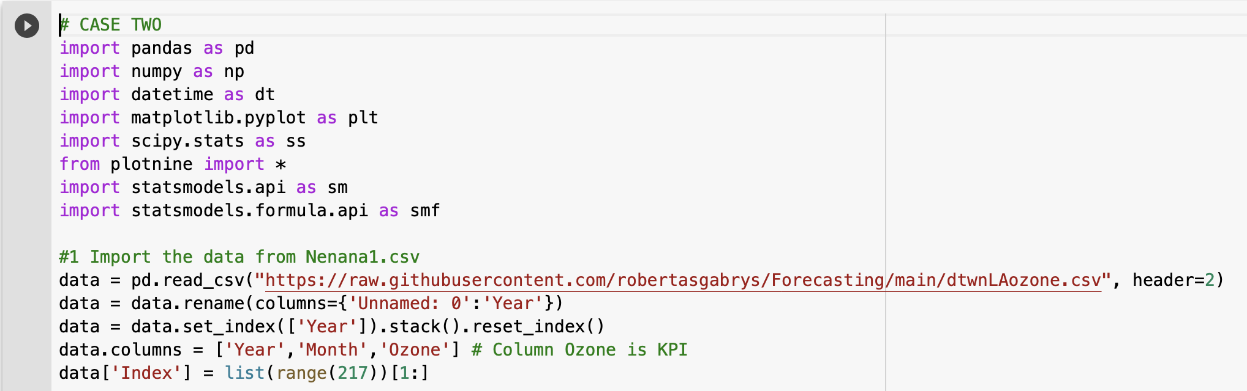

( plot is shown below in Q2.)

1. Graph the data and describe the patterns you see in the data set.

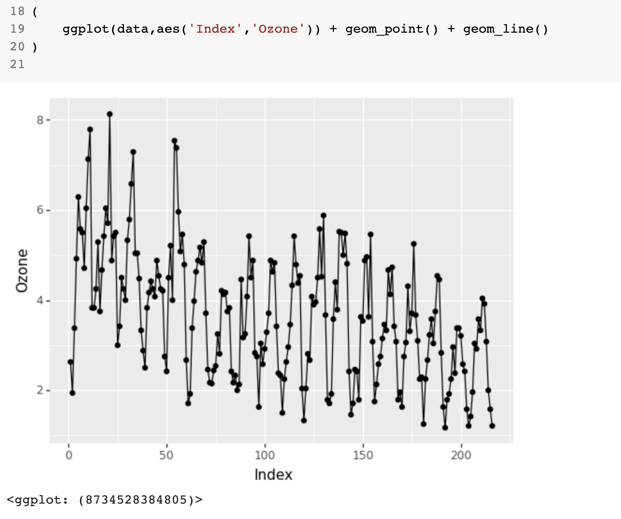

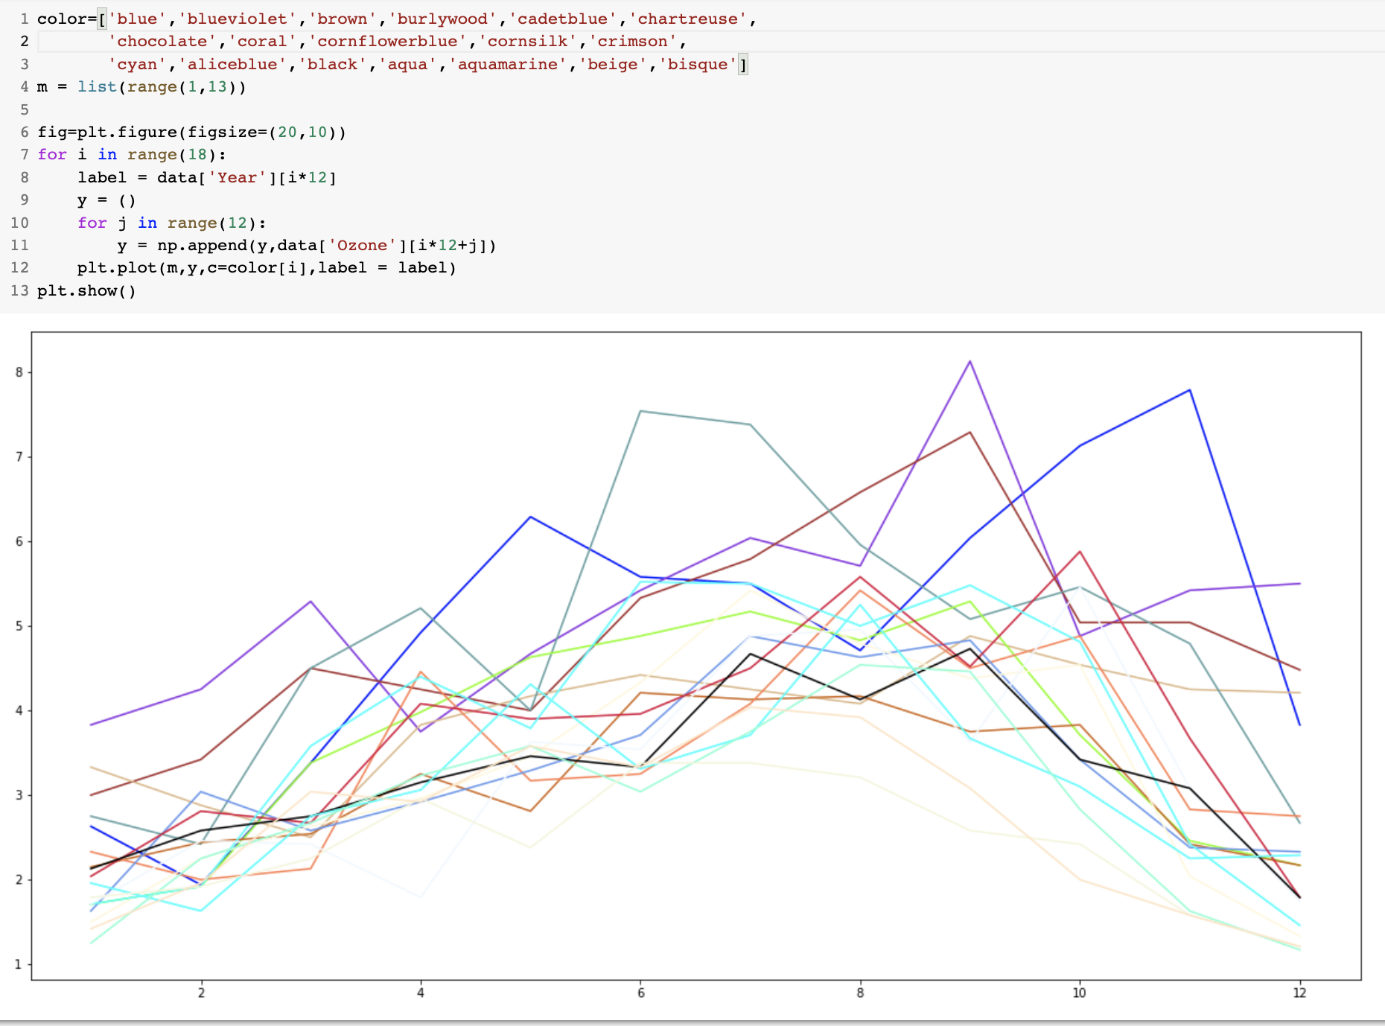

**Answer:**

Since 1955, there has been an overall downtrend in the ozone level (shown in Graph 1 above). Within a year, ozone tends to increase in the first 3/4 of the year and decrease in the last 1/4 of the year; it usually reaches its peak in late summer and early fall. This trend is probably due to increasingly longer daylight hours and higher temperatures during the summer season.

1. Does the data provide statistically significant evidence that the opening of the Golden State Freeway and the implementation of Rule 63 in 1960 reduced pollution statistically significantly? Evaluate both the abrupt and the gradual changes. Report and interpret the estimates of both the abrupt and the gradual changes in ozone. Which one do you think is more appropriate and meaningful to model Golden State Freeway and Rule 63 intervention effect?

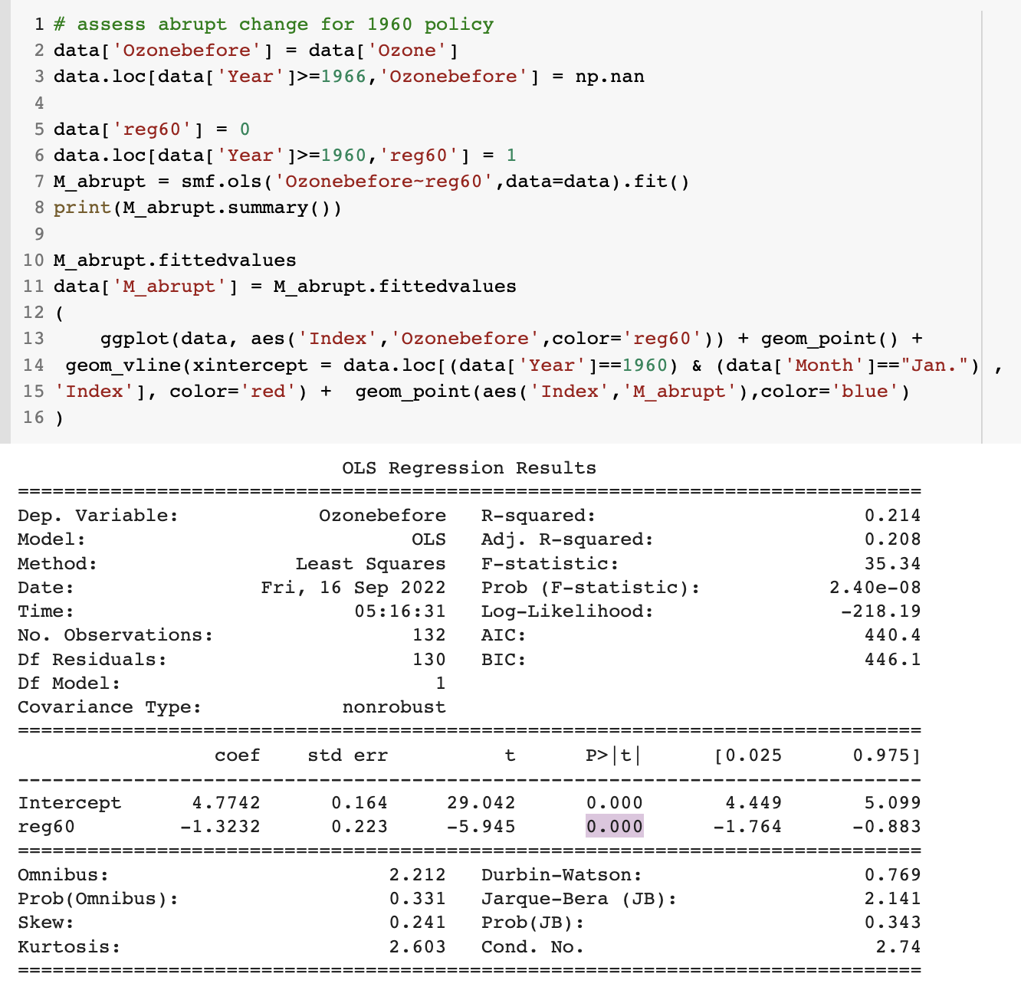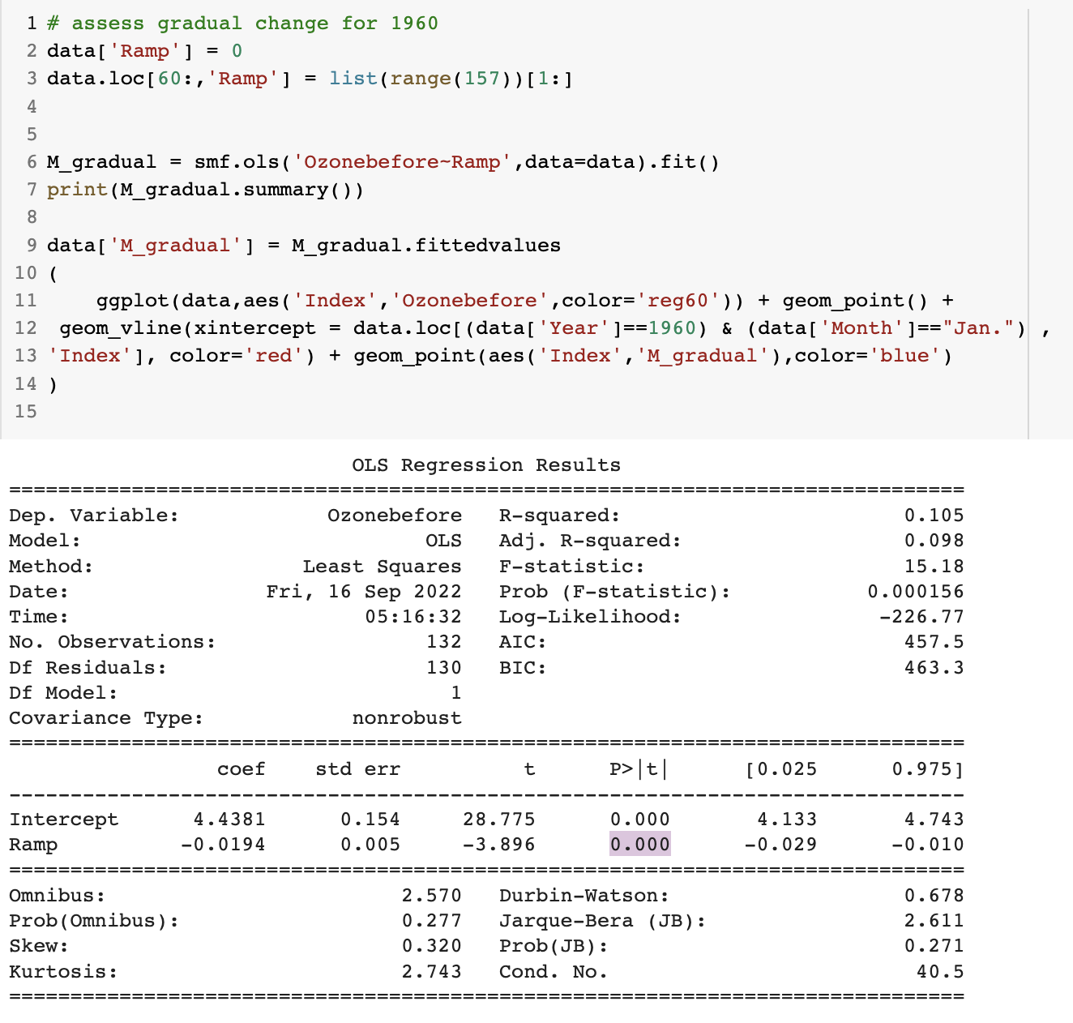

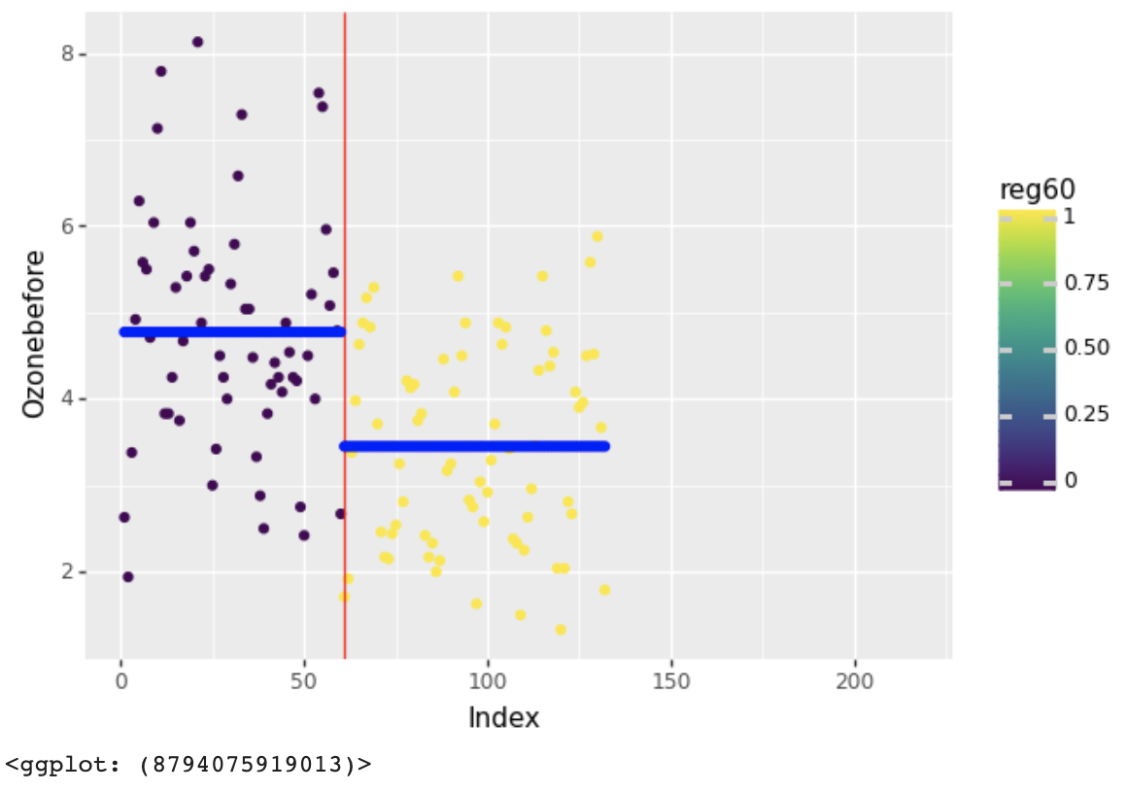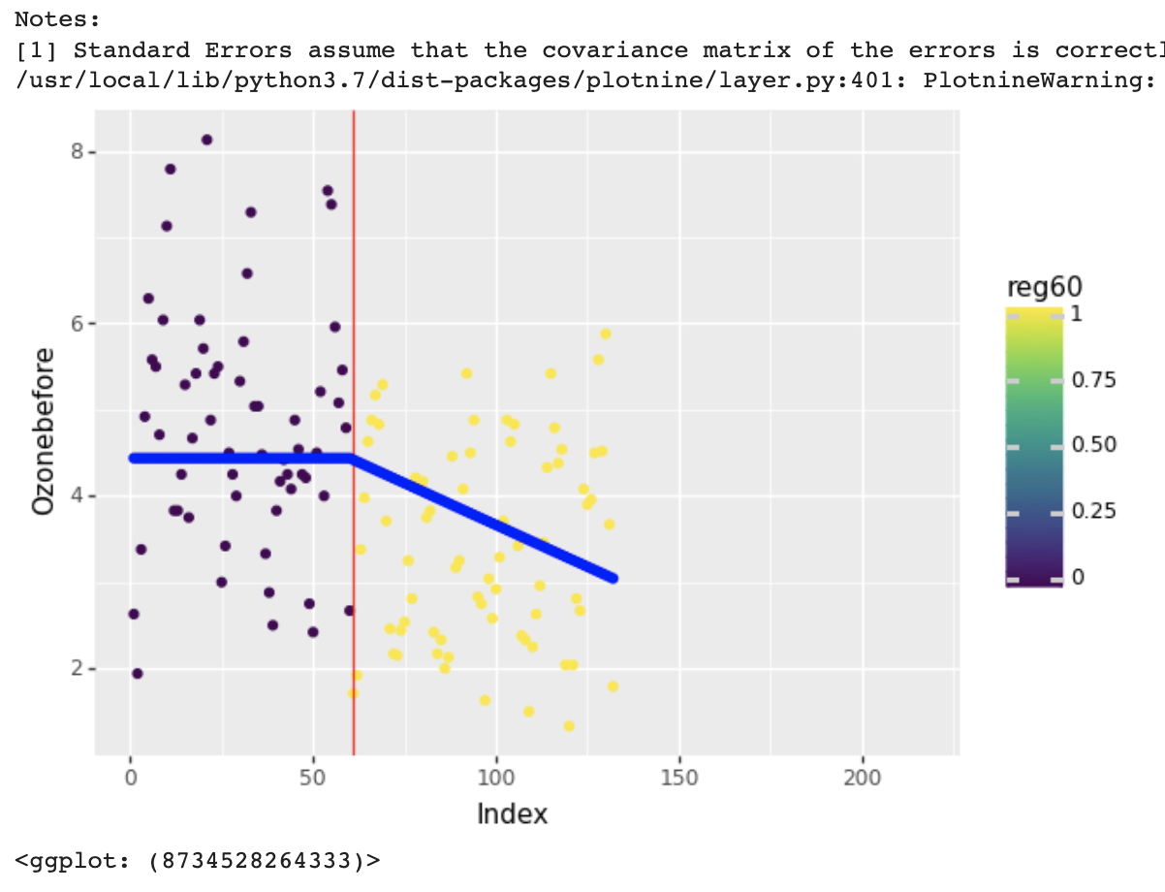

Abrupt change model Gradual change model

**Answer:**

**For Abrupt Change Model:** Since the p-value (0.00) < alpha (0.05), we conclude that the data provides statistically significant evidence that the opening of the Golden State Freeway and the implementation of Rule 63 in 1960 reduced the ozone pollution.

**For Gradual Change Model:** Since the p-value (0.00) < alpha (0.05), we conclude that the data provides statistically significant evidence that the opening of the Golden State Freeway and the implementation of Rule 63 in 1960 reduced the ozone pollution, **and the effect is gradual**.

We believe **the gradual effect of the intervention in 1960 is more appropriate** because the ozone concentration kept accumulating. Therefore, the effect of excessive ozone emissions and accumulation should be considered **incremental**.

1. Does the data provide statistically significant evidence that the special regulations for new car engines implemented in 1966 reduced pollution statistically significantly? Evaluate both the abrupt and the gradual changes. Report and interpret the estimates of both the abrupt and the gradual changes in ozone. Which one do you think is more appropriate and meaningful to model the 1966 special regulations for new car engines’ intervention effect?

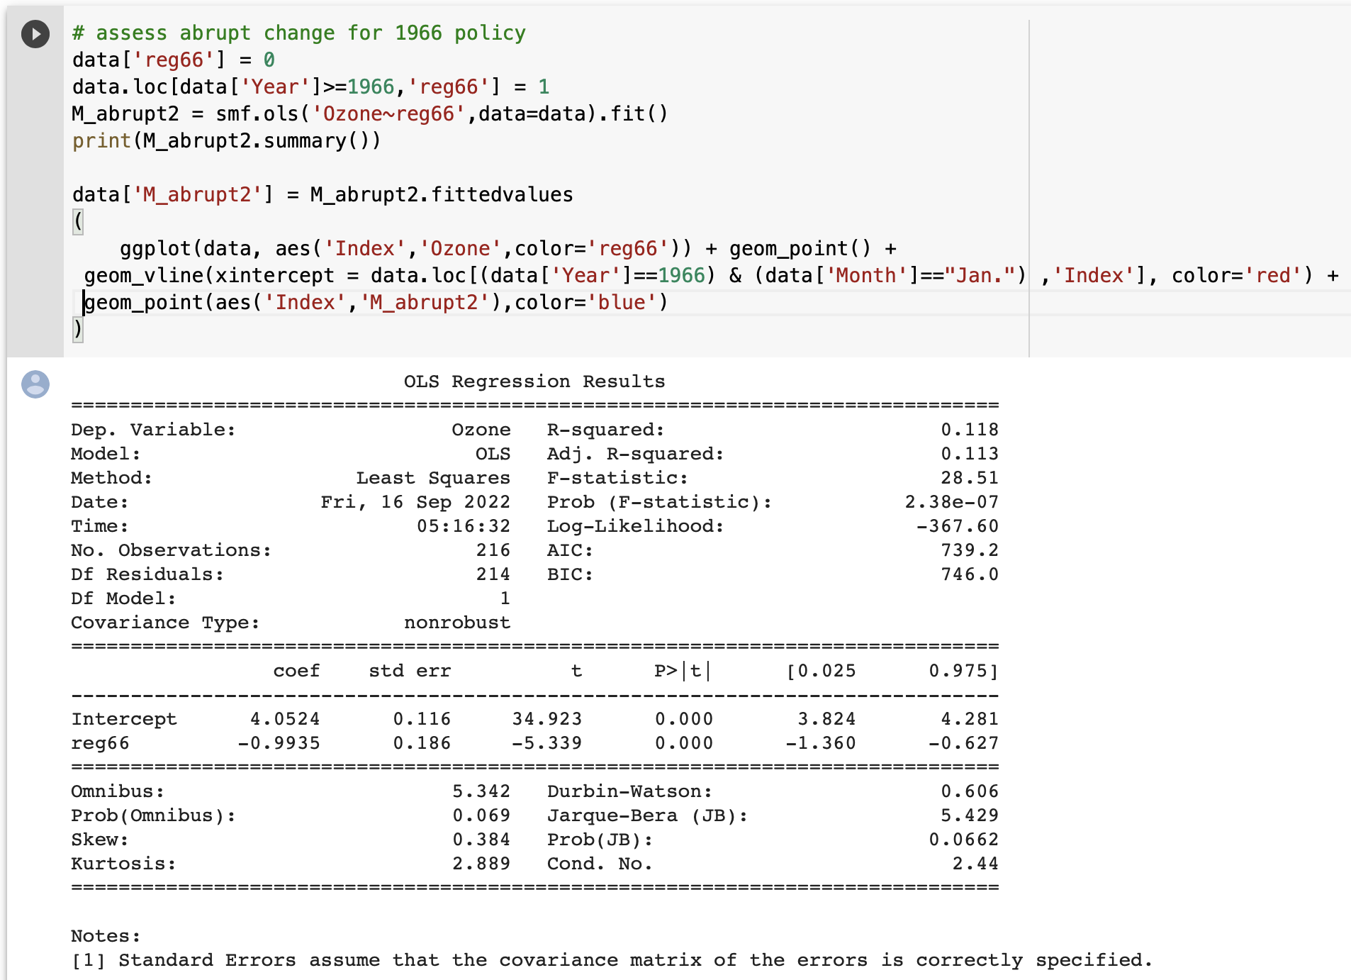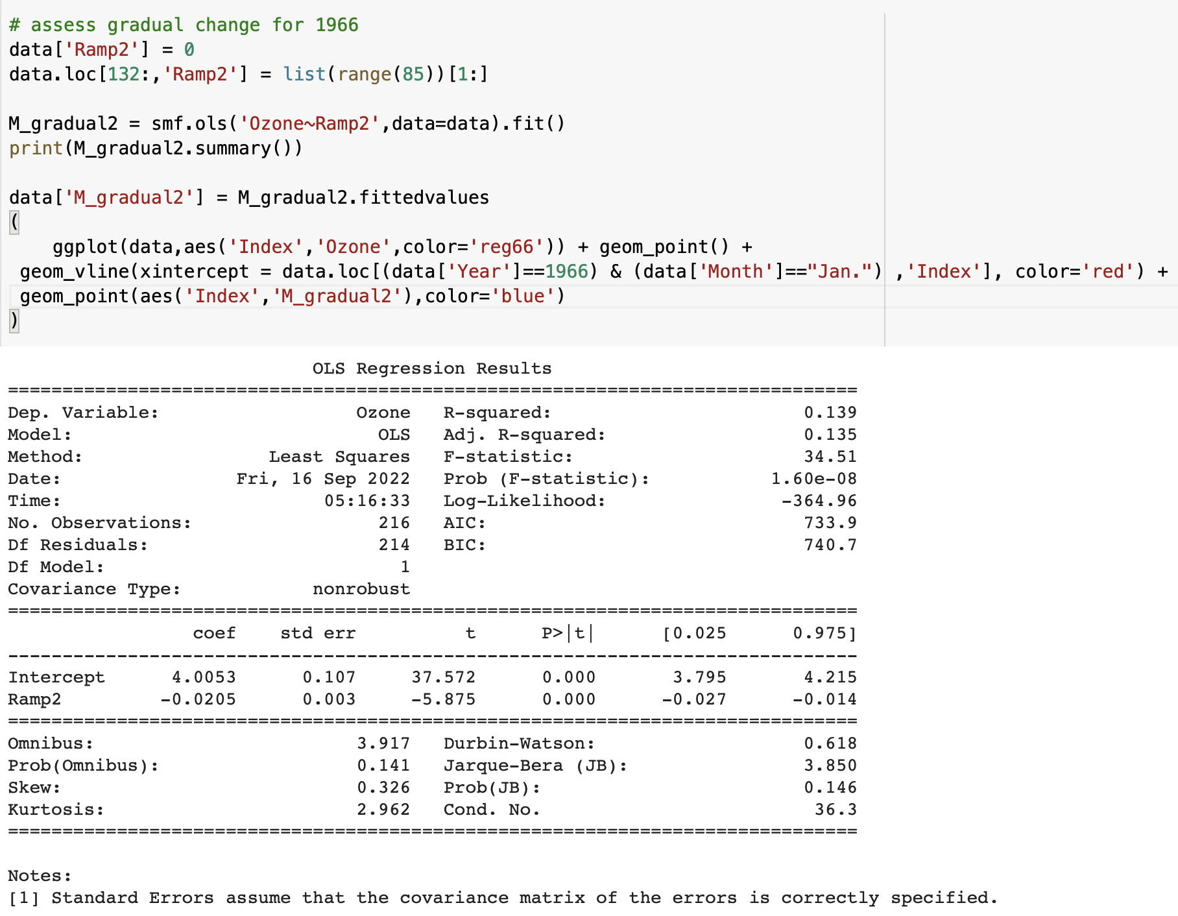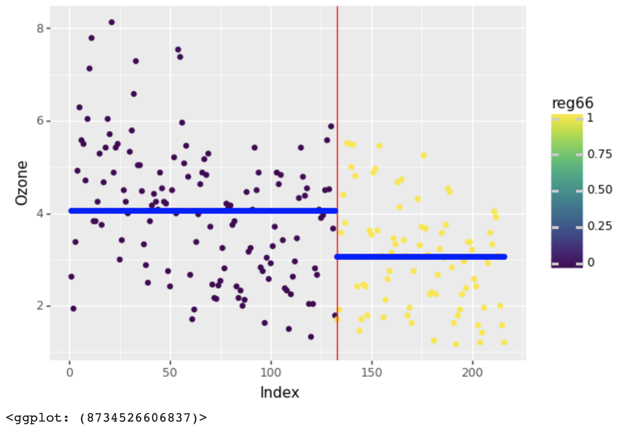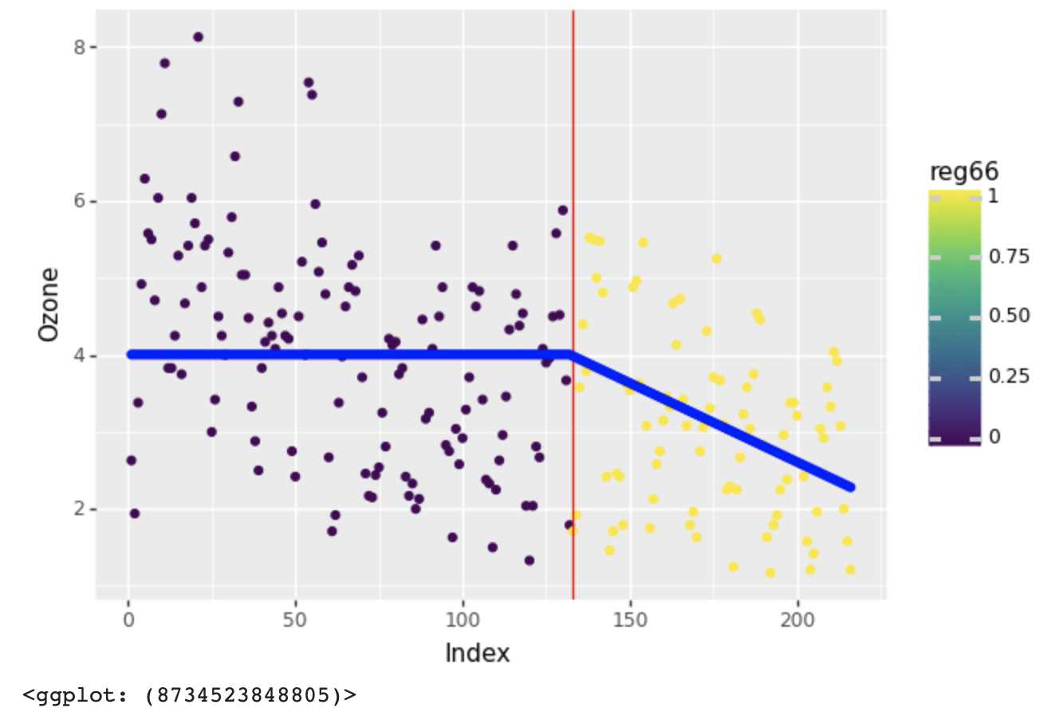

1. Abrupt change model for 1966 (2) Gradual change model for 1966

**Answer:**

**For Abrupt Change Model:** Since the p-value (0.00) < alpha (0.05), we conclude that the data provides statistically significant evidence that the special regulations for new car engines implemented in 1966 reduced the ozone pollution.

**For Gradual Change Model:** Since the p-value (0.00) < alpha (0.05), we conclude that the data provides statistically significant evidence that the special regulations for new car engines implemented in 1966

reduced the ozone pollution, **and the effect is gradual**.

Similar to the 1960 intervention, we think **the gradual effect of the intervention in 1966 is more appropriate** because the ozone concentration kept accumulating. Therefore, the effect of excessive ozone emissions and accumulation should be considered **incremental**.

1. Can you model both interventions, 1) the opening of the Golden State Freeway and the implementation of Rule 63 in 1966, and 2) the regulations for new car engines implemented in 1966 in one model? What is your final model with both interventions? What insights do you gain from such a model? 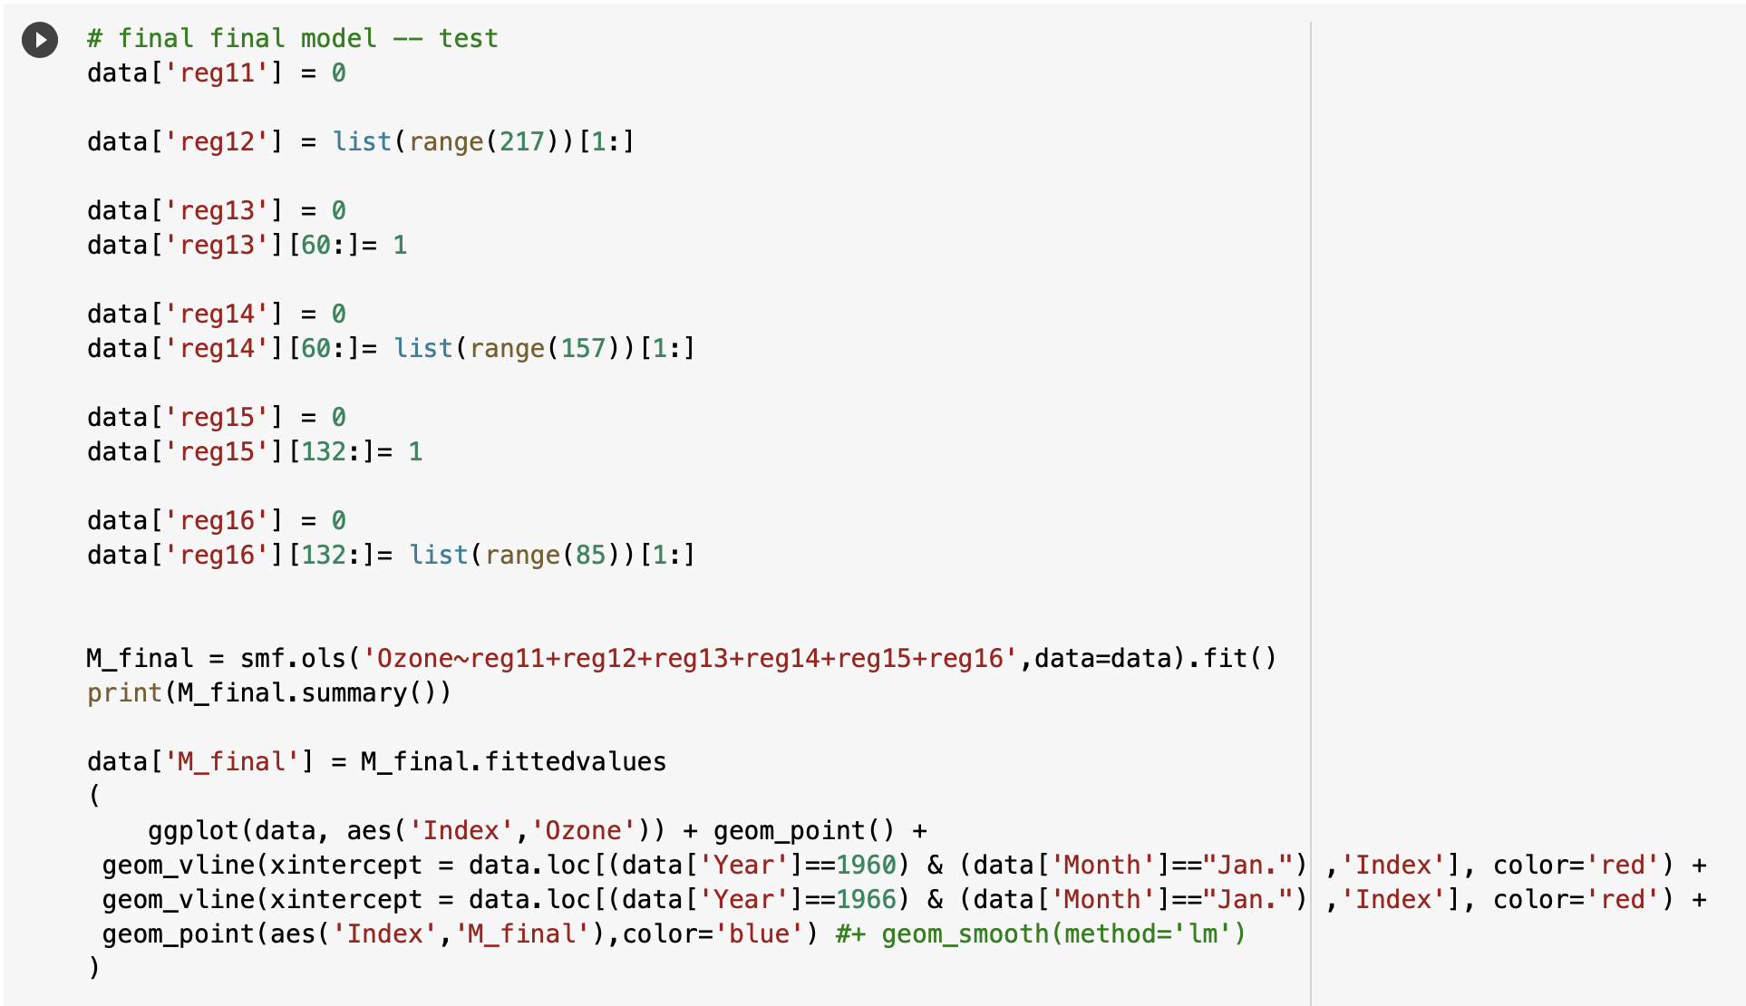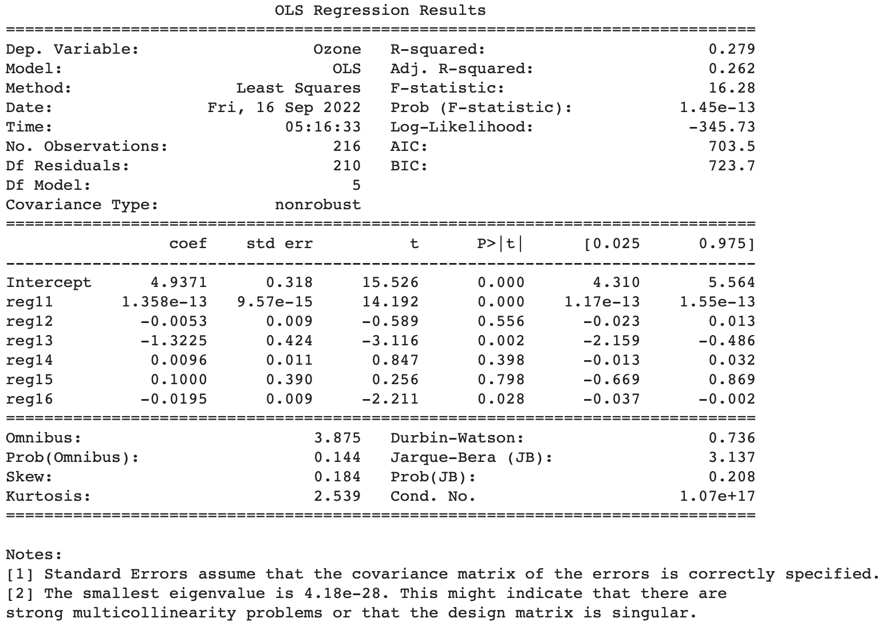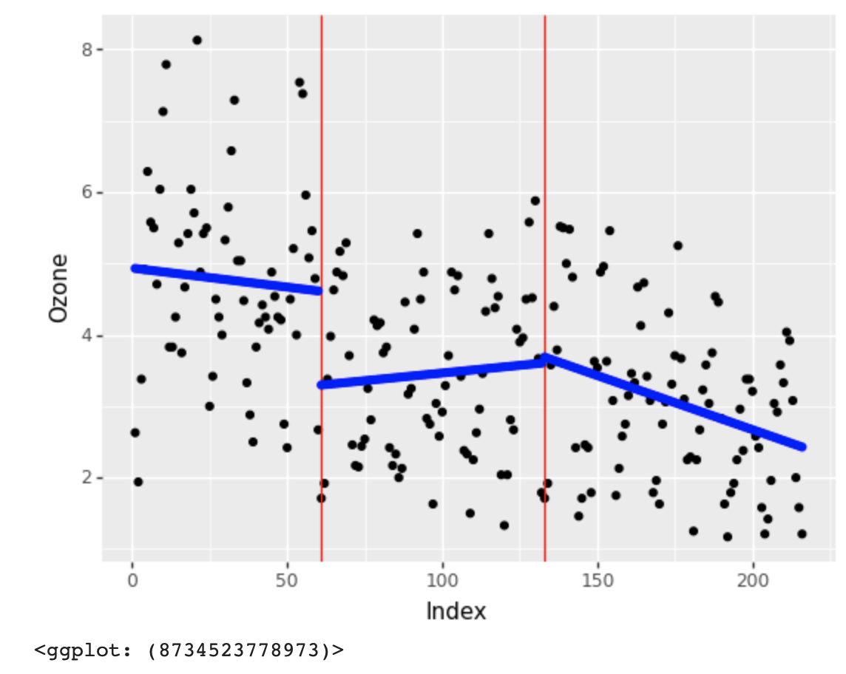

**Answer:**

*Not statistically significant interventions:*

*reg12: overall-gradual*

*reg14: 1960 intervention-gradual*

*reg15: 1966 intervention-abrupt*

There is no statistically significant evidence to prove the following interventions: the overall gradual effect, the gradul effect of the 1960 intervention, and the abrupt effect of the 1966 intervention.

From the graph above, we can see that both the implementation of Rule 63 in 1960 and the special regulations for new car engines implemented in 1966 decreased the level of ozone, especially as soon as they were in effect. However, we notice from the trendline that there is a minor increasing trend in the period of 1960-1966 (although the level of ozone was still lower than that before 1960). This slight rebounce could be caused by industrial development and increasing usage and employment of vehicles. From 1966, the new regulation for new cars mitigated the influence brought by increasing vehicle use, and the level of ozone decreased accordingly, which proves the effectiveness of the 1966 policy.