**HW #2**

Team:

1. First name: Joanna Last name: Ge
2. First name: Betty Last name: Sun
3. First name: Xinhui Last name: Yu
4. First name: Stella Last name: Zhou

**Instructions:** submit your 1) this word file, please put your non-code answers below each question, and 2) python code. Each student should submit both word and python code files. Students in one team can submit identical files. Pleas list your teammates in both word file and python code file.

**Case 2: Covid impact on Adidas and Nike**

**Data**: **Adidas.xlsx** and **Nike.xlsx** contain historical quarterly income statement information for two popular sportswear companies: Nike (US) and Adidas (German). The data was downloaded from S& P Capital IQ (available for free of charge for USC faculty and staff).

Bloomberg Business week magazine hired you to evaluate how covid effected Adidas and Nike gross profits. They expect you to **present your findings in one paragraph**. You may include one or two graphs.

Note that the covid impact on adidas and nike profit might not coincide with the official beaning and end of the covid period and may be reflected only a few quarters. By examining the data you should see that and model accordingly.

In your python code file please include all the code.

【Graph of Adidas】**We define the covid period as 2020 Q1--2021 Q1.**

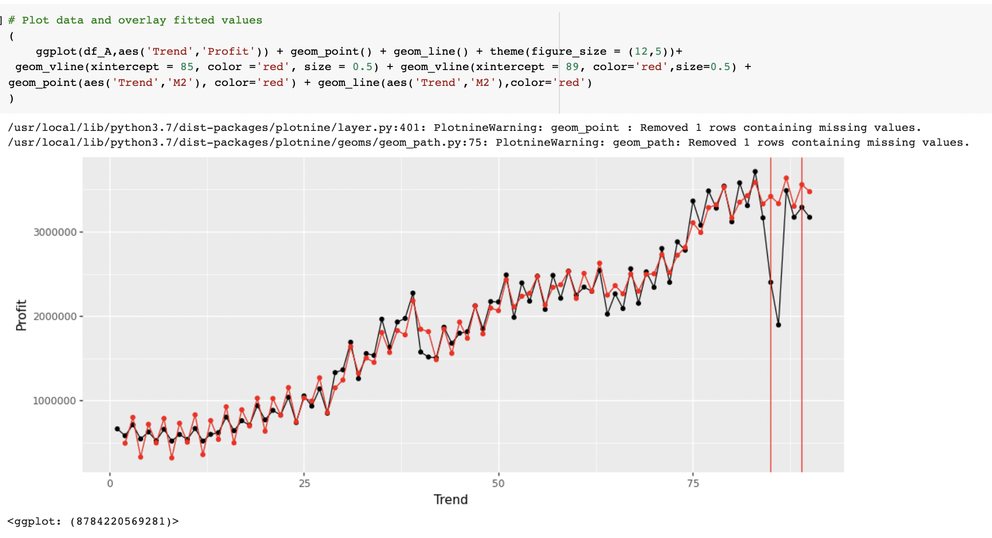

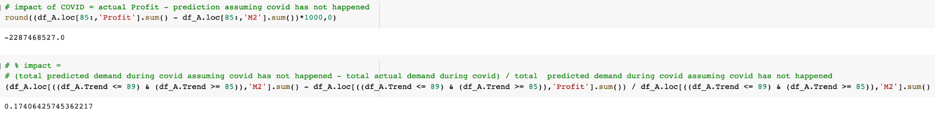

【Graph of Nike】**We define the covid period as 2020 FQ2--2021 FQ1.**

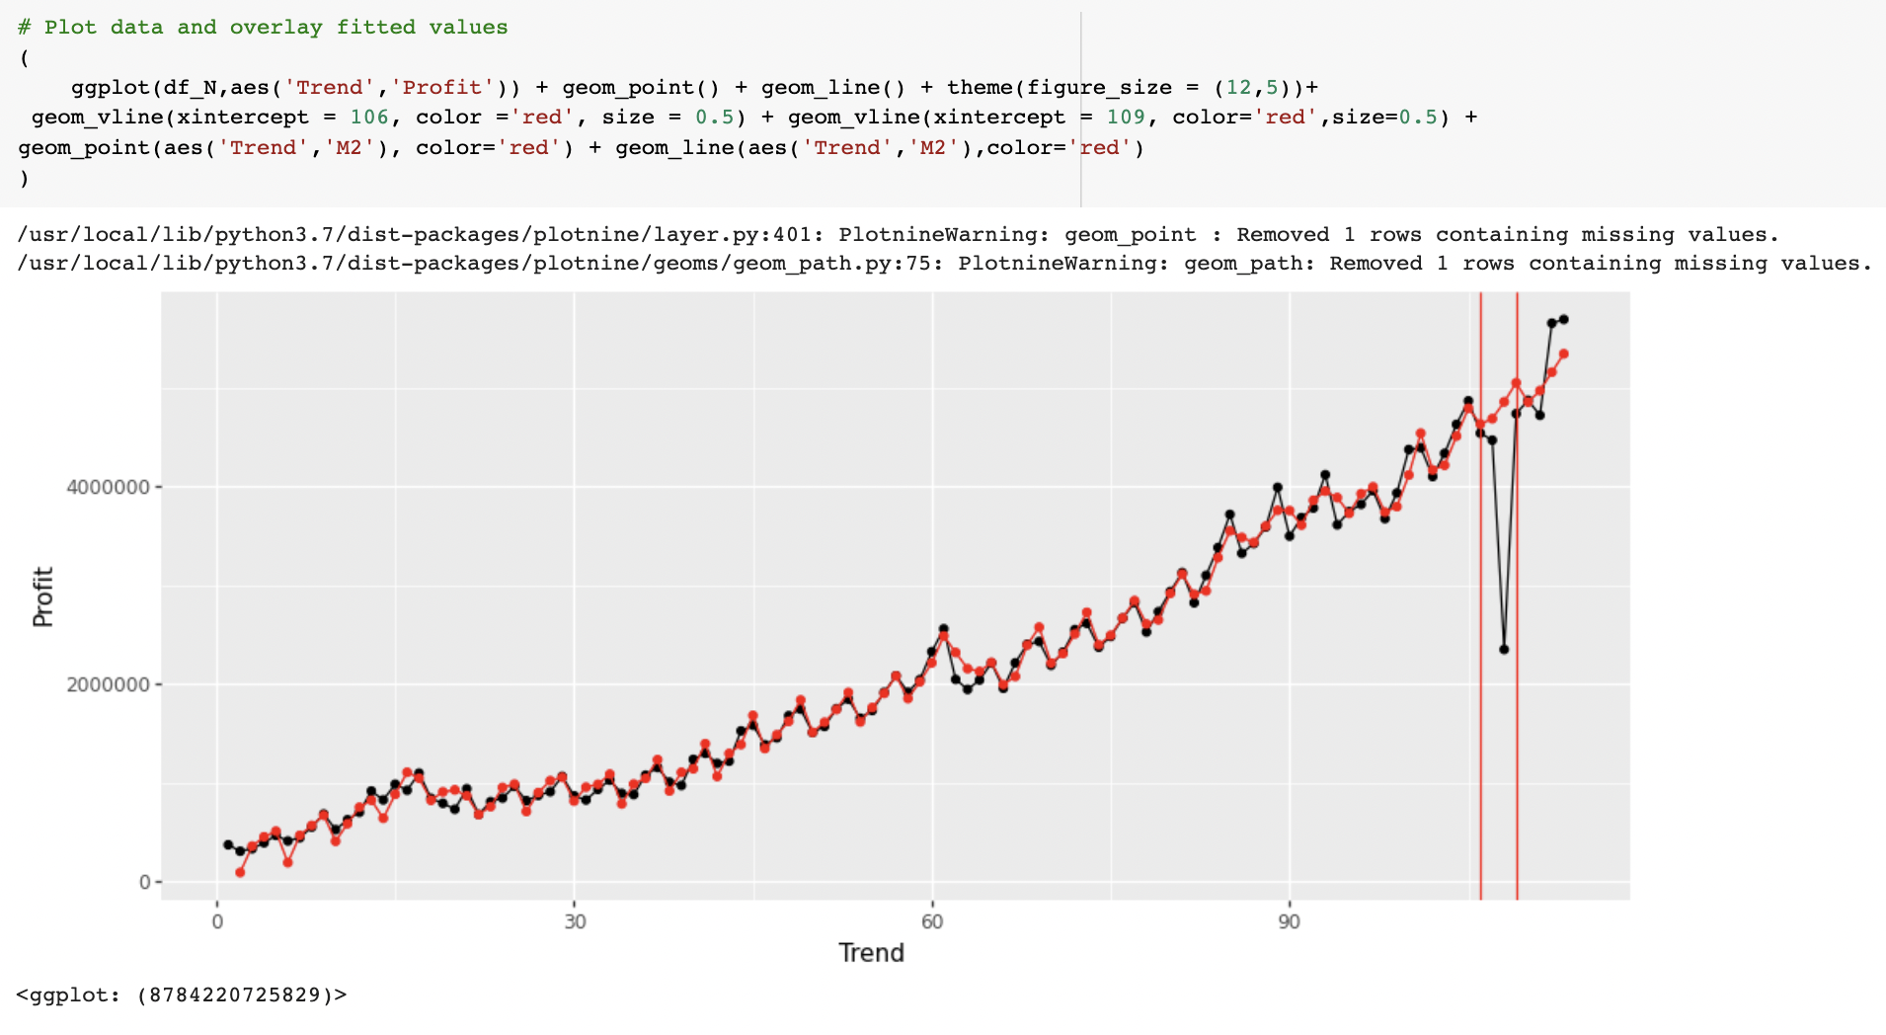

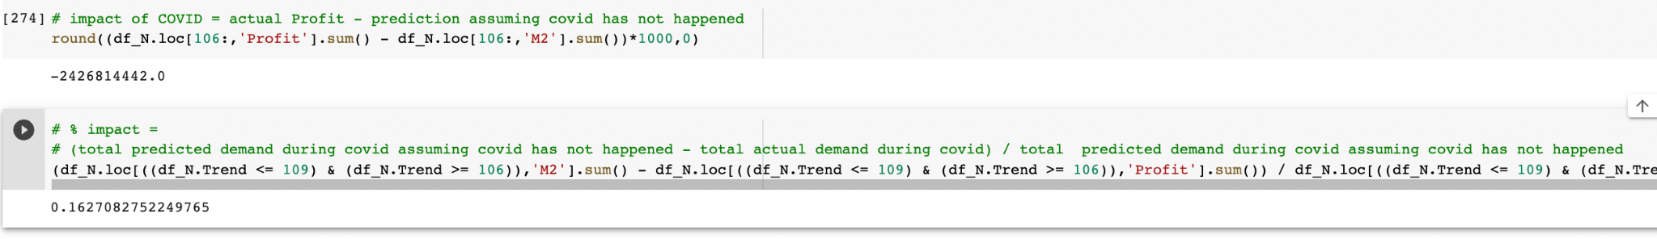

From both the graphs of Adidas and Nike, we can see sharp drops during the covid periods that we selected. Specifically, Adidas is observed to have had a drop from 2020 Q1 to 2021 Q1, and Nike experienced a profit drop from 2020 FQ2 to 2021 FQ1. Given the fact that Adidas has a fiscal year end on 12/31 while Nike has fiscal year end on 5/31, the covid period we selected for Adidas and Nike respectively refer to 2020/3-2021/3 and 2020/9-2021/9. Since Adidas’s data is from Germany and Nike’s data is from the US, the discrepancy in the selected covid periods also gives us insight that the sportswear market is impacted in Europe earlier than in North America.

As far as our modeling approach is concerned, we used Time Series Model for both datasets to predict average sales in each quarter. After plotting the systematic patterns we found the presence of seasonality, thus determining the models (colored red) as shown in the two graphs to be adequate representations.

From the predicted trend and actual sales of Adidas, we observe a large gap in profit branching from 2020 FQ2. From the analysis and calculations, we are able to conclude that covid had a huge impact on the profit of both companies. While the predicted profit remains high, the actual profit for Adidas in 2020 FQ3 had dropped down by $2,287,468,527, which was around 17.4% of the amount had covid not happened. A similar gap had occurred in Nike’s profit graph from 2020 FQ2 to 2021 FQ1, in which its profit had at most dropped by $2,426,814,442, which was around 16.3% of the amount had covid not happened.