**1. Why Preprocessing is Essential for Textual Data**

**The Problem with Raw Text**

Raw text data contains numerous elements that don't contribute to meaningful analysis:

* **Noise**: Punctuation, special characters, numbers
* **Inconsistency**: Different cases (uppercase/lowercase)
* **Common words**: Articles, prepositions that appear everywhere
* **Variations**: Same word in different forms (run, running, ran)

**Benefits of Preprocessing**

1. **Standardization**: Ensures consistent format across all text
2. **Noise Reduction**: Removes irrelevant characters and formatting
3. **Feature Quality**: Improves the quality of extracted features
4. **Computational Efficiency**: Reduces vocabulary size and processing time

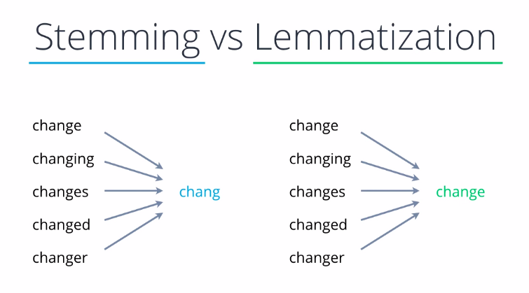**2. Stemming vs. Lemmatization**

**Stemming**

* **Definition**: Reduces words to their root form by removing suffixes
* **Method**: Uses rule-based algorithms (like Porter Stemmer)
* **Example**: "running" → "run", "better" → "better"
* **Pros**: Fast, simple
* **Cons**: May create non-words ("studies" → "studi")

**Lemmatization**

* **Definition**: Reduces words to their dictionary base form
* **Method**: Uses linguistic knowledge and dictionary
* **Example**: "running" → "run", "better" → "good"
* **Pros**: Produces real words, more accurate
* **Cons**: Slower, requires more resources

**3. Why Feature Extraction is Necessary**

**The Challenge**

Computers cannot directly process text - they need numerical representations. Raw text has:

* **High dimensionality**: Each unique word could be a feature
* **Sparsity**: Most words don't appear in most documents
* **No semantic understanding**: "good" and "excellent" are treated as completely different

**The Solution: Feature Vectors**

Feature extraction converts text into numerical vectors that:

* **Capture semantic meaning**: Similar texts have similar vectors
* **Enable mathematical operations**: Clustering, classification, similarity calculation
* **Reduce dimensionality**: From thousands of words to hundreds of features

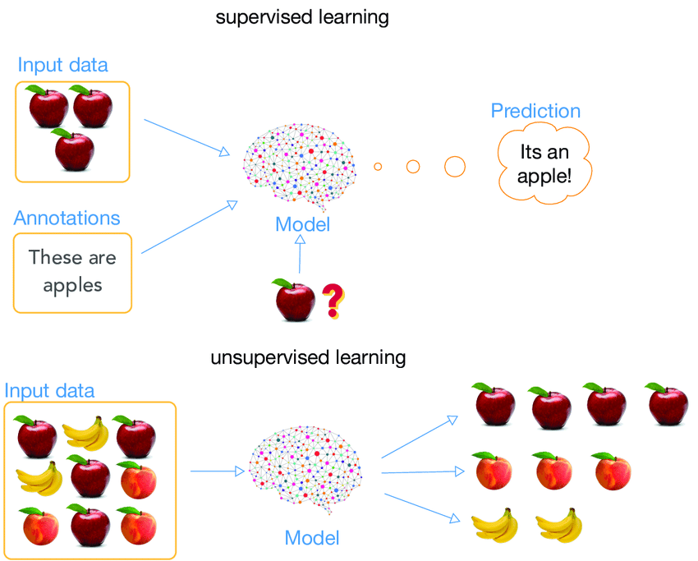**4. Supervised vs. Unsupervised Learning**

**Supervised Learning**

* **Definition**: Learning with labeled training data
* **Goal**: Predict labels for new data
* **Examples**: Classification, regression
* **Evaluation**: Compare predictions to true labels
* **Requirement**: Need labeled dataset

**Unsupervised Learning**

* **Definition**: Learning without labeled data
* **Goal**: Discover hidden patterns in data
* **Examples**: Clustering, dimensionality reduction
* **Evaluation**: Internal metrics (silhouette score)
* **Advantage**: No need for labeled data

**Comparison**

| **Aspect** | **Supervised** | **Unsupervised** |
| --- | --- | --- |
| Labels | Required | Not required |
| Goal | Prediction | Pattern discovery |
| Evaluation | External metrics | Internal metrics |
| Complexity | Generally easier | More challenging |

**5. Clustering Algorithms Explained**

**K-Means Clustering**

* **Principle**: Partitions data into K clusters by minimizing within-cluster variance
* **Algorithm**:
  1. Choose K cluster centers randomly
  2. Assign each point to nearest center
  3. Update centers to cluster centroids
  4. Repeat until convergence
* **Advantages**: Simple, fast, works well with spherical clusters
* 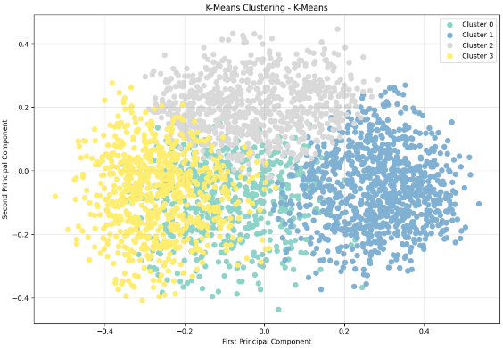**Disadvantages**: Need to specify K, assumes spherical clusters

**(Density-Based Spatial Clustering)**

* **Principle**: Groups points that are closely packed, marks outliers
* **Parameters**:
  + eps: Maximum distance between two samples
  + min_samples: Minimum number of samples in neighborhood
* **Advantages**: Finds clusters of arbitrary shape, identifies outliers
* **Disadvantages**: Sensitive to parameters, struggles with varying densities

**Hierarchical Clustering**

* **Principle**: Creates tree of clusters by merging or splitting
* **Types**:
  + **Agglomerative**: Bottom-up (merge clusters)
  + **Divisive**: Top-down (split clusters)
* **Advantages**: No need to specify number of clusters, creates hierarchy
* 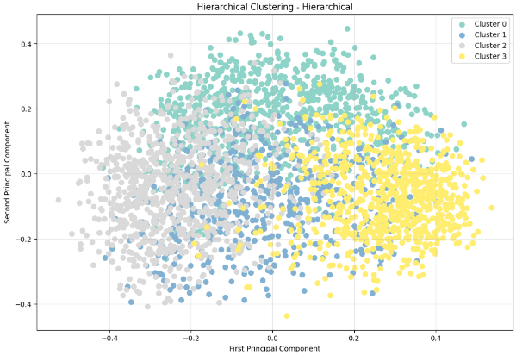**Disadvantages**: Computationally expensive, sensitive to noise

**6. Text Vectorization Methods**

**Bag of Words (BoW)**

* **Method**: Count frequency of each word
* **Pros**: Simple, interpretable
* **Cons**: Ignores word order, creates sparse vectors

**TF-IDF (Term Frequency-Inverse Document Frequency)**

* **Method**: Weighs terms by frequency and rarity
* **Formula**: TF-IDF = TF × log(N/DF)
* **Pros**: Reduces impact of common words
* **Cons**: Still sparse, no semantic understanding

**Word Embeddings (Word2Vec, GloVe)**

* **Method**: Dense vectors that capture semantic relationships
* **Pros**: Captures word relationships, dense vectors
* **Cons**: Fixed vocabulary, single vector per word

**Sentence Transformers**

* **Method**: Neural networks that create sentence-level embeddings
* **Pros**: Captures full sentence meaning, contextual understanding
* **Cons**: Computationally intensive, requires pre-training

**7. SentenceTransformers and all-MiniLM-L6-v2**

**SentenceTransformers Framework**

* **Purpose**: Create dense vector representations of sentences
* **Architecture**: Based on transformer models (BERT, RoBERTa)
* **Training**: Siamese networks with semantic similarity tasks
* **Output**: Fixed-size vectors (typically 384 or 768 dimensions)

**all-MiniLM-L6-v2 Model**

* **Type**: Lightweight transformer model
* **Architecture**: 6-layer MiniLM (distilled BERT)
* **Output Size**: 384 dimensions
* **Performance**: Good balance of speed and quality
* **Use Case**: Ideal for semantic similarity and clustering tasks

**8. Elbow Method for K-Means**

**Purpose**

Determine optimal number of clusters (K) for K-Means algorithm

**Method**

1. Run K-Means for different values of K (1 to max_k)
2. Calculate inertia (sum of squared distances from points to centroids)
3. Plot K vs. inertia
4. 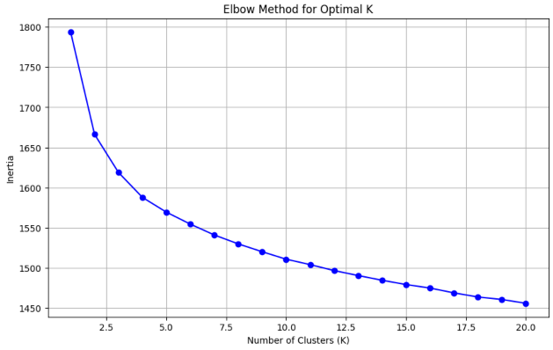Look for "elbow" point where inertia reduction slows

**Interpretation**

* **Sharp elbow**: Clear optimal K
* **Gradual curve**: Less clear, use domain knowledge
* **Multiple elbows**: Consider multiple valid K values

**9. Principal Component Analysis (PCA)**

**Purpose**

Reduce dimensionality while preserving most variance in data

**How It Works**

1. **Center the data**: Subtract mean from each feature
2. **Calculate covariance matrix**: Measure feature relationships
3. **Find eigenvectors**: Directions of maximum variance
4. **Project data**: Transform to new coordinate system

**Benefits**

* **Dimensionality reduction**: From hundreds to 2-3 dimensions
* **Visualization**: Can plot high-dimensional data
* **Noise reduction**: Focuses on main patterns

**Limitations**

* **Interpretability**: New dimensions are combinations of original features
* **Linear**: Cannot capture non-linear relationships
* **Information loss**: Some variance is always lost

**10. Evaluation Metrics**

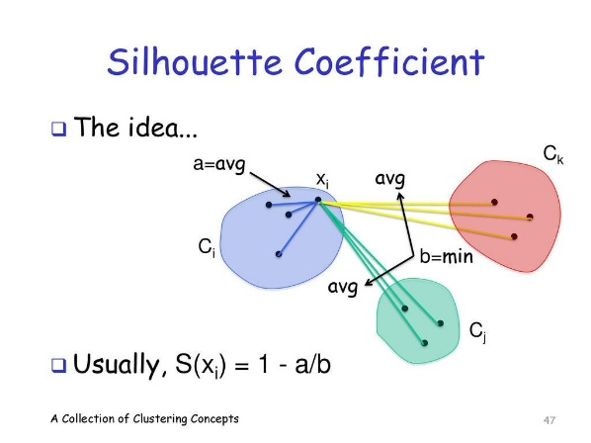**Silhouette Score**

* **Range**: -1 to 1
* **Interpretation**:
  + Close to 1: Well-separated clusters
  + Close to 0: Overlapping clusters
  + Close to -1: Incorrectly clustered
* **Calculation**: For each point, compare distance to own cluster vs. nearest cluster

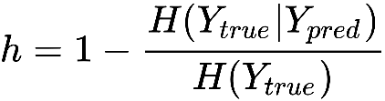**Homogeneity Score**

* **Range**: 0 to 1
* **Interpretation**: How pure are the clusters (if true labels known)
* **Calculation**: Based on conditional entropy
* **Note**: Requires ground truth labels (not available for our unsupervised task)

**Why Homogeneity Can't Be Used**

In our project, we don't have ground truth labels for song genres or themes. Homogeneity requires knowing the true cluster assignments, making it unsuitable for purely unsupervised clustering tasks.

KMeans Cluster Analysis and Interpretation

Based on the sample lyrics from each cluster, here's what your clustering algorithm has discovered:

**Cluster 0 (Size: 584) - Personal/Emotional Themes**

**Characteristics:**

* **Themes**: Personal struggles, relationships, inner thoughts
* **Language**: Conversational, introspective, emotional
* **Topics**: Marriage, therapy, personal growth, clarity, contemplation
* **Style**: Modern, relatable, everyday language

**Sample Analysis:**

* Sample 1: Relationship and personal struggles ("need therapy", "wan na marry")
* Sample 2: Change and contemplation ("time changing", "complicated contemplating")
* Sample 3: Inner growth and persistence ("place inside soul", "getting bigger")
* Sample 4: War/conflict themes (could be metaphorical for personal battles)

**Cluster 1 (Size: 934) - Hip-Hop/Rap Culture**

**Characteristics:**

* **Themes**: Party culture, street life, bragging rights, urban lifestyle
* **Language**: Slang, rap terminology, aggressive/confident tone
* **Topics**: Parties, MC culture, street credibility, rap battles
* **Style**: Rhythmic, urban vernacular, hip-hop specific references

**Sample Analysis:**

* Sample 1: Party culture ("party people", "MC icet", "syndicate")
* Sample 2: Street credibility and rap culture ("overdose overload", "rap visible")
* Sample 3: Confrontational/bragging ("acting brand new", "drunk dialin")
* Sample 4: Urban references ("magic johnson", "compton", street terminology)

**Cluster 2 (Size: 757) - Love/Romance/Pop Themes**

**Characteristics:**

* **Themes**: Love, relationships, longing, emotional connection
* **Language**: Romantic, tender, emotional, accessible
* **Topics**: Home, family, love, dreams, waiting for someone
* **Style**: Pop-oriented, mainstream appeal, emotional storytelling

**Sample Analysis:**

* Sample 1: Family and belonging ("home place roam", "mother sister brother")
* Sample 2: Romantic imagery ("wrap sky", "carve name", "beautiful impossible gift")
* Sample 3: Emotional pop themes ("used happy", "feel low", collaboration style)
* Sample 4: Classic love song themes ("waiting life", "dreamed holding tight")

**Cluster 3 (Size: 724) - Dark/Gothic/Metal Themes**

**Characteristics:**

* **Themes**: Darkness, death, existential dread, supernatural elements
* **Language**: Complex, poetic, metaphorical, intense
* **Topics**: Death, evil, spiritual darkness, societal criticism
* **Style**: Gothic, metal, alternative, philosophical

**Sample Analysis:**

* Sample 1: Supernatural/dark imagery ("shadow darkest realm", "spirit oblivion")
* Sample 2: Abstract/surreal themes ("blisswet air", "colourize pain")
* Sample 3: Mystical/spiritual elements ("tunnel worm dove", "thirteen moon temple")
* Sample 4: Social criticism and darkness ("hatred", "society blame", "bloodshed")

**Clustering Success Analysis**

**Why This Clustering Works Well:**

1. **Clear Thematic Separation**: Each cluster represents a distinct musical genre/theme
2. **Semantic Coherence**: Songs within each cluster share similar vocabulary and themes
3. **Balanced Distribution**: Clusters have reasonable sizes (584, 934, 757, 724)
4. **Genre Recognition**: The algorithm successfully identified major music genres

**Genre Mapping:**

* **Cluster 0**: Pop/Contemporary (Personal themes)
* **Cluster 1**: Hip-Hop/Rap (Urban culture)
* **Cluster 2**: Pop/Love Songs (Romantic themes)
* **Cluster 3**: Metal/Gothic/Alternative (Dark themes)

**Musical Genre Characteristics Captured**

**Lyrical Patterns Identified:**

| **Cluster** | **Genre** | **Key Indicators** | **Vocabulary Style** |
| --- | --- | --- | --- |
| 0 | Contemporary Pop | Personal pronouns, emotions | Conversational |
| 1 | Hip-Hop/Rap | Street slang, party references | Urban vernacular |
| 2 | Love/Romance | Relationship terms, tender language | Emotional, accessible |
| 3 | Metal/Gothic | Dark imagery, complex metaphors | Poetic, intense |

**Semantic Similarity Success:**

* **Within-cluster similarity**: High (songs share thematic content)
* **Between-cluster distinction**: Clear (different vocabularies and themes)
* **Cultural relevance**: Clusters align with real music genre

Hierarchical Cluster Analysis and Interpretation

**Cluster 0 (803 songs)**: Personal transformation and introspective themes

* Keywords: "change life," "exorcise demon," "memory," "dream"

**Cluster 1 (582 songs)**: Social commentary and rebellion

* Keywords: "imagination," "disease," "technology," "fight," "hatred"

**Cluster 2 (837 songs)**: Narrative and storytelling

* Keywords: "facade," "pillow dream," "strong horse," "beyond"

**Cluster 3 (777 songs)**: Hip-hop/rap style with lifestyle themes

* Keywords: "showbiz," "late night," "bill," "work," "money"