Formative Evaluation

We carried out our formative assessment in the early weeks of our project creation, having previously studied the iterative design process we believed that this was the best way to go about making our product. We split into three groups from which to create: a work flow diagram, user stories and user interface designs. These documents would all help us in the next stage of the iterative design process. We decided to use questionnaires and prototyping as the means of creating our initial designs, we sketched out initial drafts for the user interface, taking inspiration from existing similar software such as Microsoft Word and paint, our designs - which were limited in their detail, mirrored the limited understanding we had of the problem domain at the time.

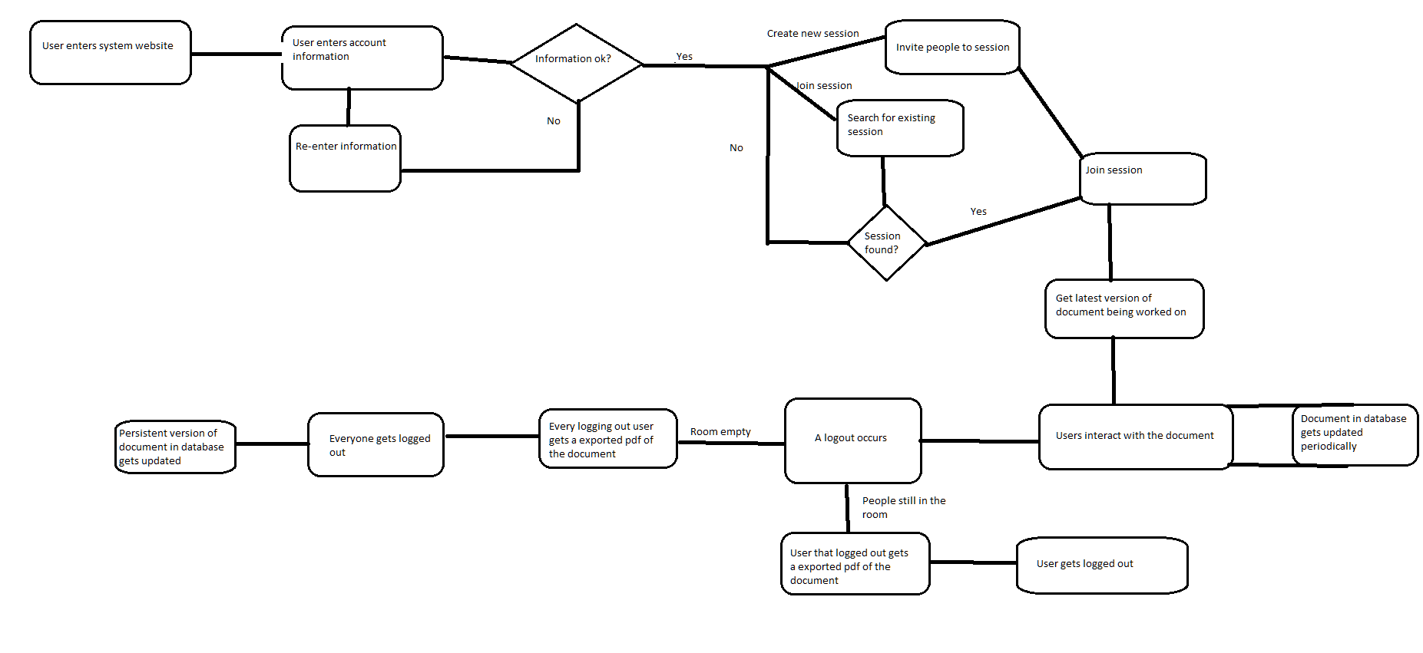
Work flow diagram

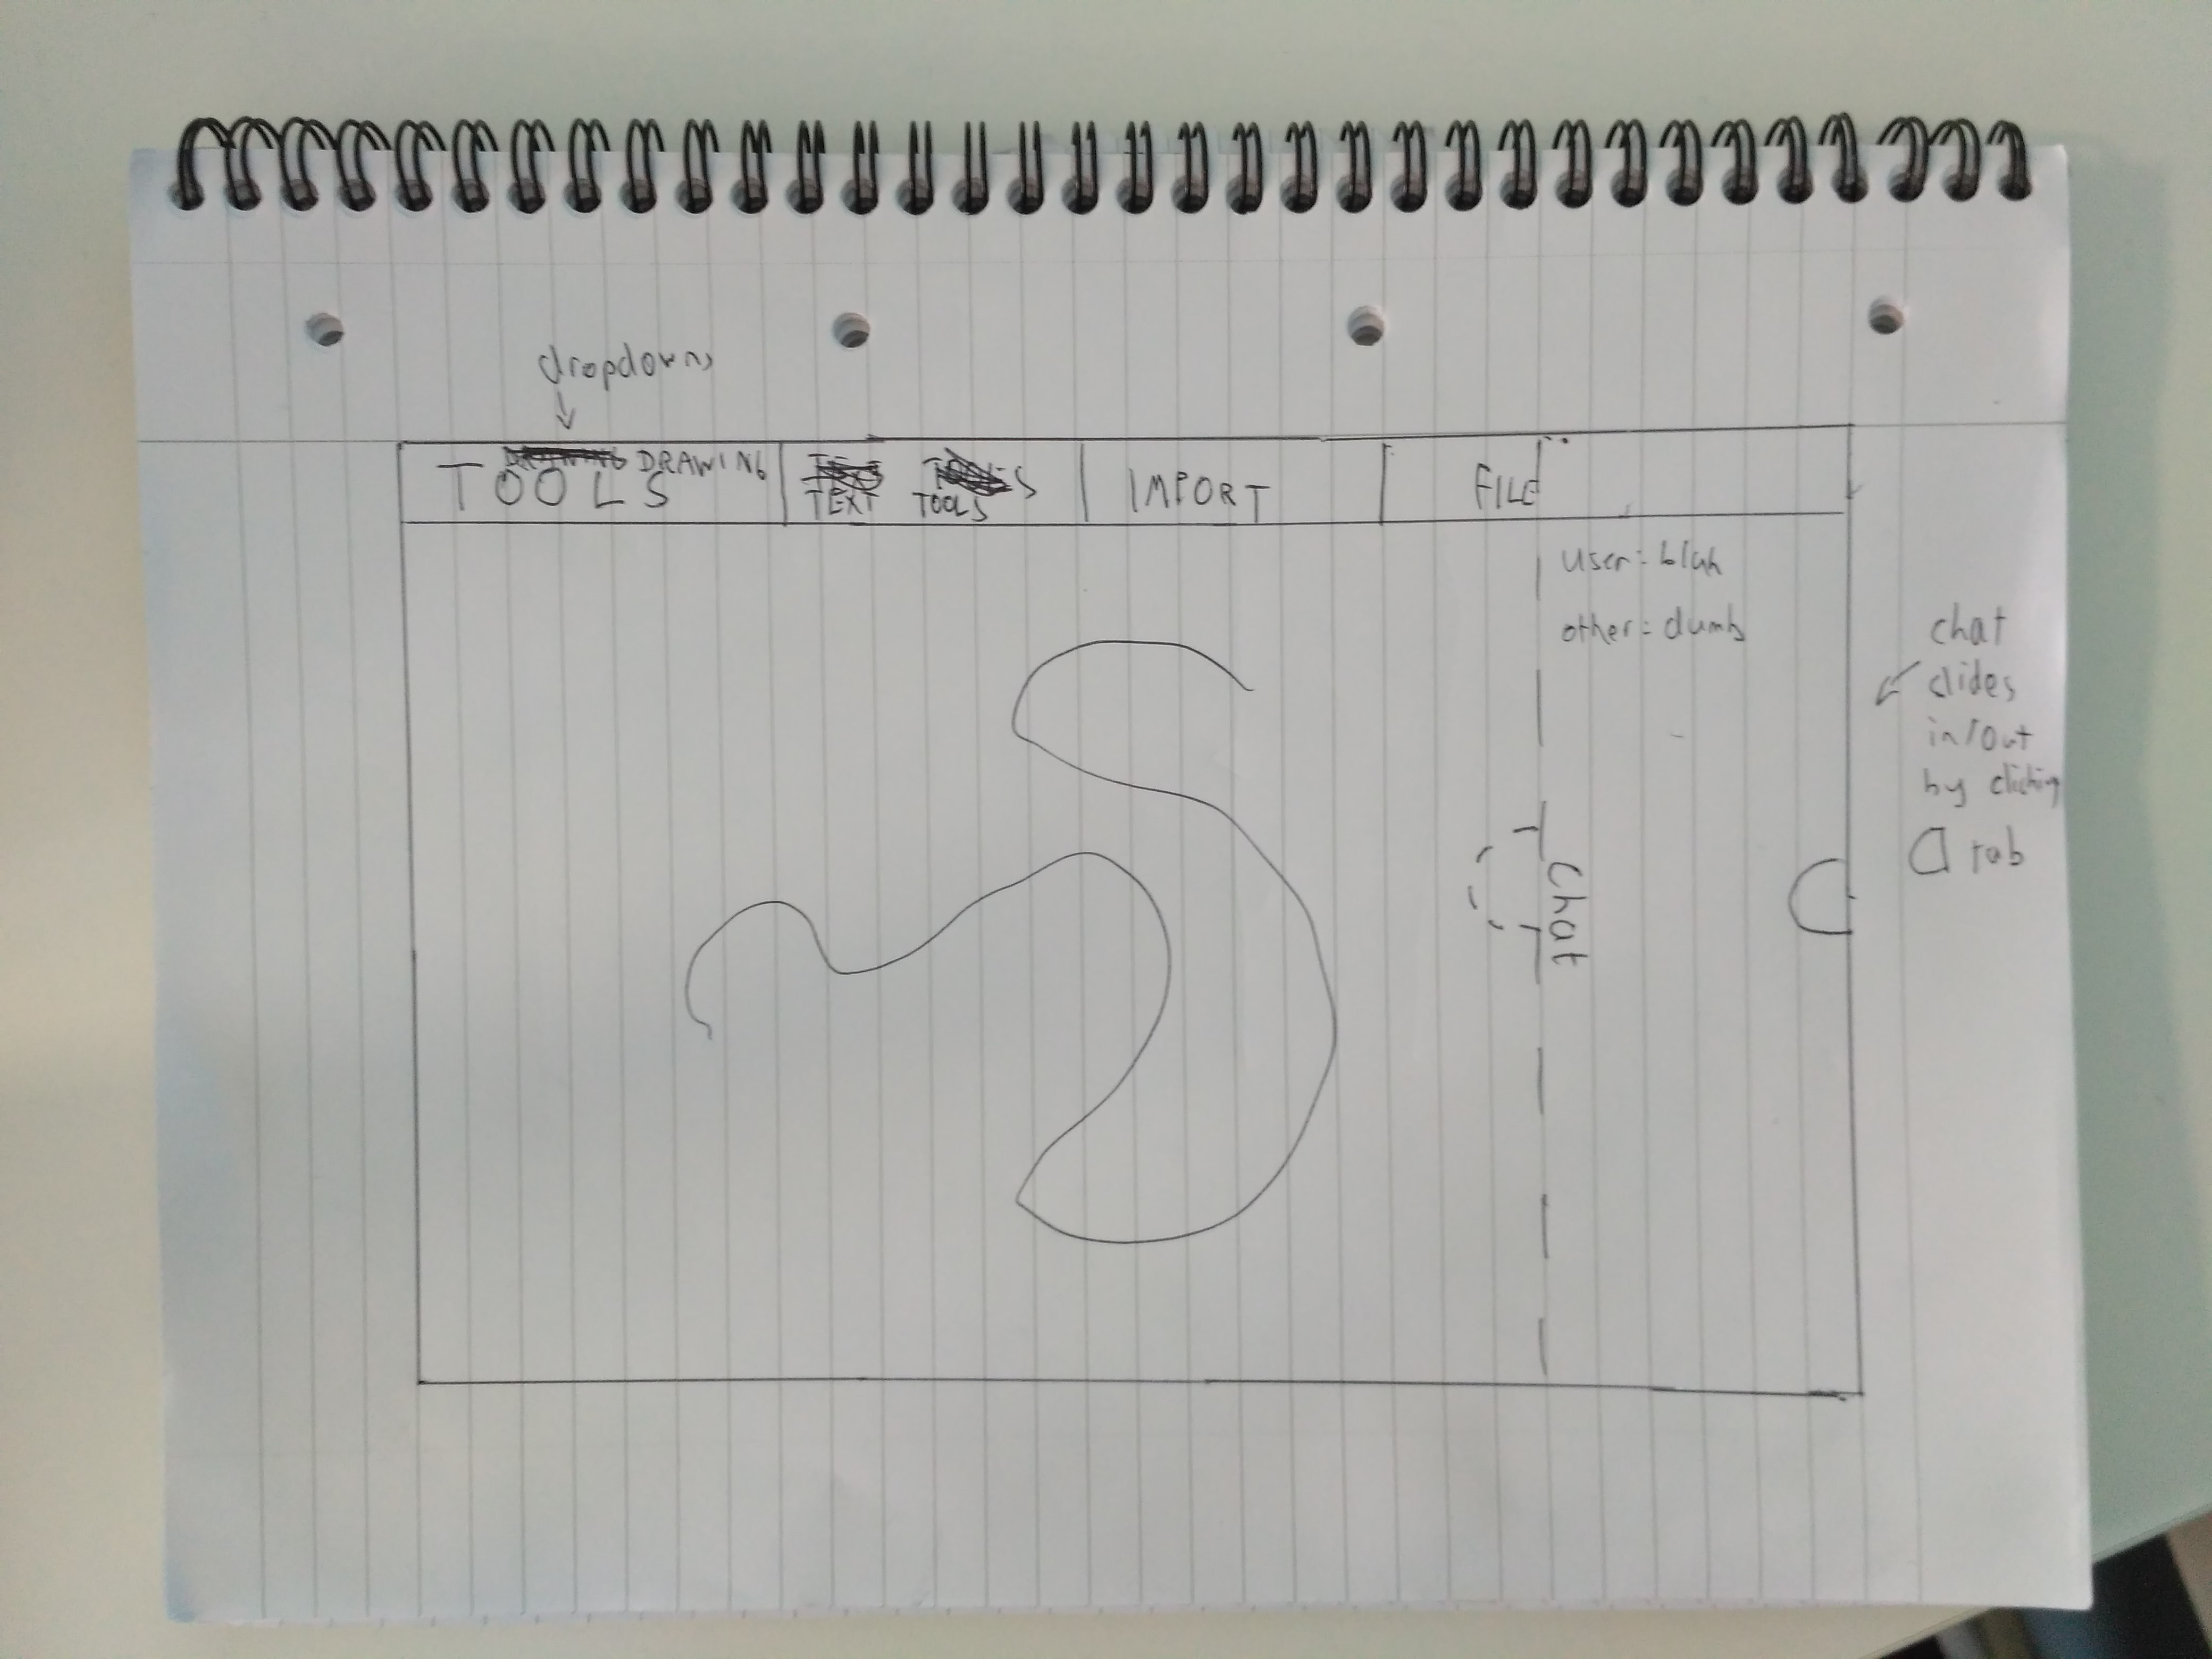

Initial user interface diagram.

The user stories and work-flow diagrams which were drafted however were much less ambiguous and provided a much more concrete understanding of the problem domain which we could all agree on. The work-flow diagram also gave us a better idea about the priority of some of the features which had been suggested, as it was apparent which features were extremely necessary to the meeting of our user requirements and which were less so. The document also brought to light features that had been suggested whose implementation would be infeasible – mainly due to expected time costs. Having all collaborated again and shared our ideas and their respective documents, we used this new understanding to draft our second user interface design, which again was far from perfect and we still had different ideas for the design but we soon settled these by referring to our user stories and work flow diagrams.

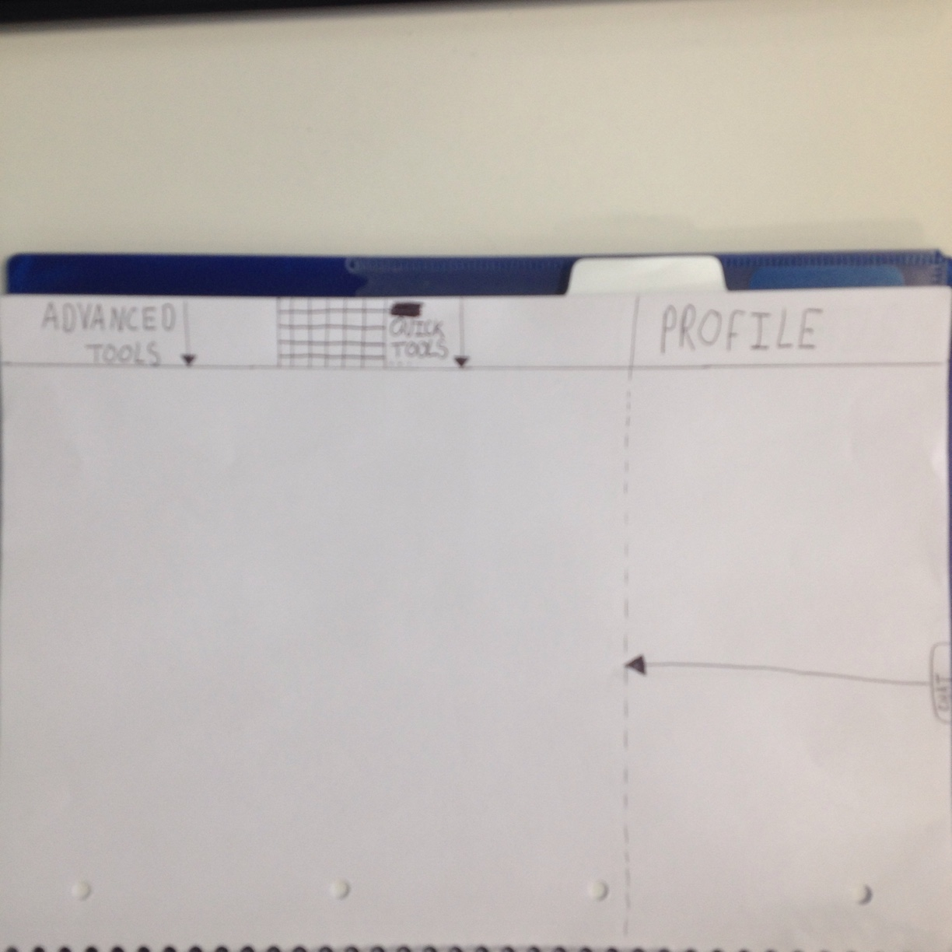

second user interface draft

From here we believed we had apt understanding of the task at hand to harness our second major tool used to be used in our formative evaluation process, our questionnaires. These would give us a much broader range of ideas as we could pool the thoughts of non-computer scientists, allowing us to consider various points of contention within the current drafts from a different angle as it was apparent that our ideas were all slightly polarised, possibly a result of us all being computer scientists thus thinking about the problem from a developer's point of view rather than a user's. For the design of the questionnaire we focused our thoughts on the main points of contention within the user interface design and those parts that weren't properly aligned with our user stories and work-flow diagrams. We settled on questions that we thought would up-root any underlying ambiguity within the problem domain so that it could be acted on, we also added questions we thought would settle any outstanding design disputes, such as whether our current choice of menus for the top of screen tool bar were suitable, needed renaming or expanding into multiple – more self explanatory menus. We came up with the following questions which we then distributed to friends/family.

Do you feel each menus purpose is made clear?
Would you feel confident creating a document with the menus and tools provided?
Should it be more clear what functions each menu is going to provide?
Should chat be a more persistent feature or is the current toggle state appropriate?
Do you feel there should be more variety in provided menus eg. a file menu or another tool menu
What is intuitive to change project settings?
Are there any features missing that you might have expected from an application such as this?

Having collected the data from these questionnaires we then reconvened, then discussed and shared our answers, the questionnaires proved to be very informative as we now felt comfortable in expanding our design, without having to worry about issues that were previously stunting the development process. We could also consider ideas put forwards by our test subjects that we had not even conceived. We found the questionnaire participants found no apparent issues with the purpose of the menu's however they expressed concerns regarding the naming of the menu's – relating to how uninformative they believed them to be and how they would be more helpful if menu's such as quick tools and advanced tools were condensed into one. Some participants also expressed their desire to be able to see who is online at any given time within the chat screen. Having discussed these suggestions we felt confident enough to draft up our third and final user interface prototype, as well as some simplistic login, registration and project management screens. We incorporated some of these new suggested features within our design, this new low-fidelity prototype would be suitable as a template to use for designing our high fidelity prototype.
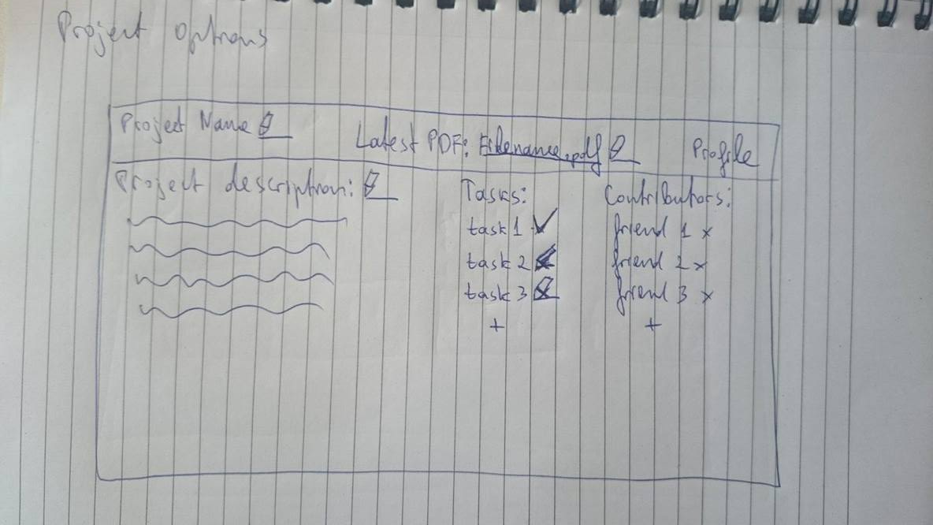
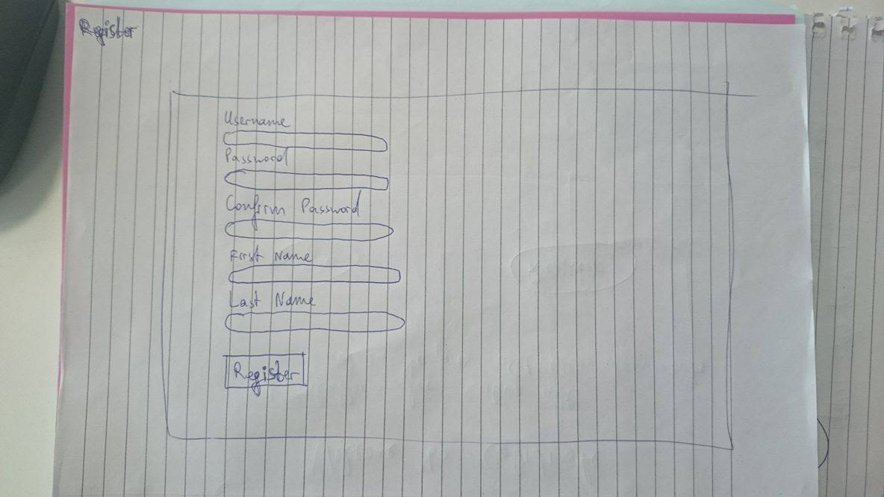
Register-view prototype
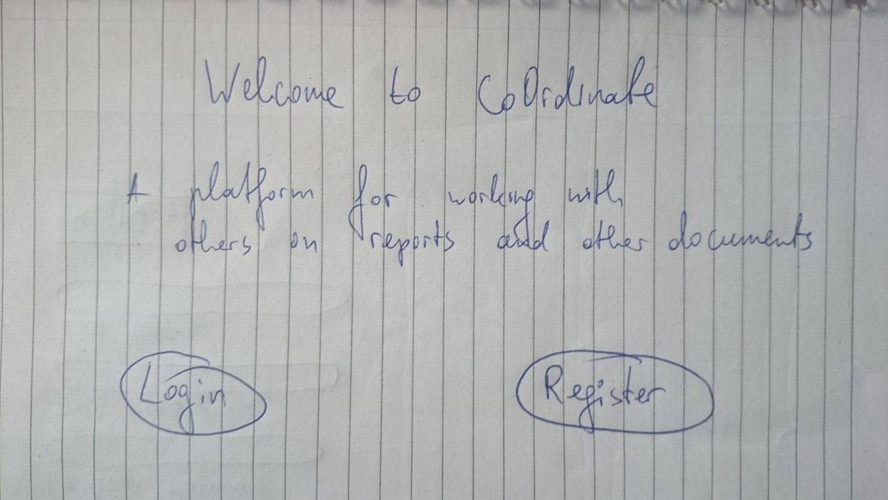
Initial login screen prototype
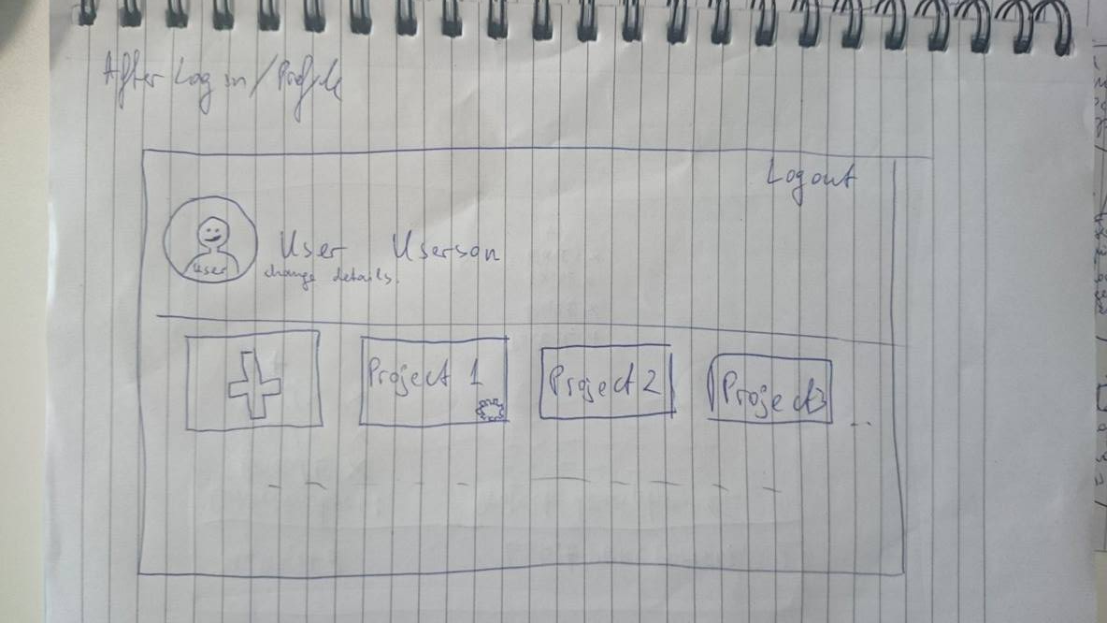
Final main-view paper prototype

