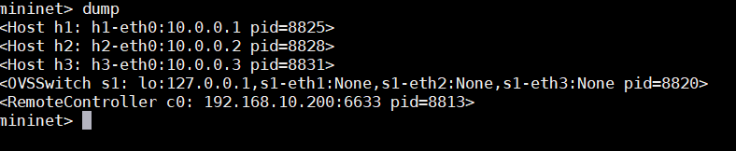



192.168.10.241

sudo mn -x --mac --topo linear,4 --link=tc,bw=10,delay=10ms --controller=remote,ip=192.168.10.200,port=6653 --switch ovsk,protocols=OpenFlow13

Sudo apt-get install openssh-server

sudo apt-get install git

sudo apt install firefox

sudo apt-get install -y unzip

sudo apt-get install curl

sudo apt-get install wireshark

sudo apt-get install tree

sudo apt-get install apache2

sudo apt-get install x264

sudo apt-get install gpac

1. git clone <https://github.com/mininet/mininet>

2. cd mininet && git fetch

3. git tag

4. git checkout -b mininet-<<version of your choice from git tag>>. For example, -b mininet-2.3.0 2.3.0 (Mininet Version 2.3) -stable most most version

5. sudo apt-get update && sudo apt-get upgrade

6. sudo nano util/install.sh

7. change one line script from "git clone git://github.com/mininet/openflow" to "git clone <https://github.com/mininet/openflow>"

8. cd out of mininet

9. mininet/util/install.sh -nfv (Only clones and installs OpenFlow Reference and Open vSwitch and also it installs Mininet)

Sudo -i

test -f .Xauthority && mv .Xauthority .Xauthority.bak

cp -a /home/mininet/.Xauthority .Xauthority

chown root: .Xauthority

XAUTHORITY=/root/.Xauthority sudo firefox

sudo apt-get update && sudo apt-get upgrade

sudo apt update

cd /var/www/html

sudo wget 10.224.41.8/bbb/dashjs.zip

Make sure to do the XAuthority stuff in root, if Authority goes missing and turns to .bak then just use mininet/util/install.sh -nfv to reinstall it.

