A Method article prepared for Ecology Letters

A robust and readily implementable method for the meta-analysis of response ratios with and without missing standard deviations
Shinichi Nakagawa*¹, Daniel W. A. Noble², Malgorzata Lagisz¹, Rebecca Spake³, Wolfgang Viechtbauer⁴ & Alistair M. Senior*⁵
Address:
¹ Evolution & Ecology Research Centre and School of Biological, Earth and Environmental Sciences, University of New South Wales, Sydney, NSW 2052, Australia
² Division of Ecology and Evolution, Research School of Biology, The Australian National University, Canberra, ACT, Australia
³ School of Biological Sciences, University of Reading, Whiteknights Campus, Reading RG6 6AS, UK
⁴ Department of Psychiatry and Neuropsychology, School for Mental Health and Neuroscience, Faculty of Health, Medicine, and Life Sciences, Maastricht University, 6200 MD Maastricht, The Netherlands
⁵ Charles Perkins Centre and School of Life and Environmental Sciences, University of Sydney, Camperdown, NSW 2006, Australia.

Running head: Improved meta-analyses of the response ratio
* Correspondence: Shinichi Nakagawa (s.nakagawa@unsw.edu.au); Alistair M. Senior (alistair.senior@Sydney.edu.au)

Abstract
The log response ratio, lnRR, is the most frequently used effect size statistic in ecology. However, missing standard deviations (SDs) are often present in meta-analytic datasets, preventing us from obtaining sampling variance for lnRR. We propose three new methods to deal with missing SDs. All the three methods use the square of the average coefficient of variation CV² to obtain sampling variances for lnRR when SD is missing. We propose three new methods that use the square of the average coefficient of variation CV to obtain sampling variances, when SDs are missing. Using simulation, the use of the average CV to estimate the sampling variances for all observations, regardless of missingness, performs best. Surprisingly, even where SDs are missing, this simple method has less bias than the conventional analysis with no missing SDs. We recommend all future meta-analyses of lnRR employ this new method along with sensitivity analysis.

KEYWORDS
Missing data, multiple imputation, meta-regression, robust variance estimation, research synthesis

INTRODUCTION
Meta-analyses are frequently used to quantitatively synthesise the outcomes of ecological studies and explain inconsistencies among study findings (Nakagawa et al. 2015; Gurevitch et al. 2018). However, incomplete reporting of necessary data in the primary literature threatens the validity of meta-analytic evidence. Specifically, many empirical papers fail to report standard deviations (SDs) or their derivatives, such as standard errors (SEs) and confidence intervals (CIs). SDs are required to calculate effect sizes and/or their precision for comparing means between two groups in ecological meta-analyses: standardised mean difference, SMD (well-known estimators include Cohen’s d and Hedges’ g) and the natural logarithm of response ratio, lnRR (Hedges et al. 1999). A recent review of 505 ecological meta-analytic studies showed nearly 70% of the datasets included studies with missing SDs (Kambach et al. 2020). The same review also showed that many meta-analyses did not use studies with missing SDs and performed complete-case meta-analysis. Using simulations, they also demonstrated that excluding studies with missing data could both upwardly and downwardly bias meta-analytic results, and that multiple imputation (MI) of missing SDs (and also sample sizes) was an effective means of providing unbiased meta-analytic results.

Multiple imputation, MI was introduced to ecologists more than a decade ago (Nakagawa & Freckleton 2008). However, there has been limited uptake of this method in ecological meta-analysis (cf. Ellington et al. 2015; Kambach et al. 2020). There are, we believe, two major reasons for this slow uptake. First, for many ecologists, the implementation of MI might be considered tedious, perhaps because it involves three steps: 1) creating multiple datasets with imputed missing data, e.g., N_{dataset} = 100 with all missing SD data imputed, 2) analysing each dataset separately, and 3) aggregating parameter estimates, i.e., regression coeffects to get unbiased estimates using Rubin’s rules (Rubin 1987) (for details, see Nakagawa 2015; van Buuren 2018). Second, there may be uncertainty around its implementation to complex models applied to ecological datasets. For example, it is unclear if Rubin’s rules are always appropriate for aggregating variance components and related quantities (e.g., I² and R²) and information criteria (e.g., AIC, BIC; cf. Nakagawa & Freckleton 2011). Furthermore, MI cannot be easily implemented for multilevel (mixed-effects / hierarchical) models unless they have only two levels (i.e. one random factor) (van Buuren 2018). Therefore, the use of MI for meta-analytic studies using multilevel models is still seldom applied, reenforcing age-old approaches of excluding studies (observations) with missing SDs.

Here, we propose alternatives to MI for handling studies with missing SDs in meta-analyses that use lnRR (Nakagawa & Santos 2012; Koricheva & Gurevitch 2014; Kambach et al. 2020). We introduce three new methods to deal with missing SDs in a multilevel meta-analytic model as well as traditional random-effects models. First, we introduce a method developed by Doncaster and Spake (2018) that uses an adjusted sampling variance formula for lnRR values. We, then, improve and extend this approach for missing SDs; we provide two procedures within this method: only using this adjustment method for effect sizes with missing SD (Method 1A), and using this adjustment method for all effect sizes regardless of missingness (Method 1B). Second, we describe a method which extends traditional weighted regression (Method 2). Next, we combine these two methods to provide a hybrid method (Method 3). We conduct a simulation study to compare these methods to the control method (a standard meta-analytic procedure without missing SDs) and show that Method 1B performs best. Surprisingly, for many cases, Method 1B (and Method 2) with missing SDs outperforms the control method without missing SDs (i.e., full data analysis). We make recommendations for future meta-analyses accordingly. Importantly, we illustrate these new methods using the widely used R package, metafor (all relevant data and code are available at a Github repository; see below).

NEW STATISTICAL METHODS

Estimating sampling variances prior to meta-analysis: Method 1A and 1B
The effect size statistic, lnRR was first proposed by Hedges and colleagues (1999) as follows:
$$\text{lnRR}=\text{ln}\left(\frac{m_{1}}{m_{2}}\right), (1)$$
$$v\left(\text{lnRR}\right)=\frac{sd_{1}^{2}}{n_{1}m_{1}^{2}}+\frac{sd_{2}^{2}}{n_{2}m_{2}^{2}}=\frac{{\text{CV}}_{1}^{2}}{n_{1}}+\frac{{\text{CV}}_{2}^{2}}{n_{2}}, (2)$$
where m₁ and m₂ is the mean of group 1 and group 2, respectively (e.g., experimental and control groups), v represents the sampling variance, sd and n is the SD and sample sizes, respectively, and CV (sd/m) is the coefficient of variation.

Using simulation, Doncaster and Spake (2018) showed that when n is small (n = 3–10 observations, meaning n₁ + n₂ = 6–20), the sampling variance of lnRR using Equation 2 is underestimated by 15–20%, with consequences for the accuracy and precision of the overall meta-analytic mean estimate. This is because when sample sizes are small, SDs themselves can be underestimated (in Equation 2). To correct for this bias, they proposed the following adjustment to the sampling variance for lnRR, instead of Equation 2:
$$v^{*}\left(ln\text{RR}\right)=\frac{\sum_{i=1}^{N_{study}}{\left({\text{CV}}_{1i}^{2}\right)}/N_{study}}{n_{1}}+\frac{\sum_{i=1}^{N_{study}}{\left({\text{CV}}_{2i}^{2}\right)}/N_{study}}{n_{2}}, (3)$$
where ${\text{CV}}_{1i}^{2}$ and ${\text{CV}}_{2i}^{2}$ are from the ith effect size (study; i = 1, 2, …, N_{study} = N_{effect-size}, as we assume N_{study} is independent). This formula uses the cross-study average of CV² rather than study-wise CV², which are vulnerable to underestimation when sample sizes are small. Doncaster and Spake (2018) demonstrated that the use of Equation 3 substantially reduced the bias in sampling variance, improving the overall (meta-analytic) mean estimate. This seems intuitive because when SD is poorly estimated, the average CV (or CV²) may well be a good substitution assuming CV stays fairly constant (cf. Nakagawa et al. 2015). Notably, Doncaster and Spake also suggested this formula could be used when SDs are missing from some studies, although this possibility was not statistically investigated.

Here we propose two improvements to Equation 3. Using simulations, Lajeunesse (2015) showed that Equation 1 and 2 are both biased when sample sizes are small to moderate, and proposed the following estimators – based on the second-order Taylor expansion – can reduce these biases (see also Senior et al. 2020):
$$\text{lnRR}=\text{ln}\left(\frac{m_{1}}{m_{2}}\right)+\frac{1}{2}\left(\frac{{\text{CV}}_{1}^{2}}{n_{1}}-\frac{{\text{CV}}_{2}^{2}}{n_{2}}\right), (4)$$
$$v\left(\text{lnRR}\right)=\frac{{\text{CV}}_{1}^{2}}{n_{1}}+\frac{{\text{CV}}_{2}^{2}}{n_{2}}+\frac{{\text{CV}}_{1}^{4}}{2n_{1}^{2}}+\frac{{\text{CV}}_{2}^{4}}{2n_{2}^{2}}. (5)$$
Therefore, Equation 3 can be further improved including extra-terms in Equation 5. Also, rather than using the average CV², we can use the square of the weighted average of CV for both point estimate and sampling variance as follows:
$$ln\text{RR}=ln\left(\frac{m_{1}}{m_{2}}\right)+\frac{1}{2}\left(\frac{{\left[\sum_{i=1}^{k}{\left(n_{1i}{\text{CV}}_{1i}\right)}/n_{1i}\right]}^{2}}{n_{1}}-\frac{{\left[\sum_{i=1}^{k}{\left(n_{2i}{\text{CV}}_{2i}\right)}/n_{2i}\right]}^{2}}{n_{2}}\right) (6)$$
$$\tilde{v}\left(ln\text{RR}\right)=\frac{{\left[\frac{\sum_{i=1}^{k}{\left(n_{1i}{\text{CV}}_{1i}\right)}}{n_{1i}}\right]}^{2}}{n_{1}}+\frac{{\left[\frac{\sum_{i=1}^{k}{\left(n_{1i}{\text{CV}}_{2i}\right)}}{n_{2i}}\right]}^{2}}{n_{2}}+$$
$$\frac{{\left[\sum_{i=1}^{k}{\left(n_{1i}{\text{CV}}_{1i}\right)}/n_{1i}\right]}^{2}}{2n_{1}^{2}}+\frac{{\left[\sum_{i=1}^{k}{\left(n_{2i}{\text{CV}}_{2i}\right)}/n_{2i}\right]}^{2}}{2n_{2}^{2}}, (7)$$

One can use Equation 7 (along with Equation 6) where SDs are missing, because the weighted cross-study CV can substitute missing SDs, allowing the inclusion of these studies in meta-analyses (Method 1A; a mixture of Equations 4-7). Alternatively, one may use Equation 7 throughout regardless of the missingness of SDs (Method 1B with Equation 6 & 7). Note we provide the reason why we use the square of weighted average of CV (Equation 6 & 7) rather than weighted average of CV² in a later section (‘The accuracy and limitation of lnRR’).

Using weighted-regression-like method: Method 2
In the absence of SDs, it has been suggested that information on sample sizes, which are commonly available, can be used to approximate the sampling variances in meta-analyses of lnRR or SMD, using the inverse of the following (e.g., Lajeunesse 2013; Kambach et al. 2020):
$$\tilde{n}=\frac{n_{1}n_{2}}{n_{1}+n_{2}}. (8)$$
However, treating Equation 8 as an estimate of the ‘exact’ sampling variance is erroneous, because it ignores other terms in Equation 2 & 5 (i.e., mean and SD) (see the review by Kambach et al. 2020). A more realistic assumption is to treat 1/$\tilde{n}$ as proportional to the sampling error; indeed, Equation 2 reduces to the inverse of Equation 8 when we set both CVs to 1. Weighted regression models, commonly used to correct for heteroscedasticity, make this assumption of proportionality, unlike the classical random-effects meta-analytical model, which assumes the exact sampling variance is known. Many ecologists are likely to be familiar with weighted regression models that specify sample sizes as the weights (Fletcher & Dixon 2012).

The simplest random-effects meta-analytic model using lnRR can be written as follows:
$${lnRR}_{i}=β_{0}+s_{i}+m_{i}, (9)$$
$$s_{i}∼N(0,σ_{s}^{2}),{ m}_{i}∼N(0,v_{i}),$$
where $β_{0}$ is the overall estimate (or meta-analytic mean); s_{i} is the between-study effect for the ith effect size, normally distributed with a mean of zero and a variance of $σ_{s}^{2}$ (sometimes, referred to as $τ^{2}$), m_{i} is the sampling error for the ith effect size, distributed with the ith sampling variance (note that i = 1, 2, …, N_{effect-size}, the number of effect sizes = N_{study}, the number of studies). As mentioned earlier, we here assume that the sample variance of lnRR is known; that is, we use either Equation 2 or 5 is equal to the true sampling variances ($v_{i}$) in Equation 9. the ratio between $σ_{s}^{2}$ and the total variance is often used to quantify heterogeneity (I²):
$$I^{2}=\frac{σ_{s}^{2}}{σ_{s}^{2}+\overset{‾}{v}}, (10)$$
where $\overset{‾}{v}$ is known as a ‘typical’ (or ‘average’) sampling variance (originally referred to as ‘typical within-study variance’; sensu Higgins & Thompson 2002), which can be estimated in several ways (Xiong et al. 2010).

Unlike the meta-analytic model, in a weighted regression, the following is assumed:
$$v_{i}=ϕ\left(\frac{1}{{\tilde{n}}_{i}}\right), (11)$$
where $ϕ$, which is estimated by the model, functions as a multiplicative parameter fulfilling the assumption of proportionality (i.e., $1/{\tilde{n}}_{i}$ is proportional to the sampling variance $v_{i}$). Importnatly, Methods 1A and 1B both make the classical assumption from meta-analysis that; that is Equation 7 is an accurate estimate of the sampling variance for a study. However, Doncaster and Spake’s simulation suggests that the sampling variance (using Equation 3) are systematically underestimated when sample sizes are small (e.g., n₁ + n₂ = 6 –20). Therefore, it may be advisable to assume that $v_{i}^{*}$ (Equation 3) is proportional to the true sampling variance. In a similar vein, we can apply the same assumption to Equation 7; that is:
$$v_{i}=ϕ{\tilde{v}}_{i}. (12)$$
We use Equation 12 as the assumption for the sampling variance, which is our Method 2.

Combining Methods 1 and 2: Method 3
In the second method, Equation 7 can be used regardless of whether SDs are missing or not. We can, however, combine Method 1 and Method 2 together into a new, hybrid Method 3. When SDs are available, we can use Equation 5 to obtain the sampling variance of lnRR (along with Equation 4 for the point estimate). When SDs are missing, we can use Equation 7 (and Equation 6) and combine this with Method 2 in a weighted regression (i.e., $v_{i}=ϕ{\tilde{v}}_{i}$). We can write such a model (Method 3), using a multilevel meta-analysis (modelling multiple effect sizes per study) as follows:
$${lnRR}_{i}=β_{0}+s_{j}+u_{i}+m_{i}, (13)$$
$$s_{j}∼N\left(0,σ_{s}^{2}\right),{ u}_{i}∼N\left(0,σ_{u}^{2}\right), m_{i}∼N(0,M)$$
where s_{j} is the between-study effect for the jth study, normally distributed with a mean of 0 and variance of $σ_{s}^{2}$ (often referred to as tau²); u_{i} is the between-effect-size effect (or within-study effect) for the ith effect size, distributed with a mean of zero and variance of $σ_{u}^{2}$ (j = 1, 2, …, N_{study}, the number of studies, and i = 1, 2, …, N_{effect-size}, the number of effect sizes; N_{effect-size} > N_{study}; cf. Equation 8), M is a diagonal matrix with $v_{i}$ when no SDs are missing and $ϕ{\tilde{v}}_{i}$ when SDs are missing (i.e., Method 3). For example, when we have five effect sizes, M can be:
$$M=\left[\begin{matrix}v_{1} & 0 & 0 & 0 & 0 \\ 0 & v_{2} & 0 & 0 & 0 \\ 0 & 0 & ϕ{\tilde{v}}_{3} & 0 & 0 \\ 0 & 0 & 0 & ϕ{\tilde{v}}_{4} & 0 \\ 0 & 0 & 0 & 0 & v_{5}\end{matrix}\right],$$
where 1^{st,} 2nd and 5th cases (effect sizes) have SDs while 3rd and 4th without SDs, and as above, $ϕ$ is estimated in the model. Because this model accounts for non-independence, it is appropriate in ecological meta-analyses that include correlations among-effect sizes such as when there is more than one effect size per study or species (Nakagawa & Santos 2012; Noble et al. 2017; Nakagawa et al. 2022).

SIMULATION

Simulation design
We conducted a simulation study to compare the performance of Methods 1A, 1B, 2 and 3 on meta-analytic datasets with varying proportions of missing SDs. We also computed a standard meta-analytic model with full data, for reference (see Table 1 for which equation was used). To represent a typical eco-evolutionary dataset, we simulated a hierarchical structure where each study contained ≥1, correlated effect size (i.e., we simulated an intra-class correlation for each study; ICC_{s} = $σ_{s}^{2}$ /($σ_{s}^{2}$ + $σ_{u}^{2}$) using the terms in Equation 13. For each simulated dataset we analysed the full dataset, before deleting SDs for 5%, 15%, 25% 35%, 45% or 55% of the studies. Missingness was imposed at the study-level, rather than the effect size-level. We then analysed each dataset with the four proposed methods for handling missing SDs (Method 1A, 1B, 2 and 3). Datasets were analysed using models that included a study-level random effect, specified using the ‘rma.mv’ function in metafor. For each model, bias was calculated as the difference between estimated and parametrised value, for the following parameters: i) the meta-estimate of the overall mean effect size, ii) coverage of 95% confidence intervals (CIs), iii) total heterogeneity (τ² = $σ_{s}^{2}$ + $σ_{u}^{2}$ in Equation 12 and τ² = $σ_{s}^{2}$ in Equation 8; log ratio of estimated and parametrised value) and bias in the estimated ICC_{s} (difference between estimated and parametrised value). CIs were calculated as the estimated effect ± t-value × SE, whereas for t-values the degrees of freedom were the number of effect sizes minus 1, when ICC_{s} = 0, and the number of studies minus 1 when ICC_{s} > 0.

Each simulated dataset contained K studies (K = 12, 30 and 100 were tested). Because studies often vary in the number of effect sizes they contain, the number of effect sizes per study, L, was assigned as a random variable. We simulated L using a double Poisson distribution, which is a discrete probability distribution that can be under/over dispersed relative to a Poisson distribution via a multiplicative dispersion parameter. Using the ‘rDPO’ function in the gamlss.dist package, L was parameterised by drawing values from a random double Poisson distribution with a mean of 2 and a multiplicative dispersion parameter of 2.88, before adding 1 (to prevent 0 values). This resulted in L having a minimum of 1, a mean of 3, and SD of 2.4 (i.e., dispersion of 1.92). We termed this set of parameters Set I. We also simulated a second set where L is fixed to 1 (i.e. each study had only one effect size; L = 1, dispersion = 0), which we called Set II. Set II is equivalent to a meta-analysis with just one effect size per study (i.e., no dependency), and which would be assessed using a standard random-effects meta-analysis (i.e., Equation 9). .

To simulate effect sizes that were correlated in a hierarchical manner we assumed an overall lnRR (θ) of 0.3 (e^{0.3} = 1.35, or a 35% increase in the mean) with either negligible (τ² = 9×10⁻⁶ or τ / θ = 0.01) or high total heterogeneity (τ² = 0.09 or τ / θ = 1). This heterogeneity was partitioned between among-, and within-study level effects assuming a given intra-class correlation (ICC_{S}; values of 0 and 0.5 were tested) such that the lth effect size (l = 1 … L) in the kth (k = 1 … K) study, θ_{kl}, was drawn from a hierarchical pair of random normal distributions (‘rnorm’ function in base R) as:

$$θ_{k}\sim N\left(θ, \sqrt{{}^{2}×{ICC}_{s}} \right),$$

$$θ_{kl}\sim N\left(θ_{k}, \sqrt{{}^{2}×\left(1-{ICC}_{s}\right)} \right).$$

To simulate variation in the precision of the studies in the dataset we treated the sample size of the underlying studies as a random variable, N. We assumed N varied at the level of the study such that each group/effect size within the same study had the same sample size. In our experience it is common for experimental designs to vary among, more than within, studies. We drew the simulated sample size for study k by drawing a random value from double Poisson distribution before adding a value of 3. The double Poisson distribution was parametrised with a mean of either 2 or 27 coupled with dispersion parameters of either 3.65 or 1.66. After adding the constant of 3, this resulted in two different distributions of N both with a minimum of 3, and (over) dispersion of 1.5, but with a means (μ_{N}) of either 5 or 30. The smaller mean value of 5 is more typical of in terrestrial/ecosystem ecology (or some pre-clinical biomedical studies), while the larger mean value is more like evolutionary/behavioural ecology studies (or even clinical trials) (Senior et al. 2016).

The underlying data in control and treatment groups in each effect size were drawn from random normal distributions ‘shifted’ to ensure both groups had a positive mean as is required for analysis using lnRR. From these individual simulated values, we calculated the mean and SD in each group for calculation of lnRR and downstream meta-analysis. The observations for the control group in effect size l in study k were drawn from the random normal distribution, $N\left(100, σ_{k}\right)$, and the paired treatment group from the random normal distribution, $N\left(100×e^{θ_{kl}}, σ_{k}\right)$, where σ_{k} is the SD in the underlying individual observations in study k.

Because we are assessing the performance of methods to deal with missing SD values, we chose to treat the within-group (among-observation) SD as a random variable, S. The SD for study k was drawn from a random Gamma distribution (the ‘rgamma’ function in base R) with shape $\frac{μ_{s}^{2}}{σ_{s}^{2}}$ and scale $\frac{σ_{s}^{2}}{μ_{s}}$, where μ_{S} is the mean of S (i.e., mean SD of studies; here 15), and σ_{S} is the SD in S. This latter parameter thus specifies how heterogeneous the within-study (among-observation) variances are; we tested values of 10⁻¹⁰ (~0), 3.75 and 7.5 (i.e., entirely homogeneous variances, or the CV for the SD among studies is 0.25 or 0.5). A summary of the key parameters and their values is given in table S1. Each combination of parameter values was simulated 10,000 times for both Set I and Set II. For Set I, presented in the main text, we used the multilevel meta-analytic model (Equation 13). For Set II, we used the random-effects meta-analytic model (Equation 9), where the results are presented in the supplementary materials. For all three methods, we needed to calculate the average CV² as in Equation 6 and 7. In Set I, this calculation was done by averaging CV within studies and then taking weighted-average CV across studies (using mean n per study as the weight), disregarding rows containing missing SDs. For Set II, we calculated weighted CV among studies (using n per study as the weight) as we only had only one CV value per study (see also Fig. S1-S3).

Simulation results
Fig. 1A shows the distribution of the median bias in the estimated overall effect under each simulated condition with complete data and using the four different methods for handling missing SDs. Even with full data, both upward and downward bias were possible in the estimated effect size, and this was reflected in the analyses using Method 1A and 3 to handle missing SDs. Notably, even at its most extreme, this bias only amounted to a little over 2% of the true effect size and was usually ~0.5%. Nonetheless, Method 1B and 2, both of which use the weighted average CV to estimate the sampling variance for all effect sizes regardless of missingness, yielded the lowest bias on average (Fig. 1A). The degree of bias across conditions in the full data analysis correlated very strongly with bias using Method 1A and 3, while bias in Method 1B and 2 correlated strongly (Fig 1B). This suggests that the methods fall into two classes that perform similarly across situations: Method 1A with Method 3, and Method 1B with Method 2. Contrasting methods 1A and 1B directly, in almost all cases the absolute level of bias in Method 1A was higher than that for method 1B (Fig. 1C). Further, where Method 1B had higher bias than method 1A, this difference was small (Fig. 1C). Although Method 1B and 2 outperformed the other approaches on average, they were prone to producing excessively large bias on rare occasions; Fig. 1D shows the range in bias among the individual replicates under each simulated condition as a function of the different methods. Large ranges in bias occurred when the SDs among different studies were very heterogeneous, and the individual studies themselves had low sample size (Fig. 1E).

All methods for handling missing data, and the full data analyses, could produce 95% CIs that were too narrow, or too wide under different scenarios (Fig. 2A). The full data, and Methods 1A and 3 tended to typically produce CIs that were slightly too narrow, whereas method 1B and 2 were prone to producing wider CIs (Fig 2A). Again, contrasting Method 1A and 1B, it is clear that Method 1B’s tendency to produce too-wide CI occurs when the total heterogeneity among studies is low (Figs 2B and 2C). However, where total heterogeneity is high Method 1B performs as well as, or better than, Method 1A (Figs 2B and 2C).

Fig. 3A shows the median bias in the estimated heterogeneity under each condition and method. Under most conditions all methods estimated heterogeneity with little bias, but the full data, as well as Method 1A and 3. were prone to substantially overestimating the total heterogeneity (Fig. 3A). All methods were prone to underestimating heterogeneity under some conditions (Fig. 3A). Method 1B displayed a distinct bimodal distribution, either estimating heterogeneity perfectly or underestimating it substantially (Fig. 3A), the latter occurring when the total level of heterogeneity was low (Fig. 3B). Method 2 most inaccurately partitioned the variance between the within- and among-study levels (Fig. 3C). Across the different scenarios tested, the other methods typically partitioned the heterogeneity with little bias, although again, bias in Method 1B displayed a distinct bimodal distribution (Fig. 3C). Method 1B was prone to overestimating the ICC for the study-level effect when the simulated study effect was absent and when the total heterogeneity was low (Fig 3D). Overall, Method 1B performs with the least bias under the broad range of simulated conditions tested (see Discussion for more).

IMPLIMENTATION

The accuracy and limitation of lnRR
The accuracy of the sampling variance for lnRR depends on whether lnRR is normally distributed. Hedges et al. (1999) suggested a simple test to check the normality assumption based on Geary (1930). This test was improved by Lajeunesse (2015) and expressed as:
$$\frac{1}{\text{CV}}\left(\frac{4n^{\frac{3}{2}}}{1+4n}\right)≥3. (14)$$
If many effect sizes fail to fulfill this relationship, then, meta-analytic results are unlikely to be robust although such tests are rarely used. This test is sometimes referred to as Geary’s test whose original form is $\sqrt{n}/\text{CV}≥3$. Lajeunesse (2015) has suggested a sensitivity analysis excluding effect sizes which failed to fulfill Equation 14 to check the robustness of the meta-analytic results including all effect sizes.

It is important to realize that count data and abundance data, which are extremely common in ecology (Spake et al. 2021), may often fail this test (Equation 14). This is because such data is usually overdispersed meaning CV > 1. For example, it is not uncommon for count data to have, say, CV = 5, especially when the mean is close to zero (cf. Lajeunesse 2015). In such a case, we would need over 226 sample sizes for each treatment and control group to pass the test, which would be difficult for an ecological study.

Importantly, because Taylor expansion used in Equation 4-7 also assumes normality, these formulations of lnRR are even more sensitivity than the original formulations (Equation 1 &2). Therefore, it may be advisable to use Equation 1 and the following sampling variance rather than Equation 7 when many effect sizes fail Geary’s test:
$$\tilde{v}\left(ln\text{RR}\right)=\frac{{\left[\sum_{i=1}^{k}{\left(n_{1i}{\text{CV}}_{1i}\right)}/n_{1i}\right]}^{2}}{n_{1}}+\frac{{\left[\sum_{i=1}^{k}{\left(n_{1i}{\text{CV}}_{2i}\right)}/n_{2i}\right]}^{2}}{n_{2}}. (15)$$
This formula still relies on the first-order Taylor expansion but less sensitivity than Equation 7. Of relevance, when underlying data are normally distributed, the square of the average of CV and the average of CV² are very similar if not identical. However, when data are non-normal (or fail to stratify ‘adjusted’ Geary’s test), they diverge. Especially, when data are overdispersed, the average of CV² could be much higher than the square of the average of CV. We chose the square of the average of CV over the average of CV² because the influence of an effect size based on overdispersed data can be lessened. Other limitations (and advantages) of lnRR are discussed elsewhere (e.g., Spake et al. 2021; Yang et al. 2022).

Worked examples
Bird and colleagues (2019) conducted a meta-analysis exploring the impacts of competition on herbivorous insect fitness when occupying the same host plant with another species or in isolation. In brief, they collected data on a series of fitness measurements (e.g., abundance, body size, development time, fecundity; see Table 2 in Bird et al. 2019) and quantified separate overall impact of competition on the various fitness measures, using phylogenetic multilevel meta-analyses (Appendix S1).
For demonstration purposes, we focus on the largest dataset that makes use of abundance data. We restricted the analysis ratio scale (required for lnRR) and those effect sizes that passed Geary’s test (see above). We use a multilevel meta-analytic model to estimate the overall impact of competition on focal insect fitness (i.e., intercept or overall meta-analytic mean) while controlling for phylogeny, research group, and research year (as per the analysis by Bird et al. 2019). We then introduced missing data at the study (article) level, so that a randomly selected ~20% of articles had effect sizes with missing SD in the control and experimental treatment; a scenario that is typical of many meta-analyses (cf. (Kambach et al. 2020).
An analysis of these data applying the different methods compared to the whole data is provided in Table 2. We can see that the complete-case analysis (excluding all data with missing SDs) results in slightly larger confidence intervals and a reduction in the meta-analytic mean effect size, relative to the other methods. Methods 1A, 2 and 3 all suggest the overall meta-analytic is slightly smaller and result in greater precision around this estimated effect size. Using this example, we show how each approach is implemented in the supplement (Appendix S2) along with another example (McDonald et al. 2019; Appendix S3).

DISCUSSION
In this study, we have developed new methodological procedures to handle missing SDs in meta-analyses of lnRR. Our simulation suggested that the least biased estimates were obtained by Method 1B that uses the weighted average CV to calculate point estimates and sampling variances for all effect sizes, regardless of missingness in SD. In terms of implementation, this is the easiest method among all (see Supporting Information). We were surprised to find that Method 1B (along with Method 2) outperformed the conventional random-effects meta-analysis of full data. This is especially so given Method 1B along with other new proposed methods use ‘single imputation’ rather than ‘multiple imputation’, and analysis with single imputation should, in theory, fare worse than meta-analysis with full data (using Equation 4 & 6, see Table 1; Nakagawa & Freckleton 2008; Nakagawa 2015; van Buuren 2018; Kambach et al. 2020; see also Fletcher & Dixon 2012).

Given that Doncaster and Spake (2018) found the use of Equation 3 (the use of average CV) perforemed better than analysis with Equation 2, we might have expected Method 2 to do well (see also Lin & Aloe 2021). It is important to note that our simulation work clearly differed in at least two respects. First, Doncaster and Spake never tested how their method fared with missing data. Second, their simulation was restricted to non-multilevel models; many ecological datasets require a multilevel approach . The main reason Method 1B and Doncaster and Spake’s procedure performed well (i.e., using Equation 3 rather than Equation 2) because even where they are reported, individual SDs from studies are often biased due to small within-study sample size, i.e., imprecise estimates of sampling variance. However, using a pooled CV improves the estimate of sampling variance, and all subsequent downstream analyses. Improvements in estimation of the overall mean were demonstrated by Doncaster and Spake (2018), while our simulation has showed that this method also improves the accuracy of heterogeneity estimates (i.e., variance components).

There were two conditions where Method 1B performs worse than other methods. The first scenario is when CVs are very different between studies and the number of studies is relatively small (e.g., K < 20). In such cases, we recommend conducting sensitivity analysis using Method 1A (or alternatively Method 3, although the latter is more difficult to implement) to check whether meta-analytic results are consistent between the methods. In addition, meta-analysis of lnCVR (log CV ratio) would help to evaluate how large the between-study variance is (Nakagawa et al. 2015; Senior et al. 2020). Large variation in between-study CVs would violate our assumption that CV stays fairly constant for our new methodologies (cf. Nakagawa et al. 2015), although our simulation shows this assumption is less important when we have relatively large number of studies (e.g., K > 20). The first scenario is when there is very low total heterogeneity (τ² = $σ_{s}^{2}$ + $σ_{u}^{2}$, which usually translates to low I²; see Higgins et al. 2003; Nakagawa & Santos 2012; also see Borenstein et al. 2017). As mentioned earlier, heterogeneity is typically high in eco-evolutionary meta-analyses. Indeed, Senior et al (2016) showed that on average, ecological and evolutionary meta-analyses have high heterogeneity with I² of around 90%. Nonetheless, when there is very low heterogeneity (or heterogeneity test Q is non-significant), we also recommend using Method 1B for sensitivity analysis. Taken together, it may be advisable to conduct meta-analysis using Method 1A and 1B in tandem, as it is straightforward to do both (see Supplementary Information).

Finally, we emphasize that these methods represent an alternative, and not a replacement, method for multiple imputation, MI. Indeed, if there are missing values in moderators, the only way to deal with such missing data is to use MI. However, our proposed method (i.e., Method 1B) is easier to implement and readily extendable to complex models, as we showed above, especially when we do not have any missing data in moderators or are less concerned about missing data in moderators. We wish meta-analysts in ecology and evolution will start adopting this new method (Method 1B) to improve their meta-analytic estimation even when no missing SDs while checking the sensitivity of results using Method 1A. Importantly, we should all be aware the limitation of lnRR, incorporating the assessment of the assumption (e.g., Geary’s test) so that we should routinely add a relevant sensitivity test involving Equation 14.

ACKNOWLEDGEMENTS
SN, ML & DAWN were supported by an ARC (Australian Research Council) Discovery grant (DP200100367).

AUTHORS’ CONTRIBUTIONS
SN and WV came up with the initial idea and statistical methods, which were discussed and expanded by the other co-authors. AMS led the simulation study, and DWAN put together Supplementary Information with the others’ inputs. SN, AMS & DWAN wrote the first draft and all the authors edited and commented on earlier versions of the manuscript.

DATA AVAILABILITY
All relevant code and data are found at the GitHub repository (https://github.com/AlistairMcNairSenior/Miss_SD_Sim)

REFERENCES

Figure Legends
Figure 1
Results on overall meta-analytic mean from multi-level meta-analytic models: A) Violin plot showing the distribution of median bias in the estimated effect under each simulated condition as a function of the method used to handle missing data (distribution assuming full data shown for reference). B) Pairwise correlations between degree of bias under each simulated condition for each method. C) Distribution of the difference between Method 1A and 1B in the absolute degree of bias under each condition (positive values indicate greater median bias under Method 1A). D) Violin plot showing the distribution of range bias (log₁₀ transformed) in the estimated effect under each simulated condition as a function of the method used to handle missing data. E. Violin plot showing the distribution of range bias (log₁₀ transformed) in the estimated effect under each simulated condition as a function of the degree of heterogeneity in SDs among studies and typical size of studies in the meta-analysis.

Figure 2
Results on coverage from multi-level meta-analytic models: A) Violin plot showing the distribution of coverage of 95% CIs under each simulated condition as a function of the method used to handle missing data (distribution assuming full data shown for reference). B) Violin plot showing the distribution of coverage under each simulated condition as a function of the simulated level of total heterogeneity and the ICC for study using method 1.1 to handle missing SDs. C) Violin plot showing the distribution of coverage under each simulated condition as a function of the simulated level of total heterogeneity and the ICC for study using method 1.2 to handle missing SDs.

Figure 3
Results on coverage from multi-level meta-analytic models: A) Violin plot showing the distribution of median bias in the estimated heterogeneity under each simulated condition as a function of the method used to handle missing data (distribution assuming full data shown for reference). Bias in heterogeneity is calculated as the log ratio of the estimated and parametrised value. B. Box plot showing the median bias in estimated heterogeneity under each simulated condition as a function of the method used to handle missing data (colours as in panel A), and the simulated level of heterogeneity. C) Violin plot showing the distribution of the median bias in the estimated ICC for study under each simulated condition as a function of the method used to handle missing data. Bias in the ICC was calculated as the difference between the estimated and parameterised value. D) Violin plot showing the distribution of the median bias in the estimated ICC for study under each simulated condition as a function of the simulated level of total heterogeneity and the ICC for study using method 1.2 to handle missing SDs.

Figure S1
Results on overall meta-analytic mean from multi-level meta-analytic models: A) Violin plot showing the distribution of median bias in the estimated effect under each simulated condition as a function of the method used to handle missing data (distribution assuming full data shown for reference). B) Pairwise correlations between degree of bias under each simulated condition for each method. C) Distribution of the difference between Method 1A and 1B in the absolute degree of bias under each condition (positive values indicate greater median bias under Method 1A). D) Violin plot showing the distribution of range bias (log₁₀ transformed) in the estimated effect under each simulated condition as a function of the method used to handle missing data. E. Violin plot showing the distribution of range bias (log₁₀ transformed) in the estimated effect under each simulated condition as a function of the degree of heterogeneity in SDs among studies and typical size of studies in the meta-analysis.

Figure S2
Results on coverage from multi-level meta-analytic models: A) Violin plot showing the distribution of coverage of 95% CIs under each simulated condition as a function of the method used to handle missing data (distribution assuming full data shown for reference). B) Violin plot showing the distribution of coverage under each simulated condition as a function of the simulated level of total heterogeneity and the ICC for study using method 1.1 to handle missing SDs. C) Violin plot showing the distribution of coverage under each simulated condition as a function of the simulated level of total heterogeneity and the ICC for study using method 1.2 to handle missing SDs.

Figure S3
Results on coverage from random-effects meta-analytic models: A) Violin plot showing the distribution of median bias in the estimated heterogeneity under each simulated condition as a function of the method used to handle missing data (distribution assuming full data shown for reference). Bias in heterogeneity is calculated as the log ratio of the estimated and parametrised value. B. Box plot showing the median bias in estimated heterogeneity under each simulated condition as a function of the method used to handle missing data (colours as in panel A), and the simulated level of heterogeneity.

Table 1 Different methods including the case with no missing data, used for simulations and which equations were used for which method
Methods | Point estimate¹ | Sampling variance  (full data) | Sampling variance  (missing SD)
Method 1A | Equation 4 and 6 | Equations 5 | Equations 7
Method 1B | Equation 4 and 6 | Equation 7 | Equations 7
Method 2 | Equation 4 and 6 | Equation 12 | Equation 12
Method 3 | Equation 4 and 6 | Equations 5 | Equation 12
No missing data | Equation 4 | Equations 5 | Not applicable
¹ Applying both Equations 4 & 6 (the latter for observations/rows with missing SD) or applying only Equation 6 for all observations when SDs are missing would make little differences for (effect size) point estimates, unless effect sizes fulfill Equation 14.

Table 2 Results from the re-analyses of a subset of data from Bird et al. (2019) using the methods we propose to deal with missing SD data estimating the overall effects of competition on focal insect abundance (LCI = lower, or 2.5%, confidence limit; UCI = upper, or 97.5, confidence limit). Note that these results exclude effect size estimates that fail Geary’s test.
Method | Est. | SE | 95% LCI | 95% UCI
Full Data | 0.202 | 0.085 | 0.036 | 0.369
Complete Case | 0.176 | 0.102 | -0.024 | 0.377
Method 1A | 0.186 | 0.091 | 0.008 | 0.364
Method 1B | 0.146 | 0.096 | -0.043 | 0.334
Method 2 | 0.192 | 0.083 | 0.03 | 0.354
Method 3 | 0.185 | 0.086 | 0.017 | 0.353

Table S1. Variables/parameters in simulations.
Variable (Notation) | Description and details | Value(s)
% Studies Missing SD | Percentage of studies that have missing SDs | 5, 15, 25, 35, 45 or 55
Overall Effect Size (θ) | The overall mean lnRR effect size | 0.3
Number of Studies (K) | Total number of studies within the meta-analytic dataset | 12, 30, 100
Number of Effect Sizes in Study (L) | The number of effect sizes within a study. Values for each study were randomly distributed using a double Poisson distribution | Random with mean of 5, and dispersion 1.5
Total Heterogeneity (τ²) | The total heterogeneity among effect sizes | 0.09
Intra-Class Correlation for Study (ICC_{s}) | The proportion of total heterogeneity that is attributable to study-level effects | 0 or 0.5
Sample Size in Study (N) | The sample size of groups within studies; individual sample sizes were randomly distributed using a double Poisson distribution | Random with mean of either 5 or 30, and dispersion 1.5
Standard Deviation in Study (S) | The within-study SDs. Individual within-study SDs were randomly distributed following a Gamma distribution | Random with mean 15 and SD of either 10⁻¹⁰, 3.75 or 7.5

Figure 1
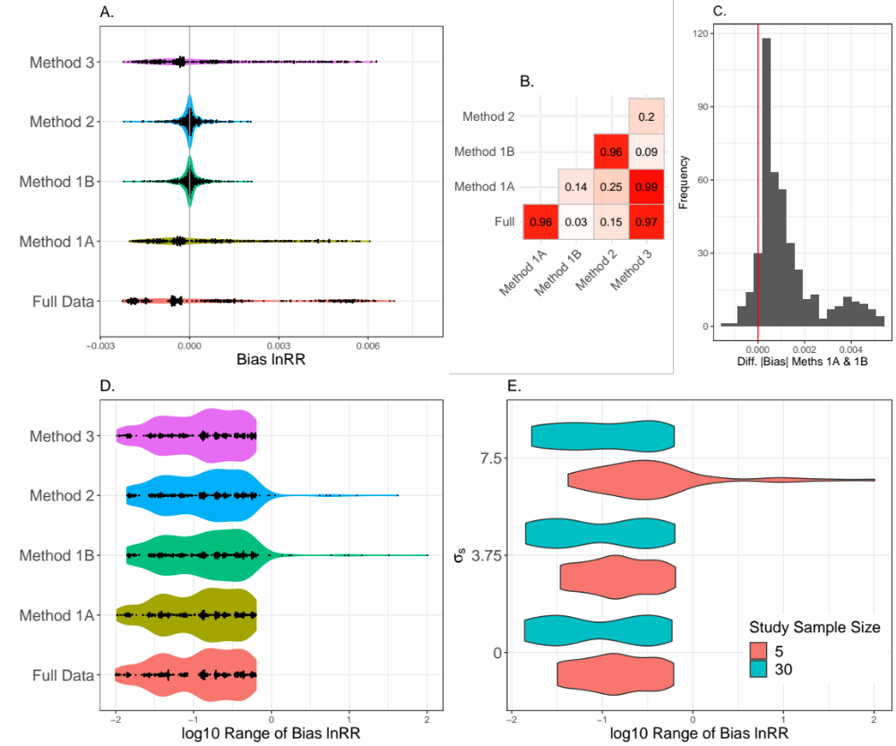

Figure 2
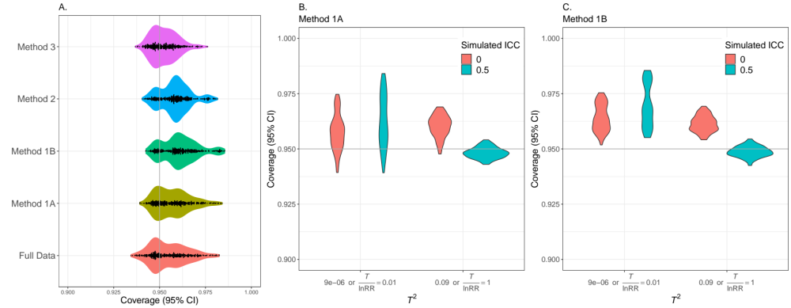

Figure 3

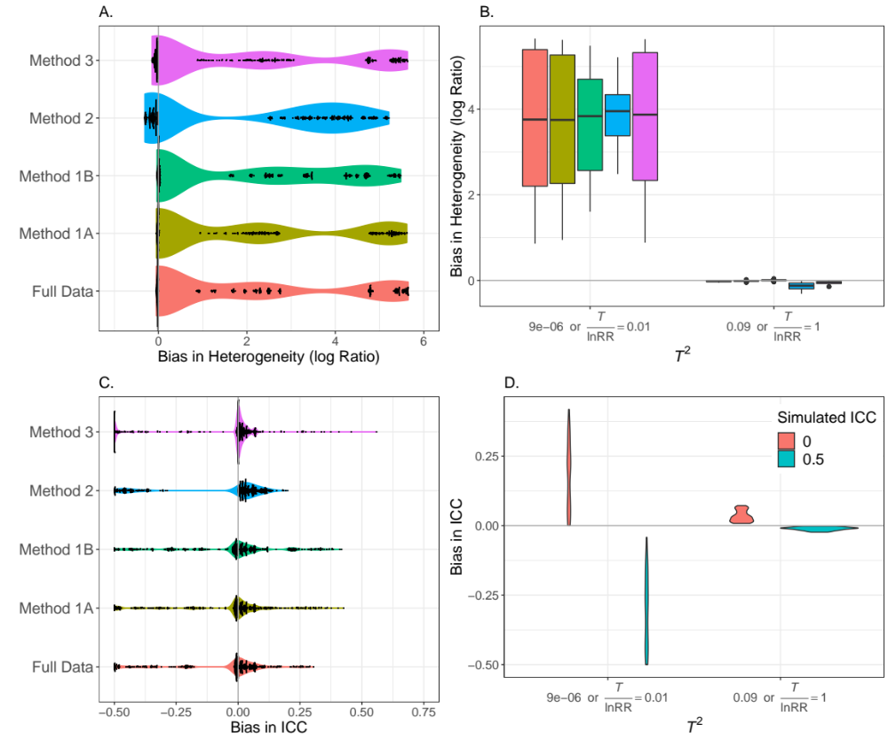

Figure S1
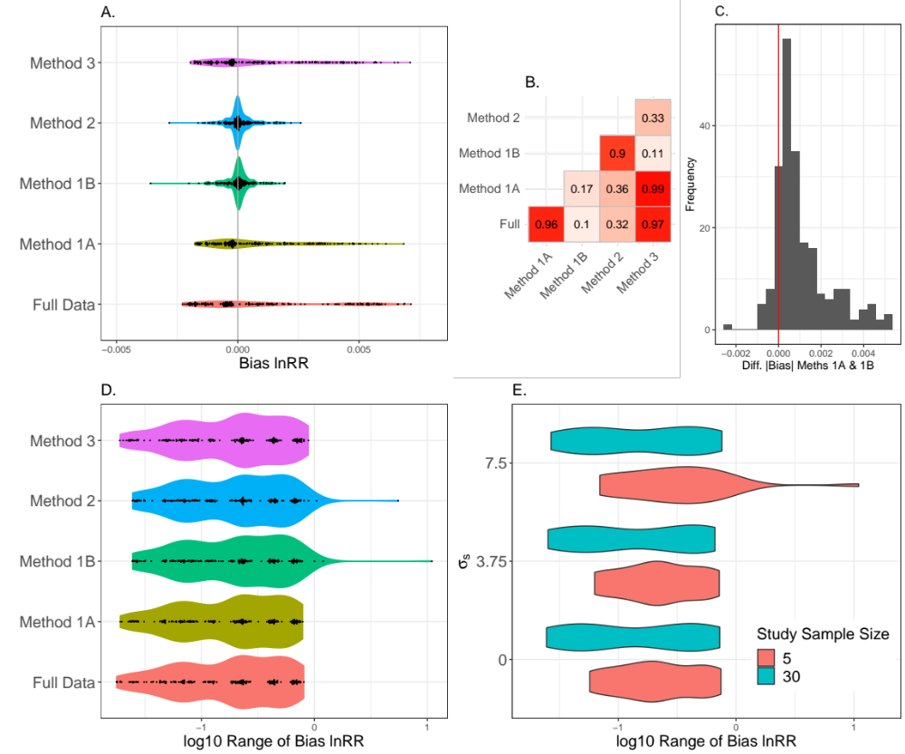

Figure S2
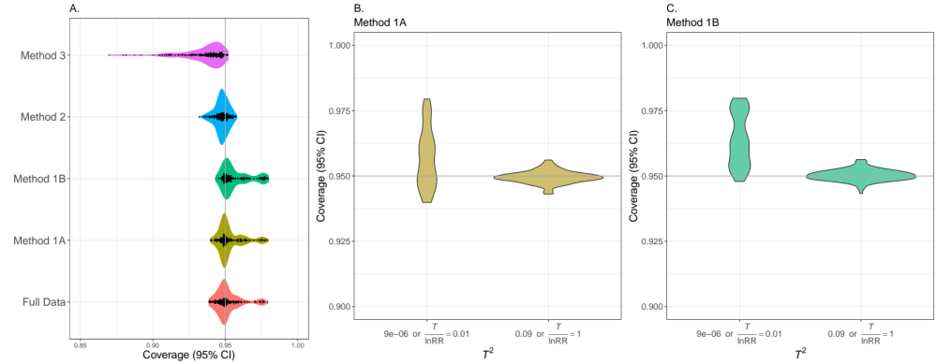

Figure S3

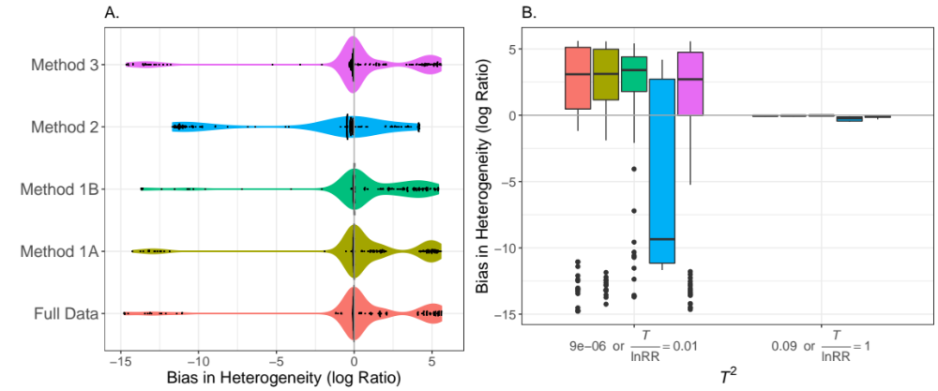

1.
Bird, G., Kaczvinsky, C., Wilson, A.E. & Hardy, N.B. (2019). When do herbivorous insects compete? A phylogenetic meta-analysis. Ecol Lett, 22, 875-883.
2.
Borenstein, M., Higgins, J.P.T., Hedges, L.V. & Rothstein, H.R. (2017). Basics of meta-analysis: I2 is not an absolute measure of heterogeneity. Res Synth Methods, 8, 5-18.
3.
Doncaster, C.P. & Spake, R. (2018). Correction for bias in meta-analysis of little-replicated studies. Methods Ecol Evol, 9, 634-644.
4.
Ellington, E.H., Bastille-Rousseau, G., Austin, C., Landolt, K.N., Pond, B.A., Rees, E.E. et al. (2015). Using multiple imputation to estimate missing data in meta-regression. Methods Ecol Evol, 6, 153-163.
5.
Fletcher, D. & Dixon, P.M. (2012). Modelling data from different sites, times or studies: weighted vs. unweighted regression. Methods Ecol Evol, 3, 168-176.
6.
Gurevitch, J., Koricheva, J., Nakagawa, S. & Stewart, G. (2018). Meta-analysis and the science of research synthesis. Nature, 555, 175-182.
7.
Hedges, L.V., Gurevitch, J. & Curtis, P.S. (1999). The Meta-Analysis of Response Ratios in Experimental Ecology. Ecology, 80, 1150-1156.
8.
Higgins, J.P.T. & Thompson, S.G. (2002). Quantifying heterogeneity in a meta-analysis. Stat Med, 21, 1539-1558.
9.
Higgins, J.P.T., Thompson, S.G., Deeks, J.J. & Altman, D.G. (2003). Measuring inconsistency in meta-analyses. Brit Med J, 327, 557-560.
10.
Kambach, S., Bruelheide, H., Gerstner, K., Gurevitch, J., Beckmann, M. & Seppelt, R. (2020). Consequences of multiple imputation of missing standard deviations and sample sizes in meta-analysis. Ecol Evol, 10, 11699-11712.
11.
Koricheva, J. & Gurevitch, J. (2014). Uses and misuses of meta-analysis in plant ecology. J Ecol, 102, 828-844.
12.
Lajeunesse, M.J. (2013). Recovering missing or partial data from studies: a survey. In: The handbook of meta-analysis in ecology and evolution (eds. Koricheva, J, Gurevitch, J & Mengersen, K). Princeton University Press Princeton, pp. 195-206.
13.
Lajeunesse, M.J. (2015). Bias and correction for the log response ratio in ecological meta-analysis. Ecology, 96, 2056-2063.
14.
Lin, L.F. & Aloe, A.M. (2021). Evaluation of various estimators for standardized mean difference in meta-analysis. Stat Med, 40, 403-426.
15.
McDonald, S.E., Lawrence, R., Kendal, L. & Rader, R. (2019). Ecological, biophysical and production effects of incorporating rest into grazing regimes: A global meta-analysis. J Appl Ecol, 56, 2723-2731.
16.
Nakagawa, S. (2015). Missing data: mechanisms, methods and messages. In: Ecological statistics: contemporary theory and application (eds. Fox, GA, Negrete-Yankelevich, S & Sosa, VJ). Oxford University Press Oxford, pp. 81-105.
17.
Nakagawa, S. & Freckleton, R.P. (2008). Missing inaction: The dangers of ignoring missing data. Trends in Ecology & Evolution, 23, 592-596.
18.
Nakagawa, S. & Freckleton, R.P. (2011). Model averaging, missing data and multiple imputation: a case study for behavioural ecology. Behav Ecol Sociobiol, 65, 103-116.
19.
Nakagawa, S., Poulin, R., Mengersen, K., Reinhold, K., Engqvist, L., Lagisz, M. et al. (2015). Meta-analysis of variation: ecological and evolutionary applications and beyond. Methods Ecol Evol, 6, 143-152.
20.
Nakagawa, S. & Santos, E.S.A. (2012). Methodological issues and advances in biological meta-analysis. Evolutionary Ecology, 26, 1253-1274.
21.
Nakagawa, S., Senior, A.M., Viechtbauer, W. & Noble, D.W.A. (2022). An assessment of statistical methods for nonindependent data in ecological meta-analyses: Comment. Ecology, 103, e03490.
22.
Noble, D.W.A., Lagisz, M., O'Dea R, E. & Nakagawa, S. (2017). Nonindependence and sensitivity analyses in ecological and evolutionary meta-analyses. Molecular Ecology, 26, 2410-2425.
23.
Rubin, D.B. (1987). Multiple imputation for nonresponse in surveys. Wiley, New York ; Chichester.
24.
Senior, A.M., Grueber, C.E., Kamiya, T., Lagisz, M., O'Dwyer, K., Santos, E.S.A. et al. (2016). Heterogeneity in ecological and evolutionary meta-analyses: its magnitude and implications. Ecology, 97, 3293-3299.
25.
Senior, A.M., Viechtbauer, W. & Nakagawa, S. (2020). Revisiting and expanding the meta-analysis of variation: The log coefficient of variation ratio. Res Synth Methods, 11, 553-567.
26.
Spake, R., Mori, A.S., Beckmann, M., Martin, P.A., Christie, A.P., Duguid, M.C. et al. (2021). Implications of scale dependence for cross-study syntheses of biodiversity differences. Ecol Lett, 24, 374-390.
27.
van Buuren, S. (2018). Flexible Imputation of Missing Data, Second Edition. 2nd edn. CRC Press, Boca Raton.
28.
Xiong, C.J., Miller, J.P. & Morris, J.C. (2010). Measuring Study-Specific Heterogeneity in Meta-Analysis: Application to an Antecedent Biomarker Study of Alzheimer's Disease. Stat Biopharm Res, 2, 300-309.
29.
Yang, Y., Hillebrand, H., Lagisz, M., Cleasby, I. & Nakagawa, S. (2022). Low statistical power and overestimated anthropogenic impacts, exacerbated by publication bias, dominate field studies in global change biology. Glob Chang Biol, 28, 969-989.

