**QIMR Diffusion Pipeline**

Setup information

1. **Install the github package**

* Ensure your current working directory is your home directory on avalon
  + E.g. cd ~/ or /mnt/lustre/home/$USER
* git clone <https://github.com/breakspear/diffusion-pipeline.git>

1. **Setup required software for the pipeline**

* Copy and paste the lines from the .bashrc file (located in the /data folder) into your user .bashrc file located in the home directory
* Or, copy the file directly into your home directory
* You may need to restart your session browser for the software to be sourced correctly

1. **Locate image files from the scanner DICOM folders**

* This DICOM data should be stored on the L-Drive or R-Drive (where users only have read access)
* The scanner will presumably give you image data in a set of DICOM folders
* Each folder should correspond to separate scanning sequences:

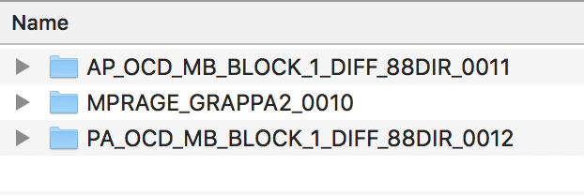

* The image folders of interest here are the diffusion sequences for:
  + A🡪 P diffusion sequence (AP_OCD_MB_BLOCK1_DIFF_88DIR_0011)
  + P 🡪 A diffusion sequence (PA_OCD.. etc)
  + And, the structural T1-image (either MPRAGE or MP2RAGE)

1. **Extract all the images with MRtrix**

* There should be a parent directory called *Raw*, with the subfolders corresponding to each subject:

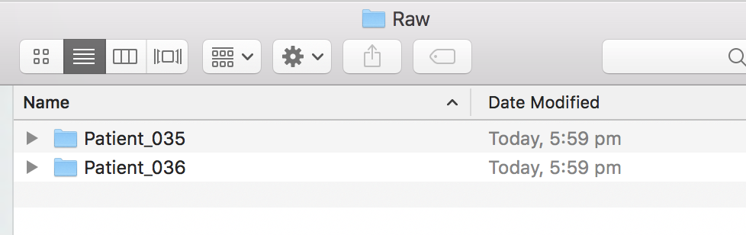

* Within each subject folder, unpack the DICOM’s into corresponding image files (note the strides are important!).
* For example,

mrconvert /path/to/AP_OCD_MB_BLOCK_1_DIFF_88DIR_0012/ rawdataAP.mif -stride +1,2,3,4

mrconvert /path/to/PA_DICOM rawdataAP.mif -stride +1,2,3,4

mrconvert /path/to/T1_DICOM T1.nii -stride +1,2,3

1. **Copy the Raw folder directory to the avalon /working space**

* Working directory is the scratch space
  + The storage capacity of each home directory (10GB, which is backed up nightly) is too small for diffusion purposes
* The location of your working scratch space will depend on your group leader
  + For myself, it is /working/lab_michaebr/alistaiP
* **rsync** the Raw folder into the desired project directory
  + rsync -vaz Raw /working/lab_michaebr/alistaiP/Park/

Processing the data

There are 4 scripts to be called

1st

sh workingdirectory processFSall

2 (perform all diffusion steps)

edit include

sh workingdirectory dtiadvfullsetup