Created By: Alistair Vermaak

Date: 12.1.2023

Title: Canadian Wildfire API

Purpose: Show Geospatial Fire Distribution

Tools: Python

Data Source: NASA Firms

Data Type: API

**NASA’s Canadian Wildfire Data**

**In this data, we looked for fire distribution patterns across regions of Canada to see if we could spot any trends.**

**I delved into the heat distribution to try make sens of why some fires are burning hotter than others, where they were concentrated and the most affected areas.**

**The goal of the project was to share geospatial fire distribution, trends and patterns across a subset of Canadian regions with interested stakeholders.**

**Table of Contents**

1. [About the project](https://github.com/DouweHorsthuis/README-Template/blob/master/BLANK_README.md" \l "about-the-project)
   * [Built With](https://github.com/DouweHorsthuis/README-Template/blob/master/BLANK_README.md" \l "built-with)
2. [Getting started](https://github.com/DouweHorsthuis/README-Template/blob/master/BLANK_README.md" \l "getting-started)
   * [Prerequisites](https://github.com/DouweHorsthuis/README-Template/blob/master/BLANK_README.md" \l "prerequisites)
   * [Installation](https://github.com/DouweHorsthuis/README-Template/blob/master/BLANK_README.md" \l "installation)
3. [Roadmap](https://github.com/DouweHorsthuis/README-Template/blob/master/BLANK_README.md" \l "roadmap)
4. [Contributing](https://github.com/DouweHorsthuis/README-Template/blob/master/BLANK_README.md" \l "contributing)
5. [License](https://github.com/DouweHorsthuis/README-Template/blob/master/BLANK_README.md" \l "license)
6. [Contact](https://github.com/DouweHorsthuis/README-Template/blob/master/BLANK_README.md" \l "contact)

**About The Project**

[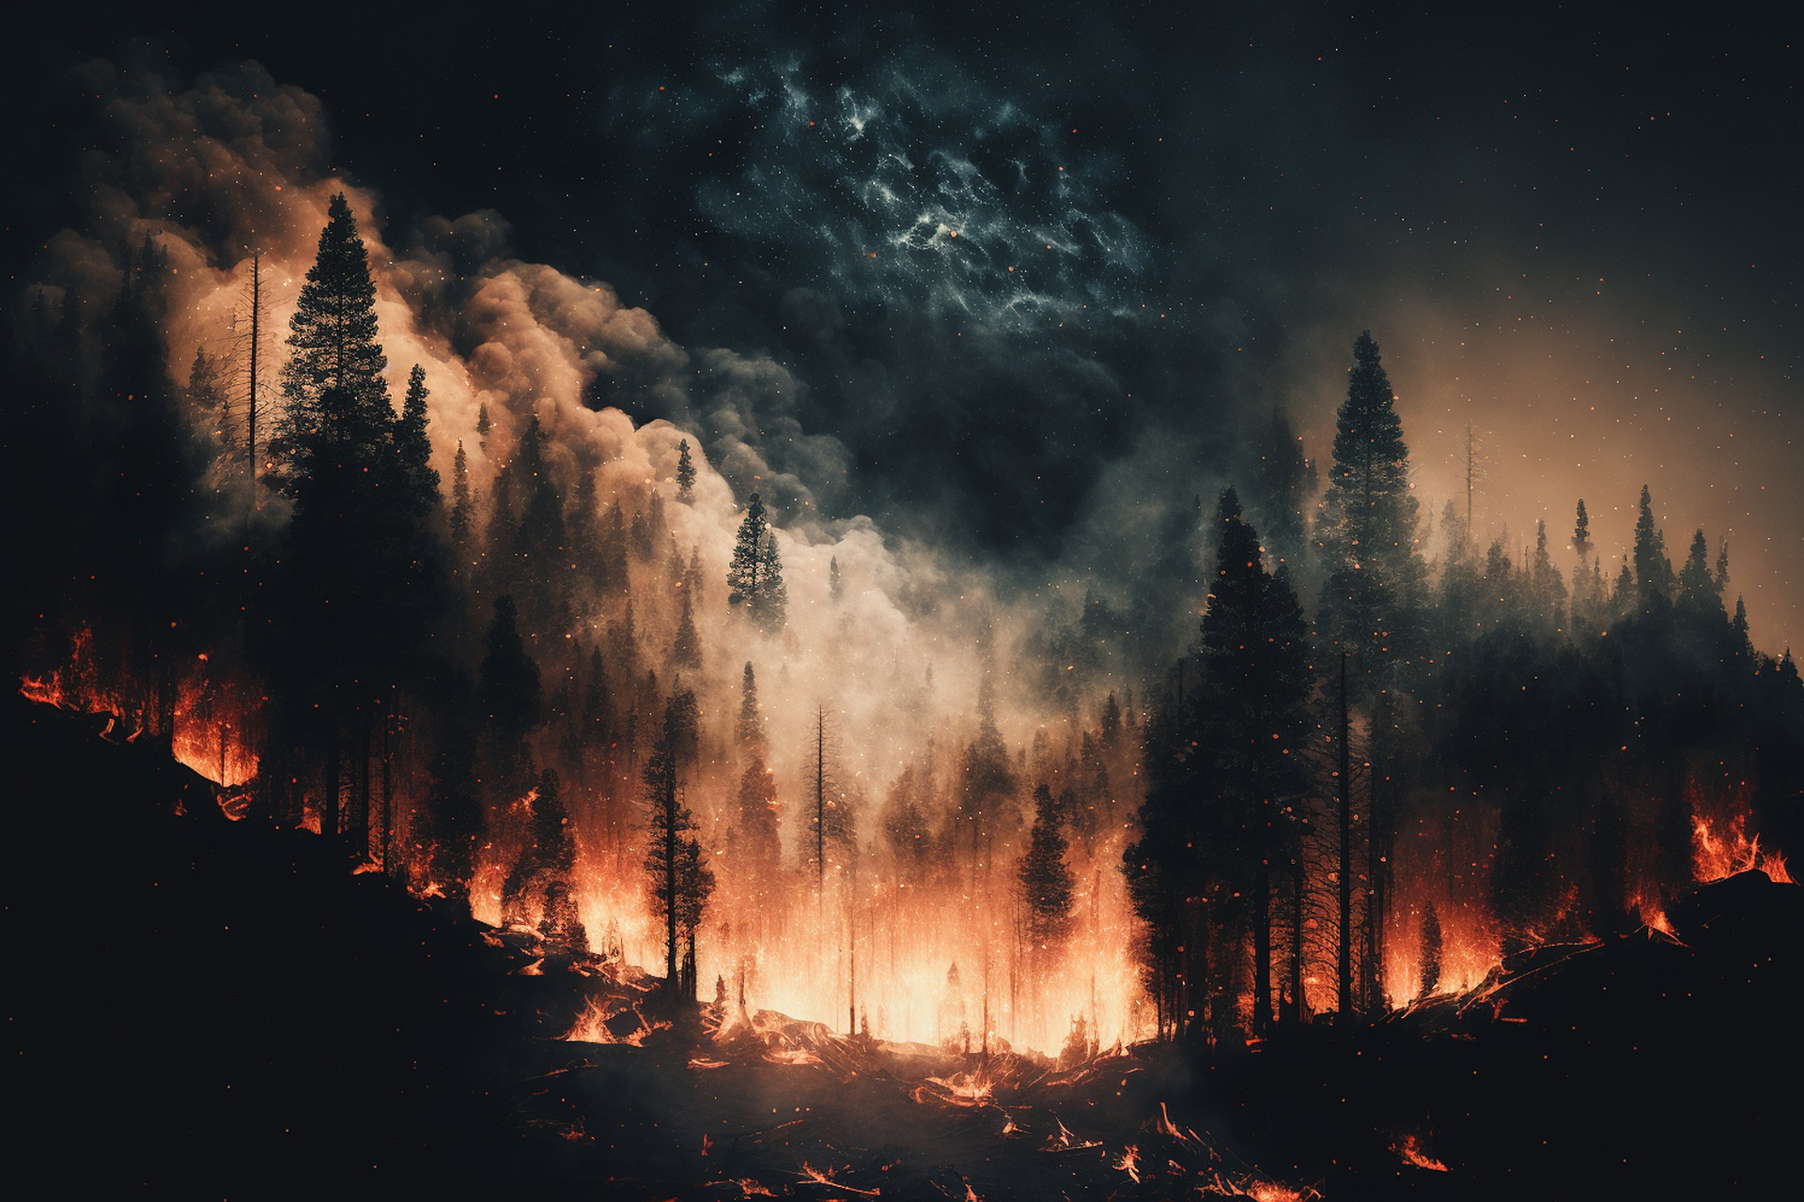](https://example.com/)

**Built With**

* Deepnote
* Python
* Jupyter Notebook

**Getting Started**

To get a local copy up and running follow these simple steps. Navigate to either of these links to get access to the project. Either view the content with the APP, or get direct access to the notebook.

You can find the app here: URL=<https://deepnote.com/@alistair-data-project/NASA-Wildfire-Data-3361fbf6-4cf8-42a9-b6ce-8cd736bb36c2>

Here’s the Notebook: URL=[https://deepnote.com/workspace/work-space1-7030e0ce-a90a-4c2d-9e07-6988a696d5c2/project/NASA-Wildfire-Data-3361fbf6-4cf8-42a9-b6ce-8cd736bb36c2/notebook/Notebook%201-c2b6542f12a34ef6881c9fee02d640d6](https://deepnote.com/workspace/work-space1-7030e0ce-a90a-4c2d-9e07-6988a696d5c2/project/NASA-Wildfire-Data-3361fbf6-4cf8-42a9-b6ce-8cd736bb36c2/notebook/Notebook 1-c2b6542f12a34ef6881c9fee02d640d6)?

Here’s a direct link to the project: URL=https://deepnote.com/workspace/alistair-data-project-7030e0ce-a90a-4c2d-9e07-6988a696d5c2/project/NASA-Wildfire-Data-3361fbf6-4cf8-42a9-b6ce-8cd736bb36c2/notebook/Notebook%201-c2b6542f12a34ef6881c9fee02d640d6

**Prerequisites**

There’s not much to do, simply follow the links I supplied, view, or follow the instructions to grab your own copy of the notebook.

**Installation**

Simply download a version of the notebook to your device. Install the necessary libraries noted in the code and you should be able to use the data as you wish.

**Usage**

You are free to do whatever you like to the data once downloaded to your device.

**Contributing**

Contributions are what make the open source community such an amazing place to be learn, inspire, and create. Any contributions you make are **greatly appreciated**.

1. Fork the Project
2. Create your Feature Branch (git checkout -b feature/AmazingFeature)
3. Commit your Changes (git commit -m 'Add some AmazingFeature')
4. Push to the Branch (git push origin feature/AmazingFeature)
5. Open a Pull Request

**License**

Distributed under the MIT License. See LICENSE for more information.

**Contact**

Alistair Vermaak - [@](https://twitter.com/twitter_handle)alistairvermaak

Email: [al@alistairvermaak.com](mailto:al@alistairvermaak.com)

Project Link: [https://](https://github.com/github_username/repo/)alistairvermaak.com/canadian-wildfires