Created By: Alistair Vermaak

Date 12.1.2023

Title: NYC Citi Bike Rental Data

Purpose: Analysis Of Bike Rental Data

Data Type: CSV

Data Source: NYC Citi Bikes

Tools Used: Python

**NYC Citi Bike Rental Data Analysis**

**I created this analysis to try answer some pressing Business questions that might be on the minds of the people who own NYC Citi Bike Rental.**

**I sought to answer questions like who are the most prevalent users, when they cycle most, where they cycle most, the most popular start and end locations etc.**

**All of the insights were aimed at providing the business owner with data to make better informed business decisions about stock holding, expansion and giving them more detailed insights into their customer base.**

**Table of Contents**

1. [About the project](https://github.com/DouweHorsthuis/README-Template/blob/master/BLANK_README.md" \l "about-the-project)
   * [Built With](https://github.com/DouweHorsthuis/README-Template/blob/master/BLANK_README.md" \l "built-with)
2. [Getting started](https://github.com/DouweHorsthuis/README-Template/blob/master/BLANK_README.md" \l "getting-started)
   * [Prerequisites](https://github.com/DouweHorsthuis/README-Template/blob/master/BLANK_README.md" \l "prerequisites)
   * [Installation](https://github.com/DouweHorsthuis/README-Template/blob/master/BLANK_README.md" \l "installation)
3. [Roadmap](https://github.com/DouweHorsthuis/README-Template/blob/master/BLANK_README.md" \l "roadmap)
4. [Contributing](https://github.com/DouweHorsthuis/README-Template/blob/master/BLANK_README.md" \l "contributing)
5. [License](https://github.com/DouweHorsthuis/README-Template/blob/master/BLANK_README.md" \l "license)
6. [Contact](https://github.com/DouweHorsthuis/README-Template/blob/master/BLANK_README.md" \l "contact)

**About The Project**

[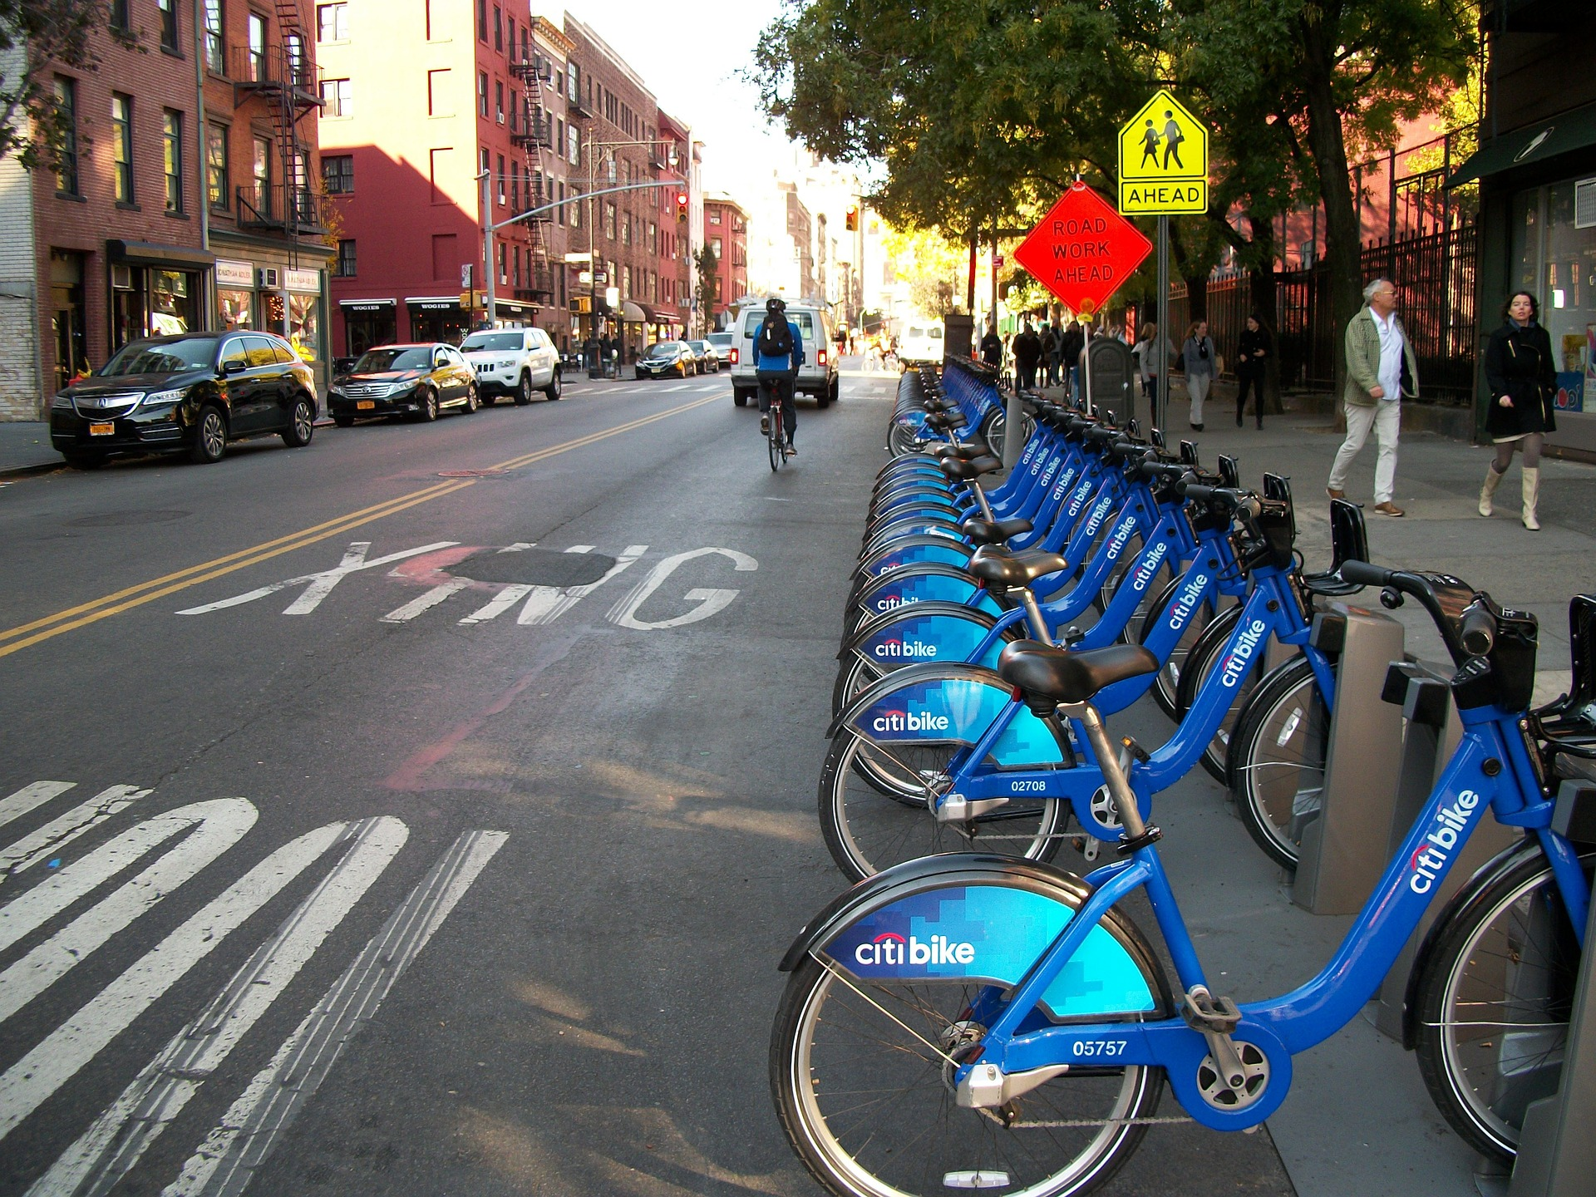](https://example.com/)

**Built With**

* Jupyter
* Datalore
* Python

**Getting Started**

To get a local copy up and running follow these simple steps. Follow this URL: URL= <https://datalore.jetbrains.com/notebook/N877tDZxmY5X8RMFoRKn76/rOQq4niygdkKMojhVA97ms> (note this is for viewing purposes only)

Or this link: URL=<https://datalore.jetbrains.com/report/static/N877tDZxmY5X8RMFoRKn76/GyvlCf7OcA3XhoBy4PZ1Ku> (here you can choose to download or export it the way you want.)

**Prerequisites**

To make use of the project, you can always download a copy from the links provided above. You may need to sign up for a Datalore account, fortunately, it’s free.

Just follow the instructions to get your own copy and make use of it the way you wish.

**Installation**

Download the project from the links provided and open in your local Jupyter installation.

Import the relevant libraries according to those we used in the notebook and you should be fine to work with it.

**Usage**

[T](https://example.com/)here’s nothing complicated. Simply download the notebook and run the code.

**Contributing**

Contributions are what make the open source community such an amazing place to be learn, inspire, and create. Any contributions you make are **greatly appreciated**.

1. Fork the Project
2. Create your Feature Branch (git checkout -b feature/AmazingFeature)
3. Commit your Changes (git commit -m 'Add some AmazingFeature')
4. Push to the Branch (git push origin feature/AmazingFeature)
5. Open a Pull Request

**License**

Distributed under the MIT License. See LICENSE for more information.

**Contact**

AlistairVermaak - [@](https://twitter.com/twitter_handle)alistairvermaak

Email: [al@alistairvermaak.com](mailto:al@alistairvermaak.com)

Project Link: [https://](https://github.com/github_username/repo/)alistairvermaak.com/nyc-citibike-data