**Format of this doc:**

* Relevant page link
* Notes of changes that are needed
* Screenshot of the area being referenced

**HOME PAGE** <http://repakelt2017.wpengine.com/>

* Search box should contain retailer, collector and ATF only 
* Currently waiting on logos, logos should be weighted towards producers/people of influence
* Possibly could have a backboard page of all logos
* Enforcement link needs to link to regs page – link currently broken

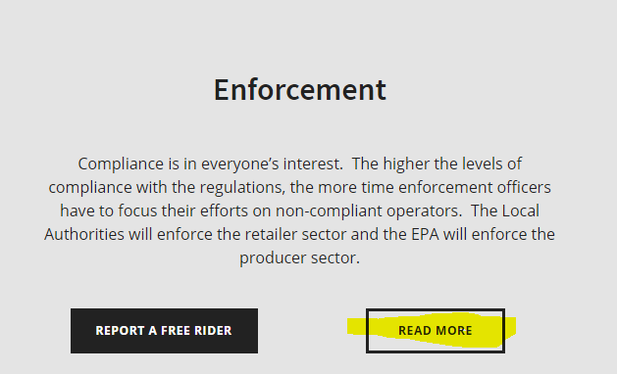

* Environment – link broken

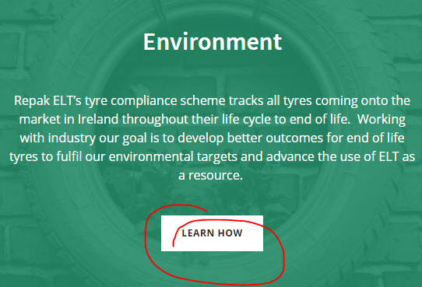

* Needs to say ‘What **do** the new Tyre Regulations mean for you’ 
* ATF: Needs to say “report the **tyres**”

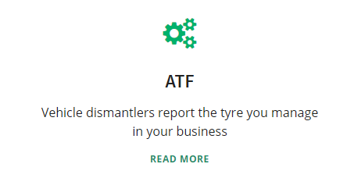

* Yellow box to link to a ‘What to do to get ready for October 1st’ page



* Add link to ‘Downloads’ section either above or below this section



* ‘Are you ready to join?’ should be on the second line



* Waste tyre regulation text needs to be added in

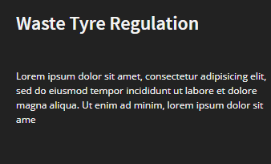

**ABOUT US PAGE** <http://repakelt2017.wpengine.com/about-us/>

* Line spacing to be increased
* Heading should be added here saying ‘Repak End of Life Tyres’

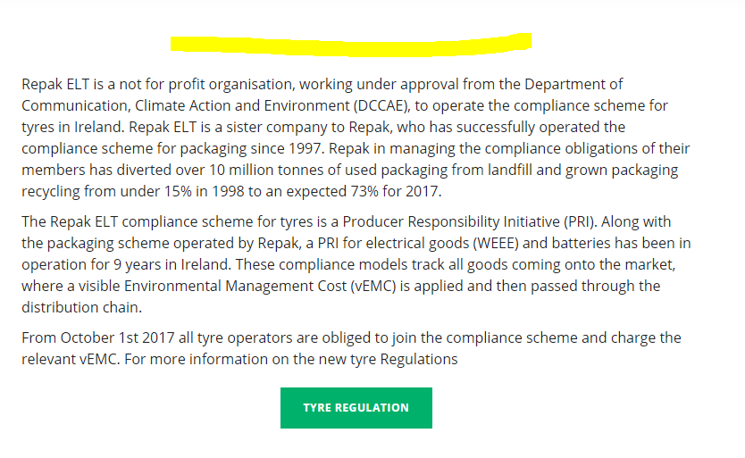

* Heading should be added here saying ‘Our mission’

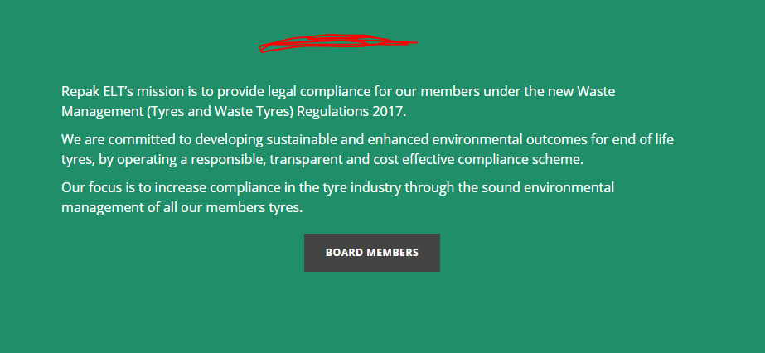

* Board members link needs content



* Take out these lines
* Add in to point two ‘These **aggregate** industry figures….’

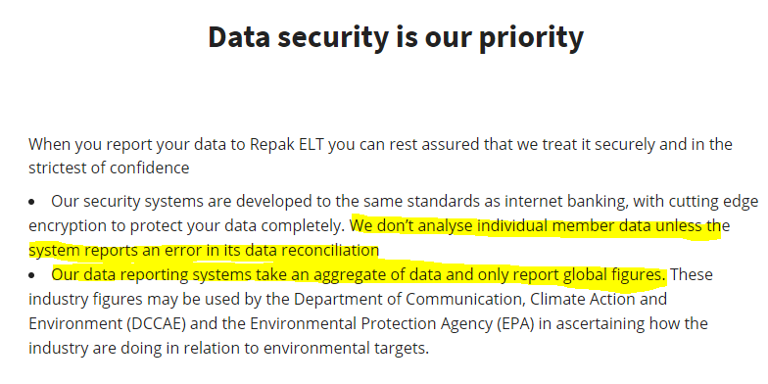

**JOIN TODAY BOX**

* Remove ‘once the PRI is launched’

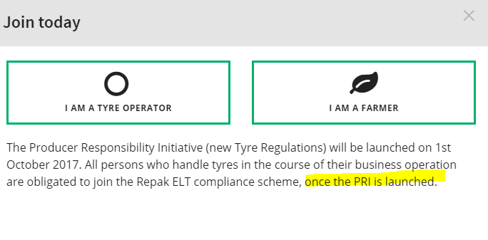

**I AM A FARMER PAGE** <http://repakelt2017.wpengine.com/farmer-application/>

* Should say: “Farmers must register with the scheme and all tyres must be recorded”

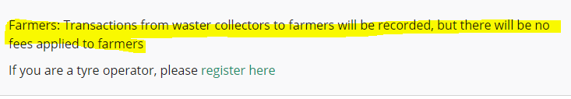

**REGULATION PAGE** <http://repakelt2017.wpengine.com/regulation/>

* Remove ‘producer register’ button and add in a button that brings you to regulations instead



* Missing links needed here:

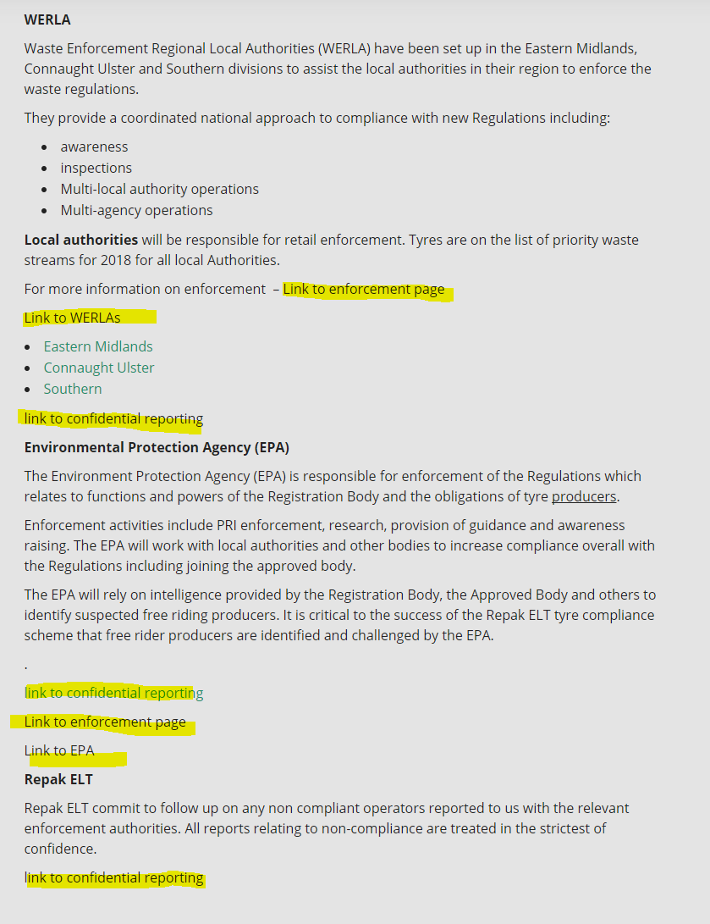

* Links to categories need to be added in

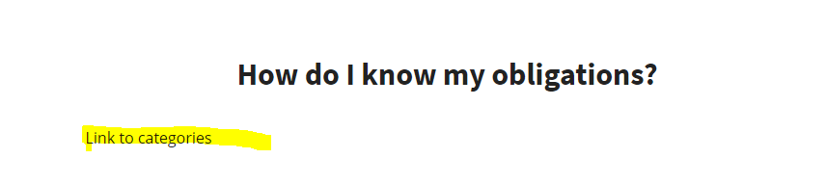

**MEMBERS LIST PAGE** <http://repakelt2017.wpengine.com/member-list/>

* Needs to jump to the top of the page when you change pages

**ENVIORNMENT PAGE** <http://repakelt2017.wpengine.com/environment/>

* Arrow needs to be included for ‘back to top’ of page

**NEWS AND EVENTS page** <http://repakelt2017.wpengine.com/news/>

* Need ‘downloads’ tab

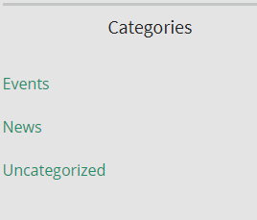

* Need to include info graphics and presentations in the downloads tab

**FAQ PAGE** <http://repakelt2017.wpengine.com/faq/>

* Need a ‘General FAQ’ box added in

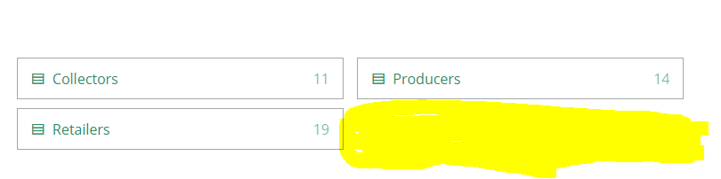

**REPORT TYRES BUTTON**

* Need links from Mark for ‘Learn more about reporting’

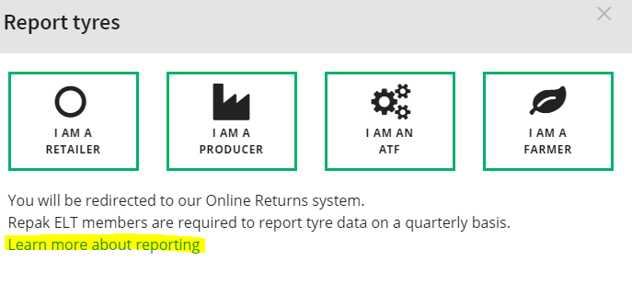

* Should say ‘I am a collector’

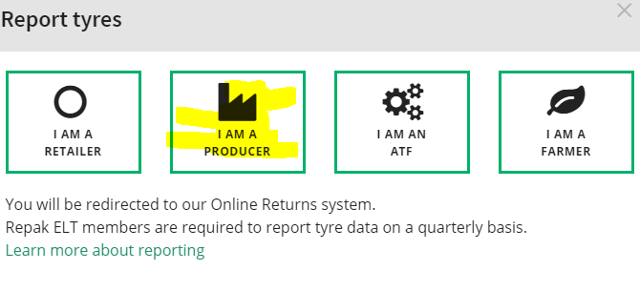

* Need to change quarterly to monthly

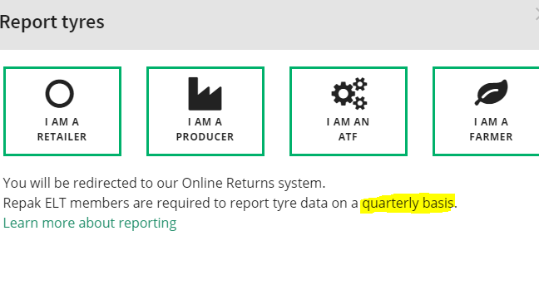

* Learn more about reporting – needs content

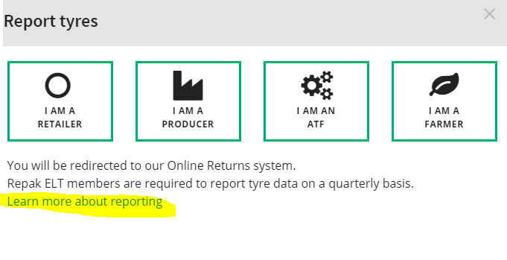

**RETAILER PAGE** <http://repakelt2017.wpengine.com/retailers/>

* Put in a ‘Back to top’ button at bottom of each section
* See can they reduce large spacing
* Remove producer at the end of the first line
* Add in actual definition of retailer from the regulations
* Remove the ‘See Producers List’ button and remove our search list for producers. Instead, add in “For more information on compliant producers, here’s the PRL producers list” and link

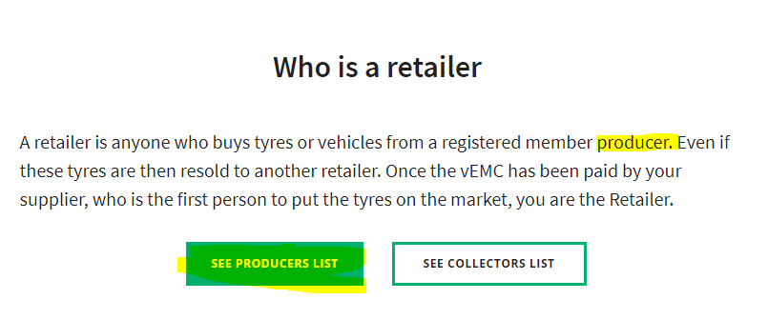

* Waiting on information from Mark for collectors list, put in a holdings list for now:

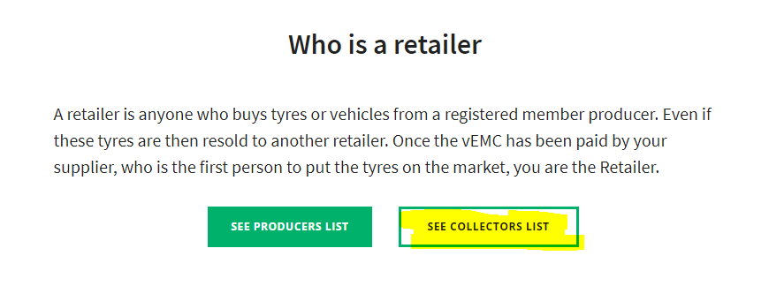

* Link to be added for VEMC section
* Bullet points to be added in
* Remove ‘More about PRI’ button and instead Link to regulations

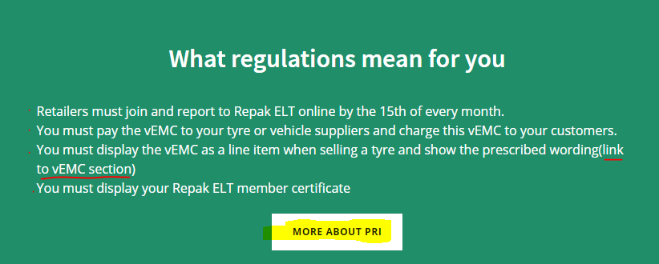

* Change to ‘join Repak ELT’ not ‘make sure you’re a member’
* Add in a point saying ‘brief your staff’
* Add in ‘and add prescriptive text’ to third point

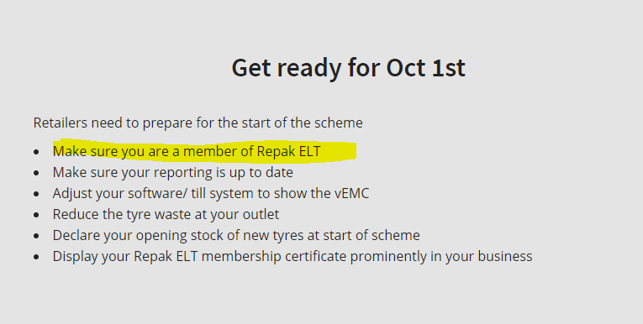

* Link needed to collectors list
* Add in that “the liability is on retailer for excess tyres, so collectors data must be validated”

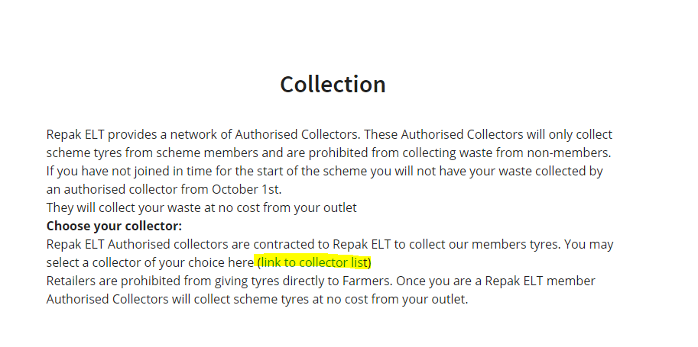

* Put in a link to info graphic of mock invoice
* Add in to last line “you are required to complete back reporting and you will be liable for VEMC on all tyres from October 1st”

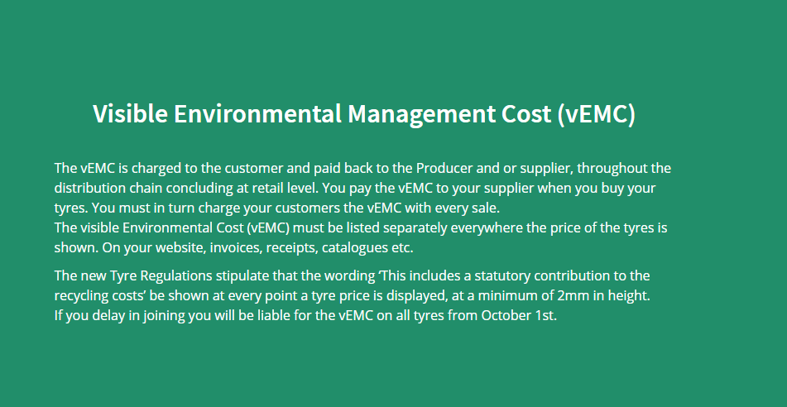

* Change to “late reporting will halt the collection of waste tyres until your returns are brought up to date”
* Change to ‘bought **,** by supplier’

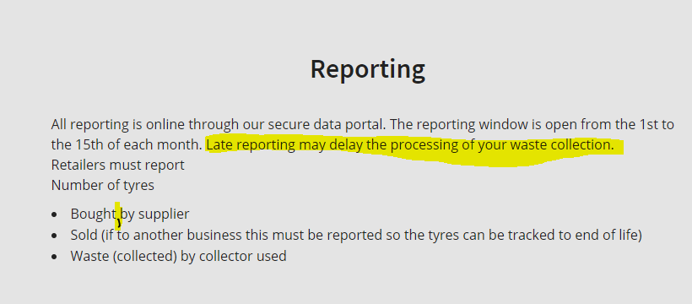

* Add in link to PRL
* Add in “All tyre operators must be registered with Repak ELT”
* Add in “All producers must be registered with PRL”
* Add in “All producers need to display PRL number on paperwork”
* Add in “It is illegal to buy/source tyres from any businesses not registered with Repak ELT”

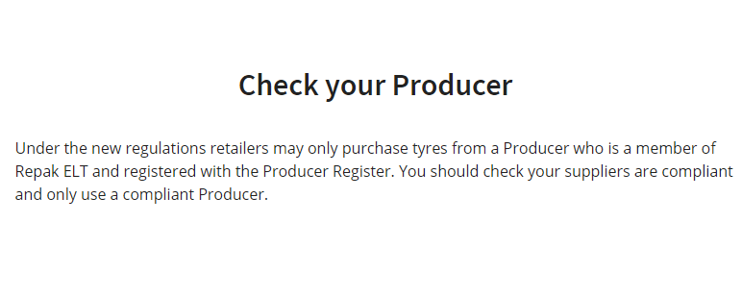

* Change to “if you have not joined”
* Change to “you will have your waste collection halted”
* Add in “back reporting will be due from October 1st regardless of when you join – this is a requirement for membership”.

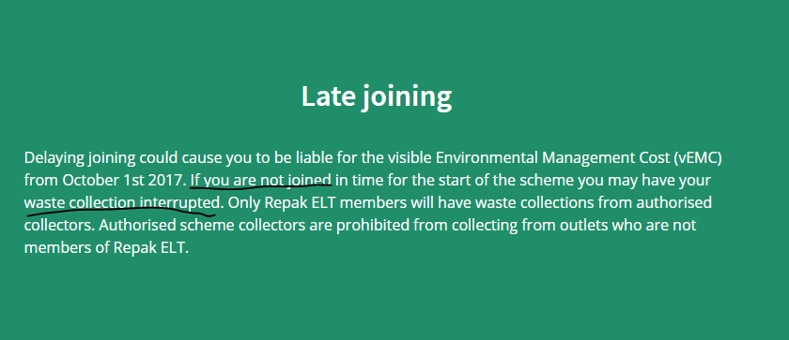

**PRODUCER PAGE** <http://repakelt2017.wpengine.com/retailers/>

* Add in definition of producer from regulations
* Check regulations for second part of first section “we can only supply Repak ELT members”

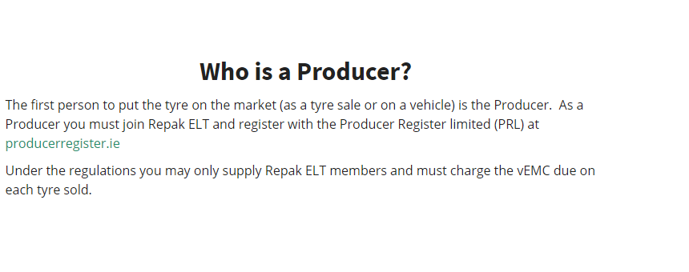

* Remove part about ’10 cents’
* Check prescribed wording
* Check with department stance on zero VEMC being displayed on invoices
* Make third point here a bullet point
* Add in “register with PRL and display PRL number on all documents”
* Add in “Consider the opt in option for reporting to Repak ELT”
* Remove the last line

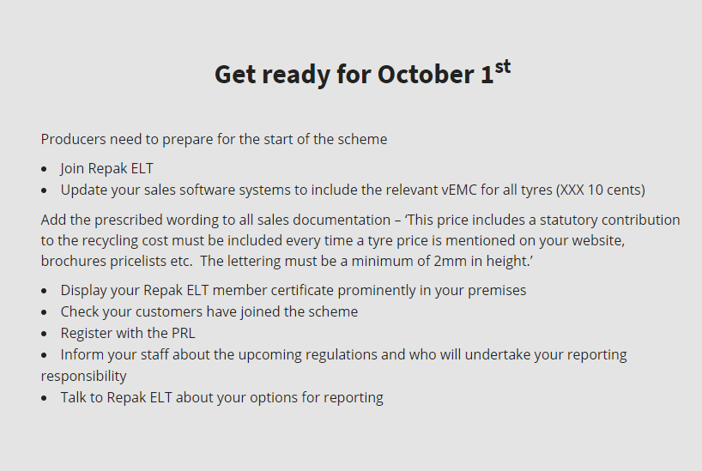

* Add in “Consider the opt in option for reporting to Repak ELT to make the process more efficient”
* Add in “Reporting is done between 1-19th of every month”

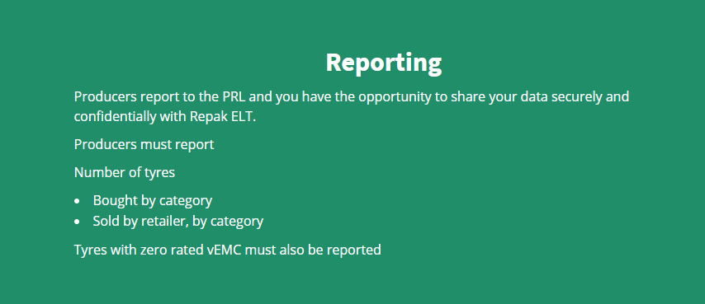

* Regs need to be checked for ‘prohibited from supplying tyres to non-members’
* Authorized representative text from regs to be copied in here somewhere

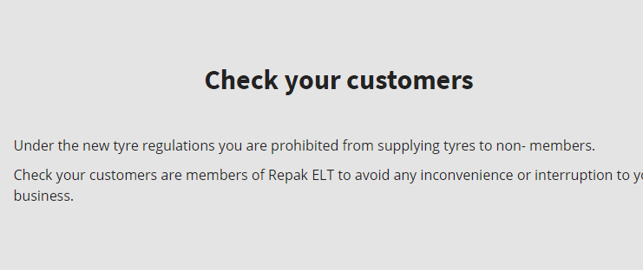

* After ‘if you delay in joining in time for October 1st’, add in : “you can’t place tyres on the market”

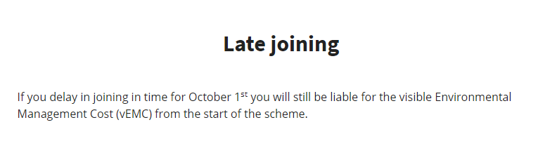

**COLLECTOR PAGE** <http://repakelt2017.wpengine.com/collectors/>

* Mark to look at this page
* Change to “From 1st October you will be prohibited….”
* Put “apply online at repakelt.ie to become an authorised collector” as the first point
* Add ‘y’ on party on the last point

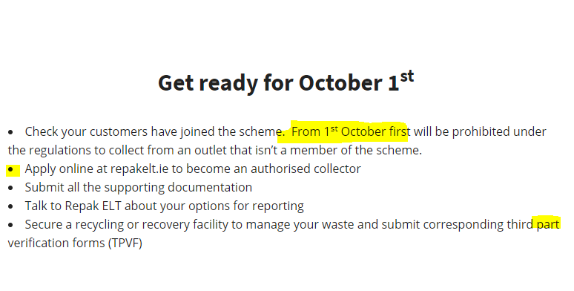

* Change “And the number sent for processing” to “And the weight sent for processing”
* Add in link here to reporting portal

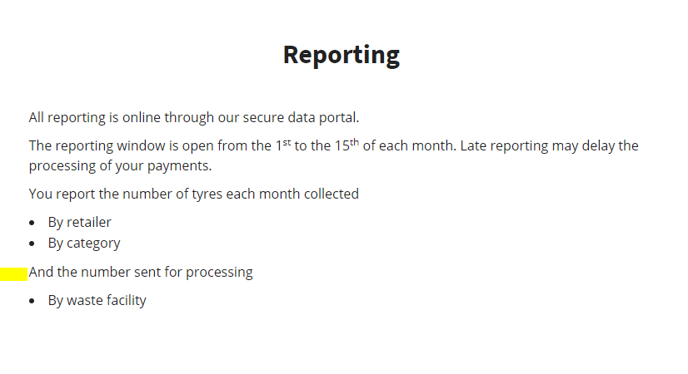

**MOTOR DEALER PAGE**  <http://repakelt2017.wpengine.com/motor-dealers/>

* John to look at this page and revert
* Should have a box saying retailer and link to retailers page
* Should have a box saying producer and link to producer page

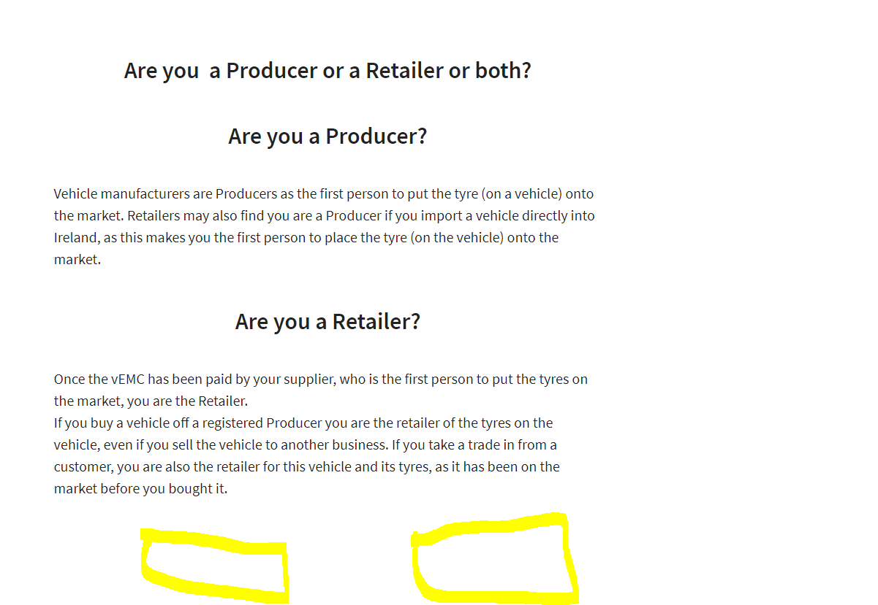

* Remove all of these links across

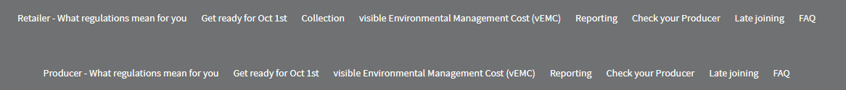

**ATF PAGE** <http://repakelt2017.wpengine.com/atf/>

* Add in link to elves.ie
* Add in to third point “and their Repak ELT Cert”

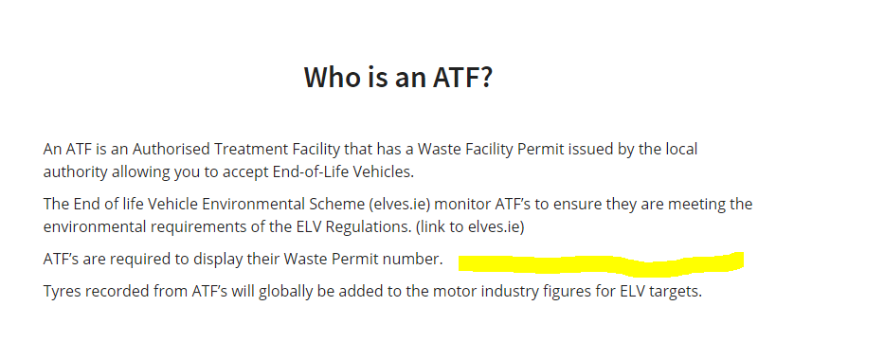

* Point one should read “ATF’s must join and report to Repak ELT”
* Add in as the next point “Reporting is done online by the 15th of every month”
* In the second paragraph “End of Life Tyres” should be changed to “Waste Tyres”

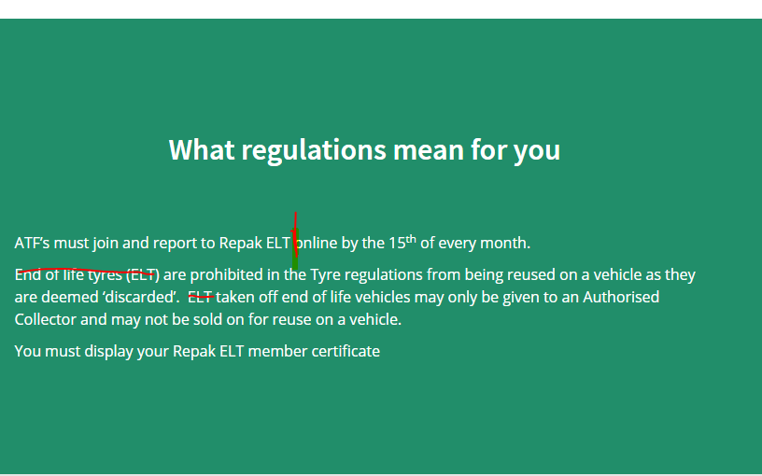

* Change ‘retailers’ to ATF’s
* Confirm 4th point with Mark and John – how will opening waste stock be dealt with for ATF’s

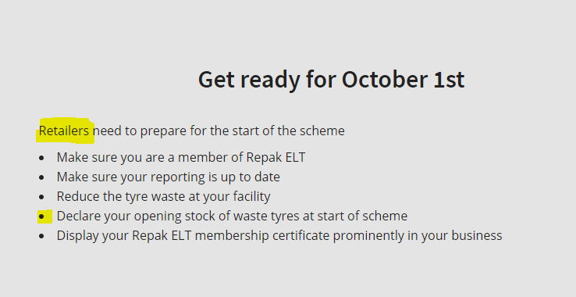

* Should read ‘Taken in to your facility on vehicles from general public / from businesses’

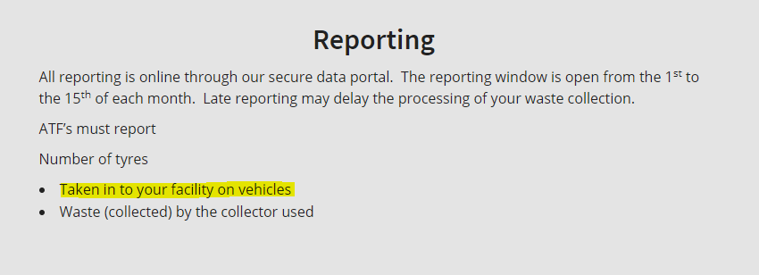

* Should use other FAQ section to form some basic ATF FAQ’s



**RETREADER PAGE** <http://repakelt2017.wpengine.com/retreaders/>

* Add in “in discussion with the industry and DCCAE”

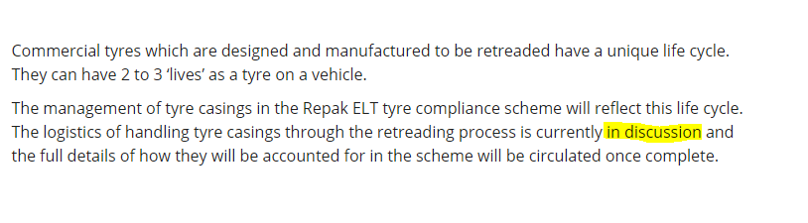

**RECYCLERS PAGE** <http://repakelt2017.wpengine.com/recyclers/>

* Double check all info on this page tally’s with regs

**FARMERS PAGE** <http://repakelt2017.wpengine.com/farmers/>

* Remove ‘All waste tyres coming off your farmer’ and change to ‘coming off your farm’
* Remove ‘local authority facility’.

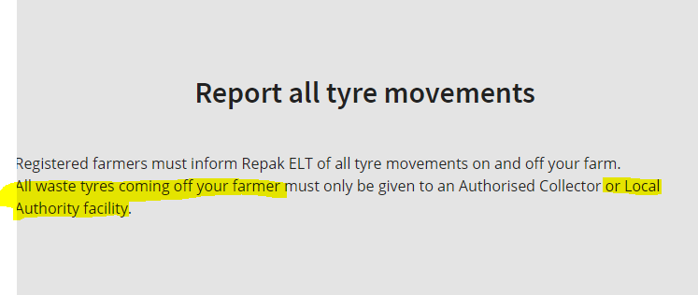

**General team notes from the meeting on the website:**

* Decision tree to be developed more and added into the website as soon as possible to assist members in clearly understanding their role/responsibilities (John)
* Links for reporting to be sent for reporting page (Mark) <http://repakelt2017.wpengine.com/reporting>
* VEMC section of Producers page to be reviewed by John <http://repakelt2017.wpengine.com/producers>
* Mark to review collector page <http://repakelt2017.wpengine.com/collectors/>
* Look into a guidance document for ATF’s and collectors - already have one for retailers (Mark and Padraig)
* Motor dealer page, John to review <http://repakelt2017.wpengine.com/motor-dealers/>
* Discuss with Mark tomorrow how will opening waste stock be dealt with for ATF’s and ATF’s VEMC costs
* Work on a better automated response email for members who sign up
* How will zero VEMC cost be displayed on invoices
* Regs need to be checked for ‘prohibited from supplying tyres to non-members’