



# authorised waste collector

# CONTRACT

# 2017 TO 2020

[ ]

***and***

**Repak ELT Company Limited by Guarantee**

**Repak ELT CLG,**

**Red Cow Interchange Estate,**

**1, Ballymount Road,**

Clondalkin,

Dublin 22.

**CONTENTS**

|  |  |  |
| --- | --- | --- |
| **Clause** | **Subject Matter** | **Page** |
|  |  |  |
|  | Contents |  |
| 1 | Definitions and Interpretation | 3 |
| 2 | Compliance with Law | 9 |
| 3 | Warranties and Indemnity | 9 |
| 4 | Amendment | 9 |
| 5 | Authorised Waste Collector Obligations | 9 |
| 6 | Repak ELT Payment Scheme | 11 |
| 7 | Force Majeure | 15 |
| 8 | Confidentiality | 16 |
| 9 | Title | 17 |
| 10 | Information Required | 17 |
| 11 | Term | 17 |
| 12 | Termination | 17 |
| 13 | Dispute Resolution | 18 |
| 14 | Insurance | 19 |
| 15 | Contract Compliance Auditing | 19 |
| 16 | Business Standards | 20 |
| 17 | Assignment and Subcontracting | 20 |
| 18 | Governing Law and Jurisdiction | 20 |
| 19 | Waiver | 20 |
| 20  21 | Notices  Modification | 21  21 |
| 22 | No Partnership | 22 |
| 23 | Signature | 22 |
|  |  |  |
| **Schedule** |  |  |
| 1 | Services |  |
| 2 | Use of Repak ELT Logo Guidelines |  |
| 3 | Documentation Specification |  |
| 4 | ROLC Manual and ROLC – Terms and Conditions |  |
| 5 | Third Party Verification Form |  |
| 6 | Reporting Requirements |  |
| 7 | EHS and CSR Policies |  |

**Repak ELT Authorised Waste Collector cONTRACT 2017 - 2020**

**THIS CONTRACT** is made between:

1. **REPAK ELT** **Company Limited by Guarantee** a company incorporated in Ireland (company registration number 565567) whose registered office is at Red Cow Interchange Estate, 1 Ballymount Road, Clondalkin, Dublin 22 (“**Repak ELT**”); and
2. Click here to enter text. (Company registration number [Click here to enter text.]) whose registered office is at Click here to enter text. (the “**Authorised Waste Collector**”).

**WHEREAS**

* + 1. Repak ELT is an approved body under the Waste Management (Tyre and Waste Tyres) Regulations 2017 (S.I. No.XXX of 2017). As an approved body, the objective of Repak ELT is primarily to promote and facilitate the Recovery and Recycling of Waste Tyres as defined in the Regulations in order to achieve the national Recovery and Recycling targets.
    2. Repak ELT has established and administers the Repak ELT Payment Scheme (“**RPS**”) to support the achievement of this objective.
    3. The Authorised Waste Collector has been registered by Repak ELT to participate in the RPS.
    4. The Authorised Waste Collector agrees to provide the Services and to participate in the RPS under and in accordance with the terms and conditions of this Contract and all applicable Laws.

**IT IS HEREBY AGREED** **BY THE PARTIES AS FOLLOWS:**

1.0 **Definitions and Interpretation**

In this Contract, any notice given under clause 21 and any other correspondence between the parties the following words and expressions shall have the following meanings:

**“Approved Body”** is as defined in the Regulations;

**“Certificates of Recycling or Recovery”** means signed declarations of having undertaken Recycling or Recovery of Waste Tyres from Repak ELT approved third parties as specified in Schedule 3;

“**Commencement Date**” means the date on which this Contract commences operation, the earliest date being the date on which the parties hereto have executed this Contract;

**“Company Logo**” means Repak ELT’s logo in the form set out in Schedule 2 as may be amended by Repak ELT from time to time.;

**“Compliance Manager”** means the individual nominated by Repak ELT to manage compliance by Authorised Waste Collectors with the terms and conditions of this Contract.

**“Compliant Invoice”** means a valid invoice with all supporting and ancillary documents as required under clause 6;

**“Confidential Information”** has the meaning ascribed to it in clause 8 hereto;

“**Contract**” means:

(a) the terms and conditions contained herein (including the Schedules); and

(b) the RPS Subsidy Rates;

“**Contract Period**” has the meaning ascribed to it in clause 11 hereto;

“**Commodity Stock**” means any (including mixed) Waste Tyres waste recovery and recyclate commodity that is ready to be sold to the market;

“**CSR Policy”** means the Repak ELT Corporate Social Responsibility (CSR) policy (as amended from time to time):

**“Day”** means the period of 24 hours running from midnight of one day to midnight of the next day;

**“Deductions”** means the deductions required to be undertaken as appropriate via ROLC to control the risk of double counting of tonnage;

**“EHS Policy”** means the Environmental, Health and Safety (EHS) policy of Repak ELT (as amended from time to time);

“**EPA**” means the Irish Environmental Protection Agency as established under the Environment Protection Agency Act 1992;

“**EWC code”** meansthe relevant code contained in the EPA published European Waste Catalogue and Hazardous Waste List (as amended from time to time);

“**Euro**” means the lawful currency of the Republic of Ireland;

“**Fit and Proper Person”** is as defined in Section 40 (7) of the WMA;

“**Force Majeure Event**” means any cause preventing or materially adversely affecting the performance by a party of its obligations under this Contract arising from acts, events or omissions beyond its reasonable control, which were not reasonably foreseeable as at the Commencement Date, including, but not limited to, the following events or circumstances:

* + 1. war hostilities (whether war be declared or not), invasion, act of foreign enemies;
    2. rebellion,terrorism, revolution, insurrection, military or usurped power, or civil war, riot, commotion, disorder, strike or lockout by persons other than the Authorised Waste Collector’s personnel and other employees of the Authorised Waste Collector;
    3. munitions of war, explosive materials, ionising radiation or contamination by radio-activity, except as may be attributable to the Authorised Waste Collector’s use of such munitions, explosives, radiation or radio-activity; and/or
    4. natural catastrophes such as earthquake, hurricane, typhoon or volcanic activity.

“**Law(s)**” means any law or other requirement having legal effect including, without limitation, common law, statutes, regulations, statutory instruments, directives, bye-laws, orders, delegated or subordinate legislation, codes and judgements having the force of law from time to time in:

(a) Ireland; or

(b) in the case of any acts required under this Contract which take place outside of Ireland, in the jurisdiction in which those acts take place;

“**Month**” means a calendar month;

“**Producer**” is as defined in the Regulations.

“**Receipt**” means a document, including, without limitation, third party or Authorised Waste Collector declarations, Certificate of Recovery or Recycling, Weighbridge Document, certificates, spreadsheets, customer lists, Commodity Stock and documents relating to the transfrontier shipment of waste and invoices, that evidences the receipt and/or method of handling, treatment, Recycling or Recovery of Waste Tyres by a third party;

**“Recovery**” means any operation the principal result of which is Waste Tyres serving a useful purpose by replacing other materials which would otherwise have been used to fulfil a particular function, or Waste Tyres being prepared to fulfil that function;

“**Recovery Operator”** means a recognised and reputable recovery operator of Waste Tyres in possession of all licences, permits and consents required under all applicable Laws for that recovery operator to operate lawfully;

“**Recycler**” means a recognised and reputable recycler of Waste Tyres in possession of all licences, permits and consents required under all applicable Laws for that recycler to operate lawfully;

**“Recycle/Recycling”** means any operation whereby Waste Tyres are reprocessed for their original purpose or for another purpose to produce a new product;

“**Regulations**” S.I. No XXX of 2017 Waste Management (Tyres and Waste Tyres) Regulations 2017.

“**Repak ELT Online Claims Manual**” means the document provided to the Authorised Waste Collector giving instructions for the use of ROLC, as amended by Repak ELT from time to time;

“**Repak ELT Approved Body Scheme”** means the approved body scheme operated by Repak ELT for the environmentally sound management of waste tyres, as approved by the Minister for Communications, Climate Action and the Environment, including all amendments subsequently made to that Scheme.

“**ROLC**” means Repak ELT’s online claim submission secure web site ([www.rolc.ie](http://www.rolc.ie));

“**RPS**” means the Repak ELT Payment Scheme, whereby Repak ELT makes subsidy payments to Authorised Waste Collectors registered by Repak ELT in respect of the performance of specified Waste Tyres collection, Recycling and Recovery services in the nature of the Services;

“**RPS Contact or Recipient**” means the duly authorised company as entered on the ROLC Master Details – Registration Details to manage on a day to day basis the required Services to Repak ELT and vice versa.

“**RPS Subsidy Rates”** means the variable RPS Subsidy Payment rates structure (as notified by Repak ELT to the Authorised Waste Collector from time to time);

“**Services**” means the services to be provided by the registered Authorised Waste Collector, as set out in Schedule 1 hereto, as may be varied by Repak ELT from time to time;

“**Subsidy Payment**” means a payment made by Repak ELT to the Authorised Waste Collector in respect of the performance of the Services in any Month, as calculated in accordance with the RPS Subsidy Rates and clause 6 of this Contract;

“**Term**” means the term for which this Contract is operative, as defined in clause 11;

**“Third Party Verification Form (TPVF)”** means a e-form, accessible via the ROLC account, detailing information to demonstrate Authorised Waste Collector due diligence in ensuring both third party and end market legitimacy and Authorised Waste Collector adherence to Repak ELT’s EHS and CSR policies;

**“Weight”** means the accepted weight of an amount of recovered or recycled Waste Tyres over the weighbridge at the relevant reception point;

**“Weighbridge Document”** means an electronically produced document recording the Weight of Waste Tyres weighed on a weighbridge at the relevant reception point which shall include the identity of the Authorised Waste Collector, a description of the material type, the Weight of which is displayed, the date and time of the weighing, the registration number of the vehicle being weighed, the gross and net Weights, the signature of the weighbridge operator certifying that the record is true and accurate, the address of the weighbridge operator;

“**WMA**” means the Waste Management Act, 1996 (as amended).

1.1 In this Contract,the contents page and headings are included for reference only and shall not affect the interpretation or construction of this Contract.

1.2 This Contract includes the Schedules and the RPS Subsidy Rates, which form part of this Contractfor all purposes.

1.3 A word or expression used in this Contract which is not otherwise defined and which is also used in the Regulations shall have the same meaning here, as it has in the Regulations.

1.4 In this Contract, unless the context requires otherwise, any reference to:

* + 1. clauses and schedules is to be construed as references to the clauses and schedules of this Contract;
    2. words importing the singular are to include the plural and vice versa, unless the context otherwise requires;
    3. a person is to be construed to include references to a corporation, firm, company, co-ownership, partnership, joint venture, unincorporated body of persons, individual or any state or agency of a state, whether or not a separate legal entity;
    4. a person is to be construed to include that person’s personal representatives, executors, administrators, assigns, transferees or successors in title, as the case may be, whether direct or indirect or any person with whom they may from time to time merge or amalgamate;
    5. any document, letter or contract is to be construed to include that document, letter or contract as amended, supplemented, novated or replaced from time to time;
    6. any statutory provision is to be construed as a reference to that statutory provision as amended, supplemented, re-enacted or replaced from time to time (whether before or after the date of this Contract) and is to include any orders, regulations, instruments or other subordinated legislation made under or deriving validity from that statutory provision.

1.5 If a party to this Contract is made up of more than one person or a term is used in this Contract to refer to more than one party:

* + 1. each obligation or liability of such person(s) is joint and several;
    2. a right held by such person(s) is held by each of them severally;
    3. any other reference to such person(s) or that term is a reference to each of such person(s) separately, so that (for example) a representation, warranty or undertaking is given by each of them separately.

1.6 In this Contractgeneral words shall not be given a restrictive interpretation by reason of their being preceded or followed by words indicating a particular class of acts, matters or things.

**2.0 Compliance with Law**

2.1 The parties undertake with each other that in carrying out the Services and in all activities relating to this Contract, each party shall comply with all applicable Laws.

2.2 Without prejudice to the generality of the foregoing, the Authorised Waste Collector further undertakes that it has acquainted itself with and will comply with each and every aspect of the Regulations and other applicable Laws by which Repak ELT was granted its licence by the Department for the Communications, Climate Action and Environment.

**3.0 Warranty and Indemnity**

3.1 The Authorised Waste Collector warrants to Repak ELT that it has the necessary skill and experience to perform its obligations under this Contract and will perform those obligations using all reasonable skill, care and diligence and will act in good faith and in the spirit of partnership and co-operation for the duration of this Contract and comply with all reasonable instructions of Repak ELT.

3.2 The Authorised Waste Collector warrants to Repak ELT that it has the full capacity and authority and all necessary licences, permits and consents enter into, and to carry out its obligations under this Contract and to supply the Services under and in the manner contemplated by this Contract including, without limitation, that it is a Fit and Proper Person.

3.3 The Authorised Waste Collector warrants

3.4 The Authorised Waste Collector warrants to Repak ELT that it is and will continue to be at all times during the Contract Period registered with Repak ELT as an Authorised Waste Collector and participate in the Repak ELT Approved Body Scheme.

3.5 The Authorised Waste Collector shall be liable for and shall indemnify and hold harmless Repak ELT for and in respect of all and any losses, claims (including third party claims), demands, damages or expenses including reasonable legal fees and disbursements and costs of investigation, litigation, settlement, judgment, interest and penalties, which Repak ELT may suffer due to and arising as a result of the negligence, act or omission, breach of contract, breach of warranty, breach of duty, recklessness, wilful default or fraud of the Authorised Waste Contractor, its employees, subcontractors or agents or any of them. This indemnity shall survive expiry or termination of this Contract for any reason.

**4.0 Amendment**

This Contract may only be varied by Repak ELT. Any such variation shall be given by notice in writing in accordance with clause 21.

**5.0 Authorised Waste Collector Obligations**

5.1 Services

For the duration of the Contract Period, the Authorised Waste Collector shall provide the Services specified in Schedule 1, participate in the RPS under and in accordance with the terms of this Contract and ensure that it is a Fit and Proper Person.

5.2 Statutory Requirements

For the duration of the Contract Period, the Authorised Waste Collector shall comply with all applicable Laws, including holding and complying with all licences, permits and consents required to be held under the Law, and providing evidence that it holds such licences, permits and consents on the Commencement Date and during the Contract Period (or is exempted therefrom) for the performance of the Services, including but not limited to the following (as relevant):

* + 1. Waste licence under the WMA;
    2. Waste Management (Tyres and Waste Tyres) Regulations 2017 (S.I. No XXX of 2017);
    3. Waste permit under the Waste Management (Facility Permit and Registration) Regulations, 2007 (S.I. No. 821 of 2007) (as amended or replaced);
    4. Waste collection permit under the Waste Management (Collection Permit) Regulations, 2007 (S.I. No. 820 of 2007) (as amended or replaced);
    5. Notification and movement documentation required in relation to the trans frontier shipment of waste under Regulation (EC) 1013/2006 on shipments of waste and the Waste Management (Shipments of Waste) Regulations, 2007 (S.I. No. 419 of 2007) (as amended or replaced);
    6. Certificate of tax clearance from the Office of the Revenue Commissioners;
    7. Certificate of Incorporation from the Companies Registration Office, as relevant.

The Authorised Waste Collector shall provide evidence on the Commencement Date that it holds the licences and/or permits specified in clauses (a) to (f) above, as relevant, which are required in connection with the Services, and thereafter when requested to do so by Repak ELT.

Without limitation to its other obligations under this clause, on request from Repak ELT, the Authorised Waste Collector shall provide Repak ELT with satisfactory evidence to demonstrate it is in compliance with the Regulations including, without limitation, by providing evidence that it has not accepted Waste Tyres for disposal from a Retailer without first receiving a written declaration, signed by the person in charge of the premises from which the Waste Tyres are to be collected, stating that the Retailer will and shall continue to present Waste Tyres for collection in compliance with the Regulations.

5.3 For the duration of the Contract Period only, the Authorised Waste Collector:

1. shall place the Repak ELT Logo on its electronic stationary to indicate that it is an Authorised Waste Collector under this Contract as advised by Repak ELT from time to time.
2. shall place the Repak ELT Logo in an appropriate place on the Authorised Waste Collector’s vehicles. Repak ELT will provide the means of affixing the Repak ELT Logo.

The Authorised Waste Collector shall remove the Repak ELT Logo from the Authorised Waste Collector’s vehicles, and stationary immediately upon termination or expiry of this Contract.

5.4 For the duration of the Contract Period only, the Authorised Waste Collector may give recognition to Repak ELT’s funding support in any new promotional literature and communication prepared by the Authorised Waste Collector relating to the Recycling and Recovery of Waste Tyres. Any recognition of and reference to Repak ELT in any promotional literature and communication must be;

* + 1. accompanied by the use of Repak ELT Logo;
    2. be pre-approved by Repak ELT in writing;
    3. removed from promotional materials and communications immediately upon the termination or expiry of this Contract.

5.5 Recycling Obligations

The Authorised Waste Collector shall procure that 30% at a minimum by weight of the Waste Tyres collected by the Authorised Waste Collector in each quarter period is recycled. The Authorised Waste Collector shall provide such information as may be requested by Repak ELT to verify that it has met this target.

5.6 Save as provided for in this Clause 5, all rights, title and interest in and to Repak ELT Logo and all other intellectual property of Repak ELT shall otherwise remain solely and exclusively with Repak ELT.

**6.0 Repak ELT Payment Scheme (RPS)**

6.1 Repak ELT operates and administers the RPS to subsidise the Recycling and Recovery of Waste Tyres collected by Authorised Waste Collectors from Producers, Retailers and Farmers who are registered with Repak ELT.

6.2 In consideration of the Authorised Waste Collector’s performance of the Services in each Month during the Contract Period, Repak ELT shall make Subsidy Payments to the Authorised Waste Collector in accordance with this clause 6, subject to the Authorised Waste Collector’s compliance with its obligations under this Contract.

6.3 The Authorised Waste Collector shall submit a Compliant Invoice via ROLC to Repak ELT within the Month immediately following the end of each previous Month during the Contract Period, unless otherwise agreed by Repak ELT.

Compliant Invoices submitted to Repak ELT by the Authorised Waste Collector after the 31st January in any calendar year for the preceding year will not be accepted by Repak ELT as being eligible for Subsidy Payment.

The Authorised Waste Collector shall submit Compliant Invoices via ROLC in accordance with the Repak ELT Online Claims Manual as attached in Schedule 4 hereto. The ROLC generated proforma invoice as per the example in Schedule 3 hereto, as submitted must include:

* + 1. a list separately by source type and Weight of the following categories of Waste Tyres collected by the Authorised Waste Collector during the relevant Month and which has been accepted by a Recycler or a Recovery Operator (as the case may be):
       1. Category of Tyres;
       2. Sub-Category of Tyres;
       3. Any other category specified by Repak ELT from time to time.
    2. such other information as may be specified by Repak ELT from time to time to demonstrate to the satisfaction of Repak ELT that the types and Weights of the Waste Tyres detailed in the invoice were in each case collected and submitted for Recycling and/or Recovery;

On the basis of the information provided in the invoice and the RPS Subsidy Rates, the Authorised Waste Collector shall state the amount of Subsidy Payment calculated using ROLC which is claimed by the Authorised Waste Collector for the relevant Month.

The ROLC proforma invoice (refer to Schedule 3 (a)) contains a declaration to be signed by the Authorised Waste Collector that the certified invoiced tonnage has been subsidised by Repak ELT and that the tonnage is not available to other third parties, including other registered Authorised Waste Collectors for the purpose of participating in the RPS.

6.4 Repak ELT has a duty under the Regulations to ensure that there is no double counting of tonnage claimed. Using ROLC and where necessary, deductions will be made for any Waste Tyres waste and/or Recycling/Recovery tonnage undertaken by the Authorised Waste Collector on behalf of any other prior agreed registered Authorised Waste Collectors.

6.5 The Authorised Waste Collector shall submit Receipt(s) in support of the information contained in any invoice submitted to Repak ELT and such further Receipt(s) as requested by Repak ELT.

Each Receipt submitted shall contain the following information (unless otherwise indicated or agreed by Repak ELT) as per the example(s) in Schedule 3(b), Schedule 3(c) and/or Schedule 3(d):

* + 1. the name and address of the Recycler or Recovery Operator, as appropriate, on that parties company headed paper (as the case may be);
    2. the date of the Receipt;
    3. the Number/Weight/Category & Sub-category type and source of Waste Tyres;
    4. Narrative as displayed in the examples contained in Schedule 3 or in such other form acceptable to Repak ELT;
    5. EWC code(s) where relevant;
    6. Customer list as requested;

6.6 It is a requirement for the invoice to be deemed compliant that Recovery and Recycling stock tonnage is also provided each claim month. Failure to enter any data via the relevant ROLC section will render the invoice as non – compliant. The following records will be required:-

1. Records of Waste Tyre stock held at the last day by the Authorised Waste Collector of the relevant claim period but which is not yet claimed for by the Authorised Waste Collector;
2. Records (from time to time) of total Recovery and Recycling commodities to enable mass balancing calculations to be undertaken.

Following receipt of an invoice by Repak ELT, Repak ELT shall review the invoice and Receipt documentation and advise the Authorised Waste Collector as soon as is reasonably practicable if the invoice and/or Receipt do not meet the requirements of this clause 6.

To the extent that an invoice and/or Receipt does not meet the requirements of this clause 6, the Authorised Waste Collector may re-submit a revised invoice and claim to Repak ELT no later than 30 days from the date the Authorised Waste Collector has been advised that the invoice and claim do not meet the requirements of this Clause 6. In the event that the revised invoice and claim continue not to meet the requirements of this clause 6 the invoice will be deemed ineligible for Subsidy Payment (unless otherwise agreed by Repak ELT). Such occurrences are subject to the dispute resolution procedure in clause 13 herein.

6.7 Where the Authorised Waste Collector submits a Compliant Invoice to Repak ELT:

1. that meets the requirements of this clause 6 in full, Repak ELT shall make a Subsidy Payment to the Authorised Waste Collector, to be calculated and paid in Euro.
2. that partly meets the requirements of this clause 6 Repak ELT may make a Subsidy Payment to the registered Authorised Waste Collector, to be calculated and paid, but only in respect of that part of the invoice which Repak ELT assesses to be compliant with this clause 6;
3. that does not meet the requirements of this clause 6, no Subsidy Payment shall be made in respect of that invoice;

In the first year of this Contract, Subsidy Payments shall be made within 60 Days from the date on which Repak ELT receives a Compliant Invoice. Thereafter Subsidy Payments shall be made within 30 Days from the date on which Repak ELT receives a Compliant Invoice.

6.8 Each Subsidy Payment shall be calculated using the information contained in the fully or partly Compliant Invoice (as the case may be) in accordance with the RPS Subsidy Rates.

6.9 For the avoidance of doubt, no Subsidy Payment or any other payment will be made by Repak ELT in respect of any operations or activities of the Authorised Waste Collector that relate to non-recoverable materials.

6.10 The parties hereto expressly acknowledge that any Subsidy Payment made by Repak ELT to the Authorised Waste Collector under this clause 6 is by way of subsidy only and Repak ELT shall not be liable to make any other payment to the Authorised Waste Collector in respect of the Services or activities connected with the Services.

6.11 All third party/end markets where recovery and recyclate Commodity Stock and Waste Tyres are sent by the Authorised Waste Collector must be notified to and approved by Repak ELT in writing prior to dispatch. Subsidy Payments by Repak ELT in respect of such recovery and recyclate Commodity Stock and Waste Tyres will only be made from the date of approval by Repak ELT of the third party/end market. No back dating of claims is permissible.

6.12 The Authorised Waste Collector shall conduct its own due diligence of the above third party or ultimate Recycler or Recovery Operator, whether within or outside the European Union, as appropriate and shall retain and provide to Repak ELT on request accurate and full records of all inspections.

6.13 Notwithstanding any other provision of this Contract, Repak ELT shall at any time be entitled:

* + 1. to suspend payment of all or any Subsidy Payments to the Authorised Waste Collector where the Authorised Waste Collector fails to meet any requirement of this Contract and it has failed to rectify this breach, after receipt of written notification from Repak ELT of the breach, to the satisfaction of Repak ELT; and/or
    2. to set off any liability of the Authorised Waste Collector to Repak ELT against any liability of Repak ELT to the Authorised Waste Collector, whether either liability is present or future, liquidated or unliquidated, and whether or not either liability arises under this Contract. Any exercise by Repak ELT of its rights under this clause 6.13(b) shall not limit or affect any other rights or remedies available to it under this Contract or otherwise.

6.14 If, prior to the end of a calendar year, it is determined by Repak ELT that the amount of a Subsidy Payment due to the Authorised Waste Collector is greater or less than the Subsidy Payment actually paid in that calendar year, Repak ELT may set off/add the amount of over/under payment against/to any other sum owed to the Authorised Waste Collector under this Contract as the case may be. The Authorised Waste Collector shall be deemed to have waived any right it has under this Contract or otherwise to have Repak ELT review the calculation of a Subsidy Payment and/or to the payment of any supplemental Subsidy Payment if it fails to report the matter concerned promptly and in any case prior to the end of the calendar year in which the relevant Subsidy Payment was made.

6.15 Repak ELT, where it determines appropriate, may require the Authorised Waste Collector to issue a credit note in the form set out in Schedule 3 hereto. Where a required credit note is not issued then Repak ELT may exercise a debit note and will provide written notice to the Authorised Waste Collector of such exercise.

6.16 For the avoidance of doubt the title or ownership of Waste Tyres shall never pass to Repak ELT and Repak ELT has no responsibility for such materials.

**7.0 Force Majeure**

7.1 If either party is delayed or hindered in or prevented from performing any of its obligations under this Contract by a Force Majeure Event:

1. that party’s obligations under this Contract shall be suspended for so long as the Force Majeure Event continues and to the extent that that party is so delayed, hindered or prevented;
2. as soon as reasonably practicable and in any event within 7 Days after commencement of the Force Majeure Event, that party affected shall notify the other in writing in accordance with clause 21 of the occurrence of the Force Majeure Event and the effects of the Force Majeure Event on its ability to perform its obligations under this Contract;
3. the party shall use all reasonable endeavours to mitigate the effect of the Force Majeure Event on the performance of its obligations under this Contract;
4. as soon as reasonably practicable and in any event within 7 Days after the cessation of the Force Majeure Event, that party shall notify the other party in writing in accordance with clause 21 of the cessation of the Force Majeure Event and shall resume performance of the suspended obligations under this Contract.

7.2 If a party delayed or hindered in or prevented from performing any of its obligations under this Contract by a Force Majeure Event fails to notify the other party in accordance with clause (b) or (d) above, it shall forfeit its rights under this clause 7 in relation to the relevant Force Majeure Event. Neither party shall be deemed to be in breach of this Contract, or otherwise be liable to the other, by reason of any delay or failure in performance of any of its obligations under this Contract, to the extent that the delay or failure is caused by a Force Majeure Event and appropriate notice under clauses (b) and (d) have been given and time for performance of that party’s obligations shall be extended accordingly.

7.3 For so long as the Authorised Waste Collector’s obligations are suspended , Repak ELT’s corresponding payment obligations shall be suspended.

7.4 If a Force Majeure Event affecting any of the obligations of a party under this Contract continues for 90 or more consecutive Days, either party may terminate this Contract by written notice to that effect to the other.

**8.0 Confidentiality**

The parties hereto shall treat as strictly confidential all information (however recorded, preserved or disclosed) disclosed by a party to the other party including but not limited to:

(i) this existence of this Contract, its terms and any information, detail or document received, obtained, generated or submitted as a result of entering into or performing this Contract including, without prejudice to the generality of the foregoing, any information or detail required to access and/or use of ROLC;

(ii) the business, affairs, customers, clients, suppliers, plans, intentions, or market opportunities of the Disclosing Party (being theparty to this agreement which discloses or makes available directly or indirectly Confidential Information);

(iii) the operations, processes, product information, know-how, designs, trade secrets or software of the Disclosing Party;

(iv) any information or analysis derived from Confidential Information;

* + 1. any submission made by a Authorised Waste Collector to Repak ELT by completing and furnishing the Repak ELT questionnaire the format of which may be modified at Repak ELT’s discretion;

(together the “**Confidential Information**”)

The parties shall not provide a copy of or disclose the Confidential Information to any third party except if and to the extent disclosure is:

* + 1. required by Law (including, without limitation, under the Regulations), or by any securities exchange or regulatory or governmental or local or nominated authority to which either party is subject, or submits, wherever situated;
    2. disclosed to the professional advisers, auditors or bankers of that party as is reasonably required in the circumstances;
    3. information that has already come into the public domain through no fault of that party;
    4. is developed by or for the recipient independently of the information disclosed by the Disclosing Party;
    5. information which is already lawfully in the possession of that party as evidenced by its or its professional advisers’ written records and which was not acquired directly or indirectly from the other party to whom it relates; or
    6. approved by the other party in writing in advance.

The recipient being the party to this Contract which receives or obtains directly or indirectly Confidential Information shall keep the Disclosing Party's Confidential Information confidential and, except with the prior written consent of the Disclosing Party, shall not use or exploit the Confidential Information in any way except for the participation in the RPS.

**9.0 Title**

Title to all Waste Tyres collected or otherwise handled by the Authorised Waste Collector during the Contract Period shall not vest in Repak ELT or be transferred to Repak ELT by the Authorised Waste Collector at any time.

1. **Information and Reporting Requirements**

10.1 On the 31stXXXXin each year of this Contract, the Authorised Waste Collector shall submit an annual forecast of Recovery and Recycling tonnages on which the Authorised Waste Collector expects to claim Subsidy Payments in the following calendar year.

10.2 The Authorised Waste Collector shall provide the information required under Schedule 6 to Repak ELT at a frequency and in the format stipulated in Schedule 6.

**11.0 Term**

This Contract shall take effect and shall bind the parties hereto from the Commencement Date, superseding and replacing, as of the Commencement Date, any and all terms and conditions previously in effect in relation to the subject matter of this Contract, and shall continue to 31st December 2020 or to the date on which this Contract is terminated, under clause 12, whichever is the earlier (the “**Contract Period**”).

**12.0 Termination**

12.1 Repak ELT shall have the right, in addition to any other rights which it has at law, to terminate this Contract immediately and without liability for compensation or damages if:

* + 1. the Authorised Waste Collector becomes bankrupt or enters into an arrangement with its creditors or if execution is levied against it; or
    2. a petition is presented or an order made or resolution is passed for the winding-up of the Authorised Waste Collector or if a receiver, receiver and manager, or examiner is appointed over and/or in respect of the Authorised Waste Collector, or any part of the Authorised Waste Collector’s business, or if action is taken by the holder of a debenture secured by a charge of any property of the Authorised Waste Collector comprised in or subject to a floating charge or fixed charge; or
    3. the Authorised Waste Collector provides false, misleading or fraudulent information to Repak ELT; or
    4. the Authorised Waste Collector is in material or persistent breach of this Contract and has failed to remedy the breach within 28 Days following receipt of a written notice from Repak ELT requesting such breach be remedied forthwith; or
    5. the Authorised Waste Collector ceases to be a Fit and Proper Person; or
    6. the Authorised Waste Collector fails to comply with clause 16 (Business Standards); or
    7. the Authorised Waste Collector consistently fails to comply with the requirements to invoice Repak ELT on time and in accordance with clause 6; or
    8. Repak ELT ceases to be an approved body.

Where the Authorised Waste Collector goes into liquidation or if a receiver, receiver and manager, or examiner is appointed over and/or in respect of the Authorised Waste Collector, Repak ELT may at its sole and absolute discretion determine to allow the Authorised Waste Collector’s continued participation in the RPS provided the liquidator, receiver, receiver and manager or examiner so appointed assumes the position of the Authorised Waste Collector as if it were the original Authorised Waste Collector registered by Repak ELT to participate in the RPS under this Contract.

12.2 This Contract may be terminated by Repak ELT for any reason, without liability for compensation or damages, upon giving 30 Days’ written notice to the Authorised Waste Collector.

12.3 This Contract may be terminated by the Authorised Waste Contractor for any reason upon giving three months’ written notice to Repak ELT.

12.4 The parties acknowledge that Repak ELT shall have no liability to the Authorised Waste Collector in respect of any termination pursuant to this clause 12, except to make any outstanding and proper Subsidy Payments due to the Authorised Waste Collector in respect of Services provided prior to the date of termination of this Contract in accordance with the terms of this Contract.

12.5 During the Contract Period after notice of termination has been given, all rights and duties of the parties shall continue intact, including without limitation, the Authorised Waste Collector’s obligations to deliver the Services in accordance with this Contract unless otherwise determined by Repak ELT.

12.6 Upon termination of the Contract:

* + 1. the Authorised Waste Collector’s right to access and/or use ROLC shall cease immediately and the Authorised Waste Collector shall not access or use ROLC for any reason or purpose after the date of termination;
    2. the Authorised Waste Collector shall immediately remove the Repak ELT Logo and any references to Repak ELT from its vehicles, website, stationary and/or any promotional material and communications distributed by it.

12.6 Termination of the Contract shall not affect any rights, remedies, obligations or liabilities of the parties that have accrued up to the date of termination of this Contract, including the right to claim damages in respect of any breach of this Contract which existed at or before the date of termination.

**13.0 Dispute Resolution**

13.1 In the event that any dispute arises between Repak ELT and the Authorised Waste Collector under or in relation to this Contract or the performance, validity or enforceability of it (“**Dispute**”), then the parties shall follow the procedure set out in this clause:

* + 1. either party shall give to the other written notice of the Dispute, setting out its nature and full particular (“**Dispute Notice**”), together with the relevant supporting documents. On service of the Dispute Notice, the Authorised Waste Collector’s designated RPS account manager and the Compliance Manager shall attempt in good faith to resolve the Dispute;
    2. if the Authorised Waste Collector’s designated RPS account manager and the Compliance Manager are for any reason unable to resolve the Dispute within 30 days of service of the Dispute Notice, the Dispute shall be referred to the chief executive of Repak ELT;
    3. The chief executive of Repak ELT shall review the Dispute, which review may involve meetings with the Authorised Waste Collector and any relevant third parties as deemed appropriate by the chief executive. The chief executive shall issue a final decision on the Dispute.

13.2 No party may commence any court proceedings in relation to the whole or any part of the Dispute unless the above procedures have been followed, provide the party’s right to issue proceedings is not prejudiced by a delay.

13.3 Without prejudice Repak ELT’s rights under clause 6.13(a), save in respect of the issue the subject matter of the Dispute, the parties’ obligations under this Contract shall not cease or be delayed by referring the Dispute to the dispute resolution procedure under this clause 13. The Authorised Waste Collector shall company fully with the requirements of this Contract at all times.

**14.0 Insurance**

The Authorised Waste Collector shall:

* + 1. ensure that it has in place throughout the Contract Period such insurance policies (with an insurer or insurers satisfactory to Repak ELT) in respect of its performance of the Services as may be reasonably required by Repak ELT (having regard to the nature of the registered Authorised Waste Collector’s business); and
    2. from time to time where requested by Repak ELT, provide Repak ELT with sufficient evidence to demonstrate that all such insurances have been effected and are being maintained.

**15.0 Contract Compliance Auditing**

15.1 From time to time Repak ELT or its agents may carry out such inspections of the Authorised Waste Collector’s records, operations and premises (including the records, operations and premises of any subcontractor or agent of the Authorised Waste Collector) during the Contract Period, without prior notification of this intention, for compliance with this Contract, which inspection will include but not be limited to:

* + 1. the inspection and auditing of all relevant documentation in the possession or control of the Authorised Waste Collector in order to verify the accuracy of any Compliant Invoice submitted pursuant to clause 6 under this or any prior Contract; and
    2. the inspection of licences and permits required to be held by the Authorised Waste Collector under applicable Laws in performing the Services;
    3. inspection and audit of premises, facilities, plant, transport logistics, operating conditions, control systems as relevant that are used in providing the Services; and
    4. inspection of financial records that demonstrate the sale/purchase (as relevant) of the claimed tonnage.

15.2 The Authorised Waste Collector hereby consents to any such inspections and agrees to provide all reasonable assistance to Repak ELT in connection with such audits and inspections

15.3 Repak ELT reserves the right to recover all reasonable and proper costs incurred as a result of carrying out such inspections whether that inspection is undertaken by Repak ELT or its agents.

**16.0 Business Standards**

16.1 The Authorised Waste Collector warrants and represents that it is and will continue to be in full compliance with Repak ELT’s CSR Policy and its EHS Policy as contained in Schedule 7 and as amended from time to time. Repak ELT reserves the right to terminate the Contract in the event of a material or repeated breach of such policies by the Authorised Waste Collector.

16.2 Repak ELT may also terminate this Contract and may seek to recover any losses and costs arising if the Authorised Waste Collector, its employees or anyone acting on the Authorised Waste Collector’s behalf does any of the following things:

* + 1. offer, give, agree to give to anyone or accept any inducement or reward in respect of the subject matter of this Contract or in connection with and operation of this Contract;
    2. commit any fraud in connection with this Contract.

**17.0 Entire Agreement**

This Contract constitutes the entire agreement and understanding of the parties, and any and all other previous agreements, arrangements and understandings (whether written or oral) between the parties with regard to the subject of the Contract are hereby excluded.

**18.0 Assignment and Subcontracting**

18.1 The Authorised Waste Collector shall not assign, novate, sub-licence, mortgage, charge, subcontract or otherwise transfer this Contract, or any part thereof, except with the prior written consent of Repak ELT.

18.2 If the Authorised Waste Collector wishes to apply for the consent of Repak ELT to appoint or change a subcontractor, the Authorised Waste Collector shall give Repak ELT not less than 14 Days’ notice of the intended appointment of the subcontractor, with detailed particulars and the intended commencement date and scope of the subcontractor’s work.

18.3 Notwithstanding any approval of a subcontractor by Repak ELT, the Authorised Waste Collector will remain solely responsible for its obligations under this Contract and shall be liable for the acts or defaults of any subcontractor, its agents or employees as if they were the acts or defaults of the Authorised Waste Contractor. The Authorised Waste Collector shall ensure that its subcontractor comply in all respects with the terms of this Contract.

**19.0 Governing Law and Jurisdiction**

This Contract shall be governed by and construed in accordance with the laws of Ireland and, subject to clause 13, any dispute between the parties arising out of, or relating to, this Contract shall be subject to the exclusive jurisdiction of the Courts of Ireland, to which both parties hereby submit.

**20.0 Waiver and Severance**

Except where otherwise provided in this Contract, no delay or omission by any party in exercising any right, power or remedy provided by law or under this Contract shall affect that right, power or remedy, or operate as a waiver of it, nor shall it prevent or restrict the further exercise of that or any other right or remedy. No single or partial exercise of such right or remedy shall prevent or restrict the further exercise of that or any other right or remedy. All rights and remedies provided for in this Contract are cumulative and in addition to any other remedies available to either party at law or on the basis of this Contract, and the exercise of any one remedy shall not be deemed an election of such remedy to the exclusion of other remedies.

If any provision of this Contract is held invalid or unenforceable by a court of competent jurisdiction that provision will be renegotiated to be restated to reflect as nearly as possible the original intentions of the parties in accordance with applicable laws.

**21.0 Notices**

21.1 Any notice provided by one party to the other (the “**Recipient**”) under this Contract shall be in writing and hand delivered and signed for by or on behalf of the Recipient or sent by registered post, facsimile or by e-mail transmission to the address of the Recipient as follows:

* + 1. where the Recipient is the Authorised Waste Collector;

the address shown in the recitals to this Contract;

facsimile number: Click here to enter text.

e-mail: Click here to enter text.

marked for the attention of:: Click here to enter text.

* + 1. where the Recipient is Repak ELT:

the address shown in the recitals to this Contract;

facsimile number:

e-mail:

marked for the attention of: the Repak ELT Compliance Manager,

or as may otherwise be notified by one party to the other from time to time.

21.2 Any notice given under this Contract shall, unless the contrary is proved, be deemed to have been given:

* + 1. if sent by hand delivery, when delivered to the address of the Recipient shown in clause 21.1;
    2. if sent by registered post, two clear business days (being a day which is not a Saturday or Sunday or public holiday in Ireland) after the date of posting;
    3. if sent by facsimile, when confirmation of its transmission has been recorded by the sender’s fax machine; or
    4. if sent by e-mail, at the time of transmission.

**22.0 Modification**

Any amendment, modification or change of this Contract will be valid only if it is in writing and manually signed by an authorised representative of Repak ELT and the Authorised Waste Collector.

**23.0 No Partnership**

Neither party shall have any authority to bind or commit the other. Nothing herein shall be deemed to construed to create a joint venture, partnership and/or fiduciary or other relationship between the parties for any purpose. The offices, employees or agents of the Authorised Waste Collector shall not hold themselves out to be servants or agents of Repak ELT for any purposed whatsoever.

**24.0 Signature**

**THIS CONTRACT IS EXECUTED BY:**

|  |  |
| --- | --- |
| Signed for and on behalf of Repak ELT Limited  by its duly authorised representative:  Signed:  Name:  Position: Contract Manager | Signed for and on behalf of the Authorised Waste Collector  by its duly authorised representative:  Signed:  Name: Click here to enter text.  Position: Click here to enter text. |
| Dated the | Dated the Click here to enter text. day of Click here to enter text. |
|  |  |

**SCHEDULE 1**

**SERVICES**

The Services to be provided by the Authorised Waste Collector to Repak ELT under this Contract shall comprise the following:

1.1 The collection and recycling and/or recovery of Waste Tyres from registered members of Repak ELT;

1.2 Any arrangements required to facilitate the lawful Recovery and Recycling of such Waste Tyres, to be carried out either by the Authorised Waste Collector or by agreed third parties who must be approved in writing by Repak ELT in advance, such arrangements to include:

* + 1. Waste Tyres collection (including separating, baling and sorting of materials as appropriate);
    2. primary processing;
    3. locating and using verified market outlets for recycled and recovery material;
    4. transportation and traceability of materials to Recyclers and/or Recovery Operators;
    5. the provision of the appropriate vehicles and other equipment as necessary for the collection and transportation of the Waste Tyres;
    6. competent management and administration of the Authorised Waste Collector RPS account as per contract conditions and as notified from time to time;
    7. use ROLC to submit eligible claims, update the master details section accordingly; and
    8. Compliant Invoices to be submitted in a timely and proper fashion;
    9. the provision to Repak ELT of detailed information to clearly establish the source(s) of Waste Tyres claimed;
    10. place Repak ELT’s Logo on vehicles, billing heads, stationary and the Authorised Waste Collector’s website; and
    11. such other Services as may be nominated by either party and accepted by Repak ELT (by notice to the Authorised Waste Collector) from time to time.

1.3 For the avoidance of doubt the Services shall not include the Recovery or Recycling of Waste Tyres from any non-registered members of RepakELT.

**SCHEDULE 2**

**Minimum Screen Size Minimum Print Size**

 

150px wide 35mm wide

**Standard Print Size A4**



43.5mm Wide

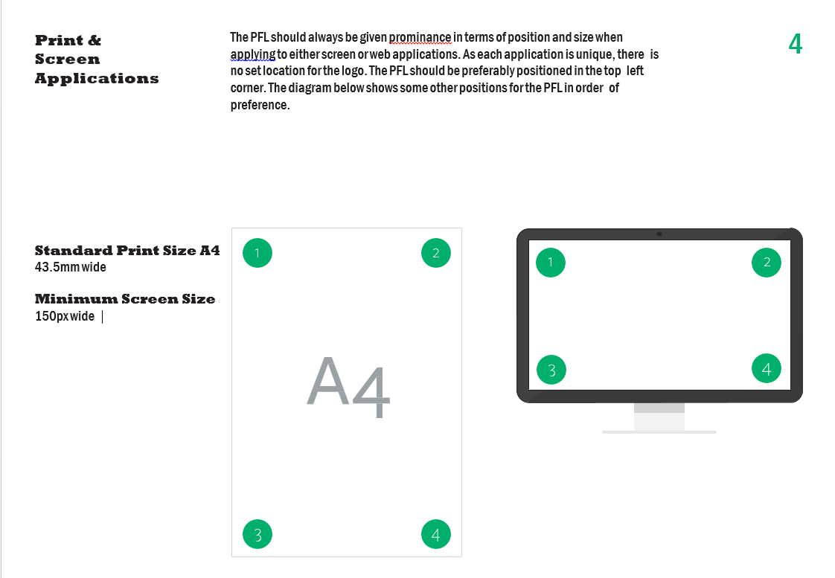

**Stickers** There are two sizes of stickers depending on the application. Both sizes are shown below. Vehicle stickers come in all three colours (Green PFL, White PFL and Black PFL) on a transparent background. Artwork files for the stickers are available upon request

**Stickers Size**  

Vehicle: BLACK LOGO

432mm X 195mm Transparent LOGO

**Schedule 3**

**Document Specification**

1. **Recycling Certificate Example**
   * 1. 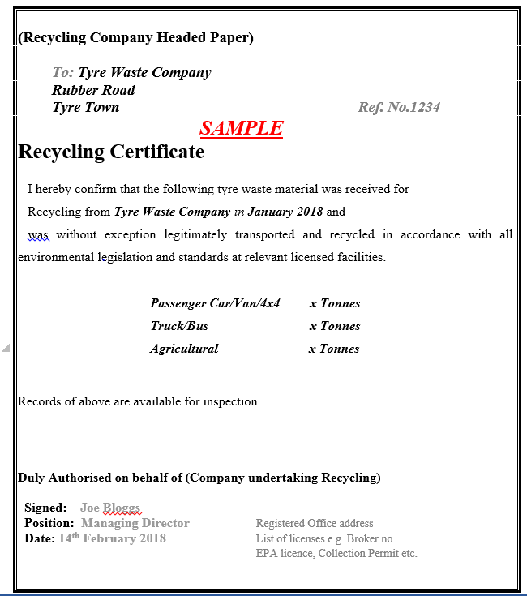b) **Recovery Certificate Example**

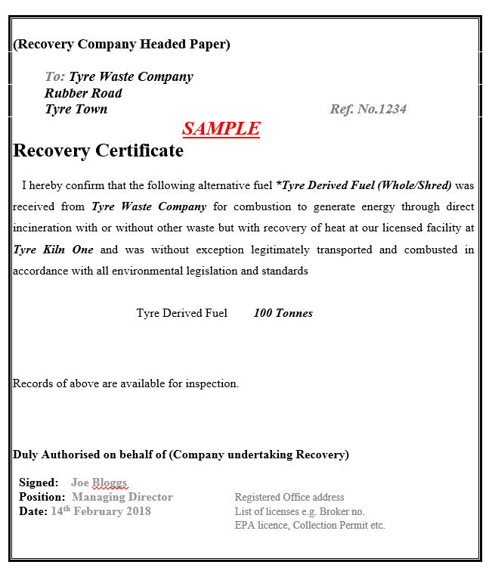

**SCHEDULE 4**

1. Authorised Waste Collector Manual



The manual will cover how to log into the collection portal and manage the information required to submit your monthly claim.

Contents

**LOGGING IN AND LOGGING OUT** 2

**REGISTRATION DETAILS** 3

**CLAIM ENTRY AND SUBMISSION** 4

Waste Tyres Collected 6

Tyres Supplied to Farms 7

Tyres delivered to Recycling/Recovery Facilities 8

Uploading documentation Screen 9

Submit Compliant Claim 10

# LOGGING IN AND LOGGING OUT

Repak ELT will provide an account username and password to the specified person within your organisation. The username and password will be notified to you.

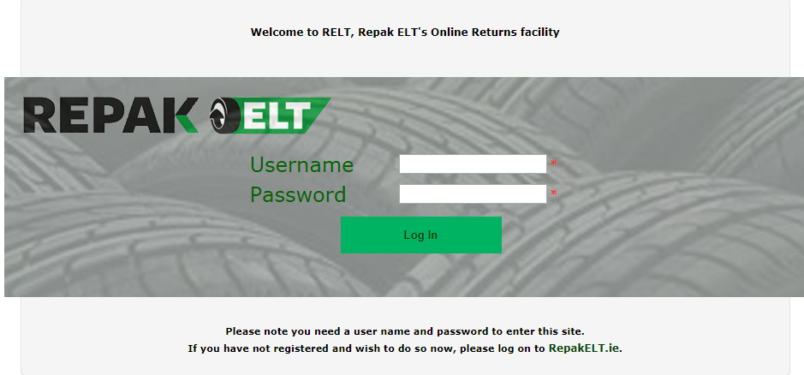

Please note: usernames and passwords are case sensitive, so make sure that any capital letters in your password are inserted as required.

You will be required to create a PIN as part of your login process, this PIN will be known only to the user and is for added security.

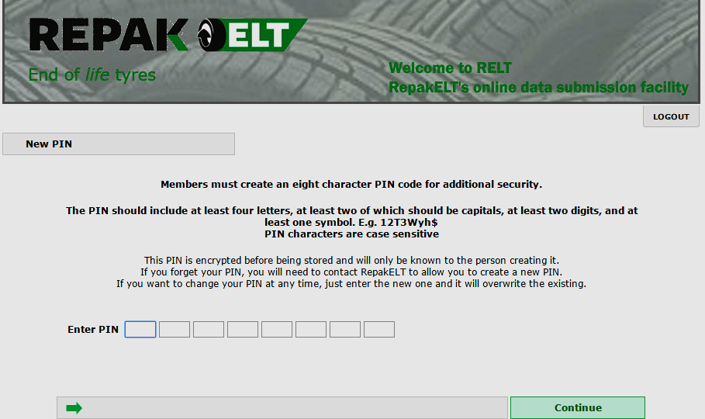

# REGISTRATION DETAILS

At the registration page please fill in any details that are blank such as relevant permit numbers and expiry dates. Updated email addresses and numbers must also be added. Please ensure that this information is accurate and correct. Errors or omissions may result in Repak ELT being unable to notify you of contract issues changes etc. The onus is on the authorised waste collector to ensure that this information is up to date and correct.

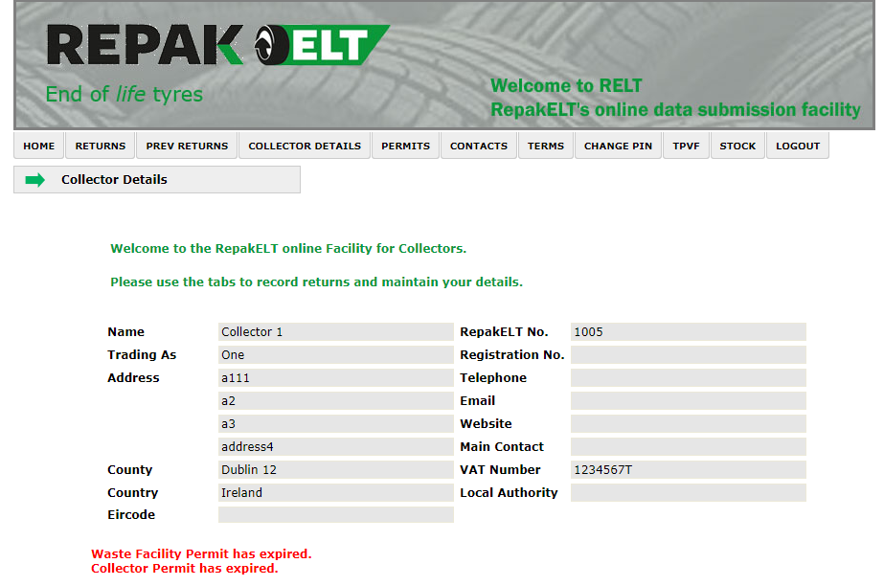

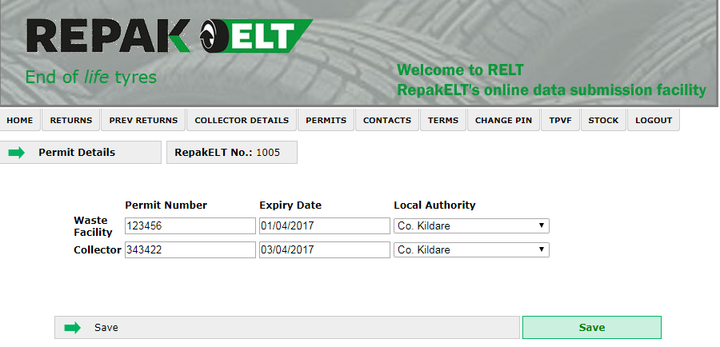

# CLAIM ENTRY AND SUBMISSION

Click in ‘RETURNS’ to make a claim and select the month.

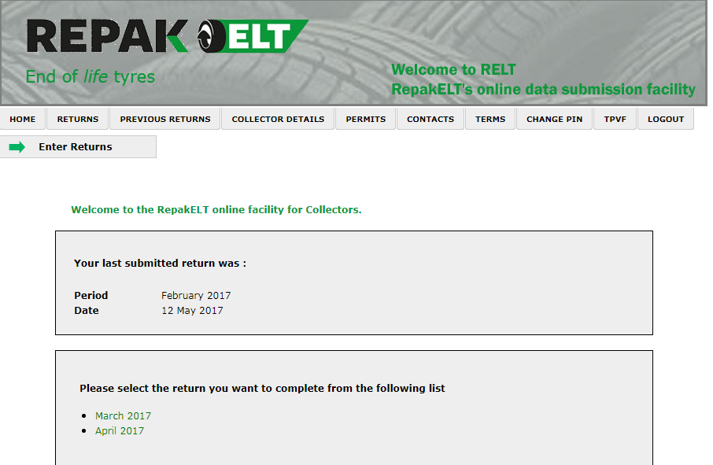

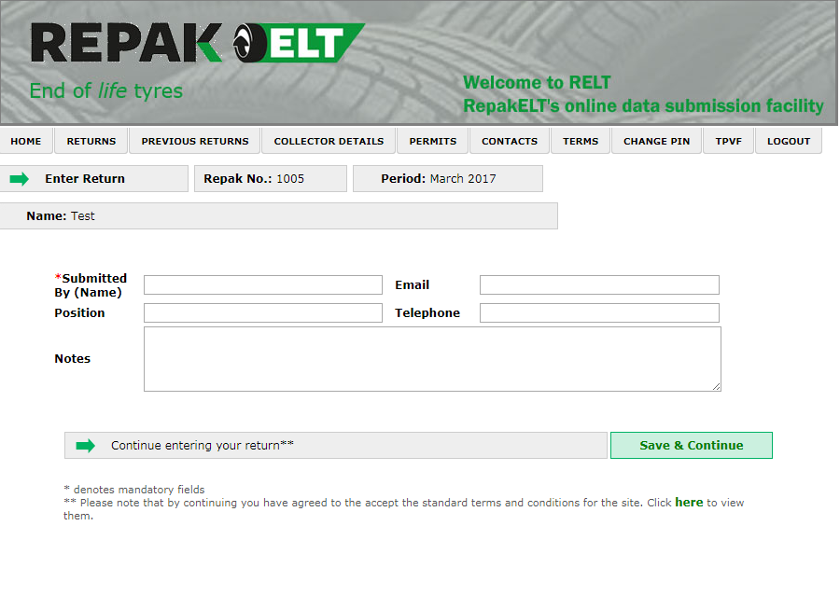

Follow each section starting in section 1 all the way down to submit.

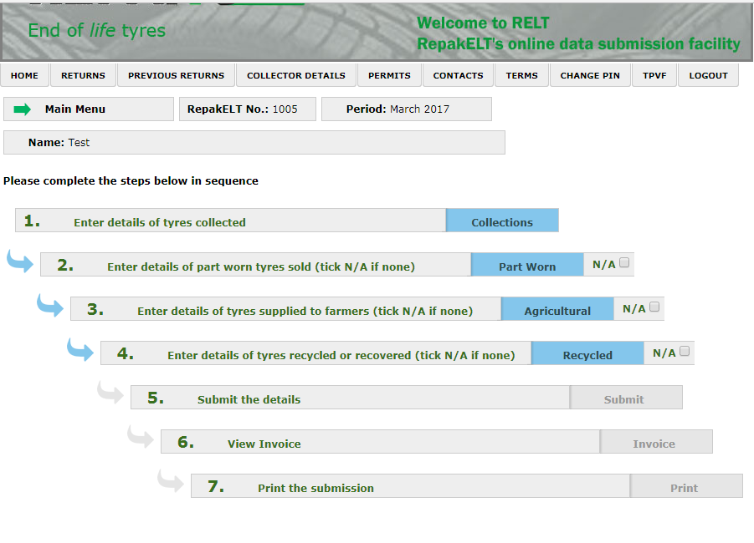

## Waste Tyres Collected

Choose the tyre category and sub category and the outlet from where the waste tyres were collected. The number of tyres must be recorded in units.

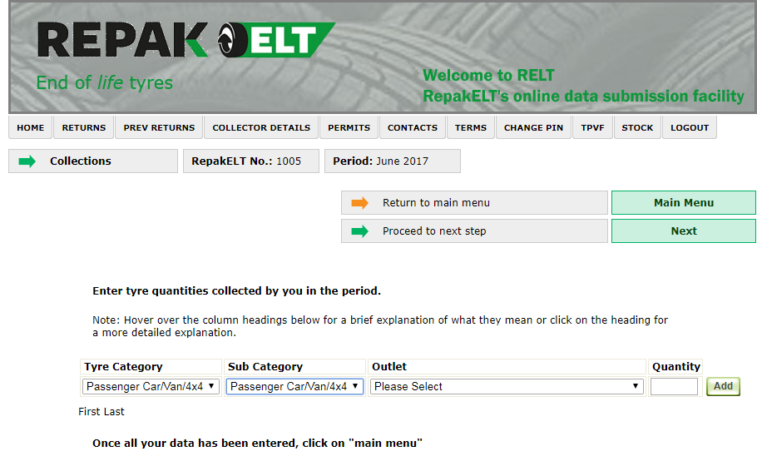

## Tyres Supplied to Farms

Submit details of all tyres supplied to farmers for use on silage pits.

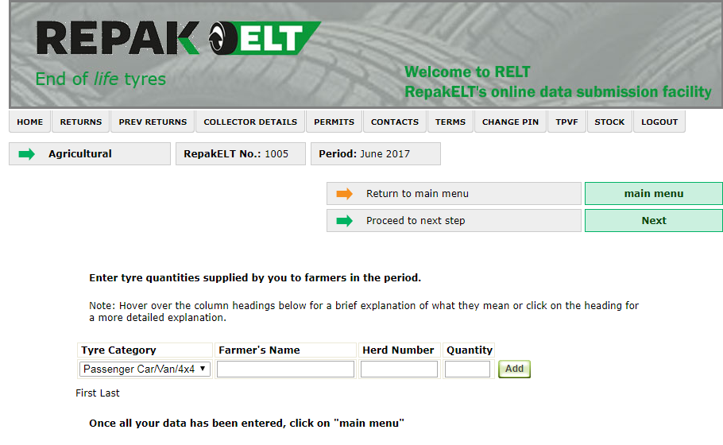

## 

## Tyres delivered to Recycling/Recovery Facilities

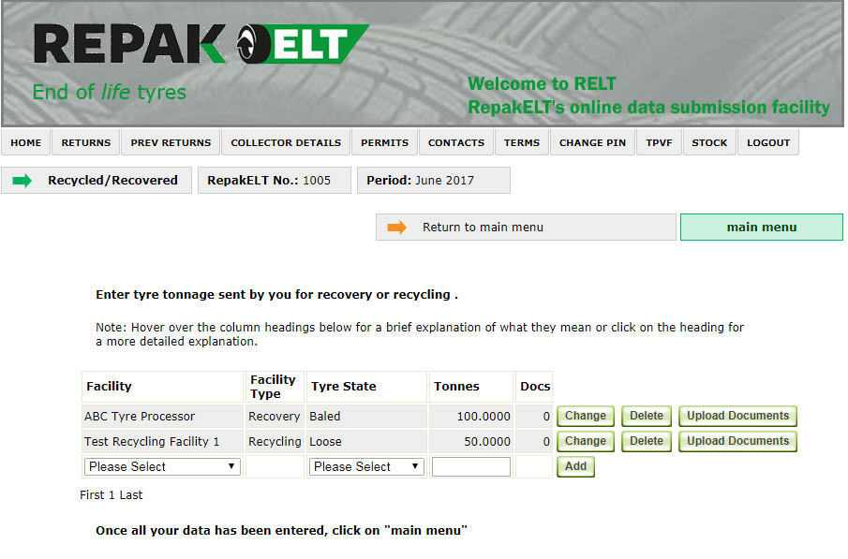

Choose your Repak ELT prior agreed third party facilities and submit the tonnage figures and upload all backup documentation. E.g pdf’s weigh bridge dockets, bills of laden, TFS documents.

## Uploading documentation Screen

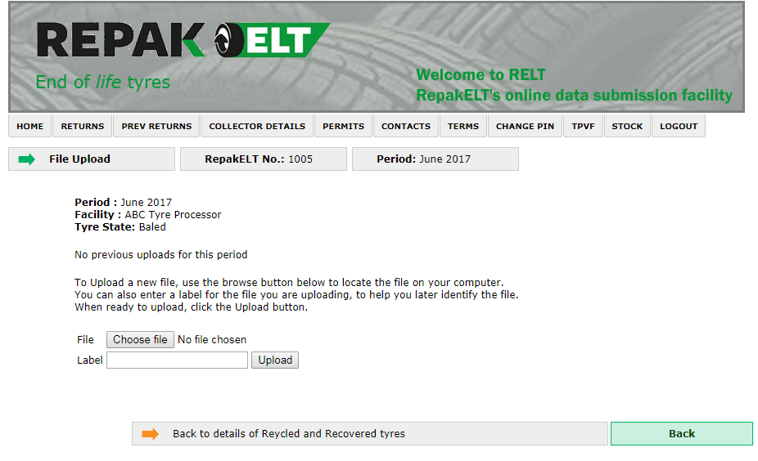

Browse to the location of your documents and then upload.

## Submit Compliant Claim

Once you are happy with all the information that is to be provided, click on the Submit button.



b) ROLC Terms and Conditions



ROLC - Repak ELT Online Claims Facility

1. Introduction

These terms and conditions (the “**Terms**”) govern the use of and access to https://www.rolc.ie, which is operated by Repak ELT, a company incorporated in Ireland with registered number 242159 and a registered address at Red Cow Interchange Estate, 1 Ballymount Road, Clondalkin, Dublin 22 (referred to herein as “**Repak**” “**we**”, “**our**” or “**us**”).

2. Terms of Access to this Site and ROLC

2.2 In consideration of Repak ELT granting approval to you as a Registered Repak ELT Authorised Waste Collector to transmit electronically information required to be included in a monthly claim form it is agreed that access to this website (the “**Site**”) and the use of the Repak ELT Online Claims Facility (“**ROLC**”) is governed by the disclaimers, terms and conditions set out below.

2.3 By using the Site and ROLC,] you agree to be legally bound by these Terms just as if you had signed this agreement.

2.4 These Terms are important and are for the protection of both you and Repak. Please take the time to read them carefully. If you do not agree to these Terms, you should not use the Site or ROLC. By proceeding further you will be deemed to have accepted these Terms.

2.5 These Terms may be supplemented by additional terms and conditions pertaining to specific content, activities and data transmission improvements. You agree and understand that such additional terms and conditions are hereby incorporated by reference to these Terms. In particular when you use the Site and/or ROLC, whether to transmit data to Repak ELT or otherwise, all uses are concluded subject to the Repak ELT Registered Authorised Waste Collector service contract 2015-2018 and you (as a Public Authorised Waste Collector or a Private Authorised Waste Collector, as applicable) (the “**Agreement**”) and nothing in these Terms shall operate to negate or supersede the terms and conditions contained in the Agreement, which are incorporated into these Terms by this reference.

Repak ELT have established a web based claim facility <https://www.rolc.ie> to administer the Repak ELT Payment Scheme. This system provides a secure and efficient method for registered Authorised Waste Collectors/Service Providers to submit their subsidy claims each month.  A number of data checks will interrogate the raw data before the claim is accepted for approval. The facility should also minimise the amount of lost paperwork and will speed up the approval process thus enabling quicker payment schedules.

The website will facilitate all subsidy claims.

The website is secure. As a registered Repak ELT Authorised Waste Collector, you will have an individual account that only your organisation can access.

The system will generate an e-invoice. Once you are satisfied that it is correct, you, or your duly authorised appointee will authorise its submission. Submissions must have attached electronic copies of third party Certificates of Recycling or Recovery and/or summary of weighbridge dockets.

Waste Tyre Recyclers must provide relevant documentation, e.g. sales invoices to demonstrate that the material recycled has been sold to legitimate markets etc.

To facilitate the use of ROLC (Repak ELT On Line Claims) a username and password to access the site is required.

As the Director or duly authorised contact responsible for the provision of services to Repak ELT on behalf of your Company/Council can you please arrange to nominate a user to be authorised by you to access and use the ROLC facility.

To request your username & password, please email rps@repak.ie and give the name of the appointed person who will be submitting the monthly claim.

**N.B**

Because the application will generate an e-invoice, You will need an **invoice number** generated from your companies account package to complete the process.  This number must be unique for each claim. This number must correspond to the reference in your own accounts system.

**3. Intellectual Property**

* 1. Repak ELT (and/or its licensors) retain all rights (including but not limited to, copyrights, patents, trade secrets and all other intellectual property rights) in all versions of ROLC and this Site. Subject to these Terms, we grant you a non-exclusive, non-transferable, limited right to access and use the Site and ROLC and the material displayed thereon for the purposes of ROLC and on the terms set out in the Agreement. However, no right, title, or interest in any such materials will be granted or transferred to you as a result of any permitted use of such materials.
  2. All materials incorporated in or accessible through the Site and/or ROLC, including, without limitation, text, photographs, images, graphics, illustrations, logos, button icons, audio clips, video clips, software, and other content, and the compilation, collection, arrangement, and assembly thereof (including the look and feel of the Site and ROLC), are protected by Irish and international copyright laws, and are owned, controlled or licensed by Repak ELT, or by the original creators of such materials or their permitted licensors. Such materials may be used only for viewing the Site in the ordinary course of transacting business with Repak ELT (as described above). ROLC may only be used by Repak ELT’s employees, Repak ELT registered Authorised Waste Collectors, agents acting on behalf of Repak ELT’s or such third parties as empowered by Repak ELT solely for the purpose of transacting business with Repak ELT. Any other use of such materials, including any copying, reproduction, modification, sale, distribution, extraction, re-utilisation, transmission, republication, downloading, display, posting, performance, or other exploitation thereof by any means or medium without the prior written permission of the copyright owner is strictly prohibited.

1. **Changes to the Site or the Terms**
   1. Repak ELT reserves the right, at its sole discretion, to change, modify, add or remove the information, design and services provided in the ROLC website without notice and without liability. Every effort will be made to advise of changes in advance.
   2. Repak ELT reserves the right, at its sole discretion, to change, add, amend, modify, remove or vary these Terms by publishing notice of such changes on this Site. You should check these Terms periodically for changes, as the continued use of the Site and ROLC will signify your acceptance of the changes, whether or not you have reviewed them.
   3. Repak ELT reserves the right to limit, in its sole discretion, the provision and quantity of any service to any person or geographic area it so desires. Any offer for any service made in or through this Site is void where prohibited. Further, please note that no advice or information, obtained by you from our personnel or through this Site shall create any warranty not expressly provided for in these Terms. These disclaimers apply to the fullest extent permitted by law.
2. **Links from our Site**

Some pages on this Site contain hypertext links to web sites not maintained by us. You are reminded that when you enter other web sites via such hypertext links, you will not be subject to these Terms and you will not benefit from the protections afforded to you in using our Site. These links are provided solely as a convenience to you and not as an endorsement by Repak ELT of the content on such third party websites. Repak ELT is not responsible for the content of linked third party sites and does not make any representations regarding the content or accuracy of materials on such third party websites. If you decide to access linked third-party websites, you do so at your own risk and in accordance with the prevailing terms and conditions of such third party sites. We will not be liable in any way for the content, availability or use of such linked web sites and you use such links entirely at your own risk.

1. **Links to our Site**

No third party is permitted to link any other web site to this Site without obtaining our prior written consent. We reserve the absolute right to refuse to consent to such links without giving reasons. Any links to this Site from another website must be presented in such a manner that the viewing of the Site is not impaired by framing or similar techniques that may impair the visitor’s user experience.

1. Submission of Information to Repak
   1. You are responsible for ensuring that all of the data submitted using this Site for the purpose the ROLC is at all times in compliance with these Terms, [this Site, your Contract with Repak] and is accurate, complete and subject to audit. For the avoidance of doubt, Clause 15 of the Contract (and in particular the Repak ELT rights of audit therein) extends to all information which is transmitted to Repak ELT using the Site or ROLC, in addition to information which is provided in any other manner.
   2. In the event of and in your transmitting material to Repak ELT using ROLC, Repak ELT has no responsibility for the accuracy, veracity and completeness of such material and for any errors in the manner of its input.
2. **Disclaimers of Warranties**

This Site is provided by Repak ELT on an “as is” basis. To the fullest extent permitted by applicable law, Repak ELT disclaims all warranties, express or implied, including, without limitation, implied warranties of merchantability, fitness for a particular purpose, compatibility, security, accuracy or infringement. Neither Repak, any of our affiliates, nor any of our or their respective licensors, licensees, service providers or suppliers warrant that this Site, ROLC or any function contained in this Site or ROLC will be uninterrupted or error-free, that defects will be corrected, or that the Site, ROLC or the servers that make this Site and ROLC available are free of viruses or other harmful components. Repak ELT does not warrant or make any representations regarding the use or the results of the use of the materials incorporated in the Site, ROLC or any third-party Site accessed through this Site in terms of their correctness, accuracy, timeliness, reliability, or otherwise and you will be solely responsible for any damage to your computer system or loss of data that results from the download of any such product, offering, content or material.

1. **Limitation of Liability**
   1. You expressly understand and agree that (to the fullest extent permitted by law) Repak ELT and our affiliates shall not be liable for any indirect, incidental, special, consequential, exemplary or punitive damages, or any other damages whatsoever, including but not limited to, damages for loss of income, profits, goodwill, use, data or other intangible losses (even if we have been advised of the possibility of such damages and regardless of whether such losses are direct or indirect), arising out of, or resulting from:
      1. the use or the inability to use this Site and/or ROLC;
      2. the use of any content or other material on this Site, ROLC or any website or websites linked to the Site;
      3. the cost of procurement of substitute goods and services resulting from any data, information or services obtained or messages received or transactions entered into through or from this Site;
      4. unauthorised access to or alteration of your transmissions or data;
      5. statements or conduct of any third party on our Site and/or ROLC; and/or
      6. any other matter relating to this Site and/or ROLC.
   2. In no event shall our total liability to you for all damages, losses, and causes of action (whether in contract, tort (including, but not limited to, negligence) or otherwise) exceed the amount paid by you to us, if any, for accessing our website or in using the services therein. If you are dissatisfied with any portion of our Site and/or ROLC, or with any of these Terms, your sole and exclusive remedy is the discontinuation of your use of this Site and ROLC. Repak ELT is not responsible for any injury and or damage to any individual as a result either directly or indirectly of any information published on this Site or ROLC. The accuracy of the information is not guaranteed and does not constitute business or other professional advice and is subject to change and therefore Repak ELT cannot accept responsibility for any loss damage or expense incurred upon using the information.
2. **Use of the Site**
   1. You agree not to use the Site or ROLC or cause or permit the Site and/or ROLC to be used:
      1. to gain unauthorised access to our Site, the server on which our site is stored or any server, computer or database connected to our Site;
      2. so as to jeopardise or prejudice the operation, quality or integrity of the Site and/or ROLC, or the operation, quality or integrity of any telecommunications network;
      3. for any commercial purpose including any direct marketing, surveys, contests or pyramid schemes, nor to use the Site and/or ROLC to participate in or cause others to participate in sending chain letters, junk e-mail, spam, duplicative or unsolicited messages, advertising or promotional material;
      4. to harvest or otherwise collect information about others, including e-mail addresses, without their consent;
      5. to distribute, download, upload or transmit any material which contains viruses, trojan horses, worms, time bombs, cancelbots, or any other harmful or deleterious programs; or
      6. Contrary to the terms and conditions of any Internet Service Provider whose services you may use.
3. Privacy

Repak ELT are committed to protecting your privacy and security. All personal data that Repak ELT collect from you will be processed in accordance with Repak ELT’s **Privacy Policy**. You should review Repak ELT’s **Privacy Policy**, which is incorporated into these Terms by this reference.

1. General Terms
   1. Other than with respect to the Agreement (as set out in Clause 2.4 above), these Terms (including the **Privacy Policy**) constitute the entire agreement between Repak ELT and you with respect to your access to and use of the Site and ROLC and any third-party site accessed through the Site.
   2. If any provision of these Terms shall be unlawful, void, or for any reason unenforceable, then that provision shall be deemed severable from these Terms and shall not affect the validity and enforceability of any remaining provisions.
2. **Jurisdiction**

This Site is established in Ireland in accordance with the laws of the Republic of Ireland and is governed by the laws of that country. When you use the Site, you unconditionally and irrevocably accept that your use of the Site and ROLC and any information on the Site and/or ROLC, will also be governed by the laws of Ireland. If any dispute arises from your use of the Site and/or ROLC or any of the information on it, you submit to the exclusive jurisdiction of the Irish courts.

**SCHEDULE 5**

Example of Third Party Verification Form (TPVF)

|  |  |  |  |  |  |  |  |  |  |  |  |  |  |  |  |
| --- | --- | --- | --- | --- | --- | --- | --- | --- | --- | --- | --- | --- | --- | --- | --- |
|  | | | | | | | |  |  | | | | | | |
|  |  | | |  | |  |  |
| eQF145 v.1 | | | | | | |  |
|  |  | | |  | |  |  |
|  |  | | | | | | |
| **Third Party Outlet Verification form for the Recycling or Recovery of Waste Tyres.**  **DIRECTIONS OF USE**  A separate form is required for each facility used by an Authorised Waste Collector. All information fields are to be completed. In the event, the relevant requested information is not applicable (N/A), please enter N/A and the reason why. Provision of inadequate information will delay and or prohibit their use for contract service purposes**. All supporting documentation must be in English.** | | | | | | | | | | | | | | | |
| **Third Party Company Details** | | | | | | | | | | | | | | | |
|  | |  |  |  | |  | |  |  | | |  | |  |  |
| **Registered Name of Company** | | |  | Click here to enter text. | | | | | | | **Registered Business Address** | | | | |
|  | |  |  |  | | | | | | | Click here to enter text. | | | | |
| **Managing Directors Name** | | |  | Click here to enter text. | | | | | | | Click here to enter text. | | | | |
|  | |  |  |  | | | | | | | Click here to enter text. | | | | |
| **Managing Directors Name Telephone Number** | | | | Click here to enter text. | | | | | | | Click here to enter text. | | | | |
|  | |  |  |  | | | | | | |  | | | | |
| **Managing Directors Email Address** | | | | Click here to enter text. | | | | | | |  | | | | |
|  | |  |  |  | | | | | | |  | | | | |
| **Contact Name(s) if different from above** | | | | Click here to enter text. | | | | | | | | | | | |
|  | | | |  | | | | | | | | | | | |
| **Contact Details** | | | | | | | | | | | | | | | |
| **Work Phone Number** | | | | | Click here to enter text. | | | | |  | | | | | |
| **Contact’s E-Mail address** | | | | | Click here to enter text. | | | | |  | | | | | |
| **Contact’s Website Address** | | | | | Click here to enter text. | | | | |  | | | | | |
| **Mobile Telephone Number** | | | | | Click here to enter text. | | | | |  | | | | | |
| **Company Email Address** | | | | | Click here to enter text. | | | | |  | | | | | |
| **Company Registration Number or Other as Appropriate (e.g. Business Licences):** | | | | | | | | | | | | | | | |
| Click here to enter text. | | | | | | | | | | | | | | | |
|  | | | | | | | | | | | | | | | |
| **Relevant Information** | | | | | | | | | | | | | | | |
| **Provide Statement of Function e.g. Processing, Manufacture, Energy generation with recovery (e.g. Combined Heat & Power),** | | | | | | | | | | | | | | | |
| Click here to enter text. | | | | | | | | | | | | | | | |
|  | | | | | | | | | | | | | | | |
| **Licenced Tonnage Capacity (Please provide statement)** | | | | | | | | | | | | | | | |
| Click here to enter text. | | | | | | | | | | | | | | | |
|  | | | | | | | | | | | | | | | |
| **List any international ISO or Other equivalent quality standards** | | | | | | | | | | | | | | | |
| Click here to enter text. | | | | | | | | | | | | | | | |
|  | | | | | | | | | | | | | | | |
| **Licences (Collection, Waste permit, EPA Licences, Broker Certificate, Import licence, business licence, State or local Environmental Regulatory licence (English language), etc.)** | | | | | | | | | | | | | | | |
| Click here to enter text. | | | | | | | | | | | | | | | |
|  | | | | | | | | | | | | | | | |
| **Corporate Social Responsibility – Please provide policy of outlet.** | | | | | | | | | | | | | | | |
| Click here to enter text. | | | | | | | | | | | | | | | |
|  | | | | | | | | | | | | | | | |
| **Demonstration of Due Diligence - Have you visited and inspected the third party outlet? – Provide Statement of confirmation.** | | | | | | | | | | | | | | | |
| Click here to enter text. | | | | | | | | | | | | | | | |
|  | | | | | | | | | | | | | | | |
|  | | | | | | | | | | | | | | | |
| This form and the information contained herein is for REPAK ELT’s internal purposes only to ensure REPAK ELT’s compliance. The Authorised Waste Collector is liable for the veracity and accuracy of the information supplied in this form of which REPAK ELT will not carry out further due diligence. In the event the information supplied in this form is used, interpreted or relied upon by any other party whosoever, they do so entirely at their own risk. REPAK ELT does not accept any liability whatsoever for any loss or damage howsoever arising (including indirect and direct loss), as a consequence of any party using, interpreting or relying on the information as supplied herein. For the avoidance of doubt, the Authorised Waste Collector agrees to indemnify and hold REPAK ELT harmless from and against any and all claims, damages, liabilities, fees, losses, fines, taxes, penalties, and/or expenses, including reasonably and properly incurred legal fees suffered or incurred by REPAK ELT arising from any action, or allegations related to, arising from, or resulting from the Authorised Waste Collector’s supply of information hereto. | | | | | | | | | | | | | | | |
| We accept full liability associated with the use of this third party and that Repak ELT have no liability or responsibility in respect of same. | | | | | | | | | | | | | | | | |
|  | |  |  |  | |  | |  |  | | | |  |  |  |
| By ticking this box we confirm and accept the Terms and Conditions above. | | | | | | |  |  | | | | | | | |
|  | |  |  |  | |  | |  |  | | |  | |  |  |
| **Date** | Click here to enter text. | | | | | | | | | | | | | | |
|  | | | | | | | | | | | | | | | |
| Should you have any queries completing this form, please contact Mark Gillick on 01 461 8600 or mark.gillick@repakelt.ie | | | | | | | | | | | | | | | |

**SCHEDULE 6**



REPORTING REQUIREMENTS

* Report to be Complete by the 15th of every month
* All reporting will be online electronic format only
* Reporting will include tyres:
  + Collected by Unit by category from a retailer
  + Tyres supplied to Farmers (co-ordinated through Repak ELT)
  + Tyres resold as part worn
  + Waste tyres by weight received into a verified facility by category
* Report waste collected for previous periods from Retailers
* Report destination of waste (facilities used in Ireland or abroad)
* Report waste tyres supplied to farmers (Farmers will register with Repak ELT through an online form on [www.repakelt.ie](http://www.repakelt.ie))
* Supply supporting documentation (e.g. Recycling Certs, Recovery Certs, Annex VII forms, TFS Trans Frontier Shipments)

**SCHEDULE 7**

* + 1. Environmental, Health and Safety (EHS) Policy



**Environmental, Health & Safety Policy.**

Repak ELT are committed to the highest standards of Environment, Health and Safety (EHS) performance across our business. Our goal is to protect people, minimise harm to the environment and contribute towards sustainable waste management. We seek to achieve continuous improvement in EHS performance.

This EHS policy is reviewed periodically to ensure its ongoing suitability and effectiveness. Everyone in Repak ELT has individual authority, responsibility and accountability for the safety of themselves and others, and an obligation to actively participate in promoting an effective EHS culture. We will regularly set and review our EHS objectives and targets with the aim of driving continuous improvement in EHS knowledge and performance.

Repak ELT expects all registered Authorised Waste Collectors to understand and fully comply with all applicable international, national, state and local laws and regulations, including, but not limited to, all Environmental, Health and Safety and related laws and regulations. In addition, Authorised Waste Collectors must agree to abide by all Repak ELT agreement conditions, including but not limited to, all applicable EHS policies, procedures and guidelines.

Repak ELT Authorised Waste Collectors must also:

* Agree to be fully responsible and indemnify Repak ELT for any liability resulting from the use, handling or transportation of non-hazardous and hazardous materials by the Authorised Waste Collector or their contractors, and;
* Have in place, management, control and continuous improvement systems to effectively manage their functional operations and Waste Tyres recovered and recycled.

Repak ELT undertakes where applicable auditing to due diligence standard of Authorised Waste Collectors. EHS management is a principal component of the audit system.

Repak ELT will cease business with the Authorised Waste Collector in the event of persistent audit failure particularly of the EHS element and of any activity been undertaken by the Authorised Waste Collector or their agents if there is an unacceptable risk of accident or environmental incident.

* + 1. Corporate & Social Responsibility (CSR) Policy



**Corporate & Social Responsibility Policy**

Repak ELT’s policy is to conduct all our business operations to best industry standards and practices. Integrity is a core element of Repak ELT’s business and operational competency model. A key feature of this is that all business interactions will be discharged in a socially responsible manner. Our goal is to behave ethically and with integrity in the communities where we work directly and indirectly, and to respect cultural, national and religious diversity.

We meet our responsibilities through compliance with relevant legislation, applying appropriate national and international standards and establishing management control systems throughout Repak ELT and via contracts with third parties.

Company personnel and Repak ELT registered Authorised Waste Collectors are responsible for ensuring compliance with this policy, and specifically to:

* Respect the rights of all employees, treating them fairly and without discrimination
* Commit to providing opportunities for staff development
* Provide equal employment opportunities
* Recognise individual and team contributions
* Encourage interactive team work
* Ensure compliance with Repak ELT’s EHS policy by all personnel involved in our activities
* Provide clear direction on key CSR initiatives, policies, performance data and targets
* Demonstrate an active process that underlines Repak ELT’s ethical activities
* Actively engage with fellow stakeholders in areas where we operate
* Support selected social and community development projects
* Maintain high ethical standards in all our relationships

Repak ELT is committed to continuous improvement in all its standards and practices.

IT - System

* Portal Program
* XXXX – Mobile
* Hardware – Network etc.