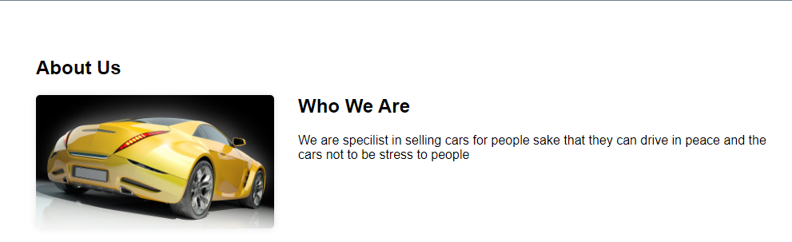We are the car directors of 2022/2023 we are going to help a costumer in whatever car he want to buy and tell the costumer on how to use the car he choose