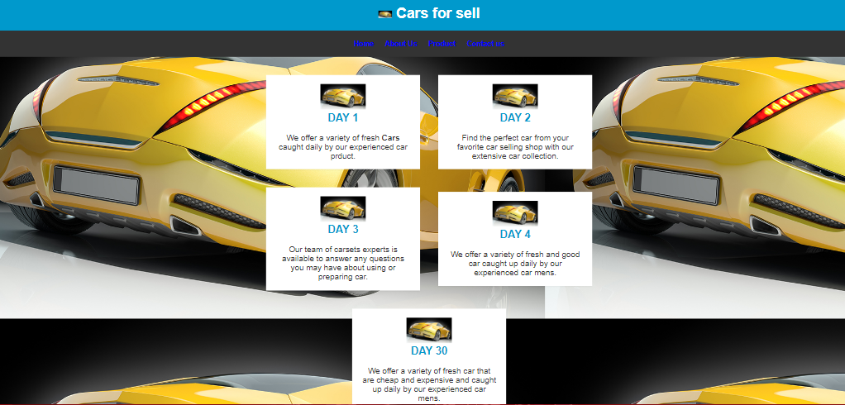My website is all about cars for selling, we sell high quality of cars and I will give you an example

Like Peugeot, Benz, Toyota, BMW, Honda and other type of cars you want to buy Thank You