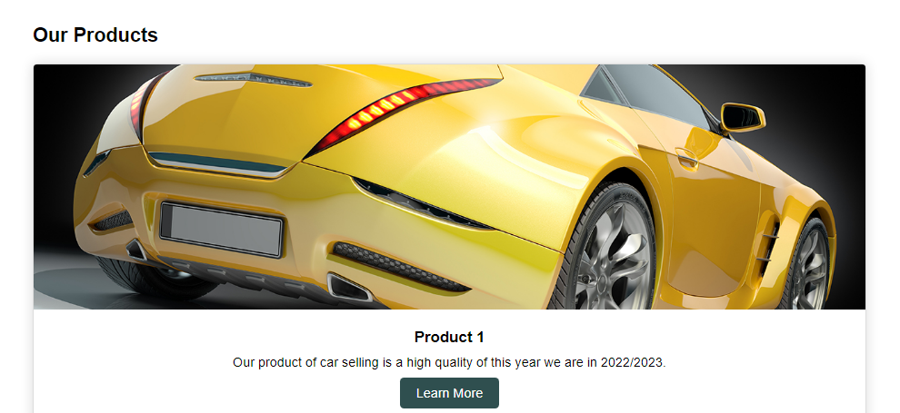

Our products for this year is high and good quality of car selling and I hope you buy our cars of this year of 2022/2023.