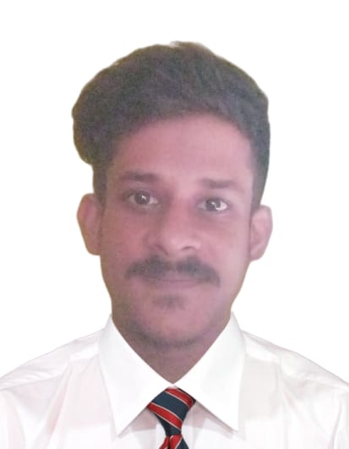Phone: +91 6290070893  
Email: alivroy25@gmail.com  
Address: Madhyamgram bankimpally, Kolkata – 700-129

## Career Objective

Motivated B.Tech Computer Science student at BWU (Barasat) with a strong foundation in full-stack development and backend technologies. Eager to contribute to dynamic tech teams and enhance skills in real-world software engineering environments.

## Education

• B.Tech in Computer Science and Engineering- BWU (Barasat) | 2022–2026 | Pursuing

• Higher Secondary-Madhyamgram High School (WBSE) | 2021 | 81.7%

• Secondary Education,- Madhyamgram High School ( (WBSE) | 2019 | 76.8%

## Skills

• Programming: C, Python

• Frontend: HTML, CSS, JavaScript, React

• Backend: Node.js, MySQL,Express, MongoDB

• Tools: Git, GitHub, VS Code

## Projects

1. Full-stack Web Application – Built using HTML, CSS, JS, and React.

2. Research Project (7th Sem) – Workin on creating a website using front-end & back-end frameworks in a team of four.

## Internships & Training

•Pursuing from Intel

## CSR & Extracurriculars

• Participated in Tree Plantation Program organized by university

• Organized Blood Donation Camp

• Participated in Inter-college cricket tournament

Date-13.07.2025