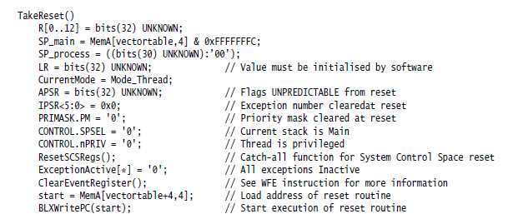

**------------------------------------------------------------------------------------------------------------------------------------------------**

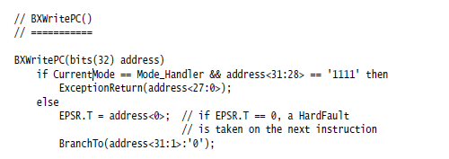

**------------------------------------------------------------------------------------------------------------------------------------------------**

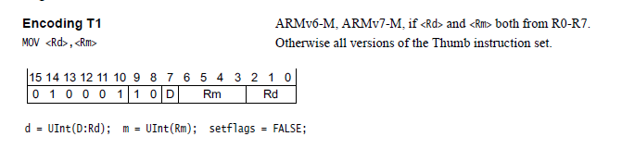

46C0 🡪 0100_0110_1100_0000 Rm=1000 Rd=1000

**-------------------------------------------------------------------------------------------------------------------------------------------------**

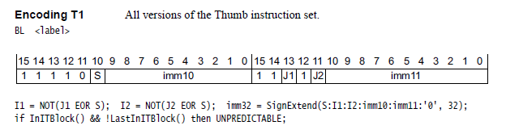

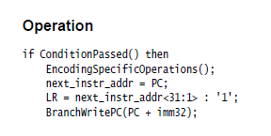

-----------------------------------------------------------------------------------------------------------------------------------------------------

F7FF_FFCE 🡪 1111_0111_1111_1111_1111_1111_1100_1110

J1=1, J2=1, S=1, I1=1, I2=1,

imm32= 1111111_111_1111111111_11111001110_0= 1111_1111_1111_1111_1111_1111_1001_1100=FFFF_FF9C

PC = 0000_00A0 + 0000_0004 = 0000_00A4,

**LR=0000_00A5**

PC=0000_00A4 + FFFF_FF9C = 0000_0040

-----------------------------------------------------------------------------------------------------------------------------------------------------

F000_F80B 🡪 1111_0000_0000_0000_1111_1000_0000_1011

J2(11)=1, J1(13)=1, S(10)=0, I1=0, I2=0,

imm32= 0000000_000_0000000000_00000001011_0= 0000_0000_0000_0000_0000_0000_0001_0110=0000_0016

PC= 0000_0040 + 0000_0004 = 0000_0044

**LR=0000_0045**

PC=0000_0044 + 0000_0016 = 0000_005A

**-------------------------------------------------------------------------------------------------------------------------------------------------**

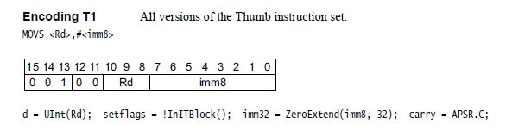

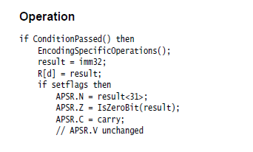

2001 🡪 0010_0000_0000_0001

Rd = 0, imm8 = 0000_0001

**R0 = 1**

**-------------------------------------------------------------------------------------------------------------------------------------------------**

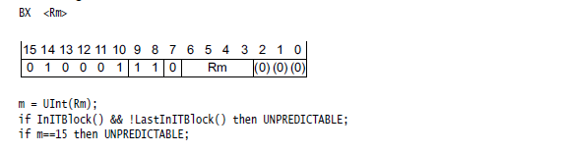

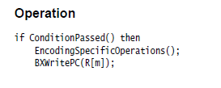

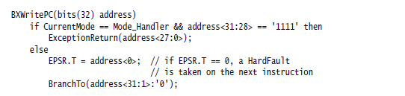

4770 🡪 0100_0111_0111_0000

Rm = 14

**PC =** **0000_0044**