**AGA 222: (PRINCIPLES OF ANIMAL PRODUCTION)**

**B. Agric. 2 (2 CREDIT UNITS)**

**SNAILS**

Snails are cold-blooded invertebrate animals, possessing soft, un-segmented, slippery skinned asymmetrical body which is enclosed in segmented calcareous shells that are also asymmetry. They belong to the phylum Mollusca and are the largest and most diverse animal group of molluscs in terms of species. They constitute the largest animal group after arthropods. Snails possess an enormous diversity and form a colossal biomass in nature. They are either terrestrial or aquatic in habitation. Snails possess segmented exoskeleton in form of calcerous shells marked with whorls separated by sutures. Our concern for this course shall be the edible terrestrial or land snails.

The bulk of snails consumed in Nigeria are picked from the wild and sold in local markets or along roadsides by gatherers. However, snail farming in Nigeria has gradually emerged as a domestic mini-livestock of importance and one of the new brides of animal agriculture. Interest in snail farming and snail-based research in Nigeria were aroused after the Food and Agriculture Organization (FAO) raised alarm on the animal protein intake deficiency status of Nigerians in the early 1980s. At present, snail farming is being approached as a hobby by interested individuals, while commercial or large scale are expected to spring up when many people eventually come to appreciate the advantages of snail rearing in Nigeria. A significant amount of snail research is ongoing in Nigeria, aimed at increasing the availability of good species at affordable price. The domestication of snails will also conserve and safeguard them against the threat of extinction posed by human activities (deforestation, slash-and-burn agricultural practice, pesticides usage, high rate of human predation or over-harvesting (collection of snails before maturity) and habitat development, expansion, degradation, fragmentation or complete destruction of agricultural lands), climate change and other anthropogenic factors.

**DESCRIPTION**

Snails are ‘belly-footed’ animals and are therefore referred to as Gastropods. The snail consists of two main parts: the hard shell and the soft body. The snail’s hard spiral shell is a whole psychedelic world of its own and constitutes about 30 – 40 % of the whole body, protecting the soft body against desiccation and osmotic changes. The shell can be of different shapes and consists of the apex, the segmented whorls, the suture (the point of attachment of the whorls) and the aperture (the shell ‘mouth’ where the snail body (foot) emerges to the external). It can be a single shell that is rounded, spiral high and pointed at the apex or it can be flat. Most snails have shells that coil to the right-hand-side (i.e. right-handed or dextral shells), while others have shells that coil to the left-hand-side (i.e. left-handed or sinistral shells). The external morphology of a typical snail shell is shown in Plate 1. The soft body which makes up about 55 – 70 % of the whole body consists of the head, the muscular foot (constituting about 35 – 40 % of the entire body) and the visceral mass (confined entirely in the shell and constitutes about 20 – 25 % of the entire body). The snail’s muscular foot can be black, grey or white in colour. Based on the variations in foot (skin) colour, snails have been referred to “ectotypes” because they are terrestrial, have exoskeleton and are not limited in existence (occurrence) to any particular ecosystem, as do the Nigerian local chickens.

Snails are most active at night and on cloudy days, meaning that snails are nocturnal animals. They do not like sunshine, hot or dry conditions. Temperature and moisture, rather than light, are the main factors that account for their nocturnal habits.



columella truncation

body whorl

**Plate 1: External Morphology of a Snail**

**Source:**

**CLASSIFICATION**

Edible terrestrial or land snails consist of two main families; Achatinidaeand Helicidae, and they have approximately about 100,000 species. The family Helicidaeis native over a large part of Europe, while Achatinidaeis native to Africa. The Achatinidae family could be referred to as giant African land snails [*Archachatina marginata* (*A. marginata var. ovum* and *A. marginata var. saturalis*), *A. degneri, Achatina* species (*A. achatina* and *A. fulica*)] or garden snails [*Limicolaria* species (*L. aurora, L. martensi and L. flammea*)] and are found mostly along the coastal zones of African countries. They have however spread with commerce to Southeast Asia and the Pacific islands where they act as crop pest. Some of these snail breeds, species and ectotypes are shown in Plates 2 – 6 below.

The taxonomic classification of land snails is shown below.

Kingdom Animalia

Phylum Mollusca

Class Gastropoda or Univalves

Sub-class Heterobranchia

Order Pulmonata

Infra order Stylommatophora

Family Helicidae Achatinidae

Genus *Helix* *Cepaea* *Otala* *Theba* *Achatina* *Archachatina* *Limicolaria*

Species*H.pomatia* *C.hortensis* *O.lactea* *T.pisana* *A.achatina* *A.marginata* *L. martensi*

*H. aspersa* *C.nemoralis* *O. vermiculata*  *A. fulica* *A. degneri* *L. aurora*

*H. aperta* *O. punctata* *A.balteata*  *A.ventricosa* *L. flammea*

*H. lucorum* *A. monochromatica*

*H. adanensis* ­

**Sources: Pilsbry (1986), Okon and Ibom (2012)**

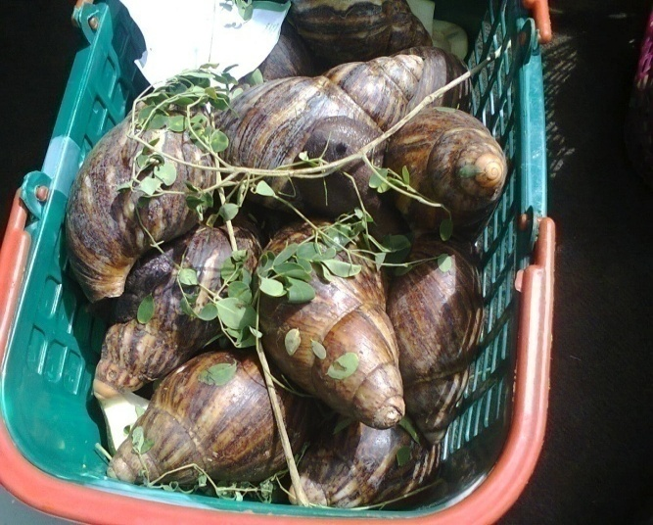 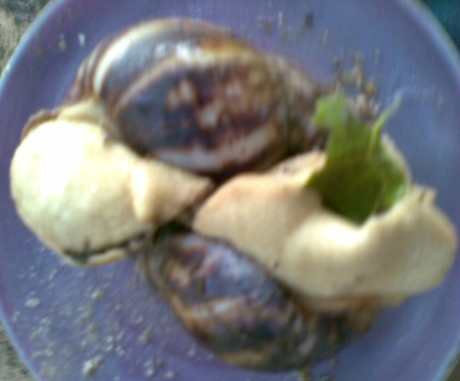

Black skinned *A. marginata*  White skinned *A. marginata*

**Plate 2: *Archachatina marginata***

**Sources: Ibom (2009), Ibom (2014)**

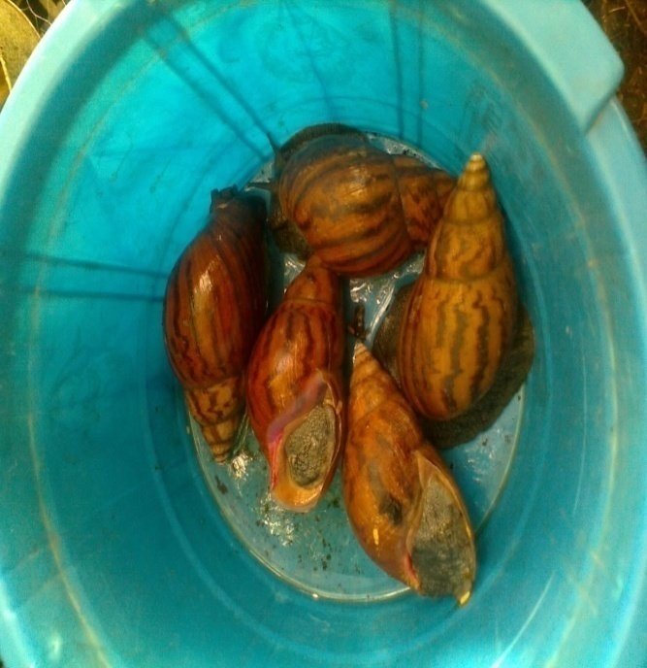 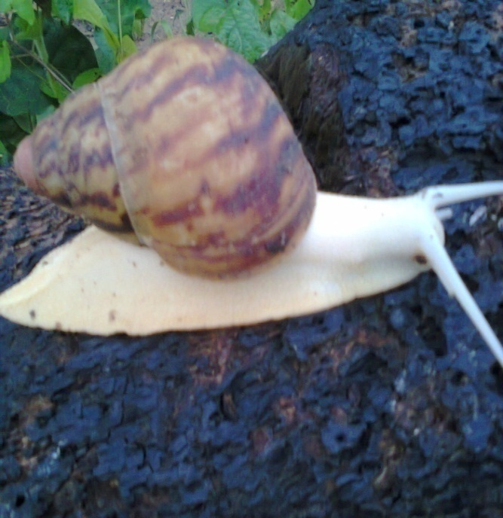

Black skinned *A. achatina*  White skinned *A. achatina*

**Plate 3: *Achatina achatina***

**Source: Ibom (2014)**

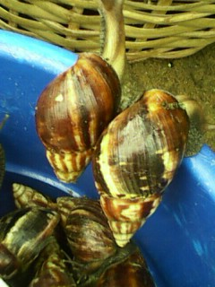 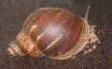

**Plate 4:** *Achatina fulica* **Plate 5:** *Archachatina degneri*

**Sources:** Ibom (2014), www.PetSnails.co.uk

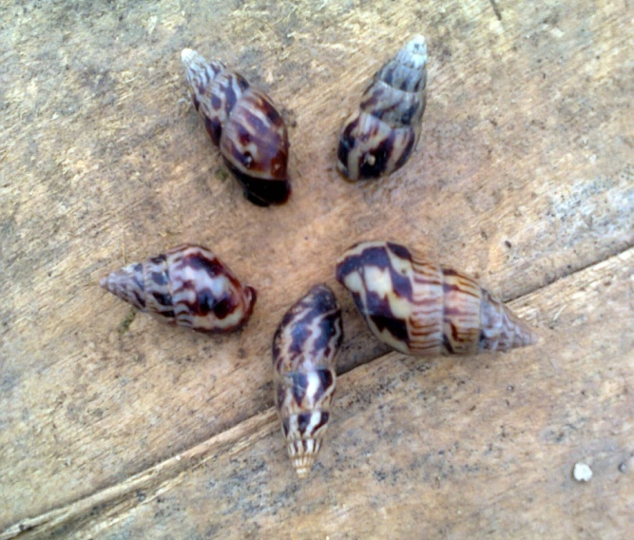 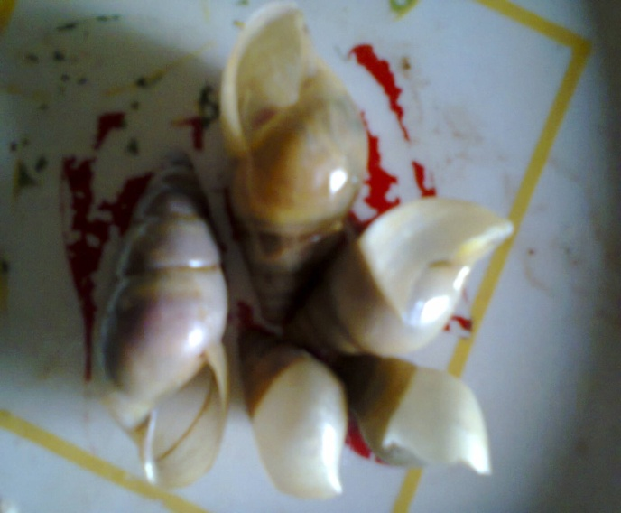

(A) *Limicolaria martensi*  (B) *Limicolaria aurora*

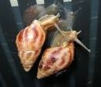 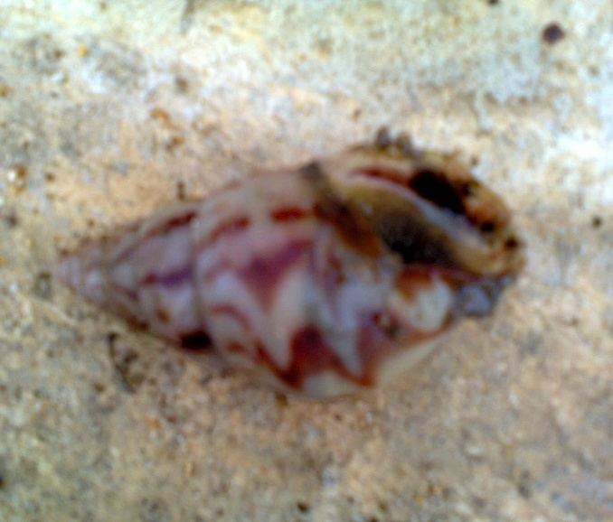

(C) *Limicolaria flammea*

**Plate 6: *Limicolaria* species**

**Source: Ibom (2014)**

**DISTRIBUTION**

Edible land or terrestrial snail species are either exotic (European) or local (African) in origin. The African land snails, especially giant African land snails (GALS) have spread with commerce to other parts of the world. Be they African or European land snails, they prefer moist areas and are seen commonly during the periods of abundant rain fall (i.e. rainy season). From the foregoing, land snails dwell mostly in the forest zones of the world. However, snails are very adaptable to times of drought and adverse climatic conditions. Native snails may be found everywhere but prefer habitats offering shelter, adequate moisture, abundant food supply and an available source of lime.

The family Helicidae is native to Europe, while the family Achatinidae is native to Africa. The most popular and most farmed among the Helicidae family is the genus Helix. In the Achatinidae family, the genera *Achatina*, *Archachatina* and *Limicolaria* are popular. The genera *Archachatina* and *Achatina* are regarded as the giant African land snails (GALS) and have emerged as micro-livestock of importance in Nigeria and other parts of Africa. They are also the most farmed, perhaps because of their size and longevity. The genus *Limicolaria* is referred to as garden snails and does not live as long as the GALS. Table 1 below shows the place of origin and distribution of some land snails.

**Table 1:** Places of origin and distribution of some land snails.

|  |  |  |  |
| --- | --- | --- | --- |
| **AFRICAN SNAILS** | | | |
| Genus | Name | Area of origin | Distribution |
| *Archachatina* | *A. marginata* | West Africa (Nigeria, Togo, Cote d’Ivoire, Liberia, Benin Republic, Sierra Leone), Zaire. | Ghana, Annobón and São Tomé, Cameroon, Congo, Fernando Po, Guinea, Germany, Gabon, Southeast Asia, The Pacific islands. |
|  | *A. degneri* | Guinea, Ghana, Togo, Benin Republic. | Nigeria. |
|  | *A. ventricosa* | Cote d’Ivoire, Liberia, Sierra Leone. | India. |
|  | *A. papyracae* | Cameroon. |  |
|  | *A. bicarinata* | Gulf of Guinea Islands, West African countries. |  |
|  | *A. gabonensis* | Gabon. |  |
| *Achatina* | *A. achatina* | Benin Republic, Ghana, Nigeria, Togo, Sierra Leone, Liberia, Cote d’Ivoire, Guinea, Cameroon. |  |
|  | *A. fulica* | South of the Sahara in East Africa (Kenya, Tanzania), Liberia, Cote d’Ivore. | Ghana, Somalia, Asia, The Pacific and Indian Ocean Islands, West Indies, California, Hawaii, North Miami, Florida. |
|  | *A. balteata* | West African Countries (Cote d’Ivoire), Angola, Zaire, Gabon, Congo, Cameroon, Gabon, Equatorial Guinea. |  |
|  | *A. monochromatica* | West African Countries (Southern Benin Republic). |  |
|  | *A. tinita* | Angola, Zaire. |  |
| *Limicolaria* | *L. martensi* | West African Countries. |  |
|  | *L. aurora* | – do – |  |
|  | *L. flammea* | – do – |  |
| **EUROPEAN SNAILS** | | | |
| *Helix* | *H. pomatia* | Large parts of Europe. | U. S. (Michigan and Wisconsin). |
|  | *H. aspersa* | Mediterranean shore, Coasts of Spain and France. | South Africa, Britain, Western Europe, Haiti, New Zealand, Atlantic Islands, Mexico, Chile, Argentina, California, Columbia, Canada, New Jersey. |
|  | *H. aperta* | France, Italy, Mediterranean countries. | California, Louisiana. |
|  | *H. lucorum* | Italy, Yugoslavia. | Turkey, Black Sea area. |
|  | *H. adanensis* | Turkey. |  |
|  | *H. cibata* | – do – |  |
|  | *H. mucula* | Europe, Middle East. |  |
| *Cepaea* | *C. hortensis* | Central and Northern Europe. | New Hampshire, Maine, Massachusetts. |
|  | *C. nemoralis* | Central Europe. | U. S., California, Canada, Tennessee. |
| *Otala* | *O. lacteal* | Spain. |  |
|  | *O. vermiculata* | Mediterranean countries. | Louisiana, Texas. |
|  | *O. punctata* | Spain. |  |
| *Theba* | *T. pisana* | Sicily. | England and several European countries. |

**Source: Okon and Ibom (2012)**

**CHARACTERISTICS OF SNAILS**

1. Snails are shell-bearing animals.
2. They possess whorls separated by sutures along the shell length.
3. The helically coiled shell is one of snails’ chief distinguishing features.
4. Both the soft body of snails and their shells are asymmetry.
5. Their movement is slow and effected by means of belly-foot.
6. They are cold-blooded invertebrate animals.
7. They are hermaphrodites but practice sexual reproduction.
8. They are highly prolific, with high fecundity.
9. They lay eggs and produce their young ones through hatching of such eggs.
10. They produce large number of offspring and have variable heritable characteristics.
11. They are not plagued with the problems of adaptation as do poultry since they are indigenous to the environment.
12. They are nocturnal in nature, being active in the night.
13. They are monogastric herbivores with a wide nutritional intake.
14. Snail production is environmentally friendly since they do not make noise and do not smell.
15. The droppings of snails is rich in nutrients and so can be used as a good source of fertilizer for crop production.
16. Snails can constitute pests of agricultural crops.

**MANAGEMENT PRACTICES AND SYSTEMS OF SNAILS PRODUCTION**

The process of farming or raising land [snails](http://en.wikipedia.org/wiki/Snail) in captivity (confinement) specifically for human consumption, and more recently, to obtain [snail slime](http://en.wikipedia.org/wiki/Snail_slime) for making [cosmetics](http://en.wikipedia.org/wiki/Cosmetics) and for the pharmaceutical industry is termed **Heliciculture** or **Achatiniculture** or **Snailery** or **Snail farming.** The names Heliciculture and Achatiniculture reflect the two snail families [Helicidae (European land snails) and Achatinidae (giant African land snails)] respectively being farmed at present. Heliciculture is to the European land snails, while Achatiniculture is to African land snails.

Successful snail culture requires the correct equipment and supplies [[snail pens](http://en.wikipedia.org/w/index.php?title=Snail_pens&action=edit&redlink=1) or enclosures; devices for measuring humidity ([hygrometer](http://en.wikipedia.org/wiki/Hygrometer)), temperature ([thermometer](http://en.wikipedia.org/wiki/Thermometer)), soil moisture, and light; a weighing scale and an instrument to measure snail size; a kit for testing soil contents; a magnifying glass to see the eggs and quality feed]. Snails can be kept in a variety of housing; in-doors and out-doors. The housing structure used for snail is called **snailery**. There are three main systems of housing snails. Namely: extensive or pasture system, semi-intensive system and intensive system. These systems of snail farming or management can be further divided into two types, namely part life-cycle snail farming and complete life-cycle snail farming.

The part life-cycle snail farming system is a simple system that involves buying juvenile or grower snails at cheap rates in periods of abundance (rainy season) from snail gatherers. These are then fattened and sold when the price has sufficiently risen in periods of scarcity (dry season) in order to make profit. This system does not include the reproductive phase of snails.

The complete life-cycle snail farming system encompasses the reproductive and growth phases of snails. Grower or mature snails are procured, bred in the farm and their offspring sold when they attain market size, usually at 2 or 3 years of age for the Helicidae family (European snails) and 7 to 12 months of age for the Achatinidae family (giant African land snails). In this system, intensive care of snails is a sine qua non. This is the system recommended for commercial or large-scale snail farmers because the reproductive performance of snails yields higher snails than in the part life-cycle snail farming. Irrespective of the system of management to be adopted, the piece of land to be used as snailery must be treated with any good disinfectant, insecticide and nematicide. The disinfectant should be dosed at the rate of 1 kg of active material per 100 m2 of land and left for not less than two weeks. Thereafter, the land should be cleared of trees stumps, and lime added. It should be ploughed and left for another two weeks before stocking.

**Extensive or pasture system:** The extensive system can also be referred to as out-door rearing system. The perimeter of the land to be used should be fenced round preferably with galvanized steel sheets reinforced with mosquito net to keep in snails and keep out predators. Devices to prevent the snails escaping from the tops of the fences should be considered when constructing the snailery. A drainage system should be constructed round the fence. The recommended stocking rate for this structure is one mature snail per square meter. However, the stocking rate of snails in a snailery depends essentially on the amount of available food and the ground space available for burrowing and egg-laying activities. After stocking the snailery in the extensive system, the snails are not provided any care. They feed only on the leaves and fruits of established plants and depend on the rain water as in their natural habitat. The core benefit of this system is that it is inexpensive to maintain because of the low labour and general management inputs. The main feature of this system is that it requires an expanse area of about 25 m2 and/or 50 m2 enclosed round with wire mesh fence fortified with mosquito nets. The disadvantages associated with this system are: the performance of the snails is not monitored, there is no control on weeds, predators, parasites and diseases, and too much of space is required.

**Semi-intensive system:** The semi-intensive system is also an out-door rearing system. It is like the extensive system, except that the snails are supplied with feeds and water in addition to what is available in the snailery. Besides, paddock and shade trees are planted to protect the snails from direct sunlight during the dry season and heavy rainfall during the rainy/wet season. The shade trees will also simulate, as near as possible, the conditions in which snails are found in their natural habitat. The number of snails to be stocked under the semi-intensive system is determined by the sizes of the snailery and the snails to be stocked. The stocking density could range from 100 – 200 snails. Out-door snail (semi-intensive) rearing can be carried out in the facilities (Plates 7 – 9) showed below.

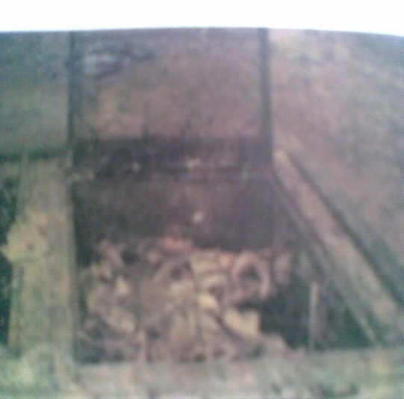 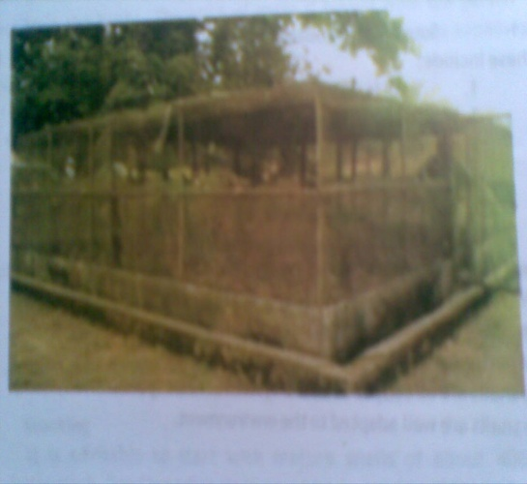

**Plate 7:** Low fenced pen. **Plate 8:** High fenced pen.

Source: Okon and Ibom (2012)

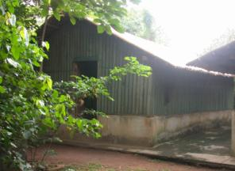

**Plate 9:** Snailery

Source: Cobbinah (2014)

**Intensive system:** The intensive system can also be referred to as in-door system. In this system, the snails are managed intensively (providing feed and water regularly). In-door rearing involves housing snails in containers and/or tanks that must be large enough to accommodate them and provide good [ventilation](http://www.petsnails.co.uk/care/equipment.html#e_heat). Such enclosures must be big enough to give them plenty room to move around and explore, must be secure (escape-proof) with ventilated lid. Snails are extremely strong and are capable of lifting weights that are 10 – 50 times their own weight. This means they could lift a lid that is not clipped or weighted down.

Enclosures should be positioned in a humid area, preferably under trees shade and out of direct sunlight and heavy rainfall. The stocking density of snails under the intensive system is determined by the sizes of the enclosure and the snails to be stocked. For instance, the old drum enclosure can hold four to five mature snails. Plates 10 to 15 show some enclosures that can be used to house snails in-doors.

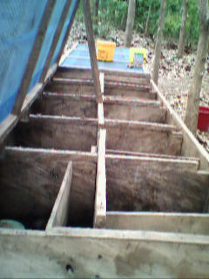 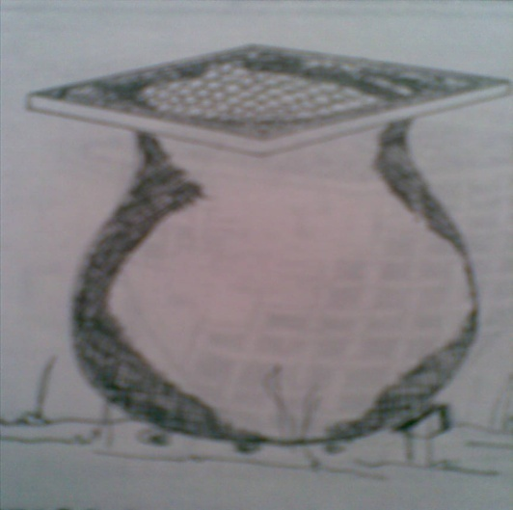

**Plate 10:** **Opened hutch Plate 11:** Earthen pot

**compartment** showing

series of cells.

**Sources: Ibom (2009), Okon and Ibom (2012)**

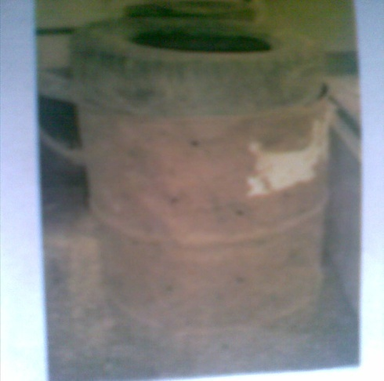 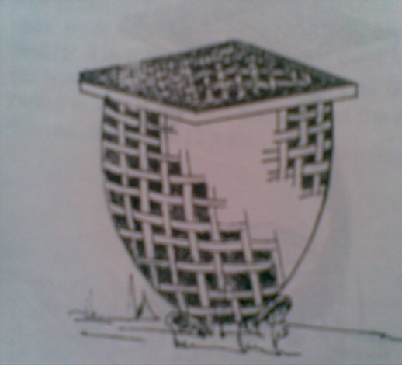

**Plate 12:** Old drum **Plate 13:** Basket

**Source: Okon and Ibom (2012)**

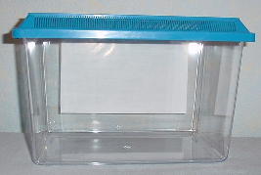 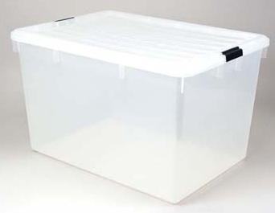

**Plate 14:** Plastic tank **Plate 15:** Storage tub

**Source: www.freewebs.com/worldofsnails/**

Be it an in-door or out-door rearing system, the enclosure(s) should have or be lined with a deep layer of sterilized (to kill a range of bacteria, pathogens and other lethal microbes) top soil (available from most garden centres) which will allow the snails to burrow (dig in) and to lay egg clutches. It is important to provide a deep substrate, which enables them to maintain a constant body temperature and prevent moisture loss by using the soil to insulate themselves. It is best to use plain top soil from a garden centre rather than compost, which can contain added chemical fertilizer residues harmful to snails. The snails must have constant access to clean fresh water for drinking. This should be provided in shallow troughs, as it is easy for snails to drown in deeper water troughs. It is a good idea to put pebbles in the bottom of their water troughs so that they can climb in and out easily and not up turn the trough easily. Where concentrate feed is provided, it should also be served in shallow troughs or feed blocks to avoid wastages. Pebbles should also be put in the feeding trough to hold the trough in place.

**SNAIL FEEDS AND FEEDING**

In the wild, snails feed and grow during the rainy season (i.e. from March to October). During this time, they are mainly herbivorous scavengers, eating various plants (vegetation and fruits) and decaying matters. The snails are able to meet their body requirements for growth and reproduction by feeding on these materials. However, their needs must be provided for in confinement. The following feeding materials have been tried on intensively reared snails and found to be acceptable and relished by the snails. The materials are: pawpaw (unripe fruits, ripe fruits and the pawpaw leaves), African spinach (*Amaranthus* species), milk weed (*Euphorbia hirta*), *Musa* species(*M. sapientum* and *M. paradaciaca* leaves and fingers), cassava leaves (*Manihot esculentum*), cocoyam leaves (*Colocasia esculentum*), ripe and unripe mango fruits (*Mangifera indica*), guava fruits (*Psidium jaguava*), oil palm fruits (*Elaeis guineensis*), melon or squash (*Cucumis melo*), water melon (*Citrullus vulgaris*), Aspilia (*Aspilia africana*), etc. Besides, snails have also been fed chaff from fermented milled maize, wheat bran sprinkled over fruit and vegetable materials. Satisfactory growth and reproductive performance have also been obtained with formulated feed containing the following ingredients; maize, soyabean meal, fish meal, bone meal, wheat offal, oyster shell, and vitamin and mineral premix (vit./min. premix); and soyabean meal, cassava flour, bone meal and oyster shell; and maize, soyabean meal, bone meal and vit./min. premix. Well-ground chicken mash (broiler starter mash, grower mash and layer mash) can also be fed to snails at different stages of growth. Calcium devoid of harmful salts and not alkaline in nature should be supplied at least once a week to snails in confinement. Below (Plates 16 to 19) are snail species feeding on various feed materials.

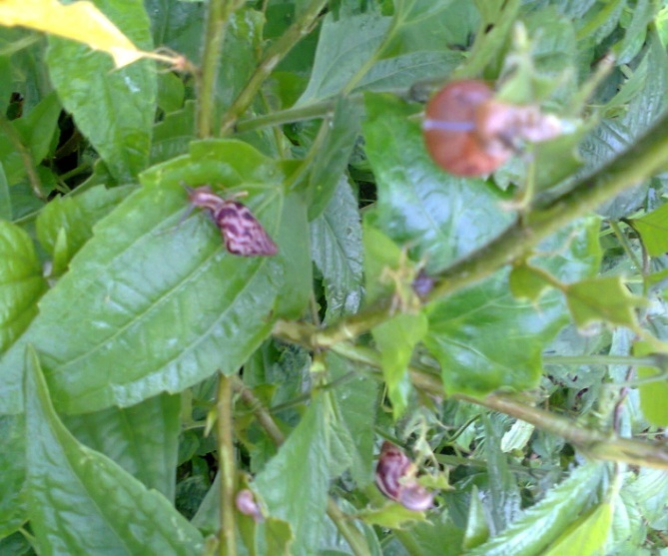 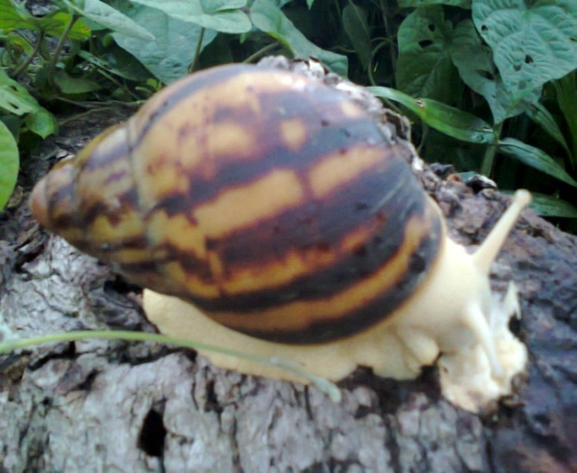**Plate 16:** Snails feeding on **Plate 17:** Snail feeding on                forage.     Mushroom.

**Source: Ibom (2014)**

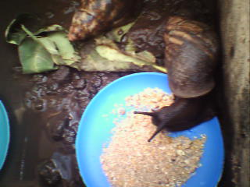 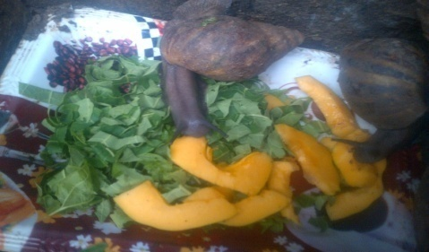

**Plate 18:** Snail feeding on **Plate 19:** Snail feeding on   concentrates. ripe pawpaw fruits.

Sources: Ibom (2009), Akinnusi (2013)

**BREEDING AND REPRODUCTION IN SNAILS**

Breeding and reproduction are used interchangeably and refer to the process through which propagation (reproduction), growth and development occur in animals. Breeding or reproduction can also be seen as the application of genetic principles for the improvement of economic traits in animals. At the present time, the act of copulation or insemination in snails is only by natural means.

Before ever conceiving breeding, there must be a known stock on ground. Experts advocated that for captive rearing, (small- or large-scale), the preferred snail classes should be grower and the sexually mature. Snails selected for use in breeding must be lively and active, their skin (foot) should fill their shells and should have whole, undamaged shells. Besides, snails for breeding should exhibit the following qualities: high fecundity (the expected number of eggs laid compared to the number laid in the previous season), good hatchability (percentage of eggs likely to hatch out of the total number laid), high establishment rate (percentage of snails likely to survive after hatching), good growth rate of baby snails (snailets) and good shell strength of the hatchlings.

There are no external signs/indicators of attainment of sexual maturity in snails, however, various ages of snails at sexual maturity and hence selection period had been reported by different workers. The differences in ages (3 to 12 months) reported by these workers are dependent on the snail breed and the husbandry practices adopted. On the other hand, snails selected for breeding should weigh between 90 – 130 g. At these age and weight ranges, they should have at least 4 – 5 complete whorls on their shells with a reflected peristome and are certainly mature and ready to reproduce.

Snails only start mating (which lasts a few minutes to many hours) to reproduce when they attain sexual maturity at body weight range of 90 – 130 g (about 3 – 12 months of age). In the wild, active mating, eggs laying and hence reproduction occur during the rainy season from February/March to October/November, while snails go into aestivation (period of dormancy) during the dry months of the year (from November to March) as a result of adverse climatic variables (high or hot temperature, dryness, etc) in Nigeria. Throughout the aestivation period, snails remain inactive and bury themselves in the soil or hide beneath stones or decomposing litters in order to avoid direct solar radiation.

It has however been established that mating and eggs laying occur both in the dry and the rainy seasons under captive rearing with proper management, thereby break the seasonality in snails’ performance (growth and breeding/reproduction) and ensure all year round supply of snail meat and snail products, at affordable prices. Snails are hermaphrodites, meaning that any given snail possesses components of both male (prostate gland, vas deferens and penis) and female (albumen gland, uterus, oviduct, vagina and spermathecae) reproductive systems. They however practise sexual reproduction since they are generally out-crossing and cross-fertilization is the rule to produce fertile eggs. The possibility of self-fertilization in some snail breeds, especially *Achatina achatina* and *Achatina fulica* cannot be absolutely ruled off. However, eggs laid by self-fertilized individuals are fewer than those laid by paired individuals and most of such eggs are sterile, and their progeny rarely survive to sexual maturity.

For copulation to take place, sexually mature snails of the same breed come together for courtship that lasts several hours. During courtship, two snails pull up next to one another, arrange themselves in such a way that the broad soles of their feet lie side-by-side. The arrangement is such that the male part (a developed muscular copulatory, penis-like matter) of one is opposite the female part (vagina) of the other, and each then injects the male spermatozoa into the female opening of the other simultaneously or alternately. For purposes of record keeping, it is better to pair larger (older) and younger (smaller) snails. This is because the larger of the pair normally carry the eggs, as young snails only produce sperm, but produce both sperm and eggs as they grow older (larger). However, if the mating is between two older snails, both may pass sperm to each other simultaneously or alternately. Sperm transfer between snails during mating is by means of a pseudospermatophore. The sperm from a partner snail is stored in the spermathecae of the mate and from there go on to fertilize the ova prior to the deposition of other egg components along the reproductive tract of the snail. Below are two snails in active mating.

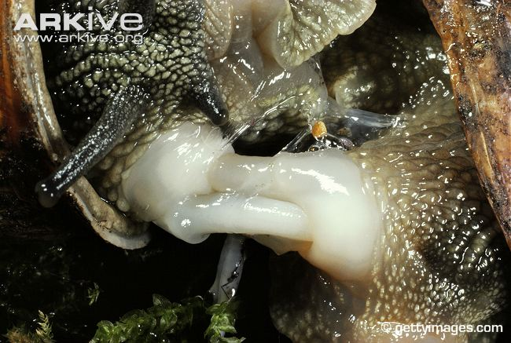

**Plate 11:** Snails in active mating.

**Source:** **Udo (2016)**

**CLIMATIC AND OTHER FACTORS AFFECTING SNAIL PRODUCTION IN NIGERIA**

Climate is a combination of weather elements: temperature, humidity, rainfall, air movement, radiative conditions, barometric pressure, ionization, day light and length, and precipitation. Temperature and rainfall are the most important of these climatic elements or factors. The climate of an area can affect the ability of snails to survive and to be productive in many ways. This could be by impacting directly on the snails or indirectly on the resources (availability of feed and/or forages) required for efficient performance. For instance, snails naturally need a moist environment, but can thrive in a mild climate of 260 – 290 C with high humidity of 75 – 95 %. They generally do better within temperatures of 18 – 30 °C and best at temperatures of between 21 – 23 °C. For the more scientific snails rearing, snails prefer between 70 – 95 % relative humidity (rH). About 80 – 90 % is more than likely ideal. Whereas there are abundance of snail species in the rainforest and derived savannah ecological zones of Nigeria, there are less consumable species of snails in the north. This could be because of the low vegetative composition of the north consequent upon lower rainfall and humidity which may probably have aided the process of natural selection.

Other factors that affect snail production in Nigeria are:

1. Awareness: Many Nigerians are ignorant of the fact that snails can be raised in confinement and commercial/large scale. Awareness campaign is therefore inevitable to conscientize the populace.
2. Non availability of foundation stock: There is hardly any snail breeding farm in Calabar that one can walk into and place order for foundation stock. However, a number of snail breeding farms have sprang up in south western Nigeria.
3. Lack of concentrate feed and water: The non availability of quality and affordable feed is a major constraint to efficient rearing of snails in Nigeria. There is no where snail feed is sold in Nigeria. Commercial feed millers should start producing quality snail feed at affordable price(s) and make them readily available so that snail farmers can walk into shops and buy feed as do poultry farmers. This will boost the production of snails in confinement.
4. Human activities: Human beings agricultural activities such as deforestation, slash-and-burn, pesticides usage, and degradation, fragmentation or complete destruction of lands pose great constraint to the existence of snails. On the other hand, human beings posing as thieves are the greatest threat to snail farming as they can cart away a whole snail unit in one visit.
5. Beliefs: Snails are linked to human existence and behaviours in many Nigerian communities. For instance, it was reported that snail plays a significant role in the Yoruba myth of creation and enjoy a prominent place or recognition among the Yoruba race. The report further stated that the numerous snails found in Ore, Western Nigeria could be traced to the fact that the earth with which Oduduwa created the whole earth was carried in a snail shell. On the other hand, the Hausa people in Nigeria view snail consumption as abominable and a taboo. They belief that snails originated from ghostly existence and detaste them. Besides, the Bekwarra and Bette people of Cross River State, Nigeria belief that expectant mothers need not touch or eat snails to avert the negative effect of salivation and/or the baby being sluggish post parturition. In Nigerian communities where the black skinned snails form delicacy in diets, the white skinned (albino) snails are being discriminated against. This is because the people of such communities’ belief that the albino snails are used by witch doctors for witch crafty.
6. Diseases: Nobody seems to know much about snails’ illnesses. This is said because most reports have it that snails do not fall sick. However, my association with snails revealed that snails under adequate intensive care develop odema and die. The following diseases have been identified among snails.
7. Oral prolapse of the buccal cavity: As the name implies, this disease affects the buccal cavity (precisely the radula) of snails.
8. Bloat: The edible portion of the snail swells and does not retract into the shell again.

Snails should be handled and treated with the same care and attention to cleanliness as any other farm animal. Like many animals and some food products, snails can carry salmonella and bacteria. Consequently, after handling snails, wash and disinfect your hands thoroughly.

**GRASSCUTTERS**

Grasscutters or cane rats (*Thryonomis swinderianus*) like snails are among the new brides of animal agriculture in Nigeria. Grasscutters as bilaterally symmetrical warm-blooded vertebrate animals of the phylum chordate. They are the second biggest wild rodent after porcupine (*Hystrix cristata*) in Africa. It is estimated that grasscutters produce about 40,000 tonnes of meat annually in West Africa. Of this quantity, only about 0.2 per cent comes from domesticated grasscutters.

A vast majority of grasscutters consumed in Nigeria are still gathered from the wild. Grasscutters domestication and its possible farming started in Nigeria in the late 1970s, whereas its farming in Ghana and perhaps Benin Republic dates back to well over twenty-five (25) years. However, the rearing of grasscutters is currently gaining a lot of awareness and positive interest among Nigerians, especially people of South-West Nigeria. The domestication and rearing of cane rats will conserve and safe guard them against the threat of extinction posed by human activities (hunting, deforestation and slash-and-burn agricultural practice), habitat development, climate change etc.

**DESCRIPTION**

Grasscutters have been described as heavily built rodents, with coarse bristly brown fur/hair speckled with yellow or grey. They have small rounded ears and almost hidden in short nose, white lips, chin and throat. They have large chisel-like incisor teeth that grow continuously. The upper teeth are grooved and bright orange, with the muzzles being squared and padded at the nose.

Grasscutters possess short thick legs with heavily padded feet. The fore feet are smaller than the hind feet. The feet bear straight, powerful claws with five digits on the fore limb and four digits on the hind limb. Their skin is very thin and fragile, thus tears easily, though also heals easily and quickly. They also have bristle tail that fracture easily near the base if seized, a feature similar to the lizard tail.

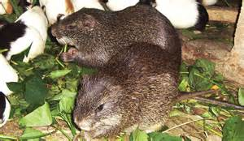

Bristly brown fur

Short nose

Bristle tail

Small rounded ear

Eye

Short thick fore-leg

**Plate 20: External Morphology of Grasscutters**

Source:

**CLASSIFICATION**

Grasscutters are of the animal kingdom and bear their young ones alive, making them mammals. They can be liken to rabbits in various characteristics and/or behaviour.

The taxonomic classification of grasscutters is as shown below.

Kingdom Animalia

Phylum Chordata

Class Mammalia

Order Rodentia

Suborder Hystricomorpha

Family Thryonomyidae

Genus Thryonomys

Species *Thryonomys swinderianus* (Temminck 1827)

*Thryonomys gregorianus* (Thomas 1894)

Source:

**DISTRIBUTION**

Grasscutters originate and are native to Africa. Their distribution is determined basically by the availability of adequate or preferred grass species for food. They occur in grasslands and wooded savannah throughout the humid and subhumid areas, south of the Sahara, and in damp or wet places.

The greater cane rat species (*Thryonomys swinderianus*) is native to West Africa and occur in such countries as Nigeria, Togo, Benin Republic, Ghana, Cote d’Ivore, Senegal and Guinea. The lesser cane rat species (*Thryonomys gregorianus*) on the other hand is native to Central, East and Southern Africa and occur in such countries as Cameroon, Chad, Democratic Republic of Congo, Ethiopia, Kenya, Malawi, Tanzania, South Sudan, Uganda, Zambia, Zimbabwe, Mozambique and Cape of South Province.

**CHARACTERISTICS OF GRASSCUTTERS**

1. Grasscutters have thick body (with the males weighing 3 – 6 kg, while the females weigh 2 – 4 kg).
2. They have blunt snout.
3. They are quick runners and skilled swimmers.
4. They are dioecious and practice sexual reproduction.
5. They bear their young ones alive, being that they are mammals.
6. They have relatively poor visual power so communication is based on hearing and well developed sense of smell.
7. They are nocturnal in nature, being active in search of food and mating partners in the night.
8. They are monogastric herbivores with a wide nutritional intake.
9. They are good food converters.
10. They are wasteful feeders.
11. They practice coprophagy or caecotrophy.
12. They are harmless and generally flee when in danger.
13. They are polygamous in nature.
14. They are agricultural pests of cereals and other crops.
15. They can live up to four (4) years in captivity.

**MANAGEMENT PRACTICES AND SYSTEMS OF GRASSCUTTERS PRODUCTION**

The grasscutter is a wild hystricomorphic rodent. In the wild, grasscutters live in small groups or colony of 3 – 12 individuals led by a single male in reed-beds and river banks. They do not live on tree tops because they cannot climb, rather they take over holes dug by other animals. In their natural habitats, they are nocturnal (being active in search of food and mating partner) between 5 pm and midnight, and again at first light. The rest of the period is spent in nest, chiefly grooming. They make nests from grasses or burrow underground. If frightened, they grunt and run towards water. Live expectancy in the wild is over four years.

Under captivity, two main systems of management have been identified for grasscutters. These are intensive and semi-intensive system.

**Intensive System:** Under this system of management, grasscutters are housed in cages and house floors. The dimensions of such structures are 180 cm (length) x 60 cm (breadth) x 45 cm (height) for one family which consists of one male and four females or one male and two to three females and their offspring.

The cage materials can be boxes, empty drums or poly vinyl chloride (PVC) pipes. Cages can also be constructed with metallic materials (angle iron, metal pipes, iron rods or metal lattice). For houses to manage grasscutters, laterite bricks, cement blocks, wire mesh, wood and bamboo lattice can be used.

Whichever structure is being adopted, cages or floors, the design must be such that the animals are protected from extremes of temperature and humidity, and also from thieves and predators.

As is the case with every other livestock, grasscutters under intensive system of management are provided with all their needs (feed, water, medication and routine services).

**Semi-intensive system:** Under this system of grasscutters management, the animals are housed in walled enclosures of varying dimensions. The enclosures could be constructed with the following materials; iron, rods, metal pipes, angle iron, metal lattice, laterite bricks, cement blocks, wire mesh, wood and bamboo lattice.

This system requires more space and the animals are given less attention compared with the intensive system. The design of enclosure(s) must be such that the animals are protected from extremes of temperature and humidity. Predators and thieves must be waded off.

**FEEDS AND FEEDING OF GRASSCUTTERS**

Grasscutters are monogastric herbivores with a wide nutritional intake. They practice caecotrophy or coprophagy (the act of eating soft, fecal pellets) like rabbits and this increases digestive efficiency. Grasscutters are wasteful feeders and 70 – 80% of their food is from the forest.

In the wild, grasscutters survive entirely on forages. These include:

1. Grasses with moisture and soluble carbohydrate [elephant grass (*Pennisetum* *purpureum*), guinea grass (*Panicum maximum*), gamba grass *(Andropogon* *gayamus)*, Congo grass (*Brachiaria ruzeziensis*), Sugar cane (*Saccharum* *officinalis*)].
2. Leguminous fodder [Centro (*Centrosema pubescens)*, Pueraria (*Pueraria phaseoloides),* Stylo (*Stylosanthes gracilis*)*,* Leucaena (*Leucaena leucocephala*)*,* gliricida (*Gliricidia sepium*)]*.*
3. Cultivated agricultural crops [Maize (*Zea mays*)*,* rice(*Oryza sativa*)*,* wheat (*Triticum spp.*)]*,* grain legumes [groundnut (*Arachis hypogea*)], roots [cassava (*Manihot esculenta*)*,* yam (*Discorea spp.*)*,* sweet potato (*Ipomea batata*)],fallen fruits [Mango (*Mangifera indica*)*,* pawpaw (*Carica papaya*)*,* pineapple (*Ananas cumosis*)*,* plantain (*Musa paradaciaca*)], egg plant, roots, pitch and fallen fruits of oil palm (*Elias guinensis*), coconut (*Cocos nucifera*) and many other crops.

Under captivity, grasscutters need to be provided for to achieve the target of improved productivity. Therefore, besides the afore mentioned feed they can also be served concentrates. The concentrate feeds must be pelletized to reduce wastages. Kitchen waste and leftovers can also be fed to grasscutters in backyard farms.

**CLIMATIC AND OTHER FACTORS AFFECTING GRASSCUTTERS PRODUCTION IN NIGERIA**

Climate as earlier said is a combination of weather elements: temperature, humidity, rainfall, air movement, radiative conditions, barometric pressure, ionization, day light and length, and precipitation. Temperature and rainfall are the most important of these climatic elements or factors as far as animal agriculture is concerned. The climate of an area can affect the ability of grasscutters to survive and to be productive in many ways. This could be by impacting directly on the grasscutters or indirectly on the resources (availability of feed and/or forages) required for efficient performance.

Other factors that affect grasscutters production in Nigeria are:

1. Awareness: Many Nigerians are ignorant of the fact that grasscutters can be raised in confinement and commercial/large scale as do chickens. Awareness campaign is therefore inevitable to conscientize the populace.
2. Non availability of foundation stock: There is hardly any grasscutter breeding farm in Calabar that one can walk into and place order for foundation stock. However grasscutters breeding farms are bound in south western Nigeria.
3. Lack of concentrate feed and water: The non availability of quality and affordable feed is a major constraint to efficient rearing of grasscutterss in Nigeria. There is no where grasscutters feed is sold in Nigeria, expect in research institutes. Commercial feed millers should start producing quality grasscutters feed at affordable price(s) and make them readily available so that grasscutters farmers can walk into shops and buy feed as do poultry farmers. This will boost the production of grasscutters in confinement.
4. Human activities: Human beings agricultural activities such as deforestation, slash-and-burn, pesticides usage, and degradation, fragmentation or complete destruction of lands pose great constraint to the existence of grasscutters. These activities destroy the natural habitat of grasscutters and will culminate in extinction of the species.
5. Diseases: Grasscutters farming is among the newest brides of animal agriculture in Nigeria. To this end, not much information is available about their diseases. However, the following have been identified to cause disease conditions in grasscutters.
6. Gastrointestinal helminthes.
7. Nematodes.
8. Teratodes.
9. Cestodes.
10. Acanthocephala.
11. Haemoparasites (Trypanosoma, Babesia).
12. Plasmodium species.

**REFERENCES**

Akinnusi, F. A. O. (2013). Feeds of Snails. *Invited paper delivered at the 2nd International Conference/Workshop on Giant African Land Snail* (NetGALS). Federal University of Agriculture, Abeokuta, Nigeria. Pp. xxxiii – xxxvii.

Cobbinah, J. R. (2014). Snail Farming Implications for Industrial and Technological Growth. *Keynote Address delivered at the 3rd International Conference/Workshop on Giant African Land snails* (NetGALS). June 1 – 4. Federal College of Education, Osele, Abeokuta. Pp. x – xv.

Ibom, L. A. (2009). Variations in reproductive and growth performance traits of White-skinned x Black-skinned African giant snail hatchlings [*Archachatina marginata* (*Swainson*)] in Obubra, Nigeria. *Ph. D. Thesis*,Department of Animal Science,University of Calabar, Calabar, Nigeria. Pp. 166.

Ibom, L. A. (2014). Personal snail pictures collection.

Okon, B. and Ibom, L. A. (2012). *Snail breeding and snailery management*. Freshdew Productions, Calabar, Nigeria. Pp. 70.

www.freewebs.com/worldofsnails/

[www.PetSnails.co.uk](http://www.PetSnails.co.uk).