Clouds Course
  - Assignment 2 Deliverable

Name:

Alice Boccadifuoco

Email:

Alice.Boccadifuoco@eurecom.fr

Run Locust for 3 minutes each on:

(i) locally deployed numericalintegral,
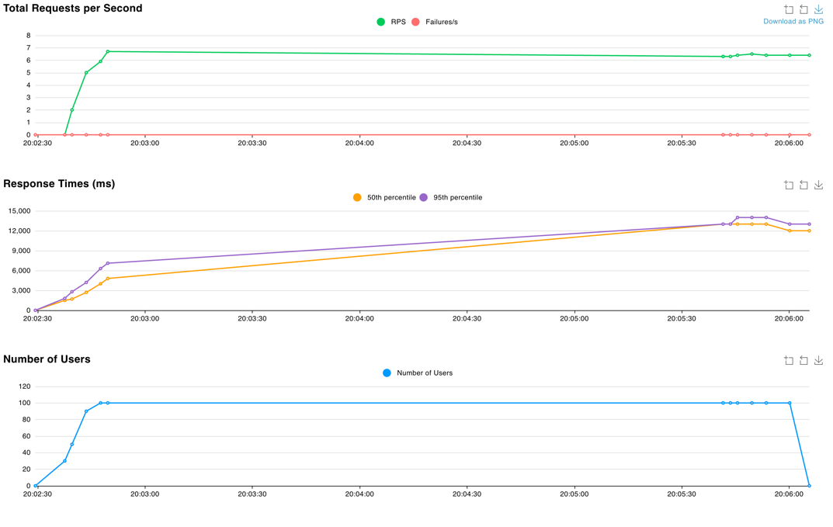

(ii) VM scaleset with 2 VMs where you shutdown the VM running the workload after 1 minute,
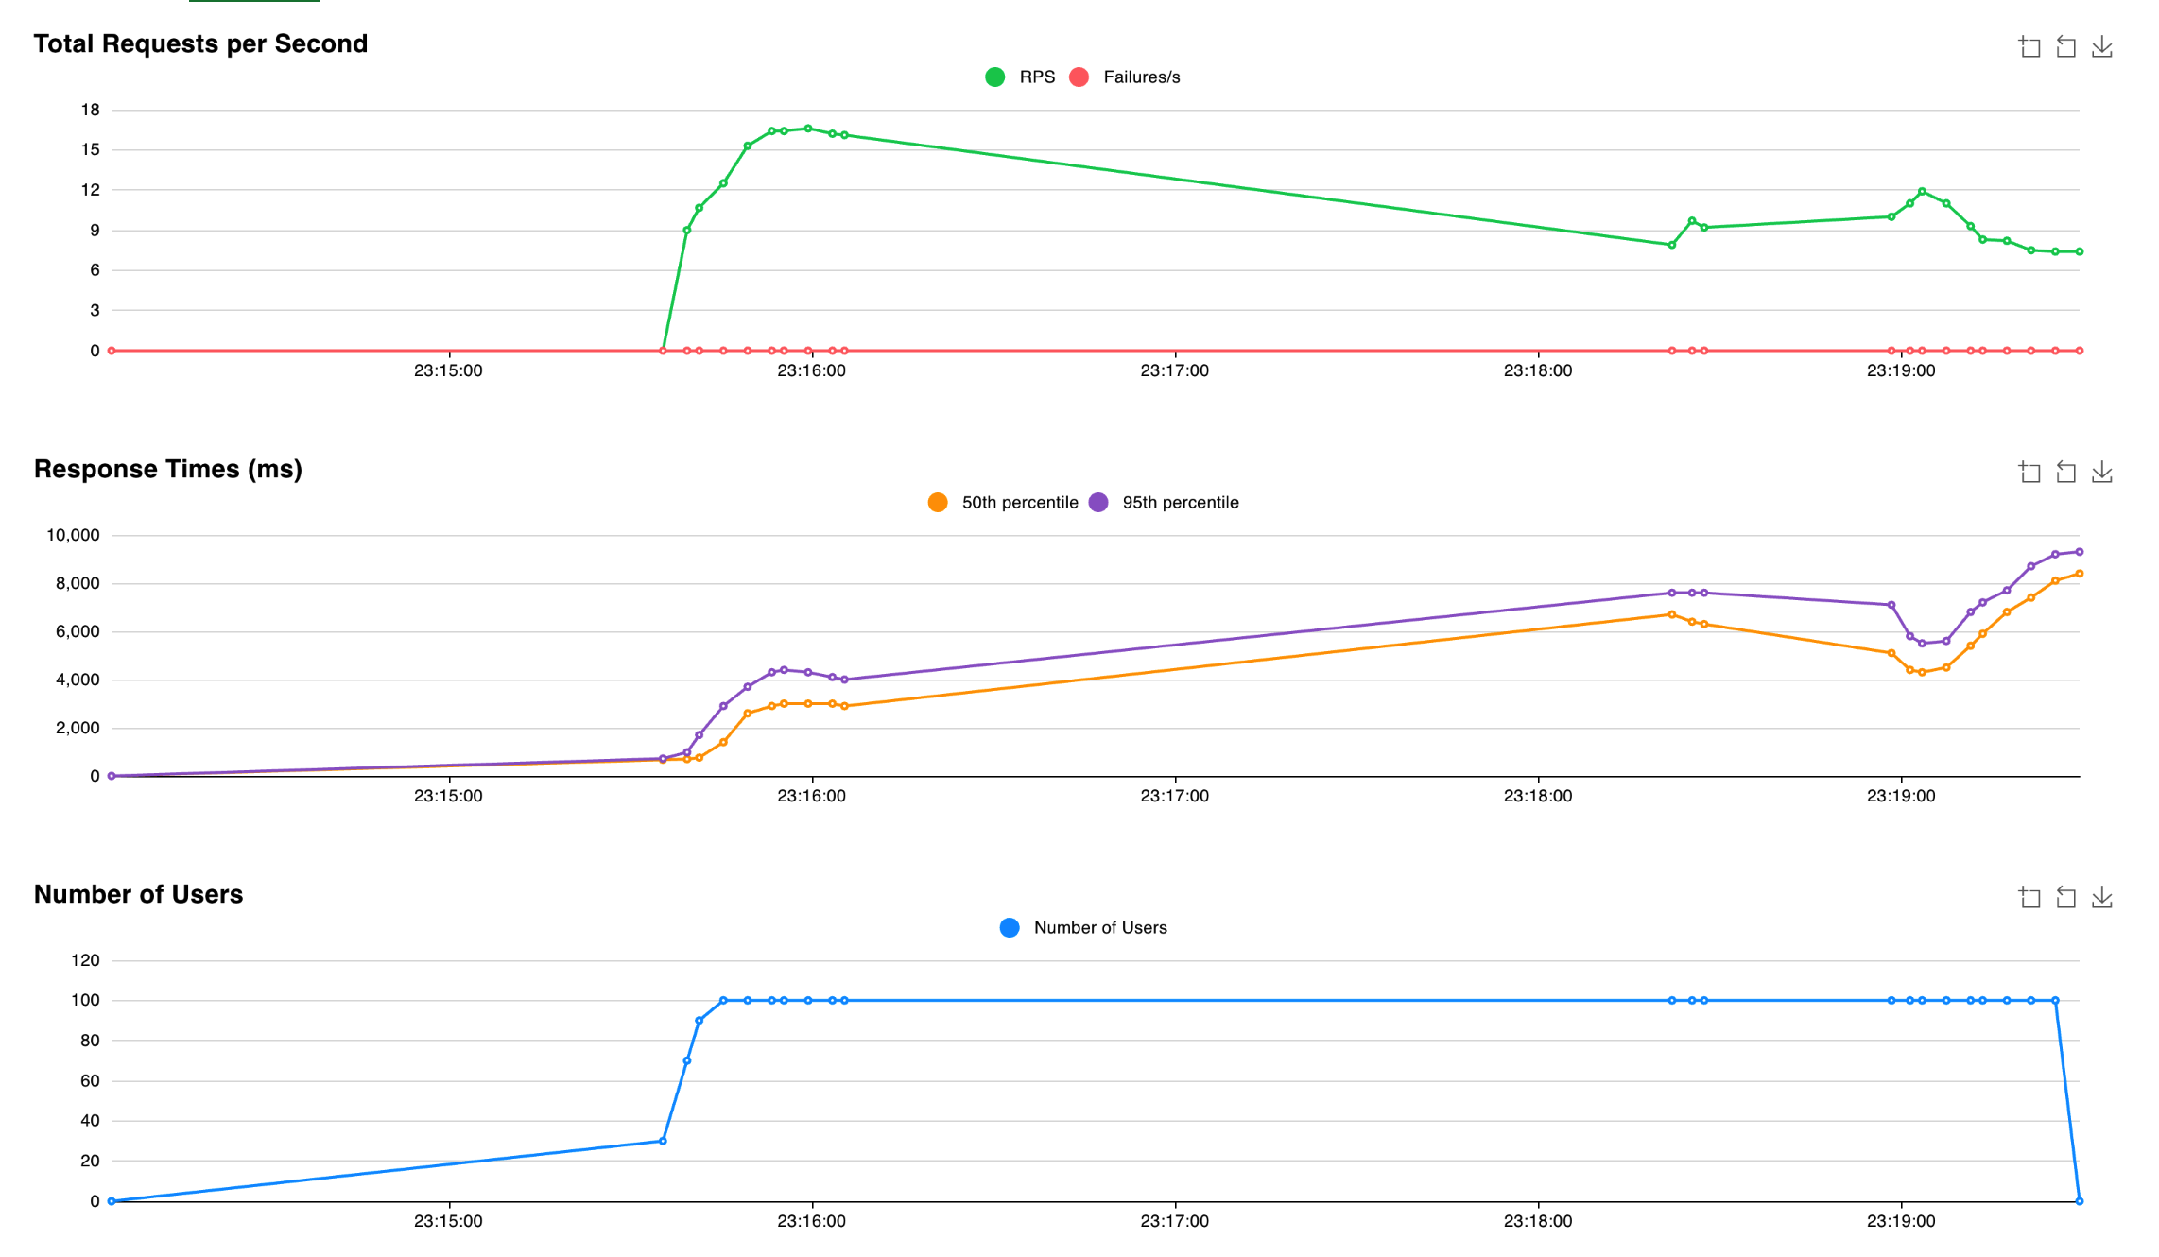
I stopped the process of one vm at around 23:18:30

(iii) autoscale webapp initially configured with 1 instance and max 3,
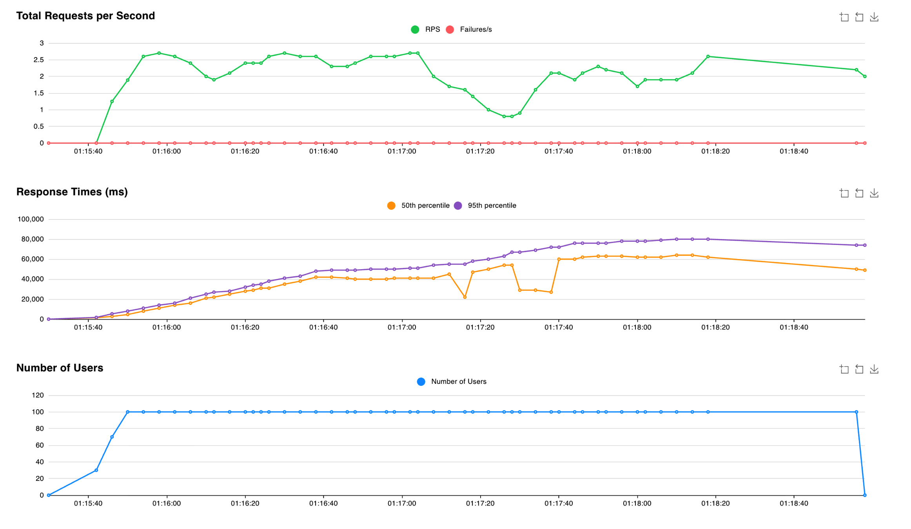
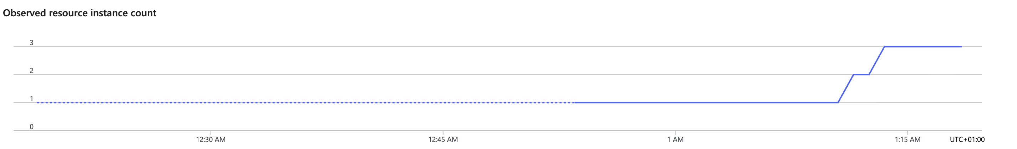

(iv) autoscale function.
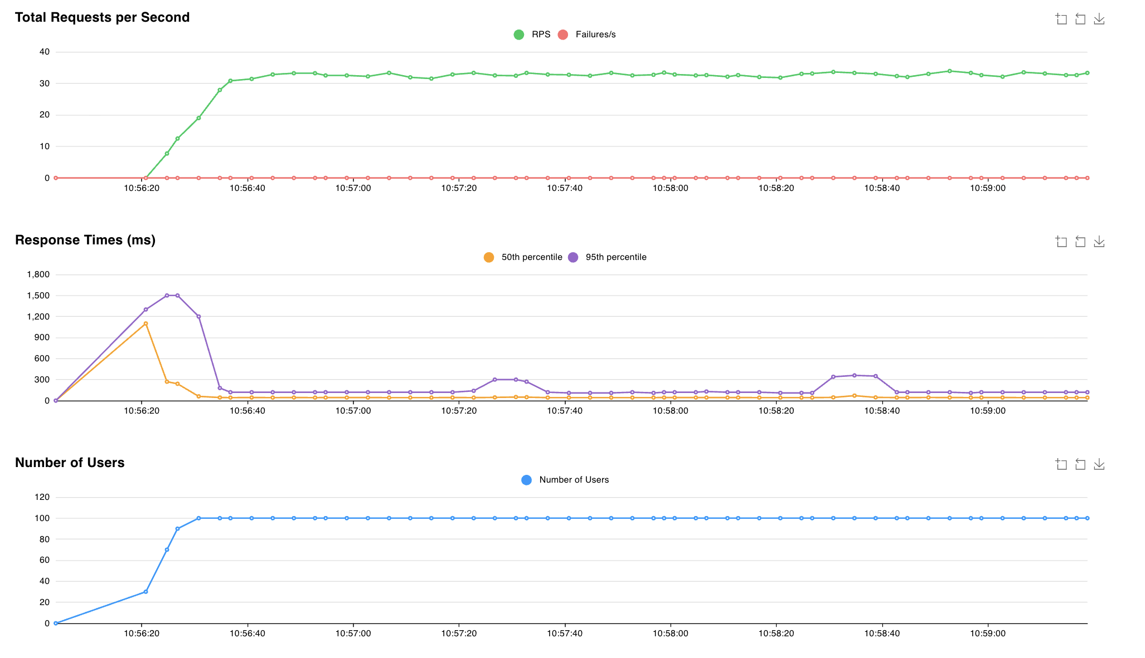

Save locust output.
Plot a graph of number of successful requests/seconds with one line for each of the four cases above. Paste the graph below.

Your answer:

What is the address of the numerical integrap webapp where we can access your site?

Your answer:
https://lab2-integral-h6ayh8afgab4gaa3.italynorth-01.azurewebsites.net/numericalintegralservice/0/3.14159

What is the address of the numerical integrap function deployment?

Your answer:
https://integral-func.azurewebsites.net/api/calculate_integral?a=0&b=3.14159&n=10000

What is the address of the mapreduce durable function deployment where can invoke it?

Your answer:

What is the gitlab URL where you have saved your assignment code?

Your answer:
https://github.com/Alix03/Cloud-Labs

