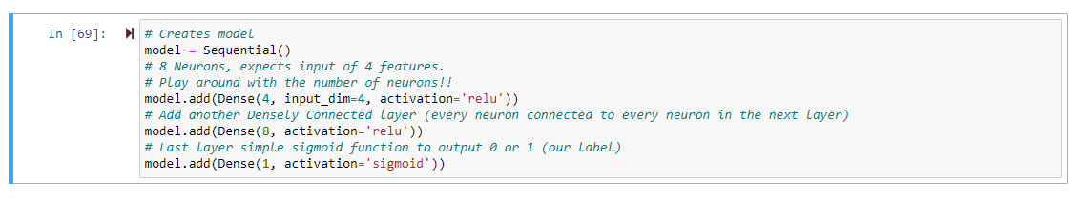

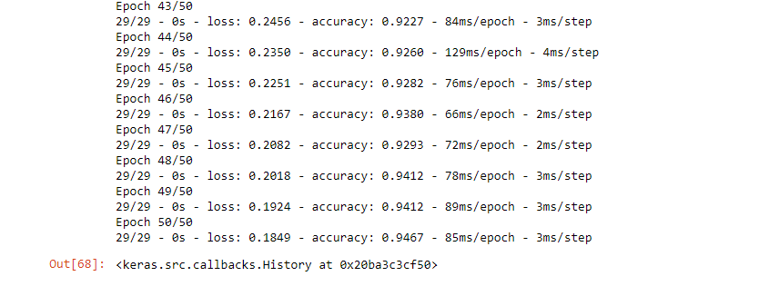

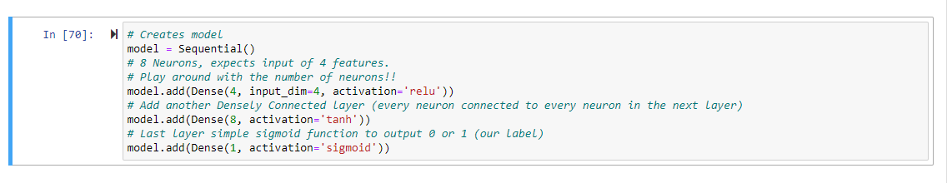

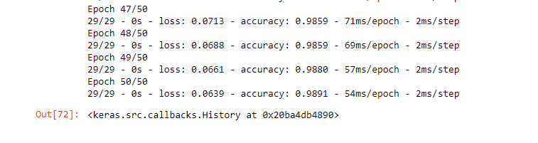

techniques for hyperparameter tuning include:

Grid Search: It involves specifying a grid of hyperparameter values and training the model with all possible combinations. This approach is exhaustive but can be computationally expensive.

Random Search: Instead of searching through all possible combinations, random search samples a fixed number of hyperparameter combinations from the specified search space. This method is more computationally efficient than grid search and often performs well.

Bayesian Optimization: It is a probabilistic model-based optimization technique that models the objective function and updates its beliefs about the hyperparameter space as more evaluations are performed. It aims to find the optimal hyperparameter values with as few evaluations as possible.

Gradient-based Optimization: Some frameworks allow for gradient-based optimization of hyperparameters, where the gradients of the model's performance with respect to hyperparameters are used to guide the sea