**WEEK-2 Logging using SLF4J**

**Exercise 1: Logging Error Messages and Warning Levels**

Task: Write a Java application that demonstrates logging error messages and warning levels

using SLF4J.

**LoggingExample.java:**

**package** com.example;

**import** org.slf4j.Logger;

**import** org.slf4j.LoggerFactory;

**public** **class** LoggingExample {

**private** **static** **final** Logger ***logger*** = LoggerFactory.*getLogger*(LoggingExample.**class**);

**public** **static** **void** main(String[] args) {

***logger***.error("This is an error message");

***logger***.warn("This is a warning message");

}

}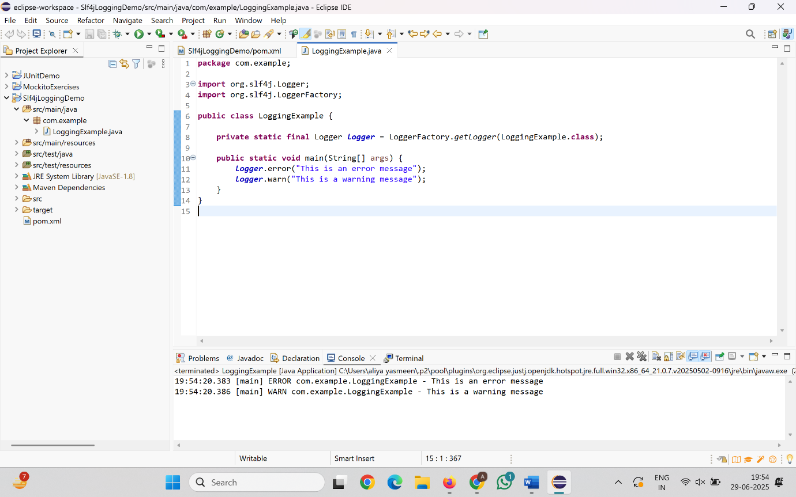

**Exercise 2: Parameterized Logging**

Task: Write a Java application that demonstrates parameterized logging using SLF4J

**ParameterizedLogging.java:**

**package** com.example;

**import** org.slf4j.Logger;

**import** org.slf4j.LoggerFactory;

**public** **class** ParameterizedLogging {

**private** **static** **final** Logger ***logger*** = LoggerFactory.*getLogger*(ParameterizedLogging.**class**);

**public** **static** **void** main(String[] args) {

String username = "Aliya";

**int** attempts = 3;

**double** balance = 1550.75;

***logger***.info("User {} has attempted to log in {} times", username, attempts);

***logger***.debug("User {} has a balance of ₹{}", username, balance);

***logger***.error("Login failed for user {} after {} attempts", username, attempts);

}

}

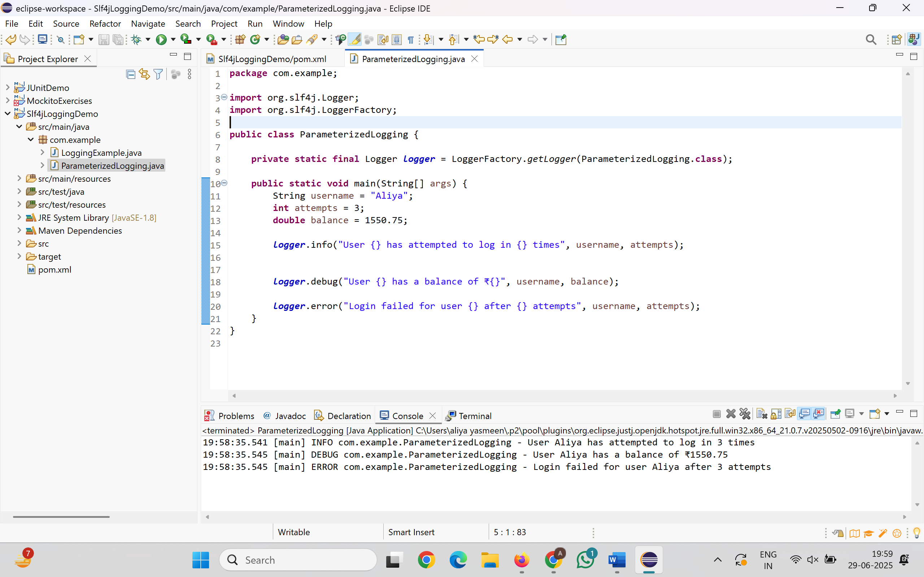

**Exercise 3: Using Different Appenders**

Task: Write a Java application that demonstrates using different appenders with SLF4J.

**MultiAppenderLogger.java:**

**package** com.example;

**import** org.slf4j.Logger;

**import** org.slf4j.LoggerFactory;

**public** **class** MultiAppenderLogger {

**private** **static** **final** Logger ***logger*** = LoggerFactory.*getLogger*(MultiAppenderLogger.**class**);

**public** **static** **void** main(String[] args) {

***logger***.info("This message goes to both console and file.");

***logger***.warn("Warning message goes to both.");

***logger***.error("Error message will also be logged in app.log");

}

}

