**WEEK-3 SPRING CORE WITH MAVEN**

**Exercise 1: Configuring a Basic Spring Application**

**Scenario:**

Your company is developing a web application for managing a library. You need to use the Spring Framework to handle the backend operations.

**pom.xml:**

<project xmlns="http://maven.apache.org/POM/4.0.0"

xmlns:xsi="http://www.w3.org/2001/XMLSchema-instance"

xsi:schemaLocation="http://maven.apache.org/POM/4.0.0

http://maven.apache.org/xsd/maven-4.0.0.xsd">

<modelVersion>4.0.0</modelVersion>

<groupId>com.library</groupId>

<artifactId>LibraryManagement</artifactId>

<version>1.0-SNAPSHOT</version>

<dependencies>

<dependency>

<groupId>org.springframework</groupId>

<artifactId>spring-context</artifactId>

<version>5.3.31</version>

</dependency>

</dependencies>

<build>

<plugins>

<plugin>

<groupId>org.apache.maven.plugins</groupId>

<artifactId>maven-compiler-plugin</artifactId>

<version>3.8.1</version>

<configuration>

<source>1.8</source>

<target>1.8</target>

</configuration>

</plugin>

</plugins>

</build>

</project>

**applicationContext.xml:**

<?xml version="1.0" encoding="UTF-8"?>

<beans xmlns="http://www.springframework.org/schema/beans"

xmlns:xsi="http://www.w3.org/2001/XMLSchema-instance"

xsi:schemaLocation="http://www.springframework.org/schema/beans

http://www.springframework.org/schema/beans/spring-beans.xsd">

<bean id="bookRepository" class="com.library.repository.BookRepository" />

<bean id="bookService" class="com.library.service.BookService">

<property name="bookRepository" ref="bookRepository" />

</bean>

</beans>

**BookRepository.java:**

package com.library.repository;

public class BookRepository {

public void display() {

System.out.println("BookRepository: Accessing book data...");

}

}

**BookService.java:**

package com.library.service;

import com.library.repository.BookRepository;

public class BookService {

private BookRepository bookRepository;

public void setBookRepository(BookRepository bookRepository) {

this.bookRepository = bookRepository;

}

public void serve() {

System.out.println("BookService: Serving books...");

bookRepository.display();

}

}

**LibraryManagementApplication.java:**

package com.library;

import org.springframework.context.ApplicationContext;

import org.springframework.context.support.ClassPathXmlApplicationContext;

import com.library.service.BookService;

public class LibraryManagementApplication {

public static void main(String[] args) {

ApplicationContext context = new ClassPathXmlApplicationContext("applicationContext.xml");

BookService bookService = context.getBean("bookService", BookService.class);

bookService.serve();

}

}

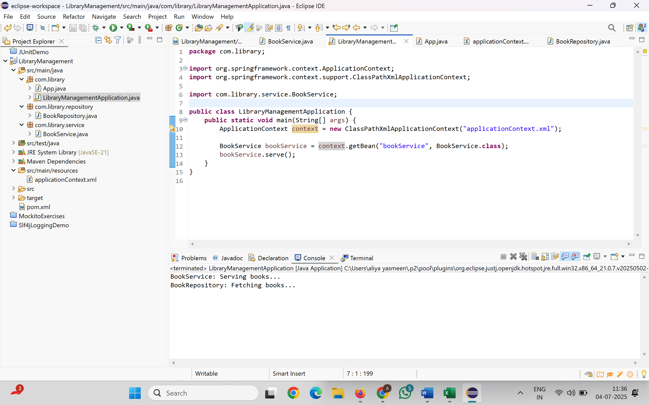

**Exercise 2: Implementing Dependency Injection**

**Scenario:**

In the library management application, you need to manage the dependencies between the BookService and BookRepository classes using Spring's IoC and DI.

**applicationContext.xml:**

<?xml version="1.0" encoding="UTF-8"?>

<beans xmlns="http://www.springframework.org/schema/beans"

xmlns:xsi="http://www.w3.org/2001/XMLSchema-instance"

xsi:schemaLocation="

http://www.springframework.org/schema/beans

http://www.springframework.org/schema/beans/spring-beans.xsd">

<!-- BookRepository bean -->

<bean id="bookRepository" class="com.library.repository.BookRepository" />

<!-- BookService bean with DI via setter -->

<bean id="bookService" class="com.library.service.BookService">

<property name="bookRepository" ref="bookRepository" />

</bean>

</beans>

**BookService.java:**

package com.library.service;

import com.library.repository.BookRepository;

public class BookService {

private BookRepository bookRepository;

public void setBookRepository(BookRepository bookRepository) {

this.bookRepository = bookRepository;

}

public void serve() {

System.out.println("BookService: Serving books...");

bookRepository.display();

}

}

**LibraryManagementApplication.java:**

package com.library;

import com.library.service.BookService;

import org.springframework.context.support.ClassPathXmlApplicationContext;

public class LibraryManagementApplication {

public static void main(String[] args) {

try (ClassPathXmlApplicationContext context = new ClassPathXmlApplicationContext("applicationContext.xml")) {

BookService bookService = context.getBean("bookService", BookService.class);

bookService.serve();

}

}

}

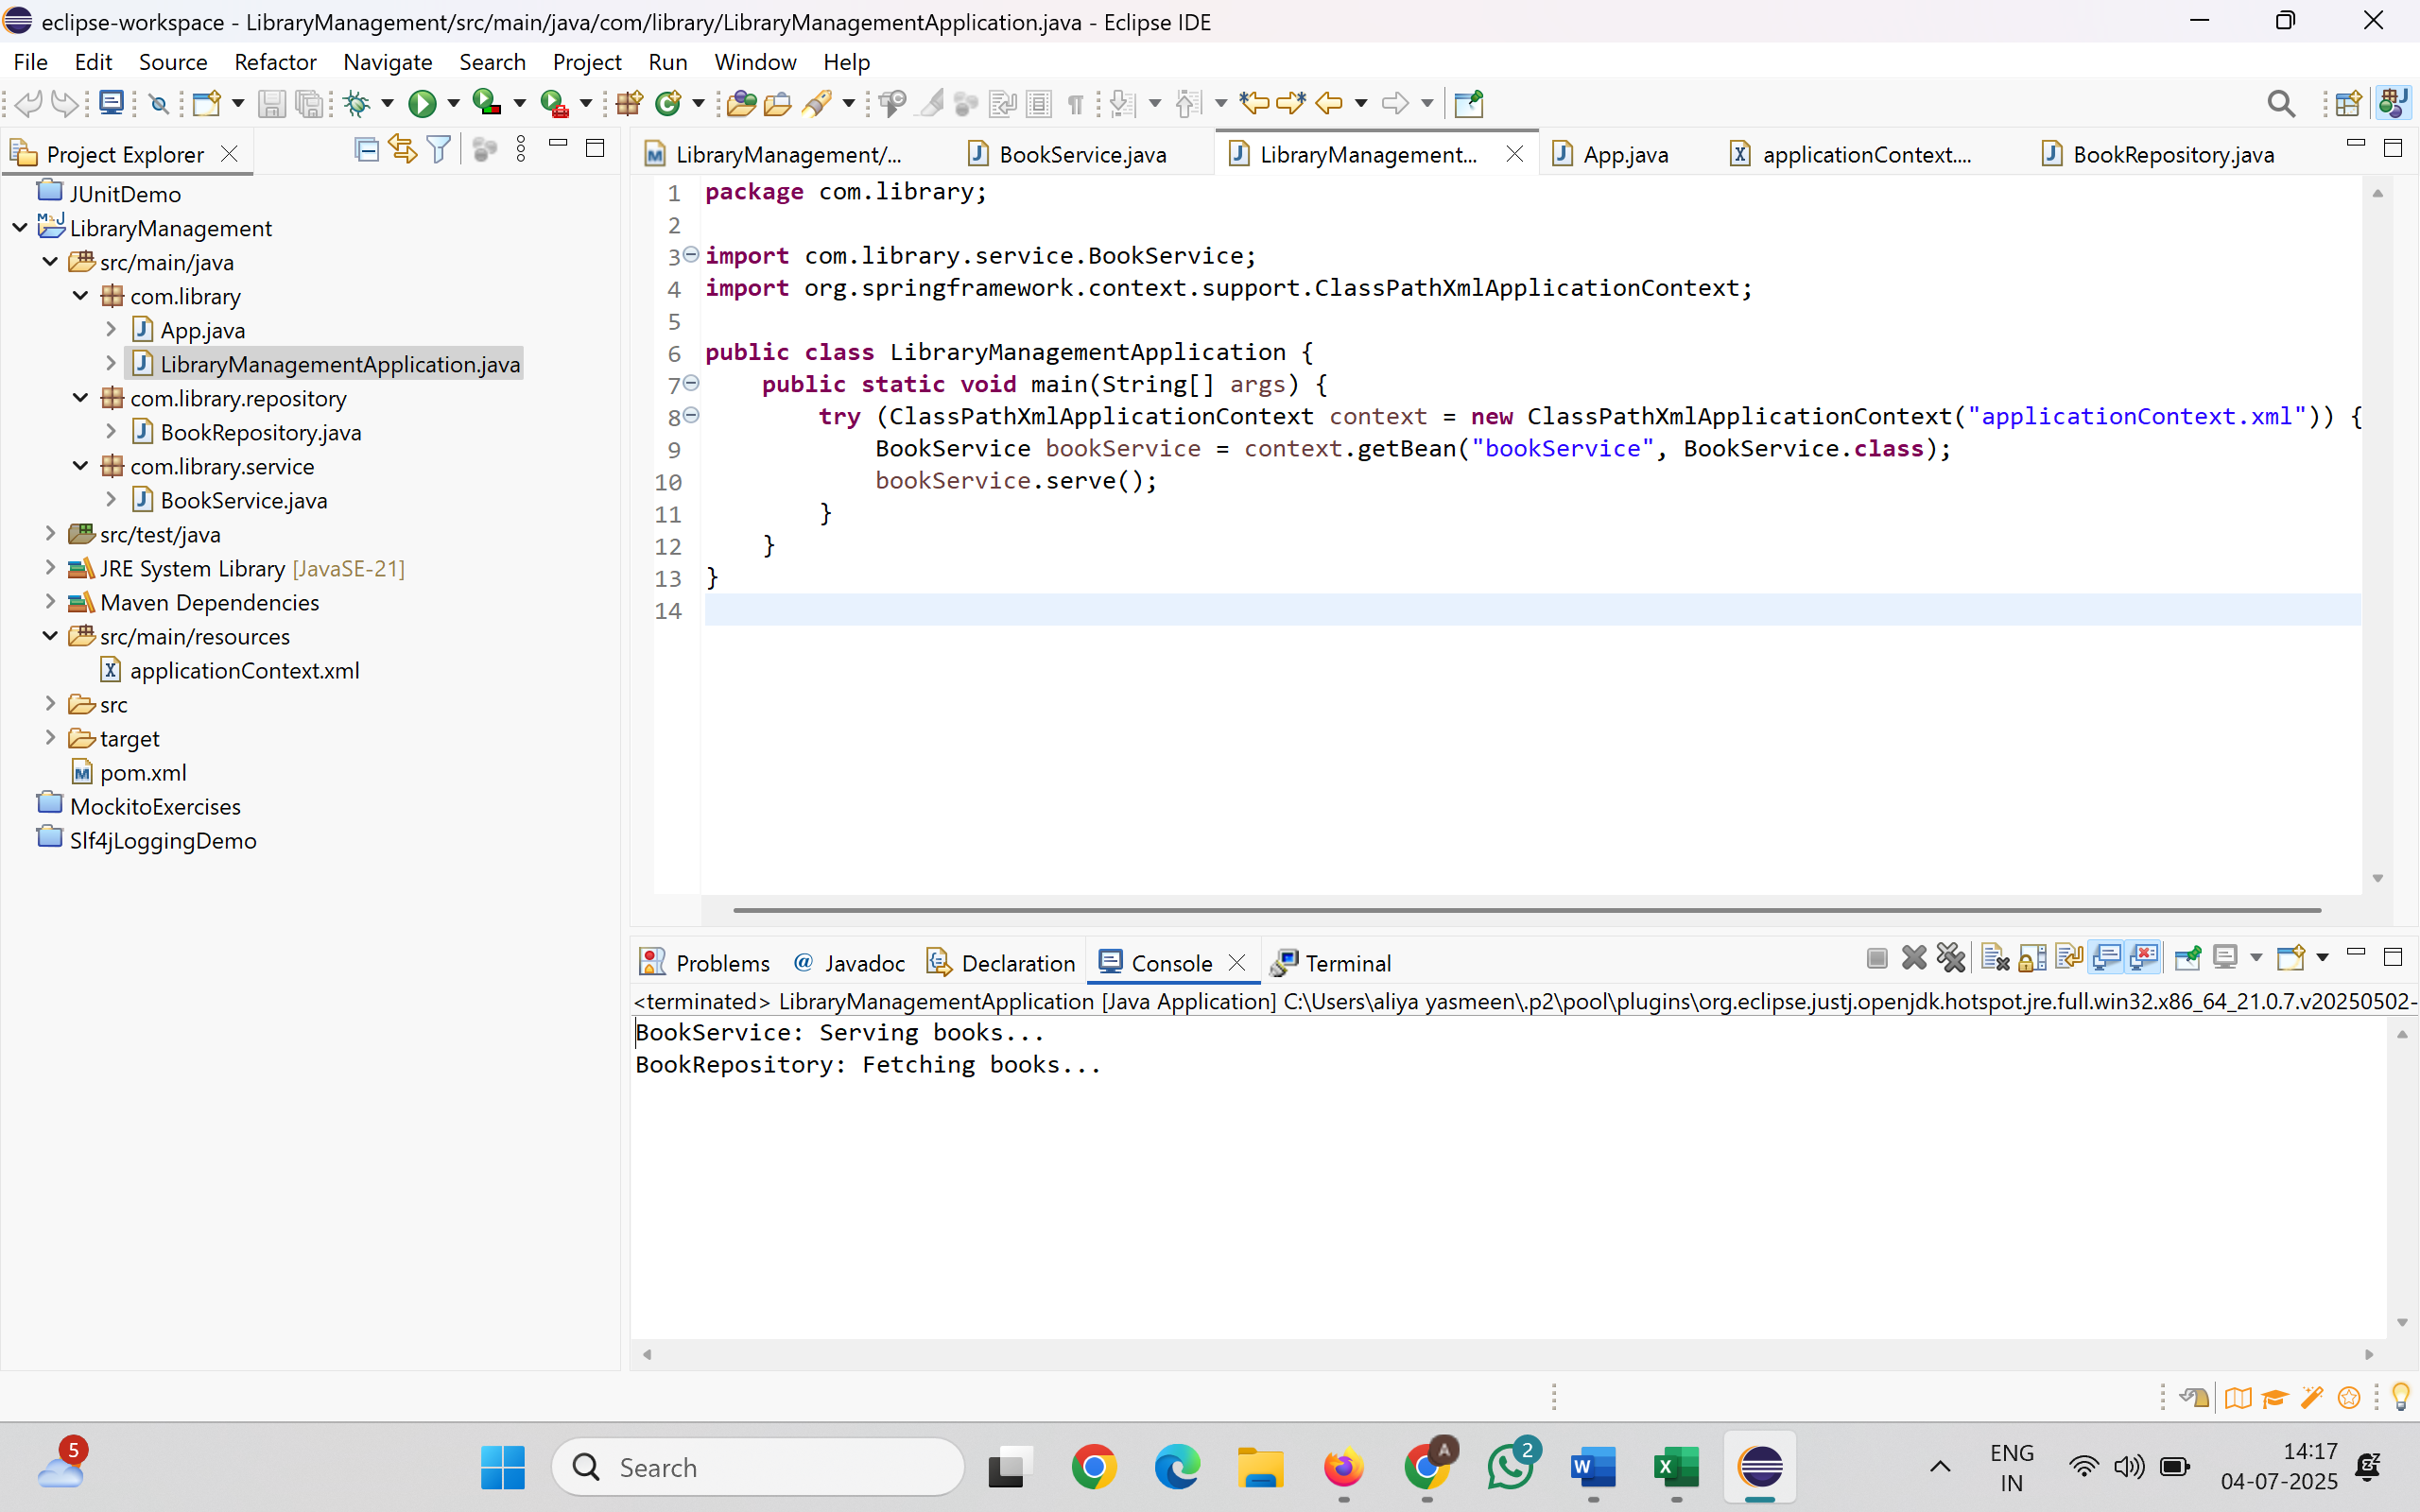

**Exercise 3: Implementing Logging with Spring AOP**

**Scenario:**

The library management application requires logging capabilities to track method execution times.

**pom.xml:**

<project xmlns="http://maven.apache.org/POM/4.0.0"

xmlns:xsi="http://www.w3.org/2001/XMLSchema-instance"

xsi:schemaLocation="http://maven.apache.org/POM/4.0.0

http://maven.apache.org/xsd/maven-4.0.0.xsd">

<modelVersion>4.0.0</modelVersion>

<groupId>com.library</groupId>

<artifactId>LibraryManagement</artifactId>

<version>1.0-SNAPSHOT</version>

<dependencies>

<dependency>

<groupId>junit</groupId>

<artifactId>junit</artifactId>

<version>4.13.2</version>

<scope>test</scope>

</dependency>

<dependency>

<groupId>org.springframework</groupId>

<artifactId>spring-context</artifactId>

<version>5.3.31</version>

</dependency>

<dependency>

<groupId>org.springframework</groupId>

<artifactId>spring-aspects</artifactId>

<version>5.3.31</version>

</dependency>

</dependencies>

<build>

<plugins>

<plugin>

<groupId>org.apache.maven.plugins</groupId>

<artifactId>maven-compiler-plugin</artifactId>

<version>3.11.0</version>

<configuration>

<source>21</source>

<target>21</target>

</configuration>

</plugin>

</plugins>

</build>

</project>

**LoggingAspect.java:**

package com.library.aspect;

import org.aspectj.lang.ProceedingJoinPoint;

import org.aspectj.lang.annotation.Around;

import org.aspectj.lang.annotation.Aspect;

@Aspect

public class LoggingAspect {

@Around("execution(* com.library.service.*.*(..))")

public Object logExecutionTime(ProceedingJoinPoint joinPoint) throws Throwable {

long start = System.currentTimeMillis();

Object result = joinPoint.proceed(); // Proceed with the original method

long end = System.currentTimeMillis();

System.out.println("[LOG] Method " + joinPoint.getSignature().getName() + " executed in " + (end - start) + " ms");

return result;

}

}

**applicationContext.xml:**

<?xml version="1.0" encoding="UTF-8"?>

<beans xmlns="http://www.springframework.org/schema/beans"

xmlns:xsi="http://www.w3.org/2001/XMLSchema-instance"

xmlns:aop="http://www.springframework.org/schema/aop"

xsi:schemaLocation="

http://www.springframework.org/schema/beans

http://www.springframework.org/schema/beans/spring-beans.xsd

http://www.springframework.org/schema/aop

http://www.springframework.org/schema/aop/spring-aop.xsd">

<aop:aspectj-autoproxy />

<bean id="bookRepository" class="com.library.repository.BookRepository" />

<bean id="bookService" class="com.library.service.BookService">

<property name="bookRepository" ref="bookRepository" />

</bean>

<bean id="loggingAspect" class="com.library.aspect.LoggingAspect" />

</beans>

**LibraryManagementApplication.java:**

package com.library;

import com.library.service.BookService;

import org.springframework.context.support.ClassPathXmlApplicationContext;

public class LibraryManagementApplication {

public static void main(String[] args) {

try (ClassPathXmlApplicationContext context = new ClassPathXmlApplicationContext("applicationContext.xml")) {

BookService bookService = context.getBean("bookService", BookService.class);

bookService.serve();

}

}

}

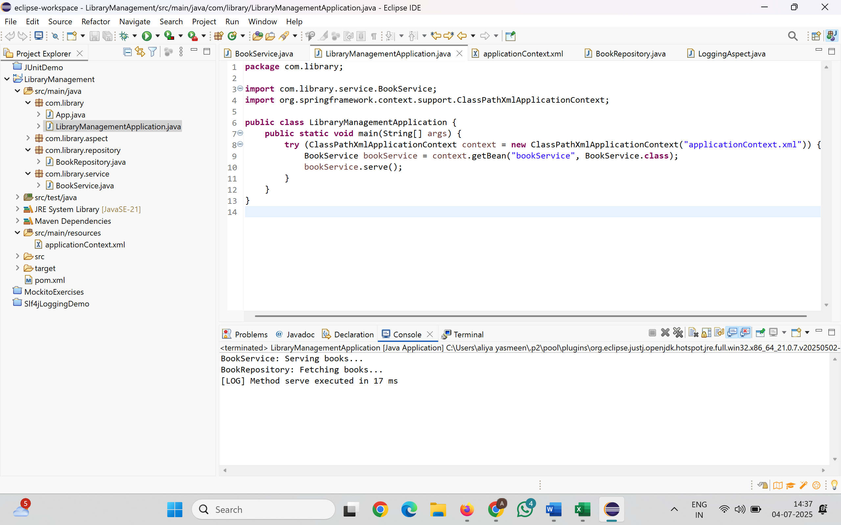

**Exercise 4: Creating and Configuring a Maven Project**

**Scenario:**

You need to set up a new Maven project for the library management application and add Spring dependencies.

pom.xml:

<project xmlns="http://maven.apache.org/POM/4.0.0"

xmlns:xsi="http://www.w3.org/2001/XMLSchema-instance"

xsi:schemaLocation="http://maven.apache.org/POM/4.0.0

http://maven.apache.org/xsd/maven-4.0.0.xsd">

<modelVersion>4.0.0</modelVersion>

<groupId>com.library</groupId>

<artifactId>LibraryManagement</artifactId>

<version>1.0-SNAPSHOT</version>

<dependencies>

<dependency>

<groupId>org.springframework</groupId>

<artifactId>spring-context</artifactId>

<version>5.3.31</version>

</dependency>

<dependency>

<groupId>org.springframework</groupId>

<artifactId>spring-aspects</artifactId>

<version>5.3.31</version>

</dependency>

<dependency>

<groupId>org.springframework</groupId>

<artifactId>spring-webmvc</artifactId>

<version>5.3.31</version>

</dependency>

<dependency>

<groupId>junit</groupId>

<artifactId>junit</artifactId>

<version>4.13.2</version>

<scope>test</scope>

</dependency>

</dependencies>

<build>

<plugins>

<plugin>

<groupId>org.apache.maven.plugins</groupId>

<artifactId>maven-compiler-plugin</artifactId>

<version>3.11.0</version>

<configuration>

<source>21</source> <!-- Or 1.8 based on your JDK -->

<target>21</target>

</configuration>

</plugin>

</plugins>

</build>

</project>

**Exercise 5: Configuring the Spring IoC Container**

**Scenario:**

The library management application requires a central configuration for beans and dependencies.

**applicationContext.xml**

<?xml version="1.0" encoding="UTF-8"?>

<beans xmlns="http://www.springframework.org/schema/beans"

xmlns:xsi="http://www.w3.org/2001/XMLSchema-instance"

xsi:schemaLocation="

http://www.springframework.org/schema/beans

https://www.springframework.org/schema/beans/spring-beans.xsd">

<bean id="bookRepository" class="com.library.repository.BookRepository" />

<bean id="bookService" class="com.library.service.BookService">

<property name="bookRepository" ref="bookRepository" />

</bean>

</beans>

**BookService.java:**

package com.library.service;

import com.library.repository.BookRepository;

public class BookService {

private BookRepository bookRepository;

public void setBookRepository(BookRepository bookRepository) {

this.bookRepository = bookRepository;

}

public void serve() {

System.out.println("BookService: Serving books...");

bookRepository.display();

}

}

**BookRepository.java:**

package com.library.repository;

public class BookRepository {

public void display() {

System.out.println("BookRepository: Accessing book data...");

}

}

**LibraryManagementApplication.java**

package com.library;

import com.library.service.BookService;

import org.springframework.context.support.ClassPathXmlApplicationContext;

public class LibraryManagementApplication {

public static void main(String[] args) {

try (ClassPathXmlApplicationContext context =

new ClassPathXmlApplicationContext("applicationContext.xml")) {

BookService bookService = context.getBean("bookService", BookService.class);

bookService.serve();

}

}

}

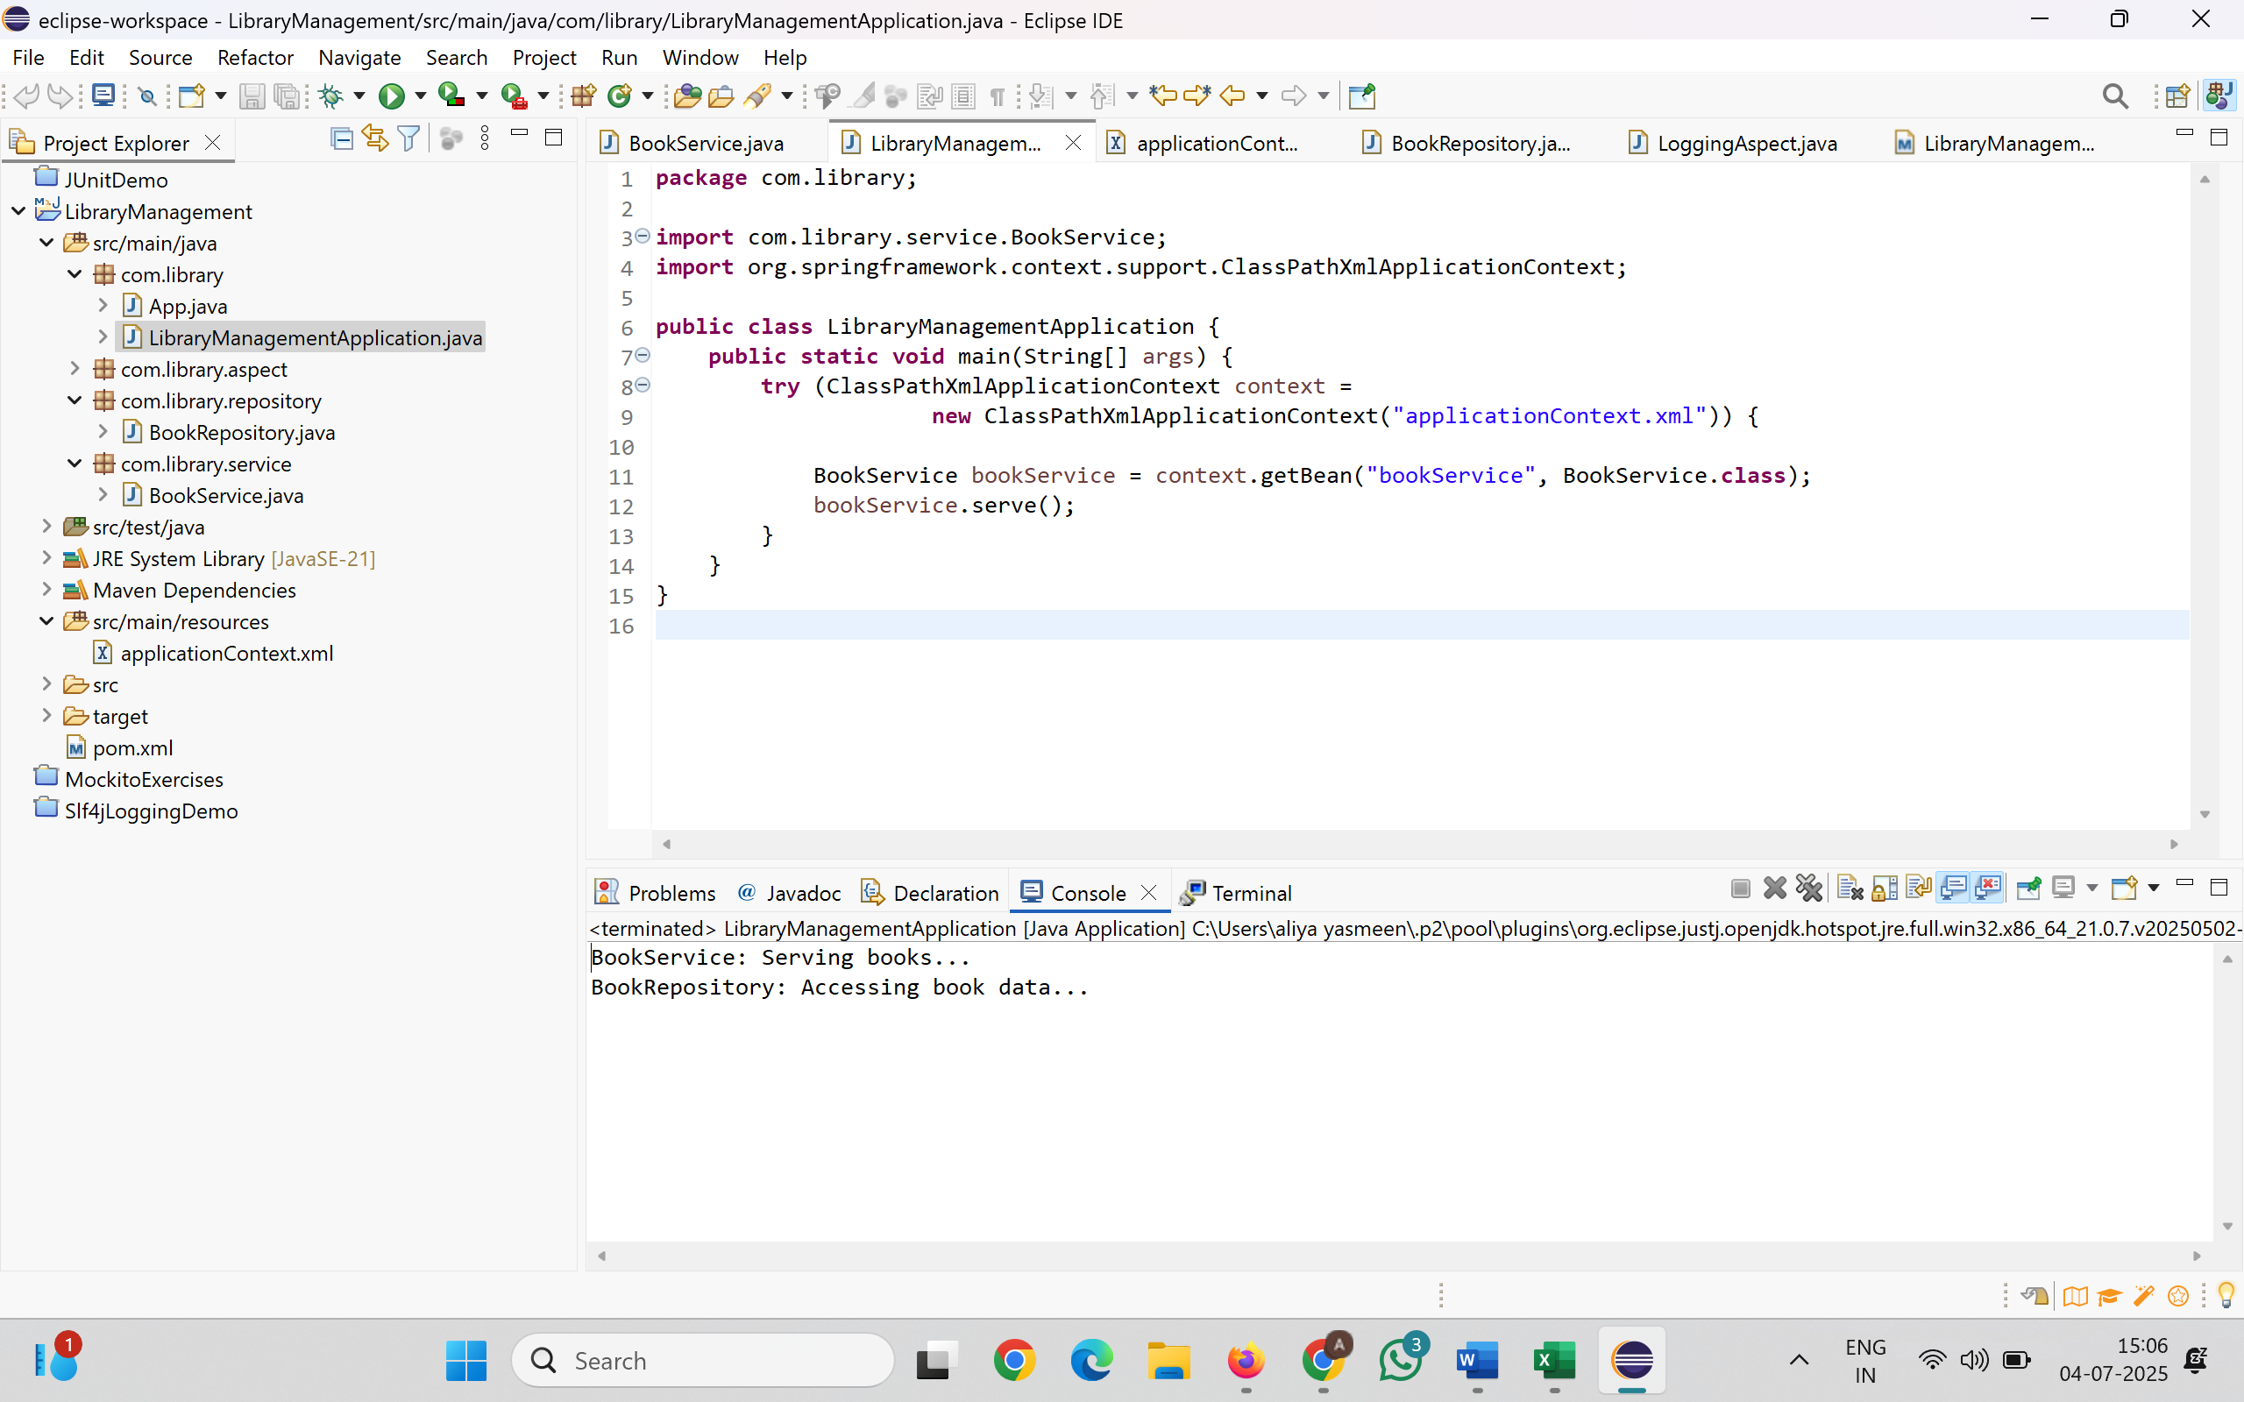

**Exercise 6: Configuring Beans with Annotations**

**Scenario:**

You need to simplify the configuration of beans in the library management application using annotations.

**applicationContext.xml**

<?xml version="1.0" encoding="UTF-8"?>

<beans xmlns="http://www.springframework.org/schema/beans"

xmlns:context="http://www.springframework.org/schema/context"

xmlns:xsi="http://www.w3.org/2001/XMLSchema-instance"

xsi:schemaLocation="

http://www.springframework.org/schema/beans

https://www.springframework.org/schema/beans/spring-beans.xsd

http://www.springframework.org/schema/context

https://www.springframework.org/schema/context/spring-context.xsd">

<context:component-scan base-package="com.library" />

</beans>

**BookService.java**

package com.library.service;

import com.library.repository.BookRepository;

import org.springframework.beans.factory.annotation.Autowired;

import org.springframework.stereotype.Service;

@Service

public class BookService {

private BookRepository bookRepository;

@Autowired // Spring will automatically inject BookRepository here

public void setBookRepository(BookRepository bookRepository) {

this.bookRepository = bookRepository;

}

public void serve() {

System.out.println("BookService: Serving books...");

bookRepository.display();

}

}

**BookRepository.java**

package com.library.repository;

import org.springframework.stereotype.Repository;

@Repository

public class BookRepository {

public void display() {

System.out.println("BookRepository: Accessing book data...");

}

}

**LibraryManagementApplication.java**

package com.library;

import com.library.service.BookService;

import org.springframework.context.support.ClassPathXmlApplicationContext;

public class LibraryManagementApplication {

public static void main(String[] args) {

try (ClassPathXmlApplicationContext context = new ClassPathXmlApplicationContext("applicationContext.xml")) {

BookService bookService = context.getBean("bookService", BookService.class);

bookService.serve();

}

}

}

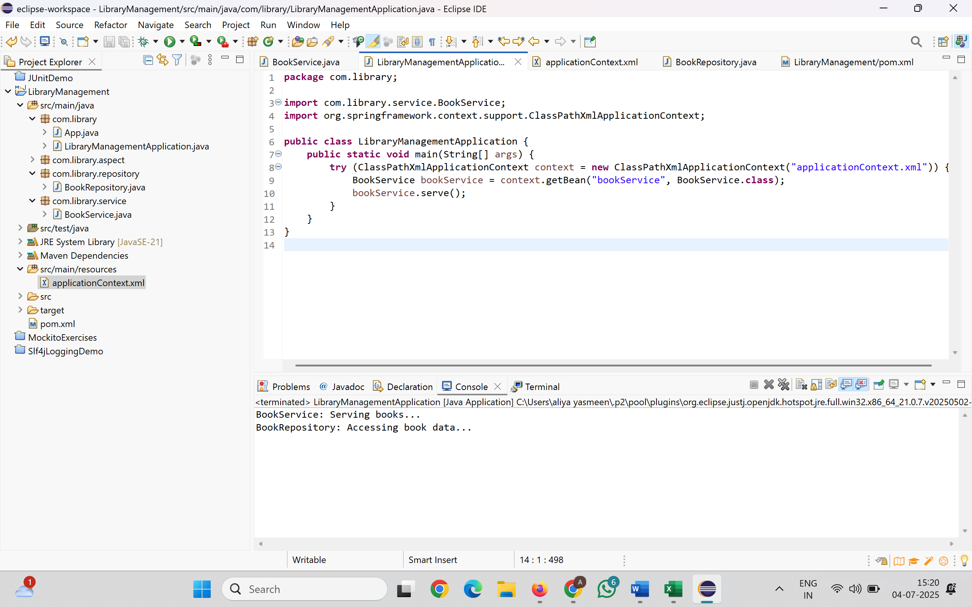

**Exercise 7: Implementing Constructor and Setter Injection**

**Scenario:**

The library management application requires both constructor and setter injection for better control over bean initialization.

**BookService.java:**

package com.library.service;

import com.library.repository.BookRepository;

public class BookService {

private BookRepository bookRepository;

private String libraryName; // Just an extra config via setter

public BookService(BookRepository bookRepository) {

this.bookRepository = bookRepository;

}

public void setLibraryName(String libraryName) {

this.libraryName = libraryName;

}

public void serve() {

System.out.println("[" + libraryName + "] BookService: Serving books...");

bookRepository.display();

}

}

**applicationContext.xml**

<?xml version="1.0" encoding="UTF-8"?>

<beans xmlns="http://www.springframework.org/schema/beans"

xmlns:xsi="http://www.w3.org/2001/XMLSchema-instance"

xsi:schemaLocation="

http://www.springframework.org/schema/beans

https://www.springframework.org/schema/beans/spring-beans.xsd">

<bean id="bookRepository" class="com.library.repository.BookRepository" />

<bean id="bookService" class="com.library.service.BookService">

<constructor-arg ref="bookRepository" />

<property name="libraryName" value="City Central Library" />

</bean>

</beans>

**LibraryManagementApplication.java**

package com.library;

import com.library.service.BookService;

import org.springframework.context.support.ClassPathXmlApplicationContext;

public class LibraryManagementApplication {

public static void main(String[] args) {

try (ClassPathXmlApplicationContext context =

new ClassPathXmlApplicationContext("applicationContext.xml")) {

BookService bookService = context.getBean("bookService", BookService.class);

bookService.serve();

}

}

}

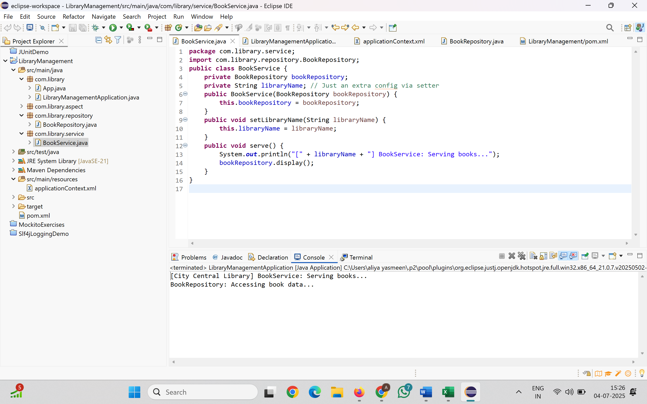

**Exercise 8: Implementing Basic AOP with Spring**

**Scenario:**

The library management application requires basic AOP functionality to separate cross-cutting concerns like logging and transaction management.

**LoggingAspect.java**

package com.library.aspect;

import org.aspectj.lang.JoinPoint;

import org.aspectj.lang.annotation.Aspect;

import org.aspectj.lang.annotation.Before;

import org.aspectj.lang.annotation.After;

@Aspect

public class LoggingAspect {

@Before("execution(* com.library.service.*.*(..))")

public void logBefore(JoinPoint joinPoint) {

System.out.println("[LOG] Before method: " + joinPoint.getSignature().getName());

}

@After("execution(* com.library.service.*.*(..))")

public void logAfter(JoinPoint joinPoint) {

System.out.println("[LOG] After method: " + joinPoint.getSignature().getName());

}

}

**Pom.xml:**

<project xmlns="http://maven.apache.org/POM/4.0.0"

xmlns:xsi="http://www.w3.org/2001/XMLSchema-instance"

xsi:schemaLocation="http://maven.apache.org/POM/4.0.0

http://maven.apache.org/xsd/maven-4.0.0.xsd">

<modelVersion>4.0.0</modelVersion>

<groupId>com.library</groupId>

<artifactId>LibraryManagement</artifactId>

<version>1.0-SNAPSHOT</version>

<dependencies>

<dependency>

<groupId>org.springframework</groupId>

<artifactId>spring-context</artifactId>

<version>5.3.31</version>

</dependency>

<dependency>

<groupId>org.springframework</groupId>

<artifactId>spring-aspects</artifactId>

<version>5.3.31</version>

</dependency>

<dependency>

<groupId>org.springframework</groupId>

<artifactId>spring-webmvc</artifactId>

<version>5.3.31</version>

</dependency>

<dependency>

<groupId>junit</groupId>

<artifactId>junit</artifactId>

<version>4.13.2</version>

<scope>test</scope>

</dependency>

</dependencies>

<build>

<plugins>

<plugin>

<groupId>org.apache.maven.plugins</groupId>

<artifactId>maven-compiler-plugin</artifactId>

<version>3.11.0</version>

<configuration>

<source>21</source>

<target>21</target>

</configuration>

</plugin>

</plugins>

</build>

</project>

**applicationContext.xml:**

<?xml version="1.0" encoding="UTF-8"?>

<beans xmlns="http://www.springframework.org/schema/beans"

xmlns:aop="http://www.springframework.org/schema/aop"

xmlns:xsi="http://www.w3.org/2001/XMLSchema-instance"

xsi:schemaLocation="

http://www.springframework.org/schema/beans

https://www.springframework.org/schema/beans/spring-beans.xsd

http://www.springframework.org/schema/aop

https://www.springframework.org/schema/aop/spring-aop.xsd">

<aop:aspectj-autoproxy />

<bean id="loggingAspect" class="com.library.aspect.LoggingAspect" />

<bean id="bookRepository" class="com.library.repository.BookRepository" />

<bean id="bookService" class="com.library.service.BookService">

<constructor-arg ref="bookRepository" />

<property name="libraryName" value="City Central Library" />

</bean>

</beans>

**LibraryManagementApplication.java:**

package com.library;

import com.library.service.BookService;

import org.springframework.context.support.ClassPathXmlApplicationContext;

public class LibraryManagementApplication {

public static void main(String[] args) {

try (ClassPathXmlApplicationContext context =

new ClassPathXmlApplicationContext("applicationContext.xml")) {

BookService bookService = context.getBean("bookService", BookService.class);

bookService.serve();

}

}

}

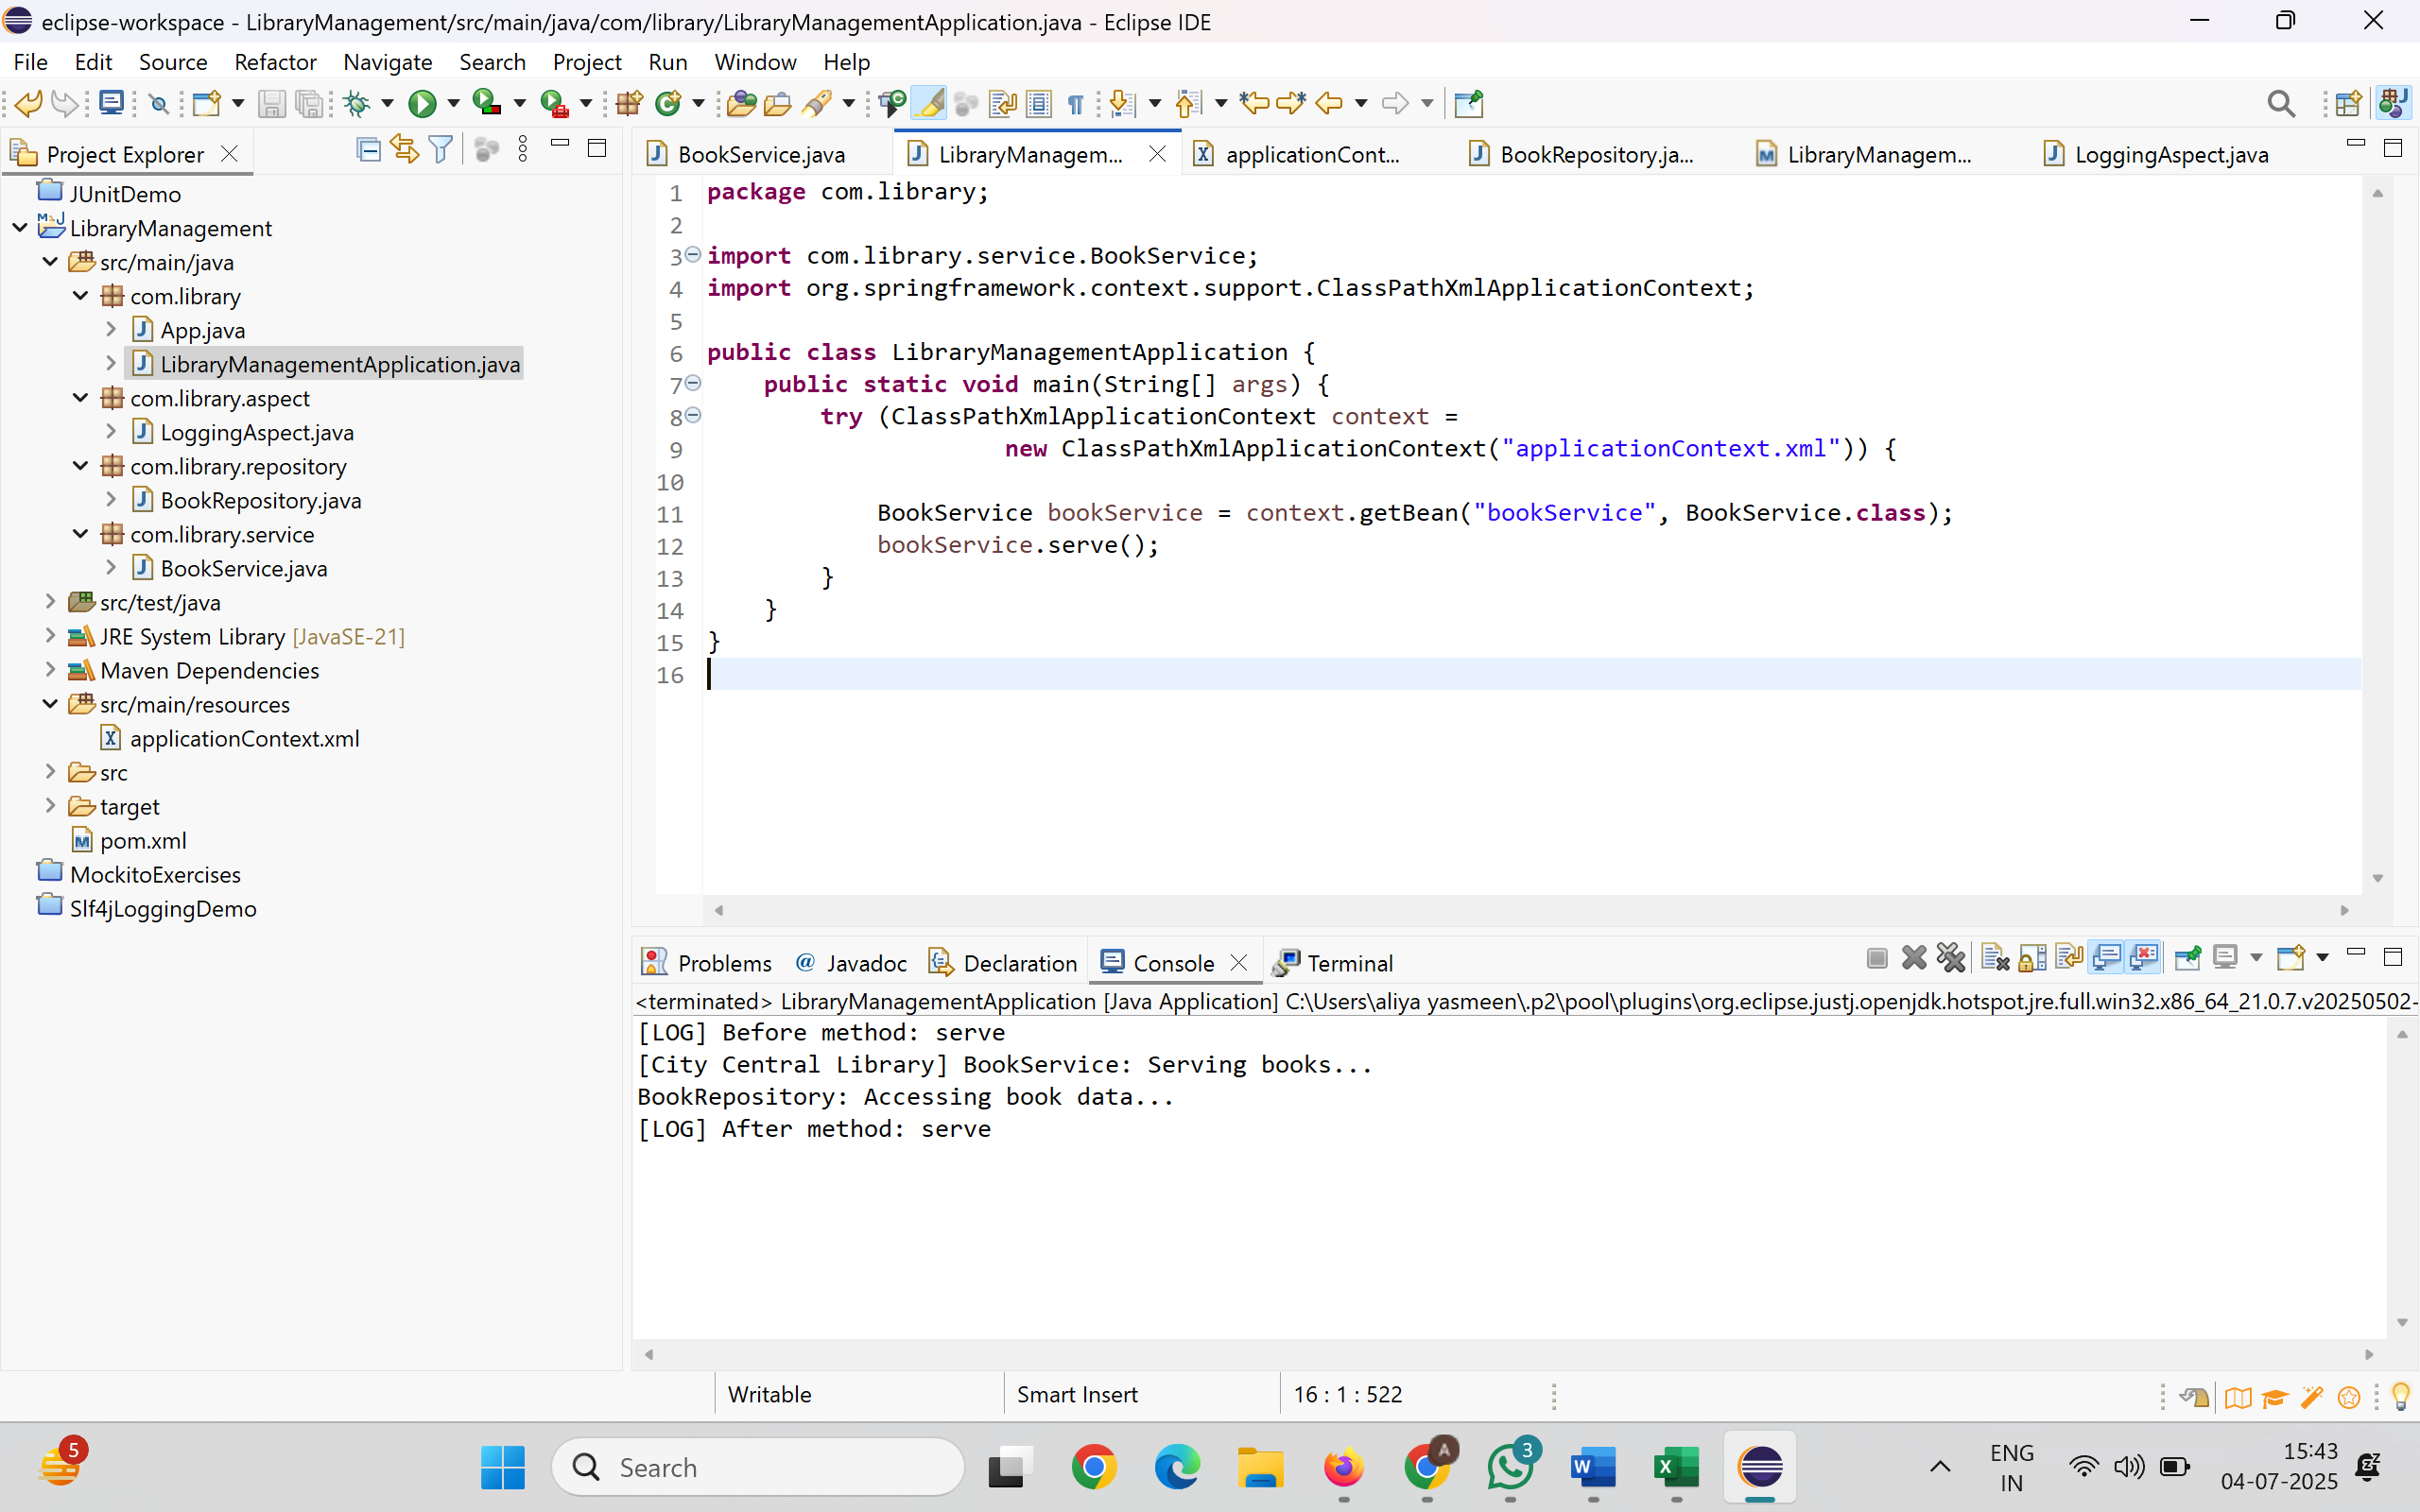

**Exercise 9: Creating a Spring Boot Application**

**Scenario:**

You need to create a Spring Boot application for the library management system to simplify configuration and deployment.

**application.properties:**

spring.datasource.url=jdbc:h2:mem:librarydb

spring.datasource.driverClassName=org.h2.Driver

spring.datasource.username=sa

spring.datasource.password=

spring.jpa.database-platform=org.hibernate.dialect.H2Dialect

spring.jpa.hibernate.ddl-auto=update

spring.h2.console.enabled=true

spring.h2.console.path=/h2-console

server.port=8080

**Book.java:**

package com.library.model;

import jakarta.persistence.*;

@Entity

public class Book {

@Id

@GeneratedValue(strategy = GenerationType.IDENTITY)

private Long id;

private String title;

private String author;

public Book() {}

public Book(String title, String author) {

this.title = title;

this.author = author;

}

public Long getId() { return id; }

public String getTitle() { return title; }

public void setTitle(String title) { this.title = title; }

public String getAuthor() { return author; }

public void setAuthor(String author) { this.author = author; }

}

**BookRepository.java:**

package com.library.repository;

import com.library.model.Book;

import org.springframework.data.jpa.repository.JpaRepository;

public interface BookRepository extends JpaRepository<Book, Long> {

}

**BookController.java:**

package com.library.controller;

import com.library.model.Book;

import com.library.repository.BookRepository;

import org.springframework.web.bind.annotation.*;

import java.util.List;

@RestController

@RequestMapping("/books")

public class BookController {

private final BookRepository bookRepository;

public BookController(BookRepository bookRepository) {

this.bookRepository = bookRepository;

}

@GetMapping

public List<Book> getAllBooks() {

return bookRepository.findAll();

}

@PostMapping

public Book addBook(@RequestBody Book book) {

return bookRepository.save(book);

}

@GetMapping("/{id}")

public Book getBook(@PathVariable Long id) {

return bookRepository.findById(id).orElse(null);

}

@DeleteMapping("/{id}")

public void deleteBook(@PathVariable Long id) {

bookRepository.deleteById(id);

}

}

**LibraryManagementApplication.java:**

package com.library;

import org.springframework.boot.SpringApplication;

import org.springframework.boot.autoconfigure.SpringBootApplication;

@SpringBootApplication

public class LibraryManagementApplication {

public static void main(String[] args) {

SpringApplication.run(LibraryManagementApplication.class, args);

}

}

