WEEK-6 React
- ReactJS-HOL

App.js:
function App() {
return (
<h1>Welcome to the first session of React</h1>
);
}
export default App;
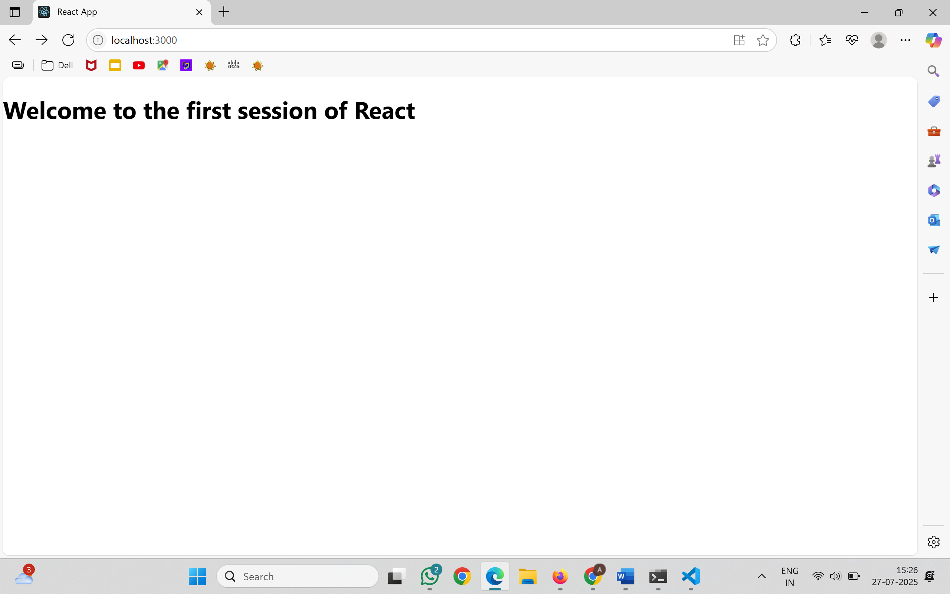
- ReactJS-HOL

Home.js
import { Component } from 'react';
class Home extends Component {
render() {
return (
<div>
<h3>Welcome to the Home Page of Student Management Portal</h3>
</div>
);
}
}
export default Home;
About.js
import { Component } from 'react';
class About extends Component {
render() {
return (
<div>
<h3>Welcome to the About Page of Student Management Portal</h3>
</div>
);
}
}
export default About;
Contact.js
import { Component } from 'react';
class Contact extends Component {
render() {
return (
<div>
<h3>Welcome to the Contact Page of Student Management Portal</h3>
</div>
);
}
}
export default Contact;

App.js
import './App.css';
import Home from './Components/Home';
import About from './Components/About';
import Contact from './Components/Contact';
function App() {
return (
<div className="container">
<Home/>
<About/>
<Contact/>
</div>
);
}
export default App;
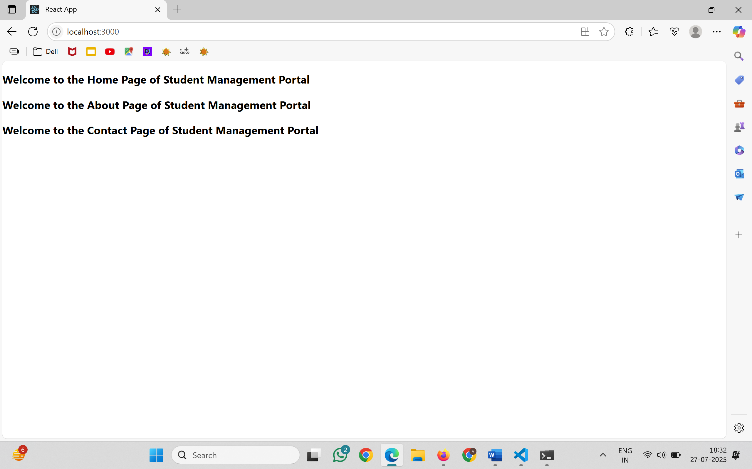
- ReactJS-HOL

C:\Users\aliyayasmeen\scorecalculatorapp\src\Components\CalculateScore.js
import '../Stylesheets/mystyle.css';

const percentToDecimal = (decimal) => {
return (decimal.toFixed(2) + ' %')
}
const calcScore = (total, goal) => {
return percentToDecimal(total/goal)
}
export const CalculateScore = ({Name, School, total, goal}) => (
<div className="formatstyle">
<h1><font color="Brown">Student Details:</font></h1>
<div className="Name">
<b><span> Name: </span></b>
<span>{Name}</span>
</div>
<div className="School">
<b><span> School: </span></b>
<span>{School}</span>
</div>
<div className="Total">
<b><span>Total:</span></b>
<span>{total}</span>
<span> Marks </span>
</div>
<div className="Score">
<b><span>Score:</span></b>
<span>{calcScore(total, goal)}</span>
</div>
</div>
)
C:\Users\aliya yasmeen\scorecalculatorapp\src\Stylesheets\mystyle.css
.Name
{
font-weight:300;
color:blue;
}
.School
{
color:crimson;
}
.Total
{
color:darkmagenta;
}
.formatstyle
{
text-align:center;
font-size:large;
}
.Score
{
color:forestgreen;
}
App.js:
import './App.css';
import { CalculateScore } from './Components/CalculateScore';
function App() {
return (
<div className="App">
<CalculateScore
Name="Steeve"
School="DNV Public School"
total={284}
goal={3}
/>
</div>
);
}
export default App;

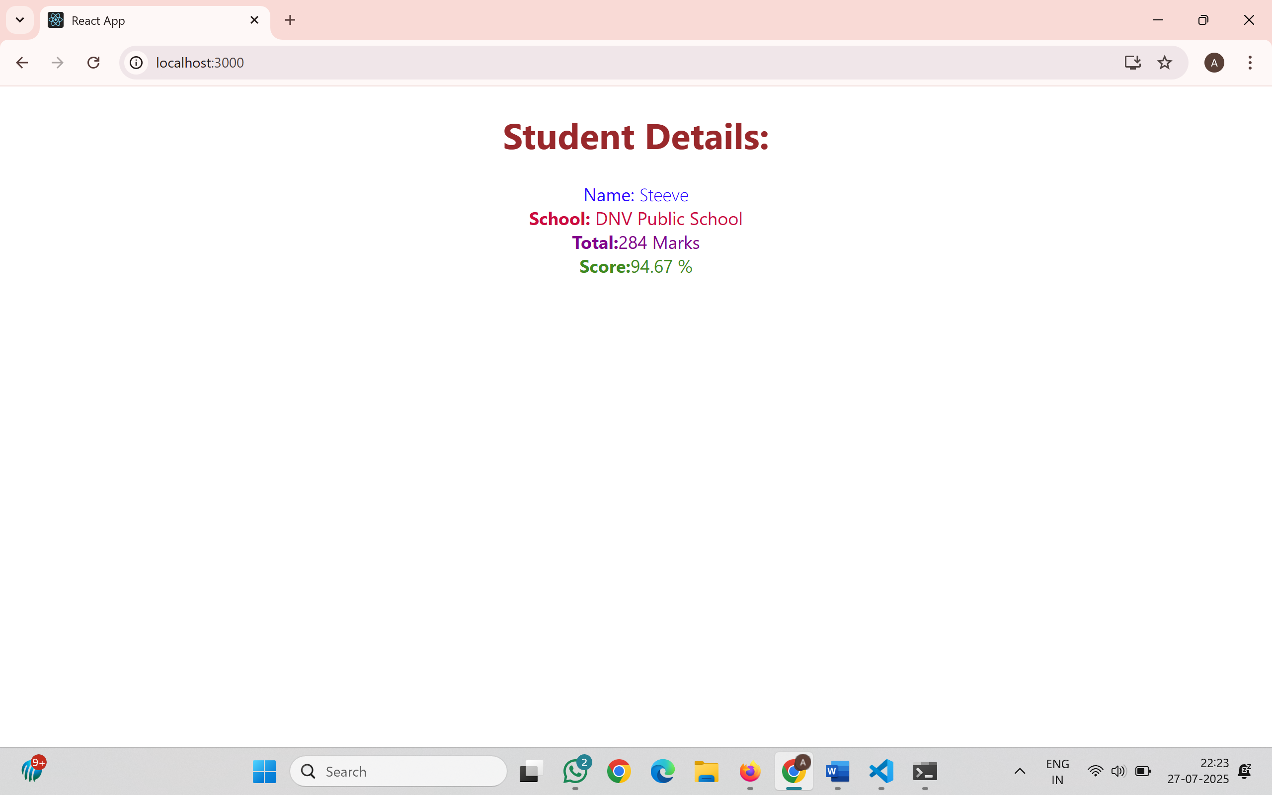
- ReactJS-HOL

Post.js
import React from 'react';
class Post extends React.Component {
render() {
return (
<div style={{ border: '1px solid gray', padding: '15px', margin: '10px', borderRadius: '8px' }}>
<h2>{this.props.title}</h2>
<p>{this.props.body}</p>
</div>
);
}
}
export default Post;
Posts.js
import React from 'react';
import Post from './Post';
class Posts extends React.Component {
constructor(props) {
super(props);
this.state = {
posts: [],
hasError: false
};
}
loadPosts = () => {
fetch('https://jsonplaceholder.typicode.com/posts')
.then((res) => res.json())
.then((data) => {
this.setState({ posts: data });
})
.catch((error) => {
this.setState({ hasError: true });
console.error("Fetch error:", error);
});
};
componentDidMount() {
this.loadPosts();
}
componentDidCatch(error, info) {
alert("An error occurred: " + error);
}
render() {
if (this.state.hasError) {
return <h3>Error occurred while loading posts.</h3>;
}
return (
<div>
<h1 style={{ textAlign: "center", color: "#333" }}>Blog Posts</h1>
{this.state.posts.map(post => (
<Post key={post.id} title={post.title} body={post.body} />
))}
</div>
);
}
}
export default Posts;
App.js
import React from 'react';
import Posts from './Posts';
function App() {
return (
<div className="App">
<Posts />
</div>
);
}
export default App;

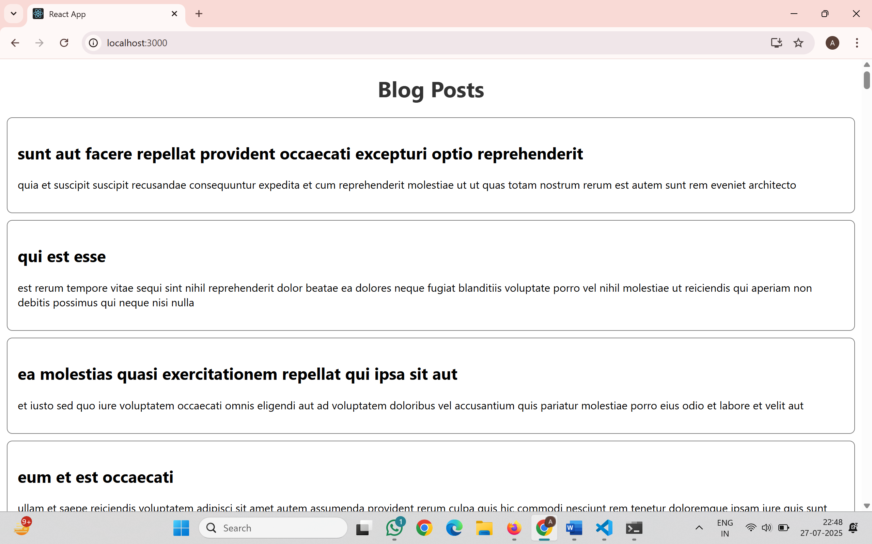
- ReactJS-HOL

CohortDetails.module.css
.box {
width: 300px;
display: inline-block;
margin: 10px;
padding: 10px 20px;
border: 1px solid black;
border-radius: 10px;
}
dt {
font-weight: 500;
}
CohortDetails.js
import styles from './CohortDetails.module.css';
function CohortDetails(props) {
return (
<div className={styles.box}>
<h3 style={{ color: props.cohort.currentStatus === 'ongoing' ? 'green' : 'blue' }}>
{props.cohort.cohortCode} -
<span>{props.cohort.technology}</span>
</h3>
<dl>
<dt>Started On</dt>
<dd>{props.cohort.startDate}</dd>
<dt>Current Status</dt>
<dd>{props.cohort.currentStatus}</dd>
<dt>Coach</dt>
<dd>{props.cohort.coachName}</dd>
<dt>Trainer</dt>
<dd>{props.cohort.trainerName}</dd>
</dl>
</div>
);
}
export default CohortDetails;
App.js
import './App.css';
import { CohortsData } from './Cohort';
import CohortDetails from './CohortDetails';
function App() {
return (
<div style={{ padding: '20px' }}>
<h1>Cohorts Details</h1>
{CohortsData.map((cohort, index) => (
<CohortDetails key={index} cohort={cohort} />
))}
</div>
);
}
export default App;
