WEEK-5
Microservices with Spring Boot 3 and Spring Cloud
Creating Microservices for account and loan
Account Microservice
AccountController.java:
package com.cognizant.account;
import org.springframework.web.bind.annotation.GetMapping;
import org.springframework.web.bind.annotation.PathVariable;
import org.springframework.web.bind.annotation.RestController;
import java.util.Map;
@RestController
public class AccountController {
@GetMapping("/accounts/{number}")
public Map<String, Object> getAccount(@PathVariable String number) {
return Map.of(
"number", number,
"type", "savings",
"balance", 234343
);
}
}

Output:
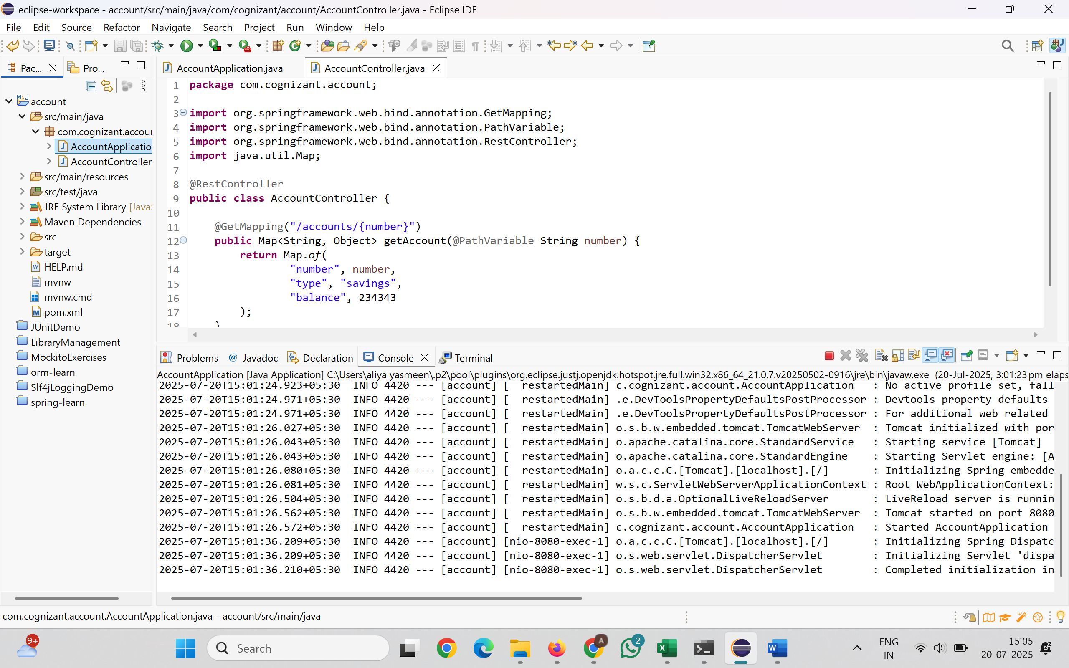
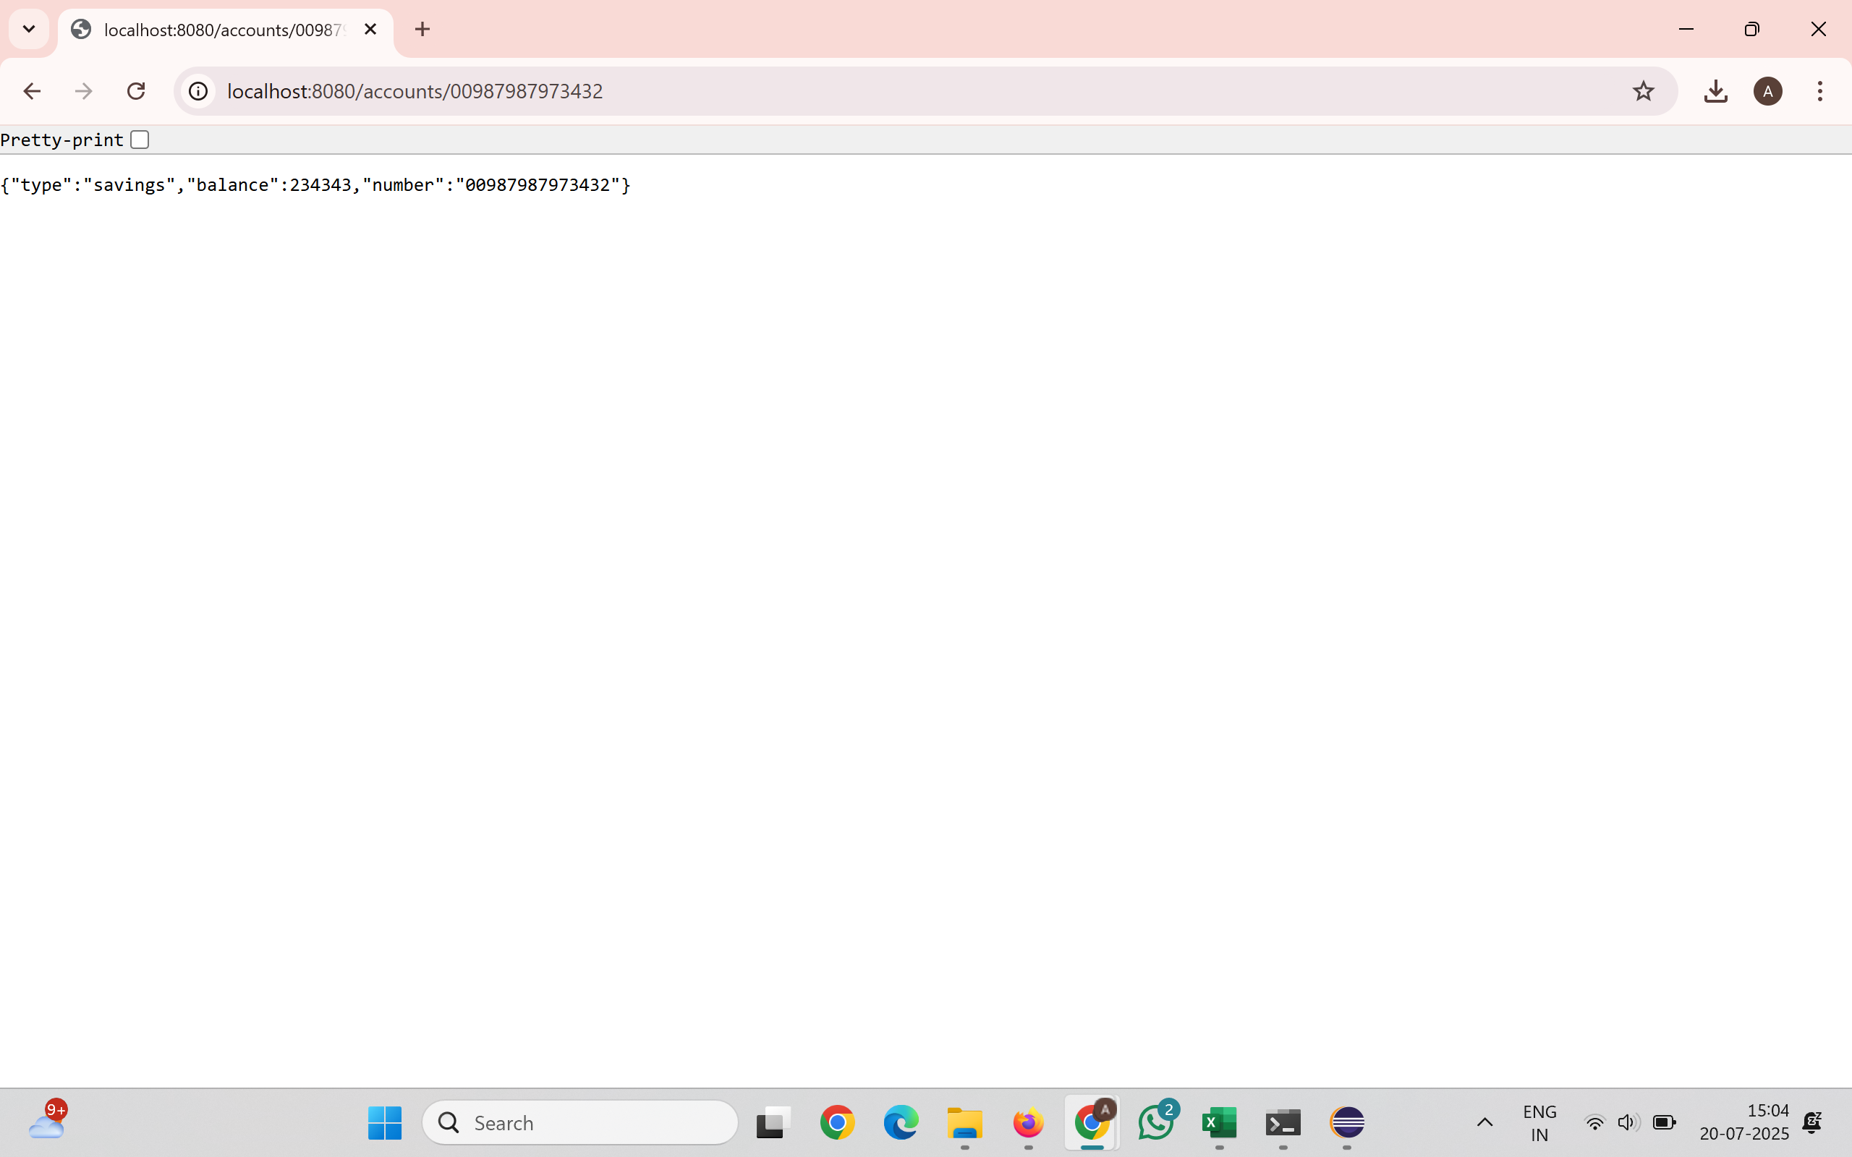

Loan Microservice
LoanController.java:
package com.cognizant.loan.controller;
import org.springframework.web.bind.annotation.*;
@RestController
@RequestMapping("/loans")
public class LoanController {
@GetMapping("/{number}")
public Loan getLoanDetails(@PathVariable String number) {
return new Loan("H00987987972342", "car", 400000, 3258, 18);
}
static class Loan {
private String number;
private String type;
private int loan;
private int emi;
private int tenure;
public Loan(String number, String type, int loan, int emi, int tenure) {
this.number = number;
this.type = type;
this.loan = loan;
this.emi = emi;
this.tenure = tenure;
}
public String getNumber() { return number; }
public void setNumber(String number) { this.number = number; }
public String getType() { return type; }
public void setType(String type) { this.type = type; }
public int getLoan() { return loan; }
public void setLoan(int loan) { this.loan = loan; }
public int getEmi() { return emi; }
public void setEmi(int emi) { this.emi = emi; }

public int getTenure() { return tenure; }
public void setTenure(int tenure) { this.tenure = tenure; }
}
}
Output:
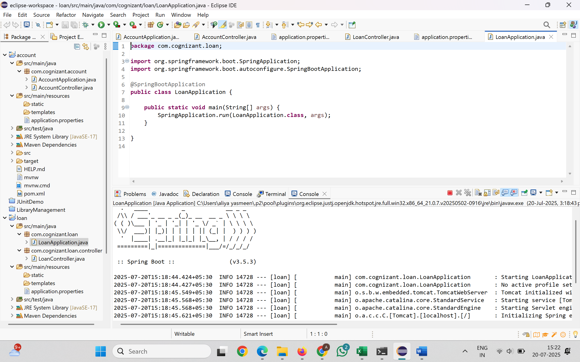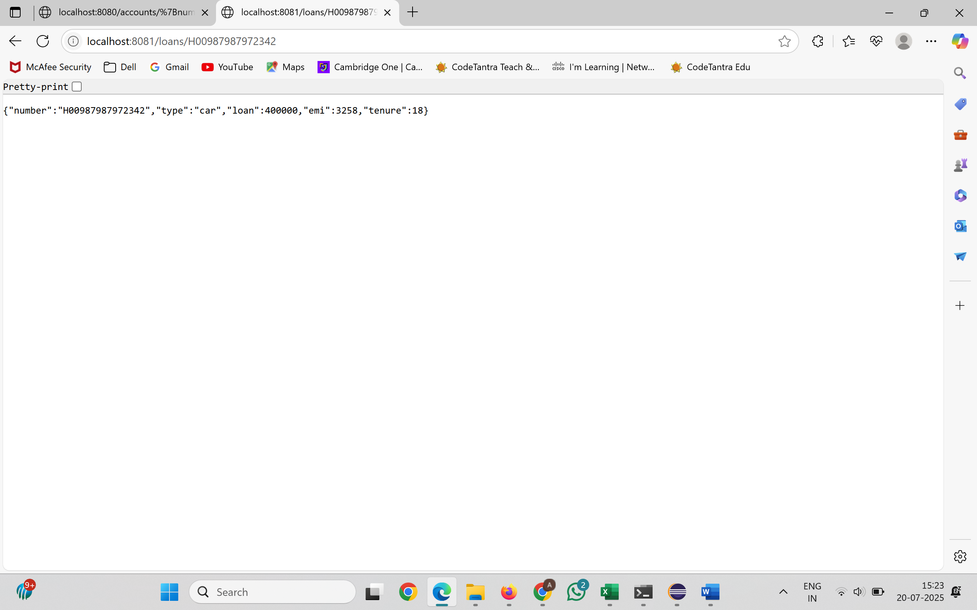
Create Eureka Discovery Server and register microservices
Create and Launch Eureka Discovery Server
EurekaDiscoveryServerApplication.java
package com.cognizant.eureka_discovery_server;

import org.springframework.boot.SpringApplication;
import org.springframework.boot.autoconfigure.SpringBootApplication;
import org.springframework.cloud.netflix.eureka.server.EnableEurekaServer;

@SpringBootApplication
@EnableEurekaServer
public class EurekaDiscoveryServerApplication {
public static void main(String[] args) {
SpringApplication.run(EurekaDiscoveryServerApplication.class, args);
}
}
application.properties
spring.application.name=eureka-discovery-server
server.port=8761

eureka.client.register-with-eureka=false
eureka.client.fetch-registry=false

logging.level.com.netflix.eureka=OFF
logging.level.com.netflix.discovery=OFF

Register Account REST API to eureka discovery
package com.cognizant.api_gateway;

import org.springframework.boot.SpringApplication;
import org.springframework.boot.autoconfigure.SpringBootApplication;

@SpringBootApplication
public class ApiGatewayApplication {

public static void main(String[] args) {
SpringApplication.run(ApiGatewayApplication.class, args);
}

}
application.properties
spring.application.name=eureka-discovery-server
server.port=8761
eureka.client.register-with-eureka=false
eureka.client.fetch-registry=false
logging.level.com.netflix.eureka=OFF
logging.level.com.netflix.discovery=OFF

Output:
