WEEK-6 React
- ReactJS-HOL
Cognizant Academy teams want to maintain a list of trainers along with their expertise in a SPA using React as the technology. You are assigned the task of creating this React app

Trainer.js
class Trainer {
constructor(TrainerId, Name, Email, Phone, Technology, Skills) {
this.TrainerId = TrainerId;
this.Name = Name;
this.Email = Email;
this.Phone = Phone;
this.Technology = Technology;
this.Skills = Skills;
}
}
export default Trainer;
TrainerDetail.js
import React from 'react';
import { useParams } from 'react-router-dom';
import TrainersMock from './TrainersMock';
const TrainerDetail = () => {
const { id } = useParams();
const trainer = TrainersMock.find(t => t.TrainerId === id);
if (!trainer) return <h3>Trainer not found!</h3>;
return (
<div>
<h2>{trainer.Name}</h2>
<p><strong>Email:</strong> {trainer.Email}</p>
<p><strong>Phone:</strong> {trainer.Phone}</p>
<p><strong>Technology:</strong> {trainer.Technology}</p>
<p><strong>Skills:</strong> {trainer.Skills.join(', ')}</p>
</div>
);
};
export default TrainerDetail;

TrainerList.js
import React from 'react';
import { Link } from 'react-router-dom';
const TrainerList = ({ data }) => {
return (
<div>
<h2>Trainer List</h2>
<ul>
{data.map(trainer => (
<li key={trainer.TrainerId}>
<Link to={`/trainer/${trainer.TrainerId}`}>{trainer.Name}</Link>
</li>
))}
</ul>
</div>
);
};
export default TrainerList;
TrainersMock.js
import Trainer from "./Trainer";
const TrainersMock = [
new Trainer(
't-syed8',
'Syed Khaleelullah',
'khaleelullah@cognizant.com',
'97676516962',
'.NET',
['C#', 'SQL Server', 'React', '.NET Core']
),
new Trainer(
't-jojo',
'Jojo Jose',
'jojo@cognizant.com',
'9897199231',
'Java',
['Java', 'JSP', 'Angular', 'Spring']
),
new Trainer(
't-elisa',
'Elisa Jones',
'elisa@cognizant.com',
'9871212235',
'Python',
['Python', 'Django', 'Angular']
)
];
export default TrainersMock;
Home.js
import React from 'react';
const Home = () => {
return (
<div>
<h2>Welcome to Trainers Application</h2>
<p>This is the home page.</p>
</div>
);
};
export default Home;
App.js
import React from 'react';
import { BrowserRouter, Routes, Route, Link } from 'react-router-dom';
import Home from './Home';
import TrainerList from './TrainerList';
import TrainerDetail from './TrainerDetail';
import TrainersMock from './TrainersMock';
function App() {
return (
<BrowserRouter>
<div>
<nav>
<Link to="/">Home</Link> | <Link to="/trainers">Trainers</Link>
</nav>
<Routes>
<Route path="/" element={<Home />} />
<Route path="/trainers" element={<TrainerList data={TrainersMock} />} />
<Route path="/trainer/:id" element={<TrainerDetail />} />
</Routes>
</div>
</BrowserRouter>
);
}
export default App;
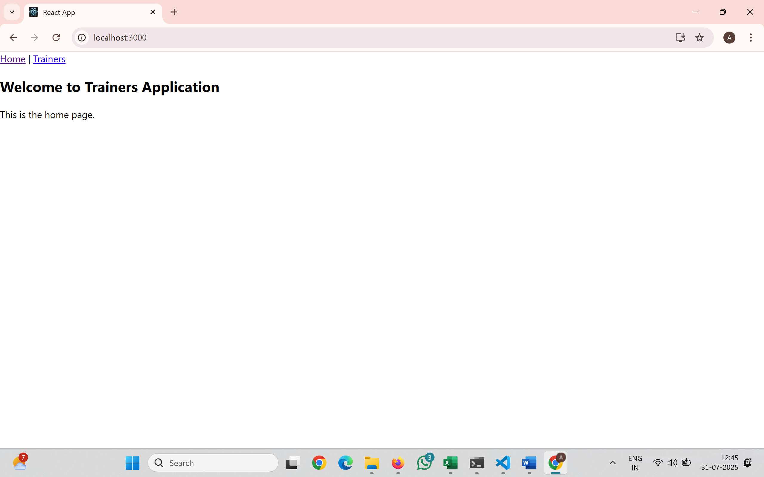
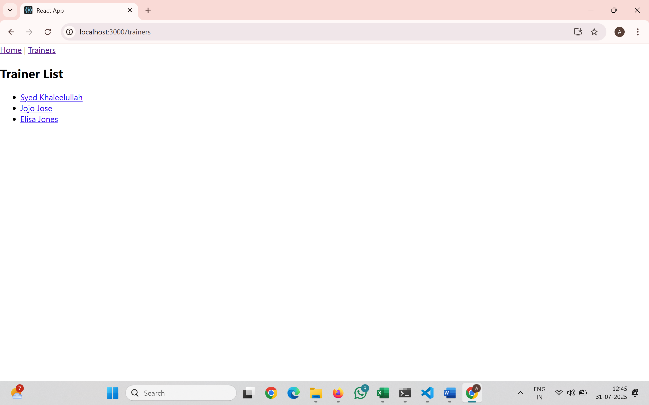
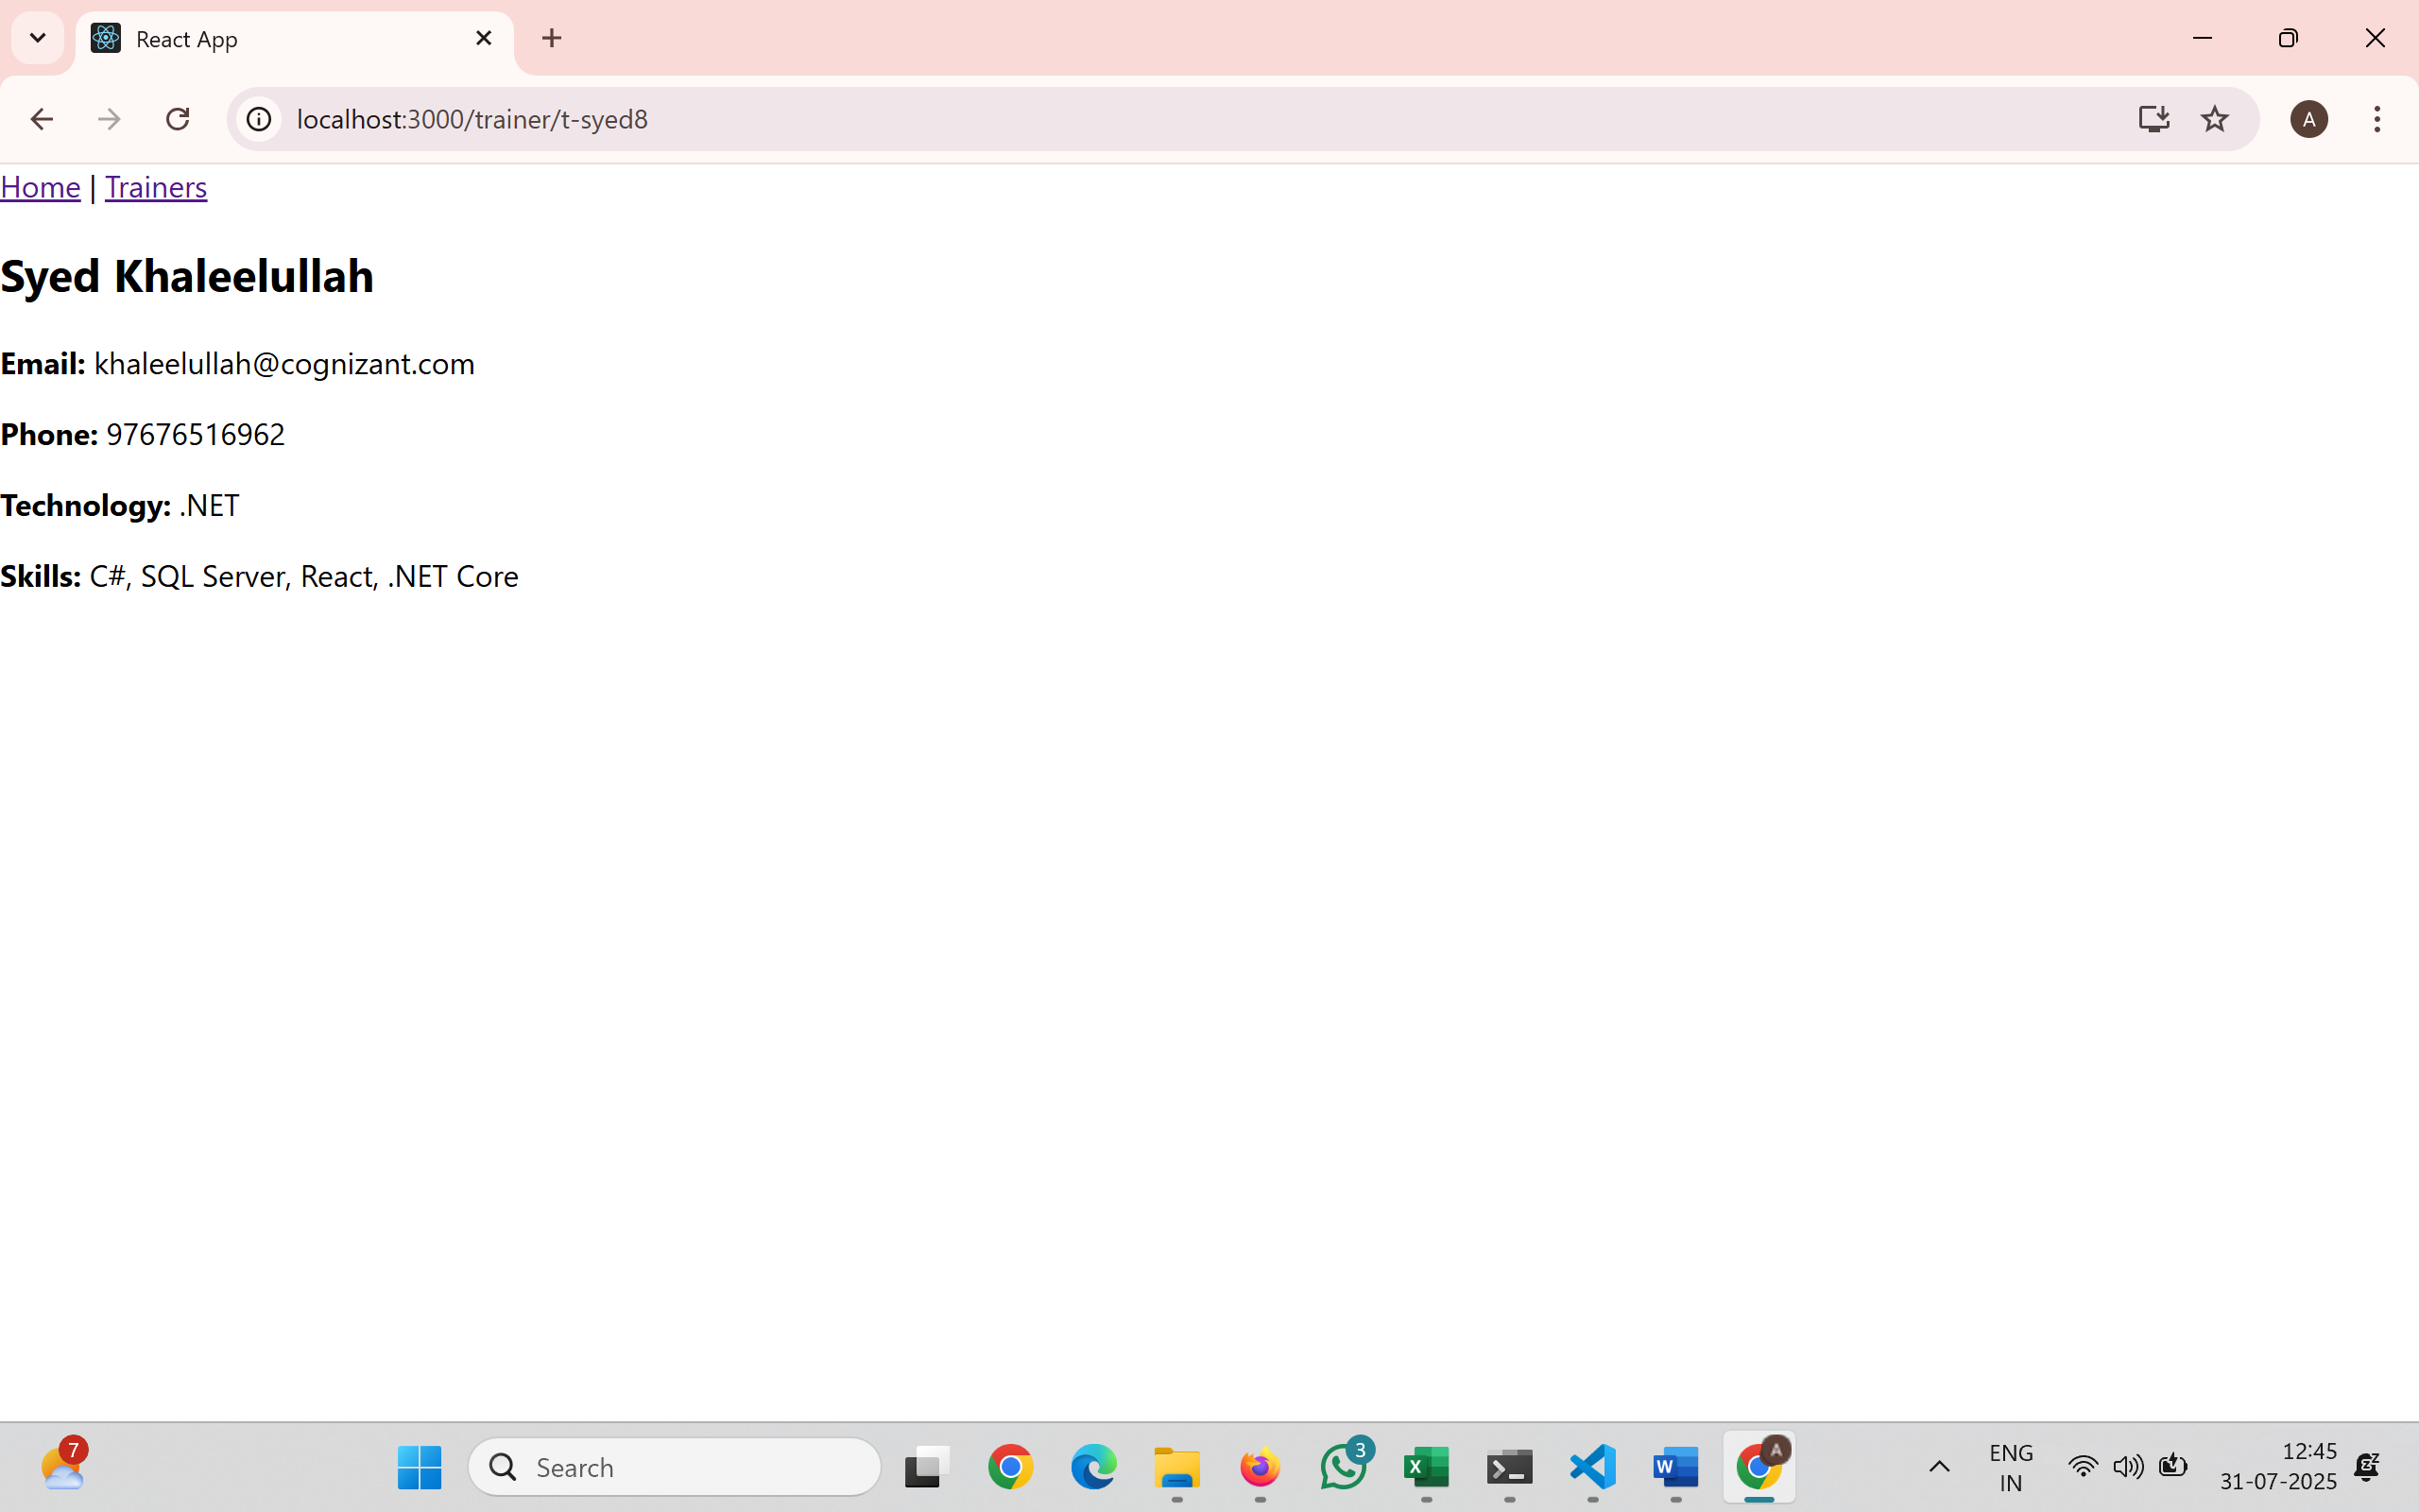
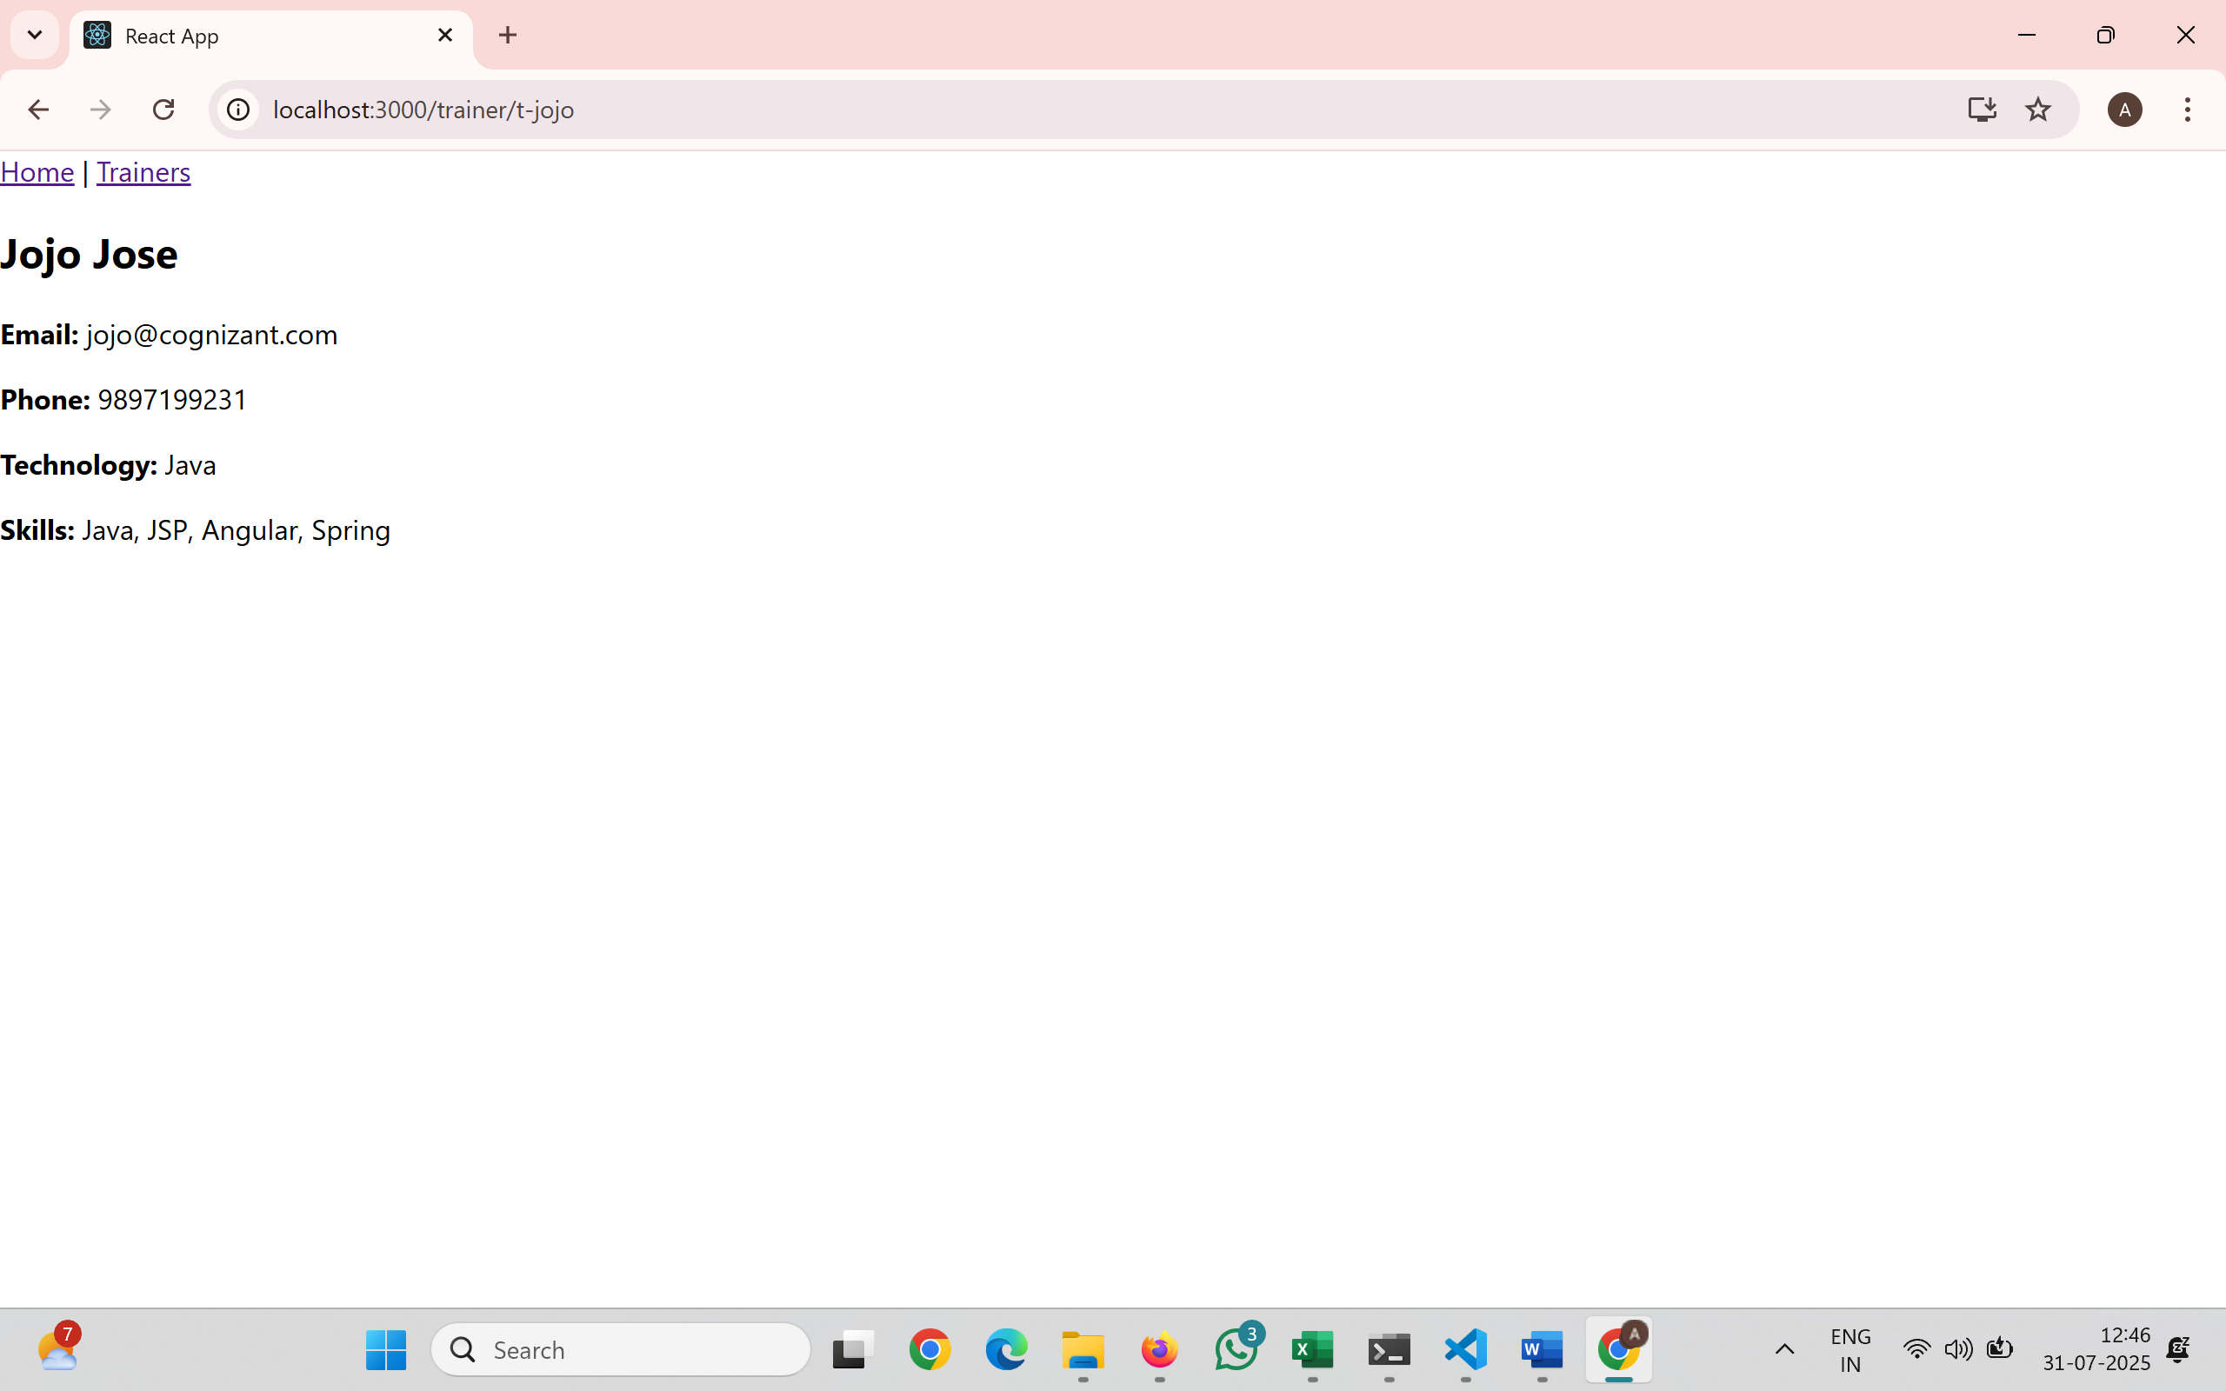
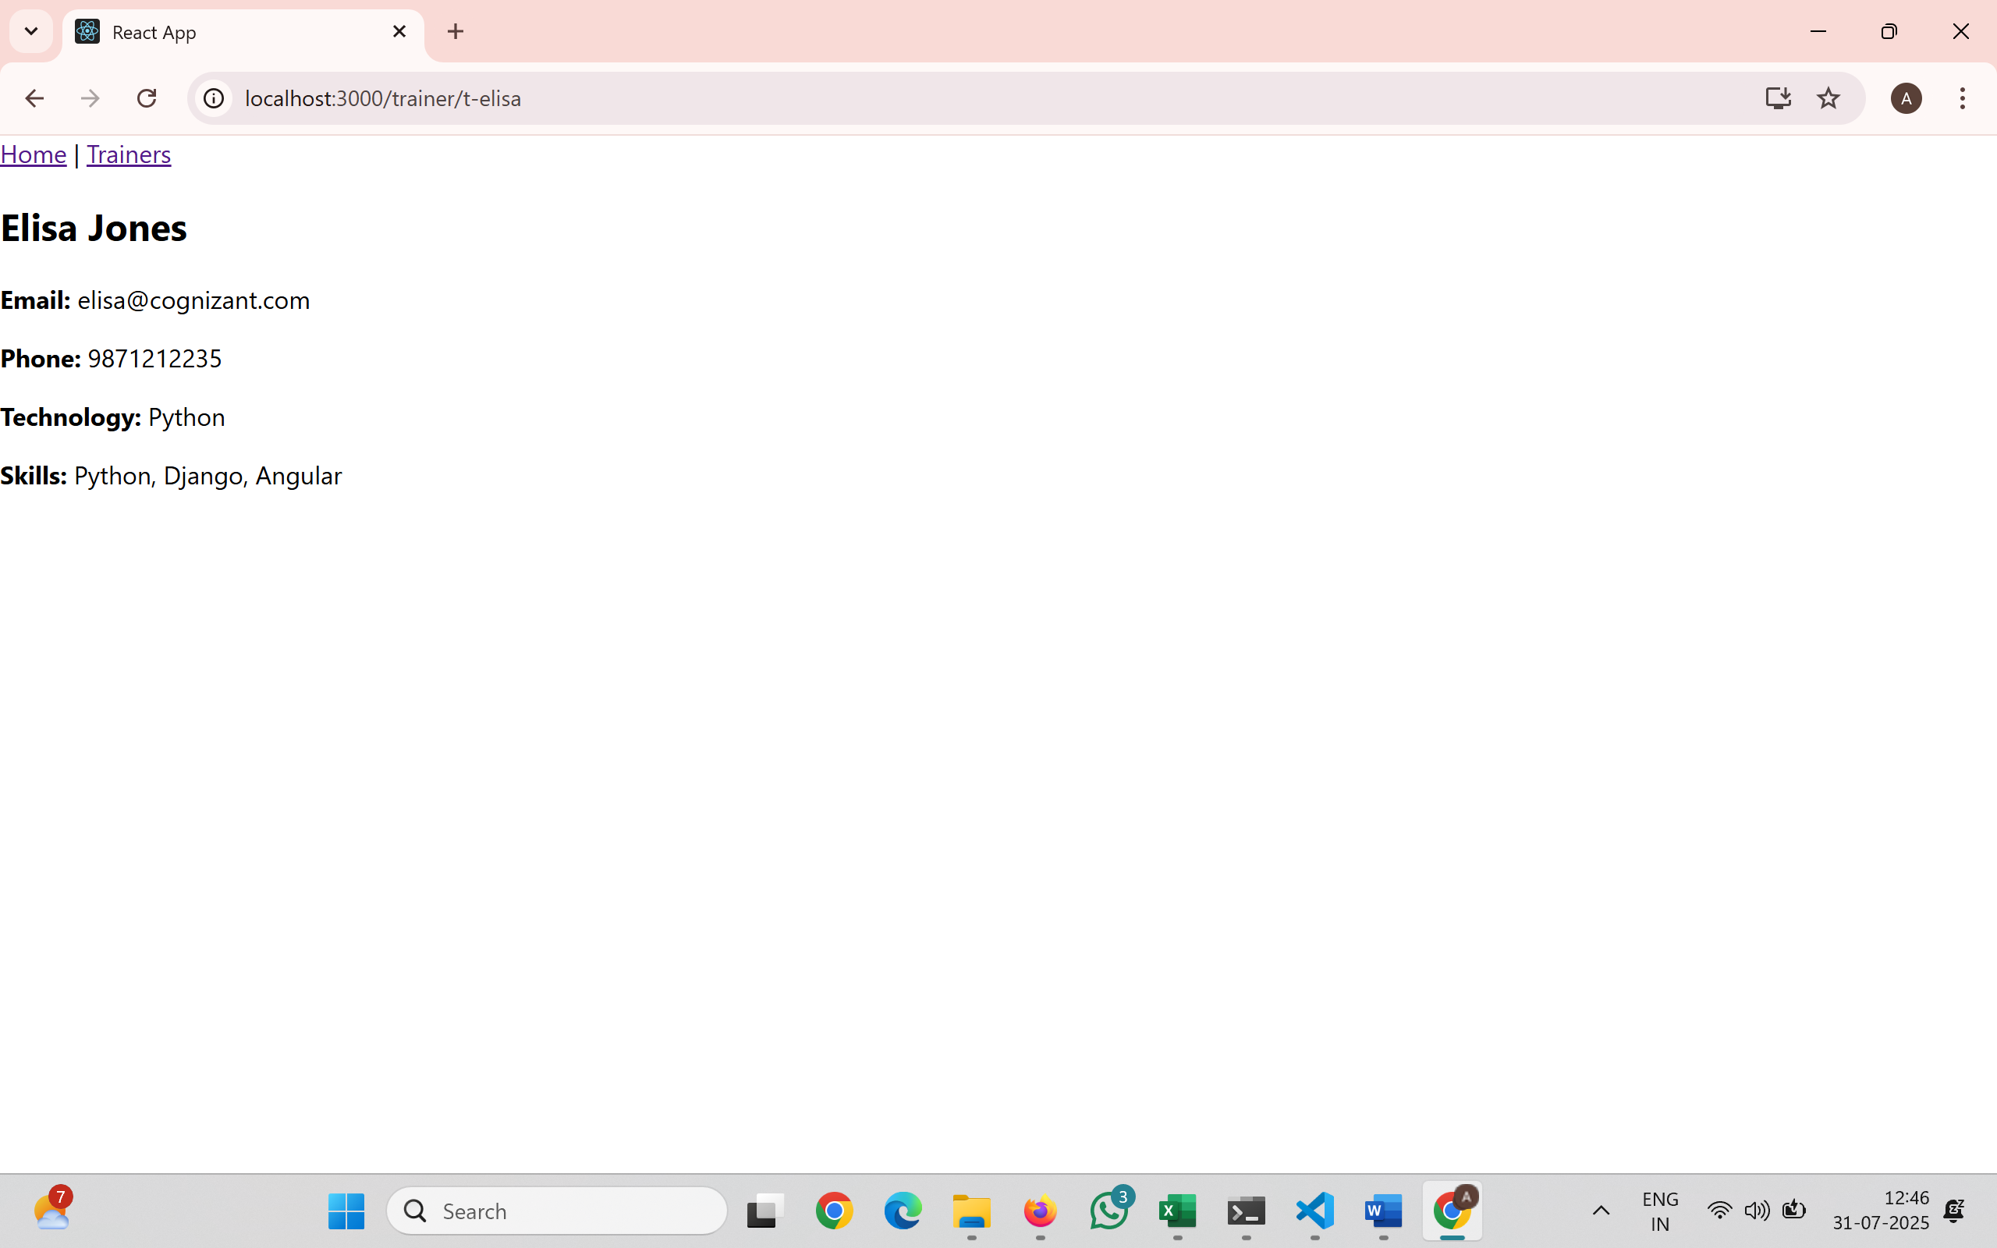
- ReactJS-HOL
Create a React Application named “shoppingapp” with a class component named “OnlineShopping” and “Cart”.
Cart.js
import React from 'react';
class Cart extends React.Component {
render() {
return (
this.props.item.map((item, index) => {
return (
<tr key={index}>
<td>{item.itemname}</td>
<td>{item.price}</td>
</tr>
);
})
);
}
}
export default Cart;

OnlineShopping.js
import React from 'react';
import Cart from './Cart';
import './OnlineShopping.css';
export class OnlineShopping extends React.Component {
render() {
const CartInfo = [
{ itemname: "Laptop", price: 80000 },
{ itemname: "TV", price: 12000 },
{ itemname: "Washing Machine", price: 50000 },
{ itemname: "Mobile", price: 30000 },
{ itemname: "Fridge", price: 70000 }
];
return (
<div className="mydiv">
<h1>Items Ordered :</h1>
<table>
<thead>
<tr>
<th>Name</th>
<th>Price</th>
</tr>
</thead>
<tbody>
<Cart item={CartInfo} />
</tbody>
</table>
</div>
);
}
}
export default OnlineShopping;
OnlineShopping.css
.mydiv {
text-align: center;
margin-top: 50px;
}
h1 {
color: green;
font-weight: bold;
font-size: 30px;
}
table {
margin: 0 auto;
border: 1px solid gray;
border-collapse: collapse;
color: green;
}
th, td {
border: 1px solid gray;
padding: 10px 20px;
text-align: center;
}
th {
font-weight: bold;
}
App.js
import React from 'react';
import './App.css';
import OnlineShopping from './OnlineShopping';
function App() {
return (
<div className="App">
<OnlineShopping />
</div>
);
}
export default App;

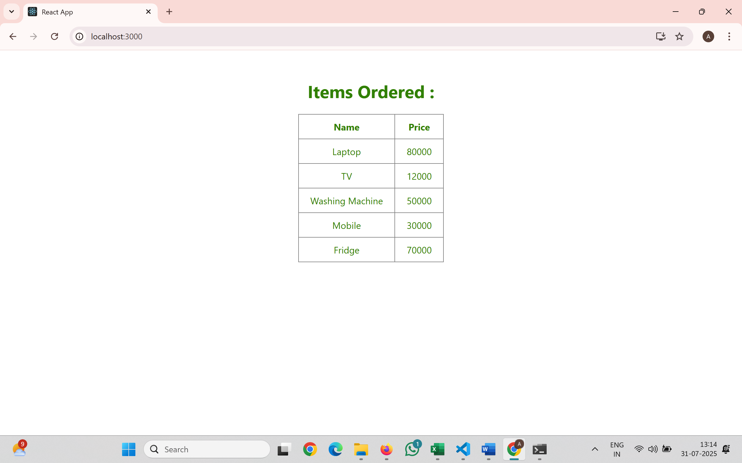
- ReactJS-HOL
Create a React App “counterapp” which will have a component named “CountPeople” which will have 2 methods.
CountPeople.js
import React, { Component } from 'react';
class CountPeople extends Component {
constructor() {
super();
this.state = {
entrycount: 0,
exitcount: 0
};
}
updateEntry() {
this.setState((prevState) => ({
entrycount: prevState.entrycount + 1
}));
}
updateExit() {
this.setState((prevState) => ({
exitcount: prevState.exitcount + 1
}));
}

render() {
return (
<div style={{ display: 'flex', justifyContent: 'center', marginTop: '100px' }}>
<div style={{ marginRight: '50px' }}>
<button onClick={() => this.updateEntry()} style={{ backgroundColor: 'lightgreen', padding: '10px', border: '1px solid green' }}>
Login
</button>
<span style={{ marginLeft: '10px' }}>{this.state.entrycount} People Entered!!!</span>
</div>
<div>
<button onClick={() => this.updateExit()} style={{ backgroundColor: 'lightgreen', padding: '10px', border: '1px solid green' }}>
Exit
</button>
<span style={{ marginLeft: '10px' }}>{this.state.exitcount} People Left!!!</span>
</div>
</div>
);
}
}
export default CountPeople;
App.js
import React from 'react';
import CountPeople from './CountPeople';
function App() {
return (
<div>
<CountPeople />
</div>
);
}
export default App;

