Netflix Content Analysis

Overview:
Netflix is an American subscription video on-demand over-the-top streaming service. The service primarily distributes original and acquired films and television shows from various genres, and it is available internationally in multiple languages.
Dataset:
- Consist of 8807 entries
- 12 variables/characteristics for each Movie/TV show
They have over 8000 movies or tv shows available on their platform, as of mid-2021, they have over 200M Subscribers globally. This tabular dataset consists of listings of all the movies and tv shows available on Netflix, along with details such as - cast, directors, ratings, release year, duration, etc.
Objectives:
- Conducting data analysis on the trends of the Netflix contents
- Investigate or recommendations for an upcoming video streaming platform.

Number of movies and shows in Netflix

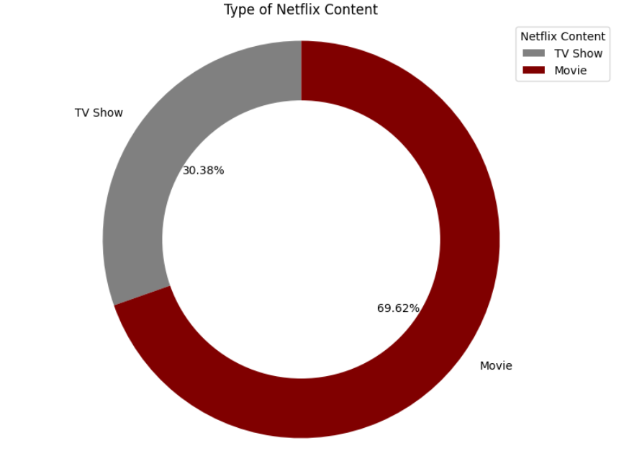
The summary of the data set shows that Netflix is currently focusing more on Movies than on TV Shows.

Movies and Shows Added over years
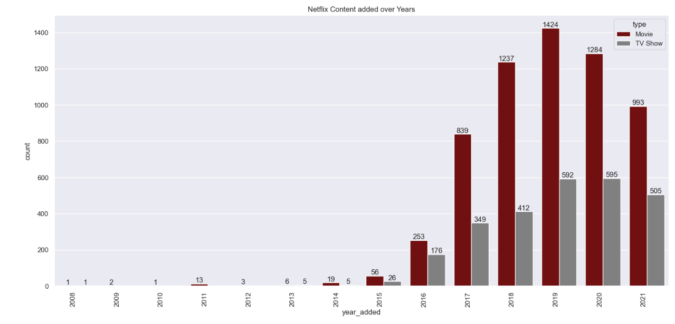
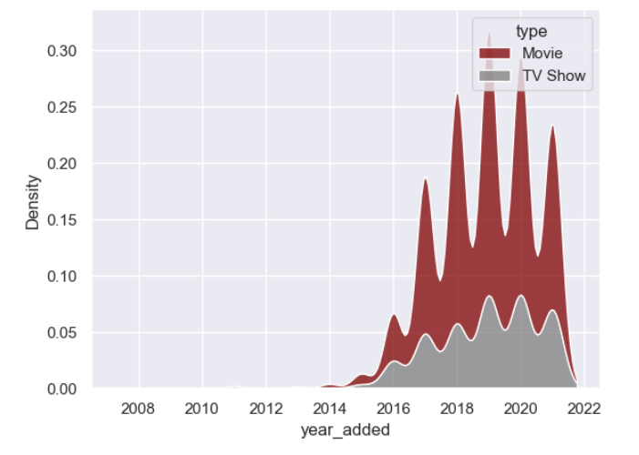
It appears that Netflix has been focusing more on increasing Movie content, compared with TV Shows, since it is shown that the number of Movies added increased much more dramatically than the number of TV shows.
We can see that from 2012 to 2018, Netflix added most recent contents, they made sure most recent contents per release year are higher than the older release year contents. Then in 2019, it started dropping, this may be due to the Covid-19, but further analysis may be needed to determine this.

Movies and Shows Added over month
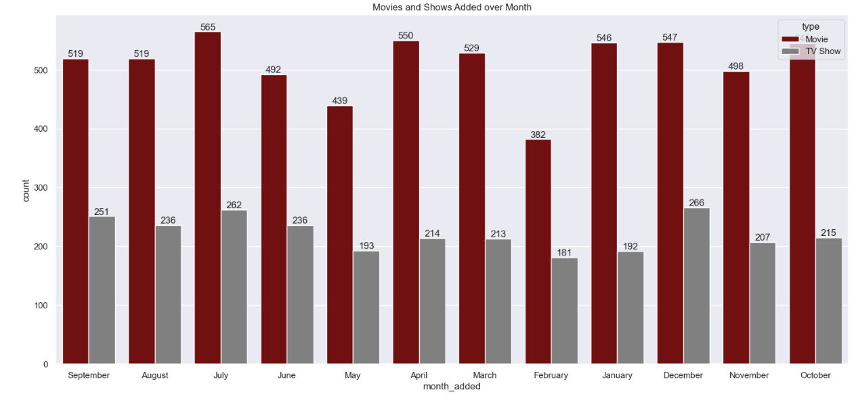
Netflix recognizes the viewing habits of its customers, acknowledging that they typically have more leisure time during certain seasons. This presents a prime opportunity to attract viewers. Additionally, it's worth mentioning that Netflix tends to release a higher number of new movies in the latter half of the year, spanning from June to December. Holiday seasons — December, January, and July seem to be the best time for the release of new content on Netflix.

Contents Across Countries
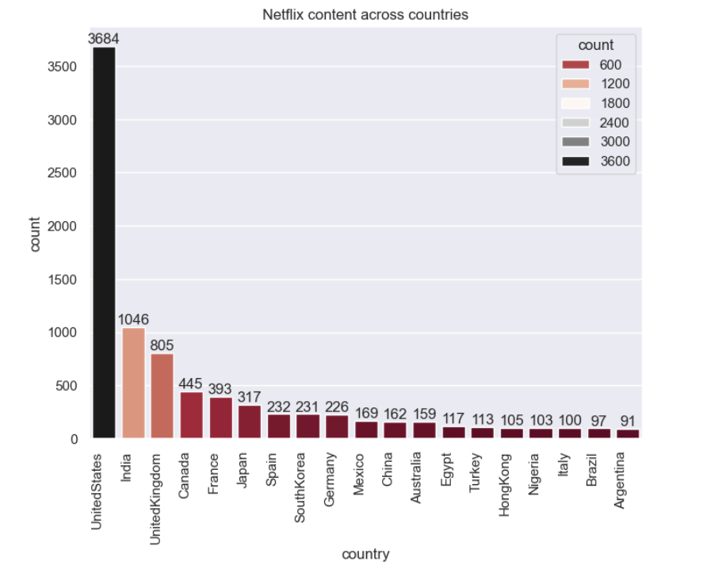
The leading contributors to Netflix's content production are the United States, India, and the UK. Given that Netflix is a U.S.-based company, it is logical that the U.S. holds the primary position in content contribution. While India and the UK rank second and third in numerical terms, their production levels are notably lower compared to the U.S.

Content_type across countries
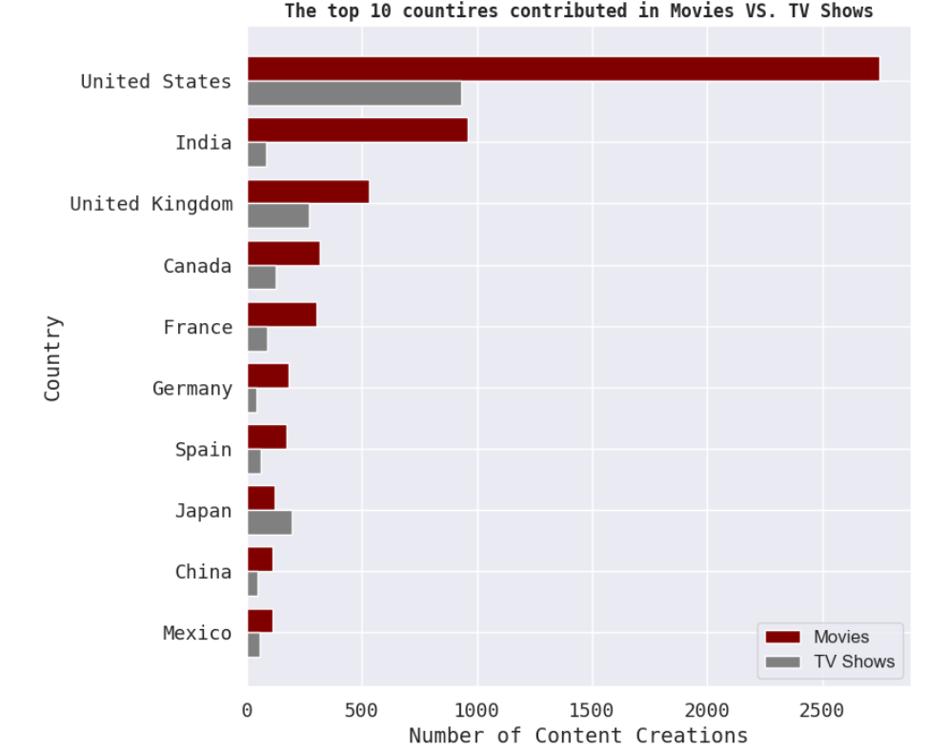
As anticipated, globally, the number of movies added to the platform exceeds that of TV shows. India, ranking as the second-highest contributor, shows a significant disparity between its movie and TV show offerings. This is attributed to the renowned Bollywood industry, which produces a greater volume of movies every year.

Most Popular Categories
International Movies and International TV shows top the list of categories. The popular genres in
- movie categories are Drama, Comedy, Documentary, Action and Adventure
- TV show categories are Drama, Comedy, Crime, Kids, Docuseries
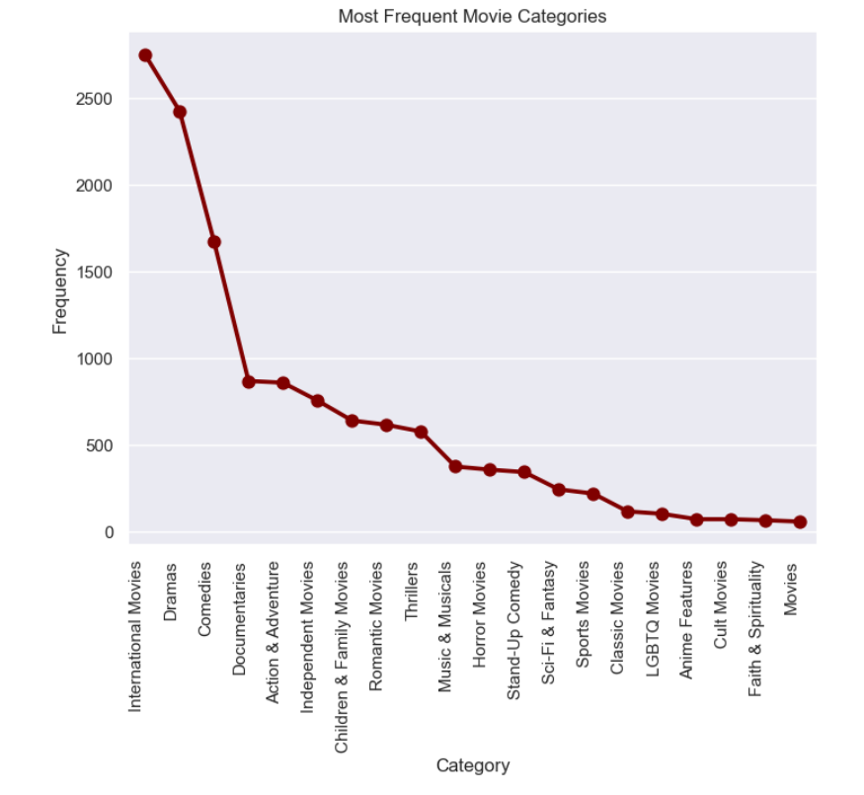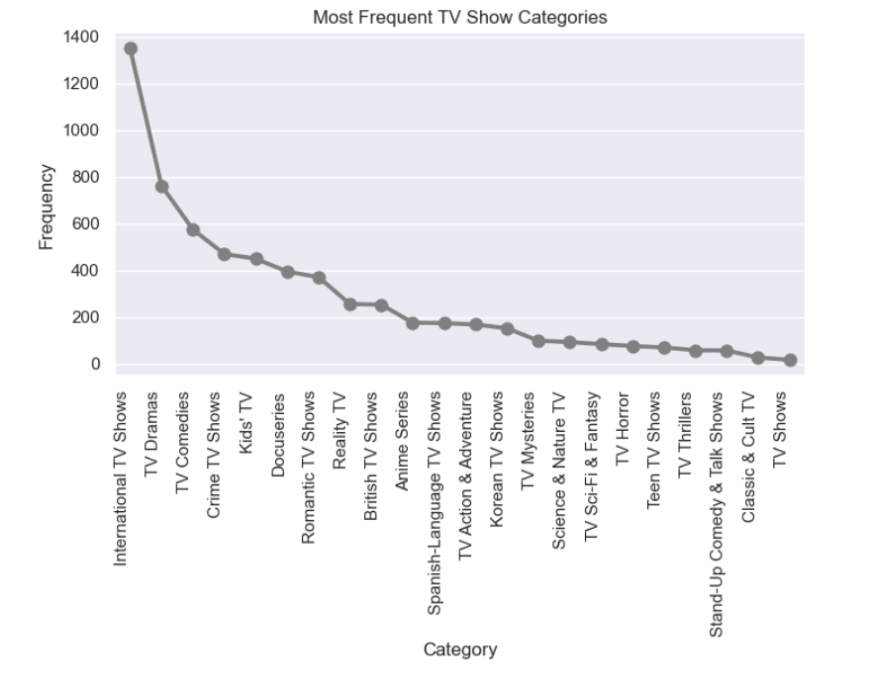
Number of movies and TV shows by Rating
Netflix assigns a maturity rating to every TV show and movie to assist members in making informed choices for themselves and their children. The determination of maturity ratings by Netflix is based on the frequency and impact of mature content within a TV show or movie. In the case of TV shows, the rating reflects the overall maturity level of the entire series.
Little Kids: G, TV-Y, TV-G
Older Kids: PG, TV-Y7, TV-Y7-FV, TV-PG
Teens: PG-13, TV-14
Adults: R, NC-17, TV-MA
Some ratings are only applicable to Movies, such as PG-13, PG, NC-17, and UR. The most common ratings for both Movies & TV Shows are TV-MA (for Adults group) and TV-14 (for Teens group).
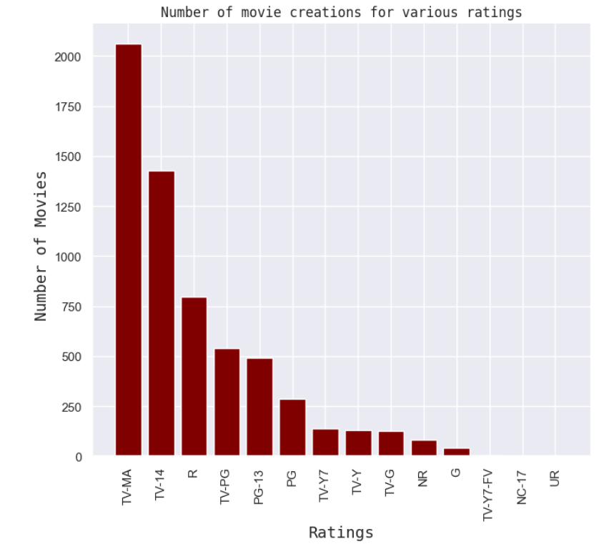
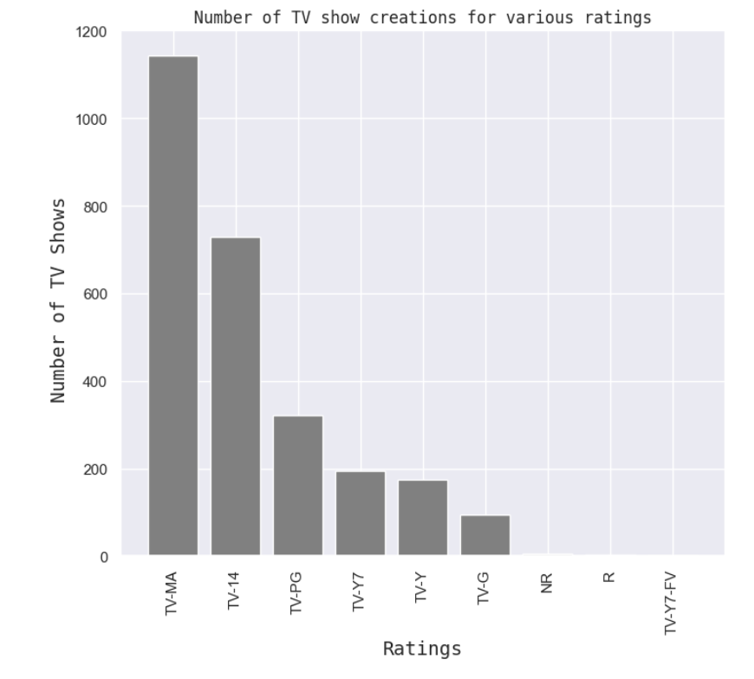
TV-MA leads in popularity on Netflix, suggesting that content for mature audiences is more in demand. Following closely are TV-14 and TV-PG, which cater to teenagers and older children, respectively. Titles rated NC-17 are relatively scarce, which makes sense as this category is exclusively meant for viewers over the age of 17.

Top 10 Directors
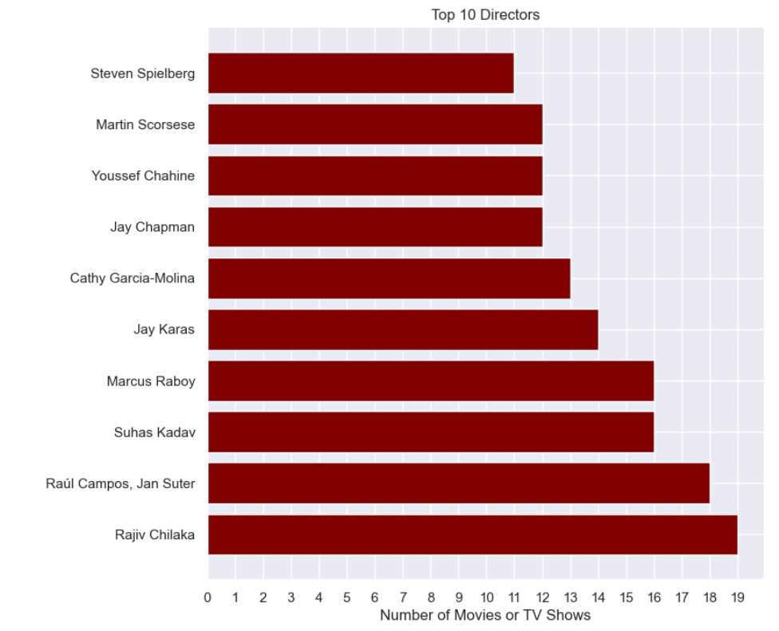

Oldest Content in Netflix
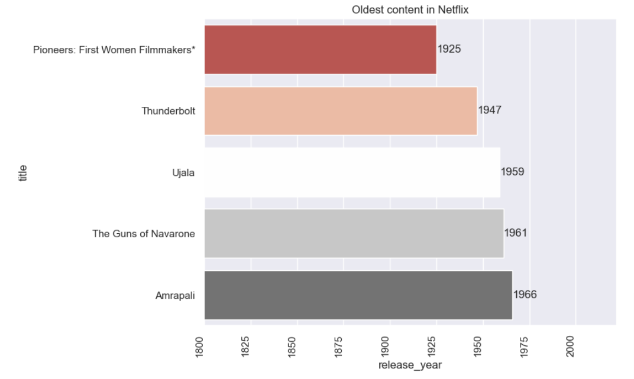

Duration of Contents
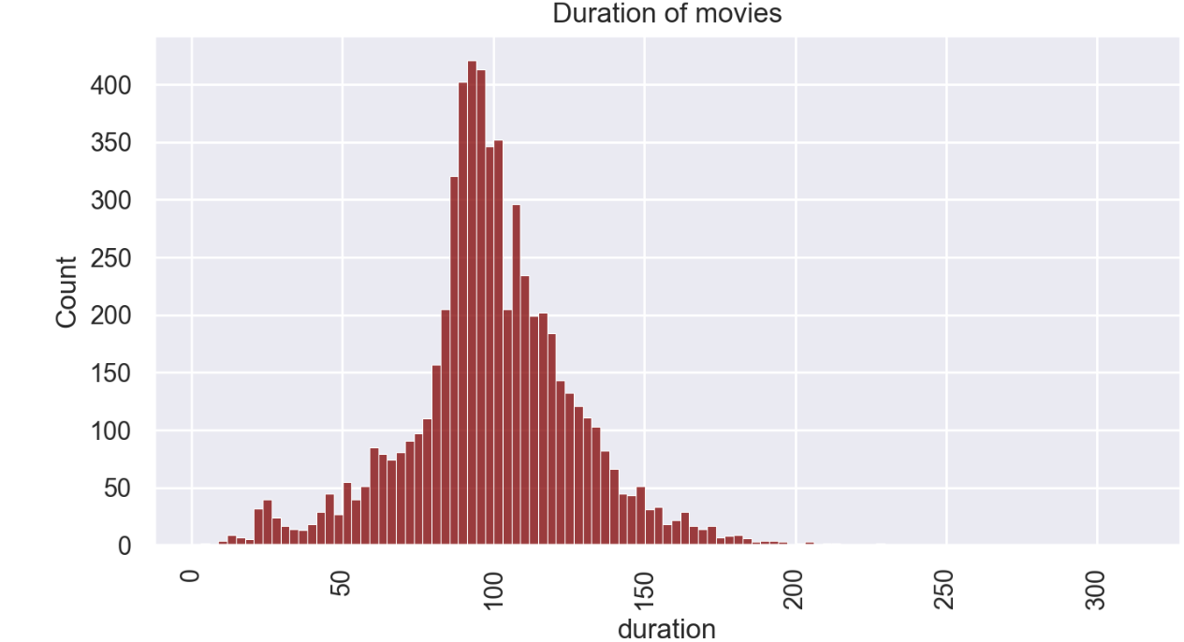

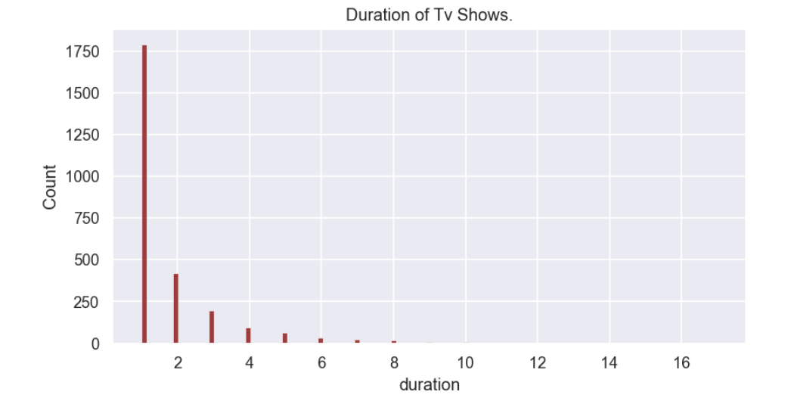

Most of the movies last for 90 to 120 minutes. Most of the Tv Shows last for 1 or 2 seasons, it is rare for a show to have more than 5 seasons.

Word Cloud for Titles

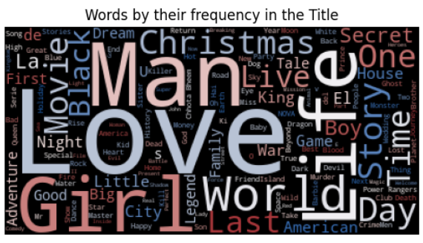

This is the word cloud of titles of Netflix content. It is interesting to note that many films and series share the same keywords in their titles. “World, Love, Life, Girl, Story, Christmas, Man, Black, Time” are the most frequent words appearing on Netflix titles.

Conclusion
- Majority of the content available on Netflix is Movies.
- In recent years, emphasis have shifted towards Tv-Shows.
- Most of the contents are released during holiday season i.e., either in the year ending or the beginning.
- United States and India are among the top 5 countries that produce all of the available content on the platform.
- TV-MA tops the charts, indicating that mature content is more popular on Netflix.
- There are some common keywords in the titles of the contents
- Most of the TV shows are 1 season and movies are 90-120 mins long
- International Movies and International TV shows top the list of categories
Recommendations
- Allocating equal attention to TV shows can result in increased subscriptions
- The analysis reveals that content releases are notably higher during the holiday season
- Promoting additional children's content can ensure a more consistent customer age group
- Implementing marketing strategies in numerous countries worldwide and encouraging them to expand their content offerings will boost global subscriptions
- In addition to considering all these factors, it is crucial to prioritize consumer emotions and make well-informed decision.

