Exercise # 1

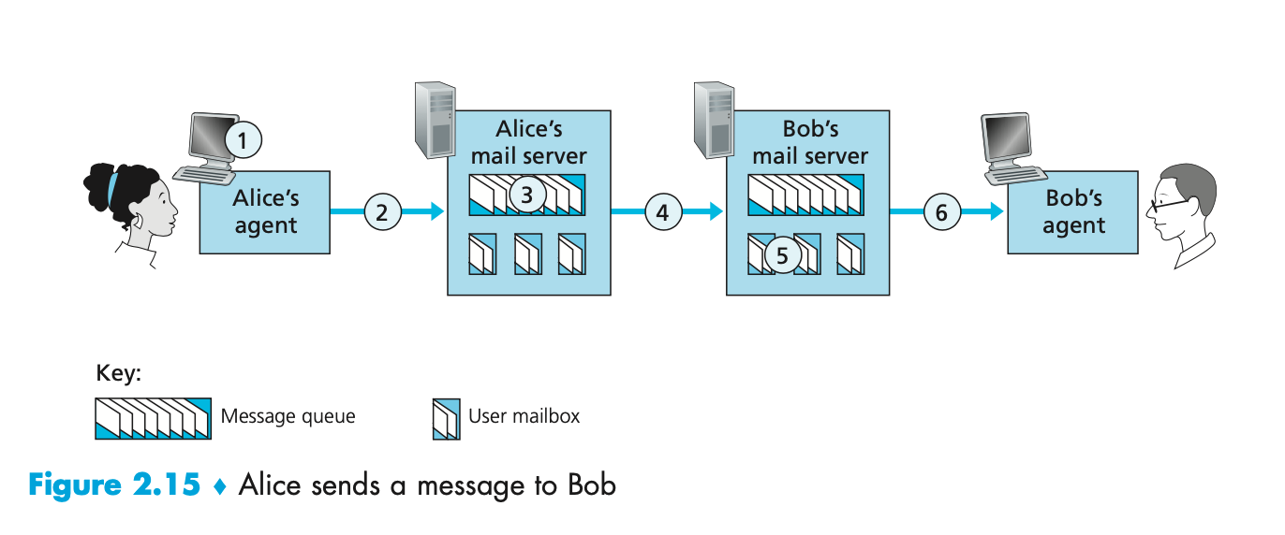

**QUESTION LIST**

1. At point 2 in the diagram, what protocol is being used?  
  
2. At point 4 in the diagram, what protocol is being used?  
  
3. At point 6 in the diagram, what protocol is being used?  
  
4. Does SMTP use TCP or UDP?  
  
5. Is SMTP a 'push' or 'pull' protocol?  
  
6. Is POP3 a 'push' or 'pull' protocol?  
  
7. What port does SMTP use?  
  
8. What port does POP3 use?

1. At point 2 in the diagram, the SMTP protocol is used.  
  
2. At point 4 in the diagram, the SMTP protocol is used.  
  
3. At point 6 in the diagram, the HTTP protocol is used.  
  
4. SMTP uses the TCP protocol.  
  
5. SMTP is a 'push' protocol  
  
6. HTTP is a 'pull' protocol  
  
7. SMTP uses port 25  
  
8. HTTP uses port 80

Exercise #2

Consider an HTTP server and client as shown in the figure below. Suppose that the RTT delay between the client and server is 20 msecs; the time a server needs to transmit an object into its outgoing link is 0.75 msecs; and any other HTTP message not containing an object has a negligible (zero) transmission time. Suppose the client again makes 100 requests, one after the other, waiting for a reply to a request before sending the next request.

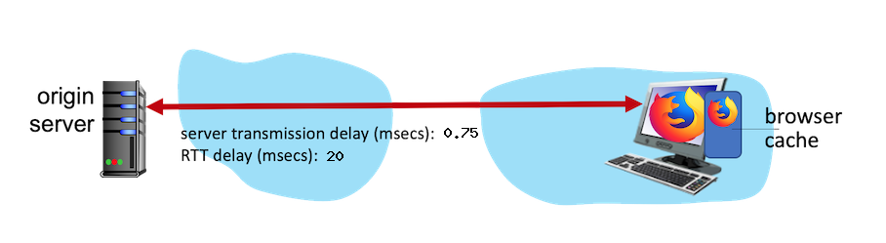

Assume the client is using HTTP 1.1 and the IF-MODIFIED-SINCE header line. Assume 50% of the objects requested have NOT changed since the client downloaded them (before these 100 downloads are performed)

**QUESTION**

1. How much time elapses (in milliseconds) between the client transmitting the first request, and the completion of the last request?

(RTT * NUM_PACKETS) + (NUM_PACKETS * (PERCENT__NOT_CACHED / 100) * TRANS_DELAY)