Table of Contents

* [What is FLSM?](https://ipcisco.com/lesson/vlsm-subnetting/#What_is_FLSM)
* [What is VLSM?](https://ipcisco.com/lesson/vlsm-subnetting/#What_is_VLSM)
* [VLSM Example](https://ipcisco.com/lesson/vlsm-subnetting/#VLSM_Example)
* [FLSM versus VLSM](https://ipcisco.com/lesson/vlsm-subnetting/#FLSM_versus_VLSM)

What is FLSM?

**FLSM** is the abbreviation of **Fixed Length Subnet Mask**. With FLSM technique, all the subnets use the same subnet masks. In other words, when we divide an ip address to create different subnets, all the subnets are **equal**.

This method provides different subnets but **does not prevent waste of ip addresses**.

Think about that we have an ip address 192.168.1.0/24. And we have four departments each need a different subnet. So, we need **four subnets**. Here, totally we have 256 ip addresses according to our subnet mask 255.255.255.0 (/24).

If we use **FLSM (Fixed Length Subnet Mask)**, we can create four equal subnets with 255.255.255.192 subnet mask (/26). Here, in each subnet there will be 64 ip addresses available.

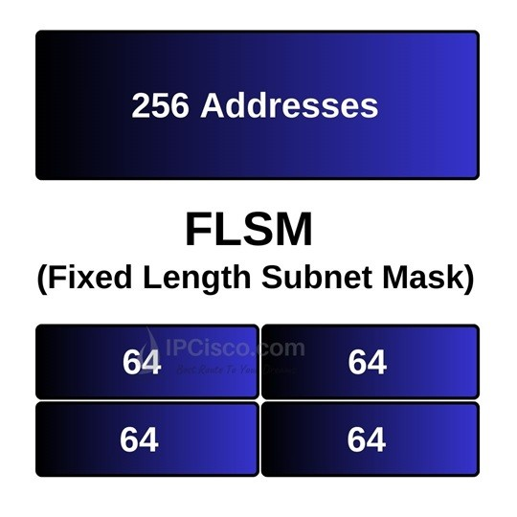

But here, there is an ip address waste. Because, there can be less ip address need in each subnet. Although, this less need, we have to use the same subnet mask with 64 available ip address.

What if we use VLSM instead of FLSM to save our ip addresses? In the following parts, you will see how we save our ip address space with the help of **VLSM Subnetting**.

What is VLSM?

So, **what is VLSM?** **Why we use VLSM?** **Variable Length Subnet Mask**is basically a technique with which we can use our ip addresses efficiently. So, how do we do this?

Before, we use the same subnet mask for all the parts of divided subnets. In other words, we were using the **same subnet masks** for each part. Now, think about a technique with which we can create **subnets with different subnet masks**. Isn’t it so efficient? With this technique, according to the requirement, we can save a lot of ip address **with smaller subnets** and **larger subnets masks**.

In traditional subnetting technique, if you have a **class C ip address**, your subnet mask is fixed **255.255.255.0**. The **CIDR** value of this subnet mask is **/24**. This means, in a subnet, there are **254** available host ip addresses. But what if you need few ip addresses? For example, if you have only **10 users**, this usage will be an inefficient way of ip addressing. So, here, we use VLSM **not to waste** the remaining ip addresses. For this example, we can select the closest **multiple of two** and it is **16**. In other words, we will use a subnet mask which will allow 16 available ip address. With 16 available ip addresses, we can use **14 ip addresses for hosts**. The remaining two ip addresses are for network and broadcast ip addresses. If we select 8, then it will not satisfy our requirement.

To have **16 ip addresses** in a subnet, we need two to the power of four. This means, **4 host bits** in the subnet mask (11111111.11111111.11111111.**1111.0000**). Here, our subnet mask will be **255.255.255.240**. The **CIDR** value of this subnet mask is **/28**.

VLSM Example

To understand **what is VLSM**, let’s do another example. Here, our company has an ip address **192.168.1.0/24**. We will use this ip address for four different departments of the company. Engineering, Sales, Accounting and HR. **Engineering** has **60 users**, Sales has **40 users**, **Accounting** has **20 users** and **HR** has **10 users**. According to these needs, let’s use our ip address space efficiently by using VLSM.

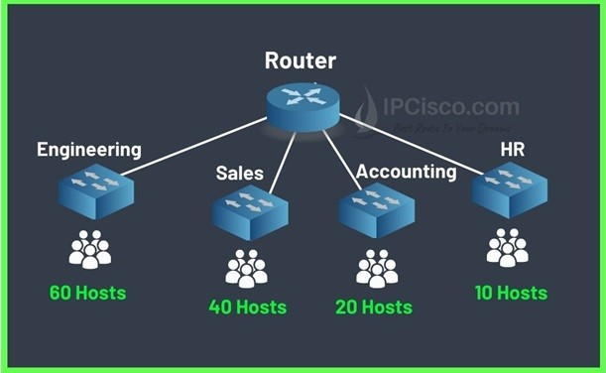

Here, we will use the below subnet masks and **CIDR values** for each department:

* **Engineering** (60 users) **/26** (64 available address) **255.255.192**
* **Sales** (40 users)             **/26** (64 available address) **255.255.192**
* **Accounting** (20 users)   **/27** (32 available address) **255.255.224**
* **HR** (10 users)                 **/28** (16 available address) **255.255.240**

Let’s write the ip addresses of each subnet.

**Engineering (/26  255.255.255.192)**

* Network Address:**168.1.0**
* First Host Address: **168.1.1**
* Last Host Address:**168.1.62**
* Broadcast Address: **168.1.63**

**Sales (/26  255.255.255.192)**

* Network Address:**168.1.64**
* First Host Address: **168.1.65**
* Last Host Address:**168.1.126**
* Broadcast Address: **168.1.127**

**Accounting (/27  255.255.255.224)**

* Network Address:**168.1.128**
* First Host Address: **168.1.129**
* Last Host Address:**168.1.158**
* Broadcast Address: **168.1.159**

**Engineering (/28  255.255.255.240)**

* Network Address:**168.1.160**
* First Host Address: **168.1.161**
* Last Host Address:**168.1.174**
* Broadcast Address: **168.1.175**

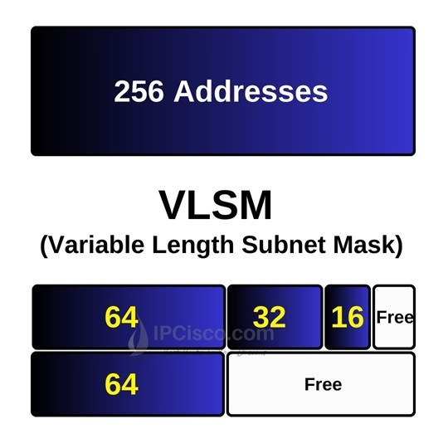

If we have used **FLSM**, our subnets will use **/26** and each one will have **64 available ip address**. And all our ip address spaced will be consumed. But with **VLSM Subnetting**, we will save many ip addresses.

Used ip addresses: **192.168.1.0-192.168.1.175**

Free ip addresses:**192.168.1.176-192.168.1.255**