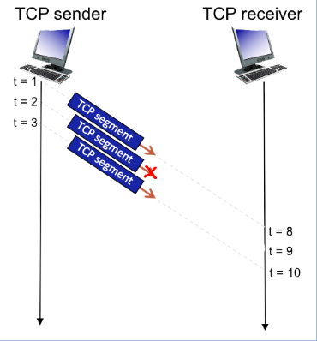Consider the figure below in which a TCP sender and receiver communicate over a connection in which the sender->receiver segments may be lost. The TCP sender sends an initial window of 3 segments. Suppose the initial value of the sender->receiver sequence number is 383 and the first 3 segments each contain 883 bytes. The delay between the sender and receiver is 7 time units, and so the first segment arrives at the receiver at t=8. As shown in the figure below, 1 of the 3 segment(s) are lost between the segment and receiver.

1. Give the sequence numbers associated with each of the 3 segments sent by the sender. Format your answer as: a,b,c,...  
  
2. Give the ACK numbers the receiver sends in response to each of the segments. If a segment never arrives use 'x' to denote it, and format your answer as: a,b,c,...

**SOLUTION**

1. The sender's sequence numbers are: 383,1266,2149  
  
2. The receiver's ACKs are: 1266,x,1266