Moodle Learning Plan Plugin
Complete End-to-End Administrator Guide & Technical Reference
A comprehensive manual covering pathway architecture, curriculum structuring, learner enrollment, the automated gamification & badges engine, real-time analytics, leaderboards, and scoring synchronization logic.
📌 Document Metadata
Target Audience: Site Administrators, Course Creators & Instructors
Plugin: local_learningplan | Platform: Moodle 4.x+
Status: Production Verified | Engine Version: 2.5 (Fully Gamified)

1. System Overview & Core Philosophy
The Learning Plan Plugin (local_learningplan) transforms traditional course catalogs into visual, gamified, step-by-step learning journeys. Learners navigate through themed adventure maps composed of Chapters and Step Nodes, unlocking XP points, star ratings, and official Moodle badges as they progress.
Key architectural capabilities include:
• Multi-Type Step Execution: Seamlessly combine whole Moodle Courses, specific Course Modules (quizzes, assignments, SCORM), File Submissions, and External URLs into a unified curriculum pathway.
• Gamification & Leveling Engine: Real-time point scoring (XP), 1-3 star milestone ratings, and automated site badge issuance with custom baked artwork.
• Cascading Unlock Mechanism: Linear sequential locking ensures students master foundational steps before unlocking subsequent chapters, with automatic completion detection upon return.
• Real-Time Cohort & Learner Tracking: Institution-wide progress reports, CSV export, and dynamic podium leaderboards.

2. Learning Plans Management Hub (manage/plans.php)
The Plans Management Hub serves as the primary administrative dashboard for creating, configuring, and monitoring all active learning pathways.
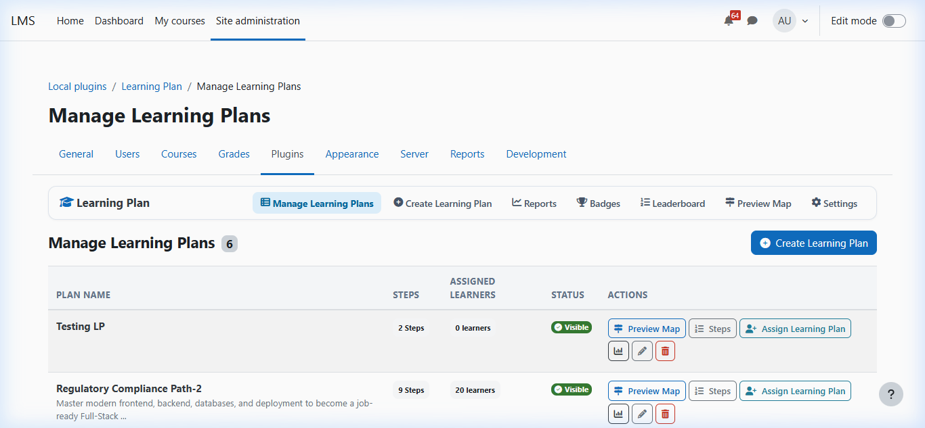
Figure: Learning Plans Administration Hub showing configured plans, themes, learner counts, and management actions.
From this central hub, administrators have one-click access to:
1. ➕ Create New Learning Plan: Define a new curriculum pathway with custom theme styling and description.
2. 🗂️ Manage Curriculum Steps: Open the chapter and step builder for the selected plan.
3. 👥 Assign Learners & Cohorts: Enroll individual students or entire cohorts to the plan.
4. 🏅 Badges & Milestones: Configure auto-generated or custom badges for chapter milestones and plan completion.
5. 📊 Progress Reports & Leaderboard: View real-time learner completions, XP totals, and export CSV reports.
6. 👁️ View Map (Admin Preview): Inspect the full interactive adventure map as learners experience it.
📌 Plan Cover Themes
Each plan can be assigned one of 4 vibrant visual palettes:
• Ocean (🌊): Crisp cyan, deep blue, and golden trail accents.
• Sunset (🌅): Warm orange, amber, and radiant twilight hues.
• Forest (🌲): Emerald green, nature mint, and lush environmental tokens.
• Candy (🍭): Royal purple, vibrant violet, and playful confectionery tones.

3. Chapter & Step Hierarchy Builder (manage/edit_steps.php)
Curriculum in the Learning Plan plugin is structured into a two-level hierarchy: Chapters and Steps. A Chapter represents a major thematic module or milestone, while Steps represent actionable learning activities.
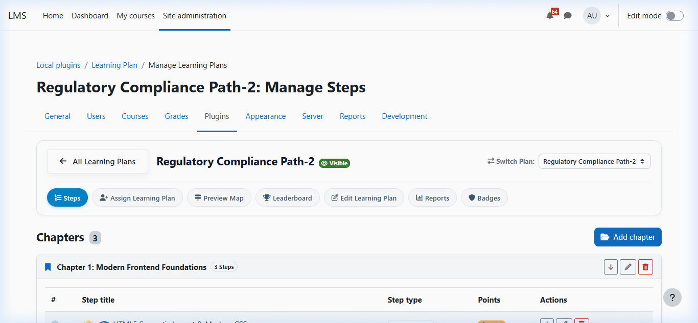
Figure: Chapter & Step Hierarchy Builder with structured milestone cards, points badges, and action menus.

Supported Step Types & Logic
Step Type | Completion Logic | Config Parameters | Student Action
🎓 Course | Moodle course completion criteria satisfied via core completion_info. | Course ID selector | Navigates to course and completes enrolled criteria.
📝 Activity | Specific activity (Quiz, Assignment, Lesson, SCORM) marked complete in Moodle. | Course Module (cmid) selector | Opens direct activity URL; auto-completes on grade/pass.
📁 File Upload | Student uploads document/evidence; auto-completes or triggers verification. | Title, instructions, points | Uploads verification file in step modal.
🔗 External URL | Student opens external resource, video, or documentation link. | External URL, points, stars | Opens link in new tab; marked completed via modal.

4. Learner Assignment & Enrollment (manage/assign.php)
Before students can view a pathway on their dashboard, they must be assigned to the learning plan. The assignment system supports both individual student selection and cohort-based bulk assignment.
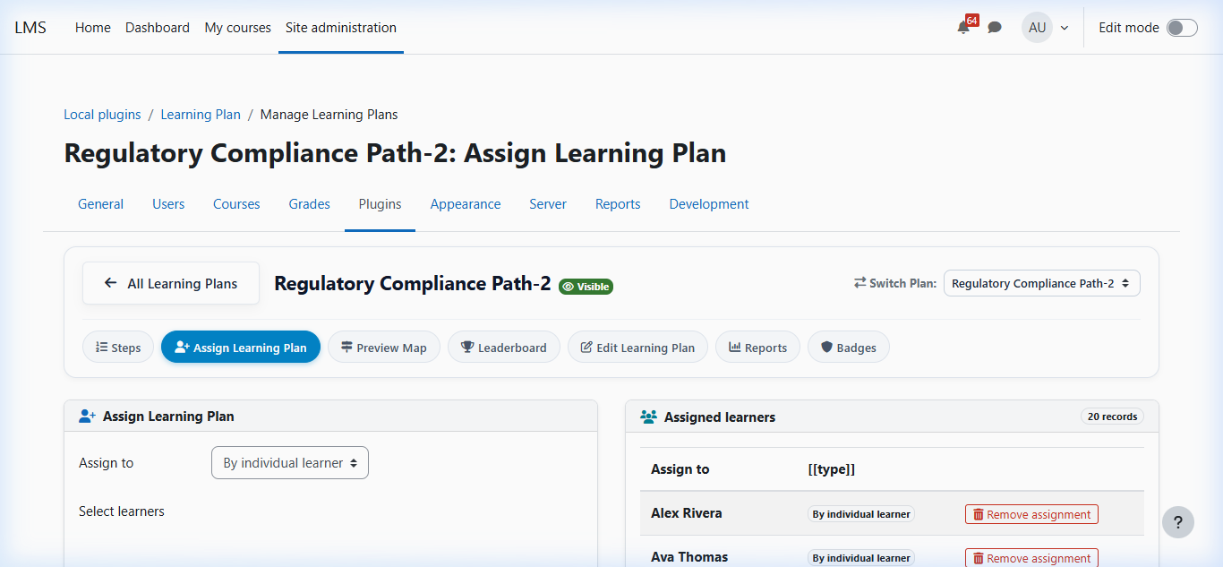
Figure: Learner Assignment Hub showing assigned students, cohort selectors, and bulk unassign controls.
When a learner is assigned to a plan:
1. Initial Progress Seeding: Step 1 of Chapter 1 is automatically initialized to 'available' (unlocked), while subsequent steps are set to 'locked'.
2. Automatic Scoring Sync: If the learner has already completed any assigned Moodle courses or activities prior to enrollment, the scoring engine immediately evaluates and unlocks corresponding steps.
3. Badge Evaluation: Any completed milestones are awarded immediately.

5. Gamified Badges & Milestones Engine (manage/badges.php)
The Badges system is a cornerstone of the learning experience. It connects chapter completions and 100% plan completion directly to Moodle's core OpenBadges system.
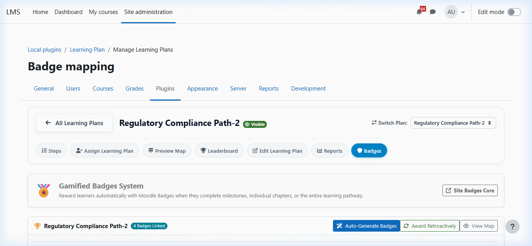
Figure: Badges Management Hub featuring 1-Click Auto-Generation, Retroactive Awarding, and side-by-side creation cards.

Badge Engine Workflows & Tools
⚡ 1-Click Auto-Generate Badges:
Administrators can click 'Auto-Generate Badges' to instantly create Moodle site badges for every single chapter milestone plus a Grand Champion badge for 100% plan completion. Badges are automatically assigned gamified emblem artwork from the plugin's icon library, set to Active status, and mapped to the plan.
🔄 Award Retroactively:
Evaluates all enrolled learners and immediately issues badges to any student who has already completed the requisite chapter or plan steps. This ensures no past achievements are lost.
🔗 Link an Existing Badge Form:
Allows administrators to attach any pre-existing site badge created in Moodle core (badges/index.php) to a specific chapter or whole-plan completion.
✨ Quick Create Custom Badge Form:
Allows creating a bespoke badge with custom title, description, and live emblem preview directly from the page without leaving the plugin interface.
📌 Technical Assurance: Idempotency & Image Baking
The badge engine enforces strict idempotency:
• Duplicate prevention: Checks existing records in {badge_issued} before triggering issuance.
• Active status guarantee: Draft badges are automatically activated prior to linking.
• Baked OpenBadges: Badges are issued with $nobake = false to ensure full PNG recipient baking and notification delivery.

6. Progress Tracking & Analytics Dashboard (manage/report.php)
The institutional progress report gives teachers and administrators comprehensive visibility into student advancement across all learning pathways.
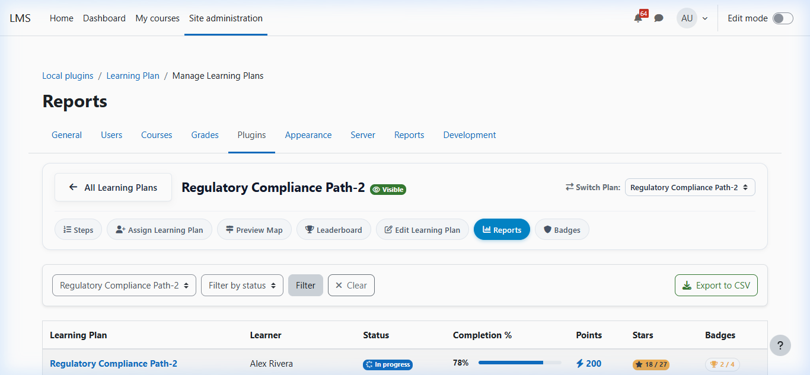
Figure: Institutional Progress Report displaying real-time completion percentages, XP points, stars, and earned badges count.
Report Capabilities:
• Multi-Plan & Status Filtering: Filter learners across specific learning plans or completion statuses (Not Started, In Progress, Completed).
• Badges Earned Metric: Displays the exact count of earned badges versus total mapped badges for each student (e.g., 2 / 4 Badges).
• 1-Click CSV Export: Export full student gradebook and progress records with formatted timestamps for audit and compliance.

7. Gamified Real-Time Leaderboard (leaderboard.php)
The leaderboard ranks enrolled learners in real time based on total XP points, completed steps, finished chapters, and stars earned.
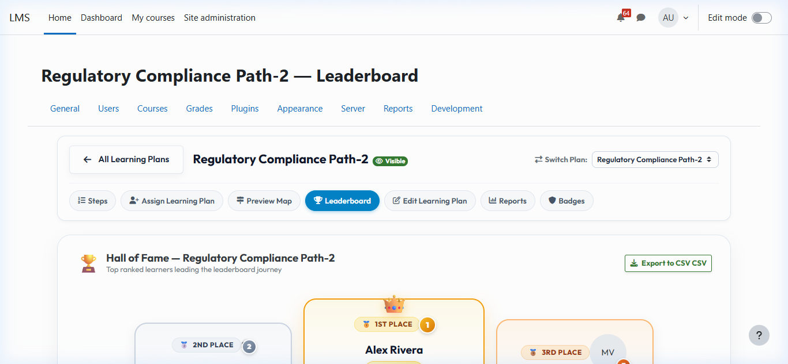
Figure: Real-time Class Leaderboard with Gold/Silver/Bronze podium ranks and milestone badges.

8. Student Map Interface & Badges Modal (index.php)
When students access a learning plan, they are presented with an interactive adventure map featuring procedurally placed nodes, animated paths, real-time HUD stats, and the Badges & Achievements modal.
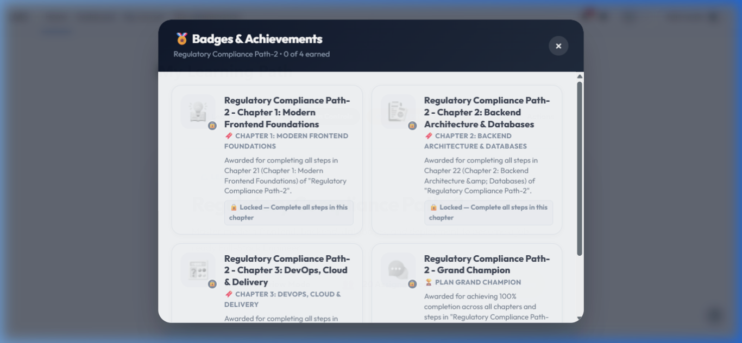
Figure: Student Map Interface with the Badges & Achievements glassmorphic modal displaying earned and locked badges.

9. Technical Scoring & Completion Pipeline
The plugin implements an event-driven completion pipeline that ensures student progress is always synchronized with core Moodle activity:
📌 Scoring & Award Pipeline Workflow
1. Event Trigger: Student completes a course module, course, or submits a file.
2. record_completion(): Sets step progress to 'completed', awards step XP points and stars.
3. Cascading Unlock: Next sequential step in the chapter is automatically set to 'available'.
4. Chapter Completion Check: If all steps in a chapter are completed, check_chapter_and_plan_completion() triggers.
5. Automated Badge Issuance: badges::award_if_mapped() issues the corresponding chapter badge.
6. Grand Champion Check: If 100% of all plan steps are completed, the Grand Champion badge is issued.
7. User Sync: scoring::sync_user() ensures all progress, scores, and badges remain perfectly synchronized.

10. Database Schema Architecture
Table Name | Primary Purpose | Key Columns
mdl_local_learningplan_plan | Curriculum pathway definitions | id, name, description, coverimage, timecreated
mdl_local_learningplan_chapter | Chapter milestone containers | id, planid, title, sortorder, description
mdl_local_learningplan_step | Step node definitions | id, chapterid, title, steptype, courseid, cmid, points, maxstars, icon
mdl_local_learningplan_user | Learner-plan enrollments | id, planid, userid, timeenrolled
mdl_local_learningplan_progress | Step completion states | id, stepid, userid, status, starsearned, timecompleted
mdl_local_learningplan_badge | Milestone badge mappings | id, planid, chapterid, badgeid, criteria
mdl_local_learningplan_score_log | Audit trail of earned XP | id, planid, stepid, userid, points, starsearned, timecreated

