**Assignment # 1**

**Instructions For Q1(9 marks)**

1. **Watch video and design exact layout using table and media queries only.**
2. **Media queries are to be applied for only three screens, screens length and width can be viewed in the video.**
3. **Layout design should be developed using table tag and its related other attributes.**
4. **Mention your roll number also and provide code with submission.**
5. **No inline css is to be applied.**
6. **No javascript should be used.**

**Q1 Assignment Video Link:**

**https://watch.screencastify.com/v/Z1L0Y8B3Y8O62tCVhaqg**

**Assignment Screenshots**

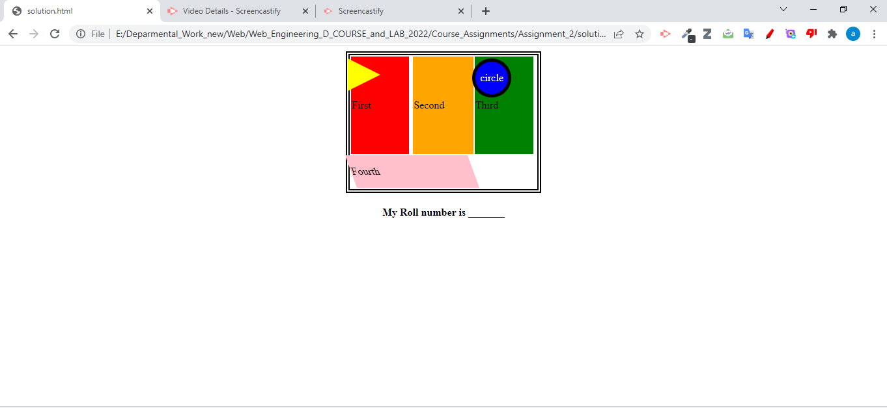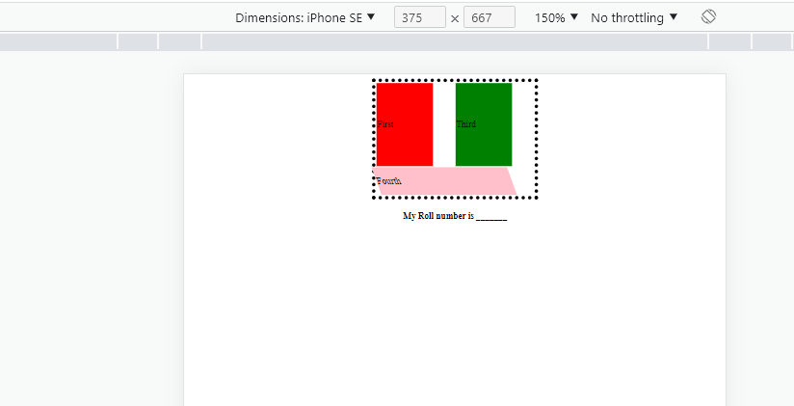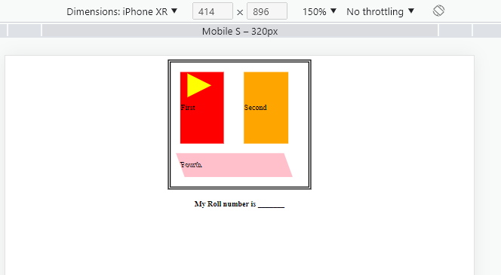

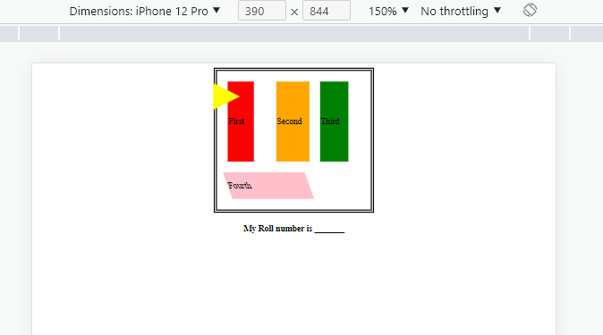

**Instructions For Q2(6 Marks)**

1. **Watch video and design exact layout using HTML only (No css is allowed).**
2. **Mention your student email also in the html mail section.**
3. **No css is to be applied.**
4. **All the Features mentioned in Video should be included.**

**Assignment Video Link:**

[**https://watch.screencastify.com/v/xBQgNm9JGvj2a44sbbXC**](https://watch.screencastify.com/v/xBQgNm9JGvj2a44sbbXC)

**Q 2Assignment Screen Shoots**

