1. Classification Fundamentals
Q1. What is classification in machine learning?
Expected answer: Classification is a supervised learning task where a model learns from labeled data to predict the discrete category or class of a new observation.
Q2. What is the difference between classification and regression?
Expected answer: Classification predicts categorical labels, while regression predicts continuous numerical values.
Q3. What is supervised learning?
Expected answer: It is a type of machine learning where the model learns patterns from labeled training data containing input features and target outputs.
Q4. What are features and labels?
Expected answer: Features are the input variables used to make predictions. The label is the target variable the model tries to predict.
Q5. What is binary classification?
Expected answer: A classification problem involving two classes, such as spam/not spam or churn/no churn.
Q6. What is multiclass classification?
Expected answer: A problem where each observation belongs to one of more than two classes, such as classifying an image as a cat, dog, or bird.
Q7. What is multilabel classification?
Expected answer: A problem where one observation can belong to multiple classes simultaneously. For example, a movie can be categorized as both action and comedy.
Q8. Why do we split our dataset into training and testing sets?
Expected answer: The training set is used to fit the model, while the test set evaluates its performance on unseen data.

Q9. What is overfitting in classification?
Expected answer: Overfitting occurs when a model learns the training data too closely, including noise, and performs poorly on unseen data.
Q10. What is underfitting?
Expected answer: Underfitting occurs when a model is too simple to capture the underlying patterns in the data.

2. Classification Algorithms

A. Logistic Regression
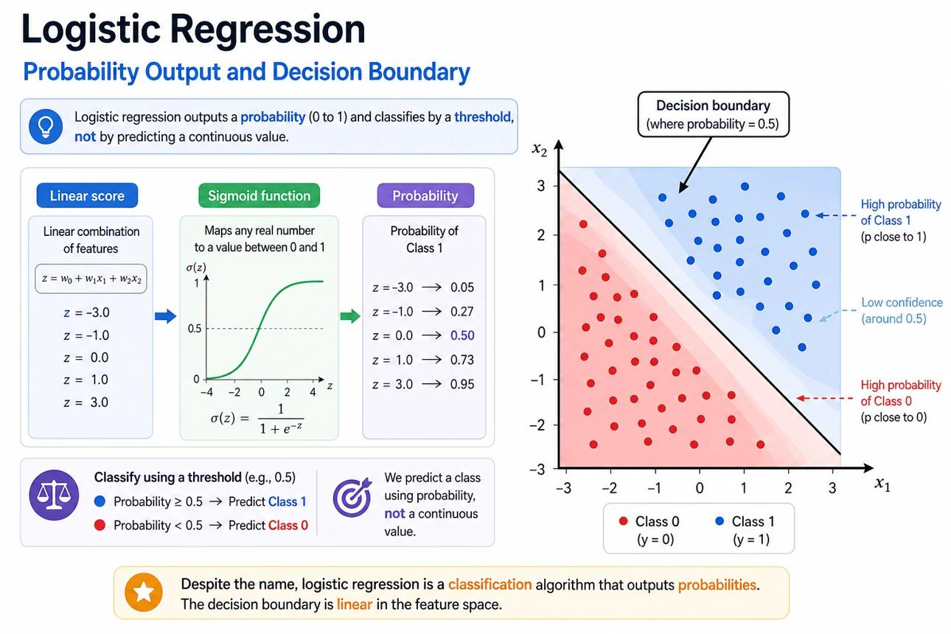

Q11. What is logistic regression, and why is it used for classification?
Expected answer: Logistic regression estimates the probability that an observation belongs to a class. It uses the sigmoid function to map a linear combination of features into a value between 0 and 1.
Q12. Why is it called logistic regression if it is used for classification?
Expected answer: It models the log-odds of a class as a linear function of the features. Despite its name, it is commonly used for classification.
Q13. What is the sigmoid function?
Expected answer: It is a function that converts any real-valued input into a number between 0 and 1.

$σ(z)=\frac{1}{1+e^{-z}}$
Q14. If logistic regression predicts a probability of 0.8, what does that mean?
Expected answer: The model estimates an 80% probability for the positive class. If the decision threshold is 0.5, it predicts the positive class.
Q15. Can logistic regression solve multiclass classification problems?
Expected answer: Yes. It can use strategies such as one-vs-rest or multinomial logistic regression with softmax.

B. K-Nearest Neighbors (KNN)
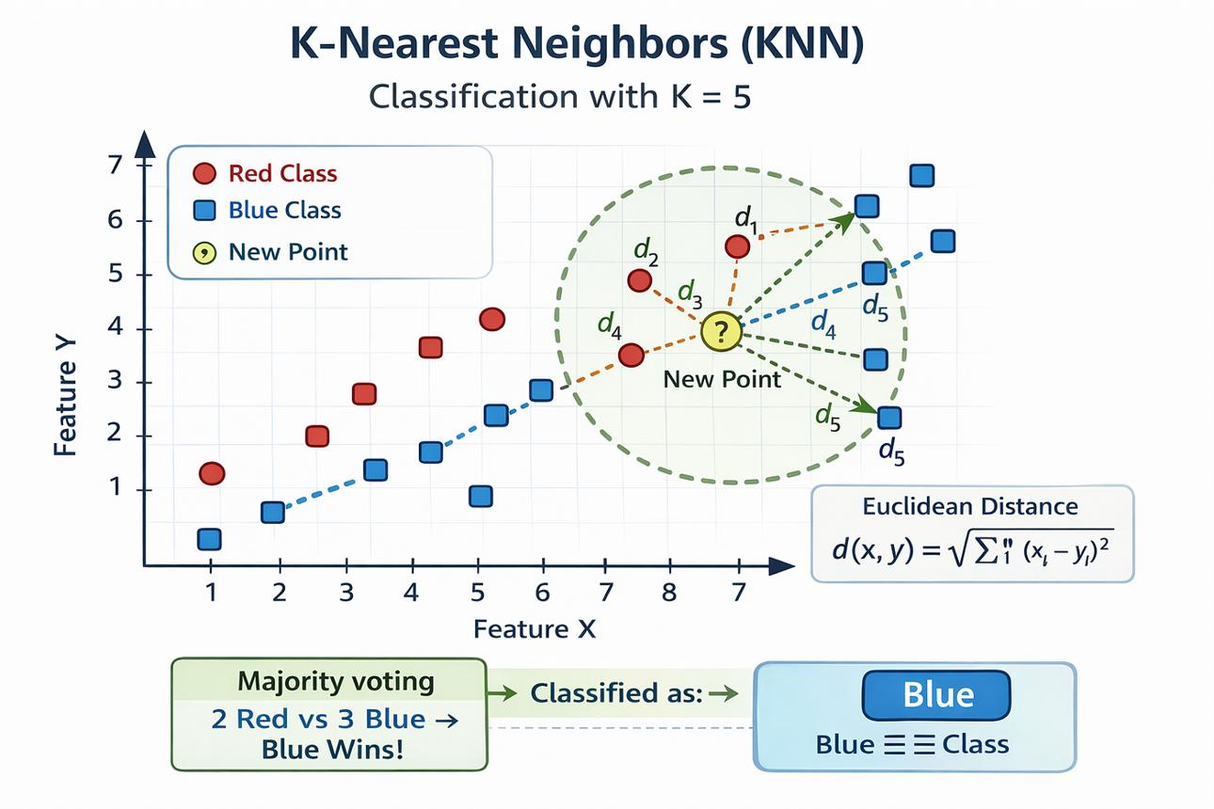
Q16. How does KNN classify a new observation?
Expected answer: It finds the K closest training observations and assigns the new observation a class based on the majority class among those neighbors.
Q17. What happens if K = 1?
Expected answer: The prediction depends on the class of the single nearest training observation. The model can be sensitive to noise.
Q18. What happens if K is too large?
Expected answer: The model may oversimplify the decision boundary and miss local patterns, potentially causing underfitting.
Q19. Why is feature scaling important for KNN?
Expected answer: KNN relies on distances. Features with larger numerical scales can dominate distance calculations if the data is not scaled.

Q20. Is KNN a parametric or non-parametric algorithm?
Expected answer: KNN is non-parametric because it does not assume a fixed functional form for the relationship between features and labels.

C. Decision Trees
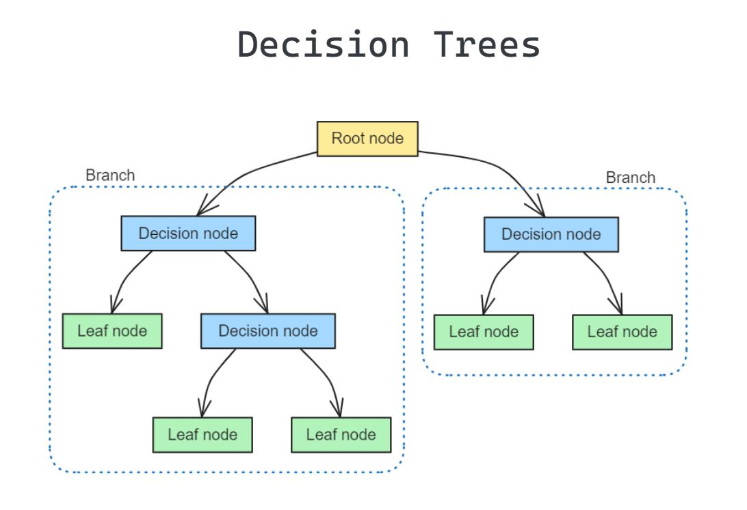
Q21. How does a decision tree perform classification?
Expected answer: It repeatedly splits data based on feature conditions until an observation reaches a leaf node, which provides the predicted class.
Q22. What are the root node, internal nodes, branches, and leaf nodes?
Expected answer:
- Root node: the starting point of the tree.
- Internal nodes: nodes where feature-based decisions are made.
- Branches: outcomes of those decisions.
- Leaf nodes: final predictions.

Q23. What are Gini impurity and entropy?
Expected answer: Both are measures of class impurity used to evaluate how mixed the classes are within a node.

$Gini=1-\sum_{i=1}^{C}{}p_{i}^{2}$

$Entropy=-\sum_{i=1}^{C}{}p_{i}\log_{2}(p_{i})$
Q24. What happens when a decision tree grows too deep?
Expected answer: It can overfit the training data by learning very specific rules and noise.
Q25. How can we reduce overfitting in a decision tree?
Expected answer: Limit maximum depth, increase minimum samples required for splitting or for a leaf, or apply pruning.

D. Random Forest
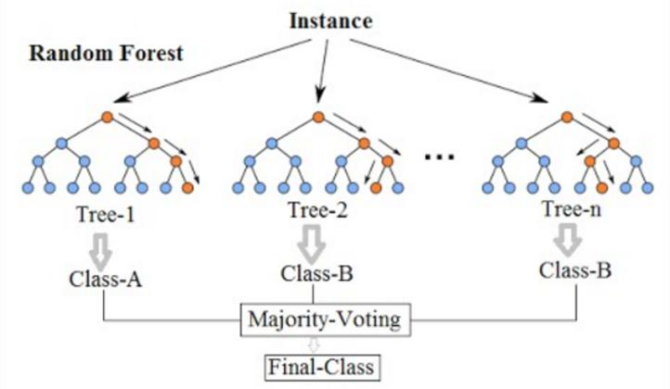

Q26. What is a Random Forest?
Expected answer: It is an ensemble learning algorithm that combines predictions from multiple decision trees to improve generalization and reduce variance.
Q27. How does Random Forest make its final classification prediction?
Expected answer: Typically, it uses majority voting across the trees' predicted classes, although probability-based aggregation can also be used.
Q28. Why does Random Forest usually perform better than a single decision tree?
Expected answer: It combines multiple diverse trees, reducing the risk that the final prediction depends too heavily on one tree's particular patterns.
Q29. What is bootstrap sampling?
Expected answer: Randomly drawing training observations with replacement to create different datasets for individual trees.
Q30. Why does Random Forest select random subsets of features?
Expected answer: To make trees less correlated with each other, increasing the benefit of combining their predictions.

E. Support Vector Machine (SVM)
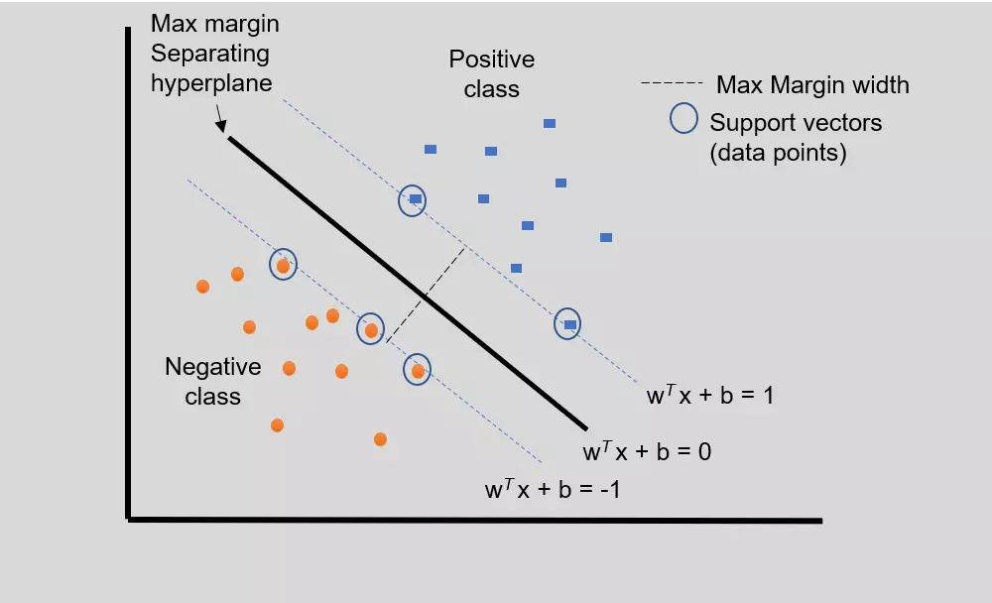
Q31. What is the main idea behind SVM?
Expected answer: SVM finds a decision boundary that separates classes while maximizing the margin between the boundary and the closest training observations.
Q32. What are support vectors?
Expected answer: They are training observations closest to the decision boundary that strongly influence the position of the separating hyperplane.
Q33. What is the kernel trick?
Expected answer: It allows SVM to model nonlinear decision boundaries by implicitly representing data in a higher-dimensional feature space.
Q34. What is the difference between a linear and an RBF kernel?
Expected answer: A linear kernel creates a linear decision boundary, while an RBF kernel can model more complex nonlinear boundaries.

Q35. Why is feature scaling important for SVM?
Expected answer: Feature scales affect distances and margins, which can significantly influence the learned decision boundary.

F. Naive Bayes
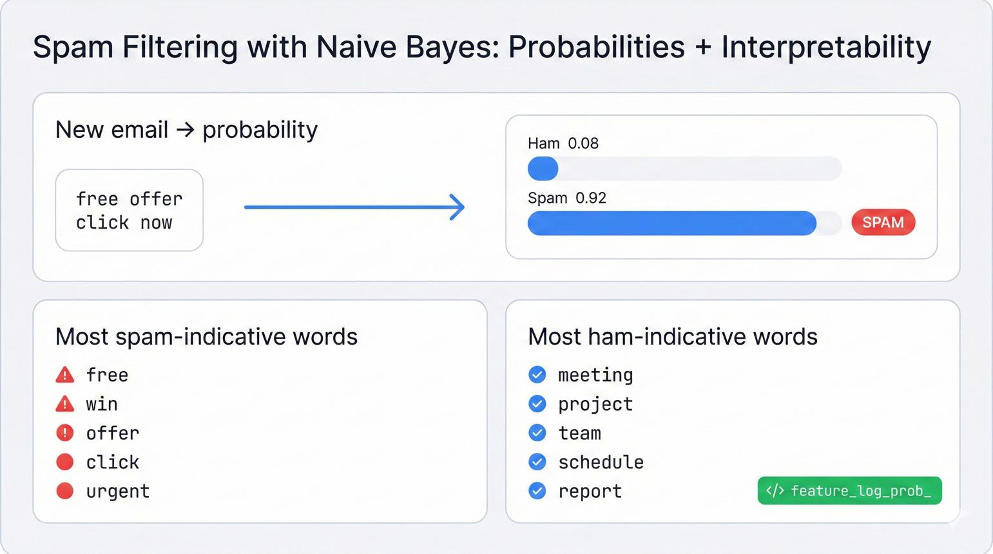
Q36. What is Naive Bayes?
Expected answer: It is a probabilistic classification algorithm based on Bayes' theorem that assumes features are conditionally independent given the class.
Q37. What is Bayes' theorem?
Expected answer:

$P(A|B)=\frac{P(B|A)P(A)}{P(B)}$
It describes how to update the probability of an event using new evidence.
Q38. Why is it called "naive"?
Expected answer: Because it makes the simplifying assumption that features are conditionally independent given the class, which often is not strictly true.
Q39. Why is Naive Bayes popular for text classification?
Expected answer: It is computationally efficient and often works well with high-dimensional, sparse text features such as word counts and TF-IDF values.
Q40. What happens if a feature value never appears in a particular class during training?
Expected answer: Without smoothing, its estimated likelihood may become zero, causing the entire class probability to become zero. Laplace smoothing helps prevent this.

G. Gradient Boosting and Related Algorithms
Q41. What is boosting?
Expected answer: Boosting combines weak learners sequentially, with later learners attempting to correct errors or optimize the objective left by the existing ensemble.
Q42. What is the difference between Bagging and Boosting?
Expected answer: Bagging trains models independently, often on bootstrap samples, and combines their predictions. Boosting builds models sequentially, where later models improve the current ensemble.
Q43. What is Gradient Boosting?
Expected answer: It builds an additive model by sequentially fitting new learners to improve the objective, typically using gradients of the loss function.
Q44. What is XGBoost?
Expected answer: XGBoost is an optimized gradient boosting implementation with regularization and computational improvements designed for efficient, high-performance learning.
Q45. What is the difference between Random Forest and XGBoost?
Expected answer: Random Forest generally builds independent trees and aggregates their predictions, whereas XGBoost builds trees sequentially to improve the ensemble's objective.
Q46. What is a learning rate in boosting?
Expected answer: It controls how much each new learner contributes to the ensemble. A smaller learning rate often requires more trees but can improve generalization.

3. Evaluation Metrics
Q47. What is a True Positive (TP)?
Expected answer: The model correctly predicts the positive class.
Q48. What is a False Positive (FP)?
Expected answer: The model predicts positive when the actual class is negative.
Q49. What is a False Negative (FN)?
Expected answer: The model predicts negative when the actual class is positive.
Q50. What is a True Negative (TN)?
Expected answer: The model correctly predicts the negative class.

B. Metrics and Formulas
Q51. What is accuracy?

$Accuracy=\frac{TP+TN}{TP+TN+FP+FN}$
The proportion of all predictions that are correct.
Q52. What is precision?

$Precision=\frac{TP}{TP+FP}$
Of all observations predicted positive, the proportion that are actually positive.
Q53. What is recall?

$Recall=\frac{TP}{TP+FN}$
Of all actual positive observations, the proportion correctly identified.
Q54. What is the F1-score?

$F1=2⋅\frac{Precision⋅Recall}{Precision+Recall}$
The harmonic mean of precision and recall.
Q55. What is specificity?

$Specificity=\frac{TN}{TN+FP}$
The proportion of actual negatives correctly identified.
Q56. What is the difference between precision and recall?
Expected answer: Precision focuses on avoiding false positives, while recall focuses on avoiding false negatives.
Q57. Why can accuracy be misleading on imbalanced datasets?
Expected answer: A model can achieve high accuracy by predicting the majority class while failing to identify the minority class.
Q58. What is a classification threshold?
Expected answer: A probability cutoff used to convert predicted probabilities into class labels.
Q59. What happens to precision and recall when we lower the positive-class threshold?
Expected answer: Recall generally increases, while precision often decreases, although the exact behavior depends on the dataset and model scores.
Q60. What is the ROC curve?
Expected answer: A plot of the true positive rate against the false positive rate at different classification thresholds.
Q61. What is ROC-AUC?
Expected answer: It measures how well a model ranks positive examples above negative examples across different thresholds. An AUC of 1 indicates perfect ranking; 0.5 corresponds to random ranking under standard conditions.
Q62. When would you prioritize recall over precision?
Expected answer: When missing a real positive case is particularly costly, such as screening for a potentially serious disease.

Q63. When would you prioritize precision over recall?
Expected answer: When false positive predictions are especially costly, such as flagging legitimate transactions for fraud investigation when investigative resources are limited.

4. Tricky Conceptual Questions
Q64. Can a model have 99% accuracy and still be a bad classifier?
Expected answer: Yes. If 99% of the data belongs to one class, a model that always predicts that class can achieve 99% accuracy while failing to identify the minority class.
Q65. Can a model have high recall but low precision?
Expected answer: Yes. It may identify most actual positive cases but also incorrectly classify many negative cases as positive.
Q66. Can a model have high precision but low recall?
Expected answer: Yes. Its positive predictions may usually be correct, but it may miss many actual positive cases.
Q67. Does a probability of 0.9 mean the model is correct 90% of the time?
Expected answer: Not necessarily. It means the model assigns a 90% probability to that prediction. Whether such predictions are correct approximately 90% of the time depends on probability calibration and the evaluation data.
Q68. Is feature scaling necessary for every classification algorithm?
Expected answer: No. It is especially important for distance-based and margin-based algorithms, such as KNN and SVM, and often useful for logistic regression. Tree-based algorithms generally do not require it.
Q69. Why should we use cross-validation?
Expected answer: It provides a more robust estimate of model performance across different data splits and helps with model selection and hyperparameter tuning.
Q70. What is data leakage?
Expected answer: Data leakage occurs when information unavailable at prediction time, or information from the evaluation data, improperly influences model training, leading to overly optimistic results.
Q71. Why should we not tune hyperparameters using the test set repeatedly?
Expected answer: Repeated tuning based on test results indirectly adapts the model to the test set, making the final evaluation less reliable.
Q72. What is the difference between a parameter and a hyperparameter?
Expected answer: Parameters are learned from the training data, such as logistic regression coefficients. Hyperparameters are configured before or during model selection, such as K in KNN or maximum tree depth.
Q73. Does a more complex model always perform better?
Expected answer: No. More complex models can capture more patterns but may overfit, require more computation, and be harder to interpret.
Q74. Can classification work without numerical features?
Expected answer: Yes. Categorical features can be encoded appropriately, and some algorithms can work with categorical data directly.
Q75. Why might we use class weights?
Expected answer: To assign greater importance to underrepresented or costly-to-misclassify classes during model training.

5. Scenario-Based Verbal Questions
Scenario 1
Q76. Email spam detection
You have 10,000 emails, of which only 500 are spam. Your model predicts every email as not spam and achieves 95% accuracy. Is the model good? Which metrics would you investigate?
Expected answer
No. It fails to identify any spam emails. Check spam-class precision, recall, F1-score, the confusion matrix, and potentially PR-AUC.
Scenario 2

Q77. Disease screening
A model identifies 98% of actual positive cases but incorrectly flags many healthy people. Which metric is high, and which may be low?
Expected answer
Recall is high. Precision may be low because of the large number of false positives.
Scenario 3
Q78. Customer churn prediction
A company wants to predict whether customers will leave. You have customer tenure, monthly charges, contract type, and support calls. Which algorithms might you try first, and why?
Expected answer
Logistic regression as a baseline, decision trees for interpretability, Random Forest for nonlinear patterns, and gradient boosting for potentially stronger predictive performance. Compare them using appropriate validation and metrics.
Scenario 4
Q79. KNN performance
KNN performs poorly when you use monthly income in thousands and age in years. What might be the issue?
Expected answer
The features have different scales, so income may dominate distance calculations. Apply an appropriate scaling method.
Scenario 5
Q80. Decision tree overfitting
Your decision tree achieves 100% training accuracy but only 75% test accuracy. What could be happening, and what would you try?
Expected answer
The tree may be overfitting. Limit tree depth, increase minimum samples per leaf, prune the tree, or compare with ensemble methods.

Scenario 6
Q81. Fraud detection
A bank has millions of legitimate transactions and very few fraudulent transactions. What challenges arise, and how would you evaluate the model?
Expected answer
Severe class imbalance can make accuracy misleading. Use precision, recall, F1-score, PR-AUC, and cost-sensitive evaluation. Select the threshold according to the cost of missed fraud and false alarms.
Scenario 7
Q82. Choosing between Random Forest and Logistic Regression
Logistic regression gives an F1-score of 0.82, while Random Forest gives 0.84. Should you automatically choose Random Forest?
Expected answer
Not necessarily. Consider cross-validation variability, the importance of interpretability, computational costs, calibration, the target metric, and whether the difference is meaningful.
Scenario 8
Q83. Threshold adjustment
A model predicts fraud probabilities. The bank currently uses a threshold of 0.5 but wants to catch more fraudulent transactions. What could you change?
Expected answer
Lower the positive-class threshold, which generally increases recall while potentially increasing false positives. Choose the threshold using validation data and business costs.

