1. Clustering Fundamentals
Q1. What is clustering in machine learning?
Expected answer: Clustering is an unsupervised learning technique that groups similar observations together based on their features.
Q2. What is the difference between classification and clustering?
Expected answer: Classification learns from labeled data to predict predefined classes, whereas clustering discovers groups in unlabeled data.
Q3. What is unsupervised learning?
Expected answer: It is a type of machine learning where the algorithm works with data without predefined target labels to discover patterns, structures, or relationships.
Q4. What is a cluster?
Expected answer: A cluster is a group of observations that are more similar to one another under a chosen similarity or distance measure than to observations in other groups.
Q5. What is the main goal of clustering?
Expected answer: To discover meaningful structure in data by grouping similar observations and separating dissimilar ones, according to the algorithm's objective.
Q6. Do we need labeled data for clustering?
Expected answer: No. Clustering typically uses unlabeled data, although known labels can later help us evaluate or interpret the discovered groups.
Q7. Give three real-world applications of clustering.
Expected answer: Customer segmentation, grouping news articles by topic, and identifying unusual patterns in network traffic. Other examples include image segmentation and grouping similar products.
Q8. What are the features in a clustering problem?
Expected answer: Features are the variables used to describe each observation and determine similarity, such as customer age, spending, and purchase frequency.

Q9. Why is feature scaling often important in clustering?
Expected answer: Distance-based algorithms can be dominated by features with larger numerical scales. Scaling can make feature contributions more comparable.
Q10. Is clustering always guaranteed to discover meaningful groups?
Expected answer: No. The results depend on the data, chosen features, distance measure, algorithm, and hyperparameters. Some datasets may not contain clear clusters at all.

2. Clustering Algorithms

A. K-Means Clustering
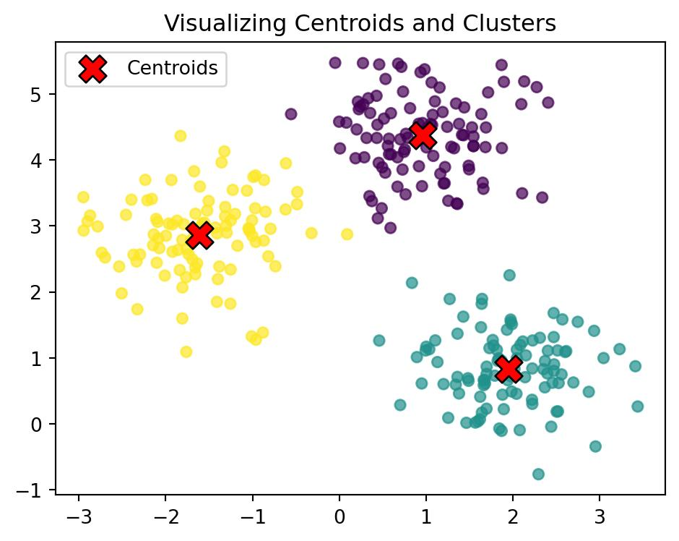
Q11. What is K-Means clustering?
Expected answer: K-Means is an unsupervised learning algorithm that partitions observations into K clusters by minimizing the within-cluster sum of squared distances to their assigned centroids.
Q12. What does K represent in K-Means?
Expected answer: K is the number of clusters we want the algorithm to produce. It must generally be specified before fitting the model.
Q13. What is a centroid?
Expected answer: A centroid is the mean position of the observations assigned to a cluster, calculated feature by feature.
Q14. Explain the steps of the K-Means algorithm.
Expected answer:
- Choose the number of clusters, K.
- Initialize K centroids.
- Assign each observation to its nearest centroid.
- Recalculate each centroid using the assigned observations.
- Repeat the assignment and update steps until a stopping condition is reached.
Q16. Why can different runs of K-Means produce different results?
Expected answer: The initial centroid positions can differ, causing the algorithm to converge to different local solutions.
Q17. What is the purpose of n_init in scikit-learn's K-Means?
Expected answer: It specifies how many initializations are attempted. The algorithm retains the solution with the lowest inertia among those runs.
Q18. What is inertia in K-Means?
Expected answer: Inertia is the sum of squared distances between observations and their assigned cluster centroids. Lower inertia means observations are closer to their centroids, but it generally decreases as K increases, so it cannot independently determine the best K.
Q19. What happens if we choose K = 1?
Expected answer: All observations are assigned to one cluster. This may be too simplistic if the data contains several distinct groups.
Q20. What happens if K is too large?
Expected answer: The data may be divided into too many small clusters, potentially separating natural groups unnecessarily or even assigning individual observations to separate clusters.
Q21. What are the main limitations of K-Means?
Expected answer:
- K must be chosen in advance.
- It is sensitive to initialization and outliers.
- It works best when clusters are reasonably compact and separated.
- It can struggle with clusters of different densities, sizes, or non-spherical shapes.

B. Hierarchical Clustering
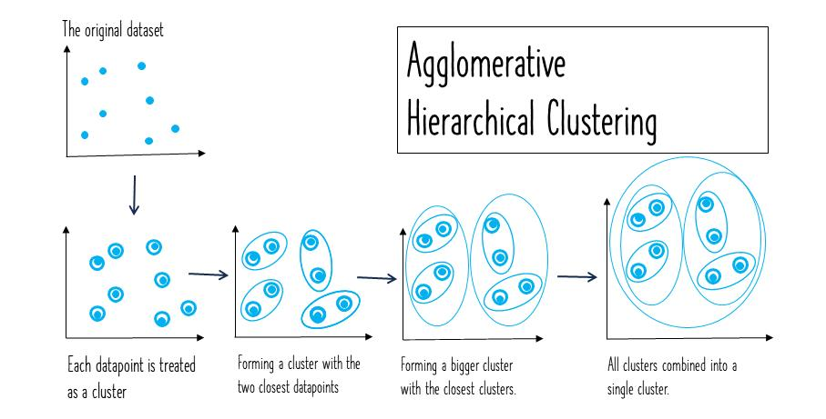
Q22. What is hierarchical clustering?
Expected answer: It builds a hierarchy of clusters, which can be represented by a tree-like diagram called a dendrogram.
Q23. What is the difference between agglomerative and divisive clustering?
Expected answer: Agglomerative clustering starts with individual observations and merges clusters. Divisive clustering starts with one large cluster and repeatedly splits it.

Q24. What is a dendrogram?
Expected answer: A tree-like visualization showing the order in which clusters merge or split and the corresponding distances or dissimilarities.
Q25. How do we determine the number of clusters from a dendrogram?
Expected answer: We can draw a horizontal cut at a chosen linkage distance. The number of branches intersected by the cut determines the number of clusters.
Q26. What is linkage in hierarchical clustering?
Expected answer: Linkage defines how the distance between two clusters is calculated.
Q27. Explain single, complete, and average linkage.
Expected answer:
- Single linkage: Uses the minimum distance between observations in two clusters.
- Complete linkage: Uses the maximum distance between observations in two clusters.
- Average linkage: Uses the average pairwise distance between observations in the two clusters.
Q28. What is Ward's linkage?
Expected answer: Ward's method merges clusters in a way that minimizes the increase in within-cluster variance, commonly using squared Euclidean distances.
Q29. What is one advantage of hierarchical clustering over K-Means?
Expected answer: It can reveal nested group structures and allows us to explore different numbers of clusters without specifying K at the beginning.
Q30. What is a disadvantage of hierarchical clustering?
Expected answer: It can be computationally and memory intensive on large datasets. In agglomerative clustering, early merges are generally not undone.

C. DBSCAN
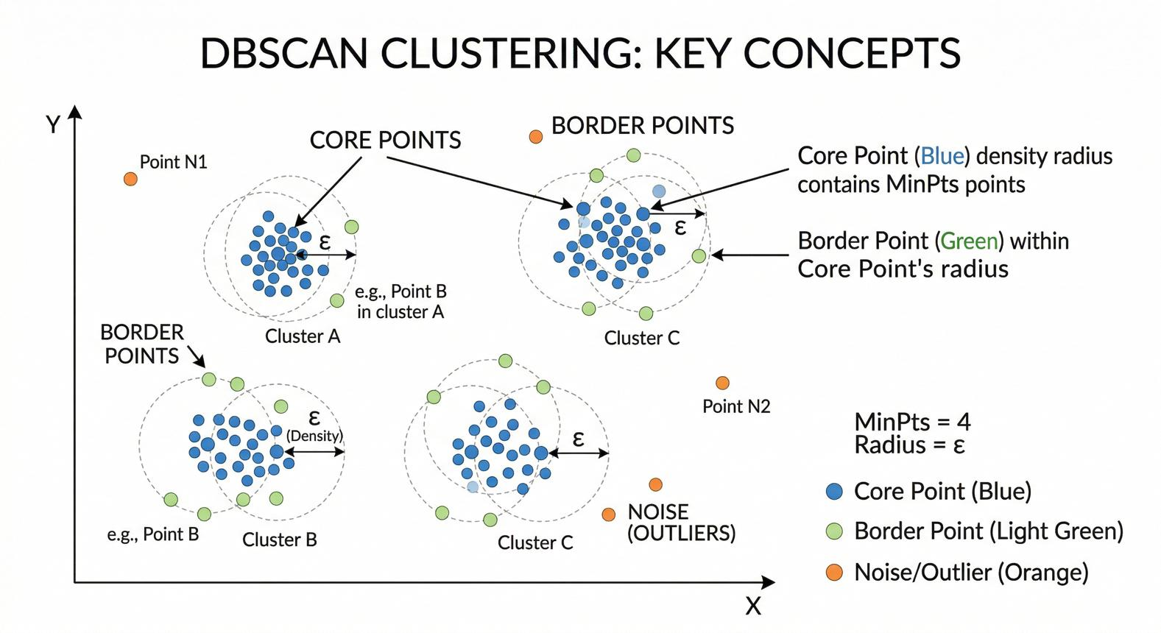
Q31. What is DBSCAN?
Expected answer: DBSCAN is a density-based clustering algorithm that groups observations in dense regions and identifies observations in sufficiently sparse regions as noise.
Q32. What do eps and min_samples mean in DBSCAN?
Expected answer:
- eps: The radius of the neighborhood around an observation.
- min_samples: The minimum number of observations in that neighborhood required for the observation to qualify as a core point, counting the point itself in scikit-learn.
Q33. What is a core point?
Expected answer: A point whose eps neighborhood contains at least min_samples observations.
Q34. What is a border point?
Expected answer: A non-core point that lies within the neighborhood of a core point and is therefore density-reachable from a cluster.

Q35. What is a noise point?
Expected answer: A point that is not assigned to any cluster under DBSCAN's density-reachability rules. Scikit-learn represents noise with the cluster label -1.
Q36. Does DBSCAN require the number of clusters in advance?
Expected answer: No. The number of clusters is discovered from the data's density structure.
Q37. Can DBSCAN identify non-spherical clusters?
Expected answer: Yes. It can discover clusters of irregular shapes if they form sufficiently dense, connected regions.
Q38. How does DBSCAN handle outliers?
Expected answer: It can label isolated observations as noise instead of forcing every observation into a cluster.
Q39. What happens if eps is too small?
Expected answer: Many observations may be classified as noise, and genuine clusters may fragment into smaller clusters or disappear.
Q40. What happens if eps is too large?
Expected answer: Separate groups may merge into one cluster, and many observations may become part of large connected clusters.
Q41. What is a major limitation of DBSCAN?
Expected answer: It can struggle when clusters have substantially different densities, because a single eps value may not work well for all groups.

D. Gaussian Mixture Models (GMM)
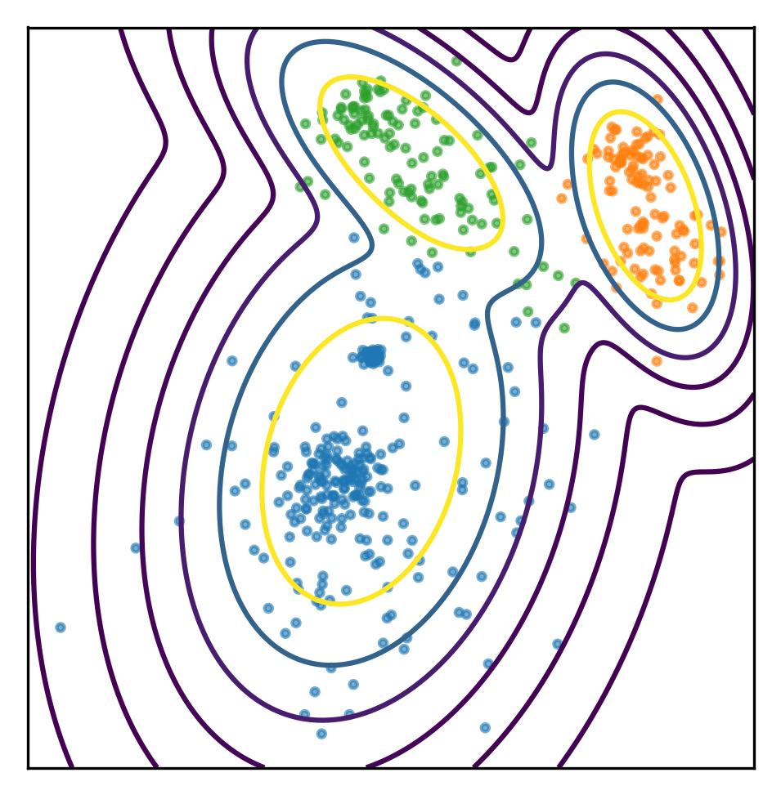
Q42. What is a Gaussian Mixture Model?
Expected answer: GMM models the data distribution as a mixture of multiple Gaussian distributions, each representing a potential cluster.

Q43. What is the difference between K-Means and GMM?
Expected answer: K-Means assigns each observation to one cluster based on distance to centroids. GMM estimates the probability that each observation belongs to each Gaussian component.
Q44. What is soft clustering?
Expected answer: Soft clustering allows an observation to have membership probabilities across multiple clusters rather than assigning it exclusively to one cluster.
Q45. What is a hard assignment?
Expected answer: Assigning an observation to exactly one cluster, usually the cluster with the highest membership probability.
Q46. What is the Expectation-Maximization (EM) algorithm?
Expected answer: It is an iterative procedure commonly used to estimate GMM parameters:
- Expectation step (E-step): Estimate the probability that each observation belongs to each component.
- Maximization step (M-step): Update the component parameters using those probabilities.
Q47. Can GMM identify elliptical clusters?
Expected answer: Yes. Depending on its covariance structure, GMM can represent clusters with different orientations, sizes, and shapes.
Q48. What is a limitation of GMM?
Expected answer: It requires choosing the number of mixture components, can be sensitive to initialization, and relies on the suitability of the Gaussian mixture assumption.

E. Mean Shift and Spectral Clustering
Q49. What is Mean Shift clustering?
Expected answer: Mean Shift is a density-based method that moves candidate cluster centers toward regions of higher estimated data density. The resulting density modes help define clusters.

Q50. What is the bandwidth parameter in Mean Shift?
Expected answer: It controls the scale over which density is estimated and how far observations influence the local density estimate. It strongly affects the number and size of discovered clusters.
Q51. What is Spectral Clustering?
Expected answer: Spectral clustering constructs a similarity graph, uses eigenvectors of a graph-related matrix to represent the observations, and then clusters those representations.
Q52. When might Spectral Clustering be useful?
Expected answer: When clusters have complex structures that conventional centroid-based approaches, such as K-Means, struggle to identify.
Q53. What is a disadvantage of Spectral Clustering?
Expected answer: It can be computationally expensive for large datasets and often requires selecting the number of clusters and designing a suitable similarity graph.

3. Clustering Evaluation Metrics
Unlike classification, clustering often has no ground-truth labels available. Therefore, evaluating clustering requires understanding both internal metrics and external metrics.

A. Silhouette Score
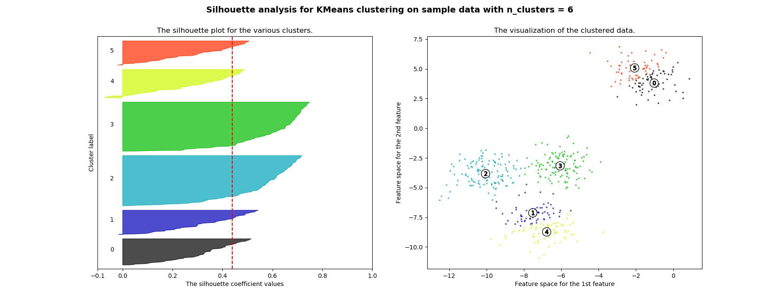

Q54. What is the Silhouette Score?
Expected answer: It measures how well an observation fits its assigned cluster compared with the nearest alternative cluster, considering within-cluster cohesion and between-cluster separation.
Q55. What is the range of the Silhouette Score?
Expected answer: From −1 to +1.
- Near +1: The observation is much closer to its own cluster than to neighboring clusters.
- Near 0: It lies near a cluster boundary or between clusters.
- Near −1: It may be closer to another cluster than its assigned cluster.
Q56. What do we mean by cohesion and separation?
Expected answer: Cohesion refers to how close observations are within the same cluster. Separation refers to how distinct one cluster is from other clusters.
Q57. Can we use the Silhouette Score to select K in K-Means?
Expected answer: Yes. We can compare scores for different values of K and investigate which provides well-separated, cohesive clusters. However, the highest score does not automatically mean the most useful business solution.
Q58. Can the Silhouette Score be negative?
Expected answer: Yes. This may indicate that an observation is closer to another cluster than to its assigned cluster.

B. Elbow Method and Inertia
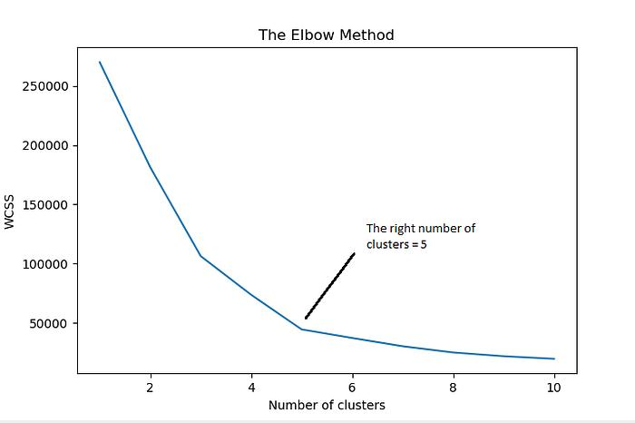
Q59. What is the Elbow Method?
Expected answer: It involves plotting an appropriate clustering cost, commonly K-Means inertia, against different values of K and looking for a point where the improvement begins to diminish.
Q60. Why does K-Means inertia generally decrease as K increases?
Expected answer: Adding more clusters allows observations to be assigned to closer centroids, reducing within-cluster squared distances.
Q61. Why is the Elbow Method not always reliable?
Expected answer: The curve may not have a clear elbow, and the chosen point can be subjective. It also does not directly establish that the resulting clusters are meaningful.
Q62. If K-Means inertia is lowest when K equals the number of observations, is that the best model?
Expected answer: Not necessarily. Each observation can become its own cluster, producing zero inertia but providing no useful grouping.

C. Davies–Bouldin and Calinski–Harabasz Scores
Q63. What is the Davies–Bouldin Index?
Expected answer: It evaluates clustering by comparing within-cluster dispersion with the separation between clusters. Lower values are generally better.
Q64. What is the Calinski–Harabasz Index?
Expected answer: It compares between-cluster dispersion with within-cluster dispersion, adjusted for the number of clusters and observations. Higher values are generally better.
Q65. Which metric is better: Silhouette Score or Davies–Bouldin Index?
Expected answer: Neither is universally better. They measure cluster quality differently, and the appropriate metric depends on the data, distance measure, and clustering objective.

D. External Evaluation Metrics
These metrics require known reference labels, even if the clustering algorithm itself was trained without them.
Q66. What is the Adjusted Rand Index (ARI)?
Expected answer: ARI measures agreement between predicted cluster assignments and reference labels, adjusted for chance. A value of 1 indicates perfect agreement, while values near 0 generally indicate chance-level agreement.
Q67. What is Normalized Mutual Information (NMI)?
Expected answer: NMI measures the shared information between clustering assignments and reference labels, normalized to a comparable scale. It is typically between 0 and 1.
Q68. Can we use accuracy to evaluate clustering directly?
Expected answer: Usually not directly. Cluster identifiers are arbitrary: cluster 0 might represent the same group as reference class 1. External metrics such as ARI or NMI are more appropriate without first aligning labels.
Q69. What is the difference between internal and external clustering evaluation?
Expected answer: Internal evaluation measures structure using the data and cluster assignments, without requiring true labels. External evaluation compares clusters against known reference labels.

4. Data Preprocessing and Clustering in Practice

Q70. Why do we remove irrelevant features before clustering?
Expected answer: Irrelevant features can distort the similarity measure and cause the algorithm to group observations according to unimportant characteristics.
Q71. Why might we use StandardScaler before K-Means?
Expected answer: It transforms each feature to approximately zero mean and unit variance, reducing the influence of differences in numerical scale.
Q72. What is the difference between StandardScaler and MinMaxScaler?
Expected answer: StandardScaler centers features and scales them by standard deviation. MinMaxScaler transforms features to a specified range, commonly 0 to 1.
Q73. Should we always scale the features before clustering?
Expected answer: No. It depends on the algorithm and the meaning of the features. Scaling is often useful for distance-based clustering, but sometimes the original scale contains meaningful information that should be preserved.
Q74. How can categorical features be handled in clustering?
Expected answer: We can use appropriate encodings or similarity measures. One-hot encoding may be suitable for some algorithms, while mixed-data methods such as k-prototypes can handle numerical and categorical features together.
Q75. How can outliers affect K-Means?
Expected answer: Outliers can pull centroids away from dense groups because K-Means minimizes squared distances.
Q76. What is dimensionality reduction, and how can it help clustering?
Expected answer: Dimensionality reduction represents observations using fewer features. It may reduce noise, redundancy, and computational cost, although important cluster structure can also be lost.

Q77. Can we use PCA before clustering?
Expected answer: Yes. PCA can reduce dimensionality while retaining directions of high variance. However, high-variance directions do not necessarily contain the most useful cluster structure.
Q78. What is the curse of dimensionality?
Expected answer: In high-dimensional spaces, distance and density measurements can become less informative, making it harder for clustering algorithms to distinguish meaningful groups.
Q79. What is the difference between fit() and fit_predict() in scikit-learn clustering?
Expected answer: fit() learns the clustering structure. fit_predict() fits the model and returns cluster assignments for the input observations, when supported by the estimator.
Q80. Why might two clustering algorithms produce different groups on the same dataset?
Expected answer: They use different assumptions, objectives, distance or similarity measures, and definitions of what constitutes a cluster.

5. Tricky Conceptual Questions
Q81. Is clustering always an objective process with one correct answer?
Expected answer: No. Different algorithms, features, distance measures, and parameters can produce different groupings. The most useful clustering depends on the problem's purpose.
Q82. Does a higher Silhouette Score always mean a better clustering solution?
Expected answer: Not necessarily. It indicates stronger cohesion and separation under the chosen distance measure, but may favor simple, compact clusters over meaningful structures such as irregularly shaped groups.
Q83. Can K-Means discover crescent-shaped clusters effectively?
Expected answer: Usually not. K-Means tends to partition data into centroid-based, approximately convex regions. DBSCAN or Spectral Clustering may be more appropriate for crescent-shaped structures.
Q84. Is DBSCAN a good choice when every observation must belong to a cluster?
Expected answer: Not necessarily. DBSCAN can label observations as noise, so it does not force every point into a cluster.
Q85. If we run K-Means twice with different random seeds, must we get the same result?
Expected answer: No. Different initial centroids may lead to different solutions. Multiple initializations can help find a better solution.
Q86. Can we use clustering when we already have labels?
Expected answer: Yes. We can still explore the data's structure without using those labels during training, then compare the resulting clusters with the known labels.
Q87. Is a cluster centroid always an actual observation in the dataset?
Expected answer: No. In K-Means, a centroid is the feature-wise mean of the observations in a cluster and may not correspond to any real observation.
Q88. Does DBSCAN always outperform K-Means because it can detect outliers?
Expected answer: No. DBSCAN can be better for irregularly shaped, density-connected groups, but may struggle with varying densities. K-Means may be more suitable for compact groups.
Q89. If the dataset has three natural groups, will every algorithm find exactly three clusters?
Expected answer: No. Different algorithms define clusters differently, and their parameters may produce a different number of groups.
Q90. Can clustering be used for anomaly detection?
Expected answer: Yes. Observations that do not belong to dense groups, or that lie unusually far from their cluster centers, can be investigated as potential anomalies. However, not every outlier is necessarily anomalous.
Q91. What happens if we include customer ID as a feature in K-Means?
Expected answer: If the ID is treated as a numerical feature, it can distort distances and produce meaningless groups. Identifiers that have no meaningful similarity information should generally be excluded.
Q92. Why is interpreting clusters important?
Expected answer: A clustering solution is useful only if we can understand what the groups represent and how they help answer the original question.

6. Scenario-Based Verbal Questions
Scenario 1
Q93. Customer segmentation
A supermarket wants to group customers using annual spending, purchase frequency, and average transaction value. Which algorithm would you try first, and what preprocessing would you perform?
Expected answer
K-Means is a reasonable baseline if the features produce compact groups. Inspect and clean the data, scale the numerical features, and compare different values of K using metrics such as the Silhouette Score and business interpretability.
Scenario 2
Q94. Irregularly shaped clusters
You have a two-dimensional dataset containing two crescent-shaped groups. K-Means splits the data poorly. Which algorithm could you try?
Expected answer
DBSCAN can detect irregularly shaped, density-connected groups. Spectral Clustering is another possible choice. The result depends on the density structure and parameter settings.
Scenario 3
Q95. Unknown number of clusters
You have no idea how many groups exist in a dataset. Which algorithms allow you to discover clusters without specifying K in advance?
Expected answer
DBSCAN and Mean Shift can discover a data-dependent number of clusters. Hierarchical clustering also lets you explore different cuts of a hierarchy. Each method has its own assumptions and parameters.

Scenario 4
Q96. Outliers in customer data
A few customers have extremely high spending compared with everyone else. Why might K-Means produce poor results, and what could you do?
Expected answer
Squared distances make K-Means sensitive to extreme values. Investigate the outliers, check whether they are valid, consider robust preprocessing, and compare with a density-based approach if appropriate.
Scenario 5
Q97. Choosing K
You calculate inertia for K values from 1 to 10. Inertia decreases continuously, but the curve has no obvious elbow. What would you do?
Expected answer
Compare Silhouette Scores and other suitable metrics, assess stability across initializations or samples, visualize the clusters, and consider the practical usefulness of each solution. There may not be a single obvious optimal K.
Scenario 6
Q98. Noise in geographical data
You are clustering GPS coordinates of restaurants and want to identify dense areas while leaving isolated locations unassigned. Which algorithm could be suitable?
Expected answer
DBSCAN is a natural candidate because it can discover density-connected groups and label isolated observations as noise. For geographic coordinates, use an appropriate geographic distance measure and units rather than blindly applying Euclidean distance.

Scenario 7
Q99. Probabilistic group membership
A customer appears to have characteristics of two customer segments. You want to quantify the customer's membership in each group. Which algorithm could help?
Expected answer
A Gaussian Mixture Model can provide estimated membership probabilities for each component rather than only a hard cluster assignment.
Scenario 8
Q100. Evaluating clusters without labels
You have no true class labels. How can you assess whether your clustering is useful?
Expected answer
Use internal metrics such as Silhouette Score and Davies–Bouldin Index, inspect cluster sizes and visualizations, test stability, and determine whether the groups are meaningful for the intended application.
Scenario 9
Q101. Clusters with different densities
Your dataset contains one very dense group and another much more spread-out group. DBSCAN either merges groups or labels many observations as noise. Why might this happen?
Expected answer
DBSCAN uses a global neighborhood radius and density threshold. One set of parameters may not capture both dense and sparse clusters well. Consider alternative parameters, HDBSCAN if available, or a different clustering approach.
Scenario 10
Q102. Comparing two clustering models
Model A has a higher Silhouette Score than Model B, but Model B produces groups that are more useful for a marketing campaign. Which would you choose?
Expected answer
It depends on the business objective. Internal metrics are helpful but do not replace domain knowledge, interpretability, stability, and practical usefulness.

