
Lab 2

Responsive Navbar and Grid Drill

Session: FA24-BCS-A

Student: Aliza Asghar

Reg. No: FA24-BCS-016

Department of Computer Science
COMSATS University Islamabad (CUI), Lahore Campus

lab statement
Lab 2 — Responsive Navbar and Grid Drill
lab-2/
Difficulty: Easy–Medium · Covers: Lectures 7–10 · Folder:
A focused, smaller-scale rehearsal for Assignment 2: build just a responsive navbar
(logo left, links center, cart icon right, collapsing into a hamburger menu below 768px) and a 4-column-desktop / 2-column-tablet / 1-column-phone product grid, using Flexbox or Grid plus Bootstrap or Tailwind. Content can be placeholder text/images — the point is the responsive mechanics, not the final design.

Screenshots
Desktop:
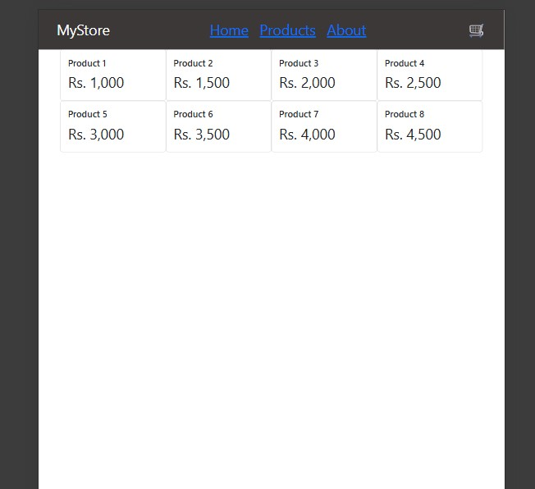
Tablet:
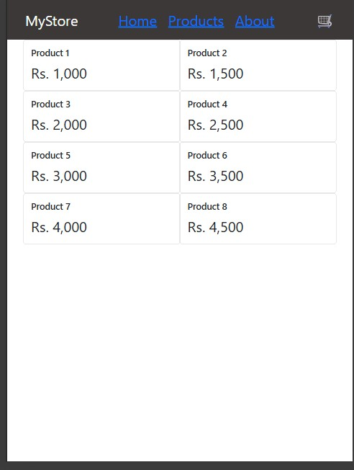
Phone:
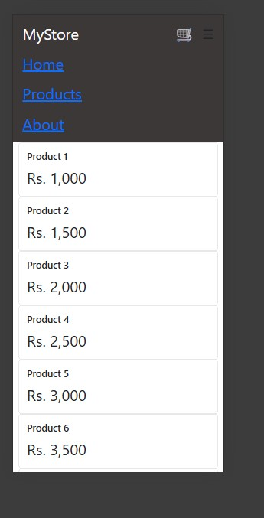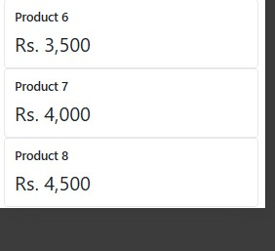

Code index.html

<!DOCTYPE html>

<html lang="en">
<head>
<meta charset="UTF-8">
<meta name="viewport" content="width=device-width, initial-scale=1.0">
<title>Lab2</title>

<link href="https://cdn.jsdelivr.net/npm/bootstrap@5.3.3/dist/css/bootstrap.min.css" rel="stylesheet">

<link rel="stylesheet" href="style.css">

</head>
<body>

<nav class="navbar">
<div class="logo order-md-1">MyStore</div>
<div class="nav-right order-md-3">
<div class="cart">🛒</div>
<label for="menu-toggle" class="hamburger">☰</label>
</div>

<input type="checkbox" id="menu-toggle">
<div class="nav-links order-md-2">
<a href="#">Home</a>
<a href="#">Products</a>
<a href="#">About</a>
</div>
</nav>
<main class="container">

<div class="product-grid">

<div class="card">
<div class="card-body">
<h5 class="card-title">Product 1</h5>
<p class="card-text">Rs. 1,000</p>
</div>
</div>

<div class="card">
<div class="card-body">
<h5 class="card-title">Product 2</h5>
<p class="card-text">Rs. 1,500</p>
</div>
</div>

<div class="card">
<div class="card-body">
<h5 class="card-title">Product 3</h5>
<p class="card-text">Rs. 2,000</p>
</div>
</div>

<div class="card">
<div class="card-body">
<h5 class="card-title">Product 4</h5>
<p class="card-text">Rs. 2,500</p>
</div>
</div>

<div class="card">
<div class="card-body">
<h5 class="card-title">Product 5</h5>
<p class="card-text">Rs. 3,000</p>
</div>
</div>

<div class="card">
<div class="card-body">
<h5 class="card-title">Product 6</h5>
<p class="card-text">Rs. 3,500</p>
</div>
</div>

<div class="card">
<div class="card-body">
<h5 class="card-title">Product 7</h5>
<p class="card-text">Rs. 4,000</p>
</div>
</div>

<div class="card">
<div class="card-body">
<h5 class="card-title">Product 8</h5>
<p class="card-text">Rs. 4,500</p>
</div>
</div>

</div>

</main>
</body>
</html>

style.css
/* NAVBAR */

.navbar { display: flex; align-items: center; justify-content: space-between; padding: 20px 40px; background-color: rgb(59, 56, 55);
}
.logo { justify-self: start; font-size: xx-large; color: white;
}

.nav-links { display: flex; justify-content: center; gap: 25px;
font-size: xx-large;
}

.nav-right { display: flex; justify-self: end; align-items: center; gap: 15px;
font-size: xx-large;
}

#menu-toggle { display: none;
}

.hamburger { display: none;
}

@media (max-width: 767px) {

.navbar { flex-wrap: wrap;
padding: 15px 20px; font-size: medium;
}

.hamburger { display: block; font-size: 28px; cursor: pointer;
}

.nav-links { display: none; flex-direction: column; width: 100%; gap: 15px;
padding-top: 15px;
}

#menu-toggle:checked ~ .nav-links { display: flex;
}
}

/* GRID */ .product-grid { display: grid; grid-template-columns: repeat(4, 1fr); font-size: xx-large;

}

@media (min-width: 768px) and (max-width: 991px) {
.product-grid { grid-template-columns: repeat(2, 1fr);
}
}

@media (max-width: 767px) {
.product-grid { grid-template-columns: 1fr;
}
}

