

**DEPARTMENT OF COMPUTER SCIENCE, UBIT**

CLASS: BSCS – A

COURSE: THEORY OF COMPUTER SCIENCE (BSCS-501)

**LAB ASSIGNMENT:**

Implementation of Deterministic Finite Automata (DFA)

**SUBMITTED BY:**

Aliza Khan (B22110006017)

**SUBMITTED TO:**

Sir Muzammil Jethwa

**DFA Graph & Transition Table**

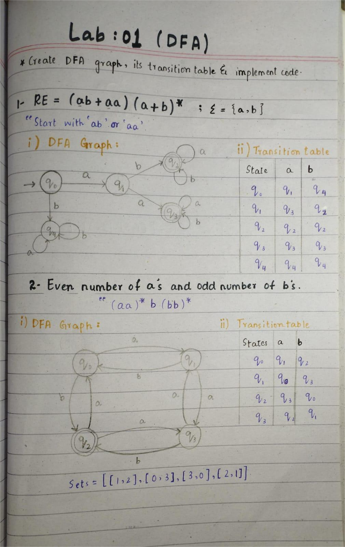

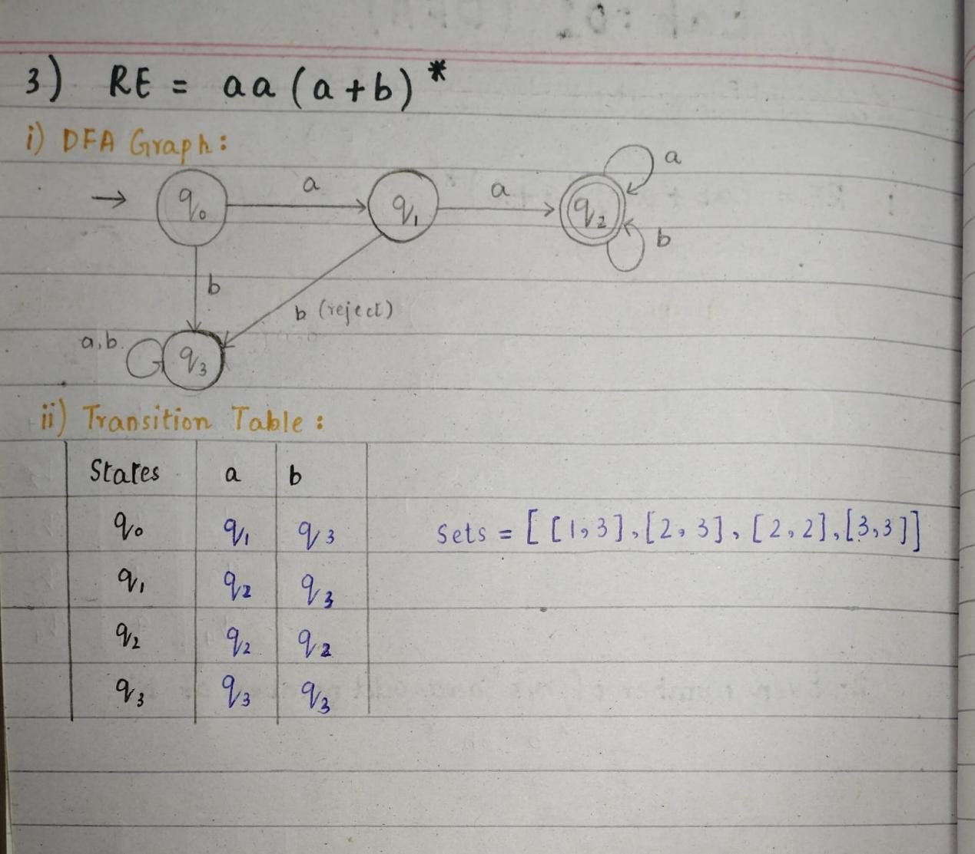

**DFA Code Implementation**

1. 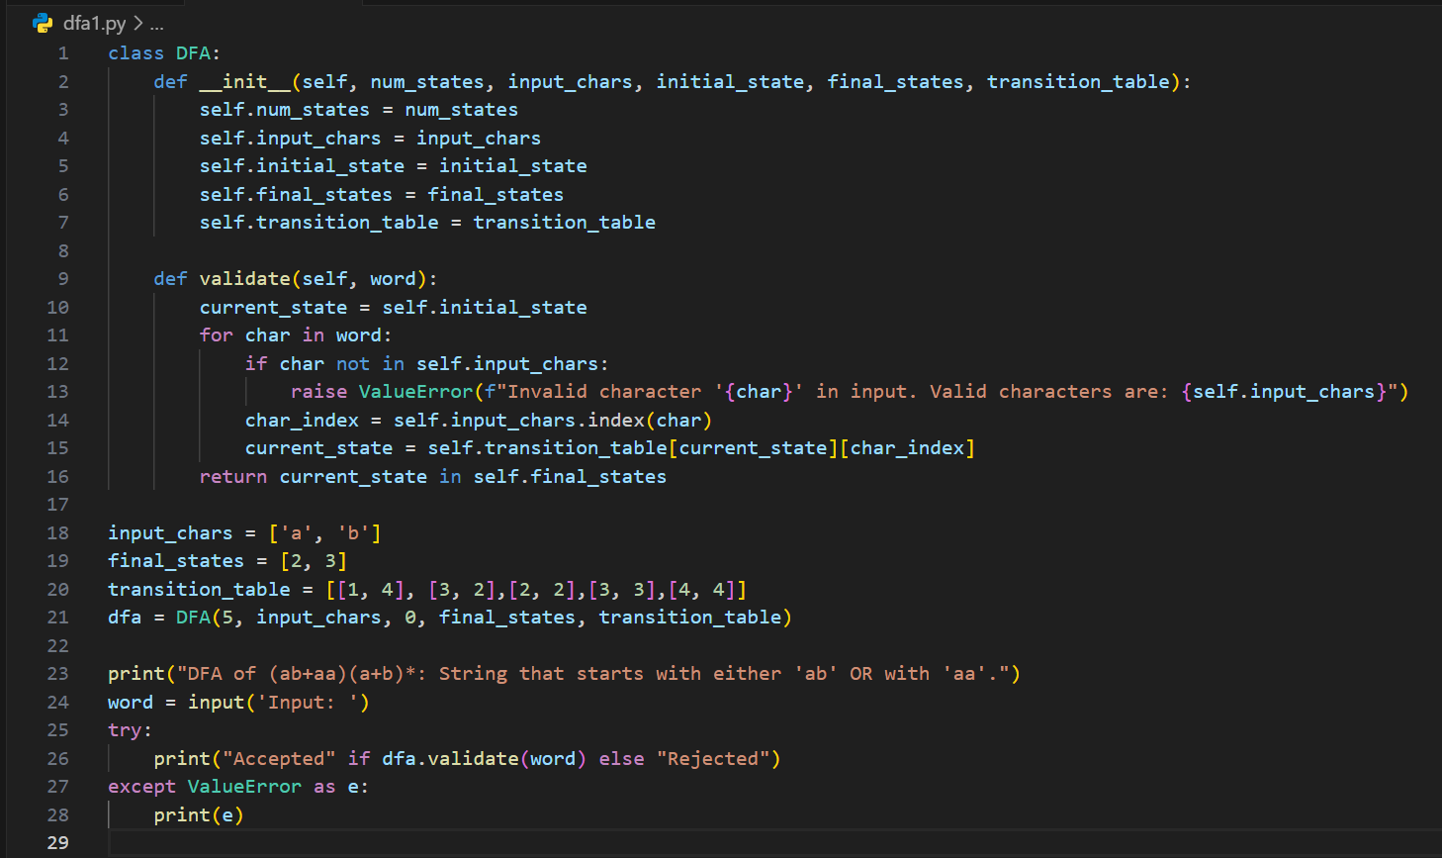**(ab+aa) (a+b)\***

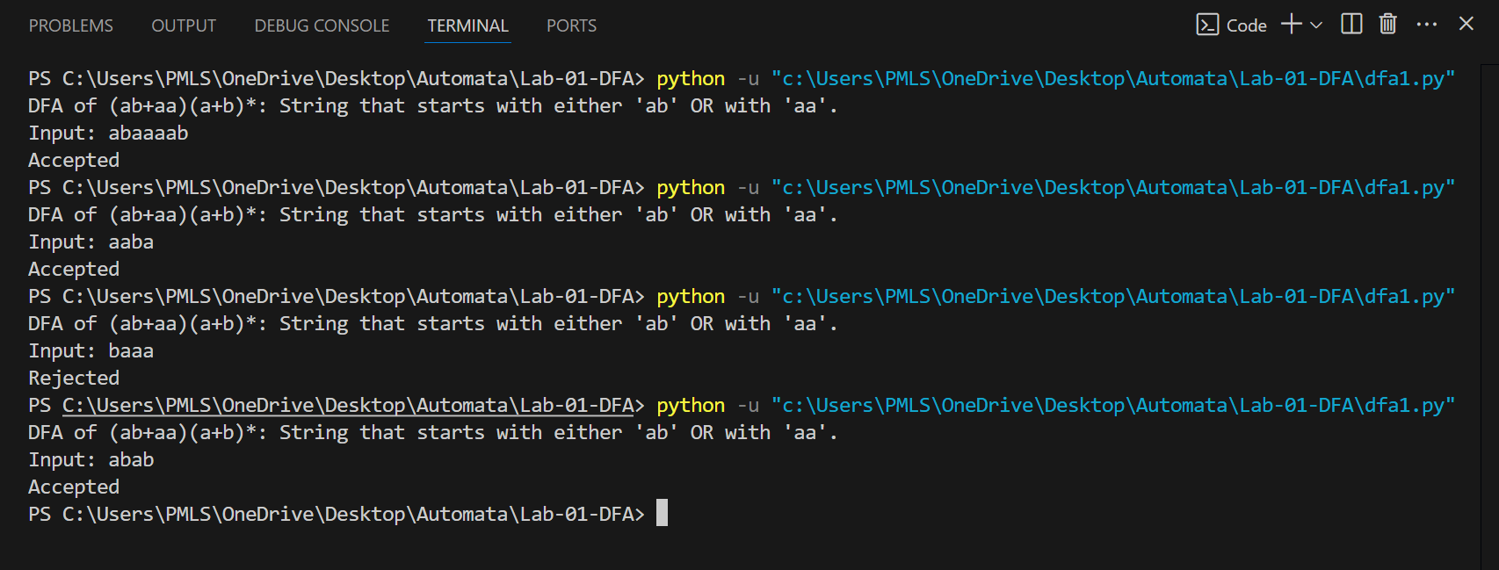

1. 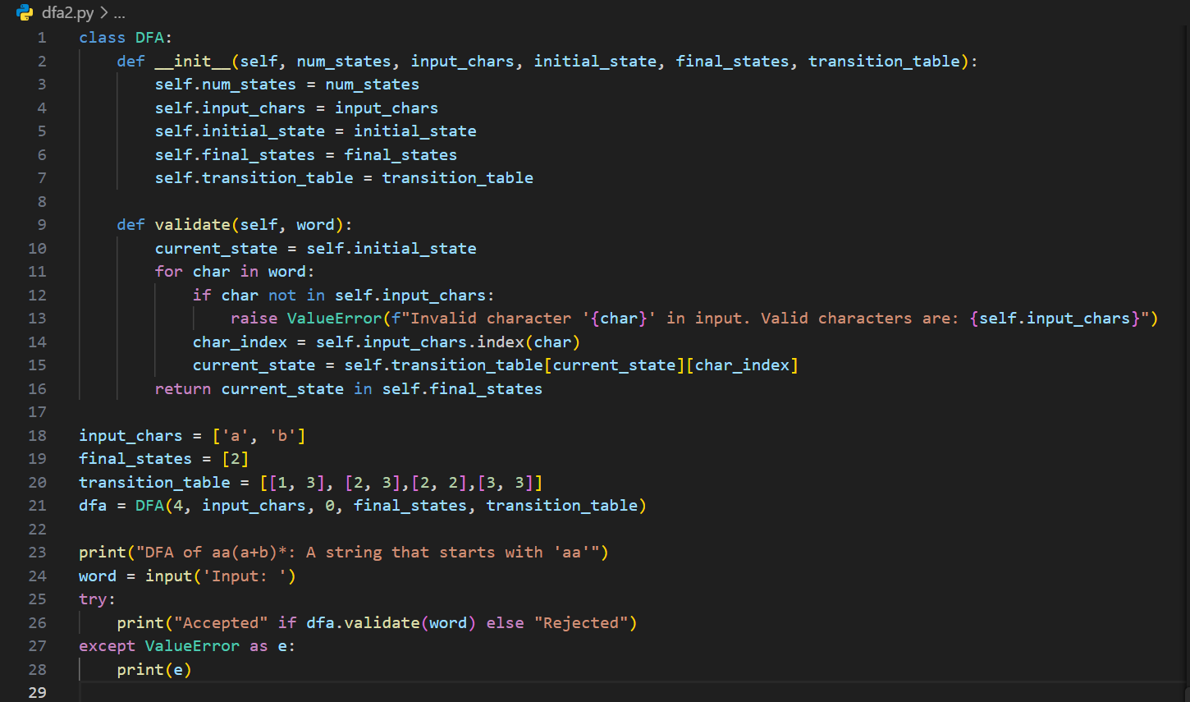 **aa (a+b)\***

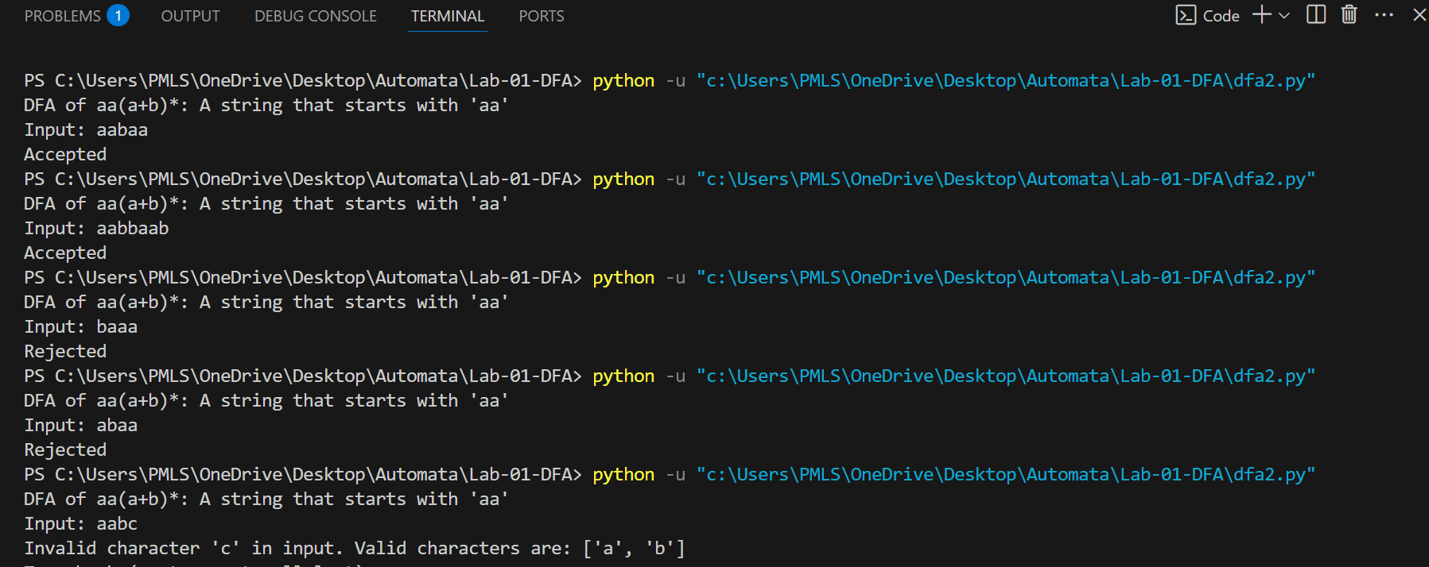

1. **Even Number of a’s and Odd Number of b’s**

