UNIVERSITY PROJECT SUBMISSION
STREAMIX
A Distributed Movie Streaming Database System
Polyglot Microservices Architecture with PostgreSQL, MongoDB & Redis
and a Netflix-style React Native Client

Course: Distributed Databases (DDB)
Project Type: Design & Implementation Report
Submitted by: _______________________________
Student ID: ________________________________
Supervisor / Instructor: ____________________
Institution: _______________________________
Date: September 2026

This document presents the complete design, database schema, distributed database concepts, implementation, evaluation, and demonstration of the Streamix system.

Declaration
I hereby declare that this project report is my original work, prepared for the Distributed Databases course. The implementation described herein — including the polyglot microservices backend, distributed PostgreSQL/MongoDB/Redis cluster, and the Streamix mobile application — was developed as part of this academic project. Sources consulted for background concepts and the original project proposal/architecture documents are acknowledged in the References section. I understand that any form of plagiarism is subject to academic disciplinary action.
Signature: _______________________ Date: _______________

Abstract
Streamix is a distributed movie-catalog platform that demonstrates core Distributed Database (DDB) concepts in a runnable system. The backend is organized as microservices behind an API gateway. Identity and the movie catalog are stored in PostgreSQL with vertical fragmentation of user data, horizontal sharding of movies across US and EU region shards, and primary–replica streaming replication. Watchlists and reviews are stored in MongoDB with application-level hash sharding. Redis provides response caching and a Streams-based event bus (Kafka stand-in). A recommendation service computes genre-affinity rankings, and an analytics service aggregates shard and cache metrics. A React Native client provides a Netflix-style interface including region-aware “Near You” routing via an X-Client-Region header. The report covers requirements, database design, architecture, implementation, testing, and viva demonstration procedures. Full CDN video delivery and production Kafka/Milvus/ClickHouse deployments are scoped as future work.
Keywords: Distributed Databases, Horizontal Fragmentation, Vertical Fragmentation, Replication, Shard Routing, Scatter-Gather, Polyglot Persistence, Microservices, PostgreSQL, MongoDB, Redis, React Native

Table of Contents
- 1. Introduction
- 2. Problem Statement & Objectives
- 3. Literature / Background on DDB Concepts
- 4. System Requirements
- 5. Overall System Architecture
- 6. Database Design
- 6.1 Conceptual ER Model
- 6.2 Vertical Fragmentation
- 6.3 Horizontal Fragmentation & Shard Keys
- 6.4 Physical Schema (Postgres / Mongo / Redis)
- 6.5 Replication Design
- 6.6 Integrity & Cross-Store References
- 7. Distributed Query Processing
- 8. Region-Aware Routing
- 9. Caching & Asynchronous Events
- 10. Recommendations & Analytics
- 11. Microservices Implementation
- 12. Mobile Application
- 13. Deployment Topology
- 14. Testing, Evaluation & Demo Results
- 15. Alignment with Proposal Diagram
- 16. Limitations & Future Work
- 17. Conclusion
- References
- Appendix A — API Catalogue
- Appendix B — Container Inventory
- Appendix C — Setup Commands

1. Introduction
Modern streaming platforms serve global audiences. A single centralized database becomes a bottleneck for latency, availability, and scale. Distributed Databases address this by fragmenting data across nodes, replicating for fault tolerance, and routing queries intelligently. This project implements Streamix — a teaching-oriented but fully runnable distributed movie streaming catalog — to apply these ideas in code.
The project pairs a polyglot backend (PostgreSQL + MongoDB + Redis) with a Netflix-style mobile client. Students and examiners can start the cluster with Docker Compose, exercise shard routing and replication, and observe region-aware “Near You” behaviour from the app.
The remainder of this report is organized as follows. Section 2 states objectives. Section 3 reviews DDB concepts. Sections 4–6 present requirements, architecture, and database design. Sections 7–10 detail distributed query, region routing, caching/events, and recommendations. Sections 11–14 cover implementation, mobile UI, deployment, and evaluation. Sections 15–17 discuss proposal alignment, limitations, and conclusions.

2. Problem Statement & Objectives

2.1 Problem Statement
Design and implement a distributed backend for a movie streaming catalog that (i) fragments user, movie, watchlist, and review data appropriately, (ii) replicates critical stores for availability, (iii) routes reads/writes and region-sensitive queries correctly, and (iv) exposes the system through a usable mobile interface — all runnable locally with free open-source software.

2.2 Objectives
- Implement horizontal and vertical fragmentation with clear shard keys.
- Deploy real PostgreSQL streaming replication (primary–replica), not a mock.
- Provide a shard router with distribution transparency to the client.
- Demonstrate scatter-gather search and region-preferred nearby queries.
- Adopt polyglot persistence (Postgres + MongoDB + Redis) via microservices.
- Build a React Native Streamix client for end-to-end demonstration.

2.3 Scope Boundaries
- In scope: catalog browse/search, watchlist, reviews, recommendations, admin sync from TMDb, trailers.
- Out of scope: full-feature CDN HLS streaming; production Kafka/Milvus/ClickHouse clusters.

3. Literature / Background on DDB Concepts
A Distributed Database Management System (DDBMS) stores data across multiple sites while presenting a unified interface. Classic design dimensions include fragmentation, allocation, replication, and transparency [Ozsu & Valduriez].

3.1 Fragmentation
Horizontal fragmentation partitions relations by rows (predicates or hash of a key). Vertical fragmentation partitions by columns, typically separating frequently accessed security attributes from bulky profile attributes. Hybrid fragmentation combines both.

3.2 Replication
Replication maintains copies for availability and read scale-out. Synchronous replication favours strong consistency; asynchronous streaming replication (as used by PostgreSQL WAL shipping) favours performance with bounded lag — a trade-off this project explicitly demonstrates.

3.3 Transparency & Query Processing
Location, fragmentation, and replication transparency hide physical details from applications. Distributed query processing may use targeted single-shard access or scatter-gather (fan-out + merge) when the shard key is unknown.

3.4 Polyglot Persistence
Polyglot persistence selects different storage engines per workload: relational for transactions, documents for flexible aggregates, and in-memory stores for cache/events. Streamix applies this pattern deliberately.

4. System Requirements

4.1 Functional Requirements
ID | Requirement
FR1 | Users can register/login; JWT authorizes subsequent calls
FR2 | Browse trending, search, and genre-filtered movies
FR3 | Near You feed prefers client region shard
FR4 | Add/remove watchlist items
FR5 | Submit and list movie reviews
FR6 | Personalized recommendations from watchlist/reviews
FR7 | Admin can sync movies from TMDb into shards
FR8 | Profile can override streaming region (US/EU)

4.2 Non-Functional Requirements
ID | Requirement
NFR1 | Local demo on Docker Desktop without paid cloud
NFR2 | Fault isolation: one movie shard down must not fail entire search
NFR3 | Distribution transparency for the mobile client
NFR4 | Documented failover for Postgres movie primary
NFR5 | Clear mapping from course DDB concepts to code artifacts

5. Overall System Architecture
Figure 0 shows the original architecture proposal presented to the instructor. Figure 1 shows the implemented polyglot microservice realization.
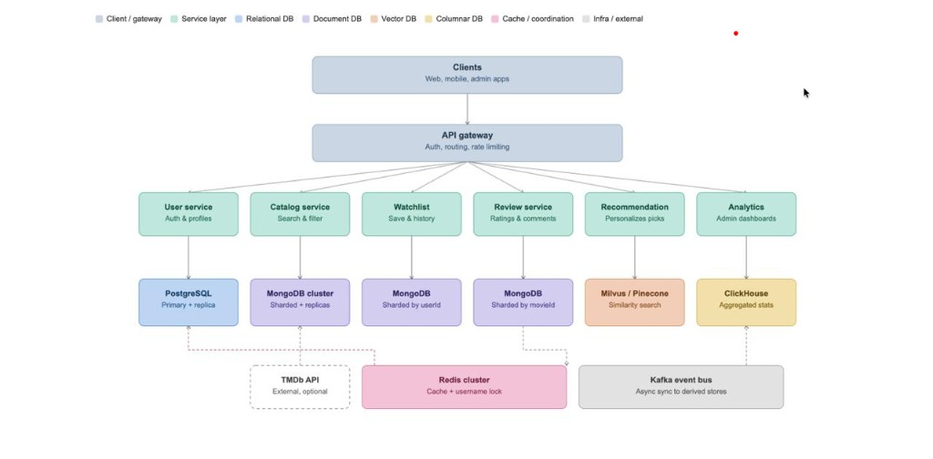
Figure 0. Original architecture proposal diagram (design target).
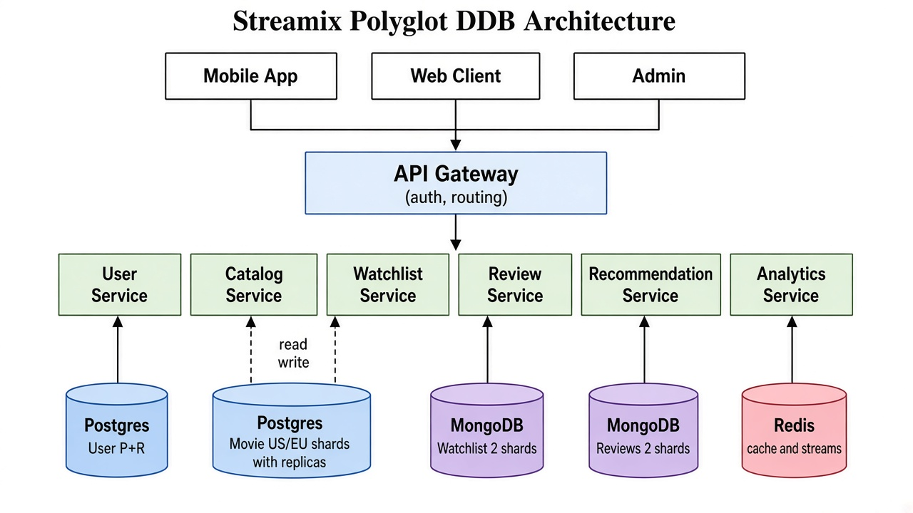
Figure 1. Implemented Streamix polyglot DDB architecture.
Clients communicate exclusively with the API Gateway (port 4000). The gateway proxies paths to User, Catalog, Watchlist, Review, Recommendation, and Analytics services. Each service owns its store(s). Figure 11 summarizes transparency layers.
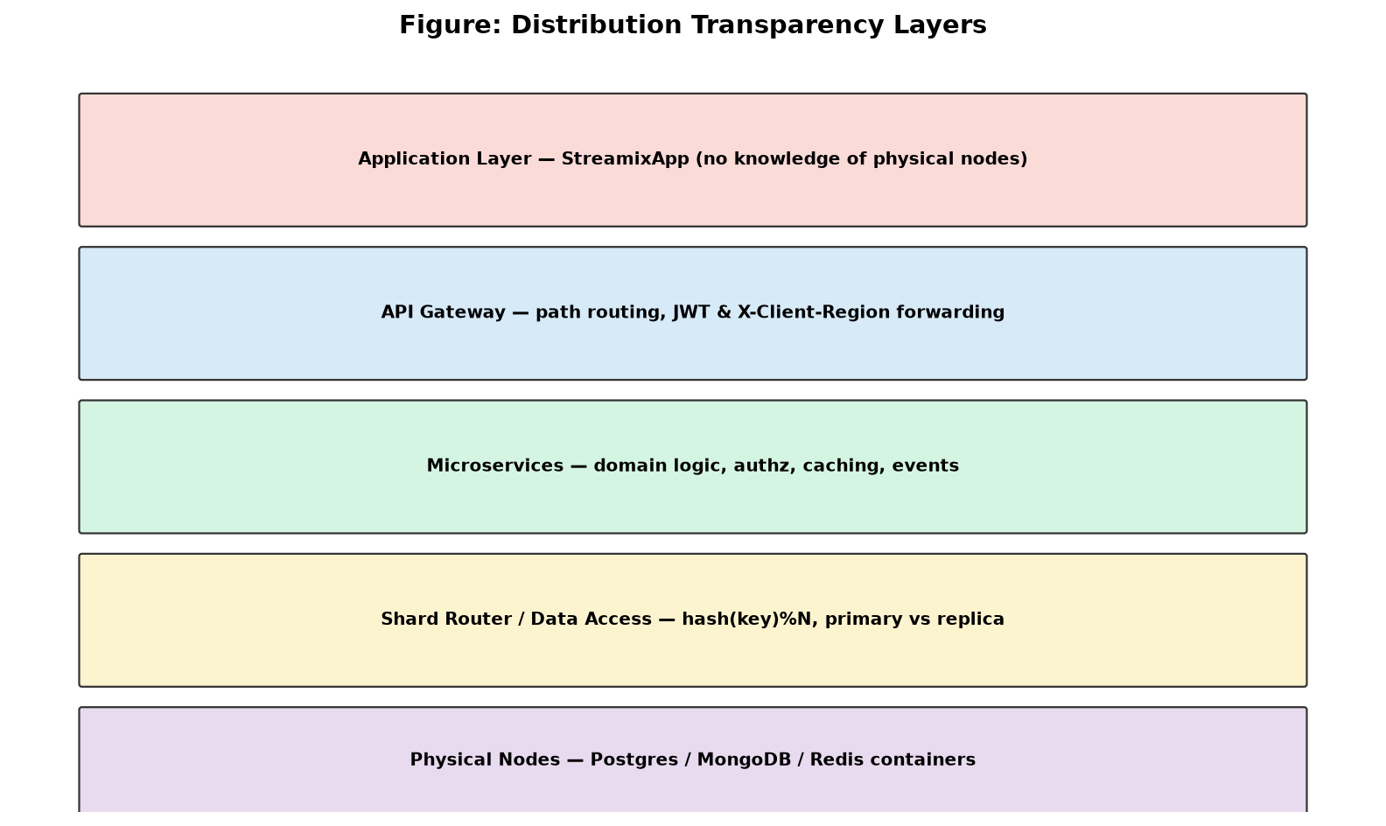
Figure 2. Distribution transparency layers from app to physical nodes.
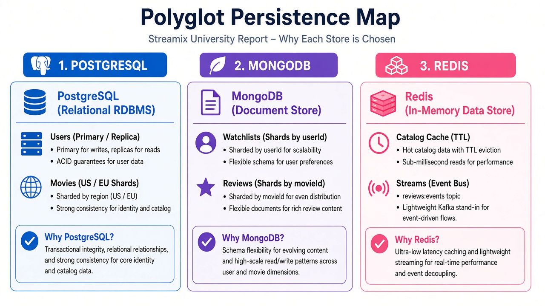
Figure 3. Polyglot persistence map (Postgres / MongoDB / Redis).

6. Database Design

6.1 Conceptual ER Model
The logical entities are User, Movie, WatchlistItem, and Review. A user has one profile, many watchlist entries, and many reviews. A movie has many reviews and may appear on many watchlists. Figure 4 captures entities, relationships, and fragmentation labels.
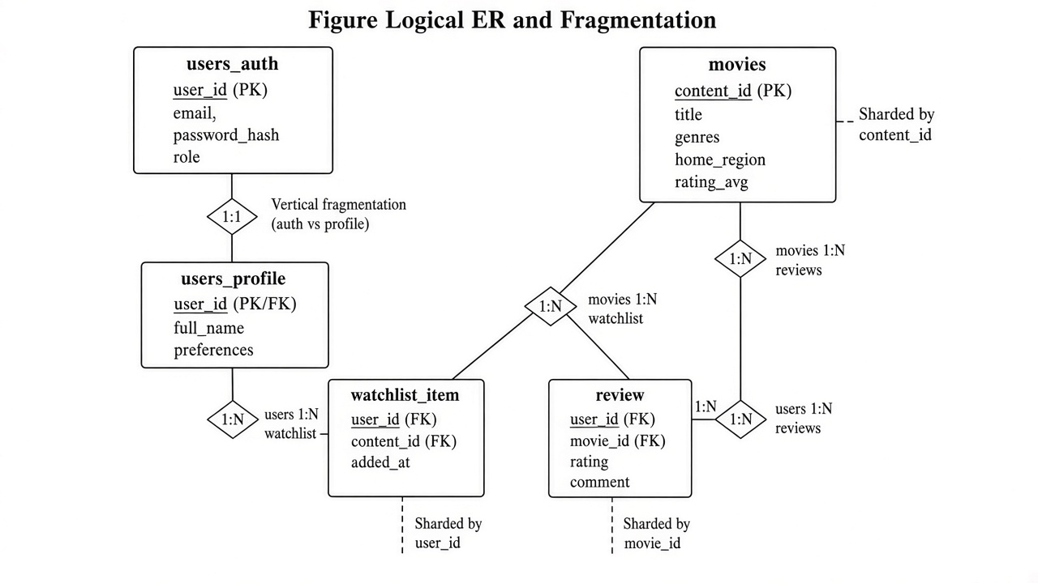
Figure 4. Logical ER model with fragmentation annotations.

6.2 Vertical Fragmentation
The logical User relation is vertically fragmented into users_auth and users_profile in the user PostgreSQL database. Auth attributes are small and hot (checked on login); profile attributes are larger and colder. Both share user_id. Registration inserts both rows in a single transaction for consistency.
users_auth(user_id PK, email UNIQUE, password_hash, role, created_at, last_login_at)
users_profile(user_id PK/FK → users_auth, full_name, avatar_url, bio, preferences JSONB, updated_at)

6.3 Horizontal Fragmentation & Shard Keys
Horizontal fragments are disjoint row subsets whose union reconstitutes the logical relation.
Logical relation | Shard key | Rule | Physical nodes
movies | content_id | hash(content_id) mod 2 | movie-shard-us-*, movie-shard-eu-*
watchlist | user_id | hash(user_id) mod 2 | watchlist-mongo-1/2
reviews | movie_id | hash(movie_id) mod 2 | review-mongo-1/2

Hashing uses MD5 of the key string, taking the first 4 bytes as an integer modulus N. This yields deterministic, even placement and stable routing for a given key.
shardIndex(key, N) = parseInt(md5(key)[0:8], 16) % N
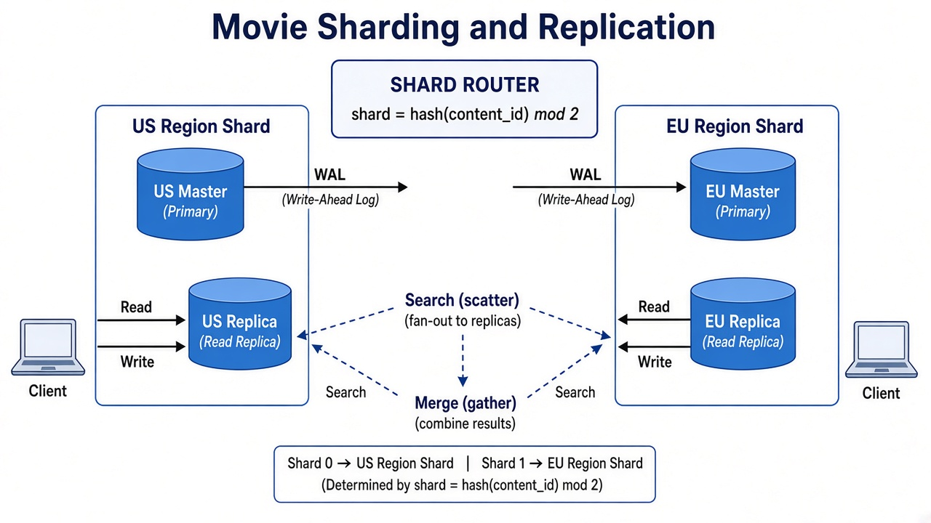
Figure 5. Movie shard routing with primary–replica pairs and scatter-gather.

6.4 Physical Schema (Postgres / Mongo / Redis)
Figure 6 consolidates physical collections/tables as deployed.
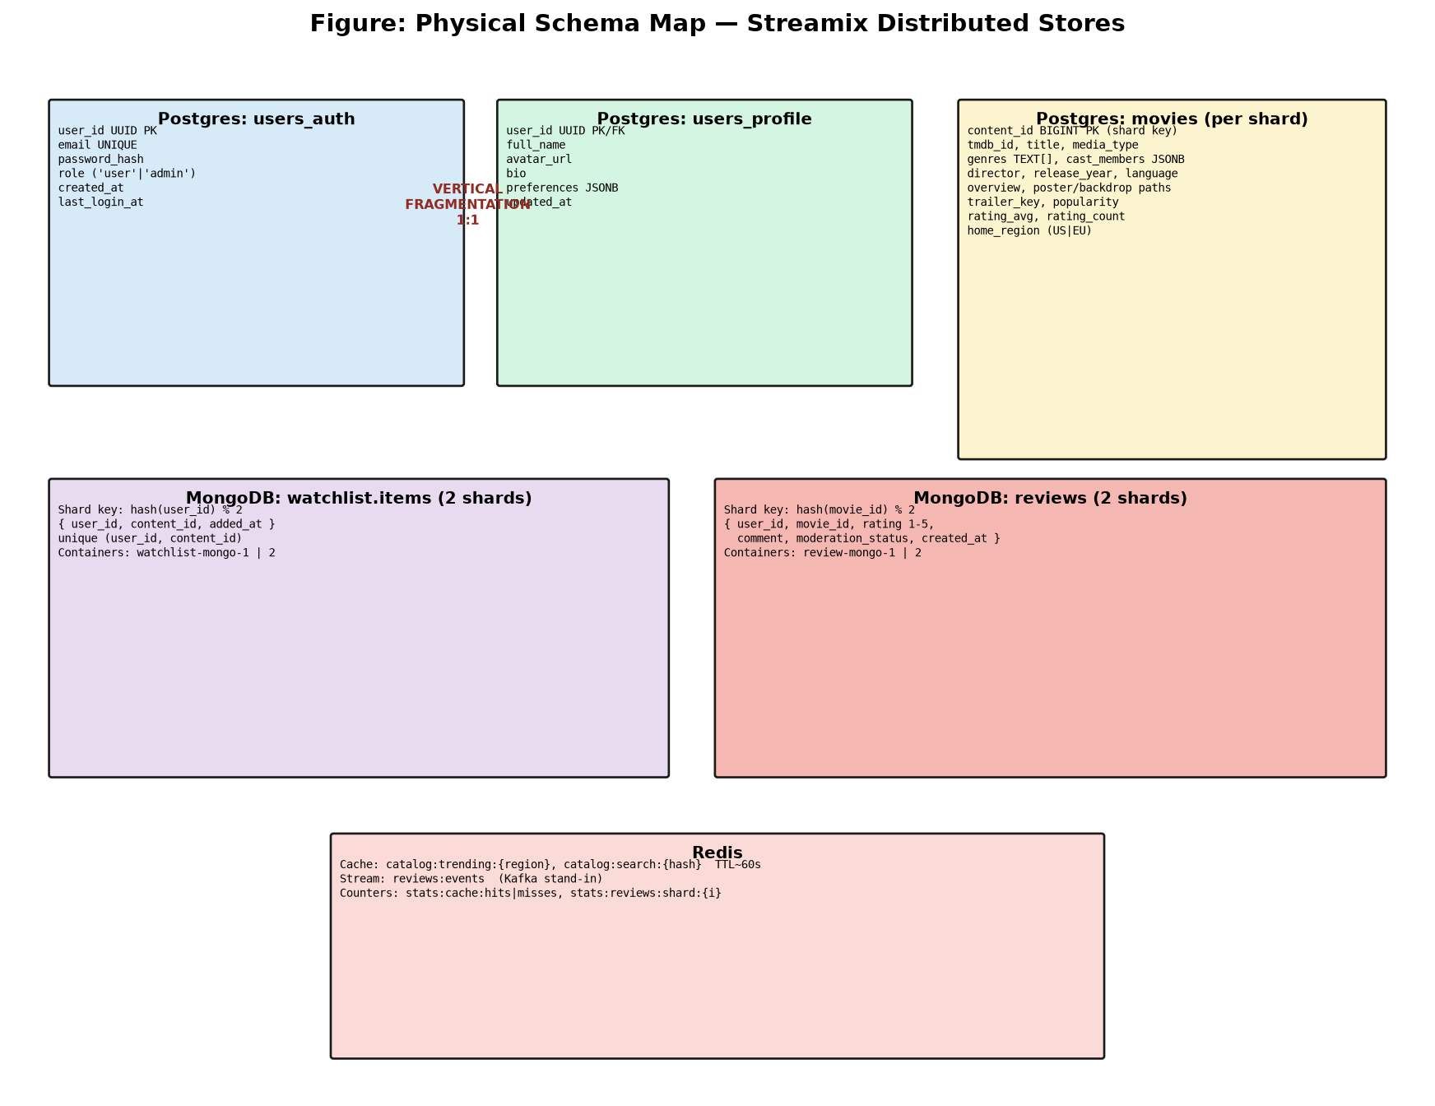
Figure 6. Physical schema map across Postgres, MongoDB, and Redis.
Movies table (identical schema on every movie shard):
movies(
content_id BIGINT PK, -- also shard key (= tmdb_id)
tmdb_id BIGINT, title, media_type,
genres TEXT[], cast_members JSONB, director,
release_year INT, language, overview,
poster_path, backdrop_path, trailer_key,
popularity NUMERIC, rating_avg NUMERIC, rating_count INT,
home_region VARCHAR(10), -- metadata US|EU
created_at, updated_at
)
Indexes: GIN(to_tsvector(title)), GIN(genres), popularity DESC, ...
MongoDB documents:
watchlist.items: { user_id, content_id, added_at } unique(user_id, content_id)
reviews: { user_id, movie_id, rating, comment, moderation_status, created_at }
Redis structures:
STRING cache keys with EX TTL ~60s
STREAM reviews:events
STRING counters stats:cache:hits|misses, stats:reviews:shard:{i}, ...

6.5 Replication Design
The user database and each movie shard run Bitnami PostgreSQL with POSTGRESQL_REPLICATION_MODE=master|slave. Replicas subscribe via WAL streaming. The application writes only to primaries and prefers replicas for reads (read/write splitting). Watchlist and review Mongo nodes in this Phase-1 demo are single-node shards (replication can be added similarly).
Asynchronous replication may briefly return stale reads — an intentional consistency/latency trade-off documented for examiners.

6.6 Integrity & Cross-Store References
Cross-database references use shared identifiers only (user_id UUID, content_id/movie_id BIGINT). There are no foreign keys across Postgres and Mongo — typical for polyglot systems. Application logic maintains referential intent (e.g., watchlist content_id should exist in catalog). Review inserts asynchronously refresh movies.rating_avg on the movie’s Postgres shard.

7. Distributed Query Processing

7.1 Targeted Access
When the shard key is known (GET /catalog/movie/:id, watchlist by user, reviews by movie), the router contacts exactly one node — O(1) shard selection.

7.2 Scatter-Gather
Search and trending fan the same SQL to every movie shard replica in parallel (Promise.allSettled), merge rows, sort, and paginate in the application layer. Failed shards are counted (shardsFailed) without failing the whole request — demonstrating partial failure isolation.

7.3 Read/Write Paths
- Write path: movieWriteConn / userWriteConn → primary only.
- Read path: movieReadConn / userReadConn → replica if available.

8. Region-Aware Routing
Movie shards are labeled US and EU. The mobile client derives a region from the device timezone (Asia maps to EU as nearest of the two deployed shards) and may override it on the Profile screen. Every request sends X-Client-Region. GET /catalog/nearby queries the preferred shard first, falling back if empty or down.
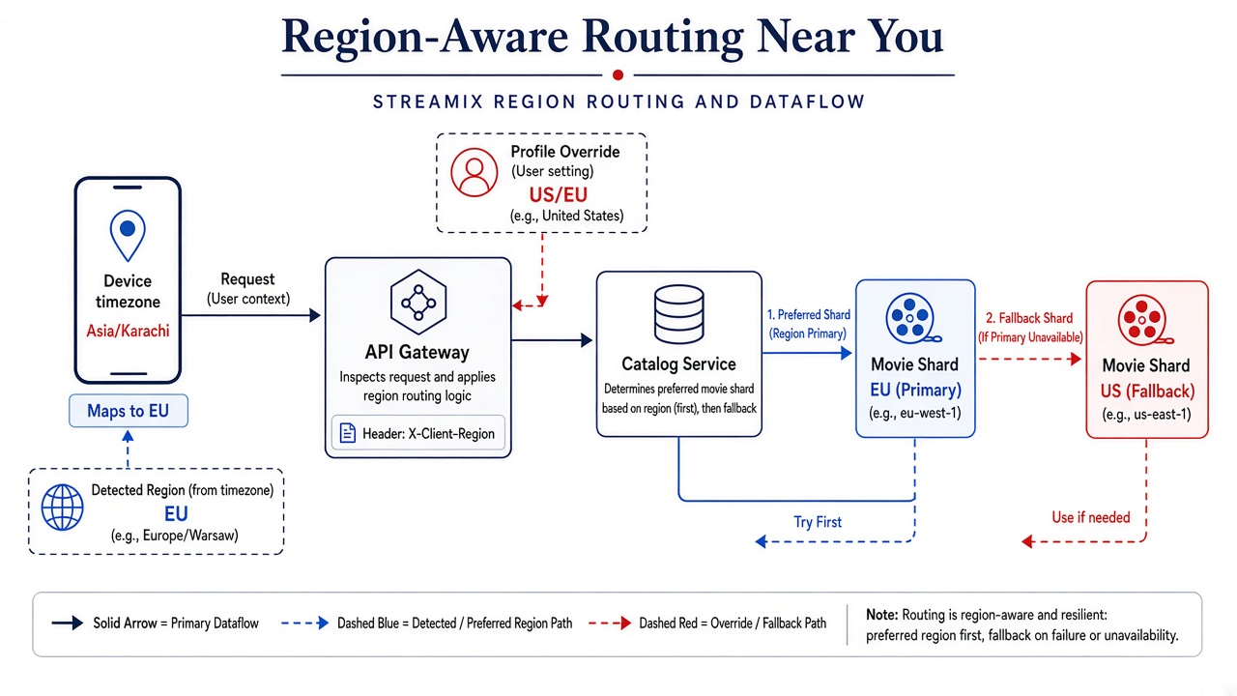
Figure 7. Region-aware routing and Near You flow.
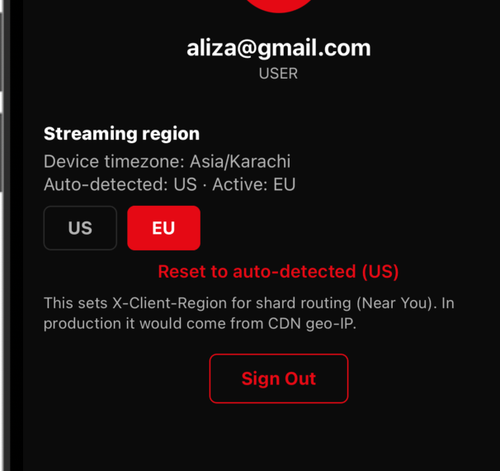
Figure 8. Streamix Profile — streaming region override (X-Client-Region).
Viva nuance: home_region is metadata written at sync time; physical placement remains hash(content_id). Near You means “prefer the US/EU-labeled shard container,” not necessarily WHERE home_region = ….

9. Caching & Asynchronous Events
Catalog trending/search responses are cached in Redis (~60s TTL) with HIT/MISS logging. On review creation, the review service XADDs to Redis Stream reviews:events. The analytics service consumes via XREADGROUP. This is the local stand-in for Kafka.
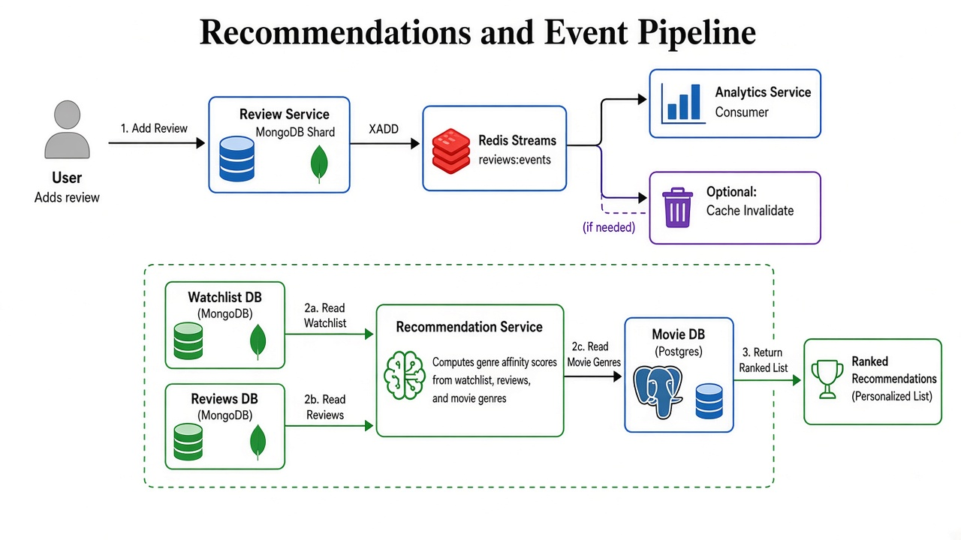
Figure 9. Review event pipeline and recommendation data sources.

10. Recommendations & Analytics

10.1 Recommendation Algorithm
- Load watchlist IDs from the user’s Mongo shard.
- Scatter user reviews across review Mongo shards.
- Fetch genres for those movies from Postgres movie shards.
- Score genres; take top 3; fetch matching movies; rank by affinity × popularity.
- Cold start → trending fallback.
This is content-based filtering — not a vector database (Milvus remains Phase-2).

10.2 Analytics Summary
GET /analytics/summary returns topology counts, Redis cache/stream stats, Mongo review counts per shard, and a polyglot map. It substitutes for ClickHouse in the local demo.

11. Microservices Implementation
Service | Port | Store | Responsibilities
api-gateway | 4000 | — | Path proxy, health aggregation, header forward
user-service | 4001 | Postgres user P/R | Register/login, JWT, vertical fragments
catalog-service | 4002 | Postgres movies + Redis | Search, trending, nearby, admin TMDb, cache
watchlist-service | 4003 | Mongo ×2 | CRUD watchlist by user shard
review-service | 4004 | Mongo ×2 + Redis | Reviews + Streams publish + rating update
recommendation-service | 4005 | Mongo + Postgres | Genre affinity recommendations
analytics-service | 4006 | Redis + Mongo | Summary metrics + stream consumer

Shared libraries live under backend/shared/ (shardHash, auth, redis, pg pools, movieShardRouter, mongoShards). The mobile API base URL remains http://localhost:4000.

12. Mobile Application
StreamixApp is a React Native client with Netflix-inspired theming (#E50914). Screens: Login/Register, Home (hero + rows), Search, Watchlist, Movie Detail (in-app YouTube trailer + reviews), Profile, Admin (role-gated).
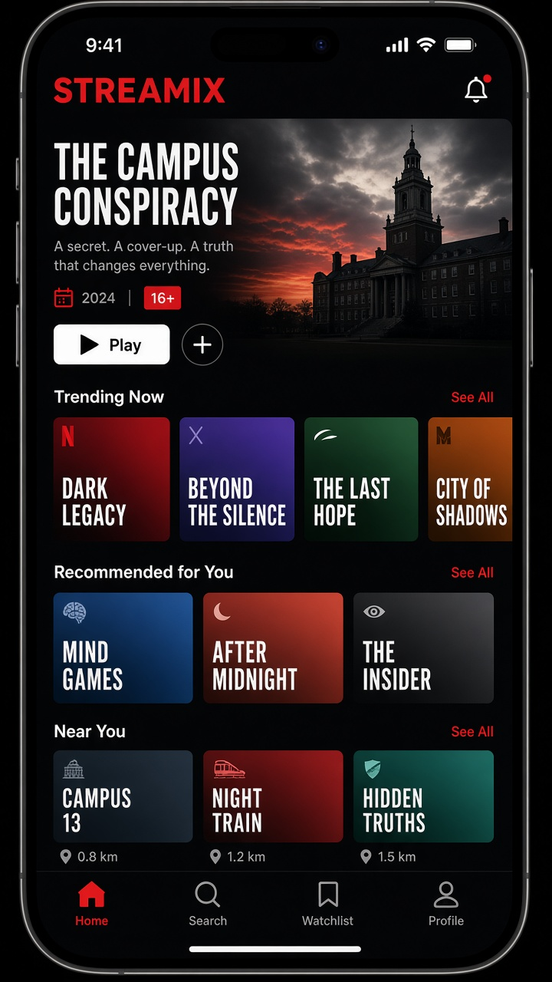
Figure 10. Streamix mobile Home UI (illustrative mock aligned to implementation).
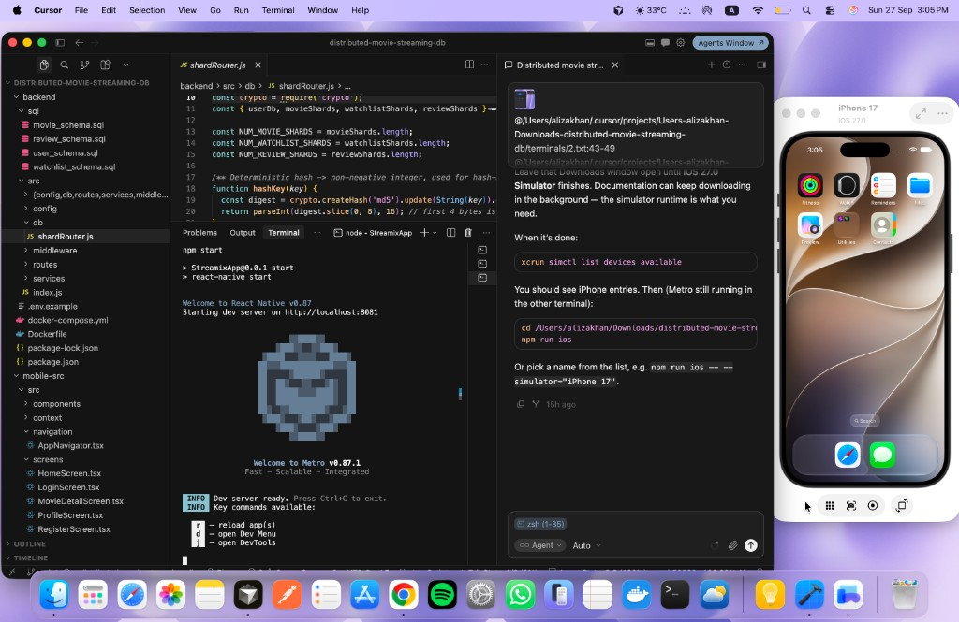
Figure 11. Development environment — StreamixApp on iOS Simulator with Metro bundler.
Tab icons use Ionicons (home, search, bookmark, person). Region preference is stored in AsyncStorage and applied as X-Client-Region on each Axios request.

13. Deployment Topology
Docker Compose defines the full cluster on network ddbnet. Figure 12 shows container groups.
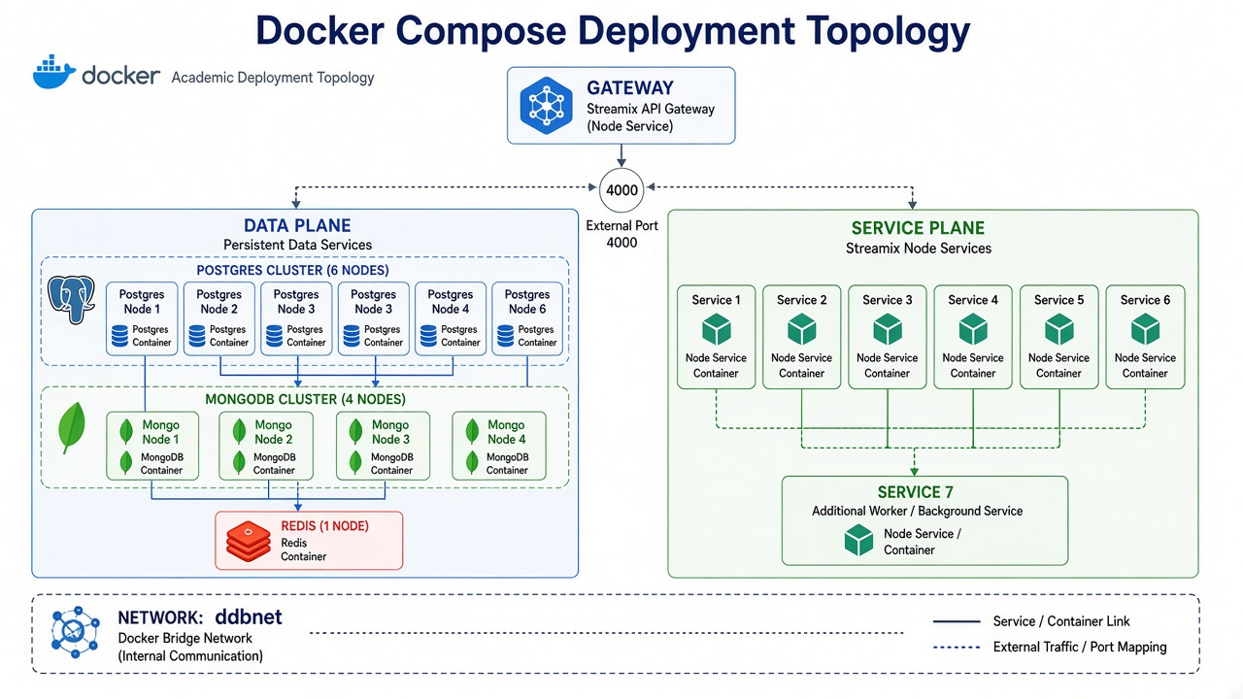
Figure 12. Docker Compose deployment topology.
External port 4000 exposes the gateway. Database ports (5401–5422 Postgres, 27017–27020 Mongo, 6379 Redis) remain published for inspection during demos.

14. Testing, Evaluation & Demo Results

14.1 Automated Tests
Unit tests in backend/test/shardRouter.test.js verify hash determinism, shard index bounds, movie distribution across shards, and region-priority ordering (node --test).

14.2 Integration Checks Performed
- GET /health → all six services status: ok; polyglot: true.
- Register/login via gateway → JWT issued.
- POST /watchlist → _store: mongodb and shard index returned.
- POST /reviews → Redis Streams event published; analytics counters increment.
- Repeated GET /catalog/trending → cache MISS then HIT in catalog logs.
- GET /analytics/summary → polyglot map and per-shard Mongo counts.

14.3 Failover Evaluation
Per failover-demo.md: stopping a movie primary leaves the other shard’s results available via scatter-gather; promoting a replica restores write capacity. This validates limited blast radius and replication usefulness.

15. Alignment with Proposal Diagram
Proposal element | Implementation status
API Gateway + clients | Implemented
User service + Postgres replication | Implemented
Catalog sharding + replication | Implemented (US/EU Postgres)
Watchlist sharding by userId | Implemented (MongoDB)
Review sharding by movieId | Implemented (MongoDB)
Recommendation service | Implemented (genre affinity)
Analytics service | Implemented (Redis+Mongo aggregates)
Redis cache | Implemented
Event bus | Redis Streams (Kafka stand-in)
Kafka / Milvus / ClickHouse | Designed — Phase-2
Mongo mongos cluster | App-level sharding in Phase-1
CDN full-movie streaming | Out of scope

Examiner statement: The architecture PDF is the complete design vision. The submitted system implements the Distributed Database core and polyglot microservices on free local tooling, with explicit Phase-2 placeholders for warehouse/vector/message-bus scale-out.

16. Limitations & Future Work
- No automatic failover controller — promotion is manual (documented).
- Mongo shards lack replicas in Phase-1.
- Recommendations are content-based only.
- Trailer playback uses YouTube; no owned CDN.
- Future: Kafka, Milvus/Pinecone, ClickHouse, mongos, automated HA.

17. Conclusion
Streamix successfully demonstrates Distributed Database principles in a complete, demoable stack: vertical and horizontal fragmentation, hash-based shard routing, primary–replica replication, scatter-gather queries, region-aware access, polyglot persistence, caching, asynchronous events, and microservices behind a transparent gateway — paired with a Netflix-style mobile client. The project meets the course goal of implementing, not only describing, distributed data management.

References
[1] Ozsu, M. T., & Valduriez, P. Principles of Distributed Database Systems.
[2] PostgreSQL Global Development Group. Streaming Replication Documentation.
[3] MongoDB Inc. MongoDB Manual — Data Modeling & Sharding Concepts.
[4] Redis Ltd. Redis Streams documentation.
[5] Newman, S. Building Microservices.
[6] Fowler, M. Polyglot Persistence.
[7] The Movie Database (TMDb) API Documentation.
[8] React Native Documentation — https://reactnative.dev
[9] Project artifacts: Distributed Movie Streaming Database Proposal; System Architecture PDF; repository README & POLYglot-DEMO.md.

Appendix A — API Catalogue
Method | Path | Auth | Notes
POST | /auth/register | No | Vertical write auth+profile
POST | /auth/login | No | Read replica + JWT
GET | /catalog/trending | No | Scatter-gather + cache
GET | /catalog/search | No | Scatter-gather + cache
GET | /catalog/nearby | No | Region-preferred
GET | /catalog/movie/:id | No | Single shard
POST | /admin/movies/sync | Admin | TMDb → primary
GET/POST/DEL | /watchlist | User | Mongo by userId
GET | /reviews/movie/:id | No | Mongo by movieId
POST | /reviews | User | Mongo + Streams
GET | /recommendations | User | Genre affinity
GET | /analytics/summary | No* | Viva metrics
GET | /health | No | Gateway aggregation

Appendix B — Container Inventory
Container | Role
user-db-master / replica | Identity Postgres P/R
movie-shard-us-master / replica | Movie shard 0
movie-shard-eu-master / replica | Movie shard 1
watchlist-mongo-1 / 2 | Watchlist shards
review-mongo-1 / 2 | Review shards
ddb-redis | Cache + Streams
ddb-*-service | Microservices
ddb-api | Gateway :4000

Appendix C — Setup Commands
cd backend
cp .env.example .env # set TMDB_API_KEY, JWT_SECRET
docker compose up -d --build
curl -s http://localhost:4000/health | jq
curl -s http://localhost:4000/analytics/summary | jq

# Promote admin (then re-login in app)
docker exec -e PGPASSWORD=app_pass user-db-master \
psql -U app -d user_db -c "UPDATE users_auth SET role='admin' WHERE email='you@example.com';"

# Mobile
cd StreamixApp && npm install && npx react-native run-ios

— End of Submission Document —

