

Gross Earnings :

EDEN FRAGRANCE SDN. BHD.

PAYSLIP

Employee Name : NRIC No./Passport No. :

Designation/Position : Pay slip for the month of :

Date :

**Earnings** Basic Pay Overtime Paid Off day Commission

**Allowances**

1. Claim
2. Bonus
3. Public Holiday

:

:

:

:

:

:

:

:

:

:

:

:

**Deductions**

Advance

EPF Employee

SOCSO Employee

Absent

Gross Deduction

Net Pay :

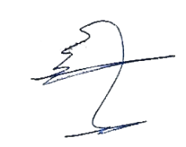

Approved By:

Employee's Signature: