**SE 500 Documentation**

**Project Name: Digital Home**

**By: Alizeh Jafri & Maisa Alghamdi**

Table of Contents

Introduction: 2

Requirement Specification: 3

Functional requirements: 3

Non-Functional requirements 3

Required resources: 4

Scrum Framework: 4

DB ER diagram 6

Database tables: 7

Software design 9

Conceptual Design: 9

Class diagram 10

Sequence diagram 11

System Architecture: 12

System Interface: 13

# Introduction:

This document discusses the details of the Digital Home System. The Digital Home (DH) is Graphical User Interface (GUI) oriented system which is developed using C# programming language in Visual Studio and Microsoft SQL Server Management Studio. The purpose of this DH System is to enhance the functionality of the Home and make it easier for the people to live. The digital home system would manage the records of the members living in the house and allow them to use the DH system and easily manage their daily routine by providing for a lifestyle that would bring together security, environmental ease and energy management (lights, temperature), and entertainment (music, TV) etc. Overall, the Digital Home system has secured registration form, login form, kitchen form, master bedroom, bedroom, bathroom, living room, garage and outdoor. Moreover, this document will be covering DB ER diagram, DB tables, system Architecture, Software design (class diagram, sequence diagram, etc.)

# Requirement Specification:

This part contains the requirements for the for Digital Home system which is shown as follows:

## Functional requirements:

They are observable capabilities that should be present for the users to complete their goals or perform the task which are specified by the use case.

Super user:

* Super user can Register into the DH system by entering his/her correct Username and password which must be at least 8 characters which should contain at least 1 capital letter and 1 special character.
* Super user can login to the DH system by entering his or her correct Username and created password. If any of the credentials are not correct, the login won’t be successful.
* Can see password while typing using the show check box.
* Super user can access everything in the DH System

Children:

* Children have limited access.
* They can’t use hot water.
* Can’t use Stove

## Non-Functional requirements

Characteristics that are not the features of the system. The non-functional requirements for DH System are stated as follows:

* Security- passwords must be stored as hashes in the database.
* Ease of usability – DH system should be straight forward to use
* System speed should be decent
* Storage- DH system must store at least 100 records.

## Required resources:

Hardware

I) A good Internet connection

II) Laptop (preferably windows 10).

Software

I) Visual Studio 2017

II) C# Language

III) Microsoft SQL Server Management Studio

# Scrum Framework:

We have been using Scrumwise to add backlog items, used to have stand up meetings every 2-3 weeks and total sprints to work for us were 3.

Maisa Product Backlog items:

**Sprint 3:**

* Design UI

**Sprint 4:**

* Login & registration (password encryption)
* TV
* Outdoor
* Livingroom
* Lights
* Garage
* Fire alarm
* AC
* Door

**Sprint 5:**

* Conceptual Design
* DB Tables/ER Diagram
* Door Automation closes.
* Super user/Children creation
* Finalize Garage
* finalize outdoor
* finalize Big window
* Finalize living room
* Database integration

Alizeh Sprint items:

**Sprint 3**

* Finalizing UI
* Finalizing Language
* Creating and finalizing database

**Sprint 4**

* Music
* Microwave
* Window
* Shower
* Faucet
* Login with more features
* Stove
* Coffee Maker
* Oven
* Login Security
* Bedroom
* Bathroom

**Sprint 5**

* DH Project integration
* Creating/finalizing documentation
* Fix errors in Login/Registration
* Finalize entire DH
* Arrange Database
* Master Bedroom
* Fire Alarm update
* Software Interface design
* Finalize Kitchen
* Finalize Bathroom
* Finalize Bedrooms
* Finalizing entire GUI

DB ER diagram

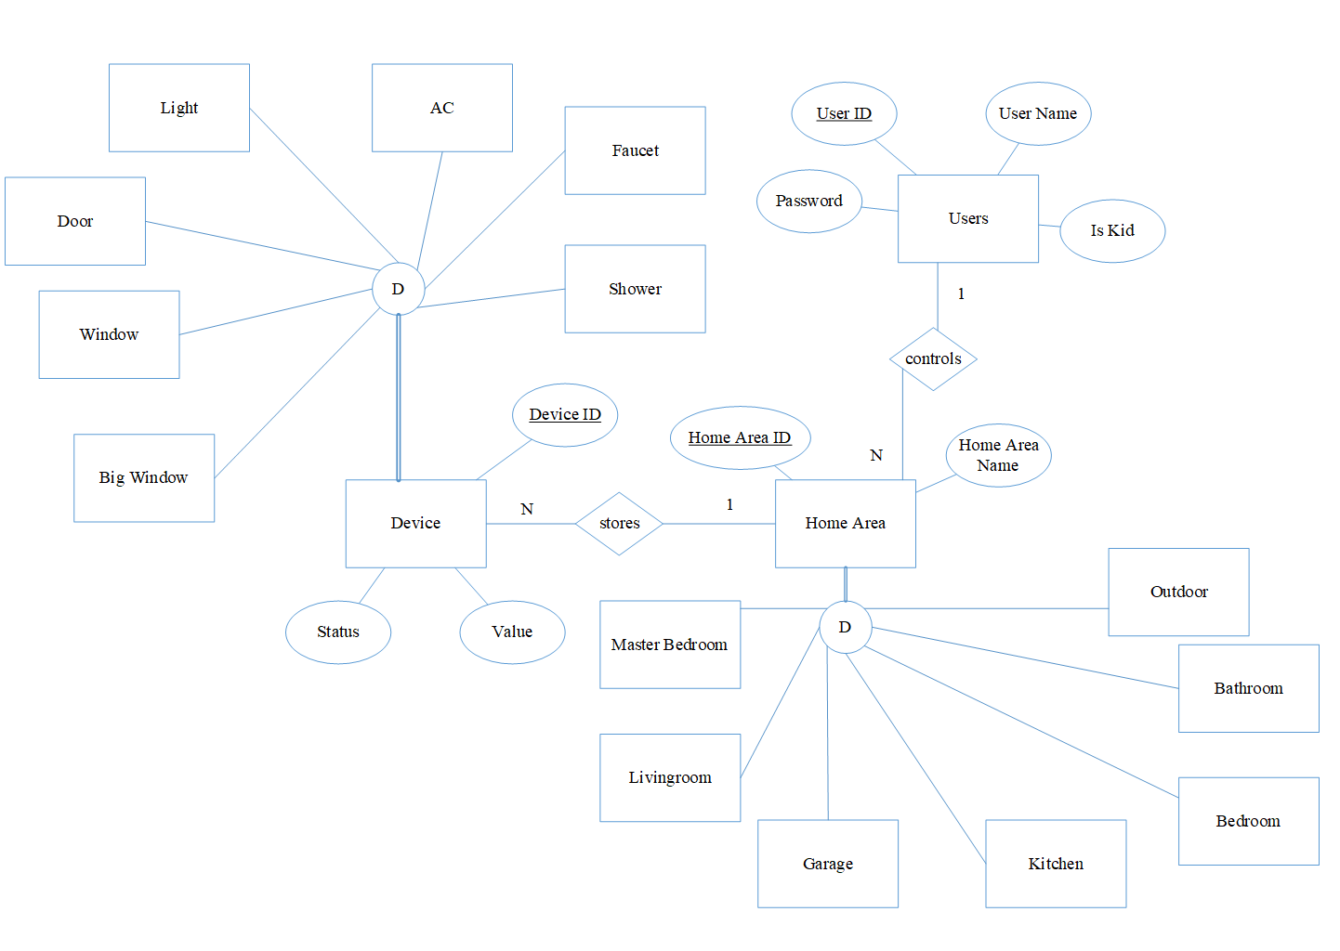

Figure 1 ERD Design

There are two users in the system that are normal users and kids. The kid users have limit of permissions such as open the front door.

The Users control many areas in the home (Home Area entity). The Home Area is Master Bedroom, Living room, Garage, Kitchen, Bedroom, Bathroom, Outdoor.

Each area in the home stores in devices. Each device has status (on or off) with the specific value such as temperature.

The device is AC, shower, faucet, Light, Door, Window, Big Window.

The following symbol describes the parent/child relationship where Master Bedroom is the specific area in the home. D means distinct so each area is master bedroom or living room … One area cannot be both master bedroom and living room.

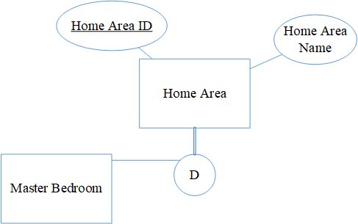

The double line means that the area must be one of its child. The Home Area ID occurs in the Home Area entity must be in one of its child entity (in a Master Bedroom, Living room, Garage, Kitchen, Bedroom, Bathroom or Outdoor).

Database tables:

The database has two tables, Users table and Device table. The user table has four columns and it saves the password as hash as shown beliw:

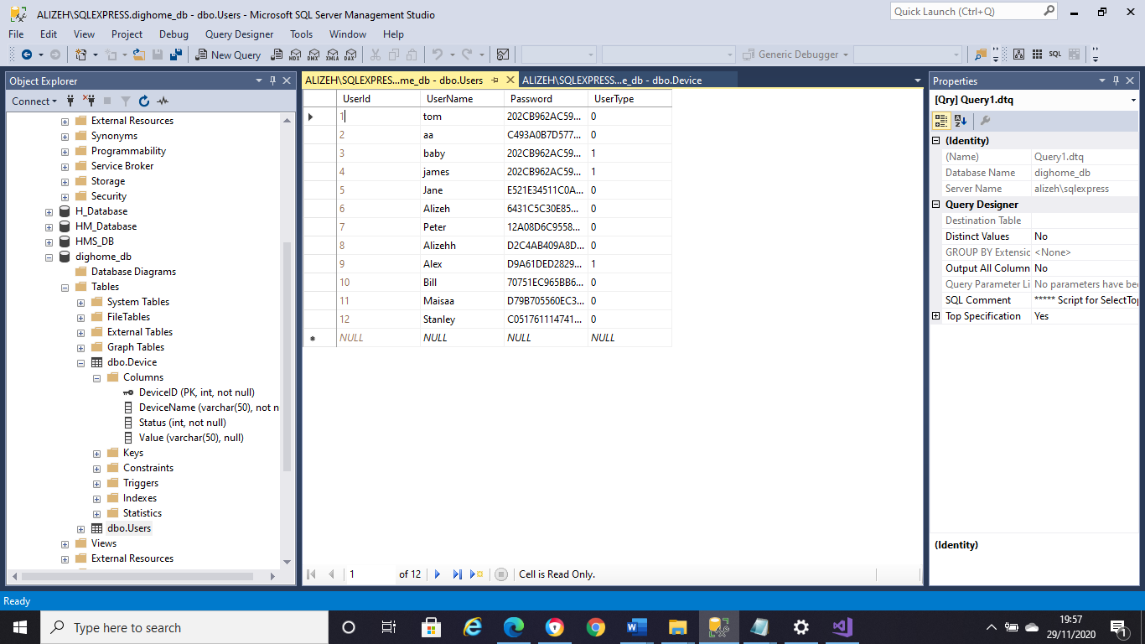

Second: Device table has four columns and 41 devices which are sorted according to their Device IDs. So, each time user performs the action, the Status and Value gets updated as shown below:

Software design

## Conceptual Design:

Class diagram

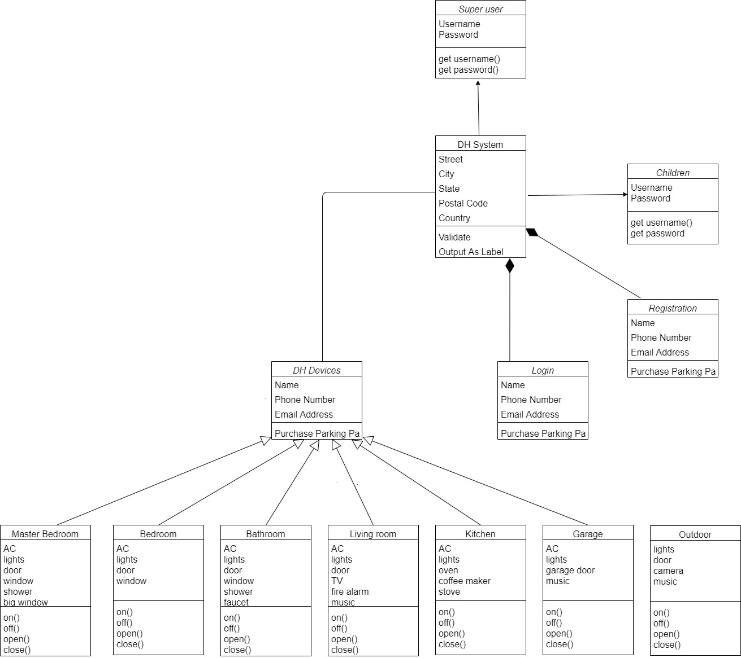

Sequence diagram

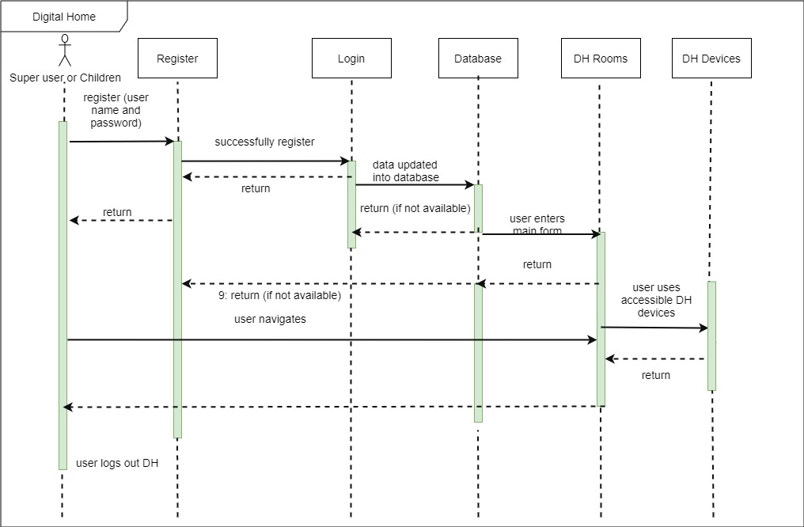

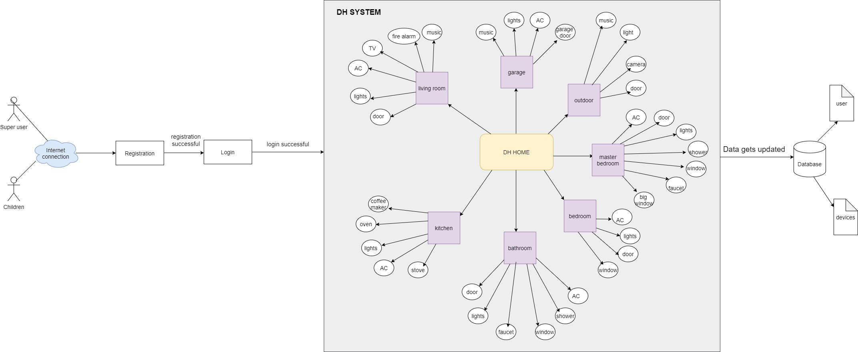System Architecture:

System Interface:

The screen shot below shows the ‘Registration’ page of the ‘Digital Home System’. This login page consists of 2 fields Username and password, show check box for password and registration for Super user and children respectively. The username/password can’t be left empty field. It also has a ‘help’ feature on top right with the necessary guidelines:

Password for both users should have at least one upper-case letter, one digit and at least one character while registering to the DH System. Otherwise, the user won’t be able to successfully register:

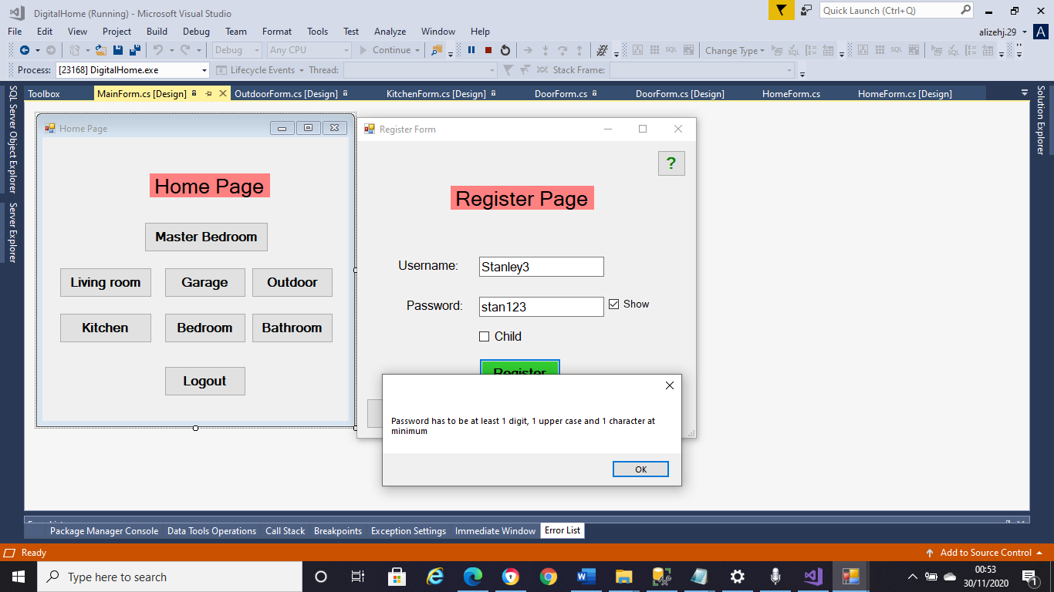

When the password requirements are met:

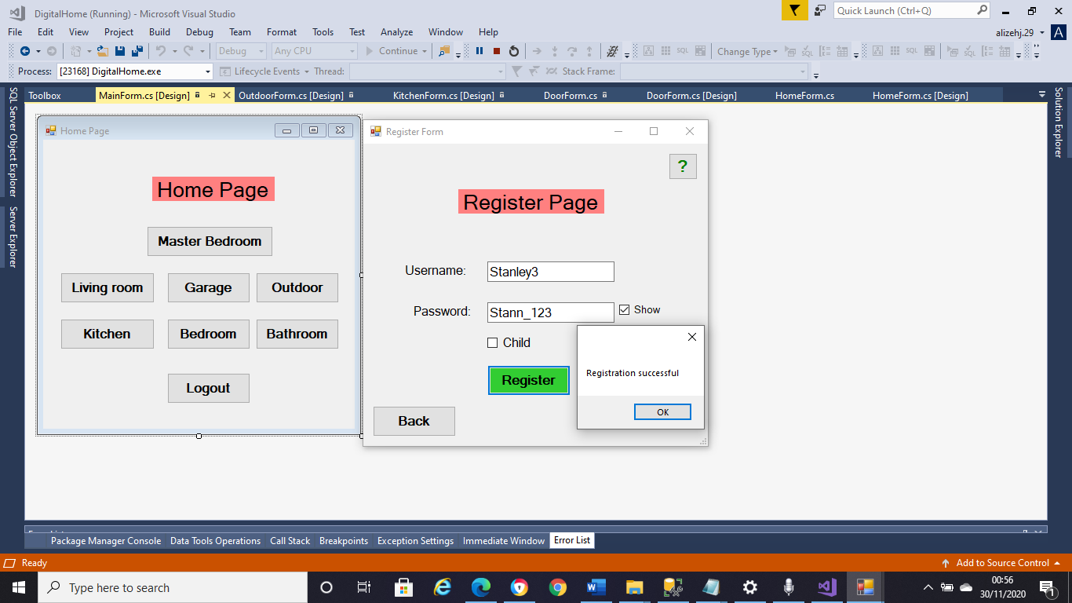

The screen shot below shows the ‘Login’ page for Super user:

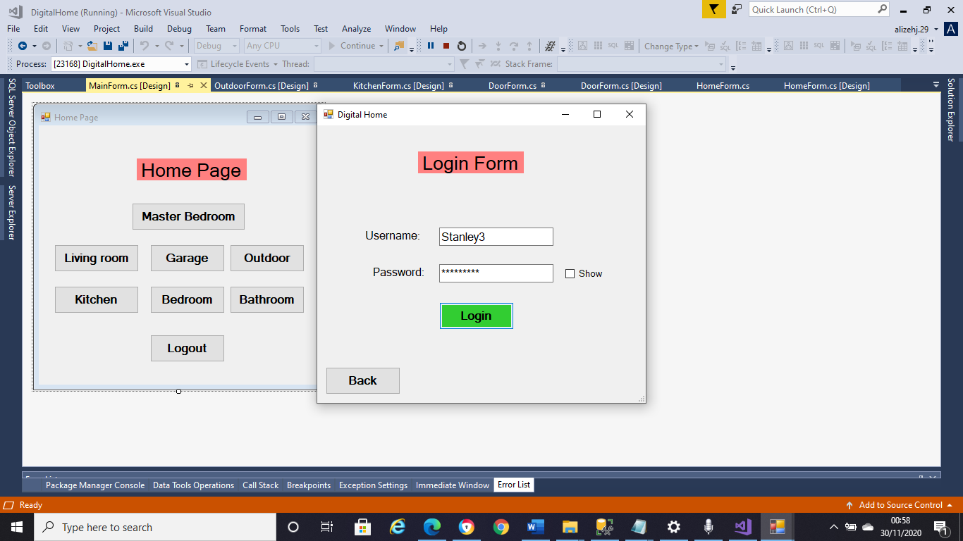

When registering for a child the child check box must be ticked as shown below

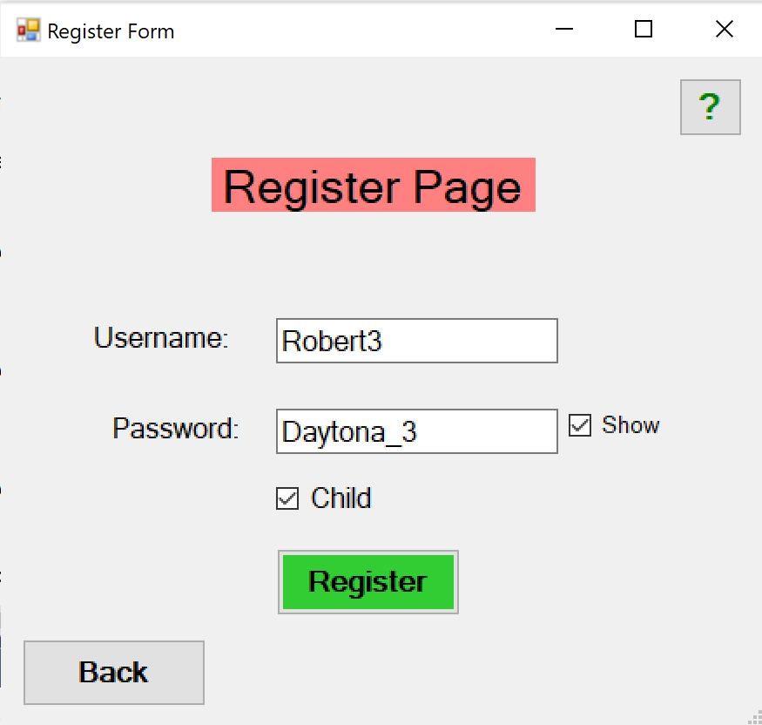

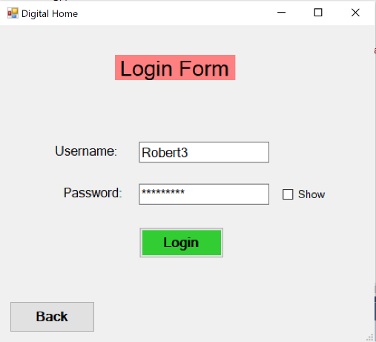.

The screen shot below shows the ‘Home page’ for Digital Home System and has the buttons to all the rooms as shown below

Logging in successfully will open the Home page:

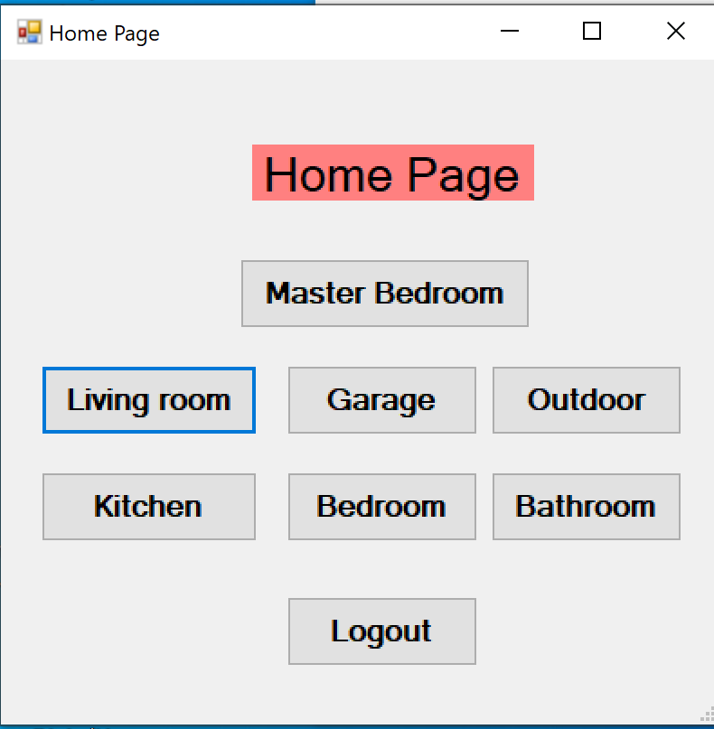

Kitchen has six features as shown below:

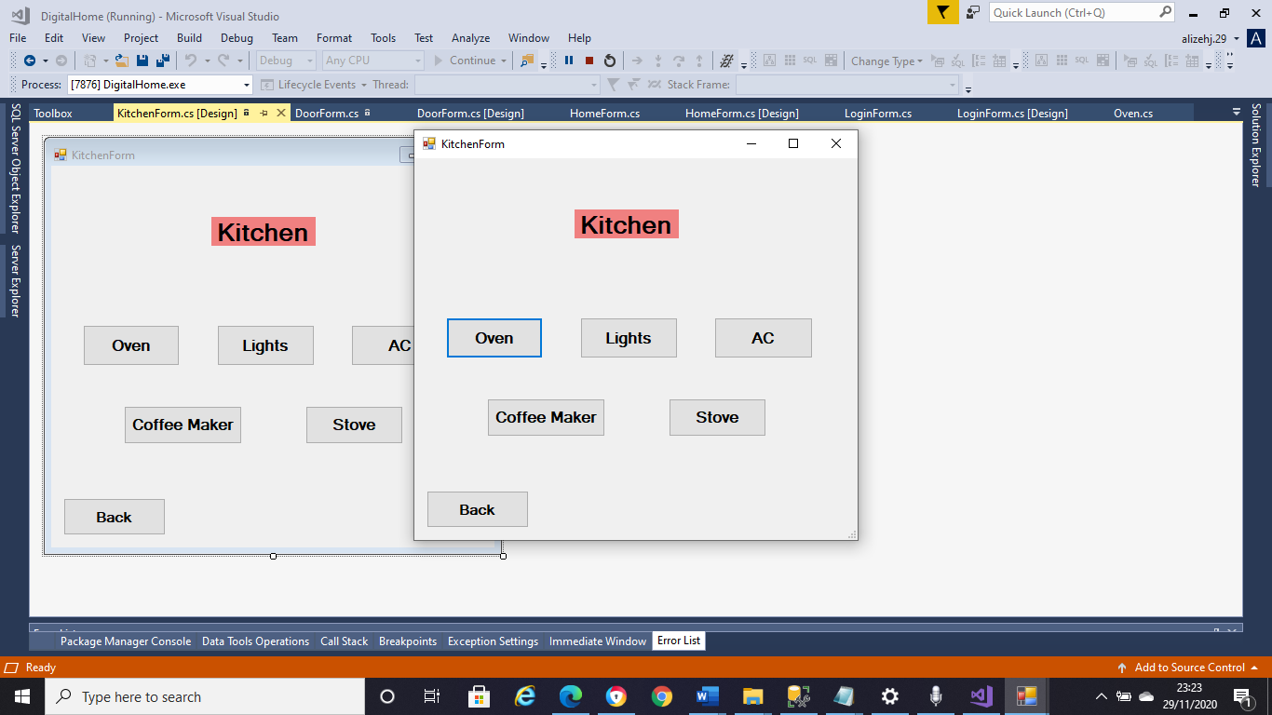

Bedroom has four features as shown below:

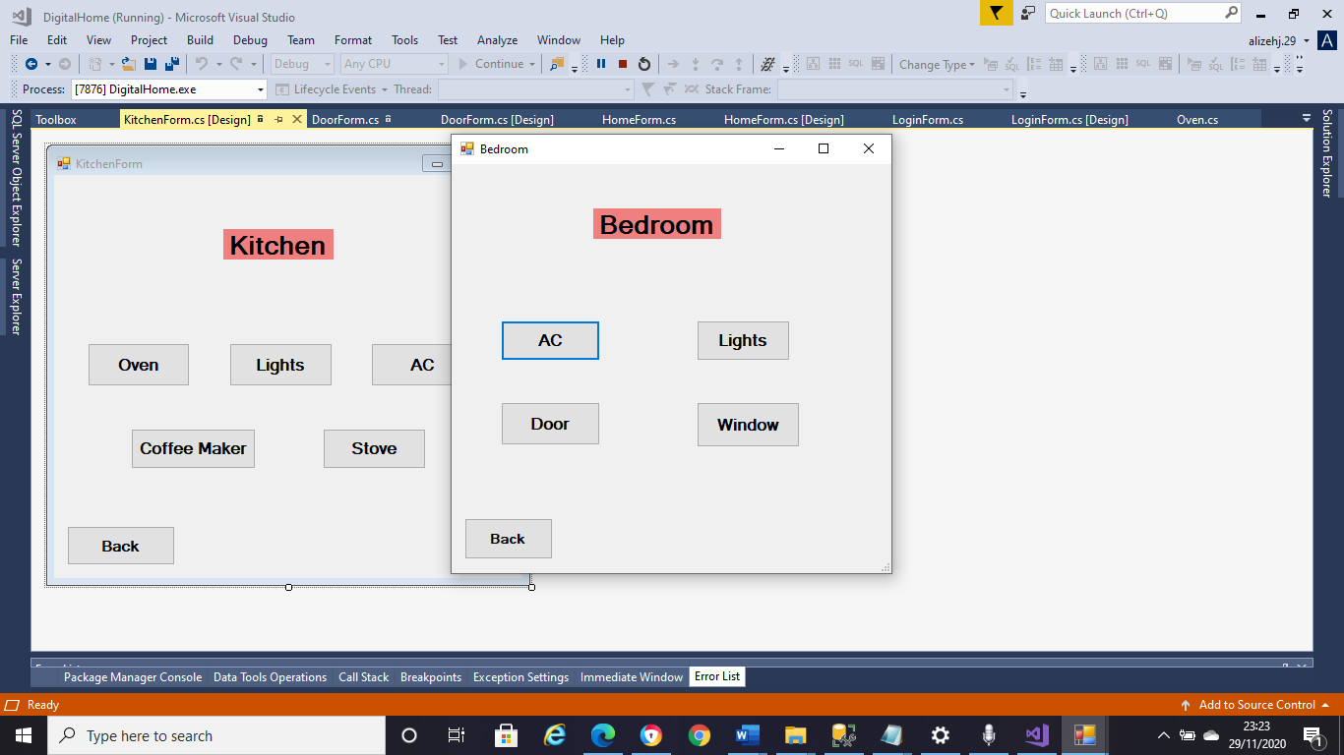

Bathroom has six features as shown below:

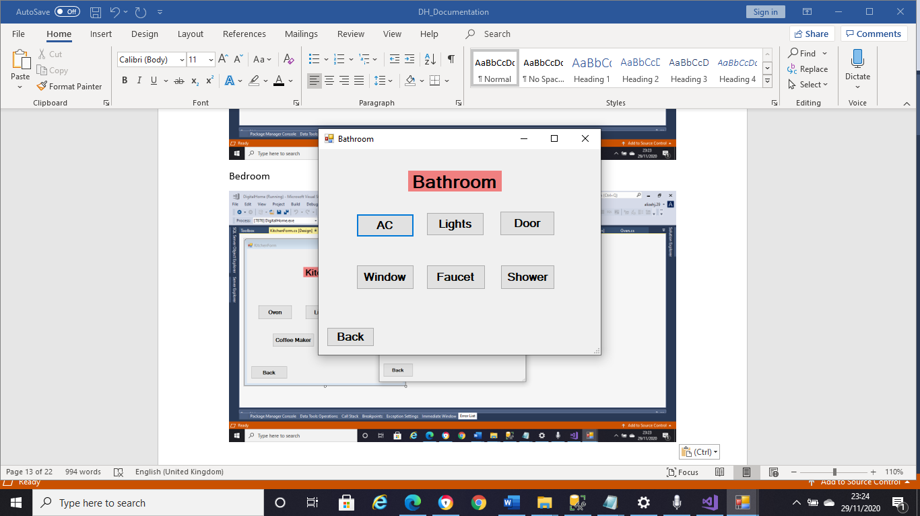

Living room main window

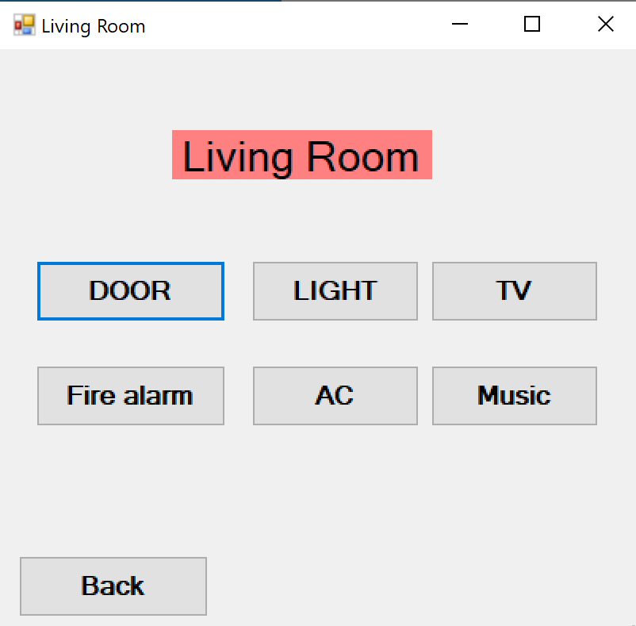

When clicking Door

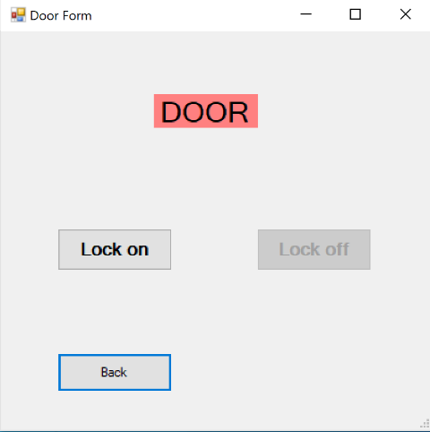

Confirmation window will appear when either button is clicked, gets updated in database

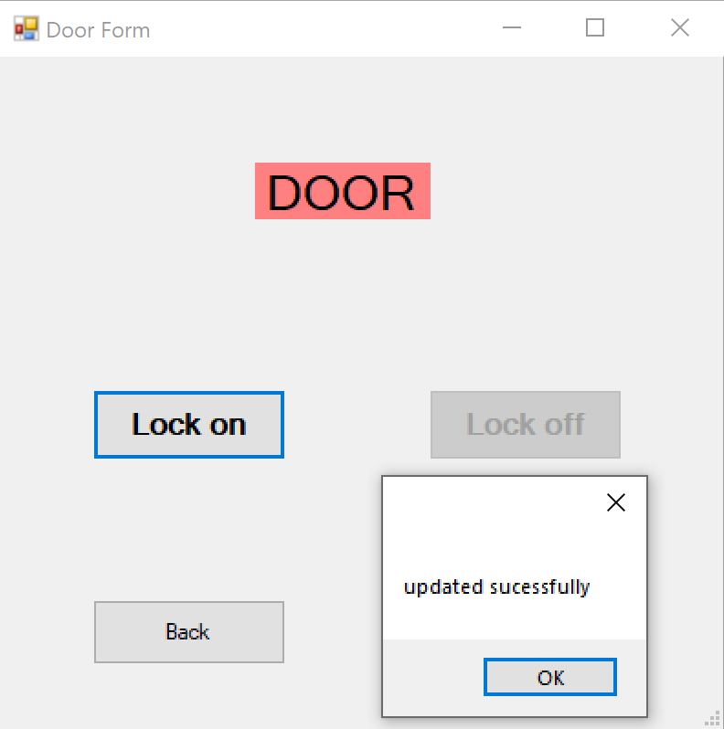

When light button is clicked, set light sets the brightness:

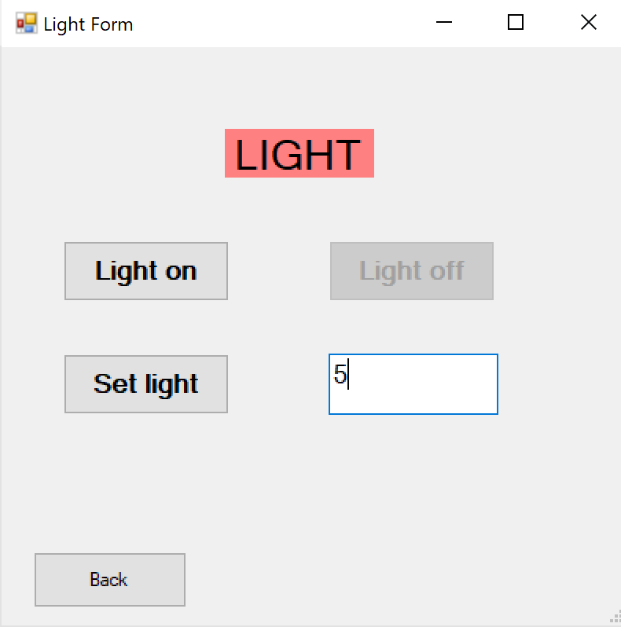

Confirmation window (pop-up) will appear to confirm that the data is updated in the database:

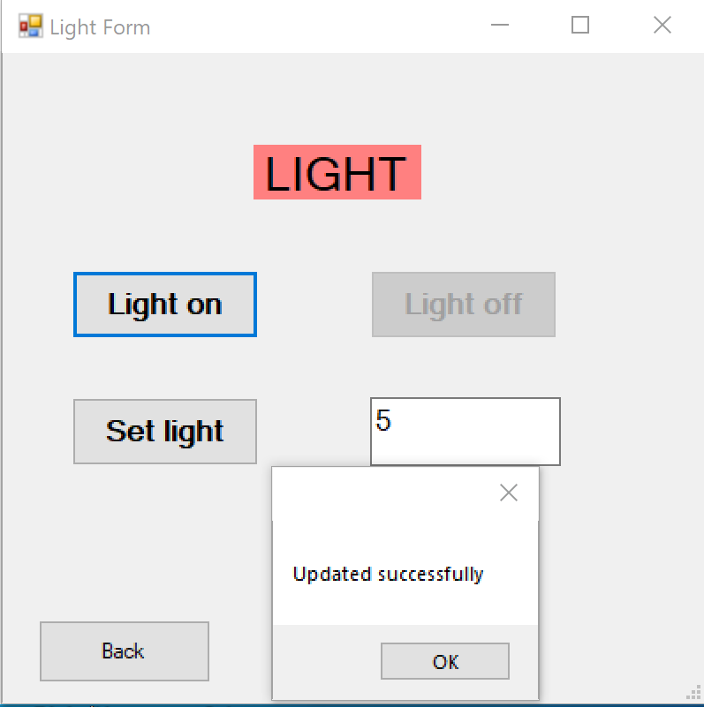

User can set the channel and click on TV on or TV off on the TV Form :

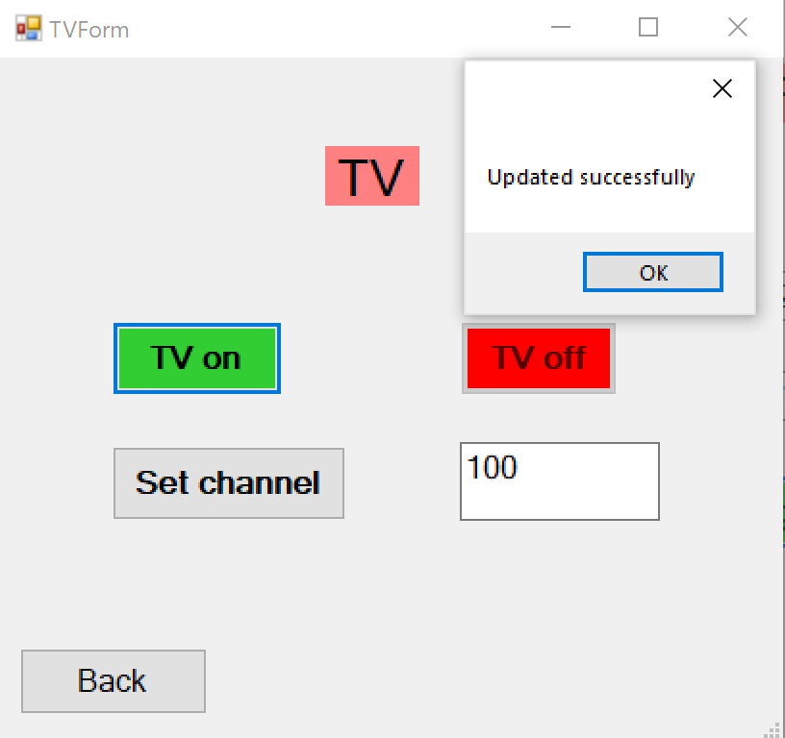

For the fire alarm, when the test button is clicked, sound will be heard to check if the fire alarm is working fine. Next, a window will pop-up when the user would click on ‘Turn off’ button as shown below:

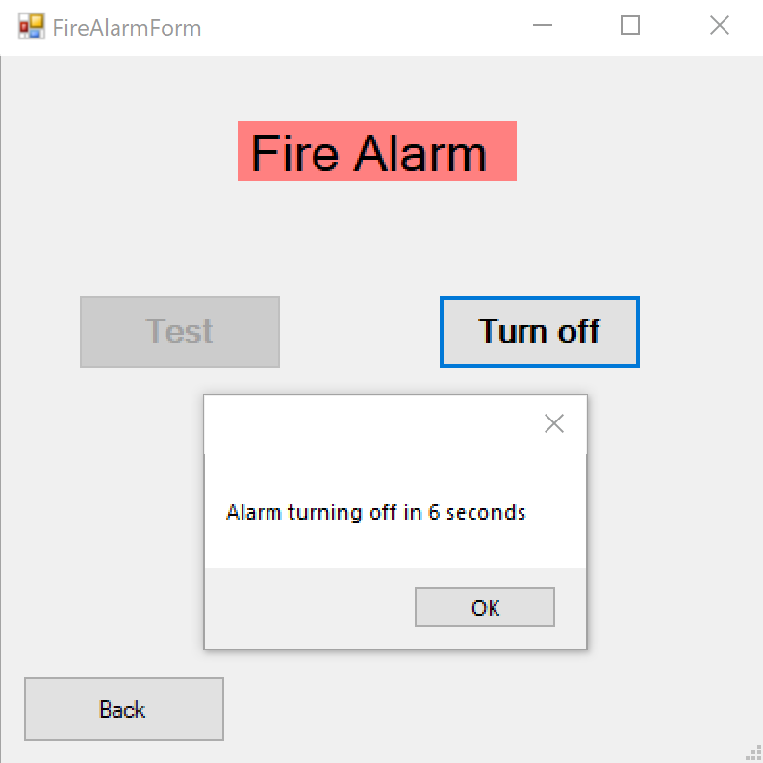

Then the alarm will be off :

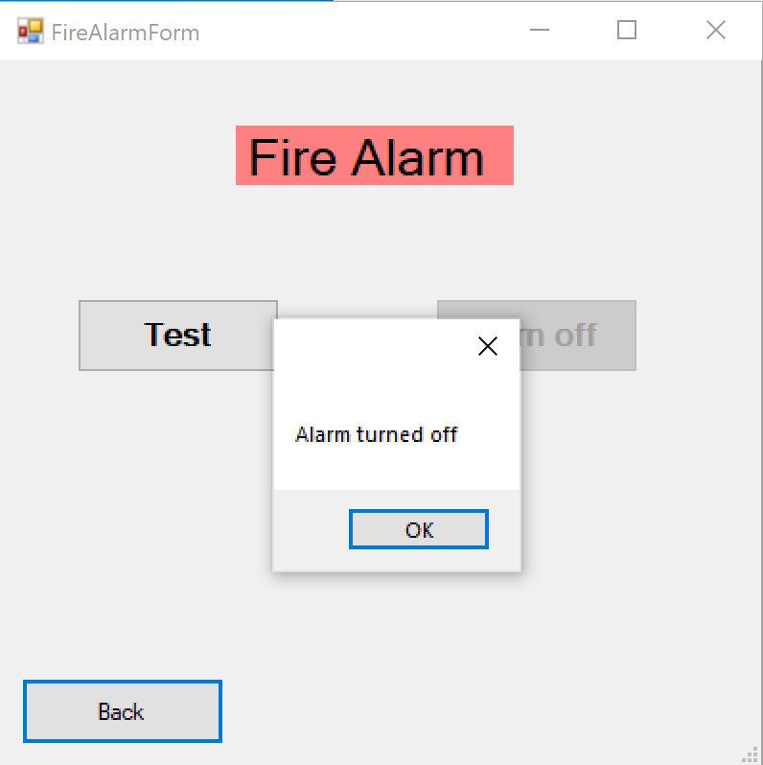

When clicking AC

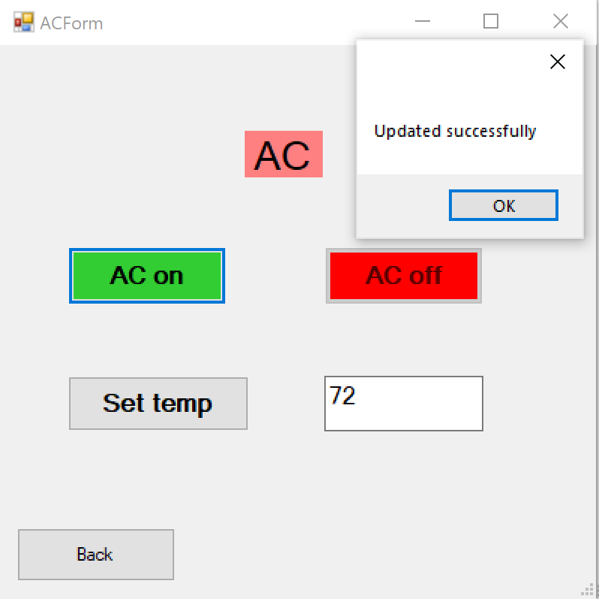

When clicking garage button from main from

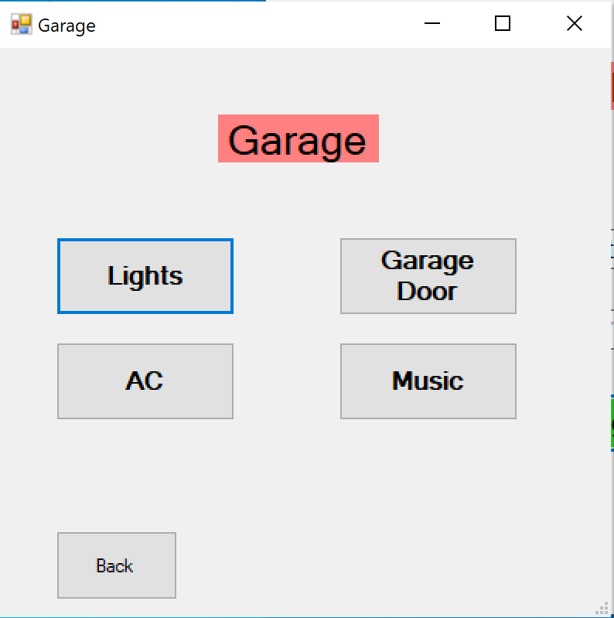

When clicking outdoor

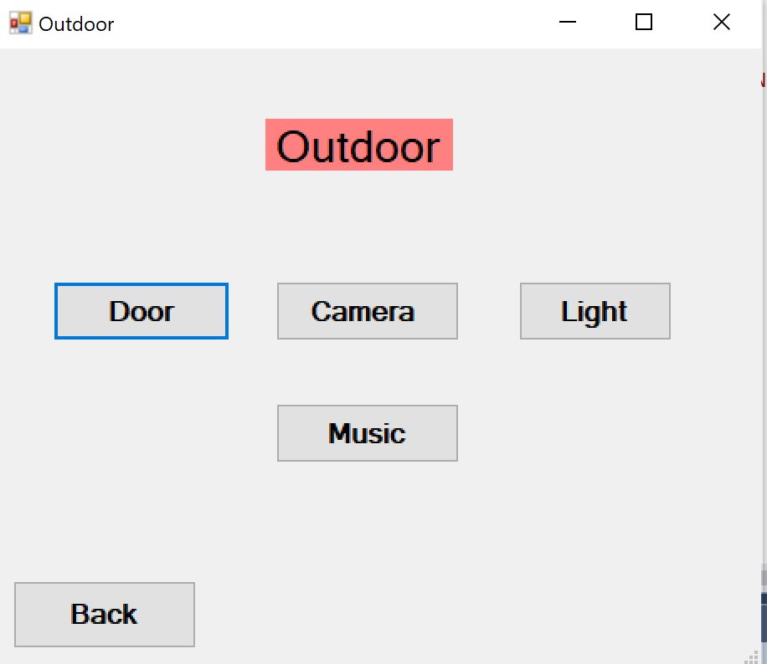

Child user will be restricted from using the below devices for safety purposes:

Outdoor door:

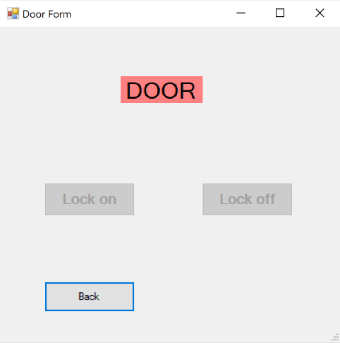

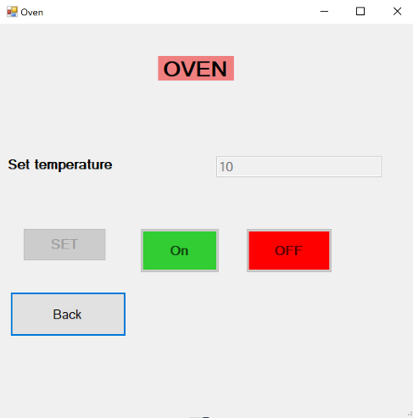

Since the coffee is Hot:

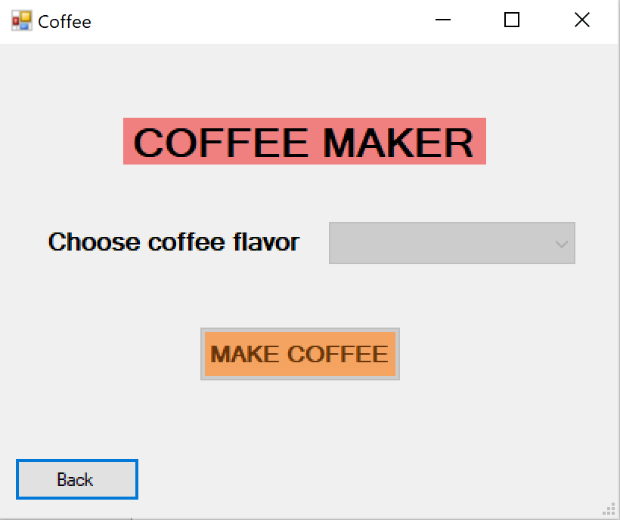

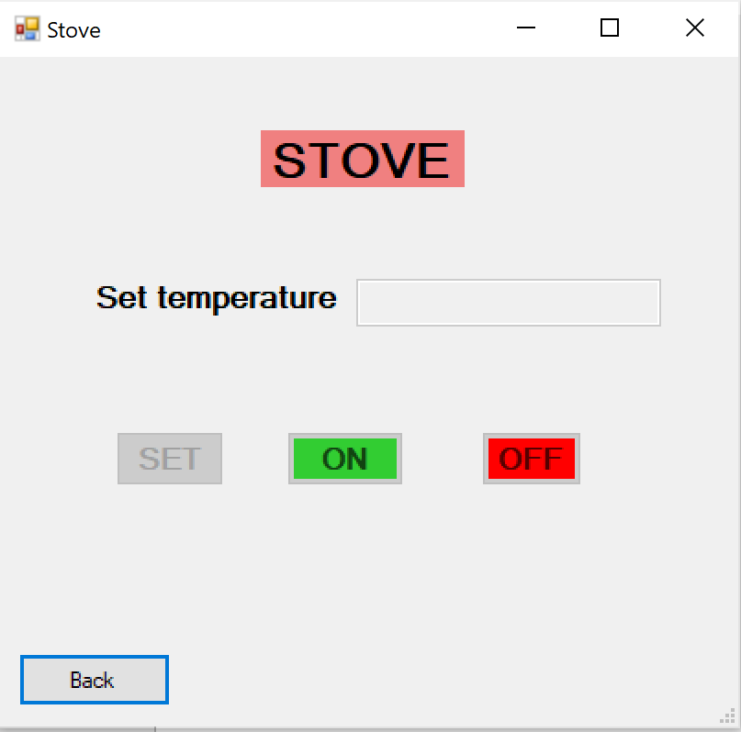

Child user cannot use HOT water while using faucet:

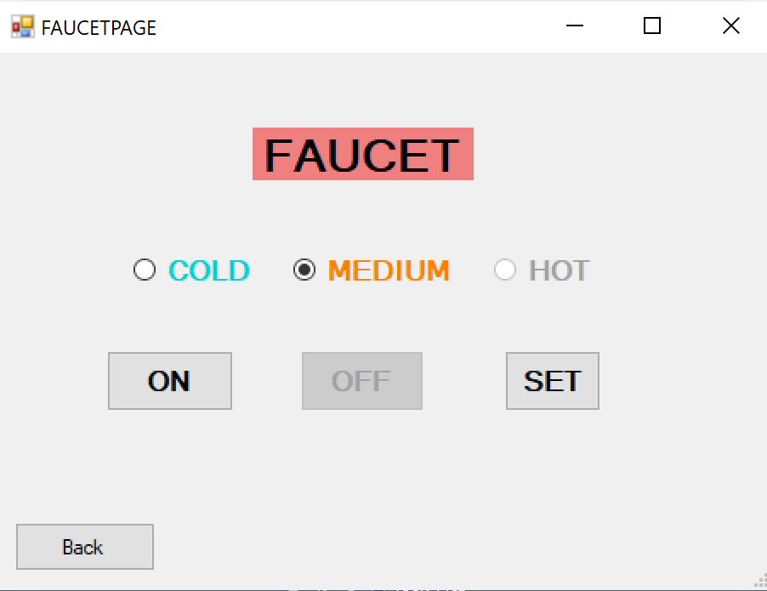

Child user cannot use HOT water while using shower:

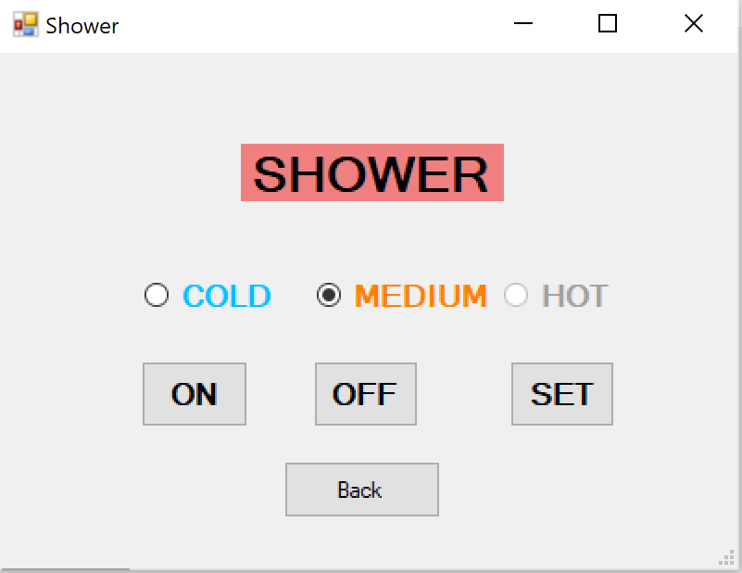

The following form is the screen shot of the outdoor door for security. When the outdoor door is open, it will be closed automatically in 6 seconds as shown below:

