**Mandala Pattern**

**Specifications**

1. Select and draw a Mandala pattern using Python. Use custom Python modules for a cleaner code. [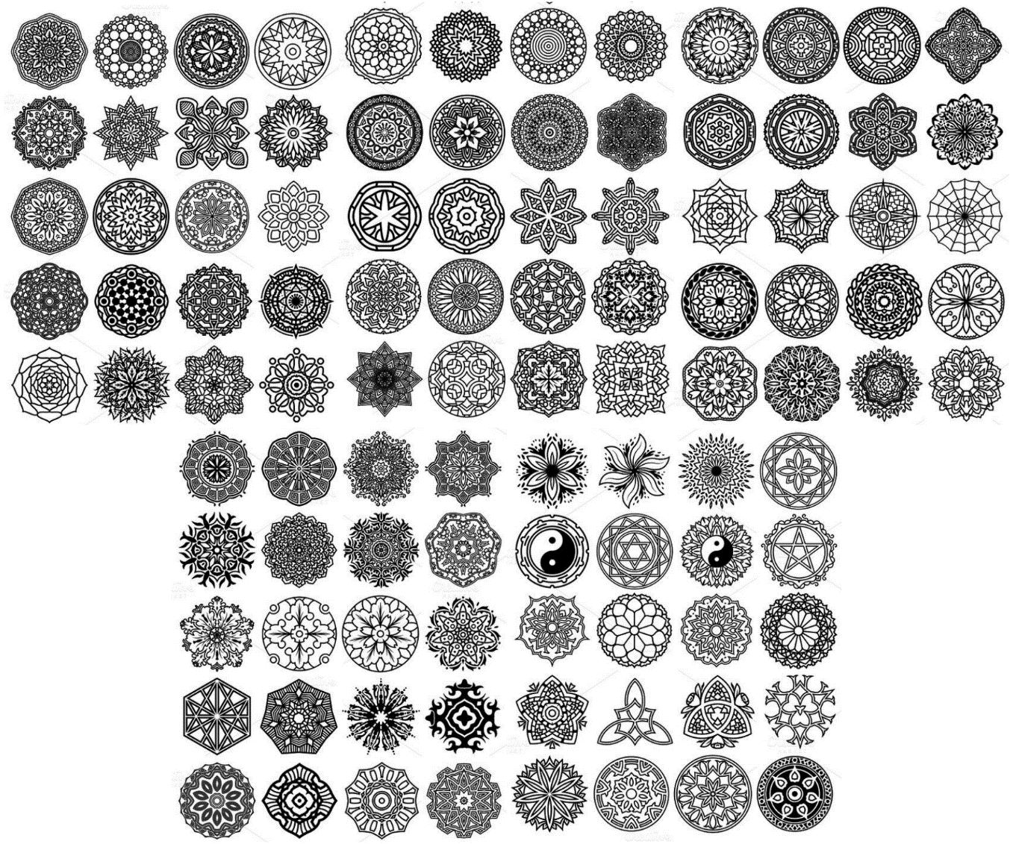](https://github.com/cict-ccs221/homeworks/blob/master/assets/pattern.png)
2. You can also create your own mandala pattern. 50% of your score will be given for your design and another 50% for your code cleanliness and functionality - be creative.
3. Upon completion, please submit your homework via git pull request inside the [jralipe/mandala](https://github.com/cict-ccs221/homeworks/blob/master/1920/mandala) directory, filename: mandala_python-your_fullname.py
4. If you happen to copy a code from other developers, please do credit them and do your best to implement it using your own style. Points will be deducted from your total score if you fail to do so.
5. Homework should be submitted on or before February 10, 2020.