Sales Performance Dashboard
An interactive Sales Performance Dashboard built using Microsoft Excel and Microsoft Power BI to analyze retail sales data from the Superstore dataset. The project demonstrates end-to-end business intelligence skills including data cleaning, data modeling, KPI development, dashboard design, and interactive data visualization.

- Project Overview
Businesses generate large amounts of sales data every day, but raw data alone does not provide meaningful insights. The objective of this project is to transform raw sales data into an interactive dashboard that enables business users to monitor performance, identify trends, compare regional sales, evaluate product performance, and make data-driven decisions.
The dashboard was designed following industry-standard dashboard development practices commonly used by Business Intelligence, FP&A, and Data Analytics teams.

- Project Objectives
- Analyze overall sales performance.
- Monitor profit and profitability.
- Track sales trends over time.
- Compare sales across regions.
- Evaluate category and segment performance.
- Identify top-performing products.
- Build an interactive dashboard for business users.
- Create an executive-level reporting dashboard.

- Dataset
Dataset: Superstore Sales Dataset
The dataset contains retail transaction data including:
- Orders
- Customers
- Products
- Categories
- Regions
- Sales
- Profit
- Quantity
- Discount
- Shipping Information

The dataset was cleaned and transformed before creating the dashboards.

Tools Used:
- Microsoft Excel
- Microsoft Power BI
- Power Query
- DAX
- Pivot Tables
- Pivot Charts
- Slicers
- Data Modeling

- Excel Dashboard Features
The Excel dashboard was developed to provide interactive business reporting using native Excel functionality.

Features:
- Interactive KPI Cards
- Pivot Tables
- Pivot Charts
- Slicers
- Sales Trend Analysis
- Sales by Region
- Sales by Category
- Sales by Segment
- Product Performance
- Dynamic Filtering

- Power BI Dashboard Features
The Power BI dashboard was designed as an executive reporting dashboard with interactive visuals.

Dashboard includes:
- KPI Cards
- Monthly Sales Trend
- Regional Sales Analysis
- Sales by Category
- Sales by Segment
- Product Performance Analysis
- Interactive Slicers
- Dynamic Filtering
- Report Navigation
- Dynamic KPI Indicators
- Business Insights

- Key Performance Indicators (KPIs)
The dashboard tracks the following business metrics:
- Total Sales
- Total Profit
- Profit Margin
- Total Orders
- Total Customers

- Business Questions Answered
The dashboard helps answer the following business questions:
- What is the total sales performance?
- Which region generates the highest sales?
- Which product category performs the best?
- Which customer segment contributes the highest revenue?
- How have sales changed over time?
- Which products generate the highest sales?
- What are the key business performance indicators?
- How do different filters affect business performance?

- Dashboard Visuals
The dashboard includes:
- KPI Cards
- Monthly Sales Trend
- Regional Sales Analysis
- Category Performance
- Segment Analysis
- Product Performance
- Interactive Filters
- Slicers
- Executive Summary Dashboard

- Key Insights

- Sales performance can be monitored through interactive KPI cards.
- Regional analysis enables comparison of sales across different geographic areas.
- Category and segment analysis helps identify the strongest business contributors.
- Monthly trend analysis highlights seasonality and sales patterns.
- Interactive filtering allows users to analyze business performance from multiple perspectives.
- Executive dashboards improve decision-making through visual reporting.

- Dashboard Preview

Excel Dashboard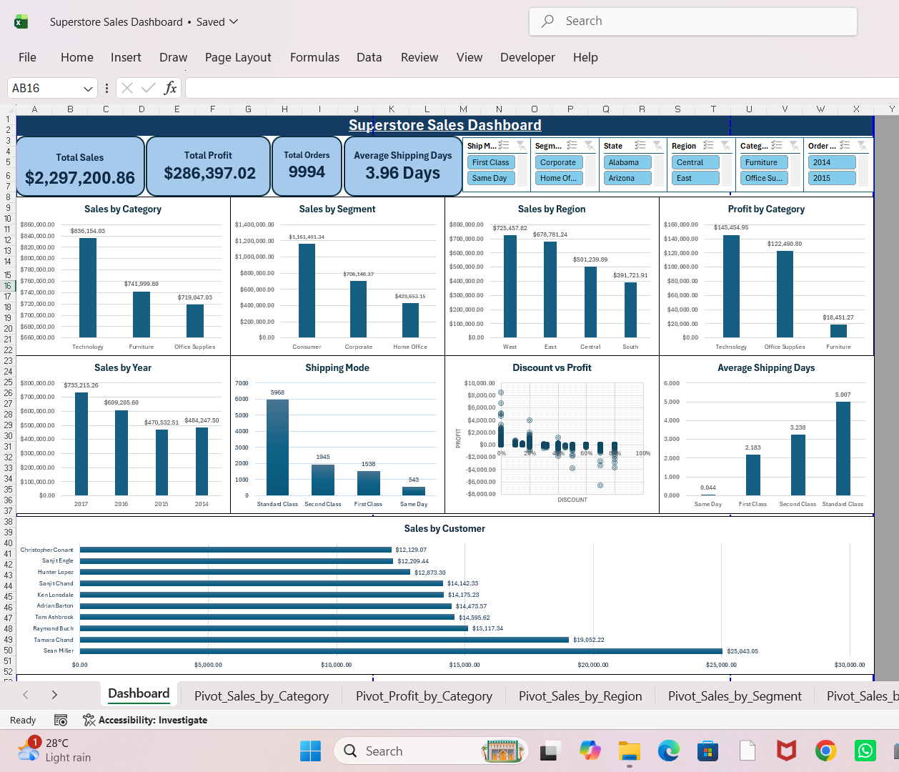

Power BI Dashboard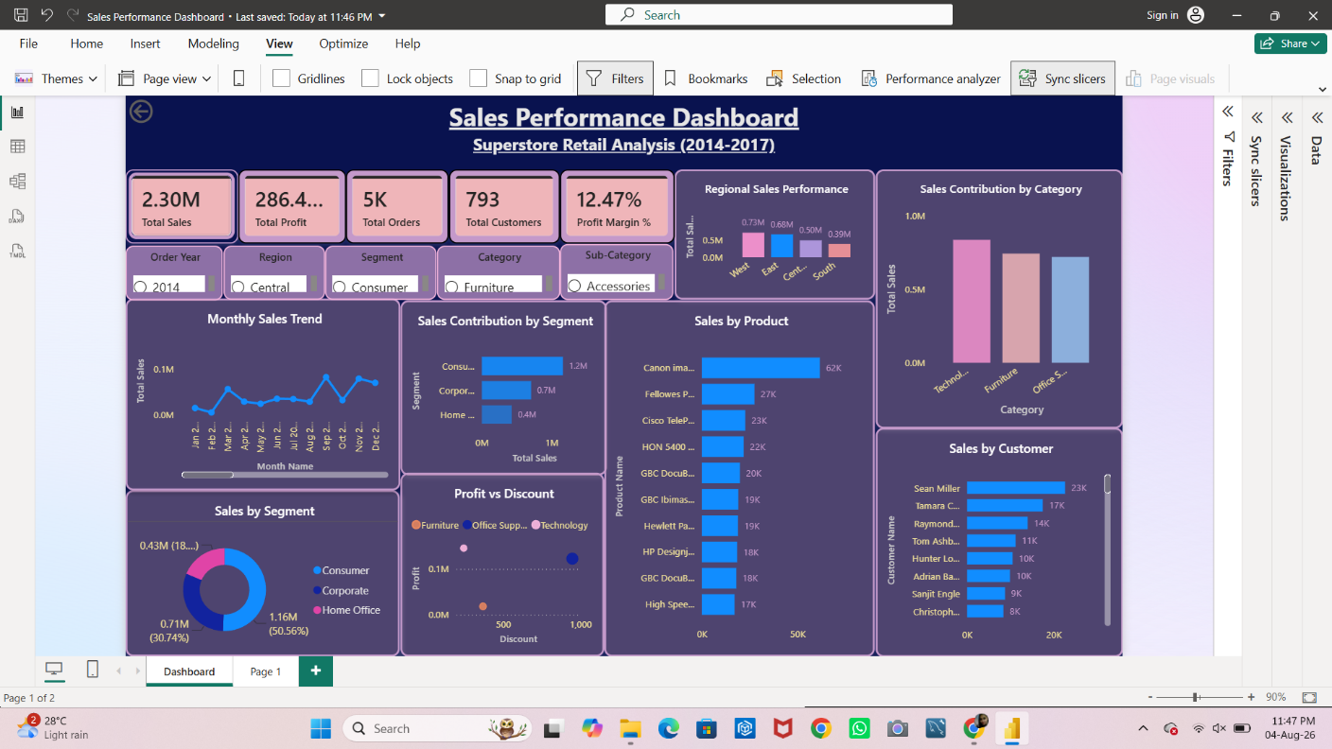

- Skills Demonstrated
This project demonstrates practical skills in:
- Data Cleaning
- Data Preparation
- Data Visualization
- Dashboard Design
- Business Intelligence
- KPI Development
- Power Query
- DAX
- Interactive Reporting
- Executive Dashboard Design
- Business Analysis
- Analytical Thinking

- Learning Outcomes
Through this project I gained hands-on experience in:
- Building professional Excel dashboards
- Designing interactive Power BI dashboards
- Creating business KPIs
- Designing executive-level reports
- Building interactive filters and slicers
- Creating drill-through reports
- Applying conditional formatting
- Developing business-focused data visualizations
- Presenting business insights through dashboards

- Future Improvements
Future enhancements may include:
- Forecasting and predictive analysis
- Customer segmentation
- Geographic sales analysis using maps
- Advanced DAX calculations
- Row-Level Security (RLS)
- Automated data refresh
- Integration with SQL databases
- Cloud deployment using Power BI Service

Author:-

Alka Prajapati
Aspiring Data Analyst | Business Intelligence Analyst | FP&A Analyst

If you found this project helpful, please consider giving it a star.

