

Final report
Prepared by: norah Mohammed alkabkabi
University id :444003676
Date 3 December 2025

Table of Contents
Introduction 4
About the Organization 4
The IT Department 4
My Role in the Department 5
Tasks, Projects, and Academic Knowledge 5
Month 1 – Foundations of the Hospital System 6
Week 1 – Orientation and Requirement Gathering 6
Week 2 – Database Design and Initial Front-End 6
Week 3 – Dashboards and Request Pages 7
Week 4 – Profiles, Inboxes, and Local Storage 8
Month 2 – Maintenance Exposure and System Expansion 9
Week 1 – Server Room and Maintenance Rounds 9
Week 2 – Delegates Management and Department Heads 9
Week 3 – Role Assignment and Weekly Reporting 10
Week 4 – Database Migration and Deployment 11
Month 3 – Advanced System Features and Maintenance 12
Week 1 – External Access and Core Interfaces 12
Week 2 – Admin Tools, Internal Tickets, and Reports 12
Week 3 – Data Center and Server Management Features 13
Week 4 – Backup, Power, Scheduling, and Incident Handling 14
Month 4 – Enhancements, Optimization, and Final Feature Set 15
Week 1 – Backend Structure and API Refinement 15
Week 2 – Workflow Enhancements and UI/UX Improvements 15
Week 3 – Multi-Approval Workflows and Security Improvements 16
Week 4 – Final Enhancements and Documentation 17
Extra Week – Final Polishing and Job Description Feature 17
Problems and Challenges 18
Challenges Related to New Technologies 19
Time Management and Task Coordination 19
Challenges Related to Training Structure and Procedures 19
Conclusion 20
References 21
Appendix (Structure Suggestion) 21
Appendix A — System Screenshots 21
Appendix B — GitHub Repository 22
Appendix C — Training Plan 22
Appendix D — Additional Documents 22

Introduction
The co-operative training program is a key requirement for completing the Software Engineering degree at Umm Al-Qura University, as it provides an opportunity to apply theoretical knowledge in a real work environment. My training was completed at the Information Technology (IT) Department of King Abdulaziz Hospital in Makkah, a government hospital operating under the Ministry of Health.
Over the training period, I participated in a variety of activities that combined full-stack web development with IT support and maintenance. I contributed to the development and enhancement of a hospital management and administrative workflow system, as well as to a maintenance and data center management system. The internship allowed me to engage in all major stages of the software development lifecycle: requirements gathering, analysis, database and system design, implementation, testing, deployment, and maintenance.
This report presents an overview of the training organization, followed by a detailed description of the tasks and projects I worked on, the technical and professional skills I developed, the main challenges I faced, and the lessons learned from this experience.

About the Organization
King Abdulaziz Hospital is located in Al-Zaher, Makkah, and operates under the supervision of the Ministry of Health (MOH). It plays an important role in providing healthcare services, including outpatient clinics, inpatient care, emergency services, and specialized medical support to the local community. As part of the national healthcare network, the hospital follows MOH standards, policies, and digital transformation initiatives that align with the Kingdom's Vision 2030. The hospital has been serving patients for more than 75 years and continues to develop its medical and administrative services to meet modern healthcare requirements.

The IT Department
The IT Department at King Abdulaziz Hospital is responsible for planning, operating, and maintaining the hospital's technical infrastructure. Its work covers a wide range of activities, including managing the data center, maintaining servers and networks, supporting clinical and administrative systems, handling user support and incident tickets, and coordinating with external vendors when needed. The department ensures that hardware, software, and communication networks operate reliably and securely so that healthcare staff can perform their duties without interruption.

My Role in the Department
During my training, I rotated between different responsibilities within the IT Department, mainly in two areas:
- Software development and system enhancement: I worked on a hospital management and administrative workflow system, as well as a maintenance and data center management system. My tasks included requirements gathering, database design, front-end and back-end development, testing, and deployment on the hospital server. I also contributed to developing and refining multiple electronic forms, approval workflows, and dashboards for different user roles.
- IT support and maintenance: I joined IT staff on maintenance rounds in the server room and hospital departments. I assisted in checking servers, handling basic network-related issues, and maintaining printers and other devices. This exposure helped me understand how infrastructure, applications, and end users are connected in a real hospital environment.
Through these responsibilities, I gained a clear understanding of how the IT Department supports both medical and administrative operations, and how software solutions are designed and maintained in a critical healthcare context.

Tasks, Projects, and Academic Knowledge
This section presents the practical work completed during my co-op training at King Abdulaziz Hospital. The work is organized by month and week, and for each week I describe the tasks performed, how they relate to academic knowledge from my Software Engineering program at Umm Al-Qura University, and the skills learned.

Month 1 – Foundations of the Hospital System

Week 1 – Orientation and Requirement Gathering

Tasks Performed:
During the first week, I received a general orientation about the hospital and an introduction to its different departments. I went on a field tour to understand the work environment and the existing infrastructure, which helped me see how clinical and administrative departments depend on IT services. After that, I started the requirement-gathering phase for the new system. I worked with stakeholders to collect initial system requirements, then participated in a review session with the team to analyze and clarify these requirements. By the end of the week, I prepared a preliminary requirements document, refined it based on feedback, and obtained final approval of the requirements list, which became the foundation for the system design.

Link to Academic Knowledge:
This week strongly applied concepts from Software Engineering 1 and Systems Analysis and Design, including stakeholder identification, requirement elicitation, and requirement documentation. It also touched on professional communication skills from soft-skills courses.

Skills Learned:
- Communicating with non-technical stakeholders in a hospital context.
- Translating business needs into structured technical requirements.
- Writing and refining a requirements document for a real system.

Week 2 – Database Design and Initial Front-End

Tasks Performed:
In the second week, I focused on designing the database. I started by preparing an initial ERD (Entity–Relationship Diagram) that modeled the main entities such as users, departments, and different request types. I then reviewed this design with the team and stakeholder, received comments, and adjusted the ERD until the final design was approved.
After the ERD was finalized, I moved to the initial front-end work. I linked the initial pages as a front-end, which included the login page, new account (registration) page, and the personal page/homepage. I then tested the buttons and navigation flows to ensure that each button worked correctly and that users could move between pages without issues. At the end of the week, I reviewed the progress with stakeholders to gather feedback on both the design and the initial interface.
(Figure 1: Initial ERD for the Hospital System designed during Week 2)
(Figure 2: Initial login, registration, and personal homepage interfaces)

Link to Academic Knowledge:
This week applied Database Systems (ER modeling, relationships, normalization basics) and Web Development (HTML/CSS/JavaScript for basic pages and navigation). Testing the buttons and flows connected to Software Quality and Testing principles like verifying functionality and user flows.

Skills Learned:
- Designing an ERD that reflects real organizational workflows.
- Implementing simple user interfaces and linking pages in a coherent flow.
- Performing early functional testing and incorporating stakeholder feedback.

Week 3 – Dashboards and Request Pages

Tasks Performed:
During the third week, I worked on role-based interfaces. I added a dashboard page for the manager and another dashboard page for the employee, each showing information relevant to that role. I then created a clearance request page (إخلاء طرف) and a work resumption request page (مباشرة عمل). All new pages were linked to the employee's homepage, so employees could easily navigate between their dashboard and request pages. At the end, I tested all added pages and buttons to ensure that routing, submission, and navigation were functioning as expected.
(Figure 3: Manager and employee dashboard interfaces)
(Figure 4: Clearance request and work resumption request pages)

Link to Academic Knowledge:
This week related to Human–Computer Interaction (HCI) and UX concepts such as clarity, consistency, and role-based design. It also built on client–server architecture ideas from software engineering courses, as I prepared front-end structures that would later connect to back-end logic.

Skills Learned:
- Designing dashboards tailored for different roles (manager vs employee).
- Structuring request pages for common HR/administrative workflows.
- Strengthening testing practice for multi-page web flows.

Week 4 – Profiles, Inboxes, and Local Storage

Tasks Performed:
In the fourth week, I enhanced the system with more detailed user features. I added a profile page for the manager and a profile page for the employee, allowing each user type to view and manage basic information. I then added two inbox sections for the manager to view different categories of received requests, and two inbox sections for employees to view the requests they created themselves.
To improve responsiveness, I linked all pages with Local Storage, which was used to temporarily store data on the client side and improve user experience in certain flows. Finally, I conducted a comprehensive review with stakeholders, walking them through the system and ensuring their satisfaction before moving into deeper development.
(Figure 5: Profile and inbox pages for managers and employees)

Link to Academic Knowledge:
This week applied knowledge from Web Technologies (Local Storage and client-side state), UX Design (organizing inboxes and profiles), and Software Engineering (iterative development and review cycles).

Skills Learned:
- Using Local Storage to support smoother interactions.
- Designing intuitive inbox structures for different user types.
- Presenting progress in a structured way to stakeholders and incorporating their feedback.

Month 2 – Maintenance Exposure and System Expansion

Week 1 – Server Room and Maintenance Rounds

Tasks Performed:
At the start of the second month, I shifted temporarily towards infrastructure and support to better understand the environment our systems run in. I joined an orientation tour in the server room to learn about the main devices used by the hospital. I received an explanation of the internal network components and how they function, including switches, routers, and connections between departments.
Throughout the week, I assisted in morning maintenance rounds, which included checking servers, monitoring their status, and noting issues. I also supported printer maintenance, ensuring printers were correctly configured and connected to the network. When incident reports related to network changes came in, I helped handle them by checking connectivity and configuration. At the end of the week, I prepared a weekly report summarizing maintenance activities and incidents handled during the rounds.

Link to Academic Knowledge:
This week built on Computer Networks (topologies, LAN, devices) and Operating Systems / System Administration concepts such as server checks and resource availability. The reporting aspect linked to IT Service Management and documentation skills.

Skills Learned:
- Understanding how IT infrastructure supports hospital systems.
- Handling basic network- and printer-related incidents.
- Writing concise maintenance and incident summary reports.

Week 2 – Delegates Management and Department Heads

Tasks Performed:
In the second week of Month 2, I returned to system development, focusing on delegation features. I added a new page for managing delegates and linked it to the admin (manager) homepage, enabling the manager to view and manage delegation relationships. After implementing the page, I reviewed it and verified its functionality.
I then updated the employee page to allow employees to receive and view delegation requests. A new page was also added for assigning department heads, where their roles could be defined, and I implemented a dedicated button for the admin to manage this. To support these features, I prepared APIs to connect the delegates page with the back-end logic. Finally, I tested the system, applied necessary adjustments, and reviewed the changes with stakeholders to ensure that delegation and department-head management matched their expectations.
(Figure 6: Delegates management page, department heads assignment interface)

Link to Academic Knowledge:
This week drew on Role-Based Access Control (RBAC) concepts from information security courses and API design from web development. It also connected to database design for modeling delegates, roles, and department heads.

Skills Learned:
- Designing and implementing delegation workflows.
- Integrating front-end pages with back-end APIs.
- Coordinating with stakeholders on sensitive, permission-related features.

Week 3 – Role Assignment and Weekly Reporting

Tasks Performed:
The third week focused on role assignment. I updated the employee page to handle role assignment requests, ensuring employees could initiate or view role-related actions. I then linked the role assignment page to the employee's front-end, integrating it into the existing navigation.
To complete the technical side, I prepared APIs to connect the role assignment page to the back-end, so that role changes would be correctly processed and saved. After these integrations, I tested the new page thoroughly, confirming that all buttons and flows worked correctly. I then reviewed the updates with stakeholders, obtained their approval, and prepared a detailed weekly report summarizing testing results and feedback.
(Figure 7: Role assignment interface and employee-side view)

Link to Academic Knowledge:
This week again related to RBAC and authorization, many-to-many database relationships (users–roles–permissions), and software testing for new functionality.

Skills Learned:
- Implementing role assignment logic from both the front-end and back-end perspectives.
- Documenting testing outcomes and stakeholder feedback clearly.
- Ensuring UI behavior dynamically reflects user roles and permissions.

Week 4 – Database Migration and Deployment

Tasks Performed:
In the fourth week, I focused on moving from prototypes to a more production-ready system. I began by reviewing earlier project components and preparing a migration plan to shift them to the real database. I then migrated the dashboard pages so they would use the database instead of mock/local data, followed by testing the dashboard after migration to verify that data displayed correctly.
Next, I migrated the clearance and onboarding request pages to use the database as well. To prepare for deployment, I adjusted server settings so the system could be hosted on the hospital's server. Finally, I deployed the system on the hospital server and conducted a final test to ensure that the system functioned correctly in its new environment.
(Figure 8: Deployed dashboard and request pages connected to the live database)

Link to Academic Knowledge:
This week applied database migration, deployment, and environment configuration concepts related to DevOps and system administration. It also reinforced regression testing ideas from software testing courses.

Skills Learned:
- Planning and executing database migrations.
- Deploying a web system on a real hospital server.
- Performing final checks and resolving environment-related issues.

Month 3 – Maintenance & Data Center Management System
For this month , my primary work shifted from the hospital management system to the maintenance and data center management system.

Week 1 –External Access and Core Interfaces

Tasks Performed:
In the first week of Month 3, I worked on the entry layer of the maintenance and data center management system. I implemented Employee Login and Authentication, allowing employees to securely access the system. I then developed an External Request Form so users outside the internal network can submit maintenance or service requests directly to the IT Department.
To help users follow up on their requests, I created a Status Tracking Page where they can check the progress of submitted tickets. I also added an Exit Request Form to handle exit or work-termination procedures related to IT services. In parallel, I improved the bilingual interface (Arabic/English) and enhanced the responsive design so the system works smoothly on different devices and screen sizes. (Figure 9: Employee login, external request, and status tracking interfaces)

Link to Academic Knowledge:
This week applied concepts from web development courses such as form design, authentication, session handling, and responsive design. It also touched on localization/internationalization topics for supporting Arabic and English in the same interface.

Skills Learned:
- Implementing secure login and authentication flows for a real system.
- Designing external request and tracking interfaces that are easy to use.
- Building bilingual, responsive pages suitable for different devices and user groups.

Week 2 – Admin Tools, Internal Tickets, and Reports

Tasks Performed:
In the second week, I focused on admin and IT staff tools inside the maintenance and data center management system. I developed an Admin Dashboard with role-based access control (RBAC), allowing administrators to view key information and access only the modules relevant to their roles.
I then implemented a Request Review Dashboard, where admins can review, approve, or reject incoming maintenance and service requests. In addition, I built an Internal Ticket System so hospital staff can register IT incidents separately from external requests.
To support monitoring and decision making, I added Statistics and Reports pages that aggregate and display ticket and system data. I also implemented Admin Exit Management for handling exit procedures from an IT perspective (such as disabling access or closing associated tickets). All of these interfaces were connected to the back end through API integration, so they work with real data instead of static content.
Link to Academic Knowledge:
This week drew on security and RBAC concepts from information security courses, data aggregation and reporting from database and software engineering subjects, and RESTful API integration from web programming.
(Figure 10: Admin RBAC dashboard, request review, and statistics views)

Link to Academic Knowledge:

This week drew on security and RBAC concepts from information security courses, data aggregation and reporting from database and software engineering subjects, and RESTful API integration from web programming.

Skills Learned:
• Designing and implementing dashboards for technical and administrative users.
• Integrating front-end components with back-end APIs in a structured way.
• Managing different types of tickets (internal and external) within one system.

Week 3 – Data Center and Server Management Features

Tasks Performed:
The third week concentrated on data center and infrastructure management inside the maintenance system. I created a Data Center Dashboard that summarizes key infrastructure elements and indicators. I then developed a Server Inventory Page that lists servers, their properties, and their roles in the environment.
To keep the information up to date, I added Edit/Delete functionality for server records so admins can maintain accurate inventory data. I integrated Server Monitoring Metrics (such as basic health or status indicators) and extended the system to include AC System Monitoring to reflect environmental conditions in the server room. Finally, I built an Alert Management System to notify IT staff when certain thresholds, errors, or abnormal conditions occur.
(Figure 11: Data center dashboard and server inventory/monitoring screens)

Link to Academic Knowledge:

This week combined concepts from Operating Systems (resource monitoring), Computer Networks (server roles and connectivity), and database systems (CRUD operations, validation, and indexing). It also reflected practical monitoring and alerting ideas from system administration.

Skills Learned:
• Modeling infrastructure components (servers, AC units) in a relational database.
• Designing inventory and monitoring views tailored to IT staff needs.
• Implementing alert mechanisms to support proactive incident detection and response.

Week 4 – Backup, Power, Scheduling, and Incident Handling

Tasks Performed:
In the final week of Month 3, the focus was on reliability and operational continuity for the maintenance and data center management system. I implemented Backup Status pages to show the current state of backups and whether they completed successfully. I then added Backup Scheduling features so backups can be executed periodically rather than manually.
To address power-related risks, I developed Power & UPS Management interfaces to monitor power conditions and UPS status. For routine IT activities, I designed a Maintenance Scheduler that allows the team to schedule and track planned maintenance tasks.
I also implemented an Incident Report System where staff can log incidents, categorize them, and follow up on their resolution status. At the end of the week, I conducted comprehensive testing and debugging of all these modules together, to make sure they interact correctly and do not introduce conflicts into the system.
(Figure 12: Backup, power/UPS, scheduler, and incident-reporting interfaces)

Link to Academic Knowledge:
This week applied concepts from system reliability and recovery (backups, scheduling, power management), as well as incident and problem management from IT operations. It also used software testing methods to validate integrated, multi-module behavior.

Skills Learned:
• Designing features that increase system resilience and operational continuity.
• Scheduling recurring tasks and operations in a live environment.
• Debugging and verifying the behavior of several interconnected modules as one complete system.

Month 4 – Enhancements, Optimization, and Final Feature Set

Week 1 – Backend Structure and API Refinement

Tasks Performed:
During the first week of Month 4, I focused on improving the internal structure of the system. I enhanced the backend structure and refined API routing to improve module performance and clarity. I reviewed existing system components, making code quality adjustments and cleaning up duplicated or unclear logic. I also optimized deployment configuration, preparing the server environment for smoother updates and potential expansions. Finally, I enhanced workflow logic in preparation for upcoming features and conducted general system checks to ensure stability and integration readiness.

Link to Academic Knowledge:
This week applied refactoring, modularity, and API design concepts from advanced software engineering courses, as well as basic DevOps ideas related to deployment and configuration.

Skills Learned:
- Improving performance and maintainability through code refactoring.
- Managing APIs in a structured, predictable way.
- Preparing production environments for feature growth.

Week 2 – Workflow Enhancements and UI/UX Improvements

Tasks Performed:
In the second week, I improved employee request workflows and expanded form functionalities based on feedback. I refactored request modules to support additional request types, making them easier to extend. I also enhanced notifications and commissioner workflow logic to better match actual approval processes. Furthermore, I improved job description and credential management interfaces, making them clearer and easier to use. I updated system UI components to improve usability and visual consistency across pages.
(Figure 13: Updated forms, notifications, and job-description/credential interfaces)

Link to Academic Knowledge:
This week aligned with UX/UI principles, workflow modeling, and maintainable software design. It also applied iterative improvement ideas from Agile methodologies.

Skills Learned:
- Evolving existing features based on real feedback.
- Designing more flexible form and workflow structures.
- Improving user experience through visual and interaction consistency.

Week 3 – Multi-Approval Workflows and Security Improvements

Tasks Performed:
The third week involved deeper logic and quality assurance. I enhanced multi-approval workflows to support more complex approval chains, such as sequential approvals and different roles participating. I tested unified inbox systems and improved how the admin dashboard behaves with various scenarios. I then ran 67 automated tests and verified that they all passed, proving the stability of core logic. I also performed security improvements, including Content Security Policy (CSP), rate limiting, and tracing to monitor potentially suspicious activity. Finally, I reviewed the database structure and migration scripts to optimize schema relations and ensure consistency.

Link to Academic Knowledge:
This week strongly connected to software testing (unit, integration), information security, and database design optimization.

Skills Learned:
- Implementing and validating complex multi-approval workflows.
- Writing and interpreting automated test results.
- Applying practical security measures to a real web system.

Week 4 – Final Enhancements and Documentation

Tasks Performed:
In the final week of Month 4, I completed enhancements for all employee request types (17+ forms in total), ensuring that each one worked end-to-end. I improved commissioner ticketing workflows and their approval routes. I finalized enhancements to job description and credentials modules to ensure accurate and reliable usage. I also created and completed the Project Management Plan (PMP) document, describing scope, timelines, risks, and roles. Then I prepared the User Manual with full workflow instructions and screenshots, enabling non-technical users to understand the system. Lastly, I conducted a final review of all enhancements and prepared the system for delivery.

Link to Academic Knowledge:
This week integrated project management concepts (PMP structure, scope and risk management) and technical documentation skills. It also brought together everything from requirements, design, implementation, testing, and deployment into a final deliverable.

Skills Learned:
- Completing and stabilizing a large set of interconnected forms and workflows.
- Writing structured project documentation and user manuals.
- Preparing a system for handover and potential production use.

Extra Week – Final Polishing and Job Description Feature

Tasks Performed:
During the extra training week, I focused on final polishing and one key feature. I revisited system flows to fix minor issues and improve clarity in navigation and messages. I also gave special attention to the Job Description feature, where an employee can submit their job description, and the admin reviews and approves it. Once approved, the job description appears to the employee who submitted it, providing a clear, traceable record.
Additionally, during this period I finalized and refined the PMP Word document and the User Manual Word document, ensuring they accurately reflected the final state of the system and included all the major form categories:
- Core Workflow Forms (3): Clearance (إخلاء طرف), Onboarding (مباشرة عمل), Delegation (تفويض).
- Certificate Requests (2): Certificate of Identification (شهادة تعريف), Experience Certificate (شهادة خبرة).
- Assignment & Transfer Forms (3): Assignment (قرار تكليف), Assignment Termination (إنهاء تكليف), Internal Transfer (نقل داخلي).
- Leave Requests (2): Leave Request (إجازة), Maternity Leave (طلب إجازة رعاية مولود).
- Housing & Allowance Forms (2): Housing Allowance for Saudi Doctors (بدل سكن أطباء سعوديين), Contractor Housing (بدل سكن المتعاقدين).
- Travel & Transportation Forms (4): Travel Order for non-Saudis, Airlines Ticket Request, Saudi Ticket Compensation, Ticket Compensation for Contractors.
- Guarantee Forms (3): Detailed Guarantee (كفالة غرم وأداء وحضور بديل), Guarantee Fine & Performance (كفالة غرم وأداء), Public Law Guarantee (كفالة غرم وأداء في الحق العام).
- Financial & Compensation Forms (1): Reward/Entitlement Refund (صرف مستحقات).
- Exit & Administrative Forms (2): Exit Request (طلب إنهاء العمل), Job Description (الوصف الوظيفي).
(Figure 14: Example interface for job description submission and admin approval)

Link to Academic Knowledge:
This final period tied back to requirements traceability, HR and administrative workflows, project management, and technical communication. The job-description approval loop reflected real-world workflow and authorization modeling.

Skills Learned:
- Finalizing a complex system and aligning it with documentation and real use cases.
- Designing and implementing a complete submission–review–approval cycle.
- Organizing and categorizing a large number of forms in a clear, maintainable structure.

Problems and Challenges
During the training period, I faced several challenges that contributed to my learning and personal growth. These challenges can be grouped into three main categories: technical, time-related, and organizational/administrative.

Challenges Related to New Technologies
At the beginning of the internship, I had not previously built a complete full-stack application on my own. Working on a real hospital system required me to connect many concepts from different university courses—such as databases, web development, software engineering, and networks—and apply them together in one project. Understanding and implementing multi-step workflows, role-based access, and deployment on a real server were initially challenging.
To overcome these difficulties, I relied on official documentation, online resources, and continuous experimentation. I also benefited from the guidance of my trainer and the IT team, and I gradually became more confident in designing and implementing complex features. Each issue I faced, whether in database design, front-end behavior, or back-end integration, became an opportunity to deepen my technical understanding.

Time Management and Task Coordination
At the start of the training, I was involved in both maintenance rounds and software development tasks at the same time. Switching between these two areas made it difficult to fully focus on either, and sometimes slowed down progress in development. Later, the team was reorganized so that some trainees focused mainly on development while others focused on maintenance. This change helped improve time management and allowed more consistent progress on the system.
Another challenge was related to changing or unclear requirements. In some cases, stakeholders were not fully sure about what they wanted at the beginning, or they requested additional changes after features had already been implemented. This sometimes led to rework and extra effort, especially when changes affected core workflows or required learning new technologies. Over time, I learned to ask more detailed questions, document requirements clearly, and confirm them before starting implementation.

Challenges Related to Training Structure and Procedures
At the beginning of the training, the overall expectations were not completely clear. It was not always obvious what the exact priorities were or which tasks should be done first, which caused some confusion in the early weeks. With time, and through regular communication with the trainer, the tasks and goals became clearer.
Towards the end of the training, there was also some uncertainty about the completion procedures—for example, whether the training ends strictly after finishing the required hours or at the official end date, and which documents were needed from the trainer. This ambiguity led to continuing work even after completing the required hours. Although this was a challenge, it also taught me the importance of asking precise administrative questions early and confirming formal requirements with the university and the training organization.
Despite these difficulties, each challenge contributed to developing my problem-solving abilities, communication skills, and adaptability in a real work environment.

Conclusion
My internship at the IT Department of King Abdulaziz Hospital was a valuable and transformative experience that helped bridge the gap between theoretical study and practical application. Through my work on the hospital management and maintenance systems, I was able to participate in the full software development lifecycle, from requirements gathering and system design to implementation, testing, deployment, and maintenance. I also gained direct exposure to IT operations in a hospital environment, including server room activities, network-related issues, and device maintenance.
This experience significantly improved my technical skills in full-stack development, database design, API integration, and system deployment, as well as my ability to read documentation, debug issues, and adopt best practices. At the same time, I developed important professional skills such as time management, teamwork, communication with stakeholders, and technical documentation. Working on real systems that support daily hospital operations gave me a clearer understanding of the responsibilities of software engineers in critical sectors like healthcare.
Overall, the internship strengthened my confidence in pursuing a career in software development and system design. It showed me how the concepts learned at university can be turned into practical solutions that solve real problems and support real users. I am grateful for the opportunity to train at King Abdulaziz Hospital and for the guidance provided by the IT team and my trainer, and I consider this experience an important step in my academic and professional journey.

References
You can use or adapt these as references in your report:
- Ministry of Health (Saudi Arabia) – official website and digital transformation materials.
- King Abdulaziz Hospital (Makkah) – internal training documents and system requirements provided by the IT Department.
- Pressman, R. S., & Maxim, B. R. Software Engineering: A Practitioner's Approach.
- Sommerville, I. Software Engineering (10th Edition).
- MySQL – Official Documentation (dev.mysql.com).
- MDN Web Docs – HTML, CSS, and JavaScript references (developer.mozilla.org).
- Node.js – Official Documentation (nodejs.org).
- Express.js – Official Documentation (expressjs.com).
If your university wants Arabic references as well, you can also add:
- وزارة الصحة – بوابة وزارة الصحة السعودية والمبادرات الرقمية.

Appendix

Appendix A — System Screenshots
screenshots of key system pages:
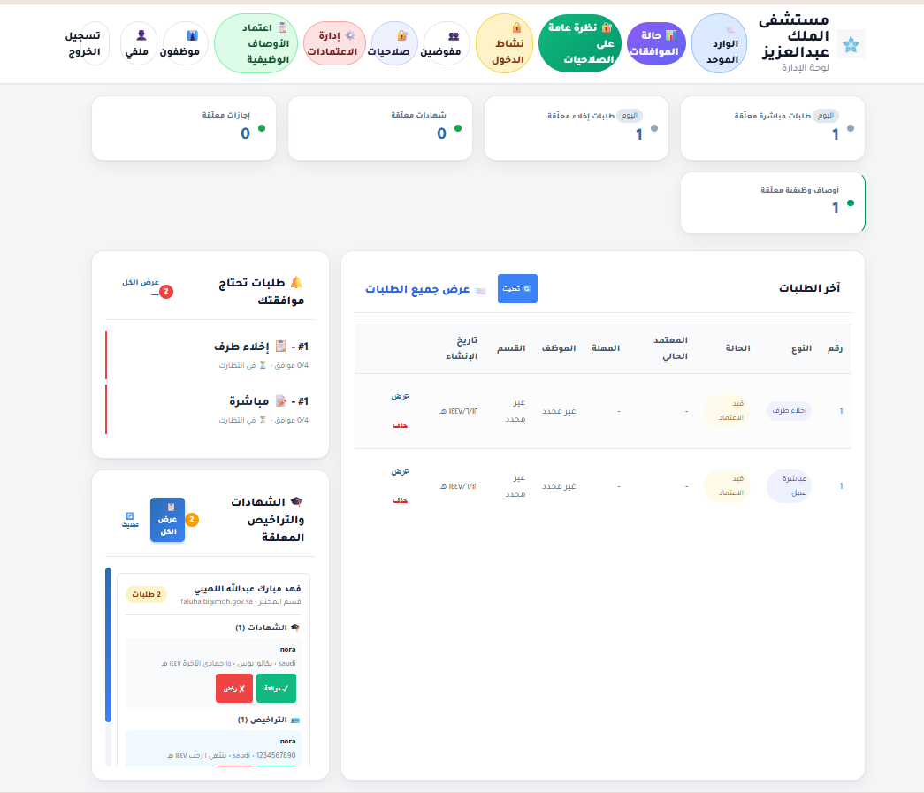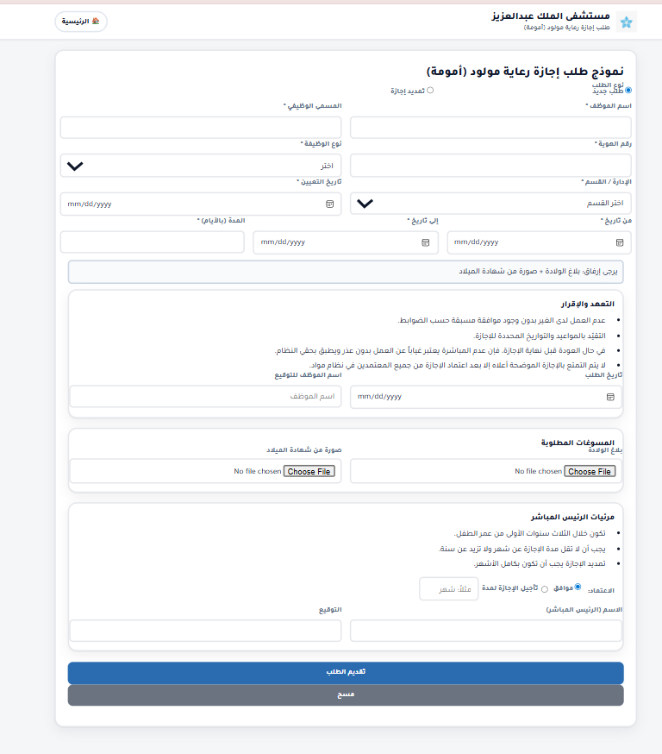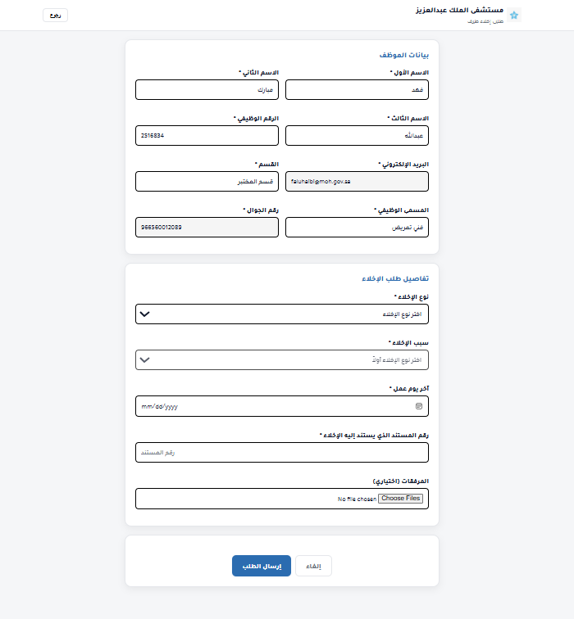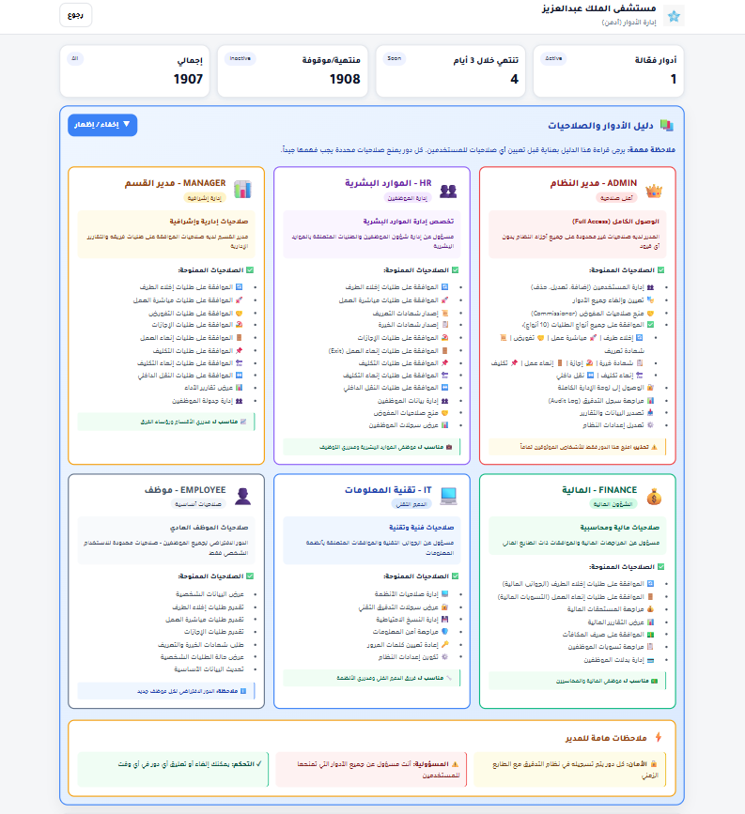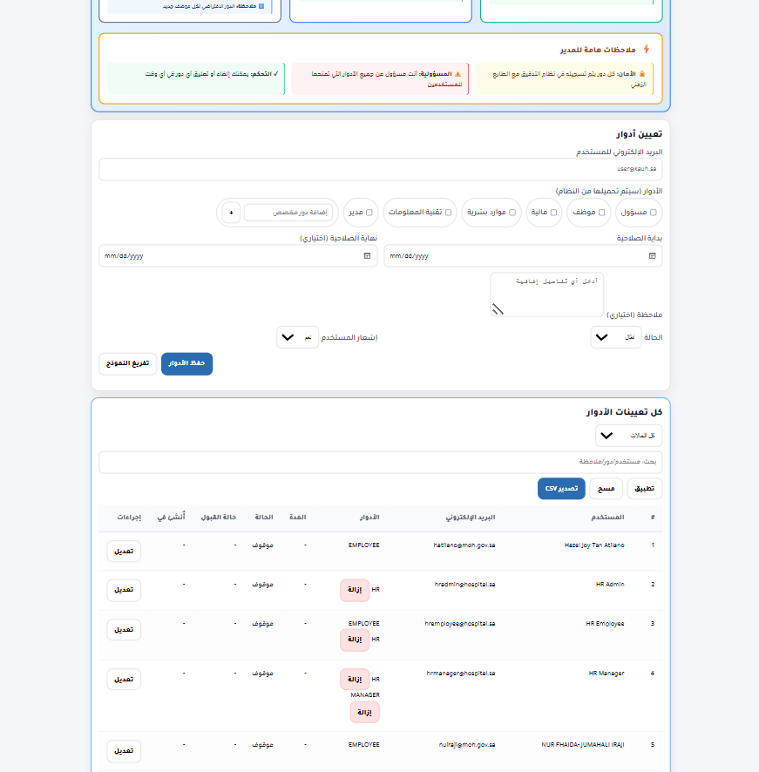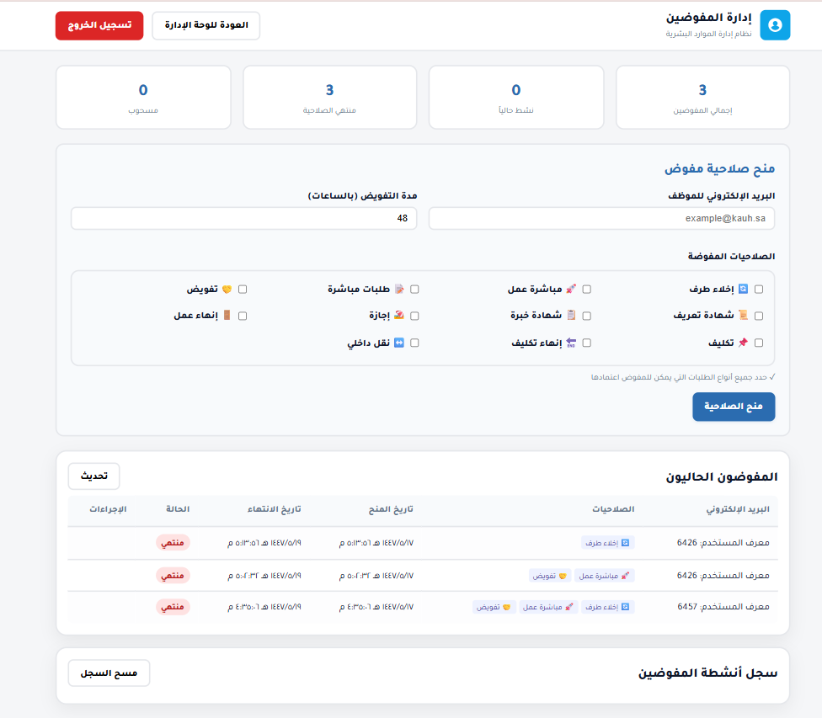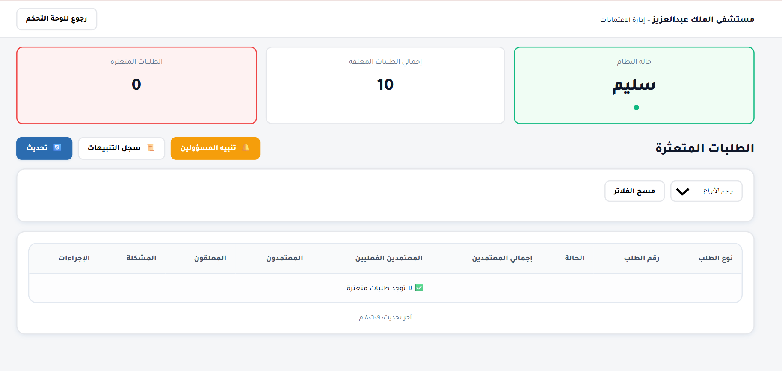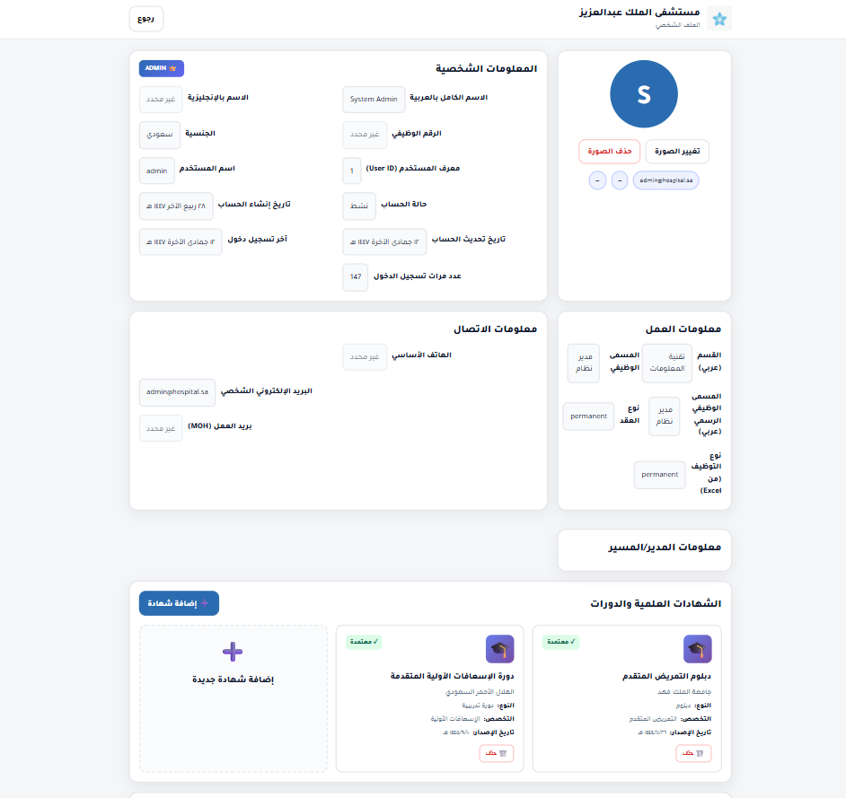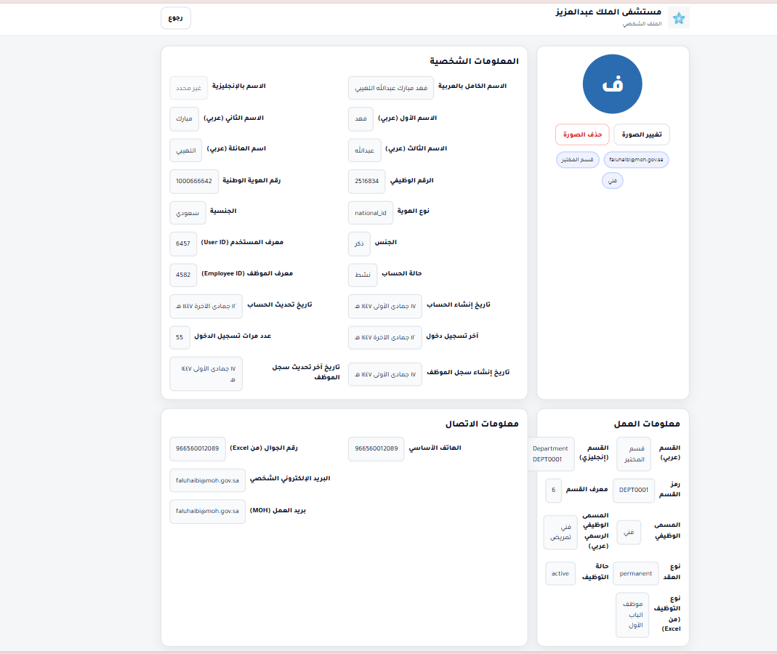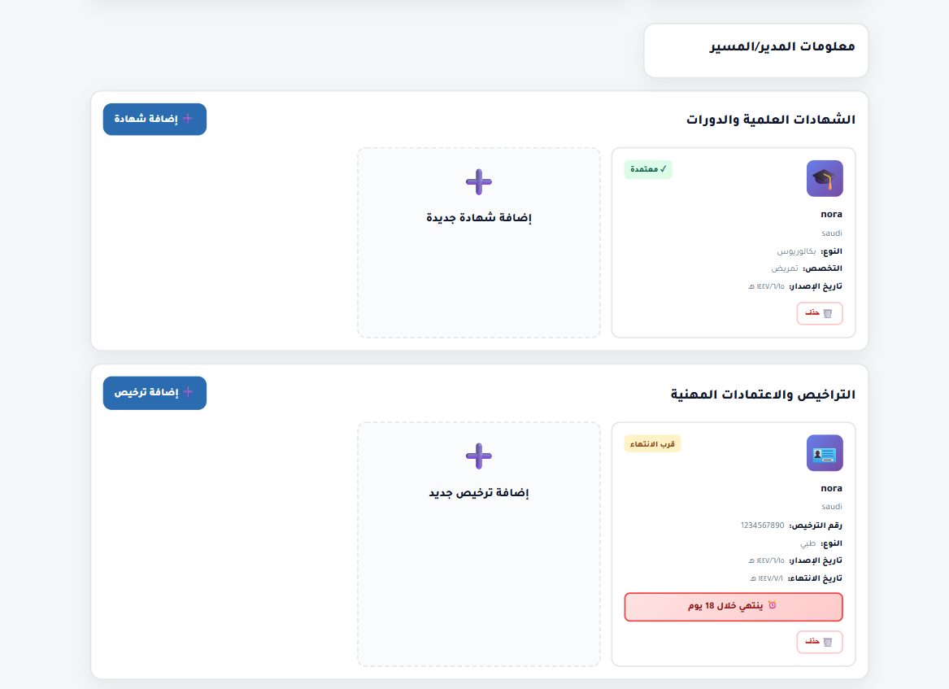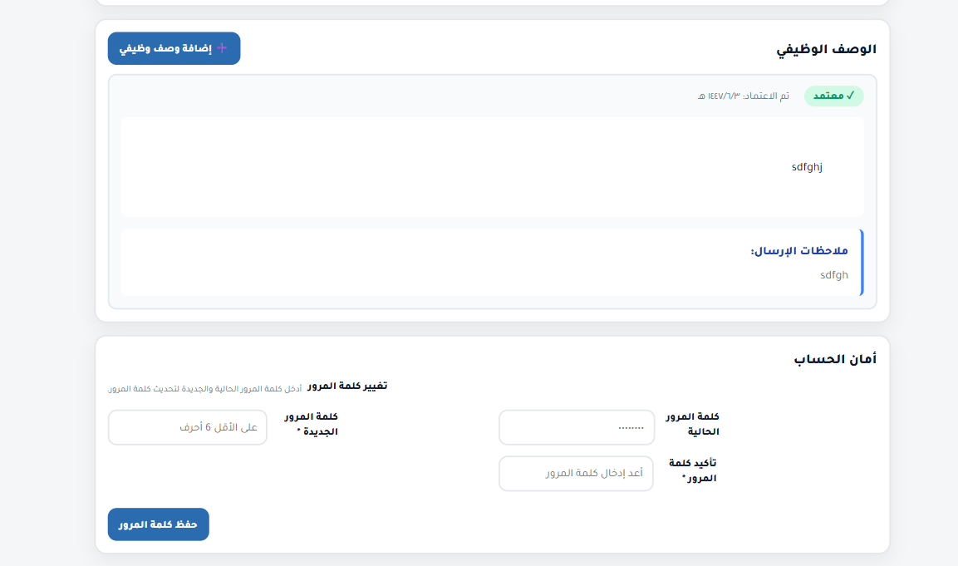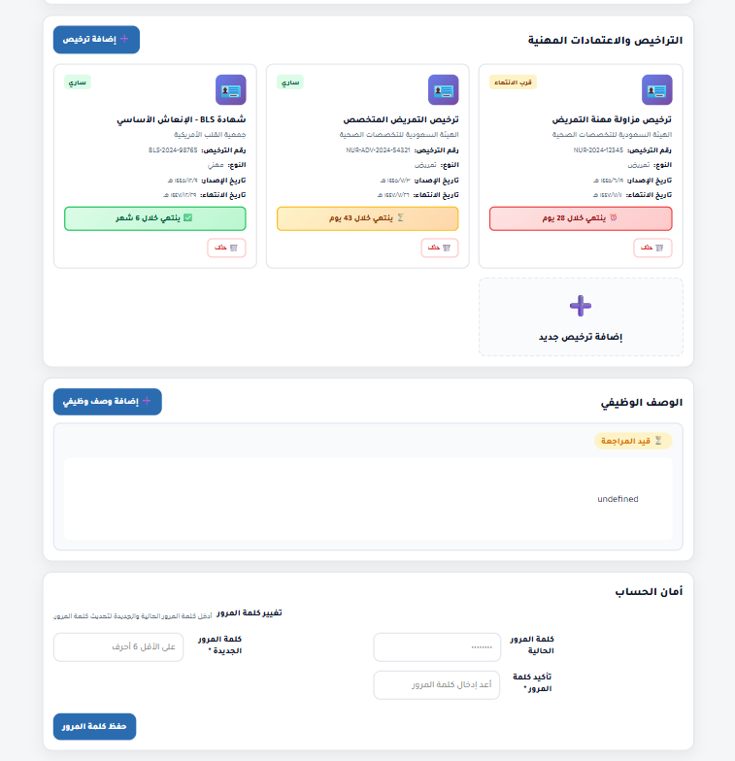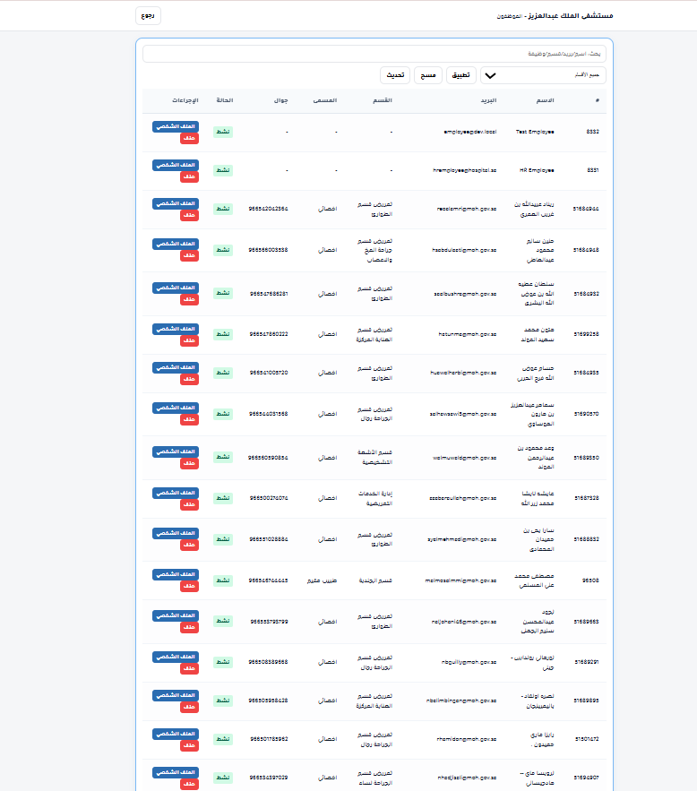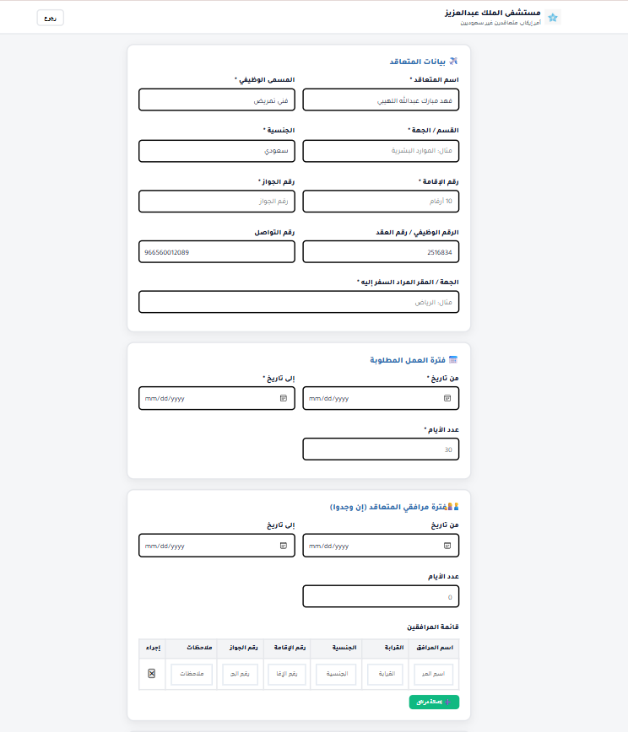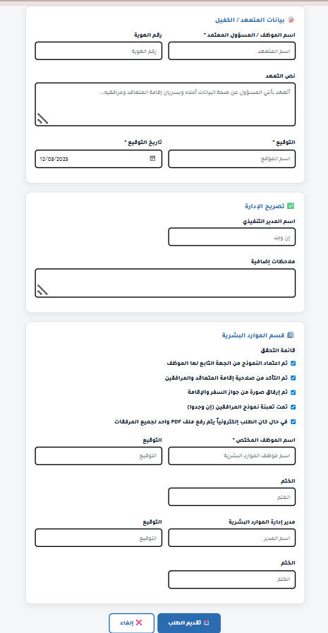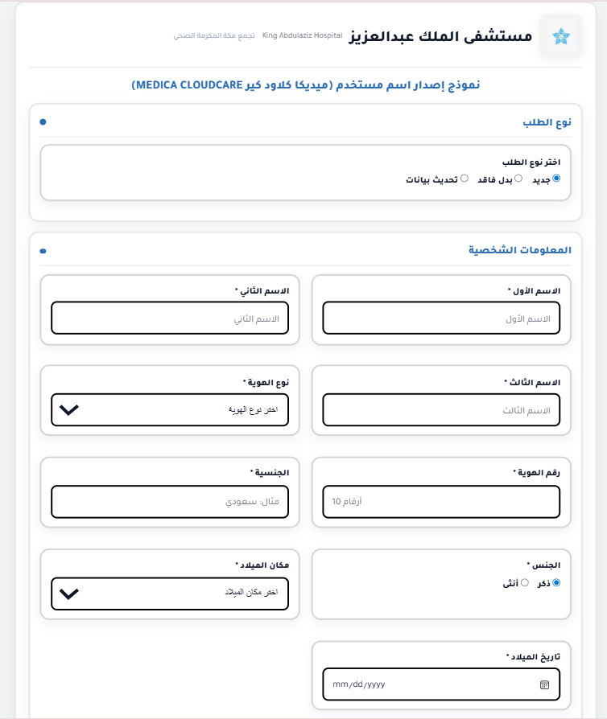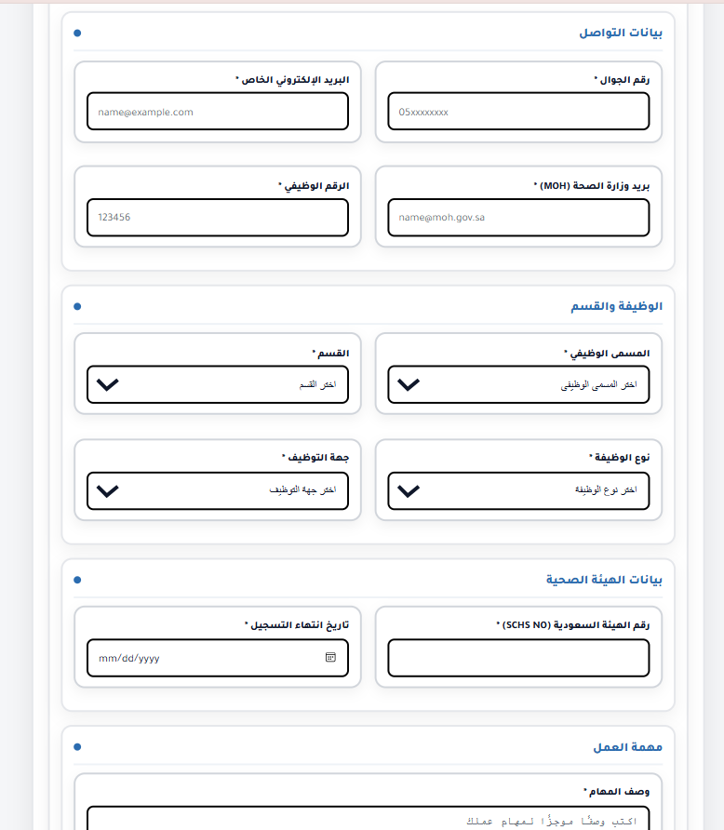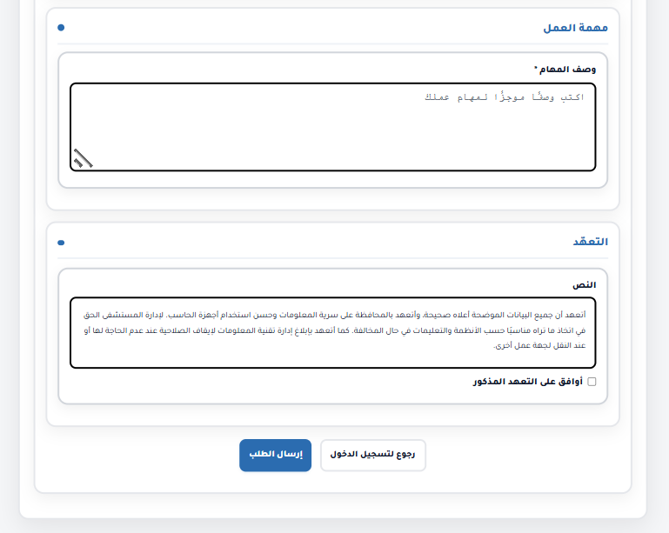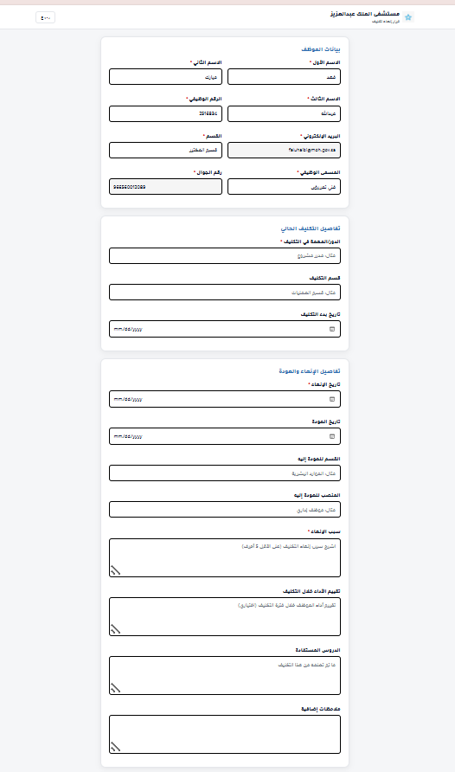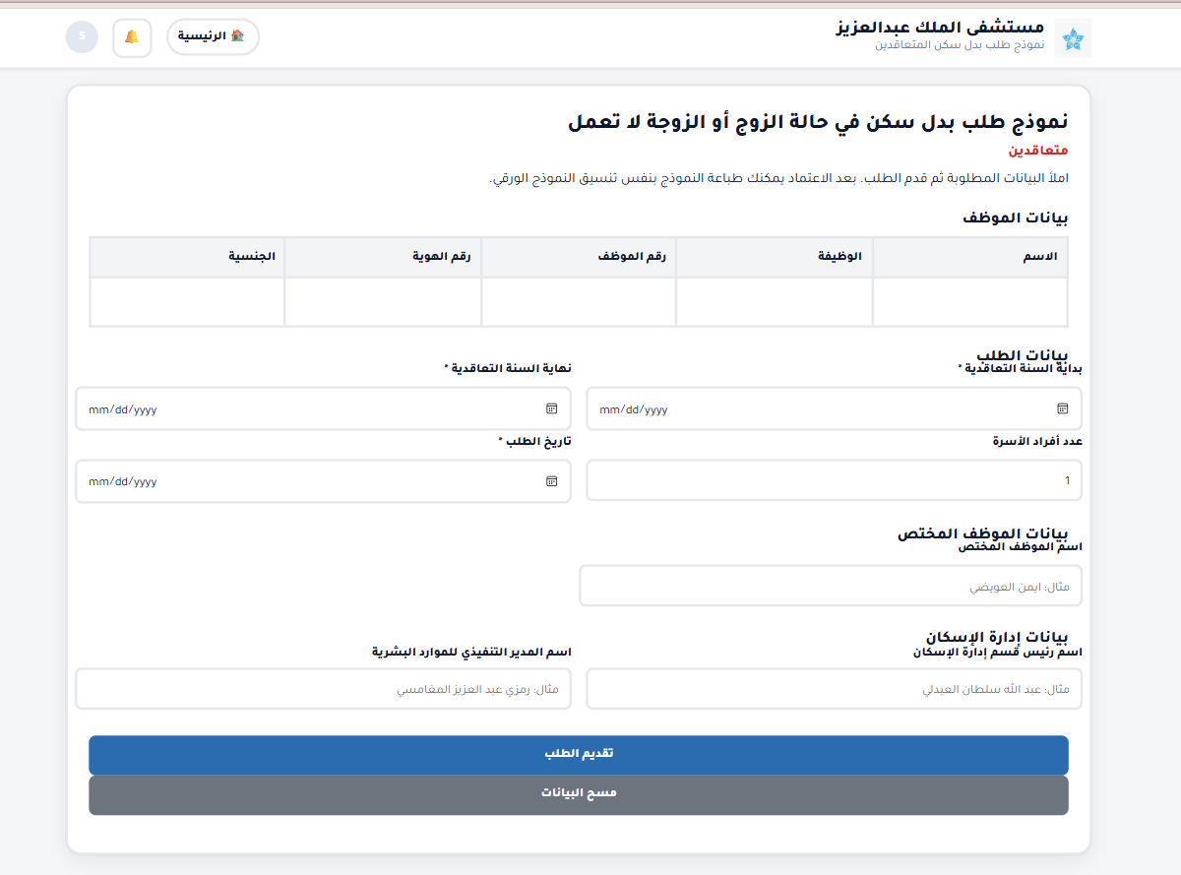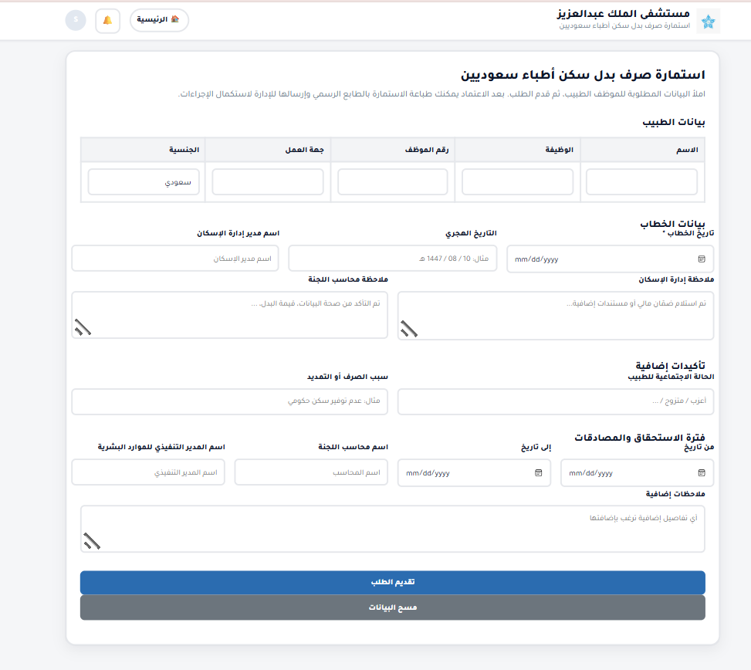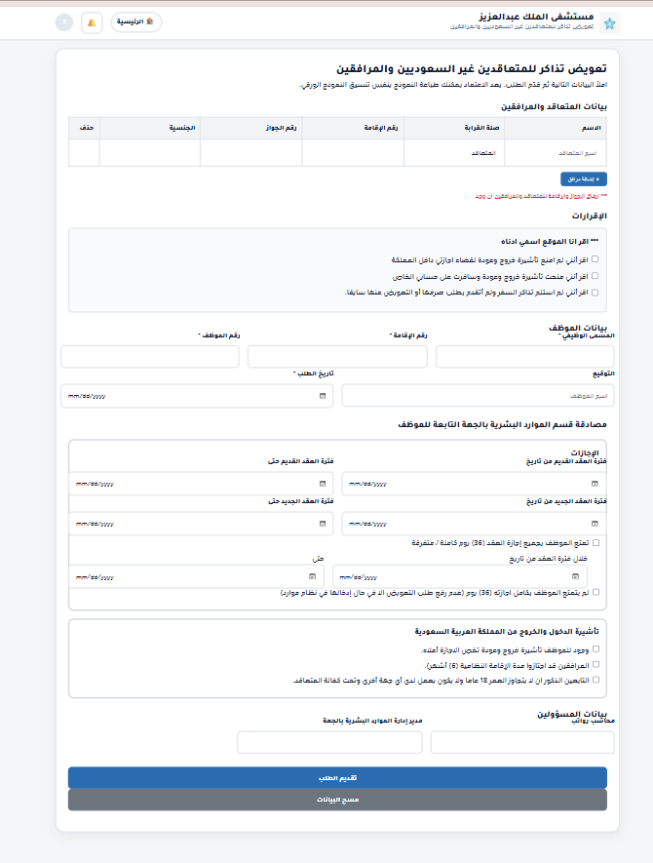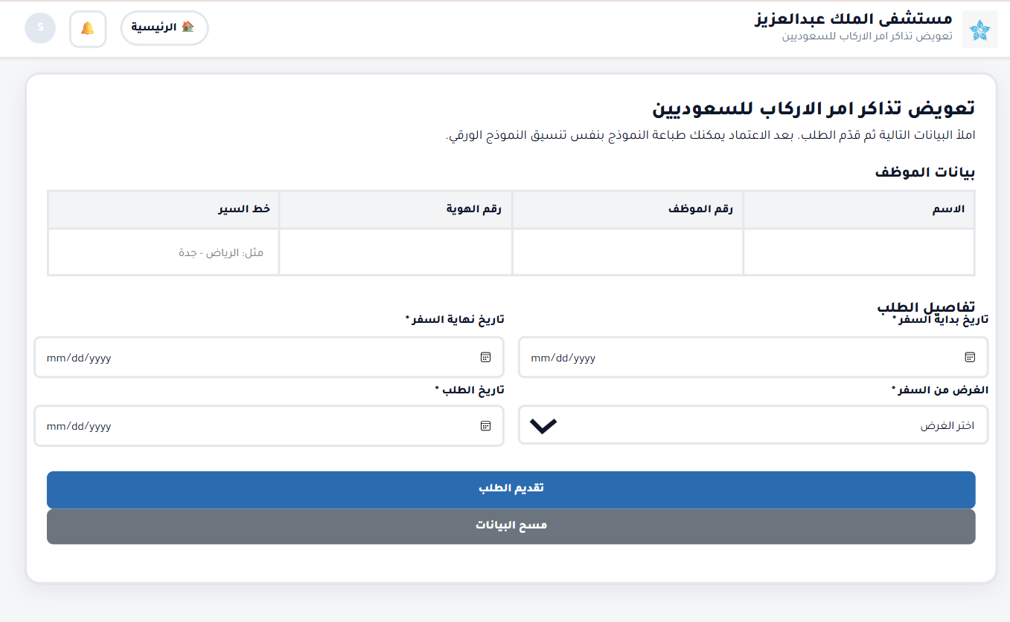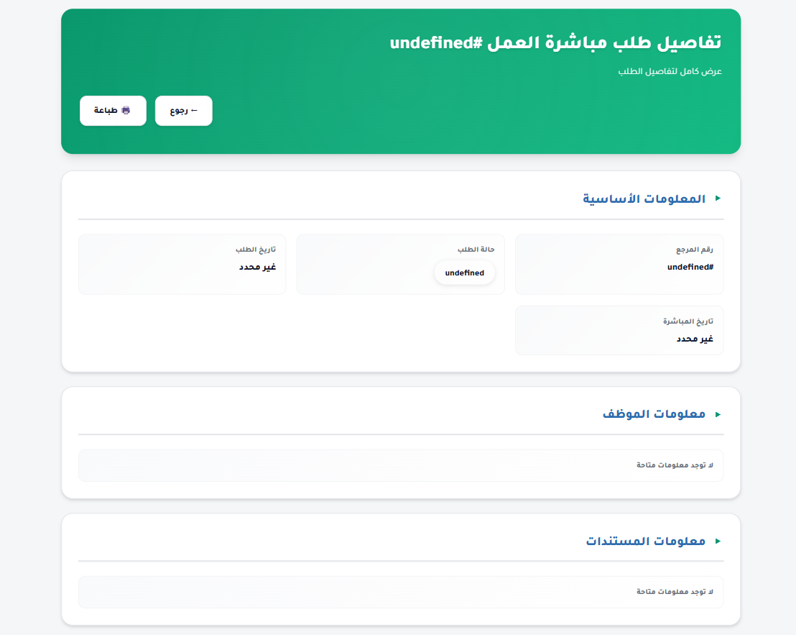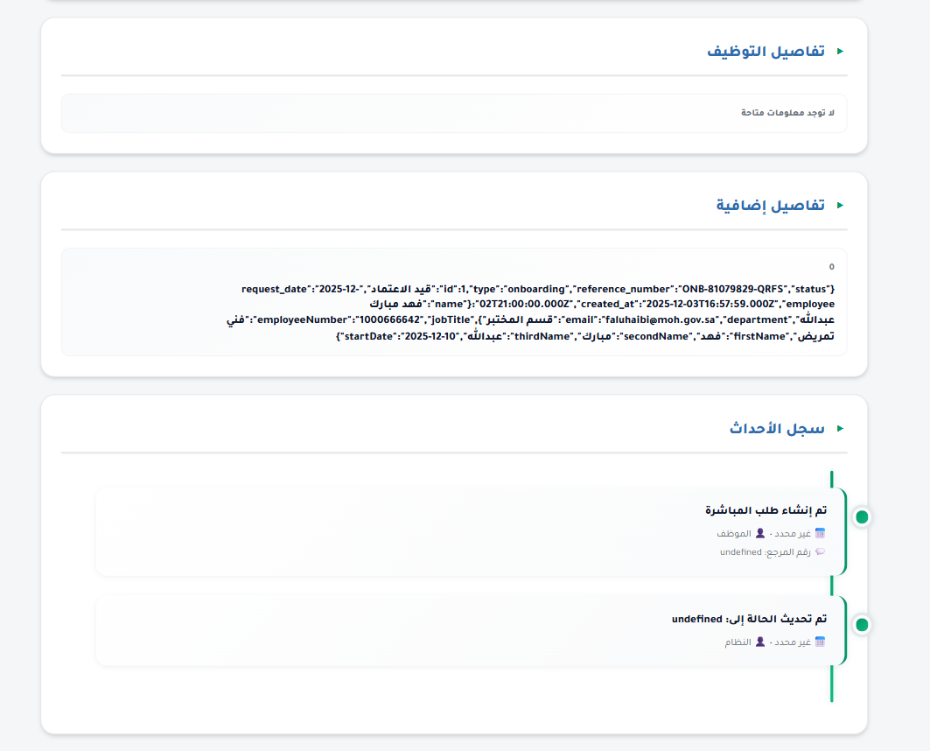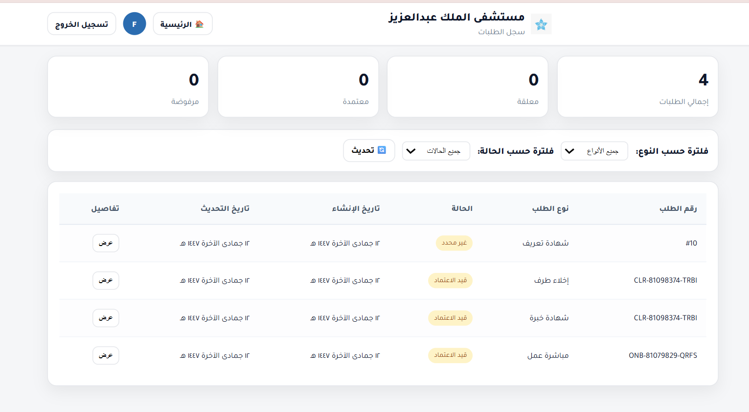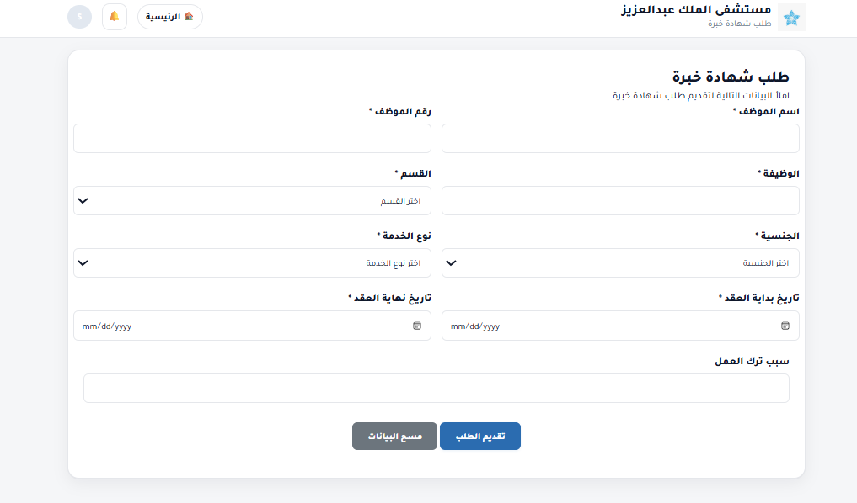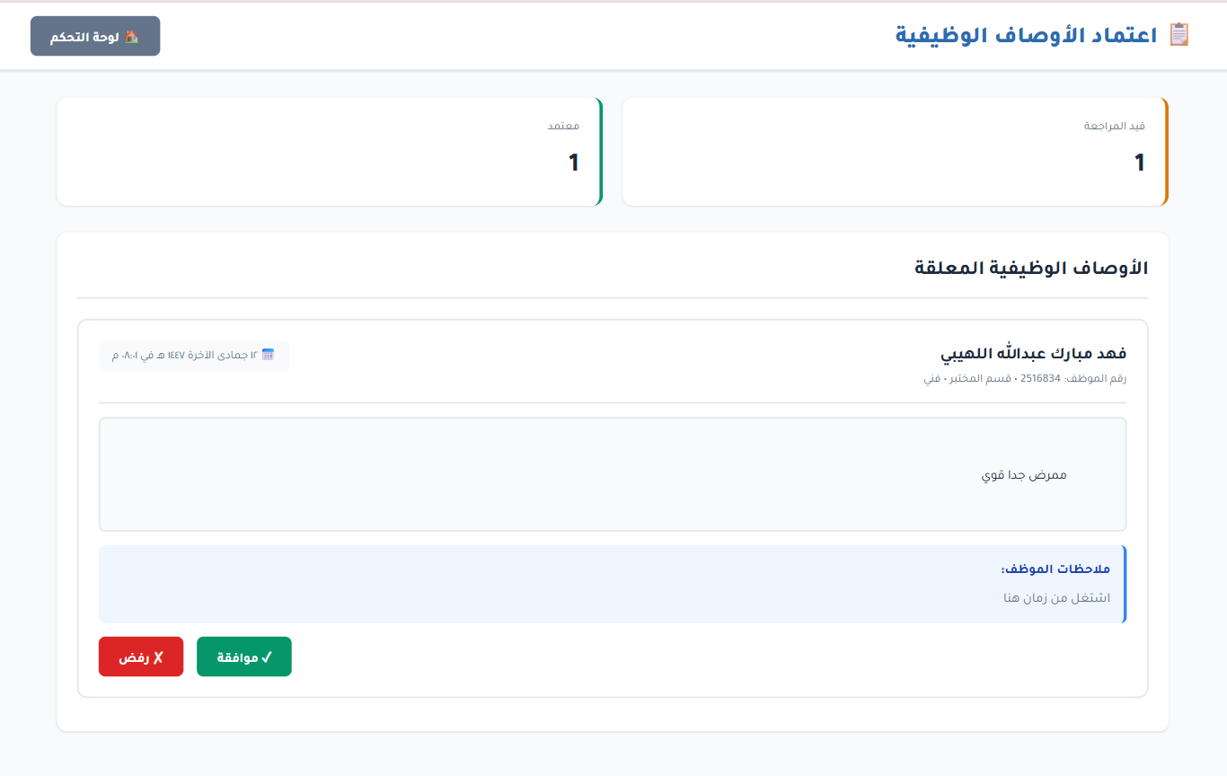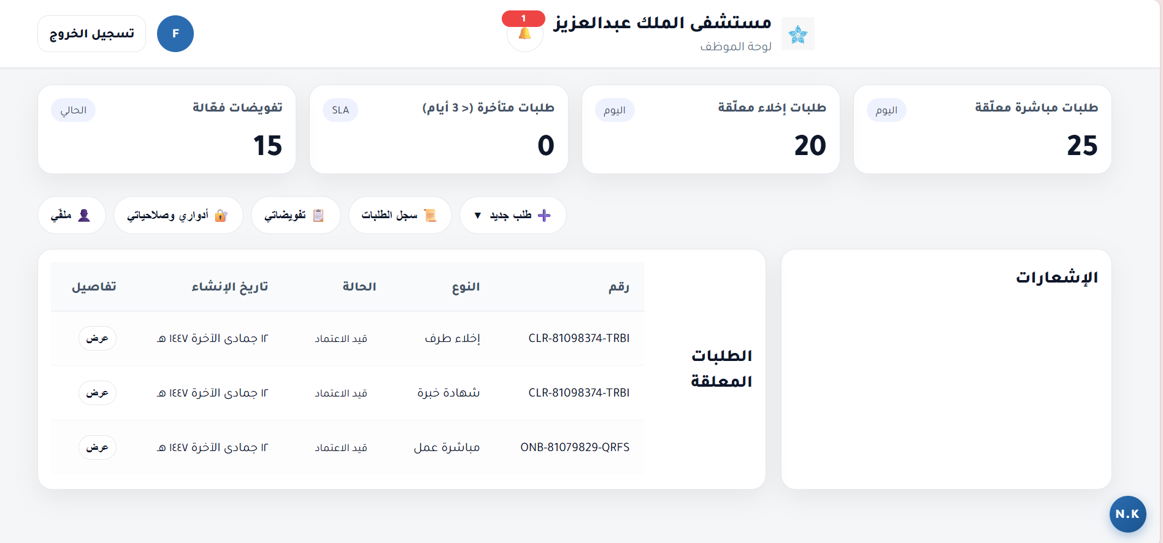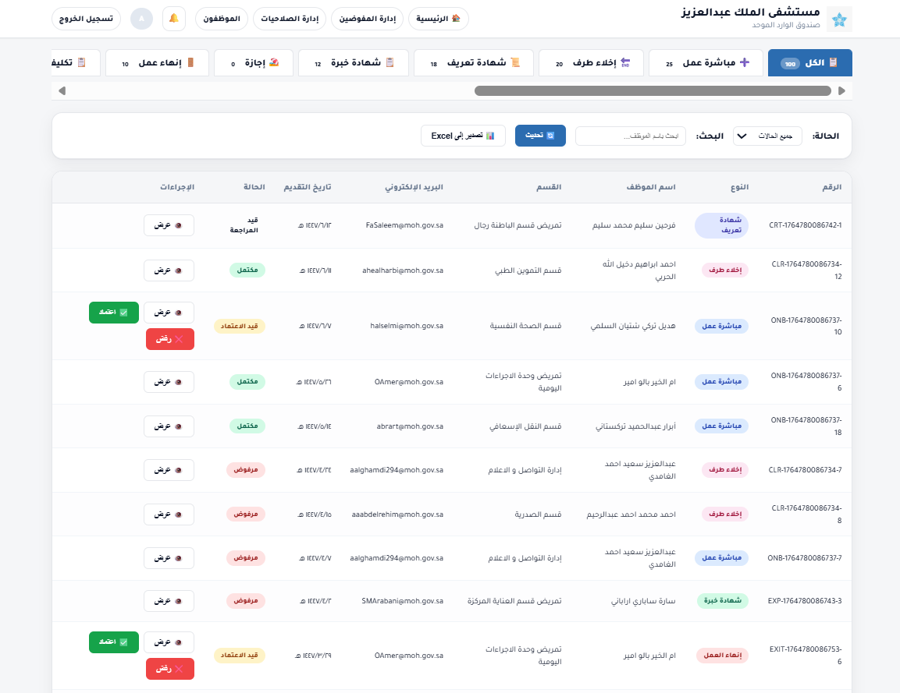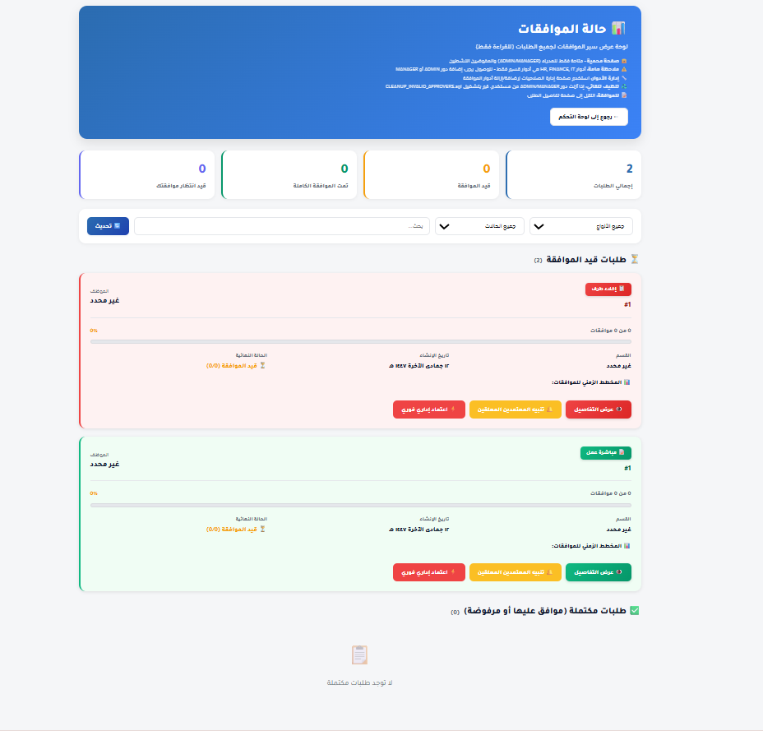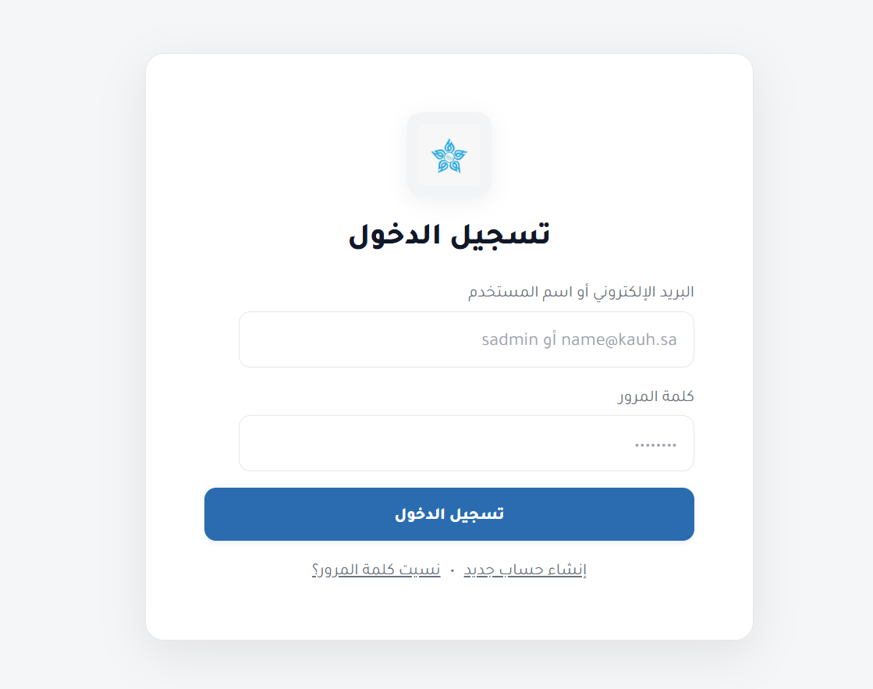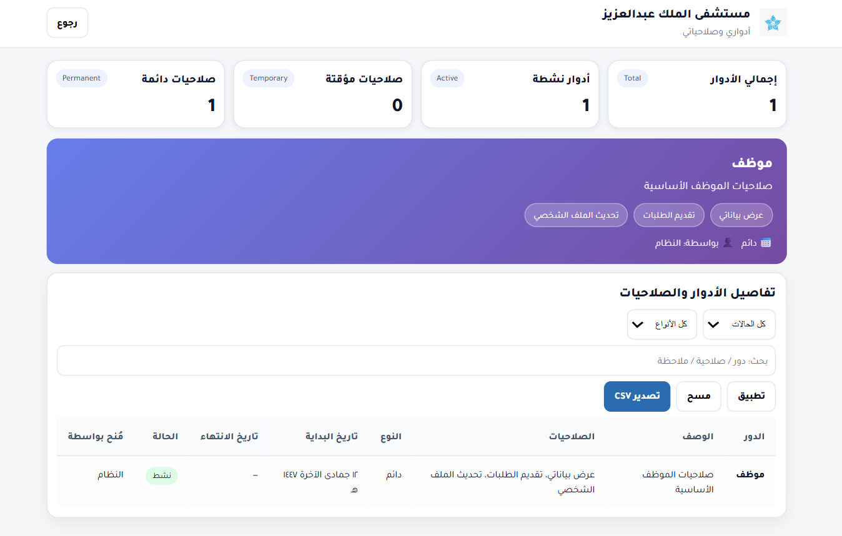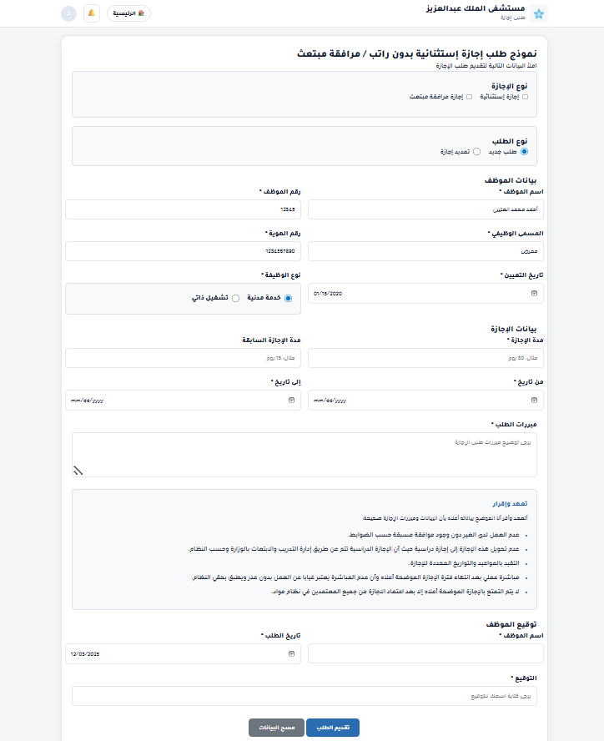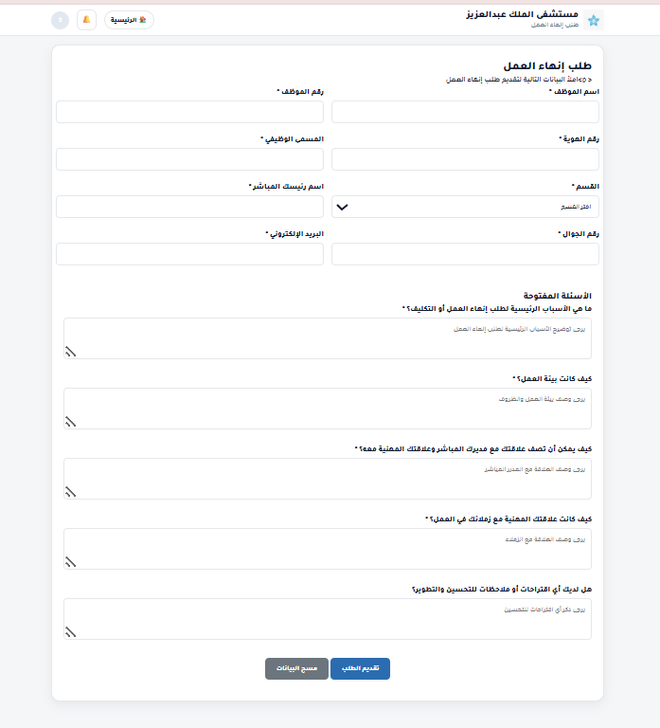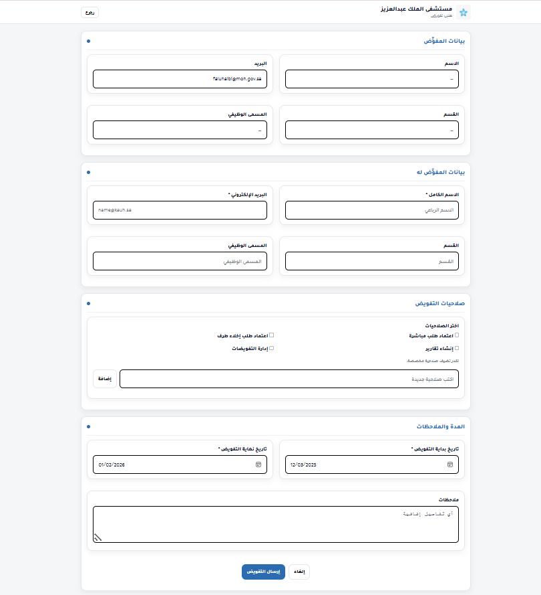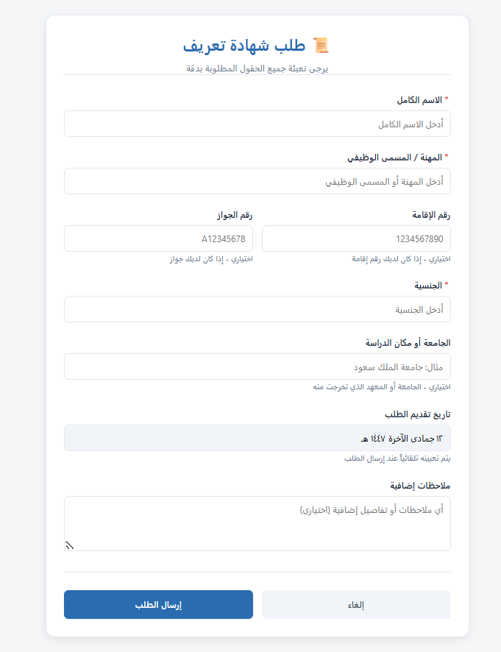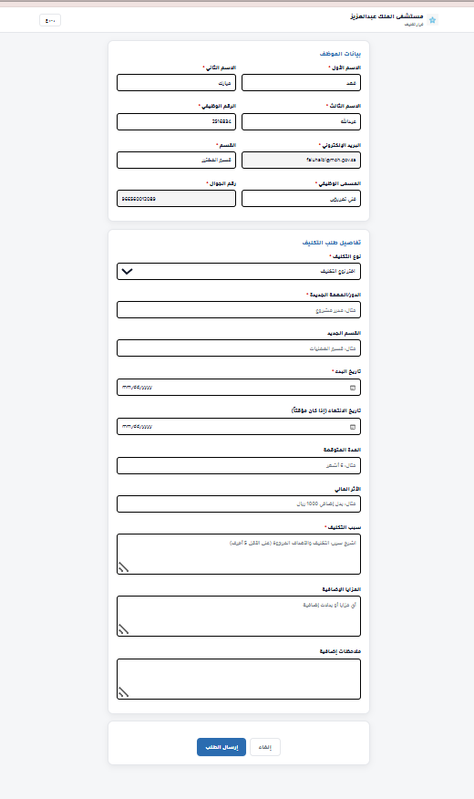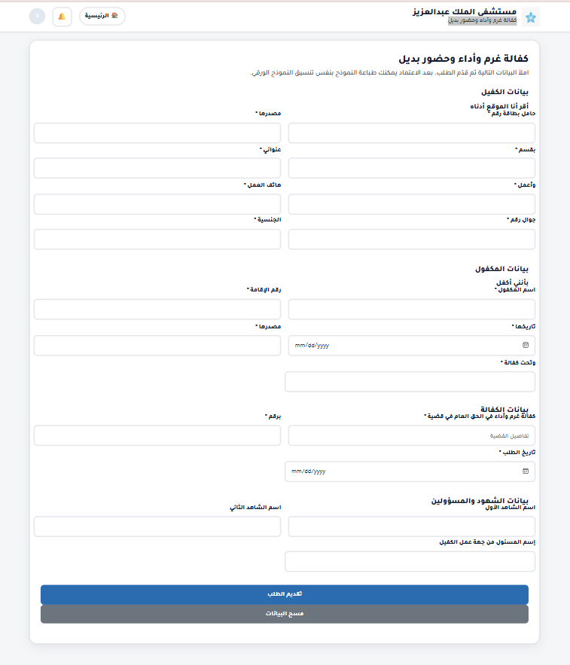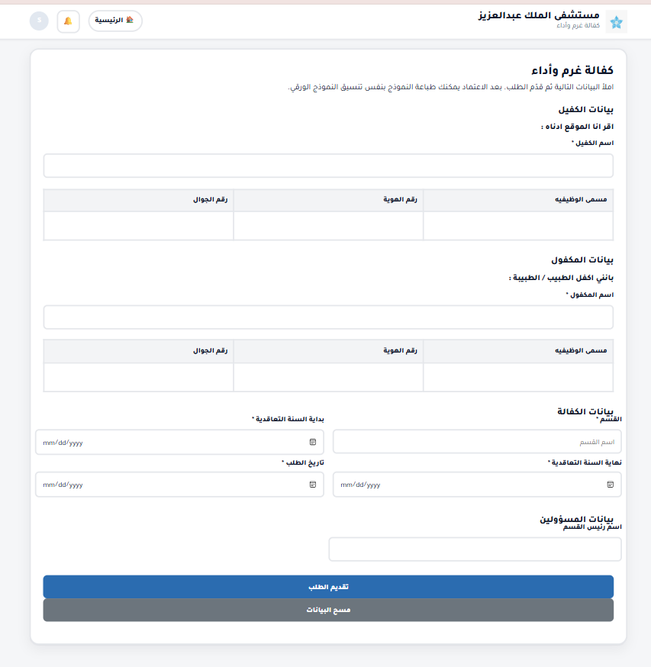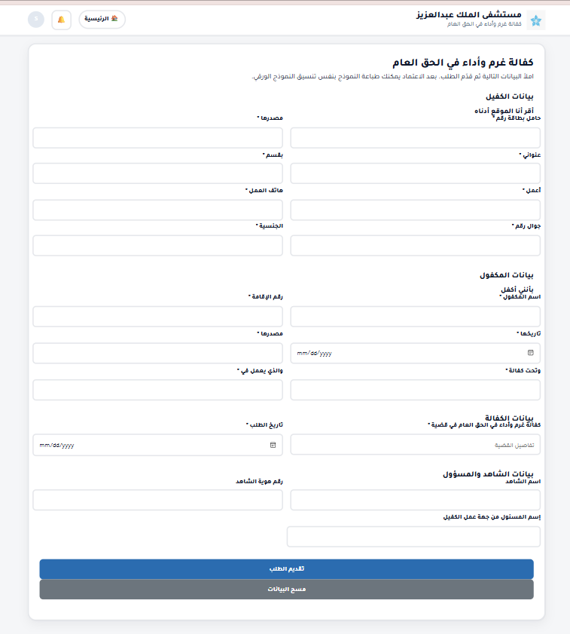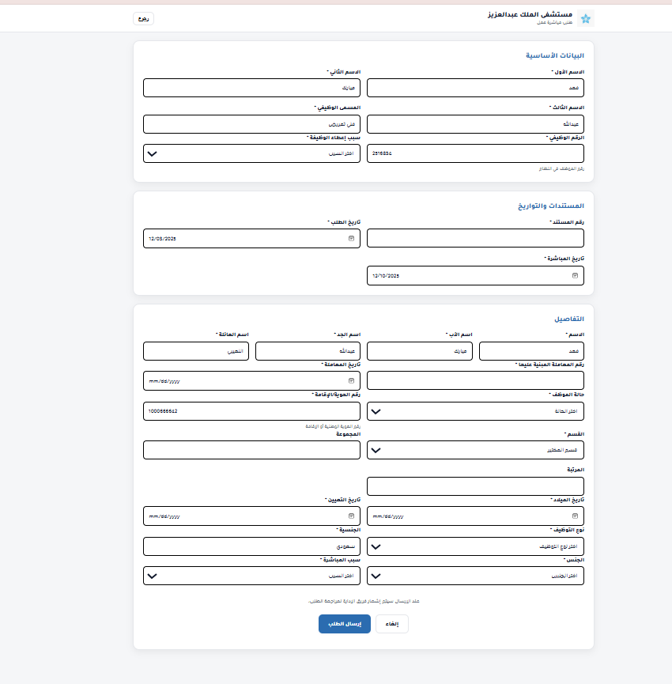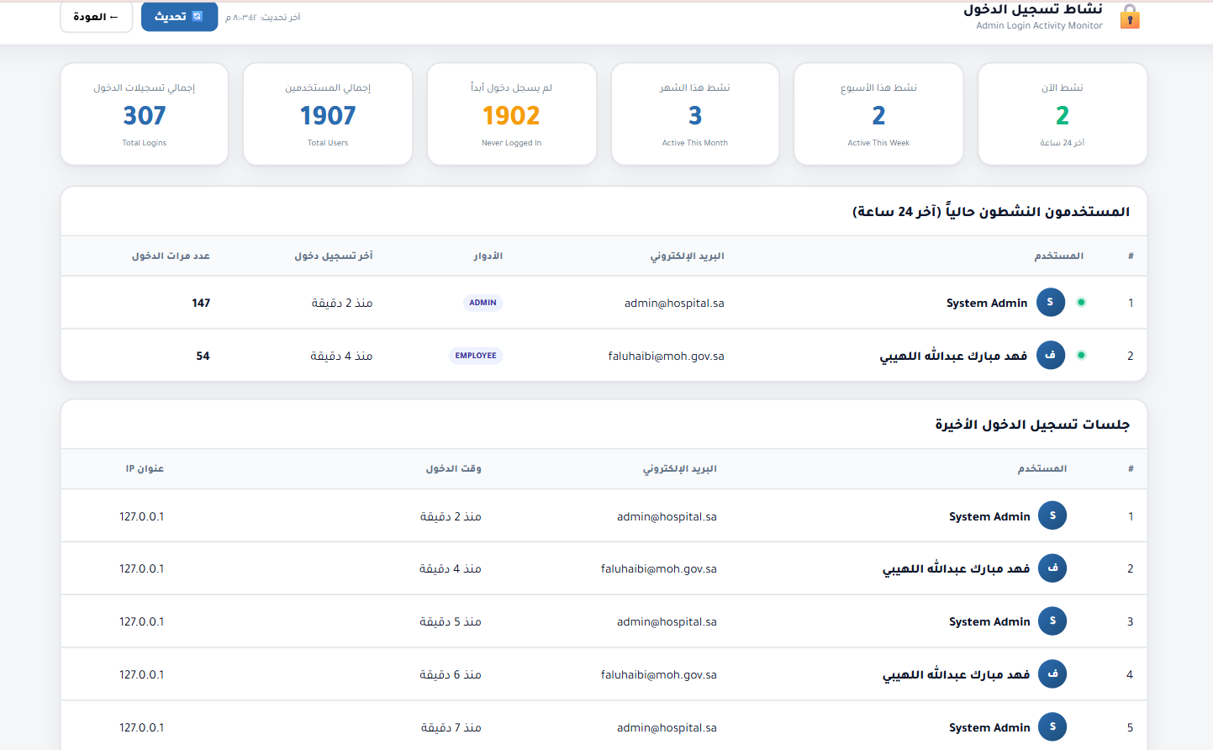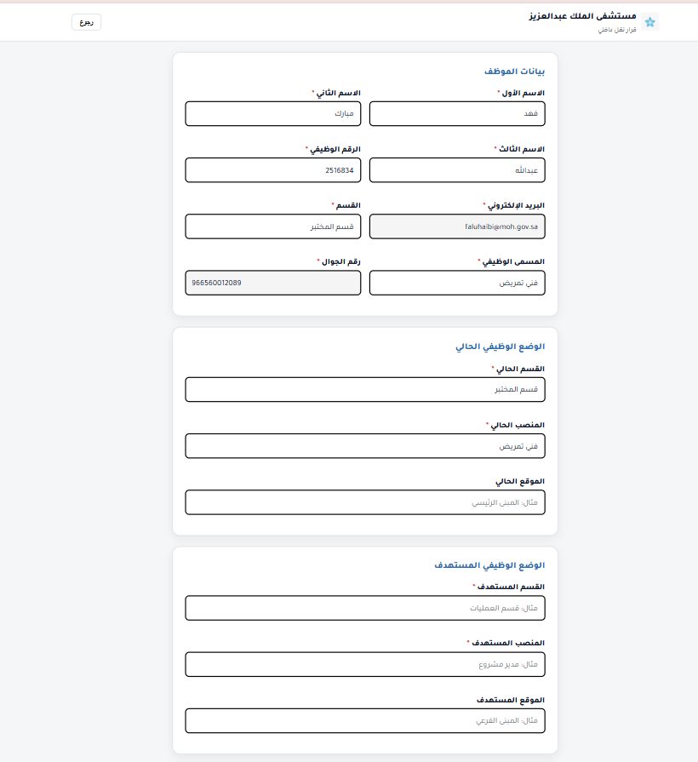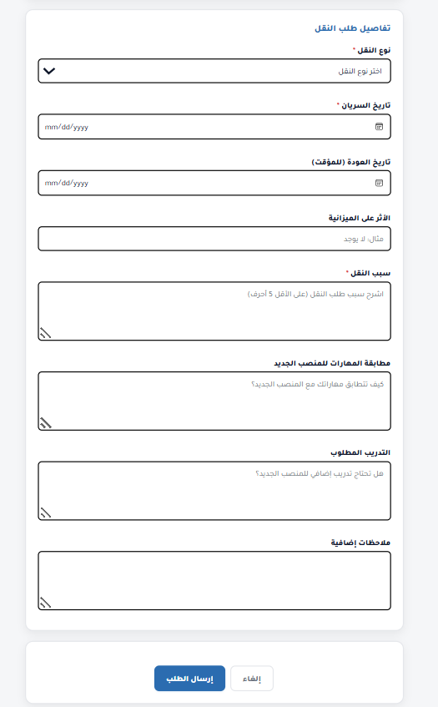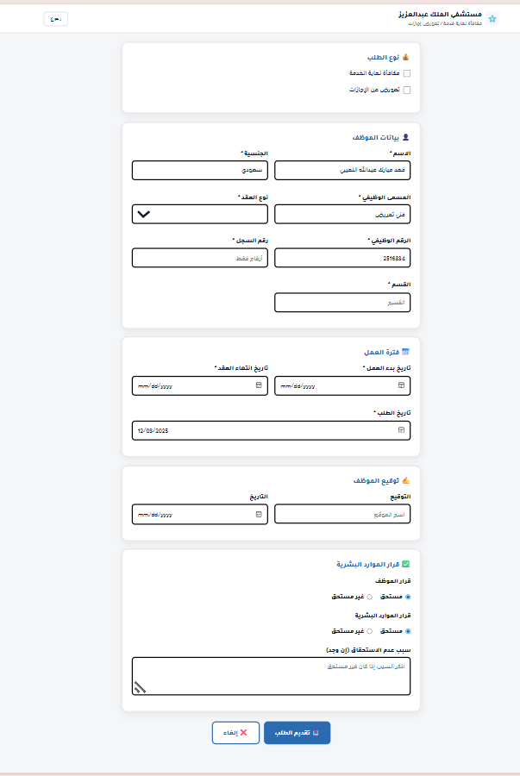

Appendix B — GitHub Repository
- Link to the project's GitHub repository containing:
- Source code
- Configuration files
- ERD diagrams
- Selected documentation

Appendix C — Training Plan
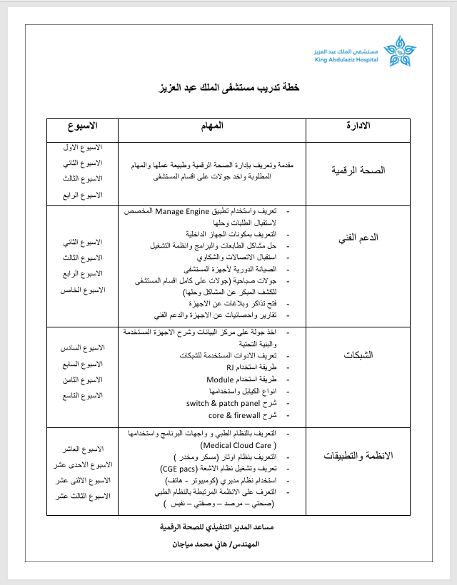

Appendix D — Additional Documents
- Project Management Plan (PMP) – only main pages or table of contents
- User Manual – table of contents or selected screenshots
- Any additional architecture or workflow diagrams

