**DISCLAIMER**

**This document contains proprietary information to General Motors exempt from public disclosure and shared only under a binding non-disclosure agreement between UEAMex and General Motors. No portion of this document may be reproduced, redistributed, or otherwise disclosed to any third party.**

**All the confidential information has been altered from its original source and has been modified for education purposes for the project between GM and UEAMex.**

**Toluca, México, 25 May 2025.**

**Best Practice 1**

BP Title: Door Trim Map Pocket to Seat Side Clearance

Abstract: This is an integration/design KPAC for the clearance required between door trim panel primary storage compartments (map pockets) and seats.

**Criteria**

Minimum Clearance: 50mm IF switch is on seat | 20mm IF switch is elsewhere in vehicle.

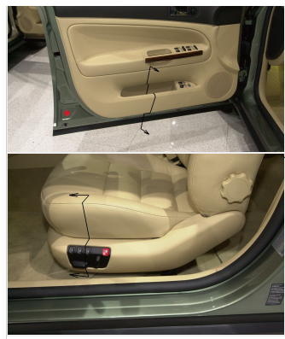

Consequences: Non conformance to the requirements of this best practice will result in poor perceived quality for difficulty in accessing seat controls and/or items stored in the map pocket.

**Best Practice 2**

BP Title: Interior Trim/Side Closures Interface - Door Trim "Trim Foot" Criteria

Abstract: The Door Trim "Trim Foot" or the perimeter extension of the Door Trim that provides a seating surface for the Body Mounted Secondary Seal. The purpose of this BP is to describe the interface of the Door Inner "N - Plane" to the "Trim Foot" as it transitions around the rear, bottom and front of door. The BP also contains criteria for the interface to the window garnish trim.

Criteria

Zone 1: 0mm

Transition zone: 1.5 mm

Zone 2: 3 mm

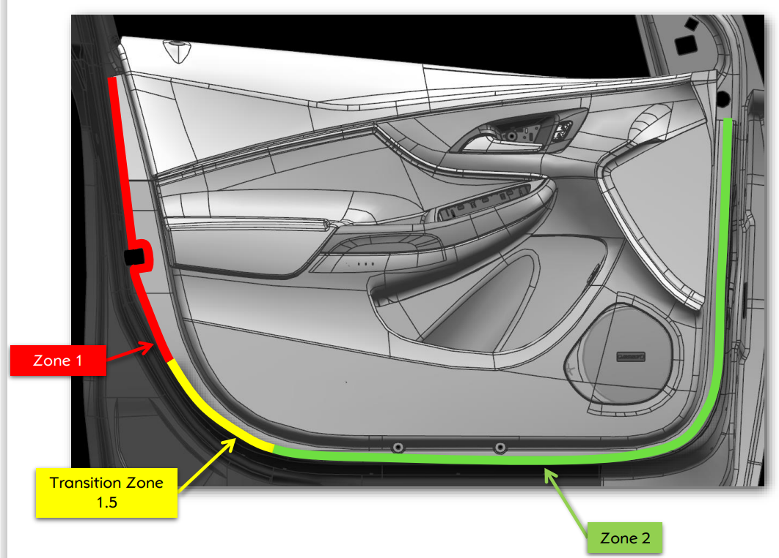

**Consequences**: Failing to follow this Best Practice can result in Perceived Quality and warranty issues for door trim poor fits to metal and sealing issues.

**Best Practice 3**

BP Title: Door Trim Pull Handle Interface to Sheet Metal

Abstract: This best practice describes the design criteria for the interface pull handle to sheet metal. This Best Practice applies to all GM programs with a door trim pull handle; it does not apply to programs using a pull cup

Criteria

The Pull handle shall be designed to attach the door trim to the sheet metal with a minimum of two M4.2 fasteners.

The required Torque is 5 ± 0.5 Nm.

Distance between attachments: min 20mm Max 30mm

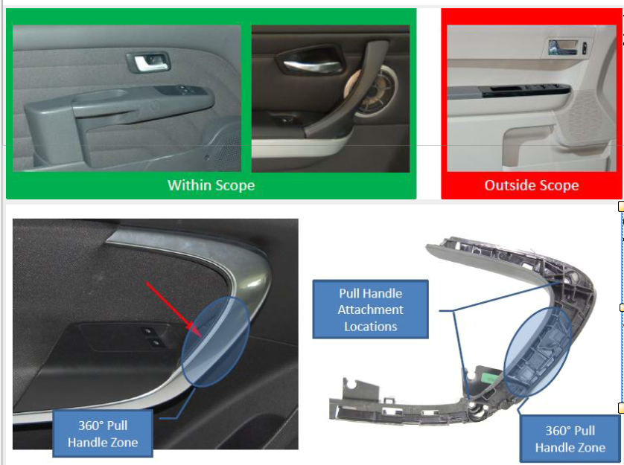

Consequences

affect global compatibility of the manufacturing solution at the assembly plants.

**Best Practice 4**

BP Title: Door Trim Pull Cup Interface to Sheet Metal

Abstract: This best practice describes the design criteria for the interface pull cup to sheet metal. This Best Practice applies to all GM programs with a door trim pull cup; it does not apply to programs using a pull handle

Criteria

The Pull cup shall be designed to attach the door trim to the sheet metal with one screw M4.2

The required Torque is 5 ± 0.5 Nm.

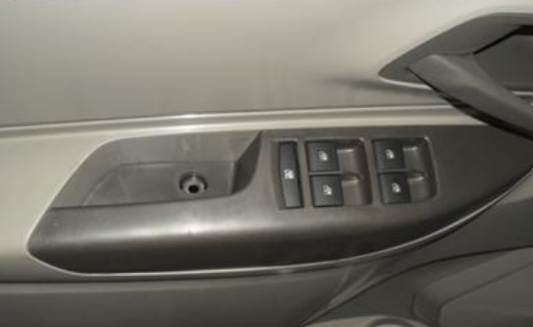

Consequences

affect global compatibility of the manufacturing solution at the assembly plants.

**Best Practice 5**

BP Title: Door trim to seat belt Interface requirements

Abstract: Review of compliance of clearance requirements at the Interface Door trim to Seat belt Latch for all seat positions. Special detail required for Coupe and Convertible Vehicles, but, this Best Practice applies to all segments.

Criteria: Seat buckle might be attached to either the seat or body as shown in the figure 2. For any of prior conditions of attachments described of the seat belt the minimum clearance between seat belt buckle or latch Tongue to the door trim shall be 30 mm for all seat travel and seat belt positions.

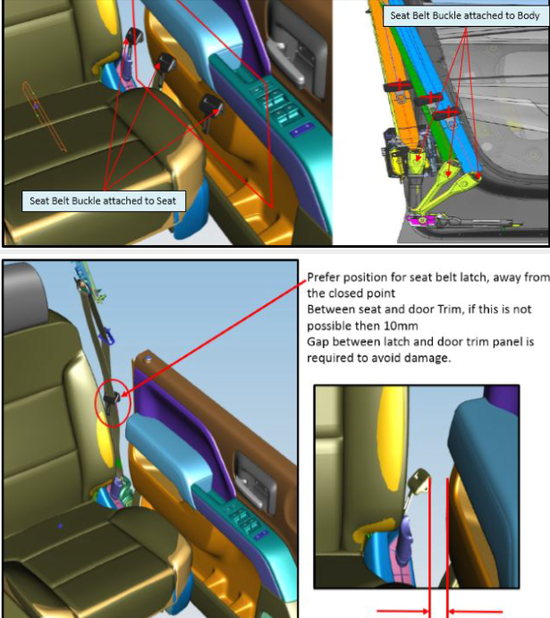



Consequences

Seat belt can cause damage to interior trim

**Best Practice 6**

BP Title: Door trim label location

Abstract: a tag or identifying mark that is attached to a product or container to provide information about it

**Criteria:**

Label shall be located in an area that is close to be flat so it can be properly adhered to the surface.

A 0.5 mm proud scribe line is recommended to be used as guide for label placement

Label size shall be enough to include all description. Typically 20mm x 50mm

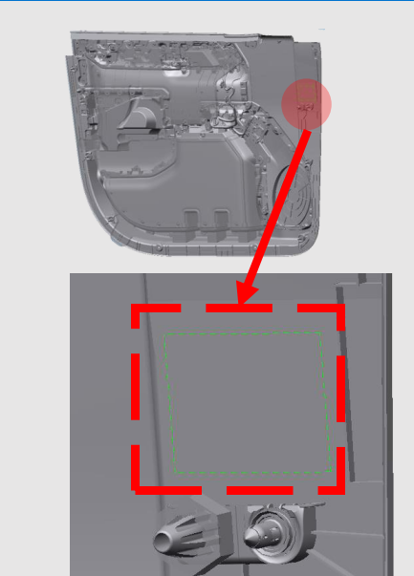

Consequences: Label scanning operation is not on acceptable by the GM plant

**Best Practice 7**

BP Title: Protective Tape Strategy

Abstract: This Best Practice provides Protective Tape Application and Validation requirements to address the failure modes related to appearance damages during door and vehicle handling & transportation such as Paint peeling / Wrapping Dents-Cuts / Grain damage / Scratches/Glue residuals, Stains.

**Criteria**

RACK TRANSPORTATION TAPE

To communize and optimize protective tape usage, size required is: 100mm x 100mm. (Teamcenter: BDY23000).

Protective Tape must cover the exposed corners that will contact Transportation Racks.

Tape should not impede Door Trim Installation.

Protective Tape is used FRT & RR Door Trim, FRT & RR Top Edge Corners and in the most Prominent Inboard corner.

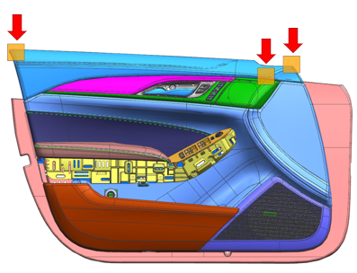

EXPORT VEHICLE ONLY REQUIREMENT

Lower Zone: 800mm x 100mm

Upper & Armrest: 300mm x 100mm

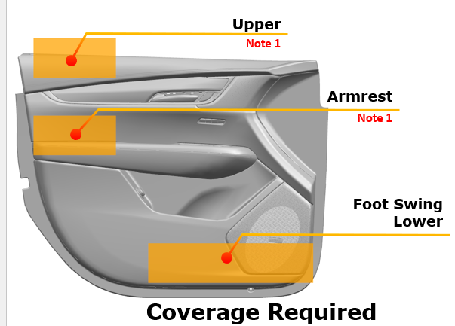

Consequence: Door trim damage before vehicle assembly. For export vehicles, damage during vehicle shipping.