# CS 255 System Design Document Template

This template lays out all the different sections that you need to complete for Project Two. Each section has guidance to prompt your thinking. You will need to continually reference the interview transcript as you work to make sure that you are addressing your client’s needs. There is no required length for the final document. Instead the goal is to complete each section based on what your client’s needs are. Remove this note when you are finished, and replace all bracketed text with the relevant information.

## UML Diagrams

### UML Use Case Diagram

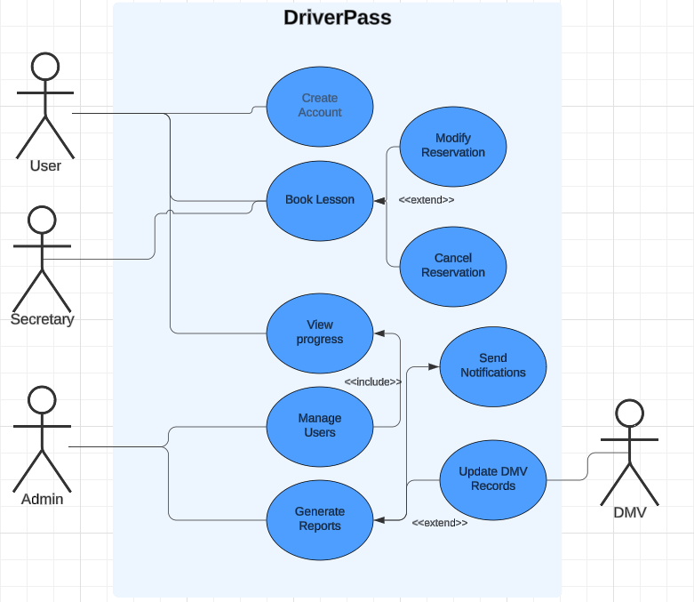

Admin was supposed to be labeled IT here, but I forgot to change it

### UML Activity Diagrams

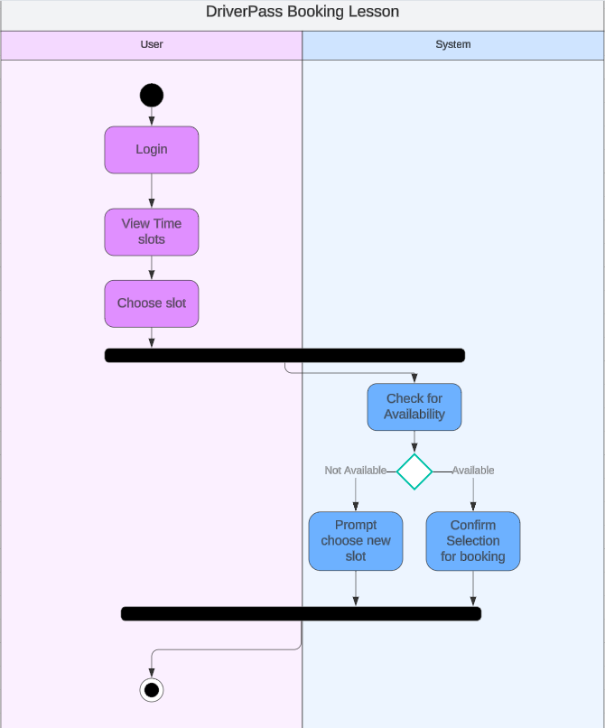

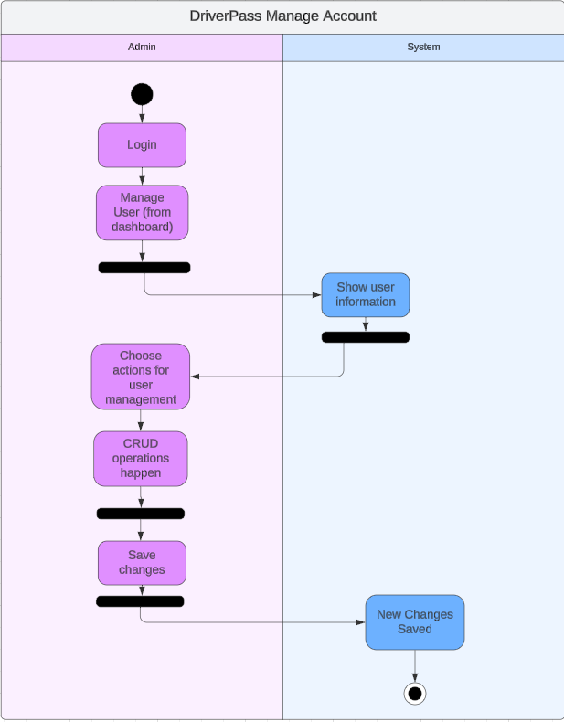

### UML Sequence Diagram

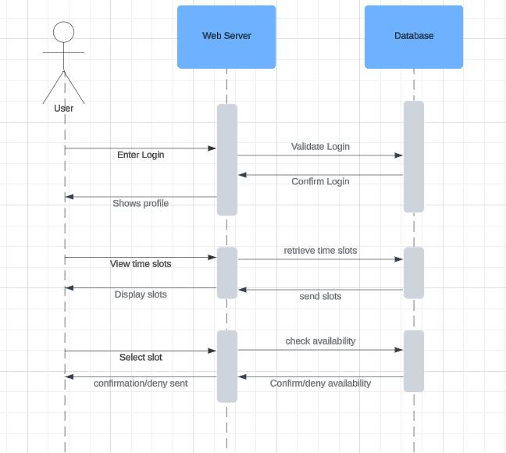

### UML Class Diagram

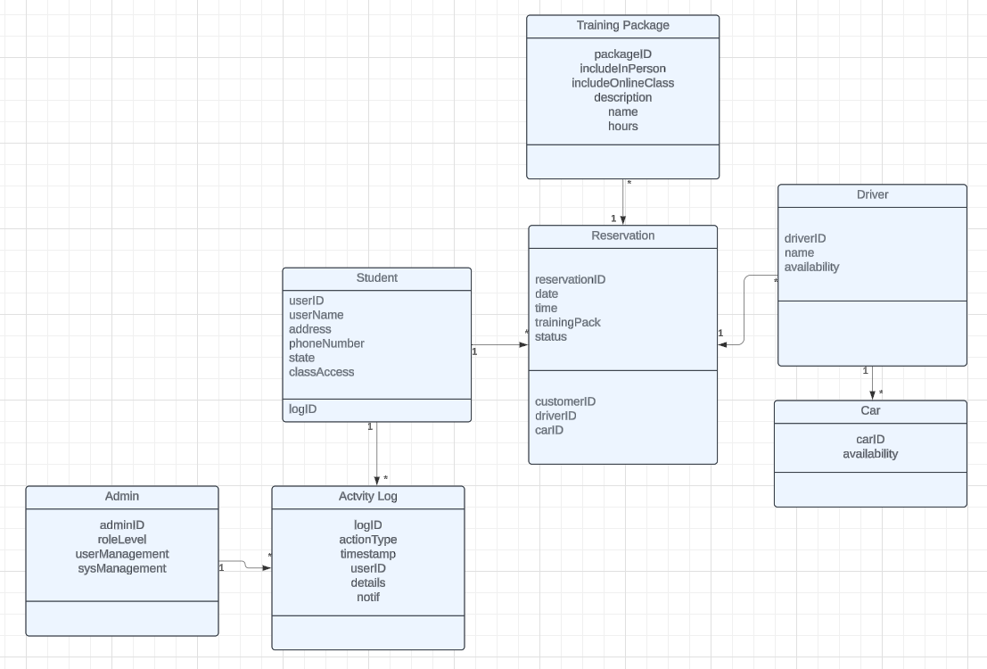

## Technical Requirements

The recommended requirements required for the system design I made require the webserver and database to both be separate and hosted on the same data cloud that DriverPass decided to use. This would allow for easier handling of data transfer and backup if needed. The webserver would hold the smaller unimportant data such as graphics, base html, etc. to avoid any problems that may occur if that were to go down because the database server would be holding the more important data that the webserver would be hosting. Therefore, the overall security of the system would be better than one single server hosting all the information. For ease of use, I would recommend SQL to be used for the database as it is easier to understand and allows for faster troubleshooting for IT admin.