#### UNIVERSITY OF BUEA

**\*\*\*\*\*\*\*\*\*\*\*\*\*\***

#### FACULTY OF ENGINEERING AND TECHNOLOGY

**\*\*\*\*\*\*\*\*\***

#### DEPARTMENT OF COMPUTER ENGINEERING

**\*\*\*\*\*\***

#### 2022/2023 ACADEMIC YEAR

PROJECT REPORT TITTLED;



Mobile Application Development

Hybrid, Native, and Web Application development

**GROUP MEMBERS SUPERVISOR;**

**Dr. Valery Nkemini**

|  |  |
| --- | --- |
| **NAMES** | **MATRICULES** |
| **ENEMBE VERINE** | **FE20A033** |
| **AYAMBA OJONG NKONGHO** | **FE20A019** |
| **TONY KENYUI NANGAH** | **FE20A120** |
| **NKONGHO AYUK SHARIMA** | **FE20A090** |
| **GABILA YASMIN NAHKUNA** | **FE20A043** |

#### FRIDAY, MARCH 31st 2

**Mobile application programming**

**FoodAuc Mobile App**

Design Phase of our system we are going to perform UML analysis bringing out the actors, use case. We make use for class diagram, use case diagram, activity, and sequence diagram to explain our use cases.

**System Analysis**

1. Actors

1). Primary

* 1. Donor
  2. Collector
  3. Admin

2). Secondary

* 1. System
  2. Admin
  3. Third-Party

1. Classes
2. Users
3. Collector // inherit user
4. Donor // inherit user
5. Admin // inherit user
6. Post
7. History
8. Messaging
9. Notification
10. Wallet
11. Transaction

The flow and connection of the system can be shown using a class diagram. The class diagram bellow shows the connection and dependences between the classes. The class diagram can be used to generate the ERD of the system.

**Class Diagram**

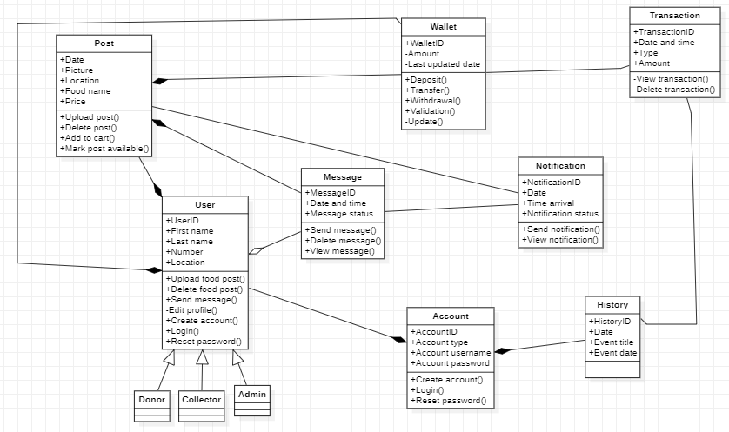

1. Use cases

The uses cases represent the processes of our system

* 1. Registration
  2. Login
  3. Logout
  4. Forgot password
  5. Create food post
  6. Collect food post
  7. Make deposit into wallet
  8. Recommend Donor
  9. Messaging(chat)
  10. Upload photo

The interaction between this the use case and their constrains is shown by the help of a use case diagram.

**Use Case Diagram**

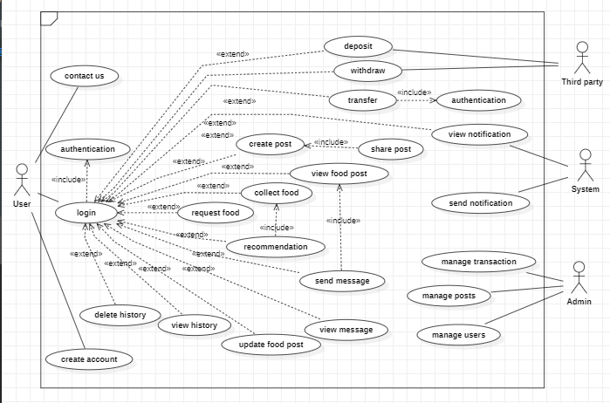

To give us a behavioral view we decided to model the flow of the system in terms of the two major activities of the system in an activity diagram.

**Activity diagram to collect food of donate food**

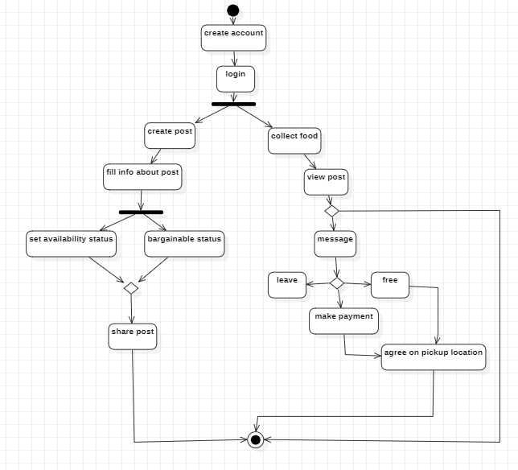

The Development of our system needs detail description and so we try to implement most of our meaningful use cases as sequence diagrams to show the flow of each use case

1. Registration:

The sequence diagram explains the registration process of our application.

**Registration Sequence Diagram**

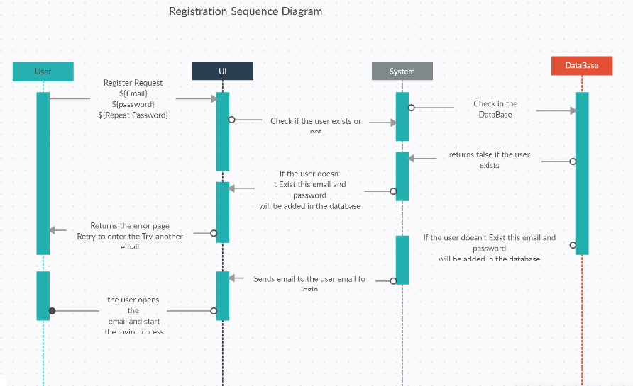

1. **Login/Logout**

The sequence diagram explains the login process of our application.

**Login**

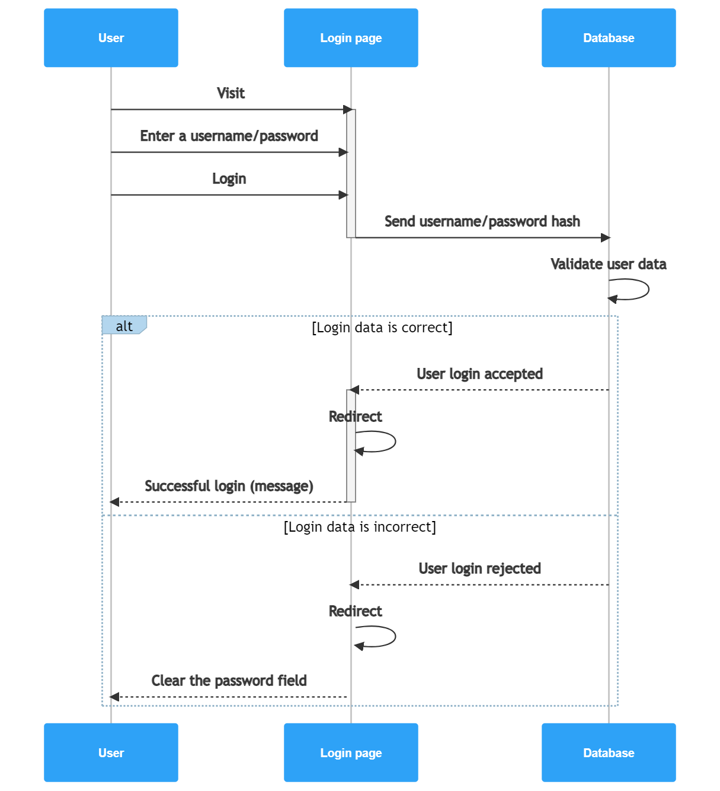

**Logout**

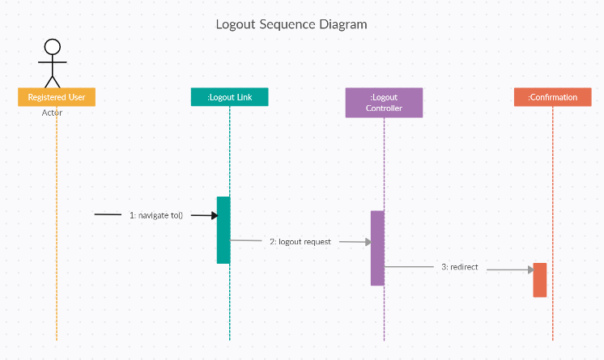

The system comes with a forgot password to ensure security, reliability, and usability we model this into a sequence diagram to show the follow of the process.

**Forgot Password Class Diagram.**

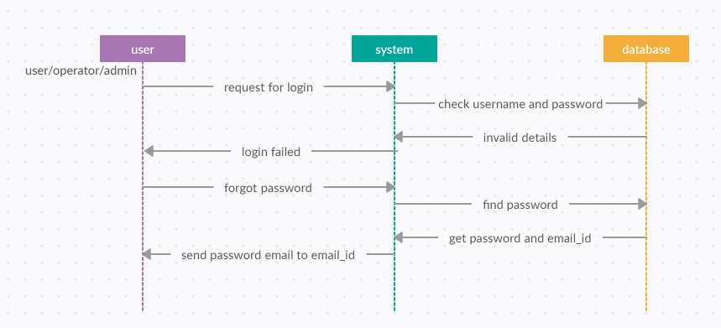

1. Create Food Post

Donors use this process to create food post in which the want to advertise or give out at an auction they can also access all options to creating the food post.

**Create Food Post**

Uses are allowed to upload post image as explained by the sequence diagram bellow.

**Upload Image**

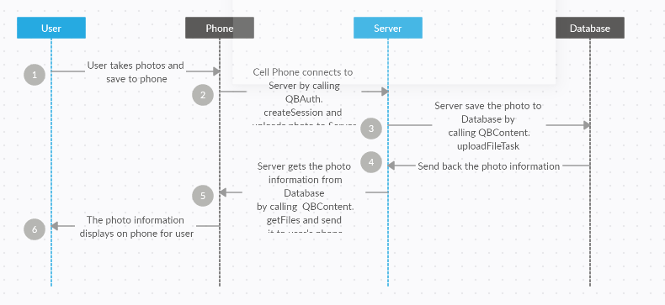

1. **Update Food post**

User have the ability to modify their post for example mark unavailable

**Update Post**

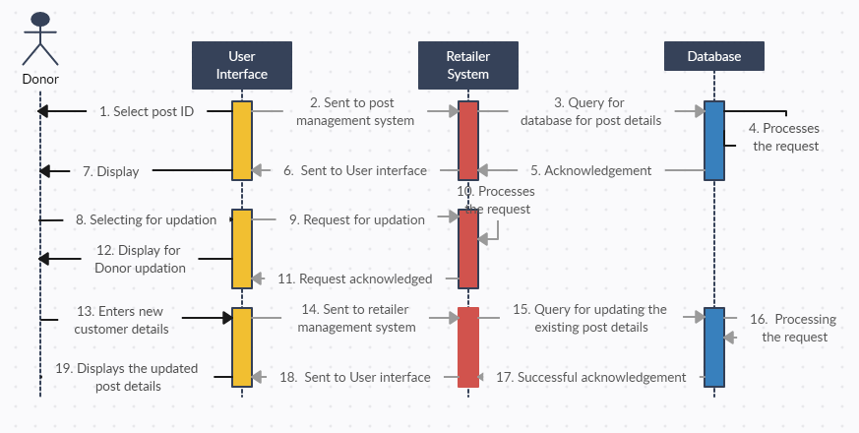

1. **Messaging**

Users have the ability to chat with each other but that most be on the basses of a food post

**Messaging**

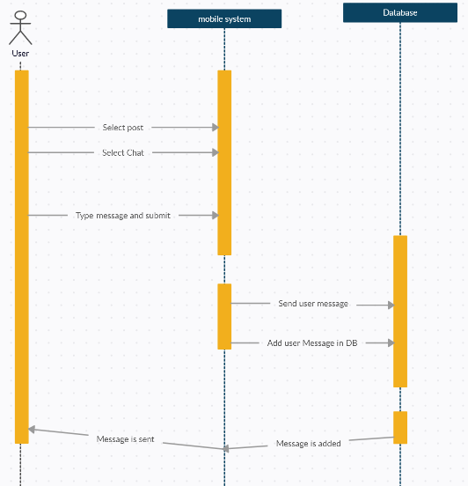

1. **Collect Food**

People come to our application is used by users to collect food from donors. A sequence diagram is designed to provide development steps on how the food collection process happens including the followed up money transferee.

**Collect Food**

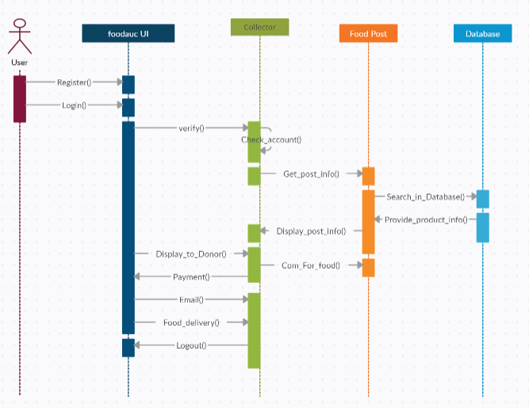

1. **Deposition**

Our system comes with a wallet which allow deposit, transfer and withdraw. The process to deposit money into your wallet account. Transfer money from one account to another. The process of development of this use cases is displayed bellow

**Deposit In Wallet.**

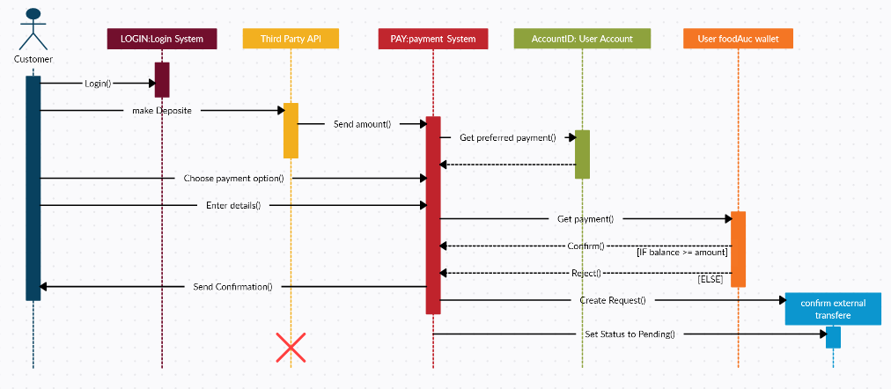

1. **Manage User**

The admin does monitor the system from users, post, and transactions, it in this capacity that the admin works as a secondary actor to the system. The sequence diagram bellow shows how the admin manages user of the system by performing add, delete edit actions on the user I information

**Manage User**

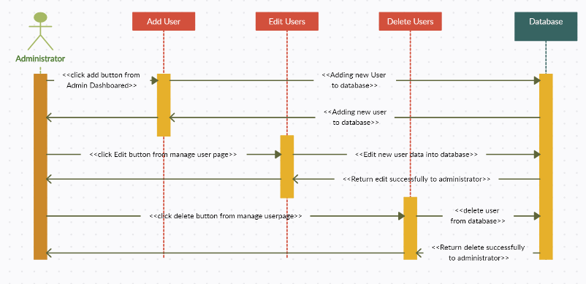

1. **Recommend User**

In our system collectors can recommend donors as a form of encouragement

