#### UNIVERSITY OF BUEA

**\*\*\*\*\*\*\*\*\*\*\*\*\*\***

#### FACULTY OF ENGINEERING AND TECHNOLOGY

**\*\*\*\*\*\*\*\*\***

#### DEPARTMENT OF COMPUTER ENGINEERING

**\*\*\*\*\*\***

#### 2022/2023 ACADEMIC YEAR

PROJECT REPORT TITTLED;



Mobile Application Development

Hybrid, Native, and Web Application development

**GROUP MEMBERS SUPERVISOR;**

**Dr. Valery Nkemini**

|  |  |
| --- | --- |
| **NAMES** | **MATRICULES** |
| **ENEMBE VERINE** | **FE20A033** |
| **AYAMBA OJONG NKONGHO** | **FE20A019** |
| **TONY KENYUI NANGAH** | **FE20A120** |
| **NKONGHO AYUK SHARIMA** | **FE20A090** |
| **GABILA YASMIN NAHKUNA** | **FE20A043** |

#### FRIDAY, MARCH 31st 2

**Mobile application programming**

**FoodAuc Mobile APP**

**INTRODUCTION**

In this phase of our project we will be looking at the UI design ang implementation. This entails designing the visual layout and interaction of the application. The UI design includes a range of elements such as the color scheme, icons, buttons, menus and other visual componenets.

**Tools Used**

* Figma
* Android studio

**Methodology**

* Agile: it will be used for the development
* Wireframe which will be used for the design

**SYSTEM UI ANALYSIS**

* Color style
* Font style
* Page size
* Device type
* Number of pages
* Content
* Structure

**IMPLEMENTATION**

* Android Studio
* DhiWise

**TECHNOLOGY**

* Kotlin
* Java
* XML

**Color**

When deciding on the colors for an application, we need to take into consideration the target audience, trends, user experience and what the application is all about. In this case we are designing an application that deals with food so the colors chosen should be aligned with the main goal of the application

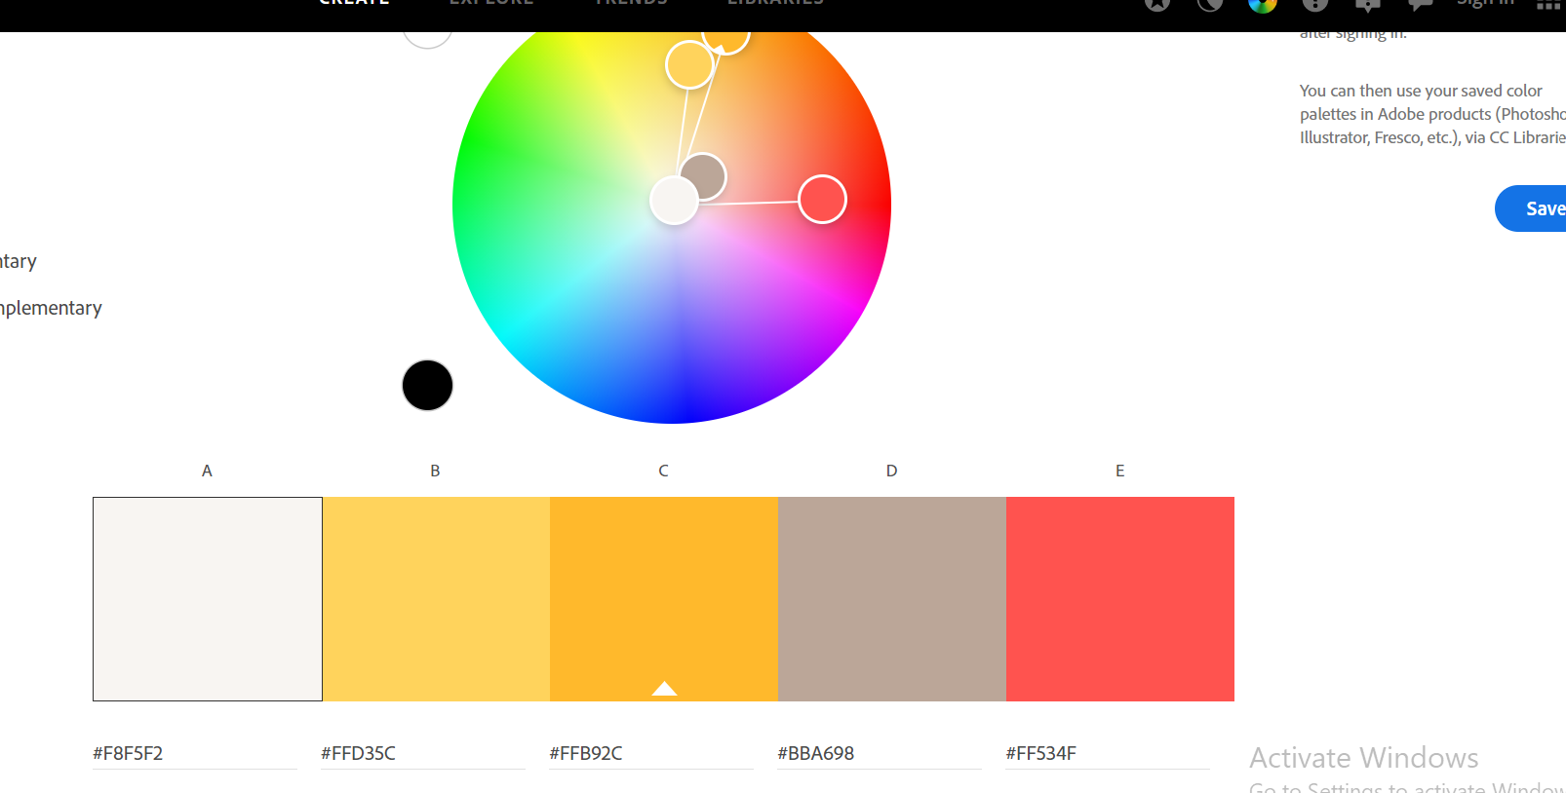

**Font style**

With regard to the font style used in an application, there are variouse criteria that need to be considered such as; the font style should be easy to read, has clear distinct letterforms and good contrast between the letters and the background. We need to ensure that the font used is appropriate for the target audience. Also, the font style should establish visual hierarchy and guide the user’s attention to important elements on the screen.

**Page size**

Choosing the right page size for a UI design is important to ensure that the content is presented in a clear and organized manner and that the user can easily navigate the interface. So to determine the page size of an application we need to take in to consideration the content of the page, the type of device this application will be used on and ensure that the page size chosen will enhance user experience by making the UI easy to navigate. We also took into consideration the screen size of the trending mobile devices.

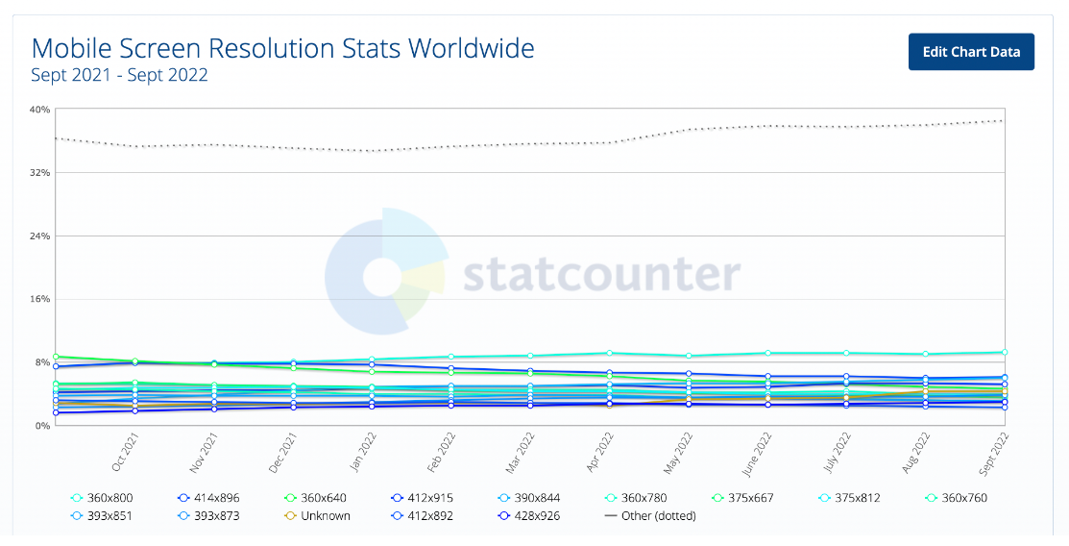

From the analysis above it is noticed that recently manufactured devices have a screen size of 360 x 760.

For our application, we are building a mobile app so our page size should be supported by a mobile phone. With all this factors taken into consideration a page size of 360 x 760 was chosen so our application will be compatible with the screen size of recent mobile devices.

**Device type**

Choosing the right device type for a UI is important to ensure that the design is optimized for the device on which it will be viewed. It is important to consider factors such as the technology used, screen size, the interaction methods. We also need to consider the context in which the application will be used that is if the application will be used in an office setting or on-the-go.

**Number of pages**

Determining the number of pages in the UI design is important is important to ensure that the content is organized in a clear and logical manner, and that the user can easily navigate between different sections of the interface. The number of pages should match the amount of content that needs to displayed, it should be appropriate for the device on which it will be viewed and also enhace the overall user experience.

**Content**

Determining the content to use in UI design is important to ensure that the information presented is clear, relevant and useful to the user. The content should meet the user’s needs, clear and easy to understand, accessible to all users. It should also be organized in a logical and intuitive manner.

**Structure**

When looking at the structure to use in UI design, it is important to ensure that the information presented is organized in a clear and logical manner. We also need to take into consideration the content, user experience and navigation of the system

Screens

