Please order illusions 1-7 by believability where 1 = most believable and

7 = least believable

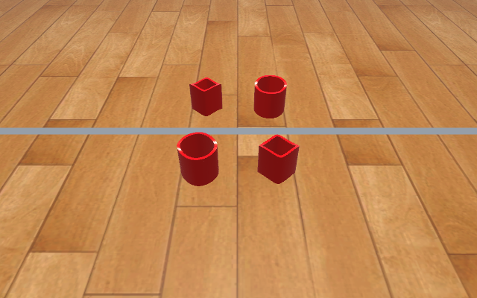

Scene : Ambiguous Cylinders

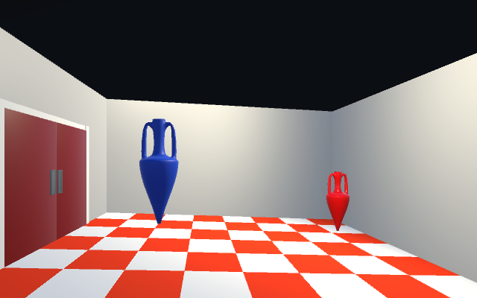

Scene : Ames Room

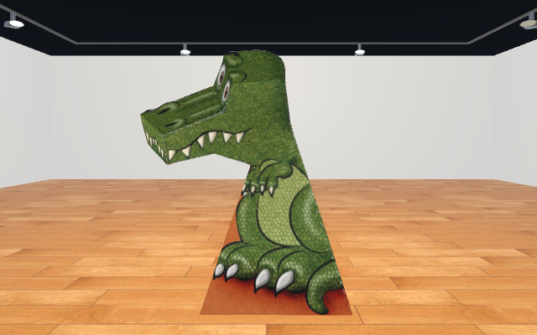

Scene : Following eyes

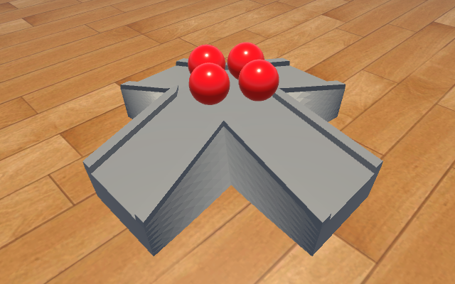

Scene : Magnetic Slopes

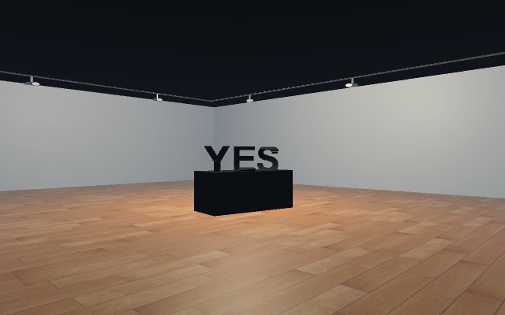

Scene : Yes/No

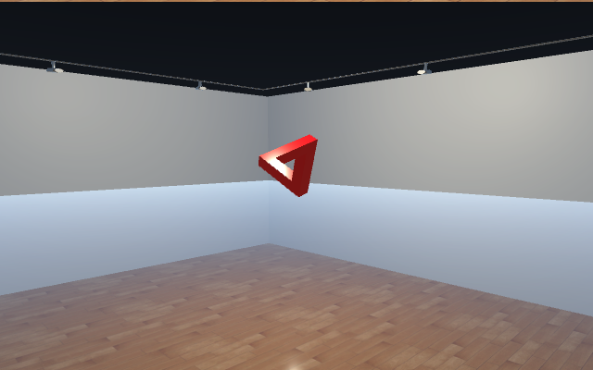

Scene : Penrose Triangle

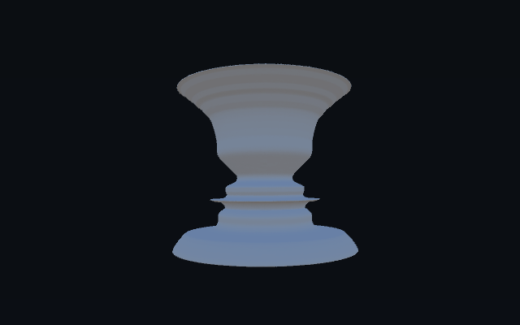

Scene : Vases/Faces