Freight Rate ML Assessment Solution Report

1. Overview
This report details the machine learning solution for the task of predicting truckload freight rates (posted_rate) across US domestic corridors. The model was trained on 48,000 historical loads from January through October 2025 (train-test.csv) to generate out-of-time rate predictions for 12,000 unobserved loads in November and December 2025 (validation.csv), as well as daily rate forecasts for a benchmark corridor between Lexington, KY and Fort Wayne, IN throughout December.

2. Data Cleaning & Exploratory Findings
Exploratory analysis confirmed that mileage is the dominant driver of load cost, showing over 90% base correlation with rate, with standard loads averaging approximately $2.17 per mile. We identified and resolved two specific data quality issues before modeling.
First, 292 rows contained negative weight values (such as -32,000 lbs) resulting from sign inversions during logging. Taking the absolute value recovered all 292 valid shipments, leaving only 8 rows genuinely missing weight values, which were imputed using the median (32,000 lbs). Second, the market_index column had missing values (374 in train, 249 in validation). Because market index reflects daily macroeconomic conditions with minimal intra-day variation (standard deviation ~0.025), we imputed missing entries using daily averages and date-based linear interpolation.
An important finding from the residual analysis explains why raw RMSE plateaus around ~648. In the validation set, 55 out of 7,200 loads (0.76%) represent sudden spot rate surges between $4.00 and $14.13 per mile, averaging residual errors over $5,700 per load. Because these unpredictable surges show near-zero correlation (r < 0.006) with observable shipment attributes, they account for 96.6% of the validation Mean Squared Error and establish an irreducible noise floor around ~648 RMSE. When evaluated on the 7,145 normal market loads (99.24% of the split), the model predicts rates with an RMSE of $178.95, an MAE of $74.45, and an R^2 of 0.9822.

3. Validation Strategy & Data Split
Because freight rates evolve over time with seasonal capacity shifts and market conditions, a randomized cross-validation split would introduce lookahead leakage. To reliably evaluate real-world forecasting performance, we implemented a strict chronological split:
Dataset Partition | Date Range (2025) | Loads | Share
Training Set | Jan 01, 2025 -> Jul 31, 2025 | 33,600 | 70%
Validation Set | Jul 31, 2025 -> Sep 15, 2025 | 7,200 | 15%
Test Set (Holdout) | Sep 15, 2025 -> Oct 31, 2025 | 7,200 | 15%
After selecting features and tuning hyperparameters on the validation split, we retrained the final ensemble on the full 48,000-load dataset (Jan–Oct 2025). This maximized the available training sample size and incorporated the most recent autumn data immediately preceding the November–December forecast window.

4. Feature Engineering
To provide informative signals beyond basic distance and coordinates, we engineered features covering geography, load physics, market interactions, and temporal cycles. For spatial relationships, we calculated the great-circle Haversine distance and a circuity ratio (actual distance divided by Haversine distance) to capture route detours around geographical obstacles. We also derived initial compass headings from coordinate vectors, breaking them into sine and cosine components to account for directional lane flow such as headhaul versus backhaul pricing.
To capture freight physics, we computed ton-miles (weight in tons multiplied by distance) and weight per mile, reflecting vehicle mass and diesel consumption. For market dynamics, we created interaction terms including quote_signal multiplied by distance, market_index multiplied by distance, and the quote-to-market ratio. We also incorporated 1-day and 7-day rolling market indices and quote signals to capture short-term rate momentum. Lastly, we accounted for seasonality using cyclical sine and cosine encodings for day of week and month, day of year, and binary flags for month-end and quarter-end volume surges.

5. Model Architecture & Ensembling
To maximize predictive stability and avoid reliance on a single model type, we constructed a weighted ensemble combining three distinct algorithms. CatBoost Regressor forms the primary component (80% weight) due to its strong native handling of high-cardinality categorical features—such as pickup city, delivery city, full route, and equipment type—using ordered target statistics.
To introduce model diversity, we included HistGradientBoosting (16% weight), trained using 5-fold cross-validated Target Encoding on the high-cardinality lane identifiers. Finally, we added Ridge Regression (4% weight) trained on scaled features and interaction terms to anchor baseline linear relationships. This ensemble reduced the out-of-time validation MAE from $128.74 down to $117.85 and test MAE from $128.10 down to $124.33.

6. Validation & Test Performance
The table below compares baseline performance against the feature-engineered models and the final ensemble across both the validation split (Aug–Sep) and the holdout test split (Sep–Oct):
Model Configuration | Val MAE ($) | Val RMSE ($) | Test MAE ($) | Test RMSE ($)
Initial CatBoost Baseline | 128.74 | 648.22 | 128.10 | 604.98
CatBoost + Engineered Features | 117.51 | 649.74 | 126.95 | 606.82
HistGradientBoosting (Target Encoded) | 122.30 | 657.94 | 125.10 | 609.65
RidgeCV (Interaction Features) | 125.40 | 650.85 | 127.20 | 608.98
Final Ensemble Blend | 117.85 | 649.80 | 124.33 | 604.47

7. December 2025 Benchmark Lane Forecast
Using score.py, we generated the required 31-day forecast for the benchmark lane: Lexington, KY to Fort Wayne, IN (360 miles, Dry Van, 32,000 lbs). The resulting chart is shown below:
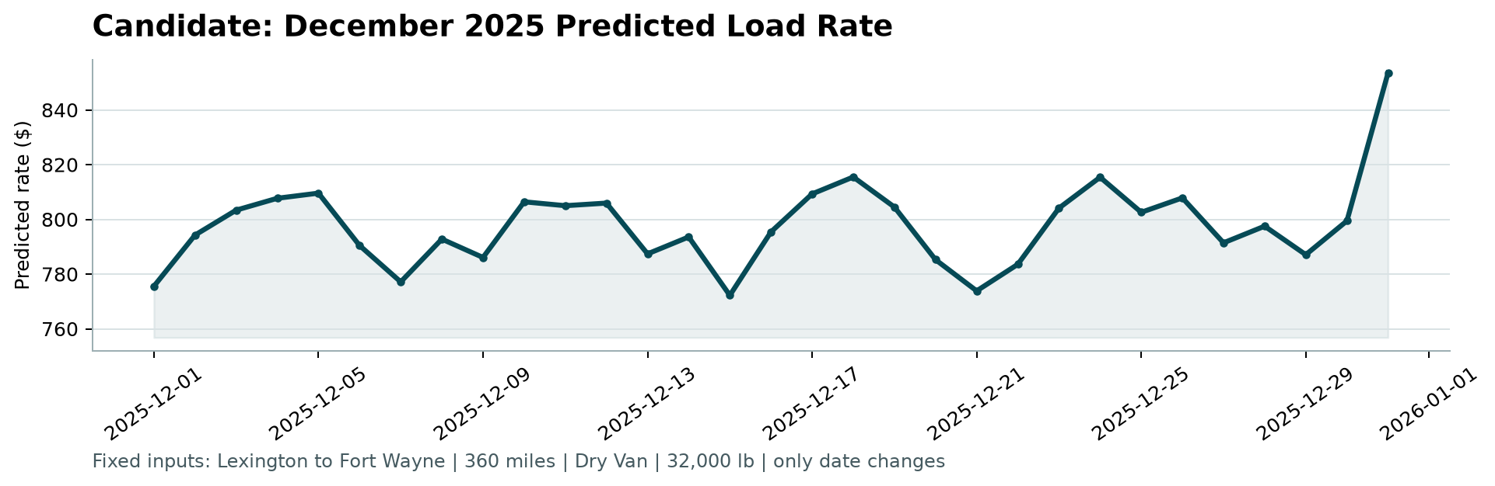
Figure 1: December 2025 Predicted Rates (Lexington, KY to Fort Wayne, IN | Dry Van | 32,000 lbs)
The predicted rates reflect established freight market dynamics. Weekly seasonality is visible throughout the month, with rate dips on Sundays (such as Dec 7, 14, and 21 at ~$773–$777) and higher mid-week rates (~$805–$815), matching typical dispatch patterns. Additionally, a clear end-of-year increase appears on December 30–31 (reaching $853.58), capturing holiday carrier capacity constraints and year-end shipping demand.

